Delays in port

With the MV Odin

Author: Liesbeth De Vylder

Supervisor: P. Harts & J. van Berlo

Date: 21 – 06 – 2016

[](http://www.reederei-speck.de/index.html)



Delays in the ports

With the MV Odin

Place of publication: Vlissingen

Date: 21-03-2016

Student number: 00064625

Education & Education year: Maritime officer 2015-2016

Semester: 2

Institution: Hz University of Applied Sciences

Study component: research report

Supervisors: P. Harts & J. van Berlo

Version: 2.0

# Abstract

In this research report a port delay-analysis was created that showed the different ports where the Odin loaded and discharged. MV Odin is a general cargo ship which always sails in liner service. This means that MV Odin always loads and discharges in the same harbours. These harbours are in Oxelösund (SE), Västeras (SE), Södetälje (SE), Hull (ENG), Velsen (NL) and Antwerp (BE). The ship mainly transports steel plates, steel coils, wooden boards and containers. The dockworkers’ working hours and rest hours from the last two years (beginning in 2014) were collected (see full analysis in the appendix).

The first chapter addresses the problem of the delays of the Odin: when the ship was delayed, charterers sometimes needed to change the schedule. Out of this problem a research question was composed. The research question was: Are there solutions for the delays when the MV Odin is in the harbours of Oxelösund, Västeras, Södertälje, Hull, Velsen and Antwerp? To answer this research question, a few sources and sub-questions were investigated. These sub-questions are:

* What are the different reasons for the delays in the harbours?
* Can the delays be related to weather, cultural differences between different countries, material shortcomings, the crew on board or another category?
* In which port does the ship have most delays?

As the results were set out, one can see clearly that Oxelösund was the port with the most delays. Main delays here were: rain/strong wind/snow, crane out of order and waiting for the berth.

In Velsen, the two delays were: crane out of order and waiting for cargo.

The delay in Södertälje was due to the fact that they only had 1 crane for discharging containers.

In England, Antwerp and Velsen the dockworkers worked fast and long times. They often worked 3 to 4 hours and then took a 30-minute break between those working hours.

In Sweden, they also worked in 2 day shifts. One from 6:00 till 14:00 and the second one from 14:00 till 22:15. First of all, in Oxelösund, the cargo operations always started with 20 or 30-minute delay. Also, the dockworkers falsely stated that their breaks always happen at regular intervals and last 30 minutes. This would mean that, when they work 8 hours, they would get a 30-minute break 3 times a day, resulting in a total of 1,5 hours. In reality, their breaks turned out to be longer. They took breaks of 40, 50 or even 60 minutes. Second of all, in Västeras, they often stopped working at 16:00 already instead of working till 22:00 (see analyse for Oxelösund/Västeras in the appendix ‘analysis of the portlogs’).

In Södertälje, they never started working before 7:00.

In Sweden, there is a big difference in performance of work. Because they have a feminine society (Sweden only scored 5% on the masculinity category), their whole culture is based around ‘lagom’. The fictional law ‘lagom’ means something like not too much, not too little, not too spectacular and means that everything should be done in moderation. Their working behaviour can also be explained by their low score (of 29%) on uncertainty avoidance. Hofstede explains uncertainty avoidance as a phenomenon where people try to maintain a more relaxed attitude, where schedules are flexible (certainly in Oxelösund) and where hard work is undertaken but only for their own benefit. This could explain why they often take longer breaks.

Hofstede’s other cultural dimensions can also play a part in the Swedish way of thinking. Sweden scores low on Power distance and therefore do not like to be checked by their supervisor. What also has an influence is the dimension Indulgence: enjoying life and having fun. The Swedish have a positive attitude towards the work and breaks. This could influence why the dockworkers decide on having longer breaks.

The dimensions Individualism indicates that Sweden is an individualistic society and therefore their employer/employee relationship is a contract based on mutual advantage. Because of this, their managers will not tell them to work faster. Even if the captain was complaining to our agent in the port and this agent informed the managers about the problem, the situation didn’t change.

The dockworkers think that it is important to keep the life/work balance.This is confirmed by the masculinity category of the literature review (cultural differences).

There were some recommendations for these three ports. For the ports of Sweden, it would be more effective to reintroduce the old working system: the dockworkers got paid a fixed amount per ship. However, when the dockworkers get a fixed amount, this cost more for the harbour and they wanted to reduce the costs. At the moment, they are getting paid per hour and this is less effective. A solution could to adapt the current working system so that dockworkers receive a bonus when they work fast.

For the port of Oxelösund, it would be a huge advantage to build an All Weather terminal (similar as the one in Antwerp) for coasters at the steel terminal for the high-grade steel coils.

For Velsen, it would be recommended to work on the truck schedule. For example, all of the trucks have to deliver their containers in the morning, so that they do not have to be on the terrain for the rest of the day.

For Södertälje, it would be helpful if the port buys a second crane for discharging containers.

For all the other harbours, it is recommended to maintain the cranes more, so that there are less crane defaults.

*List of the figures*

Figure 1: Container volumes in the port of Antwerp in million tonnes (Antwerp Port Authority, 2015)

Figure 2: Graphics of the apparent steel use of finished steel products (Dr Basson, 2016)

Figure 3: Scores of the cultural differences of Sweden in percentages (Hofstede, 2010)

Figure 4: Scores of the cultural differences of Belgium in percentages (Hofstede, 2010)

Figure 5: Scores of the cultural differences of the Netherlands in percentages (Hofstede, 2010)

Figure 6: Scores of the cultural differences of the United Kingdom in percentages (Hofstede, 2010)

Figure 7: Scores of the cultural differences of the crew on board in percentages (Hofstede, 2010)

Figure 8: Overview of the Odin in the port of Velsen (portlog, 2014)

Figure 9: Overview of the hours delay and working hours relative to total hours in the port (portlog, 2014)

Figure 10: Overview of the hours delay and working hours relative to total hours in the port (portlog, 2015)

Figure 11: Overview of the hours delay and working hours relative to total hours in the port (portlog, 2016)

Figure 12: Overview of the working- and break hours when the MV Odin was in Antwerp (portlog, 2015)

Figure 13: Overview of the working- and break hours when the MV Odin was in Velsen (portlog, 2015)

Figure 14: Overview of the working- and break hours when the MV Odin was in Västeras (portlog, 2015)

Figure 15: Overview of the working- and break hours when the MV Odin was in Oxelösund (portlog, 2015)

Figure 16: Overview of the working- and break hours when the MV Odin was in Hull (portlog, 2015)

*List of tables*

Table 1: Apparent steel use from 2009 till 2015 (Dr. Basson, 2015)

Table 2: Main delays (portlog, 2014)

Table 3: working hours in the port of Velsen with a break over 30 minutes (portlog, 2014)

Table 4: Overview of every time the ship was in Velsen (portlog, 2014)

Table 5: Main delays in figures (portlog, 2014)

Table 6: Main delays (portlog, 2015)

Table 7: Main delays in figures (portlog, 2015)

Table 8: Main delays (portlog, 2016)

Table 9: Dates when the vessel was in the port of Södertälje (portlog, 2016)

Table 10: Main delays in figures (portlog, 2016)

*Table of contents*

Abstract ii

1 Introduction 1

1.1 Problem 1

1.2 Purpose 1

1.3 Research question 1

1.4 Sub-questions 1

2 Literature review 2

2.1 The maritime economy of steel in Europe 2

2.2 Cultural differences 5

2.3 Sweden 6

2.4 Belgium 7

2.5 The Netherlands 9

2.6 United Kingdom 10

2.7 Nationality of the crew on board 12

3 Methodology 14

3.1 Type of design used 14

3.2 Research design and procedures 14

4 Results 15

4.1 What are the different reasons for the delays in the harbours? 15

4.2 Can the delays be related to weather, cultural differences between different countries, material shortcomings, the crew on board or another category? 23

4.3 In which port the ship has the most delays? 28

5 Discussion 29

5.1 Overview of the delay hours and working hours relative to total hours in the port 29

5.2 Delays related to cultural differences 30

6 Conclusion and recommendation 32

6.1 Conclusion 32

6.2 Recommendation 32

Bibliography 36

Appendix 37

I. Ship’s specifics 37

II. Different harbours 38

III. Example of a portlog of the MV Odin 44

IV. Analyse of the portlogs of 2014 46

V. Analyse of the portlogs of 2015 53

VI. Analyse of the portlogs of 2016 62

# Introduction

## Problem

MV Odin is a general cargo ship which always sails in liner service. This means that MV Odin always loads and discharges in the same harbours. These harbours are in Oxelösund (SE), Västeras (SE), Södetälje (SE), Hull (ENG), Velsen (NL) and Antwerp (BE). The ship mainly transports steel plates, steel coils, wooden boards and containers. In the recent past, the ship sometimes had to stay in port longer because of various delays. Because of the liner service, the ship frequently has to be in the same ports and when the ship has a delay, the voyage charterers sometimes need to change the schedule. When the schedule is changed too often, they will hire other vessels and then the Odin has less work.

## Purpose

The purpose of this research was to analyse the delays and to get an overview of all the different reasons for the delays in the harbours of Oxelösund, Västeras, Södertälje, Hull, Velsen and Antwerp. Possible solutions and recommendations will then be addressed.

## Research question

The research question will be: Are there solutions for the delays when the MV Odin is in the harbours of Oxelösund, Västeras, Södertälje, Hull, Velsen and Antwerp?

## Sub-questions

To get an answer to the research question, there are a few sources and sub-questions to investigate. These sub-questions are:

* What are the different reasons for the delays in the harbours?
* Can the delays be related to weather, cultural differences between different countries, material shortcomings, the crew on board or another category?
* In which port does the ship have the most delays?

# Literature review

The overall goal of this chapter was to understand the general field of study. This chapter intents to identify the approach for investigating the research question and the sub-questions. The first sub-chapter describes the maritime economy in Europe and the second sub-chapter describes the cultural differences of the different harbours of the Odin.

## The maritime economy of steel in Europe

The maritime transport plays a crucial role in enabling a growing trend in the economy. The general trade relationship between China and Europe is in balance, but the Chinese market dominates the manufactured products.

The short-term economically forecasts are essential to the operation and planning of services provided for the port of concern. The figure indicates that the container handling in the port of Antwerp is growing through the years. In 2008 there was a huge decrease in the graphic because of the economic crisis. After this crisis the economy started to grow again.

*Figure 1: Container volumes in the port of Antwerp in million tonnes (Antwerp Port Authority, 2015)*

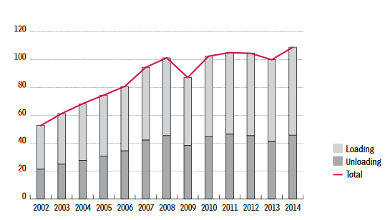

The metal industry of Sweden is not doing well, because of the low-cost metal producers in China. In the picture below two graphics are visible of the apparent steel use of finished steel products. Left graphic is a reproduction of the year 2005. The right graphic is of the year 2015 (Dr. Basson, 2016).

*Figure 2 : Graphics of the apparent steel use of finished steel products (Dr Basson, 2016)*

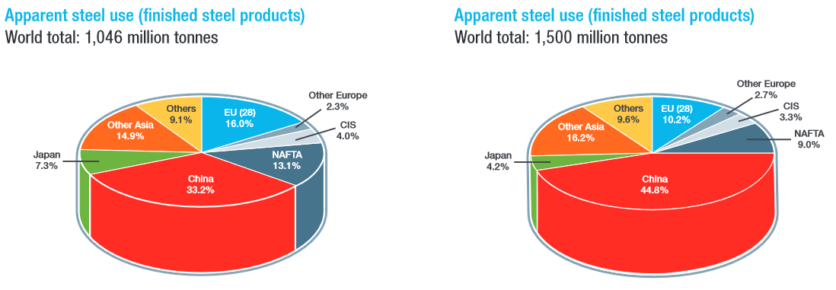

In the first graphic (2005), China manufactured a total of 33,2 % of the world production and Europe a total of 16 %. Ten years later, in 2015, Chinese production grew till 44,8% and the production of Europe decreased with 5,8% making a total of only 10,2%.

*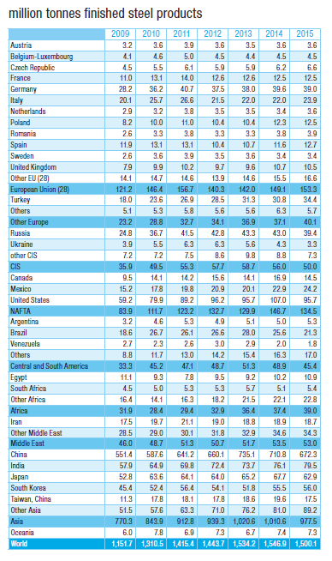 Table 1 Apparent steel use from 2009 till 2015 (Dr. Basson, 2015)*

Dr. Basson is convinced that the Steel industry will grow again, because modern society is nothing without steel. This is noticeable in table 1, showing figures from 2009 till 2015. The apparent steel production of Europe was decreasing from 2012 till 2014, but in 2015 figures start to increase again. The apparent steel production of China is decreasing in the last two years.

## Cultural differences

The crew on the MV Frej (this is a sistership of the Odin and has the same berths), mentioned a few times that in Sweden, loading and discharging takes up more time than in other ports. In this chapter the cultural differences of all the different ports will be mentioned. Later an analysis will be made about whether cultural differences can explain this problem or not.

Professor Geert Hofstede conducted one of the most comprehensive studies of how values in the workplace are influenced by culture. He analysed a large database of employee value scores collected within IBM between 1967 and 1973. The numbers shown on the graphics are in percentages. (Hofstede, 2010)

First a summary of the different subjects:

### Power Distance

Power distance deals with the fact that all individuals in societies are not equal. The rate of the power distance expresses the differences in capacity between the employers and the employees. A high score on power distance represents a high hierarchy, distance, authority and respect. A low score defines that the lower and higher staff see each other as equals.

### Individualism

The base of this dimension is the degree of the independence of the society. It has to do with people’s self-image. This is defined in terms of **“I” or “We”**. A high score on this dimension means that in this country an individualist society dominates. People are supposed to look after themselves. A low score means that in the county a collectivistic society dominates. People here belong in groups and take care of each other.

### Masculinity

The rate of masculinity indicates the values on traditionally male or female qualities. The male qualities can be linked to competition, achievement, ambition and success. In other words, the masculine countries want to be the best. These counties will have a high score on this dimension.

A low score on this dimension means that the main values in the society are feminine. The feminine qualities are solidarity, taking care of others and the quality of life. Their motivation is doing what you like.

### Uncertainty Avoidance

This dimension has to deal with the fact that the future can never be known. A society which scores high on this dimension feels threatened by ambiguous or unknown situations. They try to control the future. Societies with low scores just let things happen. They have a calm mind. Uncertainty avoidance can be achieved by regulations and official procedures.

### Long Term Orientation

This dimension describes how societies are dealing with the past, present and future. A low score on this dimension means that societies try to maintain time-honoured traditions and they care less about improvement. Social changes are suspicious. A high score means that this society is short term orientated. They care less about the traditions and care more about improvement. They are more prepared for the future.

### Indulgence

A high score on this dimension means that society is indulgent. This is when people admit to their desires and enjoying life. A low score means that society is restraint. Here, authorities will try to repress pleasure by strict rules and control.

## Sweden

The ship has tree ports of call in Sweden. It’s important to analyse the culture of this country. The graph below describes the cultural dimensions of Sweden according to Hofstede. The numbers in the graph are in terms of percentages. The cultural dimensions of Sweden can be divided in six different categories: power distance, individualism, masculinity, uncertainty avoidance, long term orientation and indulgence.

*Figure 3: Scores of the cultural differences of Sweden in percentages (Hofstede, 2010)*

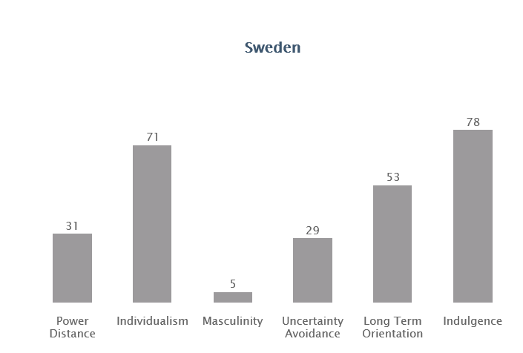

### Power Distance

Because Sweden has a low score on this dimension (a score of 31 %) the following characteristics can describe the Swedish lifestyle: being independent, no strict hierarchy, equal rights for everybody, coaching leaders. Managers are counting on the experience of their employees. They don’t like Control. **The attitude towards managers is informal and the communication is direct.**

### Individualism

Sweden, with a score of 71%, is an **Individualist society**. This means that the people of Sweden like to take care of themselves and their immediate families only. The **employer/employee relationship is a contract based on mutual advantage**.

### Masculinity

Sweden scores 5% on this dimension and is therefore a Feminine society. In Feminine countries it is **important to keep the life/work balance**. The managers will search for people who work in harmony, solidarity and are equal with others. When they have a conflict in their working team, they will try to solve this by discussions and compromises. Employees got motivated to work by free time and flexible work hours.

**Their whole culture is based around the fictional law 'lagom'**, which means something like **not too much, not too little, not too spectacular, everything in moderation.** This is a Scandinavian concept which counsels people to not try to lift themselves above others. Lagom ensures that everybody has enough. This could explain their working behaviour.

### Uncertainty Avoidance

Sweden has a **low preference for avoiding uncertainty** with a score of 29% on this dimension. This means that this society maintains a more relaxed attitude. They are more tolerated and they believe that **there should be no more rules than are necessary. Schedules are flexible, hard work is undertaken**, precision and punctuality are not natural. They do not see modernization as threatening.

### Long Term Orientation

Because of the intermediate score of 53% Sweden has no clear preference on this dimension.

### Indulgence

The Swedish culture can be described as indulgent because of the high score of 78%. The people are influenced by their impulses and desires to enjoy life and have fun. They have a positive attitude at work and they are very optimistic.

## Belgium

The graph below describes the cultural dimensions of Belgium according to Hofstede. The numbers in the graph are in terms of percentages. The cultural dimensions of Belgium can be divided in six different categories: power distance, individualism, masculinity, uncertainty avoidance, long term orientation and indulgence.

*Figure 4: Scores of the cultural differences of Belgium in percentages (Hofstede, 2010)*

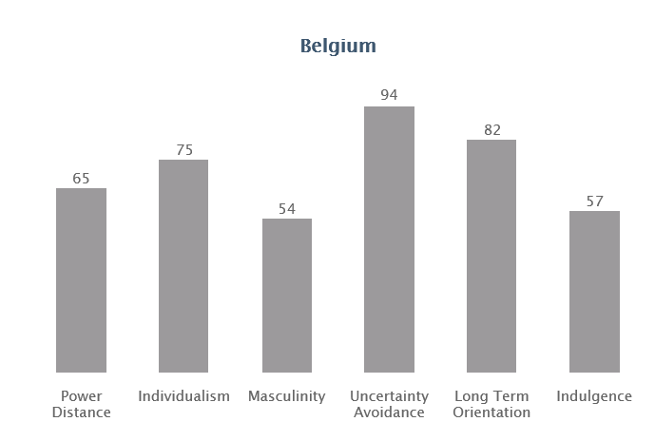

### Power distance

With a score of 65%, Belgium scores high on the scale of the Power Distance (PD). Which means that diversity is accepted, but hierarchy is needed. Managers have more advantages than employees and the attitude between them is formal. The checking of employees by supervisors is normal and even expected.

### Individualism

With 75%, Belgium scores very high on the Individualism index. This means that the Belgians only like to take care of themselves and immediate family and they don’t want to belong to a group. Work relationships are contract based, **the focus is on the task.** Employees can give their formal opinion but this is less accepted by the managers.

### Masculinity

Belgium has an intermediate score on this dimension, but a closer look into the difference between the Northern part of the country (Flemish) and the Southern part (French) shows a difference in the Masculinity value. The Flemish score 43%, and the French 60%. This certainly explains the difficulties between the two parts. The Flemish part is more feminine and in Wallonia the people are masculine-minded.

### Uncertainty avoidance

With a score of 94%, Belgium has one of the highest scores on the Uncertainty Avoidance Index. Everybody wants to have a good education to get a good job. **Rules and security** are welcome. That is why Belgians want to have **some experience** before they start a job. It is very stressful when there are no rules, security and/or planning.

### Long Term Orientation

With a very high score of 82%, Belgium has a really efficient culture. This means that people believe that **truth depends much on situation, context and time**. Traditions can be changed to save and invest for more improvement to achieve results.

### Indulgence

Belgium scores 57% on this dimension, which marks it as Indulgent. People in indulgent societies are more willing to **recognize their impulses** and desires with a **view to enjoy life and having fun**. They have a positive attitude and are more optimistic.

## The Netherlands

The graph below describes the cultural dimensions of the Netherlands according to Hofstede. The numbers in the graph are in terms of percentages. The cultural dimensions of the Netherlands can be divided in six different categories: power distance, individualism, masculinity, uncertainty avoidance, long term orientation and indulgence.

*Figure 5: Scores of the cultural differences of the Netherlands in percentages (Hofstede, 2010)*

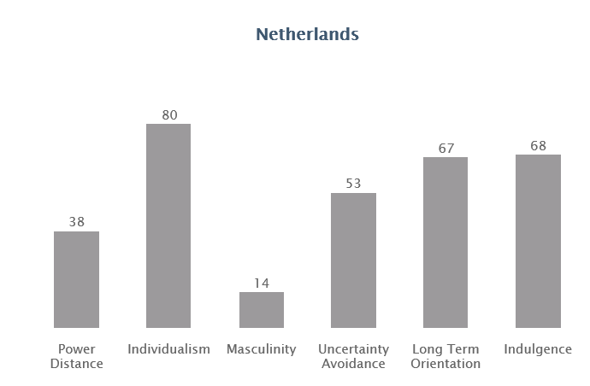

### Power Distance

Because of a low score of 38% the following characteristics representing the Dutch style: being independent, no strict hierarchy, equal rights for everybody, coaching leaders. **The attitude towards managers is informal and the communication is direct.**

### Individualism

With the very high score of 80% is the Netherlands an Individualist society. This means that in working environment **the employer/employee relationship is a contract based on mutual advantage**.

### Masculinity

The Netherlands scores 14% on this dimension and is therefore a Feminine society. In Feminine countries it is important to keep **life and work in balance.** The managers are supportive to their employees and treat them with equal value and solidarity. When they have a conflict in their working team, they will try to solve this by discussions and compromises.

### Uncertainty Avoidance

With an intermediate score of 53% their uncertainty avoidance preference cannot be determined.

### Long Term Orientation

A high score of 67% in this dimension means that the Netherlands have a practical nature. In these societies **people believe that truth depends much on the situation, context and time.** Traditions can be changed to save and invest for more improvement to achieve results.

### Indulgence

With a high score of 68%, the culture of the Netherlands is clearly one of Indulgence. People in indulgent societies are more willing to **recognize their impulses** and desires with a **view to enjoy life and having fun**. They have a positive attitude and are more optimistic.

## United Kingdom

The graph below describes the cultural dimensions of the United Kingdom according to Hofstede. The numbers in the graph are in terms of percentages. The cultural dimensions of the United Kingdom can be divided in six different categories: power distance, individualism, masculinity, uncertainty avoidance, long term orientation and indulgence.

*Figure 6: Scores of the cultural differences of the United Kingdom in percentages (Hofstede, 2010)*

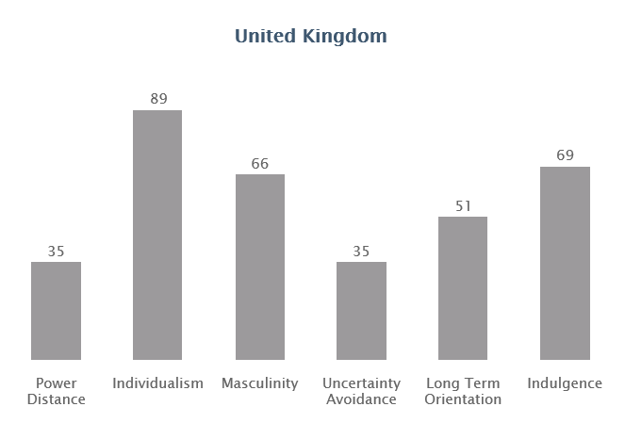

### Power Distance

With a score of 35% the British have a society that believes that differences between people should be minimized. Their belief is that **people should be treated as equals.**

### Individualism

At a score of 89% the UK is amongst the highest of the Individualist scores. This means that they are highly individualistic and private people. Children are taught from young ages to think for themselves. **They think they can be happy through personal achievement.**

### Masculinity

At 66%, Britain is a Masculine society which means that people are **highly success oriented and driven**. People in the UK live in order to work and have clear ambitions.

### Uncertainty Avoidance

With a low score of 35% the UK is a nation where the people are quite **happy to wake up not knowing what the day will bring.** They are not stressing when plans change due to new information. The British are **comfortable in uncertain situations.**

### Long Term Orientation

With an intermediate score of 51%, a dominant preference cannot be determined.

### Indulgence

A high score of 69% indicates that the British culture can be classified as Indulgent. People in indulgent societies are more willing to **recognize their impulses** and desires with a **view to enjoy life and having fun**. They have a positive attitude and are more optimistic.

## Nationality of the crew on board

The company Speck works with employees of the firm ‘Marlow Navigation’. This is a management system which provides shipping companies all the crewmembers they need. Mainly everybody on board is thus from Russia, Poland or Ukraine. (All aboard, n.d.)

*Figure 7: Scores of the cultural differences of the crew on board in percentages (Hofstede, 2010)*

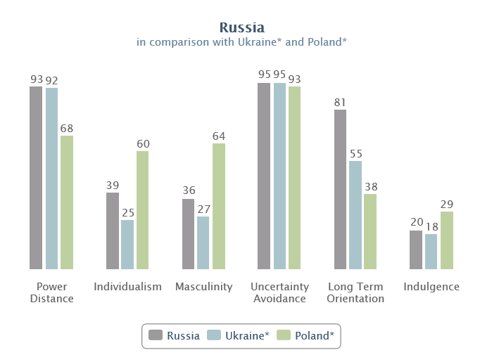

### Power Distance

**Russia and Ukraine**, scoring 93% and 92%, are nations where managers are very distant in the work environment. **The huge difference between the less and the more powerful people leads to an important hierarchy with distance.** The behaviour has to reflect and represent the status roles.

With a score of 68%, **Poland** is a hierarchical society. This means that **people accept that everybody has their place in the hierarchy**. This is seen as reflection of the differences. Employees are expecting that the managers tell them what to do.

### Individualism

With their low scores Russians and Ukrainians are collectivistic. This can be seen in language: they will use more direct language when they talk to a family member or friend and will use more formal speech when talking to a stranger. Family, friends and the neighborhood are extremely important. Relationships are crucial for obtaining information, getting introduced or successful meetings. **They need to be personal, authentic and trustful.**

Poland, with a score of 60% is an Individualist society. This means there is a high preference for **individuals to take care of themselves** and their close families only. The employer/employee relationship is a contract based on mutual advantage.

### Masculinity

Russia and Ukraine score relatively low with 36% and 27%. When they are meeting with strangers (at the workplace as well) they want the strangers to understate their personal achievements and capacities. **Dominant behavior might be accepted when it comes from their supervisor, but is not appreciated between equals.**

With a score of 64% Poland is a Masculine society. The people here live in order to work. **Managers are expected to make decisions and be assertive.** Conflicts are resolved by fighting them out.

### Uncertainty Avoidance

The high scores of these 3 countries indicate that **they feel very much threatened by new situations**. A **detailed planning and briefing is very common**. They prefer to have context and background information. In team even though they appear to communicate very formally, **formality is used as a sign of respect.**

### Long Term Orientation

With a very high score of 81%, **Russia** has a really efficient culture. This means that people believe that **truth depends much on situation, context and time**. Traditions can be changed to save and invest for more improvement to achieve results.

With an intermediate score of 51% in this dimension, a dominant preference in Ukrainian culture cannot be determined.

**Poland**'s low score of 38% in this dimension means that try to maintain time-honoured traditions and they care less about improvement. Social changes are suspicious and they focus on achieving quick results.

### Indulgence

The Restrained nature of Russian/Ukrainian and Polish cultures are easily visible through their very low scores on this dimension. Societies with a low score in this dimension do not focus on relaxation and they try to control their desires. **People with this orientation have the perception that their actions are restrained by social norms.**

# Methodology

## Type of design used

For this research, a mixture of qualitative and quantitative approach was used. The main method used featured qualitative approach.

This type of qualitative approach is an overview of analytical information of current systems of the ports, processes of the cargo operations, and the understandings of the shared beliefs and skills of the stevedores and the crew. This type of design collected narrative data (non-numerical data) based on many variables over a period of 2,5 years. The development, cultural differences and the current conditions of the stevedores in the harbour is observed and analysed for patterns in relation to internal and external influences of the delays.

The quantitative side of the research was:

1. Monitoring the working hours and different breaks/delays in hours
2. Analysing the old portlogs of the Odin of the recent past (2014-2016)

## Research design and procedures

In this research the method ‘data collection’ and ‘analyse procedures’ was used. This means the first step was data collection: monitoring the working hours of the crew and the harbour workers and trying to figure out if there were any delays. Also analysis was made of the old portlogs of the Odin from the recent past (Beginning of 2014 till April 2016).

The analysis procedure: analyse in which port(s) the most delays occurred, then make an inventory of the harbours with the most delays and conclude if there were any solutions or suggestions for these problems.

# Results

To get an answer to the research question, a few sources and sub-questions were investigated. These sub-questions were:

* What are the different reasons for the delays in the harbours?
* Can the delays be related to weather, cultural differences between different countries, material shortcomings, the crew on board or another category?
* In which port does the ship have the most delays?

To find an answer for these questions, the portlogs of the ship from the years 2014, 2015 and 2016 till the beginning of April were analysed. The lay-out of an example of a portlog is placed in the appendix as well as the overview of the analyses of the portlogs of the different years.

## What are the different reasons for the delays in the harbours?

Below, the lists of the delays is given for each year. During these years some delays were not explained in the portlogs, but the captains of the Odin and the dockworkers verbally gave more details about these delays. Further explanations can be found in the analysis.

### Main delays of the year 2014

#### Table 2: Main delays (portlog, 2014)



One time in Västeras, the crane was out of order. In Hull and Antwerp the only delay was 30 minutes shifting.

According to the list above, most of the delays occurred in Oxelösund. This makes sense, because the ship spend most of its time loading in this port. In Oxelösund the two most common delays were: rain and the crane out of order.

The second port where the most delays occurred, is Velsen. The two most common logged delays were: crane out of order and waiting for cargo. In the table below, some information is categorized for every time the Odin was in the port of Velsen. The table only mentions the dates when the dockworkers took a break longer than 30 minutes.

*Table 3: working hours in the port of Velsen with a break over 30 minutes (portlog, 2014)*



In the graphic below, an overview was created between the total hours in the port, the working hours and the break hours. The graph bars are in chronological sequence according to table 4 underneath the graphic. Started from 31-12-2013 till 31-10-2014.

*Figure 8: Overview of the Odin in the port of Velsen (portlog, 2014)*

*Table 4: Overview of every time the ship was in Velsen (portlog, 2014)*



To get a better view of the delays in comparison with the total hours the vessel was in the port, another graphic was made up. The table was made with all the data in absolute figures and in percentages.

*Table 5 : Main delays in figures (portlog, 2014)*



*Figure 9: Overview of the hours delay and working hours relative to total hours in the port (portlog, 2014)*

### Main delays of the year 2015

*Table 6: Main delays (portlog, 2015)*



In 2015, Oxelösund was again the port where the most delays occurred. This year, rain was the main delay. The ship also had to wait 8 times till the berth was available. Most of the times, this delay took more than a few hours.

In Velsen, the ship had to wait for cargo again. In Hull, the ship also had to wait 2 times for cargo.

To get a better view of the delays in comparison with the total hours the vessel was in the port another graphic was created. The table was made with all the data in absolute figures and in percentage.

*Table 7: Main delays in figures (portlog, 2015)*



*Figure 10:* *Overview of the hours delay and working hours relative to total hours in the port (portlog, 2015)*

### Main delays of the year 2016

*Table 8: Main delays (portlog, 2016)*



At the end of January 2016, the vessel had to stay longer in the port of Oxelösund and Västeras because of engine problems. This was an emergency delay.

Furthermore, the Odin was delayed three times in Oxelösund because of rain, wind and/or snow.

The first of March 2016, the ship had to wait in the port of Södertälje for 6 hours until the dockworkers started discharging the vessel. In this port the vessel only had to discharge a few containers (see table below).

*Table 9: Dates when the vessel was in the port of Södertälje (portlog, 2016)*



The captain verbally stated that the problem in Södertälje was that there is only 1 crane for loading/discharging containers. The harbour has a berth for two containerships. If there was a ship engaged in cargo operations, the second ship had to wait until the other ship was ready. This was the reason the vessel had delays in this port. The crew did not see this as a delay, because after this port the vessel sailed to Västeras (which is 4 hours) and the dockworkers in Västeras always start the next day with cargo operations. The fact that this delay does not affect the schedule is the reason why they did not mention this in the portlog.

Main delay for Södertälje was: waiting for the crane.

To get a better view of the delays in comparison with the total hours the vessel was in the port another graphic was made. First the table was created with all the data in absolute figures and in percentage.

*Table 10: Main delays in figures (portlog, 2016)*



*Figure 11:* *Overview of the hours delay and working hours relative to total hours in the port (portlog, 2016)*

## Can the delays be related to weather, cultural differences between different countries, material shortcomings, the crew on board or another category?

In this sub-chapter the second sub-question is clarified in three different subjects. These are: cultural differences between different countries, material shortcoming and the crew on board. In 4.2.1 other subjects are discussed.

### The different categories

In the portlog, there were a few categories of delays logged: shifting of cargo, shifting of ship, waiting on cargo, waiting for berth, crane out of order, rain/strong wind/snow.

**Shifting of the ship/cargo** is a short delay. Mostly not more than 30 minutes.

When the crane was out of order, this was related to material shortcoming.

Furthermore, one category needs to be added to the sub-question. This can be **failure of schedule** for when the ship has to wait for cargo or for the berth.

### Delays related to cultural differences

Out of the main delays logged in the portlog, there was no direct connection between the cultural differences of the countries because the main delays are related to shifting, material shortcomings, weather or failure of schedule. When taking a closer look at the portlogs, a big difference exists between the working hours and the breaks between the ports.

The graphics below shows all the results of the working hours and the breaks for each port. For Södertälje no graphic was made because the dockworkers never took breaks in this harbour. When they started working they worked until all containers were discharged and/or loaded. The results are discussed in the next chapter ‘discussion’.

*Figure 12: Overview of the working- and break hours when the MV Odin was in Antwerp (portlog, 2015)*

*Figure 13:* *Overview of the working- and break hours when the MV Odin was in Velsen (portlog, 2015)*

*Figure 14:* *Overview of the working- and break hours when the MV Odin was in Västeras (portlog, 2015)*

*Figure 15:* *Overview of the working- and break hours when the MV Odin was in Oxelösund (portlog, 2015)*

*Figure 16:* *Overview of the working- and break hours when the MV Odin was in Hull (portlog, 2015)*

In these graphics one can clearly see that in Oxelösund and Västeras the dockworkers took more breaks instead of the dockworkers in Antwerp, Velsen and Hull.

The captain of the Odin verbally stated that when the dockworkers of Sweden worked with their old working system, the cargo operations went faster. The reason was that they got paid per ship that they finished. When they finished very quickly, they even got a bonus. The faster they finished a ship, the faster they could go home or start with another ship. Since 2012 the system changed and they are now getting paid per hour meaning that dockworkers have fixed working hours. The old working system was eliminated because the port had to save costs. Chapter 1 of the literature review already stated that the metal industry of Sweden is not doing well because of the low-cost metal producers in China.

The Swedish steel producers needed to make profit in another way. According to the dockworkers, they still produce steel, but less every year. This is the reason why they now have different contracts.

### Delays related to material shortcoming

As already mentioned in chapter 4.2.1 ‘different categories’: when the crane is out of order, this can be related to material shortcoming.

The crane was out of order in all the ports. Most of the time in Oxelösund. The reason can be because the cranes are old. According to the dockworkers, the two track-based 45-tonne cable cranes were both build in the year 1975 and the container crane was manufactured in the year 1999. They also said that the cranes mainly have electrical problems and that these problems happen very often these last few years.

In case the crane is out of order the voyage charterers of the Odin were not working with letters of protest. A certain amount of time is agreed between the ship’s agents and the charterers for the loading and unloading operations. This period is different for every port and also depends on what the ship has to load and/or discharge. This amount of time is called ‘lay days’ or ‘laytime’. As long as such delay is due to causes beyond his control, and he has neither acted carelessly and/or unreasonably, the charterer had to make sure that his agreement to load or discharge, even with long delays, was fulfilled.

The dockworkers of the harbours had to stay between the agreed time ranges which the agents set out in the voyage schedule of the Odin.

### Delays related to the crew on board

The crew on board never caused delays. The chief mate took care of the loading operations. The second mate took care of the discharging operations. The 3 AB’s (Able seaman) on board had a deck watch schedule through which there was always at least 1 AB on deck.

This means ‘delays related to the crew on board’ can be cancelled.

## In which port the ship has the most delays?

In chapter 4.1 the different reasons of delays for the Odin are indicated. In the overview, it is discernible that Oxelösund was the port with the most delays. The main delay here was rain, crane out of order and waiting for the berth.

# Discussion

In this chapter the results of the previous chapters will be discussed.

## Overview of the delay hours and working hours relative to total hours in the port

### General

In 2014, there were never more hours of delay compared to the total working hours of the dockworkers. This means that the delays were relatively small. Only twice in Velsen (on 31-01-2014 and 31-10-2014, see figure 9 and table 5) the delays were 24% and 29% of the total duration that the ship was in the port. In figure 9, it can be seen that the ship sometimes stayed in the port much longer than necessary. When reviewing the numbers 1,2, 4, 11 and 12 in figure 2, every delay occurred when the ship was in Oxelösund.

In 2015, there sometimes were more hours of delay than total working hours of the dockworkers. In figure 10 for example, the delays 1, 3, 11, 13, 17 and 21 were from longer duration. These numbers correspond with the numbers in table 7. It represents the different days in the ports of Oxelösund (1, 11, 13 and 17) and number 3 refers to the port of Antwerp. In Antwerp, the delay (waiting for the berth) took up 93% of the total time when the ship was in the port, only 19% of the time they were working. In Oxelösund, 3 delays took up around 30% of the total time, one delay lasted 60% of the total time and on 22-10-2015 even 70% of the total time.

In 2016, there sometimes were more hours of delay than total working hours of the dockworkers. In figure 11 for example the delays 1, 2 and 5 had a longer duration. These numbers correspond with the numbers in table 10. It represents the different days in the ports of Oxelösund, Västeras and Hull. In Oxelösund, the delay was 70% of the total time when the ship was in the port, only 11% of the time they were working. In Västeras, the delay was 62% of the total time, and in Hull the delay was also around 60% of the total time.

### Velsen

In 2014, much more delays occured in Velsen than actually stated in the official portlog. The chief mates wrote in the official portlog that there were only 2 delays in one year: 31 January and 31 October (see table 3 on page 16). However, when looking at the working hours, the breaks and the total time that the ship was in the port, there were much more days with delays.

According to figure 8 of Velsen (shown on page 17), it is very clear that the vessel was sometimes in the port longer than necessary. When looking at the working hours, the blue graph bar is much longer than the orange graph bar which means that there was a delay in the port. For example, on 2 January, 17 January, 14 March…There were long breaks in the beginning of 2014. But since April these long breaks have ended.

For the years 2015 and 2016 the breaks with respect to the working hours were relatively normal. In 2015, long breaks only occurred 2 times.

### Södertälje

The fact that the port of Södertälje only has 1 crane to discharge containers can also be seen as a **material shortcoming**.

When the ship had to wait for the crane in Södertälje, the crew did not see this as a delay because after this port the vessel sailed to Västeras (which is 4 hours) and the dockworkers in Västeras always start the next day with cargo operations. That is why they do not write this down in the portlog. One can question this behaviour. Every delay should be stated in the portlog to get a better impression of all the delays.

### Other

Shifting of the ship/cargo causes a very short delay. Mostly not more than 30 minutes. Because of the short time, this delay is less relevant than the other delays like waiting for cargo or rain.

## Delays related to cultural differences

In England, Antwerp and Velsen the dockworkers worked fast and long times. They often worked 3 to 4 hours and then took a 30-minute break between those working hours. In England, they even often work during the night. This is the only port they work in the night. In the rest of the ports they work normally from 6 till 22 hour.

In Sweden, they also worked in 2 day shifts. One from 6:00 till 14:00 and the second one from 14:00 till 22:15. First of all, in Oxelösund, the cargo operations always started with 20 or 30-minute delay. Also, the dockworkers falsely stated that their breaks always happen at regular intervals and last 30 minutes. This would mean that, when they work 8 hours, they would get a 30-minute break 3 times a day, resulting in a total of 1,5 hours. In reality, their breaks turned out to be longer. They took breaks of 40, 50 or even 60 minutes. Second of all, in Västeras, they often stopped working at 16:00 already instead of working till 22:00 (see analyse for Oxelösund/Västeras in the appendix ‘analysis of the portlogs’).

In Södertälje, they will never start working before 7:00.

There is a big difference in performance of work. Because they have a feminine society (Sweden only scored 5% on the masculinity category), their whole culture is based around ‘lagom’. The fictional law ‘lagom’ means something like not too much, not too little, not too spectacular and means that everything should be done in moderation. Their working behaviour can also be explained by their low score (of 29%) on uncertainty avoidance. Hofstede explains uncertainty avoidance as a phenomenon where people try to maintain a more relaxed attitude, where schedules are flexible (certainly in Oxelösund) and where hard work is undertaken but only for their own benefit. This could explain why they often take longer breaks.The other facts also play part in the way of thinking of the people of Sweden. The score on Power distance is low and stands for control is dislike. The dockworkers have normally 30-minute break, but they like to decide how long they take a break. What also has an influence, is the category indulgence: enjoying life and having fun. They have a positive attitude towards the work and breaks.

The dimensions Individualism indicates that Sweden is an individualistic society and therefore their employer/employee relationship is a contract based on mutual advantage. Because of this, their managers will not tell them to work faster. Even if the captain was complaining to our agent in the port and this agent informed the managers about the problem, the situation didn’t change.

The dockworkers think that it is important to keep the life/work balance. This is confirmed by the masculinity category of the literature review (cultural differences).

Hofstede’s other cultural dimensions can also play a part in the Swedish way of thinking. Sweden scores low on Power distance and therefore do not like to be checked by their supervisor. What also has an influence is the dimension Indulgence: enjoying life and having fun. The Swedish have a positive attitude towards the work and breaks. This could influence why the dockworkers decide on having longer breaks.

# Conclusion and recommendation

In this chapter, the research question will be answered. The research question is: Are there solutions for the delays when the MV Odin is in the harbours of Oxelösund, Västeras, Södertälje, Hull, Velsen and Antwerp?

## Conclusion

In this sub-chapter, an overview is made of the different delays in the ports where the most delays occurred. These ports were Oxelösund and Velsen.

### General

First of all, the chief mates need to fill in the portlogs more properly, because it happens many times that there are a few hours delay in the port, but no remark is made. This will be a problem in case the schedule needs to be changed, because of too many delays and the charterers do not know anything about the delay.

Then in Sweden, the dockworkers are now working more slowly than in the past when they had their old working system. This causes an average overall delay.

### Oxelösund

As the results are set out, it is clear that Oxelösund is the port with the most delays. Main delays here are:

* Rain/strong wind/snow
* Crane out of order: this delay can be related to material shortcomings
* Waiting for the berth

### Velsen

The two delays in Velsen are:

* crane out of order: this can be related to material shortcomings
* waiting for cargo: this can be related to failure of schedule

### Södetälje

The delays in Södertälje are caused because there is only 1 crane for discharging containers.

## Recommendation

In this sub-chapter a few remarks on the delays will be determined.

### General

The chief mates cannot continuously check the cargo operations, but there is always an AB on deck watch. They can check both. The chief mate and the deck watch can keep record about any delays and write them down at that moment. The chief mate can later fill in the portlog without any problems.

For the ports of Sweden, it would be more effective to reintroduce the old working system: the dockworkers got paid a fixed amount per ship. However, when the dockworkers get a fixed amount, this cost more for the harbour and they wanted to reduce the costs. At the moment, they are getting paid per hour and this is less effective. A solution could to adapt the current working system so that dockworkers receive a bonus when they work fast.

For all the harbours, it is recommended to maintain the cranes more, so that there are less crane defaults.

### Oxelösund

For the port of Oxelösund, it would be a huge advantage to build an All Weather terminal (like there is one in Antwerp) for coasters at the steel terminal for the high-grade steel coils. Now every time it rains, cargo operations need to stop and if they had an All Weather terminal the coasters can be loaded under a cover.

The Odin has the maximum size of which kind of vessel moors here.

|  |  |
| --- | --- |
| **LOA** | 97,53 m |
| **Breadth** | 15,90 m |

**Air draft** 38,00 m

The picture below is a recommendation for the All Weather terminal. It would be suitable for 1 ship.

For the terminal:

Length 120 m

Breadth 40 m

Height 80 m

The height of the crane 60 m

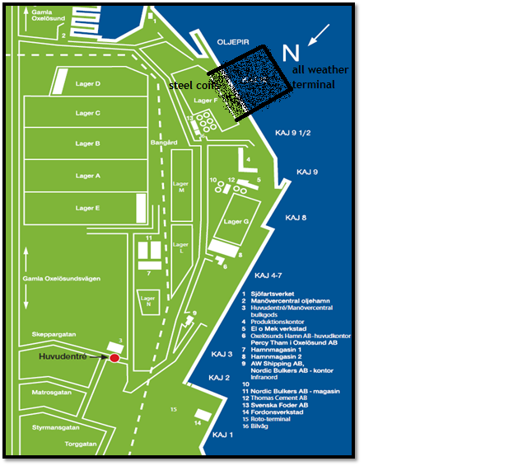[1]

For the second delay (the crane out of order), it would be recommended to buy a new crane or if this is too expensive, more maintenance can be given to the old crane.

For the last delay (waiting for the berth), it would be recommended that the captain and officers sail more slowly towards the port of Oxelösund if they know the berth is occupied. In all ports, the ships of the company (Odin, Frej and Alrek) have a usual spot. So there is mostly one of the ships at the berth (certainly in Hull and Oxelösund). When the Odin left the port of departure, the captain sends a notice of readiness and the ship then receives the time and date when the other ship is leaving berth or they receive a message that the berth is empty the whole day and the ship can come alongside on arrival.

But when there is another ship alongside and they had some delays, it happened that the vessel could not come alongside. The captain of the other ship then mostly informs the Odin and, in this case, they steam slowly towards the harbour.

### Velsen

For Velsen, it all depends on the factories and the trucks on the road. Here, it may be a good idea to let the trucks deliver their containers earlier than they mention now. Currently, all containers need to be delivered on Friday: some containers arrive in the morning, some in the evening. If all of the trucks deliver their containers in the morning, there would be less delays.

### Södertälje

For Södertälje, it is recommended to have a second crane for loading containers.

# Bibliography

Google Maps. (n.d.). Retrieved February 09, 2016, from http://maps.google.com/

Mälarhamnar AB. (n.d.). Retrieved February 09, 2016, from http://www.malarhamnar.se/sc.php?meny_id=2

About the port - Oxelösunds Hamn. (n.d.). Retrieved February 09, 2016, from http://www.oxhamn.se/en/about-the-port/

Oxelösund Hamn AB oversiktskarta 20121 [PDF]. (2015, May). Oxelösund.

Container. (n.d.). Retrieved February 09, 2016, from http://www.soeport.se/en/Port-of-Södertälje-/Container/

Havenkaart: Port of Antwerp [PDF]. (2014, January). Antwerp: HavenGIS.

Geert Hofstede, 2010. National Culture. (n.d.). From http://Geert-Hofstede.com/national-culture.html

Hull Port Plan [PDF]. (2016). Associated British ports.

Key Elements of the Research Proposal. (n.d.). Retrieved February 09, 2016, from https://www.bcps.org/offices/lis/researchcourse/key_elements.html

Port of Södetälje [PDF]. (n.d.).

All aboard. (n.d.). Retrieved February 19, 2016, from http://marlow-navigation.com/crew-management.html

Chief mates of the Odin. (2016). *portlogs .* on board of the Odin.

Dr. Basson, E. (n.d.). World steel association. *World Steel in Figures 2016,* 1-30.

Law And Sea. *Voyage charters*. (2015, March). Retrieved from http://www.lawandsea.net/CP_Voy/Charterparty_Voyage_Laytime.html

Department of transport and regional economics, University of Antwerp (2015, September). *Study on the Analysis and Evolution of International and EU Shipping*. Retrieved from http://ec.europa.eu/transport/modes/maritime/studies/doc/2015-sept-study-internat-eu-shipping-final.pdf

Antwerp Port Authority. *2015 Facts and figures*. (2015, June). Retrieved from http://www.portofantwerp.com/sites/portofantwerp/files/campaigns/Cijferboekje_2015_UK_DEF.pdf

# Appendix

## Ship’s specifics

|  |  |
| --- | --- |
| General **Name** | **Odin** |
| **type** | General cargo |
| **Tonnage BRZ** | 2997 |
| **Tonnage NRZ** | 1320 |
| **LOA** | 97,53 m |
| **Breadth** | 15.90 m |
| **Depth to main deck** | 7.54 m |
| **Draught** | 5.94 m |
| **LBP** | 91.00 m |
| **DW** | 4470 t |
| **Light vessel** | 1952 t |
| **Ballast** | 1250 t |
| **Fuel oil** | 322 t |
| **Gas oil** | 65 t |
| **Luboil** | 23 t |
| **Fresh water** | 39 t |
| **Air draft** | 38 m |
| **Engine** | 2700 kW / 3672 hp |
| **Bow thruster** | 320 kW / 435 hp |
| **Speed** | 14.5 kn |

### Propulsion particulars

**Type engine**: Mak BM453

**Max power**: 2700 kW or 3672 HP

|  |  |  |  |
| --- | --- | --- | --- |
| **Left Variable Pitch**  **rudder Engine order** | **propeller, standard**  **Rpm/pitch setting** | **Loaded speed (kn)** | **Ballast speed (kn)** |
| **Full ahead** | 95 % | 14 | 15,2 |
| **Half ahead** | 60 % | 11 | 12 |
| **Slow ahead** | 40 % | 5 | 6 |
| **Dead slow ahead** | 25 % | 2 | 3 |
| **Dead slow astern** | | 20 % | |
| **Slow astern** | | 40 % | |
| **Half astern** | | 60 % | |
| **Full astern** | | 80 % | |

## Different harbours

To picture the ports, there is an overview of them in this chapter. At some websites, the port describes a very detailed list of the mechanical equipment. Interesting for the sub-question is: ‘’can the delays be related to cultural differences between different countries, material shortcomings or the crew on board?’’ But this is not given for each harbour.

### Oxelösund (Sweden)

The port of Oxelösund develops their employees continuously by means of vocational and internal training. At the Port of Oxelösund, they operate in a flat, group-based organisation in which everyone is involved in day-to-day management, works in close collaboration with one another and can develop our business. They are a team of about 200 employees in total. (Oxelösund Hamn)

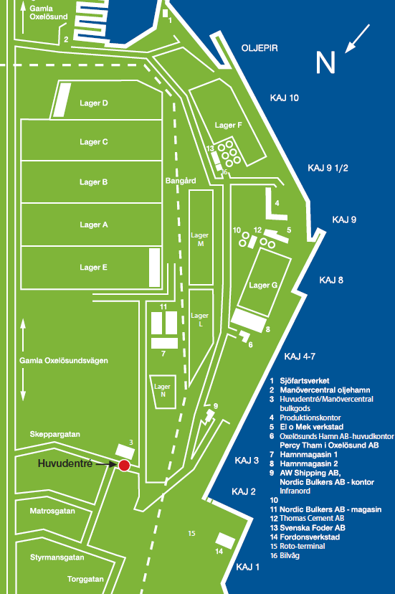[2]

Mechanical equipment at the Port of Oxelösund

* Six cranes with a safe working load up to 45 tonnes
* Two mobile cranes for flexible freight handling in smaller ships
* Two track-based 45-tonne cable cranes for handling bulk and general freight
* One track-based bulk freight crane
* Two marine loading arms for handling oil
* Equipment for unloading cement
* Forklift and container trucks, terminal tractors and loaders with capacities of up to 42 tonnes
* A conveyor system for the efficient loading of dry bulk on ships

(Oxelösund Hamn)

### Västeras (Sweden)

Mälarhamnar has flexible equipment which can be adapted to all kinds of goods handling needs. The cranes can be combined with different tools.

They load and unload ships with their 17 ton cranes and their Gottwaldkran handling up to 140 tons.

They offer the costumers the full maintenance services regarding to strip & stuff in their newly built handling warehouse of 3000 m2. The Strip / Stuff warehouse manage, by our talented staff, all types of containers, flatracks and curtinsides. (Malarhamnar, 2016)

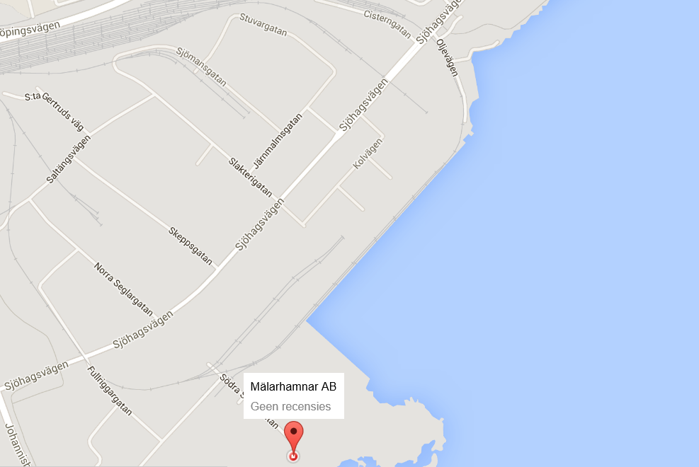[3]

Mechanical equipment for the port of Västeras

* 15 rail bound cranes from 6 to 50 tonnes lifting capacity
* 1 non-rail bound crane with a 210 tonnes capacity
* 3 mobile cranes with capacity from 4 to 15 tonnes
* 20 loading machines from 2.5 to 6 tonnes
* 4 Bobcats. 21 fork-lifts from 3.5 to 50 tonnes, plus various terminal tractors
* Container movers

(Malarhamnar, 2016)

### Södertälje (Sweden)

**Working hours of the dock workers**:

Regular working hours: 07.00 – 16.00

Break: 08.30 – 09.00

Lunch: 11.30 – 12.00

Break: 14.00 – 14.15

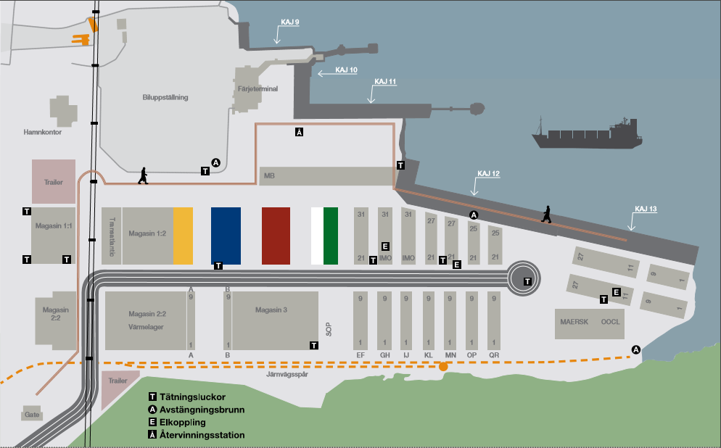[4]

Mechanical equipment for container handling:

* Two mobile cranes with lifting capacity of 110 respectively 45 tonnes
* 20 trucks, Reach Stackers and Tug Masters
* Daily departures/arrivals connecting the Port of Södertälje with other intermodal terminals
* High IT standard for container reporting

(Södertälje Hamn)

### Antwerp (Belgium)

The ship only handles steel in the port of Antwerp. This is in the Albertdock or in the Churchilldock.

These are specialized terminal operators which are able to provide quality discharging, loading and storage services for breakbulk in keeping with the customer's requirements. The terminals work with state-of-the-art equipment and the most advanced technologies. For instance in the All Weather terminal, barges and coasters can be loaded and discharged under cover. For high-grade steel and project cargo this is a huge advantage. Every terminal has multi-modal access with an immediate connection to the European road, rail, feeder and waterway network. Breakbulk cargo quickly and reliably finds its way from European production and consumption centres to all corners of the world and vice versa. (Port of Antwerp)

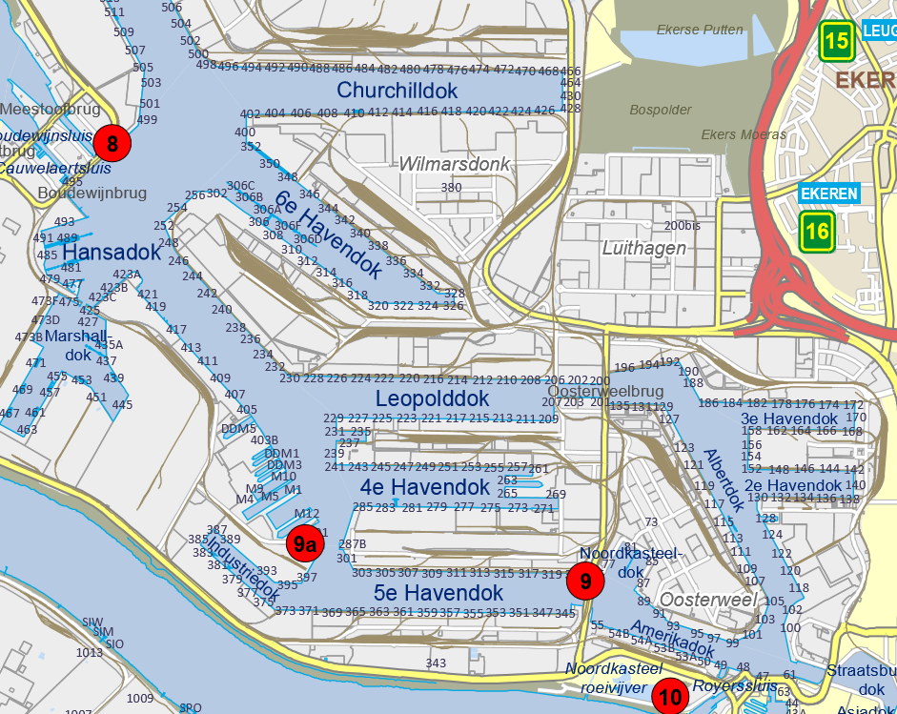[5]

### IJmuiden (The Netherlands)

For IJmuiden there is no information over the working hours of the dock workers or their material equipment.

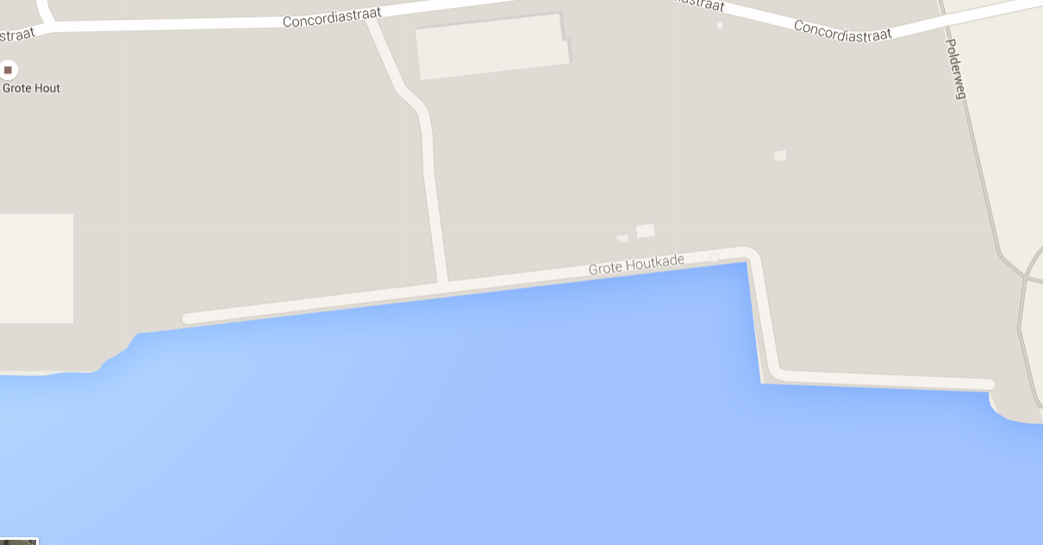[6]

### Hull (United Kingdom)

In the port of Hull the ship is always moored in the King George dock in terminal 2 at quay three.

The Hull Container Terminal, operated by PD Ports, at Queen Elizabeth Dock handles over 100,000 teu each year, which provides daily weekday sailings to Rotterdam, and MacAndrews, which provides two sailings a week to the Baltic States.

It provides over 300 m of quay and over 7.5 ha of storage for all types of container, including refrigerated units and hazardous goods.

Groupage services and cargo consolidation are available.

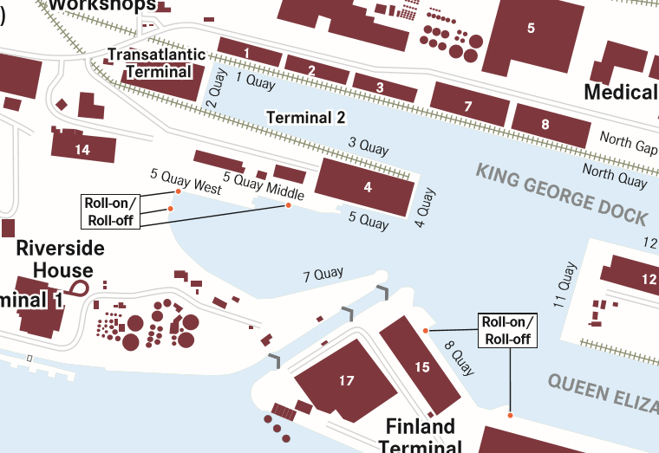[7]

## Example of a portlog of the MV Odin





## Analyse of the portlogs of 2014

Below the list of all the ports of call from the Odin in 2014. First chapter is an overview of all the ports and the following chapters are analyse of each port separately. Here are only the dates filled in when the dockworkers had a total of more than 1 hour break. That is why there is no chapter for Södertälje, because when they start working, it’s mostly for not more than 2 hours so they don’t take a break.

### General

|  |  |  |  |  |  |  |
| --- | --- | --- | --- | --- | --- | --- |
| **Port** | **arrival date** | **arrival hour** | **departure date** | **departure hour** | **total hours in port?** | **any delay?** |
| Velsen | 31-12-2013 | 09:48 | 3-1-2014 | 19:40 | 81,5 | no |
| Västeras | 6-1-2014 | 15:50 | 7-1-2014 | 15:50 | 24 | no |
| Oxelösund | 8-1-2014 | 01:00 | 10-1-2014 | 16:15 | 63 | **1:30 rain/strong wind/snow** |
| Hull | 14-1-2014 | 01:30 | 14-1-2014 | 10:30 | 8 | no |
| Antwerp | 15-1-2014 | 09:50 | 16-1-2014 | 13:10 | 27 | no |
| Velsen | 17-1-2014 | 02:30 | 17-1-2014 | 20:00 | 17,5 | no |
| Västeras | 21-1-2014 | 19:50 | 22-1-2014 | 13:40 | 18 | no |
| Oxelösund | 24-1-2014 | 20:20 | 26-1-2014 | 07:00 | 34 | **20 min crane out of order** |
| Hull | 29-1-2014 | 22:30 | 30-1-2014 | 17:30 | 18 | no |
| Velsen | 31-1-2014 | 11:30 | 1-2-2014 | 06:00 | 18,5 | **4h crane out of order + 20 min shifting ship** |
| Västeras | 4-2-2014 | 02:00 | 4-2-2014 | 18:00 | 16 | no |
| Oxelösund | 6-2-2014 | 13:00 | 8-2-2014 | 13:00 | 48 | no |
| Hull | 11-2-2014 | 15:00 | 13-2-2014 | 15:00 | 48 | no |
| Antwerp | 14-2-2014 | 14:20 | 16-2-2014 | 01:00 | 34,5 | no |
| Velsen | 16-2-2014 | 14:20 | 16-2-2014 | 20:10 | 6 | no |
| Västeras | 19-2-2014 | 12:00 | 19-2-2014 | 18:00 | 6 | no |
| Oxelösund | 21-2-2014 | 23:45 | 22-2-2014 | 15:50 | 15,5 | **2:40 rain/strong wind/snow** |
| Hull | 25-2-2014 | 18:40 | 27-2-2014 | 13:10 | 42 | no |
| Velsen | 28-2-2014 | 05:45 | 28-2-2014 | 20:00 | 14 | no |
| Västeras | 3-3-2014 | 18:00 | 4-3-2014 | 15:00 | 21 | no |
| Oxelösund | 5-3-2014 | 00:10 | 6-3-2014 | 18:15 | 42 | no |
| Hull | 9-3-2014 | 18:00 | 10-3-2014 | 18:00 | 24 | no |
| Antwerp | 11-3-2014 | 20:00 | 13-3-2014 | 14:00 | 42 | no |
| Velsen | 14-3-2014 | 07:00 | 15-3-2014 | 21:30 | 38,5 | **no (working hours = 4h)** |
| Västeras | 19-3-2014 | 14:50 | 20-3-2014 | 17:30 | 26,5 | **1h: crane out of order** |
| Oxelösund | 23-3-2014 | 13:00 | 24-3-2014 | 10:30 | 21,5 | no |
| Hull | 27-3-2014 | 07:10 | 27-3-2014 | 22:30 | 14,5 | no |
| Velsen | 28-3-2014 | 16:00 | 28-3-2014 | 22:30 | 6,5 | **1h: crane out of order** |
| Västeras | 31-3-2014 | 23:10 | 2-4-2014 | 16:00 | 41 | no |
| Hull | 5-4-2014 | 21:00 | 7-4-2014 | 12:30 | 39,5 | no |
| Västeras | 10-4-2014 | 16:50 | 11-4-2014 | 16:00 | 23 | no |
| Oxelösund | 12-4-2014 | 11:00 | 13-4-2014 | 17:15 | 30 | no |
| Hull | 17-4-2014 | 06:00 | 18-4-2014 | 13:50 | 32 | **25 min shifting ship** |
| Oxelösund | 22-4-2014 | 00:00 | 23-4-2014 | 13:00 | 37 | no |
| Hull | 26-4-2014 | 14:00 | 28-4-2014 | 14:15 | 48 | no |
| Västeras | 1-5-2014 | 16:00 | 2-5-2014 | 17:25 | 25,5 | no |
| Oxelösund | 3-5-2014 | 02:30 | 4-5-2014 | 16:00 | 37 | no |
| Hull | 7-5-2014 | 15:30 | 8-5-2014 | 17:40 | 26 | no |
| Velsen | 9-5-2014 | 11:40 | 9-5-2014 | 20:30 | 8 | no |
| Södertälje | 12-5-2014 | 10:40 | 12-5-2014 | 14:00 | 3,5 | no |
| Västeras | 12-5-2014 | 19:30 | 14-5-2014 | 16:00 | 44,5 | no |
| Oxelösund | 15-5-2014 | 01:10 | 16-5-2014 | 15:00 | 38 | no |
| Hull | 19-5-2014 | 14:45 | 20-5-2014 | 01:50 | 11 | no |
| Antwerp | 20-5-2014 | 23:40 | 23-5-2014 | 10:30 | 58 | no |
| Västeras | 26-5-2014 | 16:00 | 28-5-2014 | 16:30 | 48,5 | no |
| Oxelösund | 29-5-2014 | 02:00 | 30-5-2014 | 18:00 | 40 | no |
| Hull | 2-6-2014 | 14:40 | 3-6-2014 | 13:00 | 22 | no |
| Antwerp | 4-6-2014 | 13:10 | 4-6-2014 | 21:40 | 32,5 | no |
| Oxelösund | 7-6-2014 | 17:50 | 9-6-2014 | 07:20 | 37 | no |
| Hull | 12-6-2014 | 03:15 | 13-6-2014 | 12:00 | 33 | no |
| Velsen | 14-6-2014 | 04:40 | 14-6-2014 | 13:50 | 8,5 | no |
| Västeras | 17-6-2014 | 10:30 | 18-6-2014 | 16:00 | 29 | no |
| Oxelösund | 19-6-2014 | 01:45 | 19-6-2014 | 23:59 | 22 | no |
| Hull | 23-6-2014 | 06:45 | 25-6-2014 | 13:20 | 44 | no |
| Antwerp | 26-6-2014 | 13:00 | 26-6-2014 | 22:30 | 9,5 | no |
| Velsen | 27-6-2014 | 13:30 | 27-6-2014 | 20:40 | 7,5 | no |
| Västeras | 30-6-2014 | 19:00 | 2-7-2014 | 13:45 | 45 | 45h in port: 9:30 work and in that 9h tha had 5 h breaktime |
| Oxelösund | 3-7-2014 | 12:00 | 4-7-2014 | 20:30 | 32,5 | no |
| Hull | 7-7-2014 | 21:20 | 8-7-2014 | 16:00 | 18,5 | no |
| Oxelösund | 11-7-2014 | 22:15 | 14-7-2014 | 10:20 | 35,5 | no |
| Hull | 17-7-2014 | 11:15 | 17-7-2014 | 20:00 | 9 | no |
| Antwerp | 18-7-2014 | 21:00 | 22-7-2014 | 22:20 | 73 | only 22/7 loading all day. (18,19,20,21 nothing, but no remark) |
| Oxelösund | 25-7-2014 | 21:00 | 28-7-2014 | 07:30 | 58,5 | no |
| Antwerp | 6-8-2014 | 21:30 | 7-8-2014 | 19:05 | 21,5 | **30 min shifting** |
| Velsen | 8-8-2014 | 10:15 | 8-8-2014 | 16:30 | 5 | no |
| Hull | 9-8-2014 | 09:20 | 9-8-2014 | 17:00 | 7,5 | loaded fast, but waiting 3,5 h for the lock |
| Västeras | 13-8-2014 | 00:00 | 14-8-2014 | 12:50 | 37 | **working hours: 8:50** |
| Oxelösund | 15-8-2014 | 22:50 | 16-8-2014 | 12:45 | 14 | no |
| Hull | 20-8-2014 | 22:30 | 21-8-2014 | 15:10 | 16,5 | no |
| Velsen | 22-8-2014 | 22:20 | 23-8-2014 | 12:40 | 13 | working hours: 3:10 (23/8 7:00-10:45) |
| Västeras | 26-8-2014 | 07:45 | 27-8-2014 | 18:00 | 34 | no |
| Oxelösund | 28-8-2014 | 03:40 | 29-8-2014 | 13:45 | 33,5 | no |
| Hull | 2-9-2014 | 17:10 | 4-9-2014 | 14:50 | 46 | work day 1: 7:20-16:20, day 2: 7:20-17:00, day 3: 7:20-14:30 |
| Velsen | 5-9-2014 | 08:30 | 5-9-2014 | 20:45 | 12,5 | work from 14:15 - 19:00 |
| Västeras | 9-9-2014 | ? | 10-9-2014 | ? | not filled in in port log | work hours: 9/9 7:00 - 16:00 10/9 7:10 - 14:00 |
| Oxelösund | 11-9-2014 | 02:15 | 11-9-2014 | 22:30 | 20,5 | **3h crane out of order** |
| Hull | 15-9-2014 | 00:00 | 16-9-2014 | 16:00 | 40 | **15/9** work from 7:20 - 16:30 **16/9** 10:45-15:30 |
| Oxelösund | 19-9-2014 | 11:35 | 21-9-2014 | 08:00 | 44,5 | work 20/9 till 17:30 21/9 work 1:20 |
| Antwerp | 24-9-2014 | 13:10 | 24-9-2014 | 21:30 | 8,5 | no |
| Hull | 25-9-2014 | 20:20 | 26-9-2014 | 13:00 | 17 | no |
| Velsen | 27-9-2014 | 05:50 | 27-9-2014 | 15:00 | 9 | work from 7:00-13:30 (no breaks stated in portlog) |
| Västeras | 30-9-2014 | 09:40 | 1-10-2014 | 16:30 | 30 | no |
| Oxelösund | 2-10-2014 | 02:00 | 2-10-2014 | 22:20 | 20,5 | **50 min: crane out of order** |
| Hull | 6-10-2014 | 03:50 | 6-10-2014 | 20:50 | 16,5 | no |
| Oxelösund | 11-10-2014 | 06:20 | 12-10-2014 | 15:30 | 7 | no |
| Antwerp | 15-10-2014 | ? | 16-10-2014 | ? | not filled in in port log | work from 6:00 - 17:30 |
| Hull | 17-10-2014 | 19:45 | 18-10-2014 | 12:20 | 16 | no |
| Velsen | 19-10-2014 | 04:20 | 19-10-2014 | 12:00 | 7,5 | no |
| Södertälje | 22-10-2014 | 04:50 | 22-10-2014 | 10:30 | 5,5 | work from 7:10 - 9:15 |
| Västeras | 22-10-2014 | 16:20 | 23-10-2014 | 15:20 | 23 | no |
| Oxelösund | 25-10-2014 | 07:30 | 26-10-2014 | 15:30 | 31 | **5:00 rain/strong wind/snow** |
| Hull | 29-10-2014 | 21:00 | 30-10-2014 | 20:00 | 23 | no |
| Velsen | 31-10-2014 | 12:30 | 31-10-2014 | 20:20 | 7 | **2:15 waiting for cargo** |
| Södertälje | 3-11-2014 | 12:00 | 3-11-2014 | 13:50 | 2 | no |
| Västeras | 3-11-2014 | 19:50 | 5-11-2014 | 13:30 | 41,5 | working hours: 12:30 |
| Oxelösund | 6-11-2014 | 01:15 | 7-11-2014 | 09:00 | 32 | **5:45 rain/strong wind/snow** |
| Hull | 10-11-2014 | 07:30 | 10-11-2014 | 22:40 | 16 | **50 min delay: waiting for cargo** |
| Antwerp | 11-11-2014 | 22:20 | 12-11-2014 | 18:00 | 19,5 |  |

### Antwerp



### Velsen



### Västeras



### Oxelösund



### Hull



## Analyse of the portlogs of 2015

Below the list of all the ports of call from the Odin in 2015. First chapter is an overview of all the ports and the following chapters are analyse of each port separately. Here are only the dates filled in when the dockworkers had a total of more than 1 hour break. That is why there is no chapter for Södertälje, because when they start working, it’s mostly for not more than 2 hours so they don’t take a break.

### General

|  |  |  |  |  |  |  |
| --- | --- | --- | --- | --- | --- | --- |
| **Port** | **arrival date** | **arrival hour** | **departure date** | **departure hour** | **Total hours in port?** | **Any delay?** |
| Velsen | 3-1-2015 | 8:30 | 3-1-2015 | 14:00 | 6,5 | no (work from 8:35 - 12:30) |
| Västeras | 6-1-2015 | 07:00 | 7-1-2015 | 15:00 | 32 | no |
| Oxelösund | 8-1-2015 | 01:00 | 8-1-2015 | 00:00 | 23 | no |
| Hull | 13-1-2015 | 22:00 | 14-1-2015 | 17:00 | 19 | no |
| Velsen | 15-1-2015 | 17:40 | 16-1-2015 | 18:10 | 24 | no (start next day at 8:45) |
| Västeras | 19-1-2015 | 11:30 | 19-1-2015 | 19:15 | 7 | no |
| Oxelösund | 20-1-2015 | 10:45 | 23-1-2015 | 19:00 | 56 | **19:35 waiting for berth 11:10 rain/strong wind/snow** |
| Hull | 26-1-2015 | 21:20 | 27-1-2015 | 16:30 | 18 | no |
| Oxelösund | 30-1-2015 | 16:30 | 2-2-2015 | 11:10 | 66 | **8:35 rain/strong wind/snow** |
| Antwerp | 5-2-2015 | 06:30 | 5-2-2015 | 21:00 | 14,5 | no |
| Hull | 6-2-2015 | 21:50 | 7-2-2015 | 11:00 | 13 | no |
| Velsen | 8-2-2015 | 05:30 | 8-2-2015 | 16:20 | 10 | no |
| Södertälje | 11-2-2015 | 06:40 | 11-2-2015 | 08:35 | 2 | no (work from 7:00 - 7:50) |
| Västeras | 11-2-2015 | 14:10 | 12-2-2015 | 17:00 | 27 | no |
| Oxelösund | 13-2-2015 | 02:15 | 13-2-2015 | 16:20 | 14,5 | no |
| Hull | 16-2-2015 | 13:00 | 17-2-2015 | 14:50 | 26 | no |
| Antwerp | 18-2-2015 | 13:10 | 20-2-2015 | 20:40 | 56 | **2d 4h waiting for berth** (working hours = 10h) |
| Oxelösund | 24-2-2015 | 08:25 | 26-2-2015 | 02:25 | 42 | 15h anchored on road Oxelösund |
| Hull | 1-3-2015 | 14:20 | 2-3-2015 | 18:20 | 28 | no |
| Velsen | 3-3-2015 | 11:00 | 3-3-2015 | 18:20 | 7,5 | no (work from 11:20 - 15:20, no breaks) |
| Södertälje | 6-3-2015 | 06:40 | 6-3-2015 | 07:50 | 01:10 | no (discharge from 7:00 - 7:40) |
| Västeras | 6-3-2015 | 13:30 | 6-3-2015 | 21:00 | 7,5 | no |
| Oxelösund | 7-3-2015 | 14:30 | 9-3-2015 | 10:00 | 43,5 | no |
| Hull | 12-3-2015 | 07:20 | 12-3-2015 | 20:15 |  | no |
| Velsen | 13-3-2015 | 12:40 | 13-3-2015 | 19:30 | 7 | **40 min waiting for cargo** |
| Södertälje | 16-3-2015 | 12:10 | 16-3-2015 | 16:00 | 4 | no (working hours: 13:15 - 14:00) |
| Västeras | 16-3-2015 | 22:10 | 18-3-2015 | 16:00 | 42 | no |
| Oxelösund | 19-3-2015 | 11:20 | 20-3-2015 | 08:50 | 22 | no |
| Hull | 23-3-2015 | 07:15 | 23-3-2015 | 20:15 | 13 | no |
| Västeras | 27-3-2015 | 02:20 | 27-3-2015 | 20:00 | 17,5 | no |
| Oxelösund | 28-3-2015 | 05:50 | 30-3-2015 | 21:00 | 63 | **10:00 rain/strong wind/snow** (15h working hours) |
| Antwerp | 3-4-2015 | 01:35 | 4-4-2015 | 11:45 | 35 | **1:05 shifting of ship** |
| Velsen | 5-4-2015 | 02:00 | 5-4-2015 | 09:50 | 8 | no (working hours: 7:30 - 9:50) |
| Hull | 6-4-2015 | 06:00 | 6-4-2015 | 20:15 | 14 | no |
| Södertälje | 9-4-2015 | 16:10 | 9-4-2015 | 17:00 | 1 | no (discharging 25 min) |
| Västeras | 9-4-2015 | 22:45 | 10-4-2015 | 15:15 | 16 | no |
| Oxelösund | 11-4-2015 | 00:50 | 12-4-2015 | 09:40 | 32,5 | **10:00 rain/strong wind/snow** |
| Hull | 15-4-2015 | 10:30 | 16-4-2015 | 17:00 | 30,5 | no |
| Velsen | 17-4-2015 | 10:20 | 17-4-2015 | 17:15 | 7 | no |
| Västeras | 20-4-2015 | 17:10 | 22-5-2015 | 15:50 | 47 | no |
| Oxelösund | 23-4-2015 | 01:20 | 24-5-2015 | 08:25 | 31 | **1h: shifting of cargo** |
| Hull | 27-4-2015 | 06:05 | 28-5-2015 | 00:55 | 19 | no |
| Oxelösund | 1-5-2015 | 20:10 | 3-5-2015 | 13:00 | 41 | no |
| Antwerp | 6-5-2015 | 17:30 | 7-5-2015 | 13:30 | 20 | **1:10 crane out of order** |
| Hull | 8-5-2015 | 13:30 | 9-5-2015 | 14:50 | 25,5 | no |
| Velsen | 10-5-2015 | 07:20 | 10-5-2015 | 13:35 | 6 | no (work 5h without break) |
| Västeras | 13-5-2015 | 08:00 | 13-5-2015 | 17:00 | 9 | no |
| Oxelösund | 14-5-2015 | 02:50 | 14-5-2015 | 20:30 | 17,5 | no |
| Hull | 18-5-2015 | 16:30 | 18-5-2015 | 21:00 | 28,5 | no |
| Oxelösund | 21-5-2015 | 11:50 | 23-5-2015 | 07:20 | 43,5 | no |
| Antwerp | 26-5-2015 | 07:30 | 27-5-2015 | 14:30 | 30 | no (2h waiting for lock) |
| Hull | 28-5-2015 | 12:20 | 29-5-2015 | 16:50 | 27,5 | no |
| Velsen | 30-5-2015 | 09:30 | 30-5-2015 | 15:20 | 6 | no (work from 9:40 - 14:20) |
| Södertälje | 2-6-2015 | 06:45 | 2-6-2015 | 09:25 | 2 | no |
| Västeras | 2-6-2015 | 15:00 | 3-6-2015 | 15:45 | 25 | no |
| Oxelösund | 4-6-2015 | 01:40 | 5-6-2015 | 10:00 | 32 | no |
| Hull | 8-6-2015 | 08:15 | 8-6-2015 | 00:55 | 17 | no |
| Oxelösund | 11-6-2015 | 21:00 | 13-6-2015 | 18:00 | 45 | no |
| Antwerp | 16-6-2015 | 18:20 | 18-6-2015 | 15:00 | 44,5 | no (working hours = 13h ) |
| Hull | 19-6-2015 | 12:50 | 19-6-2015 | 22:45 | 10 | no |
| Velsen | 20-6-2015 | 15:50 | 20-6-2015 | 22:45 | 6,5 | finished 19:15, waiting for 3,5 hours before departure |
| Södertälje | 23-6-2015 | 12:10 | 23-6-2015 | 13:50 | 2 | no (work 1:10) |
| Västeras | 23-6-2015 | 19:20 | 24-6-2015 | 17:00 | 21,5 | no |
| Oxelösund | 25-6-2015 | 02:10 | 25-6-2015 | 19:10 | 17 | no |
| Hull | 28-6-2015 | 16:30 | 29-6-2015 | 18:00 | 25,5 | no |
| Oxelösund | 2-7-2015 | 10:30 | 5-7-2015 | 08:00 | 69,5 | 22h waiting for berth (working hours = 17h) |
| Antwerp | 8-7-2015 | 09:00 | 8-7-2015 | 22:45 | 14 | no |
| Hull | 9-7-2015 | 22:25 | 10-7-2015 | 17:00 | 18,5 | no |
| Velsen | 11-7-2015 | 12:45 | 11-7-2015 | 18:25 | 5 | no (working hours = 4h) |
| Södertälje | 14-7-2015 | 04:40 | 14-7-2015 | 09:50 | 5 | no (work from 7:00 till 9:40) |
| Västeras | 14-7-2015 | 14:40 | 15-7-2015 | 15:40 | 25 | no |
| Oxelösund | 16-7-2015 | 01:10 | 17-7-2015 | 12:35 | 35,5 | **2:15 rain/strong wind** |
| Hull | 20-7-2015 | 10:20 | 20-7-2015 | 22:20 | 12 | no |
| Oxelösund | 23-7-2015 | 19:20 | 26-7-2015 | 07:20 | 36 | no |
| Antwerp | 29-7-2015 | 17:40 | 30-7-2015 | 16:45 | 23 | no (working hours: 8h) |
| Hull | 31-7-2015 | 17:00 | 1-8-2015 | 03:20 | 10,5 | no |
| Velsen | 1-8-2015 | 19:40 | 1-8-2015 | 23:30 | 4 | no |
| Södertälje | 4-8-2015 | 13:20 | 4-8-2015 | 16:20 | 3 | no |
| Västeras | 4-8-2015 | 22:00 | 5-8-2015 | 16:00 | 18 | no |
| Oxelösund | 6-8-2015 | 01:25 | 7-8-2015 | 21:25 | 44 | **16h waiting for cargo** |
| Hull | 10-8-2015 | 21:50 | 13-8-2015 | 17:00 | **67** | working hours= **12h**, 1 day they didn't work but no remark in portlog |
| Velsen | 14-8-2015 | 10:30 | 14-8-2015 | 20:30 | 10 | no (2h delay, no remark) |
| Södertälje | 17-8-2015 | 10:40 | 17-8-2015 | 12:30 | 2 | no |
| Västeras | 17-8-2015 | 17:35 | 19-8-2015 | 13:40 | 20 | no |
| Oxelösund | 19-8-2015 | 23:10 | 20-8-2015 | 22:30 | 23,5 | no |
| Hull | 24-8-2015 | 00:00 | 24-8-2015 | 20:30 | 20,5 | no |
| Oxelösund | 27-8-2015 | 21:20 | 29-8-2015 | 18:45 | 46 | no (11h anchored on road Oxelösund) |
| Antwerp | 1-9-2015 | 17:30 | 2-9-2015 | 21:30 | 28 | **2h waiting for lock** |
| Hull | 3-9-2015 | 21:30 | 4-9-2015 | 15:10 | 17 | no |
| Velsen | 5-9-2015 | 08:30 | 5-9-2015 | 21:05 | 12,5 | no (wait 3h for lock/pilot) |
| Södertälje | 8-9-2015 | 17:00 | 8-9-2015 | 19:00 | 2 | no |
| Västeras | 9-9-2015 | 00:30 | 9-9-2015 | 15:50 | 15,5 | no |
| Oxelösund | 10-9-2015 | 23:30 | 11-9-2015 | 18:10 | 18,5 | no (11h anchored on road Oxelösund) |
| Hull | 14-9-2015 | 13:10 | 15-9-2015 | 13:05 | 24 | no |
| Oxelösund | 18-9-2015 | 05:45 | 19-9-2015 | 17:15 | 35 | no |
| Antwerp | 22-9-2015 | 16:10 | 24-9-2015 | 11:40 | 44 | no (working hours= 17h) |
| Hull | 25-9-2015 | 10:30 | 25-9-2015 | 17:30 | 7,5 | no |
| Velsen | 26-9-2015 | 09:20 | 26-9-2015 | 19:20 | 10 | no |
| Södertälje | 29-9-2015 | 08:00 | 29-9-2015 | 10:15 | 2 | no (work from 9 till 10:10) |
| Västeras | 29-9-2015 | 15:15 | 30-9-2015 | 15:15 | 24 | no |
| Oxelösund | 1-10-2015 | 01:15 | 1-10-2015 | 18:10 | 17 | no |
| Hull | 4-10-2015 | 13:15 | 5-10-2015 | 13:00 | 24 | **3:30 waiting for cargo** |
| Oxelösund | 8-10-2015 | 18:15 | 10-10-2015 | 08:35 | 39 | **3h waiting for berth Oxelösund** |
| Antwerp | 13-10-2015 | 09:30 | 13-10-2015 | 20:00 | 10,5 | no (3h anchored on road Steenbank) working hours= 4h |
| Hull | 14-10-2015 | 18:30 | 16-10-2015 | 14:15 | 43 | no |
| Velsen | 17-10-2015 | 09:05 | 17-10-2015 | 13:30 | 4,5 | no |
| Södertälje | 20-10-2015 | 01:20 | 20-10-2015 | 08:30 | 7 | no (work from 7:20 till 8:20) |
| Västeras | 20-10-2015 | 13:45 | 21-10-2015 | 16:00 | 26 | no |
| Oxelösund | 22-10-2015 | 18:30 | 23-10-2015 | 17:30 | 23 | no (16:30 anchored o road Oxelösund) |
| Hull | 16-10-2015 | 14:25 | 16-10-2015 | 21:15 | 31 | **3:30 waiting for cargo** |
| Oxelösund | 29-10-2015 | 17:40 | 31-10-2015 | 13:30 | 43 | no |
| Antwerp | 3-11-2015 | 13:30 | 4-11-2015 | 17:15 | 27 | no (working hours= 9h) |
| Hull | 5-11-2015 | 13:35 | 6-11-2015 | 14:50 | 25,5 | no |
| Velsen | 7-11-2015 | 08:10 | 6-11-2015 | 12:00 | 4 | no |
| Södertälje | 9-11-2015 | 21:05 | 10-11-2015 | 08:30 | 11,5 | no (work from 7:20 till 8:25) |
| Västeras | 10-11-2015 | 14:00 | 11-11-2015 | 17:45 | 28 | no |
| Oxelösund | 12-11-2015 | 03:20 | 12-11-2015 | 23:50 | 21 | no |
| Hull | 16-11-2015 | 14:15 | 16-11-2015 | 23:55 | 10 | no |
| Oxelösund | 19-11-2015 | 16:10 | 23-11-2015 | 14:00 | 94 | **10h waiting for loading, 4h crane out of order & 1:15 shifting of ship** |
| Antwerp | 26-11-2015 | 22:10 | 27-11-2015 | 14:20 | 16 | no (work from 6:00 till 14:20 with no break) |
| Hull | 28-11-2015 | 13:20 | 28-11-2015 | 20:30 | 7 | no (work from 13:30 till 18:30 with no break) |
| Velsen | 29-11-2015 | 13:40 | 30-11-2015 | 08:15 | 18 | 29/11 work till 17:20, next day work from 7 till 8 |
| Västeras | 3-12-2015 | 02:30 | 3-12-2015 | 16:05 | 13,5 | no |
| Oxelösund | 4-12-2015 | 02:00 | 5-12-2015 | 17:30 | 39,5 | no |
| Hull | 6-12-2015 | 14:00 | 9-12-2015 | 14:00 | 48 | no (working hours = 16h) |
| Velsen | 12-12-2015 | 06:10 | 12-12-2015 | 14:10 | 8 | no |
| Södertälje | 15-12-2015 | 04:30 | 15-12-2015 | 10:00 | 5,5 | no (work from 7:00 till 9:40) |
| Västeras | 15-12-2015 | 15:30 | 16-12-2015 | 16:00 | 23,5 | no |
| Oxelösund | 17-12-2015 | 01:50 | 17-12-2015 | 21:50 | 20 | no |
| Antwerp | 20-12-2015 | 23:50 | 21-12-2015 | 23:00 | 25 | no |
| Hull | 22-12-2015 | 22:50 | 23-12-2015 | 11:00 | 12 | no |
| Oxelösund | 26-12-2015 | 08:15 | 27-12-2015 | 11:10 | 27 | no |
| Hull | 30-12-2015 | 12:05 | 31-12-2015 | 13:10 | 25 | no (8h working hours) |

### Antwerp

### 

### Velsen



### Västeras



### Oxelösund



### Hull



## Analyse of the portlogs of 2016

Below the list of all the ports of call from the Odin in 2016, till april. First chapter is an overview of all the ports and the following chapters are analyse of each port separately. Here are only the dates filled in when the dockworkers had a total of more than 1 hour break. That is why there is no chapter for Södertälje, because when they start working, it’s mostly for not more than 2 hours so they don’t take a break.

### General

|  |  |  |  |  |  |  |
| --- | --- | --- | --- | --- | --- | --- |
| **Port** | **arrival date** | **arrival hour** | **departure date** | **departure hour** | **Total hours in port?** | **Any delay?** |
| Velsen | 2-1-2016 | 6:30 | 2-1-2016 | 22:10 | 15 | no |
| Oxelösund | 5-1-2016 | 15:20 | 6-1-2016 | 14:05 | 23 | no (working hours = 4h30) |
| Västeras | 7-1-2016 | 00:40 | 7-1-2016 | 17:00 | 16,5 | no |
| Hull | 11-1-2016 | 04:35 | 11-1-2016 | 17:05 | 13,5 | no |
| Oxelösund | 14-1-2016 | 10:00 | 17-1-2016 | 13:20 | 51,5 | no |
| Antwerp | 20-1-2016 | 09:50 | 21-1-2016 | 15:50 | 30 | no (start discharging 20/1 at 14:00) |
| Hull | 22-1-2016 | 21:30 | 23-1-2016 | 07:00 | 9,5 | no |
| Velsen | 23-1-2016 | 23:20 | 24-1-2016 | 13:10 | 14 | no (cargo op from 7:00 till 12:00) |
| Södertälje | 27-1-2016 | 02:30 | 27-1-2016 | 09:45 | 7 | no (working hours = 1:50) |
| Oxelösund | 27-1-2016 | 16:05 | 28-1-2016 | 18:10 | 22 | **From 27.01 / 2030 hrs to 28.01 / 1210 hrs vessel remains idle at SSAB berth due to engine problem** |
| Västeras | 29-1-2016 | 03:50 | 30-1-2016 | 10:30 | 30,5 | **From 29.01 / 1530 hrs to 30.01 / 1030 hrs vessel remains idle at Västeras undergoing engine repairs** |
| Hull | 4-2-2016 | 09:00 | 4-2-2016 | 19:45 | 11 | no |
| Velsen | 5-2-2016 | 11:40 | 5-2-2016 | 20:00 | 8,5 | no |
| Södertälje | 8-2-2016 | 10:30 | 8-2-2016 | 14:00 | 3,5 | no (work from 12:10 till 13:30) |
| Västeras | 8-2-2016 | 19:30 | 9-2-2016 | 17:00 | 21,5 | no |
| Oxelösund | 10-2-2016 | 02:30 | 10-2-2016 | 21:45 | 18 | **4:40 strong wind/rain/snow** |
| Hull | 13-2-2016 | 20:25 | 14-2-2016 | 10:45 | 15 | no (finish loading at 2:15) |
| Oxelösund | 17-2-2016 | 17:00 | 20-2-2016 | 15:00 | 46 | no |
| Antwerp | 24-2-2016 | 00:50 | 25-2-2016 | 01:00 | 24 | no |
| Hull | 25-2-2016 | 23:55 | 26-2-2016 | 16:30 | 16,5 | no |
| Velsen | 27-2-2016 | 10:00 | 27-2-2016 | 16:50 | 7 | no (working hours= 5:30) |
| Södertälje | 1-3-2016 | 09:00 | 1-3-2016 | 16:45 | 8 | no (loading from 14:15 till 16:30) |
| Västeras | 1-3-2016 | 22:20 | 2-3-2016 | 17:50 | 19,5 | no |
| Oxelösund | 3-3-2016 | 03:45 | 3-3-2016 | 19:00 | 15 | no (working hours = 4h) |
| Hull | 6-3-2016 | 17:00 | 7-3-2016 | 05:00 | 12 | no |
| Oxelösund | 9-3-2016 | 21:00 | 11-3-2016 | 22:30 | 49 | **9:30 strong wind/rain/snow** |
| Antwerp | 14-3-2016 | 22:55 | 16-3-2016 | 13:05 | 38 | no |
| Hull | 17-3-2016 | 12:30 | 17-3-2016 | 21:30 | 9 | no |
| Velsen | 18-3-2016 | 13:10 | 18-3-2016 | 22:00 | 9 | no (start cargo operations at 17:00) |
| Södertälje | 21-3-2016 | 11:30 | 21-3-2016 | 13:10 | 2 | no |
| Västeras | 21-3-2016 | 18:50 | 22-3-2016 | 19:30 | 24,5 | no |
| Oxelösund | 23-3-2016 | 05:05 | 23-3-2016 | 21:25 | 16,5 | no |
| Hull | 26-3-2016 | 23:55 | 28-3-2016 | 05:30 | 29,5 | 17:00 in port because storm on Northsea |
| Oxelösund | 31-3-2016 | 04:10 | 1-4-2016 | 13:35 | 33,5 | **3:00 rain** |

### Antwerp



### Velsen



### Västeras



### Oxelösund



### Hull



1. Port of Oxelösund (Oxelösund Hamn, oversiktskarta, 2015)
2. Map of the port of Oxelösund (Oxelösund Hamn, oversiktskarta, 2015)
3. Map of the port of Västeras (google maps)
4. Map of Södertälje (sodetalje)
5. Map of the port of Antwerp (Port of Antwerp, 2014 )
6. Map of the port of IJmuiden (google maps)
7. Map of the port of Hull (abports, 2016)