Author: Shee Mzee
Student number: 67409
Bachelor Thesis
Rotterdam, 09/07/2018

Ballast Water Treatment
Wagenborg Shipping Ballast Water Treatment
An innovative solution to comply with Ballast Water Treatment regulations.

Thesis on ballast water treatment
  - ‘’In which way can mobile ballast water treatment plants can be a suitable replacement for fixed ballast water treatment units?’’

  - Name: Shee Mzee
  - Studentnumber: 67409
  - Place if issue: Vlissingen
  - Date of issue: 09 July 9, 2018
  - Semester: 8
  - Course component: Thesis
  - 1st examiner: M.C. Meerburg
  - 2nd examiner: P.G. Harts
  - Version: 1.1

“To conclude an interesting educational experience, many thanks to all of the teachers, crewmembers, what an adventure!” - Shee

Abstract
To ensure stability for ships, ballast water is often used to correct or adjust the list or trim of a ship. After loading the ballast water is often carried across the ocean and discharged in an area with another aquatic environment.
As a result, invasive species can end up in the water and effect the local biodiversity.
For this reason, the IMO has set regulations for the treatment of ballast water in the ballast water management convention.
These regulations compel ships to treat the ballast water so the chance of harmful aquatic organisms being introduced in a foreign environment will be minimized and eventually even prevented.
From the 8th of September 2017, the regulations are taken into effect. All ships will have to comply with the D-1 standard and new build ships will also have to comply with the D-2 standard.
To treat the ballast water, ballast water treatment systems are used. These systems filter the water and treat the water with chemicals or UV-light.
In the next 7 years, over 450.000 ships are required to retrofit and install a ballast water treatment system.
The retrofit is time- consuming and needs to be carefully planned to minimize the loss of revenues.
Currently most shipping companies choose a fixed system in the engine room but in some cases the space in the engine room is restricted, which makes it difficult to install the treatment plant. In this case a mobile ballast water treatment can a solution. These containerized ballast water treatment units can be placed on deck or a shore and can be connected on the ships ballast water system.
This research aims to answer the question in which way a mobile ballast water treatment unit could be a suitable replacement for a fixed ballast water treatment plant.
By explaining a fixed- and a mobile treatment unit compatible for the MV Fivelborg in detail, an idea about the working principle and the specifications of these systems is given. Furthermore a research is carried out among professionals in the shipping industry to gather opinions about the concept of deploying mobile ballast water systems on a large scale.
A difference in approach depending on function becomes visible.
Deck officers tend to be more optimistic about the concept while engineers show more skepticism towards the idea.
The biggest obstacles to realize this concept according to the interviewed are the logistic challenges and the fleet wide standardization.
The space consumption, extra operations for the crew and time loss in port are important disadvantages given by the interviewed.
The advantages according to the interviewed are lower investment costs, less units per ship and the possibility of shore based maintenance.
Concluding this, the mobile ballast water treatment units could be a good outcome for shipping companies with standardized ships sailing on fixed routes with limited space in the engine room.

Table of contents
1. Introduction 1
1.2 Hypothesis 1
1.3 Research question 2
2. Theoretical framework 3
2.1 The phases of a retrofit project 3
2.1.1 Feasibility study 3
2.1.2 Basic design 4
2.1.3 Detail design 4
2.1.4 Installation 4
2.2 Regulations 5
2.3 MV Fivelborg 6
2.3.1 Current method of ballast water exchange 6
2.3.2 The components of the ballast system 7
2.4 Treatment solutions 8
2.5 Fixed Ballast Water Treatment Unit 9
2.5.1 The treatment system 9
2.5.2 The installation 10
2.5.3 Positioning of the ballast water treatment unit 12
2.6 Mobile Ballast Water Treatment Unit 14
2.6.1 The treatment system 15
2.6.2 The connection 16
2.6.3 Positioning of the container 16
3. Method 18
3.1 Interview 19
4. Results 20
5. Discussion 26
6. Conclusion 27
7. Recommendations 30
8. Bibliography 31
Annexes 32
Annex I 32
International Convention for the Control and Management of Ships' Ballast Water and Sediments (BWM) 32
Annex II 37
Bilge/ Ballast/ Firefighting system 37
Annex III 38
Tanksplan + capacity 39
Annex IV 40
Brochure Damen Invasave 300 40
Annex V 41
Deck load plan 41
Annex VII 42
Article Invasave 300 42
Annex VIII 43
MEPC174.58 43

Introduction
Ballast water is essential to control the stability, draught, trim, list and stresses of the vessel. There are, however, several environmental hazards concerning the carriage of ballast water across the world. The ballast water may contain aquatic organisms that interfere with the biological diversity in the area where it will be discharged.
It is estimated that at least 7,000 different species are being carried in the ballast tanks of vessels around the world.
Studies on this issue indicated that many species of plants, bacteria and animals can survive in viable form in the ballast tanks, even during voyages of several months.

The discharge of the ballast water, containing the harmful aquatic organisms and pathogens, into the waters of port States can cause threats to indigenous human, animal and plant life, and the marine environment. In some cases, when the factors are favorable, an introduced species can establish a reproductive population in the host environment and sometimes even outcompete native species, changing the local biodiversity.
(Wagenborg Shipping B.V., 2017)

Therefore, IMO has developed guidelines for the development and implementation of a Ballast Water Management on board vessels. These guidelines aim to minimize and eventually eliminate the risk of introducing harmful aquatic organisms and pathogens by the ballast water of vessels.

From 8 September 2017, new rules concerning the ballast water management system (BWMS) will take effect. All new ships have to be equipped with a ballast water treatment system(BWTS) and by 8 September 2024, all ships using ballast water will have to be equipped with a BWTS system. Most of these BWTS are fixed on the ships.
For these research, another way of applying this system will be investigated.
Instead of placing a fixed ballast water treatment plant on the ships, several ballast water treatment units in containers will be available for the ships sailing between the Great Lakes and Europe.
The objective of this research is to find out if in this way less ballast water treatment plants are needed, the maintenance of the plants will get easier and with the current doubt about the regulations and approval of certain systems, no unnecessary expenses have to be done because the systems can be changed at all times.
(IMO, sd)

1.2 Hypothesis
Due to the new regulations, ships have to invest in expensive systems to keep the ship seaworthy. Due to the number of ships that might not be worth the investment, other idea’s that are feasible and can save costs are worth investigating.

1.3 Research question
The aim of this research is to answer the following question:

In which way could mobile ballast water treatment units be a suitable replacement for fixed ballast water treatment units?

Sub questions:
- What is a retrofit project?
- Where does a ballast water system consist of?
- Which regulations have to be complied with?
- What is a fixed ballast water treatment system?
- What is a mobile ballast water treatment system?
- What do professionals think about this concept and what is their preference?

Theoretical framework
Because of the new regulations, there are more than 45,000 vessels in the world fleet that have to be retrofitted during the 7 year IMO/USCG implementation schedule. This means an average of around 17.6 retrofit systems will be installed per day.
(HydeMarine, Hyde Marine Guide to Ballast Water Treatment Retrofits Webinar, 2014)

2.1 The phases of a retrofit project
The retrofit for a Ballast Water Treatment project can be divided into four main phases:
- Research for the different options, feasibility study
- Basic design
- Detail design
- Installation

2.1.1 Feasibility study
During the feasibility study, the shipowner will investigate possibilities of the different systems to see which is most suitable for the vessel.
Most important is that the system complies with the standards set by the IMO and, in case the ship also sails in American waters, the US Coast Gard.
The Ballast Water Treatment Systems can roughly be divided into two groups, chemical- and physical systems.
The physical systems include the systems that work with UV- light, filters, cavitation and hydro cyclone.
The chemical systems include systems that work with ozone, chlorination and electro- chlorination.
Systems working with the same principle can still have different methods of operating, depending on the manufacturer.
To find the suitable BWTS for a vessel, the following factors have to be taken into account:
- The vessels general particulars and operational profile
- The pump capacity of the vessel and the ballast water exchange annually
- The holding time of the ballast water
- The water quality and characteristics such as level of pollution, salinity and temperature.
In order to select the suitable BWTS method, the ship owner has to choose the system that meets all the requirements for the vessel and the operational area of the ship.
The systems that fit these requirements have to be further investigated to compare the pros and cons of the systems.
Important factors at this point are the investment costs and the operational costs.
The next step is to see if the system is compatible with the particular ship. The weight, space and electrical balance have to comply with the vessels space and characteristics. 3D scan’s and calculations can give a definite answer on these points.

2.1.2 Basic design
The second phase of choosing the BWTS is the basic design.
In this stage a schematic diagram and layout of the BWTS is made. The particulars and systems of the ship are being taken into account because the chosen system has to comply with the existing systems on the ship.
The drawings at least have to include to following:
- The General Arrangement
- Machinery Arrangement
- Ballast Water Diagram
- Electric Balance Report
- Main Switchboard Diagram
The drawings above have to be adjusted to the new situation and sent to the classification society.
Based on these drawings, the characteristics of the ship and the BWTS the designers can identify how the treatment system will work in principle.
At the end of phase 2, there will be a concept of how and where the system will be placed. This includes the amount of piping that will be necessary, the adjustments that have to made and the other aspects of the installation that are important to know.
In this way there will be a clear image of ‘What’ is necessary for this refit.

2.1.3 Detail design
The third phase is the detail design. In this phase the actual plans of the installation will be drawn up. The drawings and documents which are necessary for pre- fabrication and installation are created during this phase. The main question that has to be answered at this point is: ‘How will the BWTS will work in practice’.
Besides that it is clear ‘What’ is necessary for this refit, the third phase will also answer all the questions concerning ‘How’ the refit will be carried out.

2.1.4 Installation
The fourth phase is the installation of the Ballast Water Treatment System. In the previous phases it is investigated what is needed for the installation and how the installation will be carried out. Based on these findings, a plan will be made to carry out the installation of the Ballast Water Treatment System.
It is important to have a tight and achievable planning, so the ships owner has a good idea what the cost will be for the installation and the time the ship will be ‘off hire’.
Besides a planning it is important to have a complete list of the materials so the installation can be carried out smoothly, without time delays.
(Leino, 2017)

In the image below (figure 1) an average time schedule can be seen, this gives an idea of the amount of days the process takes.
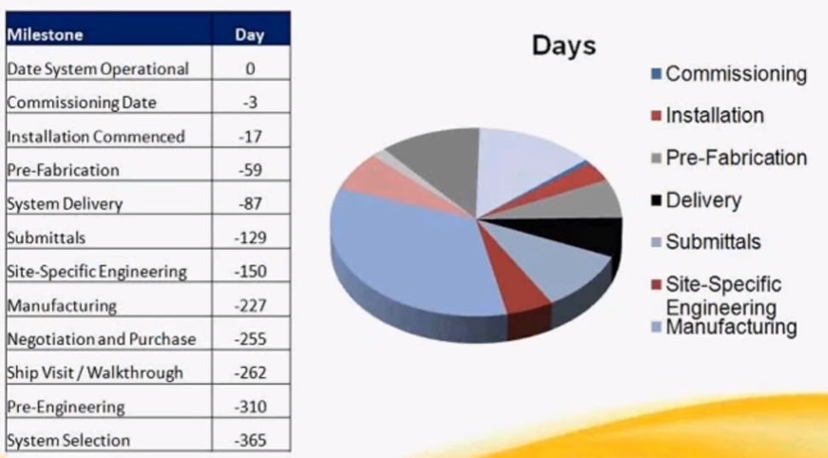
Figure 1: Average timeframe of a retrofit (HydeMarine, Hyde Marine Guide to Ballast Water Treatment Retrofits Webinar, 2014)

2.2 Regulations
From 8 September 2017, IMO’s Ballast Water Management Convention is actively going into force. This means all ships must manage their ballast water to avoid the introduction of alien species into coastal waters. To achieve this, ships must exchange their ballast water or treat their ballast water with a ballast water management system.
Initially there will be two different standards to these two options:
- D1 standard, exchange ballast water in open seas 200 nautical miles from land in water 200 meters deep.
- D2 standard, a performance standard which specifies the maximum amount of viable organisms allowed to be discharged.

Starting 8 September, all ships must conform at least to the D1 standard and all new ships to the D2 standard.
By 8 September 2024, all ships using ballast water have to comply with the D2 standard. In figure 2 the set dates concerning the D2- implementation can be seen.
The exact rules and regulations concerning the standards can be found in Annex I.

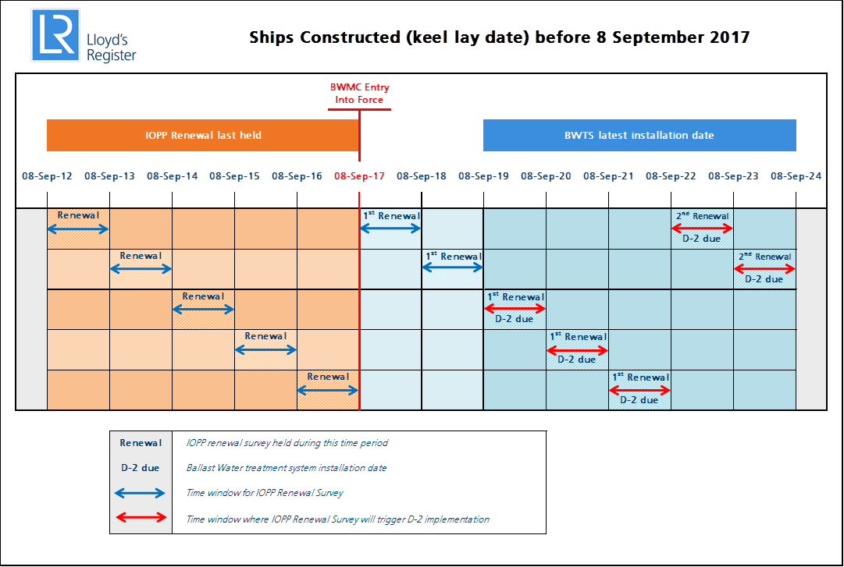
Figure 2: Dates D-2 implementation actively goes into force. (Lloyds Register, sd))

2.3 MV Fivelborg
The name of the ship where this research will be carried out is the MV Fivelborg, property of Wagenborg Shipping B.V.
This ship will be used as example for the research that is carried out concerning the current aspects of the ballast system manifold, the refit possibilities and the positioning and handling of the ballast water treatment container.

2.3.1 Current method of ballast water exchange
The current method of ballast water exchange is the sub sequential method. With this method, the complete ballast tank is emptied and refilled with replacement ballast water. A volumetric exchange of at least 95% should be achieved.
The convention concerning ballast water exchange requires the exchange is at least 200nM from the coast and the water has a depth of at least 200m.
If this is not possible, it should be as far from the coast as possible, at least 50nM and the water depth should be at least 200m. Or in sea area’s designated by Port State.
All local and national regulations should be taken into account at all times.
The exchange may not bring the safety of the ship or crew in danger.

In addition to this method, the new rules state that from the 8th of September 2017, the exchanges have to be reported in a Ballast Water Management Plan. In the Ballast History Log, the time of exchange together with the position, salinity, residual volume, final content, BWM method, used pump and the specific action (in or out) are being administrated of every specific tank. (Wagenborg Shipping B.V.) (Wagenborg Shipping B.V., 2017)

2.3.2 The components of the ballast system
The ballast water manifold of the Fivelborg can be found in Annex II. Here it is visible that the system consists of the following aspects:
- Pumps
- Valves
- Tanks
- Electronic system for remote operation
- Piping
(Ferus Smit Group, 2008)

Pumps
The two pumps currently being used for the ballast system are from Azcue type CM-VP200/33B.
The pumps have the following particulars:

Capacity | 300m³/h
Power | 45kW
Speed | 1450 RPM
Weight | 580kg
Table 1: Pump specifications BWTS Fivelborg (Azcue)

Valves
The ballast system contains different type of valves:
- Non return valves
- Control valves
- Actuators
The valves to open the lines to sea suction are control valves which can be operated from the computer. At the discharge side of the pump and at the sea outlet, there are non- return valves that make sure the water flow can only go in one direction. The valves to open/close certain tanks are equipped with pneumatic actuators which makes it possible to open and close the valves from the computer.
In Annex III, the drawing of the manifold with the different valves explained above can be found.
(Ferus Smit Group, 2008)

Controls
The ballast operation is possible from for different screens in the ship:
- Engine control room
- Engine room
- Deck office
- Wheelhouse

Tanks
A complete overview of the tanks and where the tanks are situated on the ship can be found in Annex III.
(Ferus Smit Group)

2.4 Treatment solutions
The treatment of ballast water is typically a two stage process.
The first stage, physical liquid- solid separation is done to remove larger organisms and to reduce sediment. This could be done by hydro cyclone separation which separates fluids from different density’s or with screen filters depth/disk filters and some other methods.
The second stage is disinfection. This is done to kill or inactivate the remaining organisms that are still in the water. Chemical disinfection system utilise some kind of direct disinfectant. The disinfectant is created from or added to the ballast water to remove the organisms from the ballast water flow. The disinfection can be done chemically by electro- chlorination, chlorine, ozone, peracetic acid and several other means.
The majority of non- chemical ballast water treatment systems uses UV- light to disrupt the DNA of the organisms in the ballast water which renders them harmless to the receiving environment. In effect they remove the organisms ability to reproduce so they cannot form an invasion to the receiving water body.
There are more methods to treat the ballast water but in this investigation only the methods mentioned above will be treated because they make up for more than 90% of the systems sold today.
(HydeMarine, Hyde Marine BWTS Installations Lessons Learned Webinar, 2014)

There are several benefits and disadvantages for both systems:
Benefits of chemical disinfection:
- Effective disinfection/ oxidation agent
- Certain benefits for high flow systems
Disadvantages of chemical disinfection:
- Most require some kind of discharge analysis and neutralization process in order that the discharged ballast water meets al discharge standards
- Safety and cost of carrying chemicals on board
- Creation of explosive hydrogen gas with electrolysis
- Does not treat chlorine resistant organisms
- Ineffective in low salinity and low temperature water (Electro- chlorination)
- Must neutralize discharge with chemical agents which means more chemicals to carry.
Benefits of a UV- system:
- Kills/ inactivates living organisms
- Environmentally neutral (no residual disinfectant)
- Eliminates handling and storage of toxic chemicals
Disadvantages of a UV- system
- Frequent cleaning of lamp sleeves
- Electrical consumption is higher for high capacity systems
- Subject to water quality issues
(HydeMarine, Hyde Marine BWTS Installations Lessons Learned Webinar, 2014)

LP2.5 Fixed Ballast Water Treatment Unit
To comply with the rules and regulations of the IMO, all ships will have to install a ballast water treatment unit. This unit will clean the ballast water before it goes in the tanks and will treat the ballast water again when discharging. In this way organisms that are possibly being carried in the ballast water will be removed.

For this research, the ballast water management technology of Hyde Marine will be used as an example for fixed ballast water treatment systems.
The technology is approved by the IMO as well as the USCG and is used on the T- ships of Wagenborg Shipping B.V.
(Wagenborg, 2018)

The Hyde Marine fixed ballast water treatment unit consist out of two main components to treat the ballast water:
- UV- system
- Self- cleaning disk filter
The stack disc filter technology ensures the removal of solids and larger organism while the automatic back- flushing allows for a continuous flow while keeping the filter elements clean.

During ballasting, the flow is processed through the filter and UV system and then back to the main ballast system. During de- ballasting, the filter is bypassed and the water flows only through the UV system and then overboard trough the discharge line.
(HydeMarineAcademy, 2003)

2.5.1 The treatment system
The particular type, suitable for the Fivelborg would be the ‘Hyde Guardian Gold^{tm} HG300G’. The HG300G has the following particulars (figure 3):

Treatment rated capacity | 300 m³/h
Electrical supply | 380 – 690V · 50/60 Hz · 3 phase
Power consumption | 24 kW Nominal · 40.5 kW max
Max. operating pressure | 10 bar
Minimum flow | 30 m³/h
Weight | 2180 kg
Table 2: Specifications of HG300G (HydeMarine)

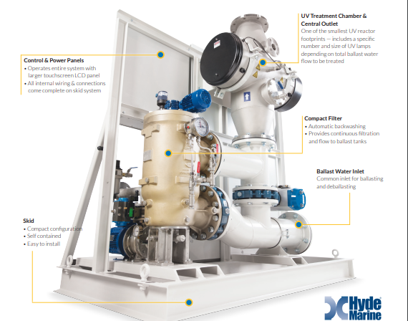
Figure 3: Hyde Marine ballast water treatment unit (HydeMarine)

2.5.2 The installation
To install the ballast water treatment unit, the procedure described above have to be followed.
A few images of a retrofit with the Hyde Guardian Gold^{tm} HG300G will be given bellow to give an idea of what it would look like.
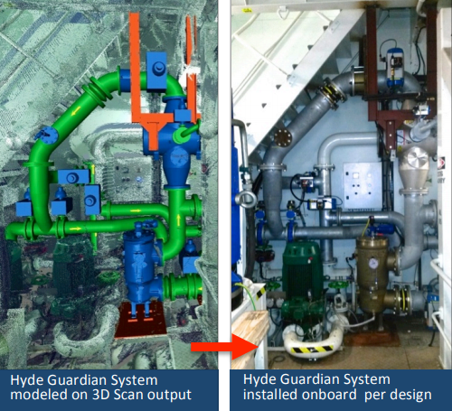
Figure 4: Hyde Guardian HG300Gretrofit (Hyde Marine)
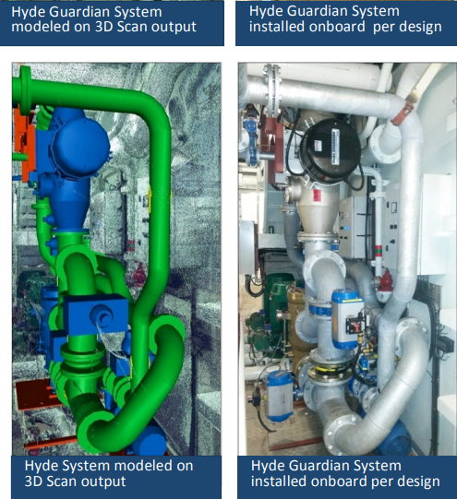
Figure 5: Hyde Guardian HG300G retrofit (Hyde Marine)

2.5.3 Positioning of the ballast water treatment unit
The positioning of the ballast water treatment unit in the Fivelborg will be a challenge because of the limited amount of space.
The most suitable place to position the ballast water treatment unit would be on the tween deck in the engine room, next to the separator room.
The advantage of situating the ballast water treatment unit on this position is that the piping of the ships original ballast water system is exactly underneath the tween deck. In this way, the BWTS can be easily connected to original piping and cost will be saved on materials.
The deck is currently constructed with steel floor panels so it is important to calculate the maximum deck load on this position to make sure the construction is strong enough to carry the ballast water treatment unit.
The dimensions of the place are sufficient to fit the ballast water treatment unit.
Bellow two images of the position will be showed, together with the dimensions of the Hyde Marine HG3003G:
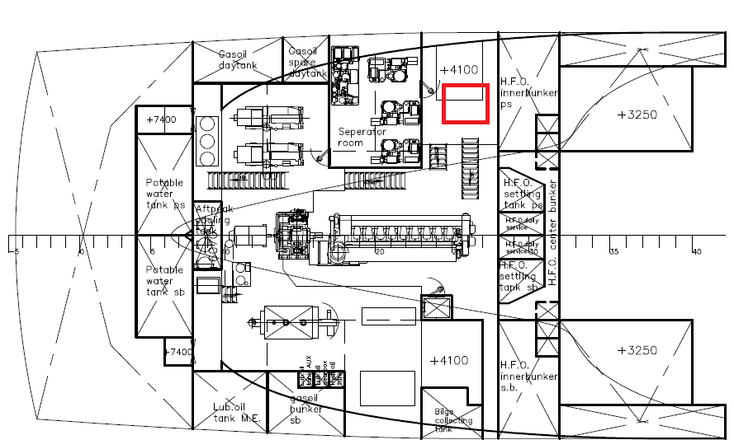
Figure 6: Tweendeck on drawing of General Arrangements Fivelborg
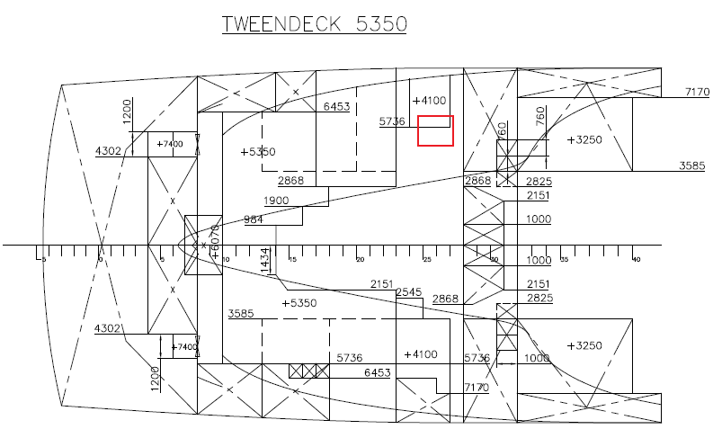
Figure 7: Tweendeck on drawing of Dimensionsplan Fivelborg
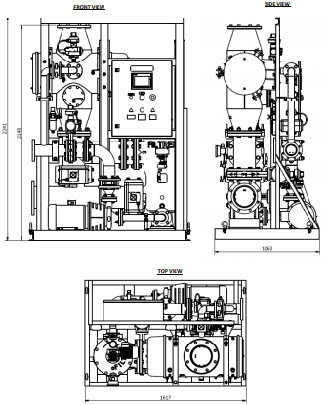
Figure 8: Dimensions of Hyde Marine HG300G (1617x1063x2241 mm) (HydeMarine)

2.6 Mobile Ballast Water Treatment Unit
Instead of a fixed BWTS, it could also be possible to clean the ballast water with a mobile BWTS
For this research, the Invasave 300 from Damen will be used as an example for the containerized BWTS.
This particular product is chosen because Wagenborg Shipping B.V. has already had a test with this system on the new vessel Egbert Wagenborg.
(Damen Green, sd)

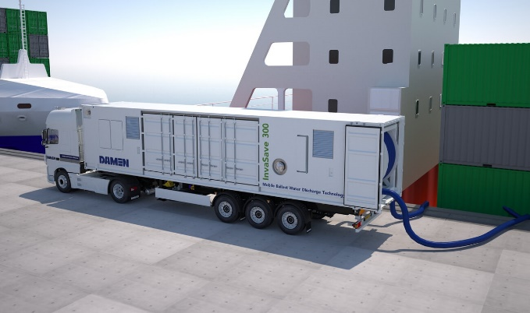
Figure 9: Example of a mobile ballast water treatment unit

Another reason this product is chosen as an example for the BWTS is because it is already tested and already has an approval of the Dutch Administration of the BWMS G8 (MEPC174(58).
(Class NK)

The Invasave 300 is a containerized BWTS manufactured by Damen.
Invasave 300 has the following particulars:
Size | 40’ high cube container:  12,02m x 2,35m x 2,69m
Capacity | 300 m³/h
Power consumption | 60- 100 Kw
Design pressure | 10 bar
Weight | 28 ton
Lifespan | 30 years
Table 3: Specifications invasave 300 (Schuiten, 2018)

2.6.1 The treatment system
The treatment system of the Invasave 300 is a combination between constant fine filtration and ultraviolet treatment. In a secondary treatment stage, the backwash of the filter is dewatered and compacted. The result is that the treated water exceeds the current IMO specifications of the ballast water performance standard, specified in Regulation D2 of the IMO Ballast Water Management Convention.

The Invasave 300 has two options to treat the ballast water:

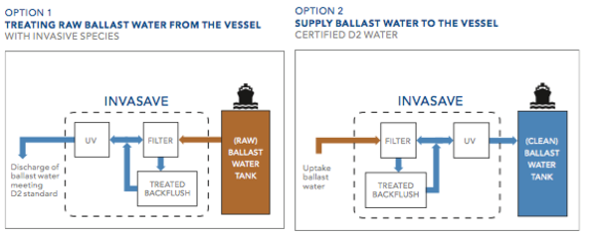
Figure 10: Image: Options of ballast water treatment by Invasave 300 from ‘Brochure Damen Port Solutions Invasave 300’

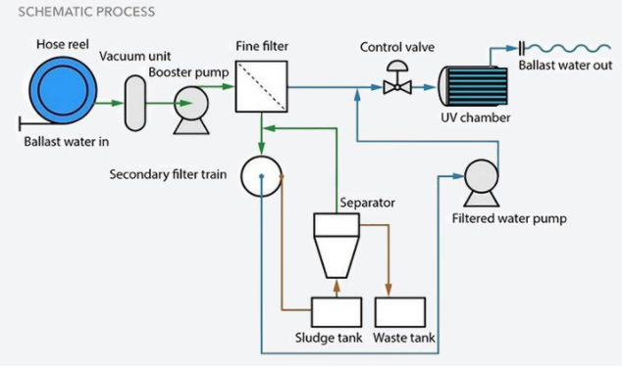
Figure 11: Schematic process ballast water treatment Invasave 300
To make the Fivelborg compatible with the ballast water treatment module, there will have to be some refits. In this part the different changes throughout the ship will be explained.

2.6.2 The connection
To be able to connect the treatment plant to the ship, new connections on deck have to be made.
The best place to situate these connections on the Fivelborg will be in front of the accommodation around the bunker station. This is a convenient place to place the connections because a minimum amount of piping is necessary and it will be close as close as possible to the position of the container.
The treatment unit can be connected with the ships ballast system with a flanges connections.

2.6.3 Positioning of the container
There are several options to position the container. The container can be supplied in port by truck as can be seen in figure 9.
Another possibility would be to place the container on deck at one of the designated container positions. This however can lead to difficulties when the hatches have to be shifted in case of loading or discharging cargo.
To be able to position the container without impeding the working space, a possibility would be to make a construction on which the container can be situated.
The idea is to construct a container pedestal on which the container can be rigged using twist locks. The dimensions of the container pedestal 12,30m x 2,50m x 3,00m. The weight of the module is approximately 30 ton using 50mm steel plating.
A calculation and image can be seen in figure 12.

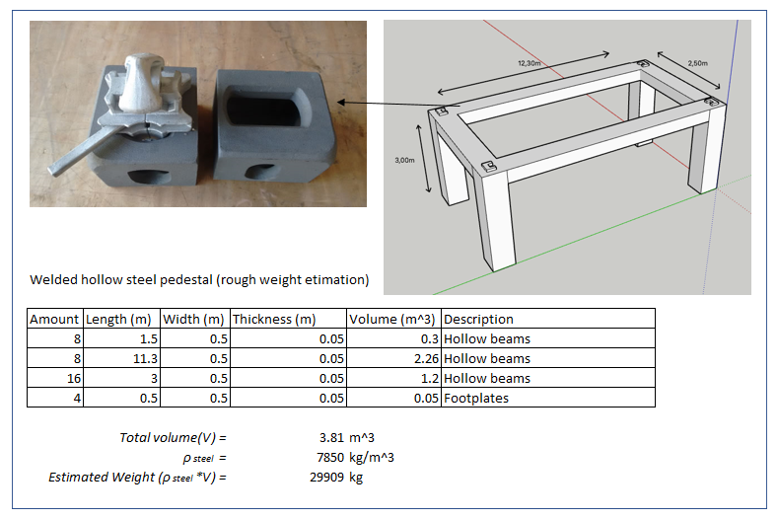
Figure 12: Rough design and weight of container pedestal
In Annex V the container positions of the Fivelborg are shown.

Method
The research carried out was an applied qualitative research. The aim was to find out if a mobile ballast water treatment plant can be a suitable replacement for a fixed ballast water treatment plant.
By gathering practical knowledge and exploring the market of the ballast water treatment units, a plan was made to make it suitable for a particular type of ship.
The initial research was conducted on an F- type of Wagenborg to test the feasibility of the concept and to see what the possibilities were.
The findings regarding results of the research were tested and explained using documents and particulars of an F- type ship but will, of course, also relate to other ships with similar particulars.

The information necessary to conduct this research was gathered by different means.
A literature study was conducted to find information about the rules and regulations that will have to be complied with, the different possibilities and concepts currently on the market, the technical particulars of the ship and other background information which was necessary to give a complete picture of the refit.
A part of the literature study was conducted on board of the Fivelborg using the manuals and information available on the ship because information about the specific particulars of the ballast water system and the dimensions of the ship were only available on board.
Information about the particulars of the ballast water treatment systems was found in brochures and by contacting the companies of the product.
Furthermore, additional information about rules and regulations and the process of the retrofit was found on the internet in web seminars and in case study’s.

The results found in the literature study were evaluated by presenting it to several professionals in the shipping industry and gather their opinion by an interview.
In this interview crewmembers of different companies were asked several questions concerning the BWTS and the plug and play principle.
To gain an objective result via the interviews, the author tried to pick several crewmembers with a different specialization and in different positions.
Deck officers, engineers and a specialist from a company that sells these particular mobile ballast water treatment plants.
All will answer the same questions but gave a different insight on the pro’s and con’s regarding the concept.
By comparing these possible advantages and disadvantages a conclusion can be made.

3.1 Interview
To gain an objective image whether a mobile BWTS would be a suitable replacement for a fixed BWTS, several professionals with a different expertise in the shipping industry were asked the following questions:

- Which shipping company do you work for, what is your function and for how long are you already working in the shipping industry?
- I just gave you a short description of the idea to use plug and play containers instead of fixed systems, what is your first thought?
- What do you see as the biggest disadvantage to use this system?
- What do you see as the biggest advantage of using a plug and play system?
- Which arguments do you see as most important?
- Do you think the idea of plug and play containers for the whole fleet is realistic?
- What do you think will be the biggest problems to solve when the shipping company is choosing for a plug and play system?
- Do you think the advantages out way the disadvantages?
- Do you have any other remarks concerning this subject?
Before the interview started some background information about the subject was given in an introduction. The idea of the mobile BWTS was explained and a short description of the operation was given.
To exclude several arguments such as the whether the system is approved by authorities or the pump capacity would not be sufficient for a particular ship, it is mentioned that all the requirements to meet the regulations and necessary specifications are in order.

The following interviews were conducted:
- Chief engineer at Wagenborg, working on the F- types
- 2nd engineer working as freelancer at Atlas and sailing on different types of ships
- 2nd mate at Wagenborg
- 2nd mate at Rolldock
- 3rd mate at Wagenborg, sailing on T- types and A- types
- 3rd engineer at Global Seatrade

The expectation is that deck officers will have different arguments on the matter than engineers and that the company selling the product will have a different view on the possible advantages and disadvantages then the shipping company that will use the product.
A separate set of comments were added from the logistic planner of Wagenborg North America to answer a specific set of logistical challenges before the interview was conducted.

Results
The first reaction of the interviewed, when they read about the concept is mostly positive, as can be seen in the quotes below.

- According to a 3rd mate at Wagenborg: ‘’the concept can be handy for ships that sail on fixed routes.’’
- A 2nd mate at Amasus and a Chief Engineer at Wagenborg thinks: ‘’it can be a good solution for ships that don’t have a lot of space in the engine room.” The 2nd mate of Amasus also adds: ‘’it can be a good solution for older ships for which the investment of a fixed ballast water treatment system is not lucrative.’’
- On the other hand, a 2nd engineer of Wagenborg: ‘’questioning the practicability’’, and thinks: ‘’it is hard to realize the concept.”

Despite the initial reaction, when asked if the concept of plug and play containers is realistic, the opinions are completely divided (as seen in figure 13).

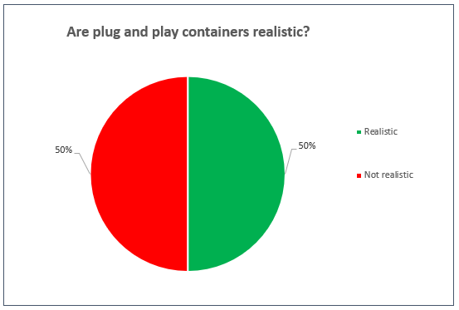
Figure 13: Opinion of the interviewed on plug and play container concept
Figure 14 shows the results from the same question, but then sorted per company that the interviewed are employed by.

Only Wagenborg and Rolldock employees see plug and play containers as a realistic option. Possibly due to the fact that Wagenborg already experimented with a mobile BWTS and advertised it. (Damen Green, n.d.)
Figure 14: The opinion of the interviewed per company

To further investigate, the opinion of the interviewed is illustrated based on function. This shows that the Deck officers are more optimistic about the possibility to realize the concept.

Figure 15: The opinion of the interviewed based on function

When the interviewed are asked about the possible disadvantages, several different arguments are brought forward:

- Chief Engineer of Wagenborg: ‘’Not every ship, nor every berth has space to fit a 40’ container. When the mobile unit is supplied by barge, it can cause difficulties with bunkering.”

- 2nd engineer of Wagenborg thinks ‘’it can be unpractical and hard to realize because of the adjustments that will have to be made on the ship.” He is also concerned that ‘’the logistics to supply the ships with the mobile treatment units is hard to plan.” A 3rd engineer from Gobal Seatrade and a 3rd mate of Wagenborg share this opinion.
- The 3rd mate of Wagenborg also thinks ‘’the transshipment of the mobile unit can be a point of concern because not every ship, nor every port has the possibility to handle the container.”

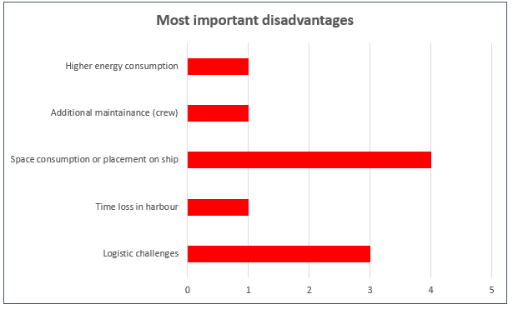
Figure 1616: Most important disadvantages
Figure 16 clearly shows that the space on the ship and logistic challenges are key responses when it comes to disadvantages.

When asked about the possible advantages of the concept the following statements were made.

- A 2nd mate at Rolldock: ‘’the mobile treatment units makes shore based maintenance possible.” He also thinks ‘’the possibility of leasing’’ can be practical in some cases because it ‘’can save costs.” He also adds ‘’the retrofit can save costs.”
- A 3rd engineer of Global Seatrade and 2nd mate of Amasus is both think it can be a good outcome for ship sailing on fixed routes.
- The 2nd mate of Amasus is saying: ‘’If you have five regular ports, with more than five ships sailing in between them, it is possible to supply these ships with just five treatment plants. The problem however, is that in case more than one ship needs a container, a delay will be inevitable.”

Figure 17 summarizes this and shows that the cost effectiveness is a key argument when it comes to the advantages,

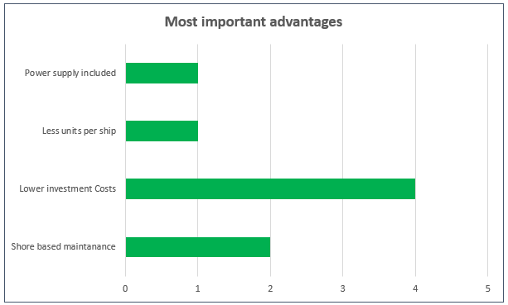
Figure 17: Most important advantages

The opinion on whether this concept is feasible and realistic is once again divided and is summarized below.
- 2nd mate at Amasus: “the concept won’t be feasible on small ships because the space will be an issue. There will not be enough place on deck to situate the container and if the container would be placed in the cargo hold, it will occupy space for the cargo which means less cargo can be shipped,” and, “it will lead to considerable time loss if the mobile treatment unit is taken aboard and the procedures happen in port.”
- Chief Engineer of Wagenborg: ‘’It is not realistic for all ships because the space on board it not always sufficient” adding, ”These are extra expenses that will have to be taken into account when considering the choice of the treatment plant.
- 3rd engineer at Global Seatrade: ‘’the concept is not realistic because of the logistic planning that is necessary to realize the supply of the ships,” advising, ‘’it would be realistic if the units are placed in port and the ships can rent a treatment unit when needed. It would be an outcome if big ports would include this in their facilities. In this way all ships, from big shipping companies to captain owners can use the units when necessary.”

When asked if the advantages of a mobile treatment unit outweigh the disadvantages, the opinions are yet again divided. As illustrated in figure 18 only half of the interviewed think that this is so.

- 3rd engineer of Global Seatrade: ‘’Ships can better have a fixed system on board because most ships sail international and can’t be supplied with the treatment units at all times. This is a solution solely for ships that sail locally and sometimes international in between fixed ports.”
- 2nd mate of Amasus states the following: ‘’I can’t overcome the issue of space, this makes it difficult to see the concept really working. It is also an extra job for the crew who are already busy with a lot of different things during loading/ discharging. The ballast water treatment process shouldn’t be needed to look after by the crew but should go by itself, there are enough things that need your attention.”
- 3rd mate of Wagenborg: ‘’if the disadvantages can be solved in a creative way, the advantages can out way the disadvantages and the problem of lack of space can be solved on smaller ships.”

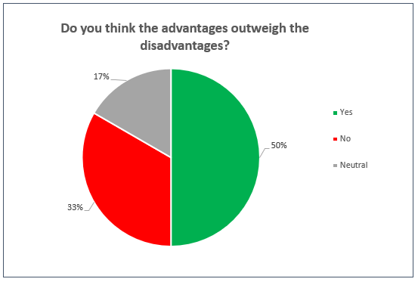
Figure 18: Advantages vs. Disadvantages
When the practicability of the BWTS is questioned a difference in approach is visible.
- The deck officers tend to think about place on deck, cargo, stability and maintenance like extra paintjobs. The engineers are concerned about the amount of extra piping needed and the way to connect this piping with the current ballast water system.
- The engineers see difficulty of complying with the rules laid down by the Classification Society, how to avoid the wiring in place and how the adjustments are been carried out. Also the placement on deck is a concern and it is mentioned that carrying out the operation with a barge can have restrictions when the ship also has to bunker fuel.

According to the logistical planner of Wagenborg North America, the logistic plan to supply the ships when necessary would be a huge challenge and an important argument to take into consideration (this correlates with Figure 16, which shows this as a key concern). He illustrates this with the following information per email (Scalzo, 2017)
- The data about the exact amount of Wagenborg ships sailing between the Great Lakes and Europe is not available but the main ports for loading on the Great Lakes are Thunder Bay/ Duluth/ Hamilton/ Windsor/ Toledo. The most common discharge ports on the Great Lakes are Hamilton/ Cleveland/ Detroit/ Chicago/ Burns Harbor/ Duluth.
- The ports mentioned above is a list of most common ports, which means there are several other ports where the ships of Wagenborg load/discharge less frequently.
- The cargo loaded by Wagenborg at ports on the Great Lakes is mostly designated for Europe or Scandinavia.
- The cargo discharged by Wagenborg on the Great Lakes is mostly loaded in Europe, Scandinavia or Russia.
- The list of ports is too divers and misses regularity which makes it complicated to plan the logistic rotation of the ships and the supply of the mobile ballast water treatment units.

Finally the 3rd engineer of Global Seatrade and the 2nd mate of Amasus explained a few scenario’s in which a mobile BWTS could be a good outcome.
- For companies with a small amount of ships in the fleet and with ships sailing a fixed route between the same ports.
- The containers could be placed in port and the ships can carry out the ballast water treatment procedure when loading and discharging.
- Also shipping companies owning ships not worth the investment because of age or designation could benefit from the option of using mobile ballast water treatment units. In case of selling the ship, the unit could be sold or used on other ships.

The outcome of the interviews raises some contradiction and difference of opinion between the parties and roles involved. This sparks some discussion which will be elaborated in the following chapter.

Discussion
During this research, an attempt was made to gain an objective view based on the opinion of several professionals in the shipping industry about the possibilities of using mobile BWTS as a substitute for of fixed BWTS.

A total 32 requests were sent out and reminders, however only 6 people took the time to respond. As a result the diversity in expertise that was aimed for was not achieved leaving a small population to base substantial conclusions on. Having said this some correlations can be seen in the answers which trigger recommendations in chapter 7.

The input from key people is not included are the product manager at DamenGreen and the fleet development engineer at Wagenborg.

- The product manager of DamenGreen, who knows everything about the mobile ballast water treatment system Invasave 300, the system that is used as an example for this investigation, chose not to respond to the questions in the interview due to confidentiality.
- The fleet development engineer could have given insight in the financial aspects of the retrofits, the exact amount off ships at Wagenborg that is expected to get a retrofit and the system that is most practical for the ships of Wagenborg.

The findings are now based solely on crewmembers from different shipping companies. The problem with this is that the crewmembers have to work with the product on board and it is expected that their perspective alone could not sufficiently answer the main question in this thesis (which is a strategic question as opposed to only an operational question).

Due to confidentiality, the companies in question (Damen Green & Wagenbord) refused to give insight in the financial costs of the treatment plants and the costs of a retrofit. This was unfortunate for the research because the financials play a major role in the choice (and are also named by the respondents as a key advantage).

Conclusion
Because of the limited participants it is difficult to draw a conclusive opinion.
The opinions are quite divided. Rearranging the gathered data, there are some interesting correlations depending on the role of interviewed.

Figure 19 shows the disadvantages that where named the most, were mentioned by engineers, mainly technical people working in the engine room, who’s main concern is space consumption.
The advantages that were named the most, were from deck officers who were optimistic about the lower investment costs and the possibility that maintenance could be carried out on shore.

Both points could be reinforced with more respondents. If the financial aspects are confirmed through the fleet development engineer the choice of a mobile BWTS could be very interesting for the shipping industry.

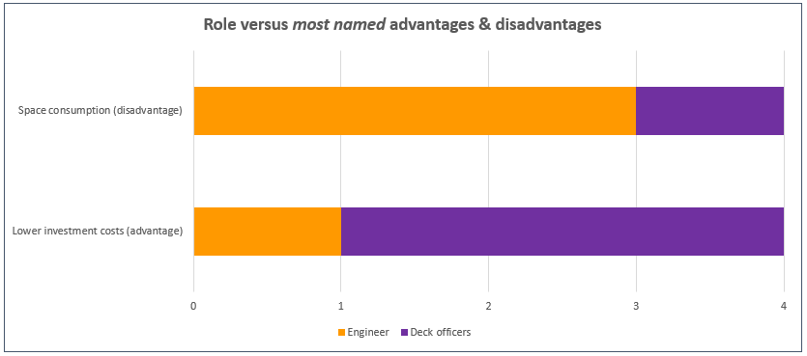
Figure 19: Role vs. 'most named' advantages & disadvantages

When comparing the responses from deck officers to engineers, despite the limited data illustrated in figure 20, there is clearly a trend of optimism towards the mobile BWTS when it comes to the deck officers. Carefully leading to the conclusion that these offers are open for change.

When it comes to the engineers there is more doubt and skepticism. If further investigation proves the usefulness of mobile BWTS then the engineers will have to be convinced and informed of the advantages to take away their concerns and to be heard. This will make the changes easier to be executed as is does influence their working environment directly.
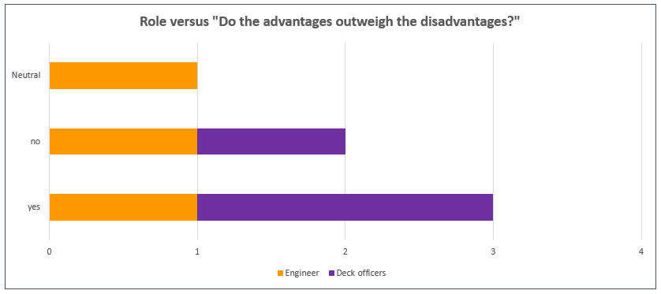
Figure 20: Role vs. 'Do the advantages outweigh the disadvantages?'

When presented with the choice between a mobile or fixed BWTS the immense logistical challenge to supply all the ships at the right time will need to be addressed accordingly. Due to the diversity in types and sizes of ships, the capacity of the mobile BWTS which is necessary to keep up with the ballast water requirements varies widely, adding to the complexity of such a logistical solution. Concluding that a fleet wide standardization would be a challenge to establish.

Information gathered from the logistic planner of Wagenborg North America on the various different ports the fleet of Wagenborg is using around the world, reinforces the conclusion stated above. To equip every port with sufficient materials and mobile BWTS would be extremely difficult for one company to do alone, so more companies would have to be involved to establish the potential cost savings per ship.

The space on board to place the unit and the extra operations for the crew are also an important argument that is given for the preference to a fixed treatment system. Having said this the space that the mobile BWTS would take could actually free up space in the engine room making it a safer and less clustered environment to work in. For ships which do not have the ability to handle the mobile BWTS (loading/unloading/transferring), the pedestal is relatively cost efficient option, due to the standard sizes of the mobile BWTS.

Summarizing all of the above: shipping companies with fixed routes, with standardized size ships with limited space in the engine room which do not comply with the rules laid down by the IMO, the mobile BWTS could be an extremely suitable solution, saving both money and project time during the retrofit.

The conclusion, based on the data so far, is that the concept of mobile ballast water treatment units is interesting for a part of the Wagenborg fleet but a standardization over the entire fleet is not feasible, due to the diversity of ships and ports.

To further strengthen these conclusion, the following recommendations are advised in the next chapter.

Recommendations
To make the research representative the following recommendations are advised to be carried out:

- Data from a larger population is needed to answer the questions stated in chapter 4.
- More roles and experts in the shipping industry have to be included.
- Diverse companies have to be involved in the research.
- Financial data should be made available and compared to the alternatives. This way the main positive argument, being cost effectiveness, can be either validated or discredited.

Finally, taking into account that this entire project is about improving the pollution challenges that the shipping industry brings with it, an extended study comparing water quality data of already installed treatment units should be carried out. And compared to the mobile BWTS. This should play a major role in the choice of the system, being more important than the financial aspect.

Bibliography
Azcue. (n.d.). Azcue Manual.
Class NK. (n.d.). Ballast Approval. Retrieved from https://www.classnk.or.jp/hp/pdf/activities/statutory/ballastwater/approval_ballast_e.pdf.
Damen Green. (n.d.). Damen InvaSave port-based ballast water management system has world premiere. Retrieved from http://www.damen.com/en/news/2017/05/damen_invasave_port_based_ballast_water_management_system_has_world_premiere.
Ferus Smit Group. (2008, Augustus). Bilge and Ballast and Firefighting.
Ferus Smit Group. (n.d.). Tanksplan and Capacity Plan.
Hyde Marine. (n.d.). Retrieved from http://hydemarine.com/media/images/site_library/58_Case_Study_Hyde_Guardian_BWT_Retrofit_MV_Polar_Queen.pdf?t=8432
HydeMarine. (n.d.). Retrieved from http://hydemarine.com/media/images/site_library/63_HG300G_-_Product_Data_Sheet.pdf?t=2064
HydeMarine. (n.d.). Retrieved from http://www.hydemarine.com/media/images/site_library/26_Hyde_Marine_Brochure_2013_V3.pdf
HydeMarine (Director). (2014). Hyde Marine BWTS Installations Lessons Learned Webinar [Motion Picture].
HydeMarine (Director). (2014). Hyde Marine Guide to Ballast Water Treatment Retrofits Webinar [Motion Picture].
HydeMarineAcademy (Director). (2003). Case Study Video [Motion Picture].
IMO. (n.d.). International Convention for the Control and Management of Ships' Ballast Water and Sediments. Retrieved from Website van IMO: http://www.imo.org/en/About/Conventions/ListOfConventions/Pages/International-Convention-for-the-Control-and-Management-of-Ships'-Ballast-Water-and-Sediments-(BWM).aspx
Leino, O. (2017). Ballast Water Treatment Retrofits.
Lloyds Register. (n.d.). http://info.lr.org/l/12702/2017-07-07/45c254/12702/164489/Copy_of_BWM_MEPC_71_DIAGRAM.pdf.
Scalzo, A. (2017, December 22). Wagenborg North America. Email.
Schuiten, M. (2018, Maart 3). Product Manager Damen Green. (S. Mzee, Interviewer)
Wagenborg Shipping B.V. (2017). Wagenborg Ballast Water Management Plan (Vol. 2). Delfzijl: Wagenborg Shipping B.V.
Wagenborg Shipping B.V. (n.d.). Ballast History Log. Wagenborg Shipping B.V.
Wagenborg, 3. O. (2018, June). Interview. (S. Mzee, Interviewer)

Annexes

Annex I

International Convention for the Control and Management of Ships' Ballast Water and Sediments (BWM)
Adoption: 13 February 2004; Entry into force: 8 September 2017

Invasive aquatic species present a major threat to the marine ecosystems, and shipping has been identified as a major pathway for introducing species to new environments. The problem increased as trade and traffic volume expanded over the last few decades, and in particular with the introduction of steel hulls, allowing vessels to use water instead of solid materials as ballast. The effects of the introduction of new species have in many areas of the world been devastating. Quantitative data show the rate of bio-invasions is continuing to increase at an alarming rate. As the volumes of seaborne trade continue overall to increase, the problem may not yet have reached its peak.
However, the Ballast Water Management Convention, adopted in 2004, aims to prevent the spread of harmful aquatic organisms from one region to another, by establishing standards and procedures for the management and control of ships' ballast water and sediments

Under the Convention, all ships in international traffic are required to manage their ballast water and sediments to a certain standard, according to a ship-specific ballast water management plan. All ships will also have to carry a ballast water record book and an international ballast water management certificate. The ballast water management standards will be phased in over a period of time. As an intermediate solution, ships should exchange ballast water mid-ocean. However, eventually most ships will need to install an on-board ballast water treatment system.
A number of guidelines have been developed to facilitate the implementation of the Convention.
The Convention will require all ships to implement a Ballast Water and Sediments Management Plan. All ships will have to carry a Ballast Water Record Book and will be required to carry out ballast water management procedures to a given standard. Existing ships will be required to do the same, but after a phase-in period.

Parties to the Convention are given the option to take additional measures which are subject to criteria set out in the Convention and to IMO guidelines

The Convention is divided into Articles; and an Annex which includes technical standards and requirements in the Regulations for the control and management of ships' ballast water and sediments.

General Obligations
Under Article 2 General Obligations Parties undertake to give full and complete effect to the provisions of the Convention and the Annex in order to prevent, minimize and ultimately eliminate the transfer of harmful aquatic organisms and pathogens through the control and management of ships' ballast water and sediments.

Parties are given the right to take, individually or jointly with other Parties, more stringent measures with respect to the prevention, reduction or elimination of the transfer of harmful aquatic organisms and pathogens through the control and management of ships' ballast water and sediments, consistent with international law. Parties should ensure that ballast water management practices do not cause greater harm than they prevent to their environment, human health, property or resources, or those of other States.

Reception facilities
Under Article 5 Sediment Reception Facilities Parties undertake to ensure that ports and terminals where cleaning or repair of ballast tanks occurs, have adequate reception facilities for the reception of sediments.

Research and monitoring
Article 6 Scientific and Technical Research and Monitoring calls for Parties individually or jointly to promote and facilitate scientific and technical research on ballast water management; and monitor the effects of ballast water management in waters under their jurisdiction.

Survey, certification and inspection
Ships are required to be surveyed and certified (Article 7 Survey and certification) and may be inspected by port State control officers (Article 9 Inspection of Ships) who can verify that the ship has a valid certificate; inspect the Ballast Water Record Book; and/or sample the ballast water. If there are concerns, then a detailed inspection may be carried out and "the Party carrying out the inspection shall take such steps as will ensure that the ship shall not discharge Ballast Water until it can do so without presenting a threat of harm to the environment, human health, property or resources."

All possible efforts shall be made to avoid a ship being unduly detained or delayed (Article 12 Undue Delay to Ships).

Technical assistance
Under Article 13 Technical Assistance, Co-operation and Regional Co-operation, Parties undertake, directly or through the Organization and other international bodies, as appropriate, in respect of the control and management of ships' ballast water and sediments, to provide support for those Parties which request technical assistance to train personnel; to ensure the availability of relevant technology, equipment and facilities; to initiate joint research and development programmes; and to undertake other action aimed at the effective implementation of this Convention and of guidance developed by the Organization related thereto.

Annex - Section A General Provisions
This includes definitions, application and exemptions. Under Regulation A-2 General Applicability: "Except where expressly provided otherwise, the discharge of Ballast Water shall only be conducted through Ballast Water Management, in accordance with the provisions of this Annex."

Annex - Section B Management and Control Requirements for Ships
Ships are required to have on board and implement a Ballast Water Management Plan approved by the Administration (Regulation B-1). The Ballast Water Management Plan is specific to each ship and includes a detailed description of the actions to be taken to implement the Ballast Water Management requirements and supplemental Ballast Water Management practices.

Ships must have a Ballast Water Record Book (Regulation B-2) to record when ballast water is taken on board; circulated or treated for Ballast Water Management purposes; and discharged into the sea. It should also record when Ballast Water is discharged to a reception facility and accidental or other exceptional discharges of Ballast Water

The specific requirements for ballast water management are contained in regulation B-3 Ballast Water Management for Ships.

Other methods of ballast water management may also be accepted as alternatives to the ballast water exchange standard and ballast water performance standard, provided that such methods ensure at least the same level of protection to the environment, human health, property or resources, and are approved in principle by IMO's Marine Environment Protection Committee (MEPC).

Under Regulation B-4 Ballast Water Exchange, all ships using ballast water exchange should:
whenever possible, conduct ballast water exchange at least 200 nautical miles from the nearest land and in water at least 200 metres in depth, taking into account Guidelines developed by IMO;
in cases where the ship is unable to conduct ballast water exchange as above, this should be as far from the nearest land as possible, and in all cases at least 50 nautical miles from the nearest land and in water at least 200 metres in depth.
When these requirements cannot be met areas may be designated where ships can conduct ballast water exchange. All ships shall remove and dispose of sediments from spaces designated to carry ballast water in accordance with the provisions of the ships' ballast water management plan (Regulation B-4).

Annex - Section C Additional measures
A Party, individually or jointly with other Parties, may impose on ships additional measures to prevent, reduce, or eliminate the transfer of Harmful Aquatic Organisms and Pathogens through ships' Ballast Water and Sediments.
In these cases, the Party or Parties should consult with adjoining or nearby States that may be affected by such standards or requirements and should communicate their intention to establish additional measure(s) to the Organization at least 6 months, except in emergency or epidemic situations, prior to the projected date of implementation of the measure(s). When appropriate, Parties will have to obtain the approval of IMO.

Annex - Section D Standards for Ballast Water Management
There is a ballast water exchange standard and a ballast water performance standard. Ballast water exchange could be used to meet the performance standard:
Regulation D-1 Ballast Water Exchange Standard - Ships performing Ballast Water exchange shall do so with an efficiency of 95 per cent volumetric exchange of Ballast Water. For ships exchanging ballast water by the pumping-through method, pumping through three times the volume of each ballast water tank shall be considered to meet the standard described. Pumping through less than three times the volume may be accepted provided the ship can demonstrate that at least 95 percent volumetric exchange is met.

Regulation D-2 Ballast Water Performance Standard - Ships conducting ballast water management shall discharge less than 10 viable organisms per cubic metre greater than or equal to 50 micrometres in minimum dimension and less than 10 viable organisms per milliliter less than 50 micrometres in minimum dimension and greater than or equal to 10 micrometres in minimum dimension; and discharge of the indicator microbes shall not exceed the specified concentrations.

The indicator microbes, as a human health standard, include, but are not be limited to:
a. Toxicogenic Vibrio cholerae (O1 and O139) with less than 1 colony forming unit (cfu) per 100 milliliters or less than 1 cfu per 1 gram (wet weight) zooplankton samples ;
b. Escherichia coli less than 250 cfu per 100 milliliters;
c. Intestinal Enterococci less than 100 cfu per 100 milliliters.

Ballast Water Management systems must be approved by the Administration in accordance with IMO Guidelines (Regulation D-3 Approval requirements for Ballast Water Management systems). These include systems which make use of chemicals or biocides; make use of organisms or biological mechanisms; or which alter the chemical or physical characteristics of the Ballast Water.

Prototype technologies
Regulation D-4 covers Prototype Ballast Water Treatment Technologies. It allows for ships participating in a programme approved by the Administration to test and evaluate promising Ballast Water treatment technologies to have a leeway of five years before having to comply with the requirements.

Review of standards
Under regulation D-5 Review of Standards by the Organization, IMO is required to review the Ballast Water Performance Standard, taking into account a number of criteria including safety considerations; environmental acceptability, i.e., not causing more or greater environmental impacts than it solves; practicability, i.e., compatibility with ship design and operations; cost effectiveness; and biological effectiveness in terms of removing, or otherwise rendering inactive harmful aquatic organisms and pathogens in ballast water. The review should include a determination of whether appropriate technologies are available to achieve the standard, an assessment of the above mentioned criteria, and an assessment of the socio-economic effect(s) specifically in relation to the developmental needs of developing countries, particularly small island developing States.

Annex- Section E Survey and Certification Requirements for Ballast Water Management
Gives requirements for initial renewal, annual, intermediate and renewal surveys and certification requirements. Appendices give form of Ballast Water Management Certificate and Form of Ballast Water Record Book.
http://www.imo.org/en/About/Conventions/ListOfConventions/Pages/International-Convention-for-the-Control-and-Management-of-Ships'-Ballast-Water-and-Sediments-(BWM).aspx

Annex II

Bilge/ Ballast/ Firefighting system
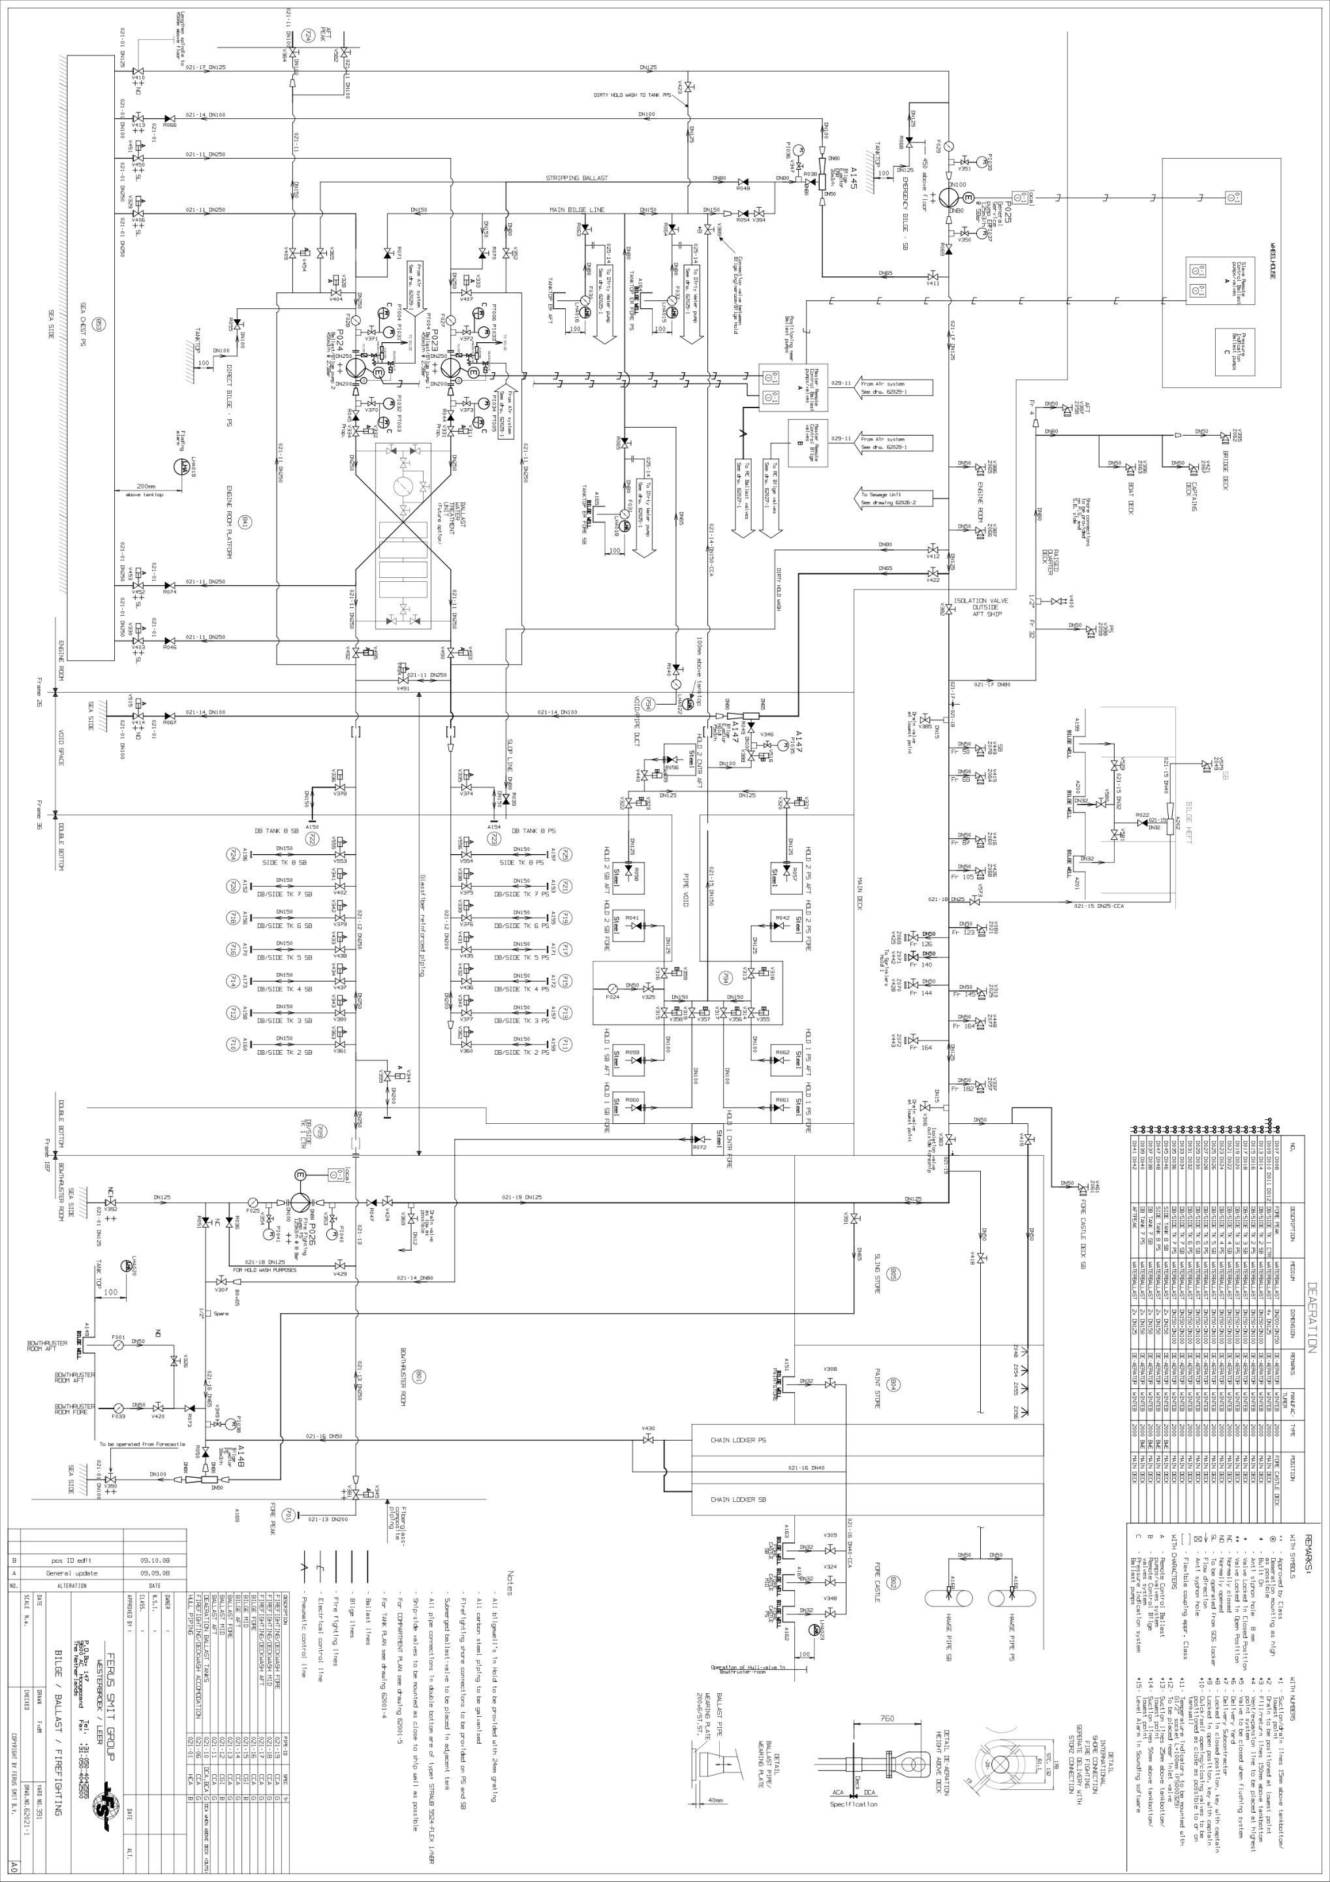

Annex III
The ballast system consists of the following tanks:
Name | Purpose | Volume M³ | Description on deck
Forepeak | Waterballast | 272.7 | FP
DB/Side tank 1 Center | Waterballast | 891.0 | DBS1C
DB/Sidetank 2 SB | Waterballast | 253.3 | DBS2S
DB/Sidetank 2 PS | Waterballast | 253.3 | DBS2P
DB/Sidetank 3 SB | Waterballast | 350.2 | DBS3S
DB/Sidetank 3 PS | Waterballast | 350.2 | DBS3P
DB/Sidetank 4 SB | Waterballast | 350.4 | DBS4S
DB/Sidetank 4 PS | Waterballast | 350.4 | DBS4P
DB/Sidetank 5 SB | Waterballast | 329.7 | DBS5S
DB/Sidetank 5 PS | Waterballast | 329.7 | DBS5P
DB/Sidetank 6 SB | Waterballast | 337.6 | DBS6S
DB/Sidetank 6 PS | Waterballast | 337.6 | DBS6P
DB/Sidetank 7 SB | Waterballast | 337.5 | DBS7S
DB/Sidetank 7 PS | Waterballast | 337.5 | DBS7P
DB tank 8 SB | Waterballast | 166.6 | DB8S
DB tank 8 PS | Waterballast | 166.6 | DB8P
Sidetank 8 SB | Waterballast | 239.8 | S8S
Sidetank 8 PS | Waterballast | 239.8 | S8P
Aftpeak | Waterballast | 166.3 | AP
Total volume | Waterballast | 6060.2

Tanksplan + capacity
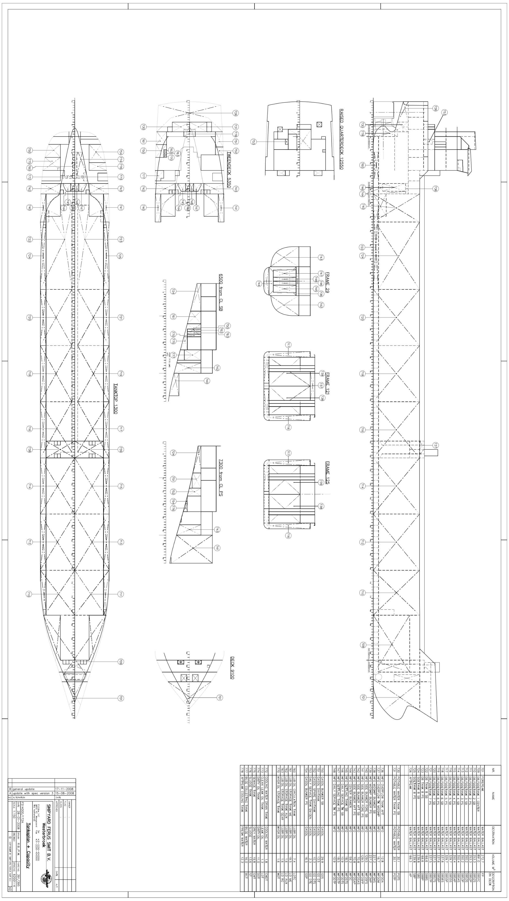

Annex IV
Brochure Damen Invasave 300
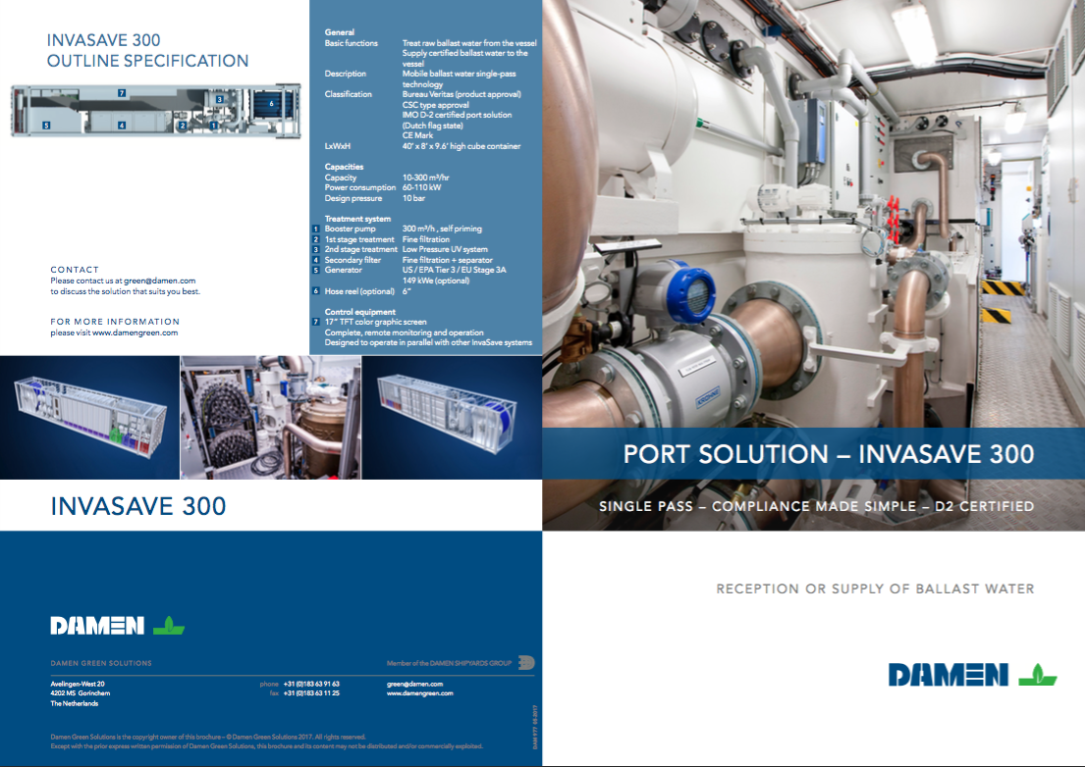
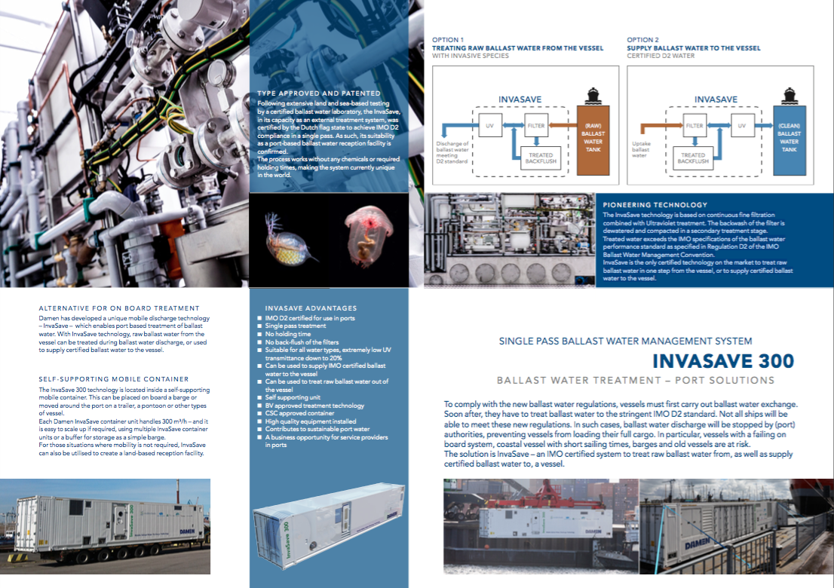

Annex V

Deck load plan
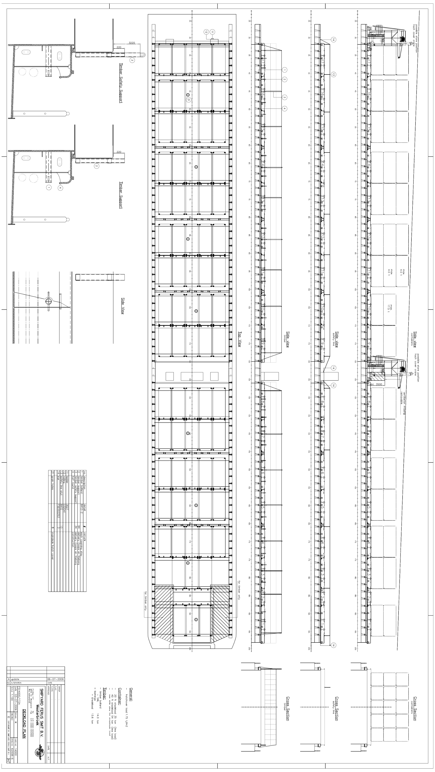

Annex VII

Article Invasave 300
(Damen Green, sd)2 May 2017
On April 25th Damen’s award-winning and IMO certified InvaSave BWMS(BWMS) received its world premiere in front of an invited audience courtesy of Groningen Seaports at the harbour of Delfzijl and Eemshaven, The Netherlands. This marks the culmination of a seven-year programme to develop an effective mobile BWMS for use in ports.
The premiere was a joint presentation between Damen Shipyards, the designated operator MariFlex and Groningen Shipyards, as well as Royal Wagenborg. This was the first time that the InvaSave has been used by a commercial operator. The newly launched MV Egbert Wagenborg was brought alongside a quay and the containerised InvaSave 300 mounted on a barge in front of the bow. Ship-to-ship operator MariFlex then quickly connected the vessel and InvaSave using a convenient standard hose connection. The ballast water was then pumped out of the ship and passed through the InvaSave for treatment before being released into the harbour.
The operation was witnessed by representatives from port operators and authorities, ship owners and other maritime organisations. Anneke Schäfer, Director of Nature and Environment Federation Groningen, gave a speech welcoming the arrival of this new technology before officially turning it on. While the treatment process was taking place, the guests were also entertained by a water jet flyboard performing acrobatics in the harbour.
Philip Rabe, responsible for InvaSave sales at Damen, commented: “We’re delighted that the Damen InvaSave is finally operational in a commercial environment. It is a unique product and, in many cases, it enables ports to offer vessel owners a viable and cost-effective alternative to retrofitting on-board systems. And, in the event of failure of an onboard system, ports can offer owners a means by which they can access ballast water treatment at short notice, ensuring minimal downtime.”
The IMO-approved Damen InvaSave is the world’s first external ballast water treatment unit designed primarily for use in ports. The system receives ballast water from inbound vessels and treats it to IMO D-2 standard to eliminate potentially invasive marine micro-organisms. It can also deliver water treated to the same standard to outbound vessels. Its mobile, containerised format means that it can be operated from the dockside or from onboard a vessel alongside.
The new unit is now ready for operations at the harbour of Delfzijl and Eemshaven for vessels either without, or with malfunctioning, onboard BWTS capability. MariFlex also plans to have a second operational in Rotterdam ahead of the September implementation of the IMO Ballast Water Management Convention.
For more information please visit Damen Green website: www.damengreen.com
http://www.damen.com/en/news/2017/05/damen_invasave_port_based_ballast_water_management_system_has_world_premiere

Annex VIII

MEPC174.58

http://www.imo.org/en/KnowledgeCentre/IndexofIMOResolutions/Marine-Environment-Protection-Committee-%28MEPC%29/Documents/MEPC.174%2858%29.pdf

For more information please visit Damen Green website: www.damengreen.com
http://www.damen.com/en/news/2017/05/damen_invasave_port_based_ballast_water_management_system_has_world_premiere

