Influence of selenium enriched growing environment upon the phenolic composition of several Allium species
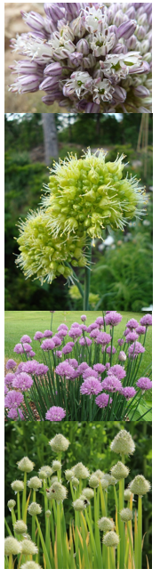
Alexandra Gândea

Influence of selenium enriched growing environment upon the phenolic composition of several Allium species

University: HZ University of Applied Science, Vlissingen, the Netherlands
Bachelor program: Chemistry
Course: CU06726 Final thesis & project
Course instructor: Dr. T.C.W. Moerdijk & Dr. S.T.Popovici
Client: Babes-Bolyai University, Cluj-Napoca Romania;
Faculty of Chemistry and Chemical Engineering –
Analytica Research Center.
Daily Supervisor: Lect. Dr. Augustin Catalin Mot
Date: 06/06/2019
Deadline: 06/06/2019
Version: 1.0

Abstract
During this research project the influence of selenium enriched growing environment on the phenolic composition on several Allium species is studied. Besides this, the influence on morphological properties is also monitored. Folin-Ciocalteu method is used to determine the total phenolic content and High Performance Liquid Chromatography coupled to a Diode Array detector is used for polyphenol composition. Eighteen polyphenols (i.e. gallic acid; 3,4-dyhydroxybenzoic acid; 4-hydroxybenzoic acid; chlorogenic acid; caffeic acid; syringic acid; p-coumaric acid; ferulic acid; sinapic acid; hyperoside; rutin; myricetin; quercitrin; rosmarinic acid; quercetin; luteolin; kaempferol; apigenin) were analyzed, from which seventeen were partially or base line separated. The calibration curves were constructed in the interval 12-200 µg/mL with R² values ranging from 0.9849 to 0.9992, using injection volume of 2 µL. The limit of detection (LOD) and limit of quantification (LOQ) per compound is determined, with values ranging from 5.5 µg/mL to 22.8 µg/mL and from 16.6 to 68.5 µg/mL, - respectively.
The species of Allium that were analyzed showed diverse compositions of polyphenols. From the seventeen polyphenols that could be analyzed using this method, only one, 3 4-dyhydroxybenzoic acid, was not found in any of the samples. Gallic acid is found in five out of six species, and for three of these samples the amount decreases as the concentration of added selenium increases. The most diverse composition of polyphenols is found to be in Allium cepa, with ten polyphenols in the control and sample treated with 1 mg/L selenium and eleven polyphenols in the one treated with 5 and 20 mg/L selenium solution. Generally, the samples treated with 20 mg/L selenium were the most affected ones, with lower amounts and number of polyphenols in their composition. For some samples like Allium cepa and Allium ampeloprasum the phenolic content increases when growing environment was enriched with 1 mg/L selenium, for other cases like Allium senescens the amount increases when 5 mg/L selenium added.
This research project gives an overview on how selenium influences the phenolic composition in Allium species. Allium cepa is the species that showed the most interesting results, showing a significant difference in total phenolic content, and the compositions of polyphenols. Nevertheless, more research has to be done to have a complete picture of the processes.

Table of Contents
1. Introduction 1
2. Theoretical background 2
2.1 Selenium bio-fortification 2
2.2 Elemental analysis 3
2.3 Polyphenols 3
2.3.1 Total phenolic determination 7
2.3.2 Polyphenol HPLC-DAD-MS analysis 8
3. Material & Method 10
3.1 Materials 10
3.2 Sample 10
3.3 Sulfur determination 11
3.4 Polyphenol analysis 11
Total phenolic analysis 11
HPLC-DAD-MS analysis 12
4. Results 13
4.1 Sample’s morphology 13
4.2 Elemental analysis 15
4.3 Extraction & Total phenolic analysis 17
4.4 Chromatographic analysis 19
5. Discussion & Recommendations 24
6. Conclusion 26
References 27
Appendix I 31
Appendix II 34
Appendix III 35
Appendix IV 37
Appendix V 38
Appendix VI 40
Appendix VII 42
Appendix VIII 45

1. Introduction

Selenium is an essential nutrient for both humans and animals. Even though in large quantities it is toxic, at low concentrations it is beneficial for living systems, including plants (Gupta et al. 2017). Low doses of selenium protect the plant from stressors such as cold, desiccation and metal stress. Due to the fact that it has similar chemical properties to sulfur it is taken up by plants via sulfur transporters inside the root of the plants and metabolized using sulfur assimilatory pathways (Shibagaki et al. 2001). Which is why determining the percentage of sulfur is also of interest, one of the methods being elemental analysis. Selenium containing crops can be used to deliver this element to the consumers (biofortification of the crops), for example, in China in Se-deficient areas it is practiced to prevent the Keshan disease, characterized by Se deficiency (Malagoli et al. 2015). Supplementation of fertilizer with selenium is an effective way to increase the mineral intake in feasible countries (Xu et al. 2003).
According to the research done by Xu et al. (2003) the content of polyphenols is greatly increased by application of the selenium-enriched fertilizer. Polyphenols receive a lot of interest from the consumers and manufacturers, due to several reasons, one of it being the fact that they are antioxidant agents that along with vitamin C, vitamin E and carotenoids protect the body tissue from oxidative stress (Scalbert et al. 2000), which can cause illnesses like cancer, cardiovascular and inflammatory diseases (Manach et al.2004). Polyphenols have a great diversity of their structures and several thousand of natural polyphenols have been identified in plants (Naczk et al. 2006).
Considering the import role of polyphenols and the promising roles of selenium bio-fortification the following investigation is proposed: determination of selenium uptake at three different concentrations by Allium species, the effect on sulfur content and polyphenol composition. Thus, the main research question is formulated:
“What are the effects of inorganic selenium enriched growing environment upon the polyphenol composition and properties of several Allium species?”
To be able to provide a complete and complex answer to the research question the following sub-questions are formulated and will be investigated:
- How does the selenium enriched growing environment affect the growth (roots and leaves length) and other morphological properties of the tested Allium species?
- How does the selenium content associates with the presence of other elements like sulfur?
- How does the selenium content affects the polyphenol composition (phenolic acids, flavonoids)?

2. Theoretical background

2.1 Selenium bio-fortification

More than half of the world population is affected by the phenomena called micronutrient malnutrition, particularly in developing countries (Mayer et al. 2008). Same source states that bio-fortification of the crops has a positive impact on solving this issue. Bio-fortification is delivering the micronutrients to the crops and relies on the plant’s biosynthetic and physiological capacity to accumulate the desired nutrients (Mayer et al. 2008).
Selenium is an essential mineral for human (Reilly et al. 2014) and is known to prevent cancer in numerous mammals (Ganther, 1999). Besides this selenium is a co-factor in two enzymes (glutathione peroxidase and iodothyronine 5’-deiodise), first one acting as an antioxidant by destroying peroxides that attack cellular membrane (MacLeod et al. 1995). Selenium has a dual role being an essential element at low levels and a toxic substance at higher concentration (Ganther, 1999; Gupta et al. 2017). According to Izgi et al. (2005) at low levels it also inhibits the toxicity of the several metals like lead and mercury. Same source states that due to the narrow concertation range between the two contrary effects, additional knowledge about selenium effects are needed. Furthermore, selenium shows toxicities being exhibited for organic and inorganic compounds (Izgi et al. 2005). Selenium is obtained in the diet mostly from plants and the level is dependent on the amount present in the soil (MacLeod et al. 1995). Many soils worldwide have low levels of selenium, including China, Russia and some parts of Europe (Reilly et al. 2014). According to MacLeod et al. (1995) addition of selenium to fertilizers and selenium supplementation have been successfully used to overcome deficiency problems; it has been used in Finland since 1984 to address low dietary intake (Reilly et al. 2014). According to Hu et al. (2001) the content of selenium is low in the areas where the concertation of the selenium is low in the soil. Selenium is taken from soil mainly in the form of selenate (SeO₄²⁻) and in less quantities as selenite (SeO₃²⁻) (Gonzalez-Morales et al. 2017; White et al. 2007)
On the other hand, not all plants have the ability to absorb, metabolize and accumulate certain elements including selenium (Gonzalez-Morales et al. 2017). Same source states that plants from the genus Allium can be good alternatives for selenium bio-fortification due to its nature to accumulate many sulfur compounds in their tissue. Selenium and sulfur are similar in size and chemistry which is why selenium is often a substituent for sulfur in physiological and metabolic processes (Toler et al. 2007; White et al. 2007). Selenium is taken up by plants via sulfur assimilation pathways and metabolized to seleno-methionine and seleno-cysteine which are analogues of the sulfur containing amino acids (Reilly et al. 2014). In selenium accumulator plants seleno-cysteine is methylated to methylseleno-cysteine which prevents aberrant protein formation (Broadley et al. 2006). According to Reilly et al. (2014) methylseleno-cysteine which is dominant in accumulator crops like Allium shows better health promoting biological effects than seleno-methionine which is predominant in non-accumulating crops. Allium crops do not show good volatilization activity in the presence of high concentration of sulfur and selenium, due to this fact it is possible to obtain Allium plants enriched in both elements, consequently, being and excellent dietary source (Gonzalez-Morales et al. 2017). However, the absorption of selenate competes with the uptake of sulfate and selenate induce the decrease in the concentration of sulfur metabolites even when high levels of sulfate are available (Hoewyk et al. 2008). Which is the reason why the sulfur content is determined in the tested species during this project.

2.2 Elemental analysis
To determine the ratio of sulfur along with the percentage of carbon, hydrogen and nitrogen elemental analysis is going to be performed. During this analysis the organic substance undergoes oxidative decomposition on a catalyst and, consequently, conversion of carbon, hydrogen, nitrogen and sulfur to the final product of carbon dioxide, water, elemental nitrogen and sulfur dioxide, respectively (Fadeeva et al. 2008). Reduction of the combustion gases happens when passed through a reduction furnace, followed by separation by gas chromatography which is then detected by a thermal conductivity detector giving an output signal proportional to the concentration of the analyte.
The analysis requires a high temperature combustion, around 1000°C furnace temperature, in an oxygen rich environment, which can be static (adding a set volume of oxygen) or dynamic condition (constant flow of oxygen) (Royal Society of Chemistry, 2006). According to the same source once the combustion products are formed they are passed over heated high purity copper, which has the aim to remove residual oxygen not consumed in combustion chamber. Separation and detection of the gases can be carried out in a couple of ways, the main one being gas-chromatography separation followed by a detection using thermal conductivity (Royal Society of Chemistry, 2006). Thermal conductivity detector (TCD) measures changes in the thermal conductivity of the carrier gas (Rhodes, 1996). According to the same source the thermal conductivity of the mix between the compound and the carrier gas is different than the one of the pure carrier gas. The detector measures the change in conductivity and therefore provides information about the presence of various compounds (Rhodes, 1996). See Figure 1 for the schematic representation of an elemental analyzer.
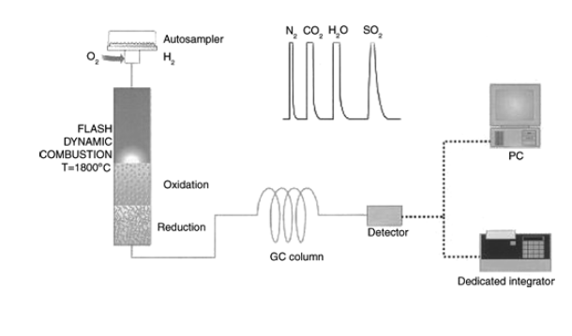
Figure 1. CHNS Elemental Analyzer (Royal Society of Chemistry, 2006)

2.3 Polyphenols
Polyphenols are bioactive micronutrients widely distributed in natural products (Vlase et al. 2013). According to Manach et al. (2004) they play an important role in prevention of degenerative diseases like cancer and cardiovascular diseases. However, the health effects are directly dependent on the amount they are consumed and their bioactivity (Manach et al. 2004). Polyphenolic compounds, like flavonoids are known to be effective antioxidants due to the fact that they have the capability to scavenge free radicals of fatty acids and oxygen (Lachman et al. 2003). Polyphenols also provide essential function in the reproduction and growth of the plants, as they act like defense mechanism against pathogens and parasites (Reis, 2013).
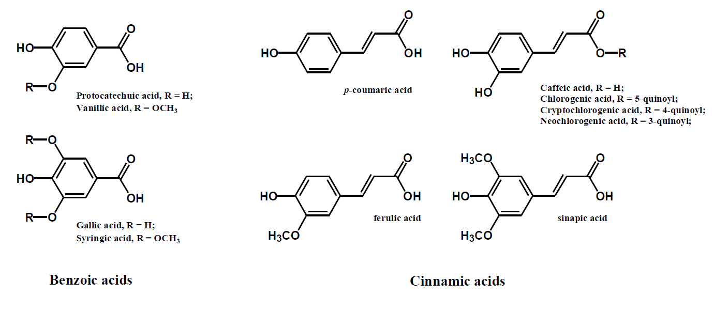
Polyphenolic compounds can be classified into different groups depending on the number of phenol rings that they contain and the structural elements that bind these ring to each other (Manach et al. 2004). According to the same source this group of compounds can be classified into phenolic acids, flavonoids, stilbenes and lignans. Phenolic acids are non-flavonoid polyphenolic compounds that are usually divided in two subcategories: benzoic and cinnamic acids derivatives, having C1-C6 and C3-C6 backbone respectively (Tsao, 2010), see Figure 2 for the chemical structures of typical phenolic acids and Appendix I, Table 1 for the information about phenolic acids used for this research. Flavonoids on the other hand have a C6-C3-C6 general structural backbone, where the two C6 units are of phenolic nature (Tsao, 2010), see Figure 3 for the basic flavonoid structure, and Appendix I, Table 2 for the ones used for this research.
Figure 2. Typical phenolic acids structures; left benzoic acids, right cinnamic acids (Tsao, 2010).

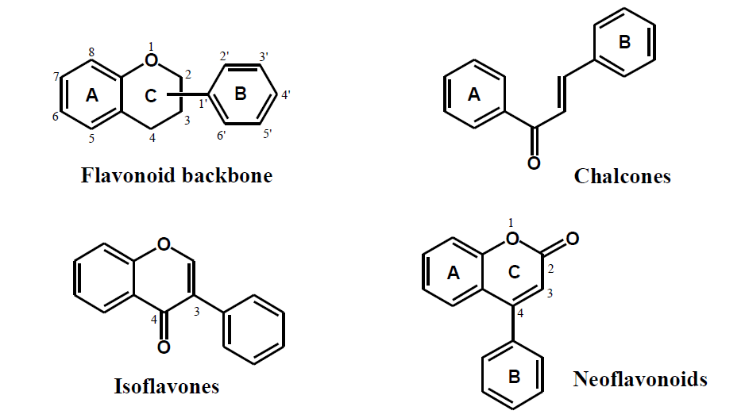
Figure 3. Basic flavonoid structures (Tsao, 2010)

According to Lachman et al. (2003) Allium species are one of the richest sources of flavonoids in general, but especially of quercetin. Also considerable amounts of protocatechuic acid and spiraeoside are found, see Table 1 for the content of major polyphenols founds in Allium cepa. On the other hand, during his study Vlase et al. (2013) found out that coumaric acid and ferulic acids are found in all of the species of Allium they analyzed, see Table 2 for the results found during the mentioned study.
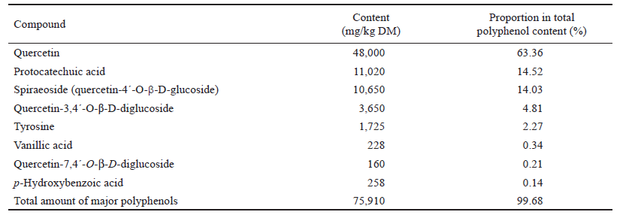
Table 1. Contents of major polyphenols in Allium cepa, expressed in mg/kg dry mass (DM) sample (Lachman et al. 2003)

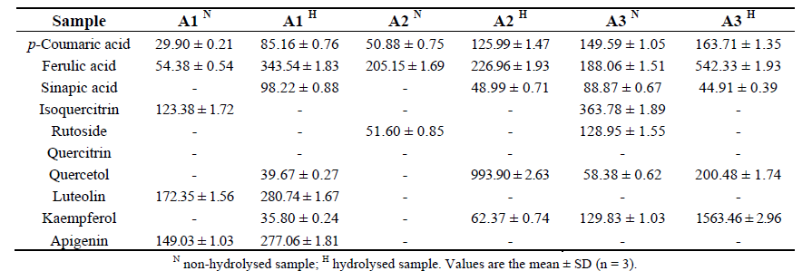
Table 2. Polyphenolic compounds content of Allium species (µg/100 g vegetable product); A1- Allium obliquum, A2- Allium montanum, A3- Allium schoenoprasum (Vlase et al. 2013)

During a study performed by Bystricka et al. (2015) a positive association was found between the selenium concentration in the soil and the total polyphenol content in Allium cepa. This study tested the effect different concentration of selenium added in the form of an aqueous solution of sodium selenate to Allium cepa would have on the total polyphenol concentration. The concentration of 0.225 mg Se added per kg soil showed the highest content of polyphenols. The tested concentrations were 0.150, 0.225 and 0.300 mg Se per kg of soil (Bystricka et al. 2015), see Table 3 for the results. Similar results were found in other plants that were treated with selenium additives, according to Antonenko et al. (2017) selenium had a positive influence on the increase of phenolic content in malt.
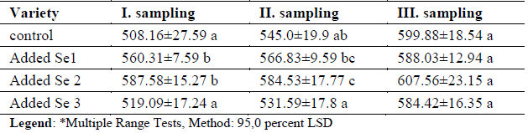
Table 3. Total polyphenol content (mg/kg) in Allium cepa; Se1 - 0.150 mg Se/kg soil, Se2 – 0.225 mg/kg, Se3 – 0.300 mg/kg; I sampling – at the beginning of vegetation period; II sampling – middle of vegetation period; III sampling – end of vegetation period; LSD- least significance difference test; (Bystricka et al. 2015)

2.3.1 Total phenolic determination

The Folin-Ciocalteu (F-C) method is considered to be one of the simplest and the most used methods available to determine total phenolic content in various products (Agbor et al. 2014). According to Chen et al. (2015) Folin-Ciocalteu method is a convenient analytical technique with good reproducibility for the determination of the total polyphenols in biological materials. It has been used extensively for samples like plant tissues, fruit juices and wines (Chen et al. 2015). Same source stated that F-C method does not require particular equipment and can be used in characterizing and standardizing botanical samples.
Quantitative determination of polyphenols is hampered by their diversity and structural complexity and considering the fact that quantification of individual polyphenols does not reveal the proportion of the polymeric compounds, spectrophotometry in the ultraviolet region can be a method to help solve this problem (Blainski et al. 2013). Colorimetric analyses are often used in the UV/VIS spectrophotometric analyses due to rapidity, applicability in routine laboratory use and low-cost. However, a reference substance has to be used, to be able to measure the concentration of phenolic compounds in the samples. According to Blainski et al. (2013) in plants extracts the polyphenols react with the redox reagent (Folin-Ciocalteu reagent) which form a blue complex and consequently quantified by the visible-light spectrophotometry. As a result of this reaction a blue chromophore constituted by phosphotungstic-phosphomolybdenum complex is formed, where the maximum absorption of the chromophores depends on the alkaline solution and the concentration of the phenolic compounds, see Figure 4 for the equation.

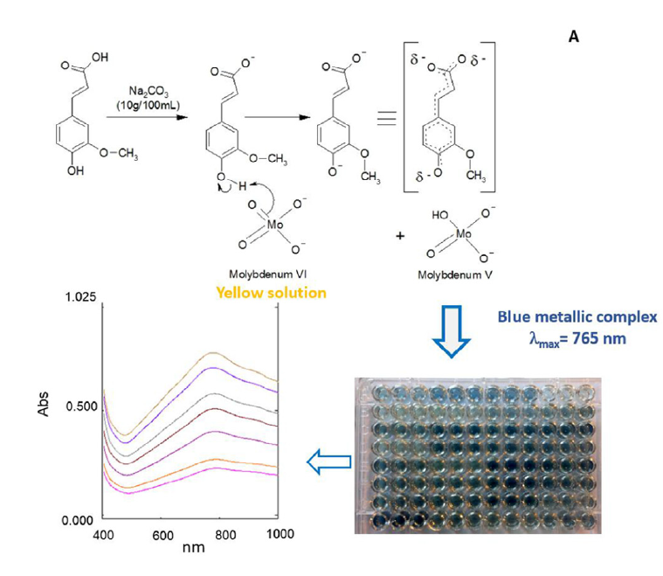
Figure 4. Chemical reaction and UV/VIS spectra of phosphotungstic-phosphomolybdenum complex generated after phenolic interaction with Folin-Ciocalteu reagent (Granato et al. 2016)

2.3.2 Polyphenol HPLC-DAD-MS analysis

Liquid chromatography and capillary electrophoresis are the two most cited techniques for the separation, identification and quantification of the polyphenols (Dalluge et al. 2000). According to Fang et al. (2007) high performance liquid chromatography coupled to a photodiode-array detector and a mass spectrometer (HPLC-DAD-MS) is a powerful tool suitable for polyphenol analysis from plants extract. HPLC coupled to DAD detection allows high-sensitivity and provides information about the polyphenol structures, however, it does not discriminate different compounds having similar chromophore group (Wang et al. 2008). MS detector provides more details on structure and molecular weight of the polyphenols from the fragmentation data (Fang et al. 2007; Wang et al. 2008).
For polyphenol separation a Hypersil Gold UPLC column (50 mm x 2.1 mm, 1.9 µm particle size) from Thermo Scientific is used. It is a C18 column used for reversed-phase ultra-performance liquid chromatography. According to Thermo Scientific (2010) this column has a highly pure silica stationary phase and proprietary derivatization and end-capping with an alkyl chain chemistry. These have a positive influence towards resolution, efficiency, sensitivity and reduction of peak tailing. According to the same source the column is stable at both high and low pH values. Due to 1.9 µm particle size and only 50 mm length this column gives equivalent efficiency as longer columns but acquires shorter analysis time and solvent savings (Thermo Scientific, 2010).
According to Swartz (2010) photodiode-array detectors extend the utility of an UV detector, due to the fact it provides a spectra of the eluted peaks. This detection method can be used to aid in peak identification, along with monitoring for co-elution. For some examples of UV/Vis spectra of the different phenolic compounds see Figure 5.
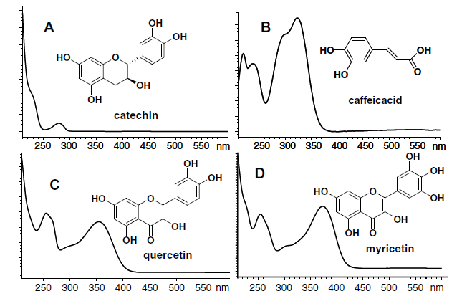
Figure 5. UV/Vis spectra of the different phenolic classes (Arapitsas, 2008)

3. Material & Method

3.1 Materials

Polyphenol standards: 3,4-Dihydroxybenzoic acid ≥97.0%, 4-Hydroxybenzoic acid 99%, Quercetin dehydrate minimum 98% HPLC, Caffeic acid ≥98.0%, Syringic acid ≥95%, p-Coumaric acid, Rutin hydrate 95%, Myricetin ≥ 96.0%, Chlorogenic acid ≥ 95%, Hyperoside, Sinapic acid ≥98.0%, Rosmarinic acid ≥96.0%, Quercitrin ≥97.0%, Kaempferol ≥97.0% were purchased from Sigma Aldrich (Steinheim, Germany). Ferulic acid ≥98.0%, Luteolin ≥99.0%, Apigenin ≥95.0% were purchased from Fluka Biochemika (Buchs, Switzerland) and 3,4,5-Trihydroxybenzoic acid monohydrate 99% (Gallic acid) was purchased from Alfa Aesar (Karlsruhe, Germany). All the standards were prepared in methanol.
Elemental analysis standard: BBOT Standard ( 2,5 Bis (5-tert-butyl-benzoxazol-2-yl) thiophene) containing C – 72.53%; H – 6.09%; N – 6.51%; S – 7.44%; O – 7.43% purchased from Thermo Electron Corporation (Milan, Italy)
Folin-Ciocalteu’s phenol reagent and Methanol were purchased from Merck Millipore (Darmstadt, Germany). Sodium carbonate was purchased from Chimopar (Bucharest, Romania). Trifuoroacetic acid (TFA) was purchased from VWR International (Pennsylvania, USA). Sodium selenate was purchased from Alfa Aesar (Massachusetts, USA). Soil was purchased from Canna Terra (London, UK).

3.2 Sample

For this project six different species of Allium are chosen: Allium fistulosum (Welsh onion), Allium cepa (bulb onion or common onion), Allium ampeloprasum (wild leak), Allium schoenoprasum (chives), Allium semescens, subspecie Montana (Germanic garlic), and Allium obliquum (twisted-leaf onion). The last two being mainly used for ornamental purposes.
Around 300 mL soil is transferred to a pot, the seeds are laid over the soil, watered with tap water and covered with a wet paper towel. They are left for 48h at 4°C in a closed system for cold treatment. After this step the closed system in placed in the growing chamber, after 5 days the lid of the closed system is removed and the pots with the germinated seeds are left in the plant growing chamber until pricking. The settings for the plant growing chamber are the following: 70 % humidity; temperature 21°C; 12h light, 12h dark; light intensity 40 µmol/m²/s. Once the plants started growing (after cca 2 weeks) they are pricked into bigger plant pots (1000 mL soil) and are placed back into the growing chamber at the same settings.
The plants are left for a week to get used to the new growing environment after which the selenium bio-fortification starts. Three different concentration of selenium are tested: 1, 5 and 20 mg/L. The solutions are prepared from a stock of 500 mg/L in ultrapure water, sodium selenate is used for preparation. Per each specie four plant pots are available, one per concentration and one control. To each pot a volume of 200 mL of the selenium solution and ultrapure water for the control is added two times per week on the top of the pot. The solution is added directly on the soil, without touching the plat itself. Selenium bio-fortification lasts for 4 to 5 weeks.
The samples are collected, washed, the leaves and roots were separated and frozen using liquid nitrogen, then freeze-dried for 48 hours, crushed using a tissuelyser until powder like state and stored at -20°C for further analysis. For the samples used during this research project the water percentage was determined by weighing in the samples before and after the freeze drying. No replicates are available as only one pot per specie, per concentration of selenium added was available and all individuals from one pot are freeze-dried and tissuelysed at once. Per pot from 4 to 12 individuals were available, depending on the species.
When the growing period of the samples ended (after 4-5 weeks of selenium bio-fortification) the length of the leaves and the roots was measured to determine any influence of the selenium in the growing environment on the morphological properties of the samples. The mean length of the leaves and of the roots is calculated and T test is applied to determine how significant is the difference between the means of the samples treated with selenium compared to the control. Standard error mean (SEM) is calculated by the following formula:
SEM = $\frac{SD}{√n}$ where SD is standard deviation of the original distribution and n is sample size or number of samples.

3.3 Sulfur determination

The analysis is performer on a Thermo Scientific FlashEA 1112 Series Elemental analyzer. No sample pre-treatment is needed for this method, the leaves of the samples in freeze-dried, powder like state are used for analysis. Masses between 1.05 and 3.38 mg are used during the analysis, all of them in duplicate. Standards with the known percentage of carbon, hydrogen, nitrogen and sulfur are used, a three point calibration curve is plotted to measure the dependence between signal and concentration. The calibration curves and percentage of these elements in samples are automatically calculated by the soft, Eager 300. The combustion happens at 950°C in the presence of oxygen, with the flow of 250 ml/min. For the separation a GC Thermo Scientific steel column is used, with the length of 2 m and 6x5 mm diameter. Helium is used as mobile phase with the flow rate of 140 ml/min. The run time is 11 min.

3.4 Polyphenol analysis

Total phenolic analysis
The extraction method used for the polyphenol analysis is a hydro-alcoholic extraction procedure. A certain mass of the leaves of the sample is transferred to an Eppendorf tube with the concentration of 100 mg sample per one mL of solvent. The corresponding volume of solvent (70:30 methanol to water) is added to the sample. The tubes are sonicated for 15 min and left at room temperature for one hour. These are later centrifuged for 20 min at 14000 rpm, supernatant is transferred to a clean tube and centrifuged again for 30 min, and the supernatant is then used for further analysis. Extraction performed in duplicate per each sample.
To determine the total phenolic content Folin-Ciocalteu assay is used. The polyphenols present in the sample are exposed to a basic medium (saturated carbonate solution is added) which leads to deprotonation the compounds; as a result, phenolate ions are obtained. 10 µl of sample extract is mixed with 220 µl water and 20 µl Folin-Ciocâlteu reagent in a 96 wells Tecan microplate and left to incubate in the dark for about 5 minutes. Then 50 µl of 20% sodium carbonate solution is added and the whole mixture was incubated for 30 minutes. Folin-Ciocâlteu reagent contains a combination of phospho- tungsten and molybdenum compounds along with lithium sulfate as bromine. When the reagent is added, the polyphenols are oxidized, whereas the molybdenum is reduced, obtaining the metallic complex (PMoW₁₁O₄)⁴⁻ which has a bluish color. After incubation the microplate is placed in a Tecan spectrophotometer and the absorbance is measured at 725 nm. To determine the dependence between signal and concentration, standards varying from 0 to 50 µg/mL gallic acid are prepared the same way using 20 µl Folin-Ciocâlteu reagent and 50 µl of 20% sodium carbonate solution. The volume of water is adjusted depending on the volume of the gallic acid stock solution used. The calibration curve is plotted and the equation is used to calculate the phenolic content in the samples. The measurement is performed two times and the average absorption is used to plot the calibration curve and calculate the content in the samples. Relative average deviation is calculated by dividing the average deviation by the mean concentration and is expressed in percentage.

HPLC-DAD-MS analysis
The separation of polyphenolic compounds is performed on an Thermo Accela HPLC system (Massachusetts, United States) which is equipped with an on-line vacuum degasser, quaternary pump, automatic injector, a column thermostat compartment and DAD detector. The column used is Hypersil gold C18 column (50 mm x 2.1 mm, 1.9 µm particle size) also from Thermo Scientific. The injection volume was 2 µL, the column temperature was set to 30 °C and the flow rate was 450 µL/min. As mobile phase A aqueous solution with 0.1% TFA is used and as solvent B methanol. A multistep gradient elution is used with the following program (Table 4):
Table 4. Gradient elution program used for the chromatographic analysis
Time min | Mobile phase A % | Mobile phase B %
0.0 | 90 | 10
0.5 | 90 | 10
10 | 50 | 50
12 | 20 | 80
13 | 0 | 100
14.5 | 0 | 100
14.6 | 90 | 10
15.0 | 90 | 0

For the UV-Vis detection of the compounds a DAD detector is used, it is set to measure the entire spectrum in 200-600 nm region (1 nm resolution), every 1 millisecond. To quantify the phenolic compounds standards with the concentration from 12.5 to 200 µg/mL are prepared and a calibration curve is plotted. The equation of the calibration curve is used for quantification. The same extracts, in duplicate per sample, as the one from total phenolic analysis are used for the HPLC-DAD analysis. Limit of detection (LOD) and limit of quantification (LOQ) are calculated per compound present in the calibration standard range. LOD is calculated as described by Miller et al. (2005) and LOQ is described as described by Wenzi et al. (2016) by using the following formulas:
LOD= $=\frac{3 x Sx/y}{b}$ LOQ = 3 x LOD
Where Sx/y is the standard deviation of the residuals and b is the slope of the calibration curve.

4. Results

The water percentage in leaves ranges from 77% for the Allium obliquum control up to 93% for the Allium cepa control. On the other hand, for the roots of the samples the water percentage ranges from 81% for Allium schoenoprasum treated with 1 mg/L selenium solution to 93 % for Allium cepa control, see Appendix II for detailed results.

4.1 Sample’s morphology

One of the sub-questions of this research is to determine what influence the selenium enriched growing environment has upon the morphological properties. In case of Allium schoenoprasum it is observed that with the increase of the Se concentration in the growing environment the length of both leaves and roots of the sample decreases. The length of the leaves decreasing from 25 cm to 17 cm and from 19 cm to 10 cm for the roots. By applying the t-test and determining the p-value the significance of the difference in means between the mean lengths of a sample grown in Se enriched environment and the control is determined. Thus, for Allium schoenoprasum there is an extremely significant difference for the samples grown in environment enriched with 5 mg/L and 20 mg/L Se in case of the roots, and an extremely significant difference for the sample grown in environment enriched with 20 mg/L for the leaves (Figure 6). Nevertheless, for the sample Allium cepa the length of the roots is higher for the plants grown in the soil enriched with 1 mg/L Se, while the plants grown with 5 mg/L have higher length of the leaves, see Figure 6. In case of the roots there is a significant difference for the ones grown with 20 mg/L Se concentration with the p-value of 0.01 and a significant difference for the ones grown with 1 mg/L Se and highly significant difference for the samples grown with 20 mg/L Se, see Appendix III, - for the results and for the rest of the graphs.

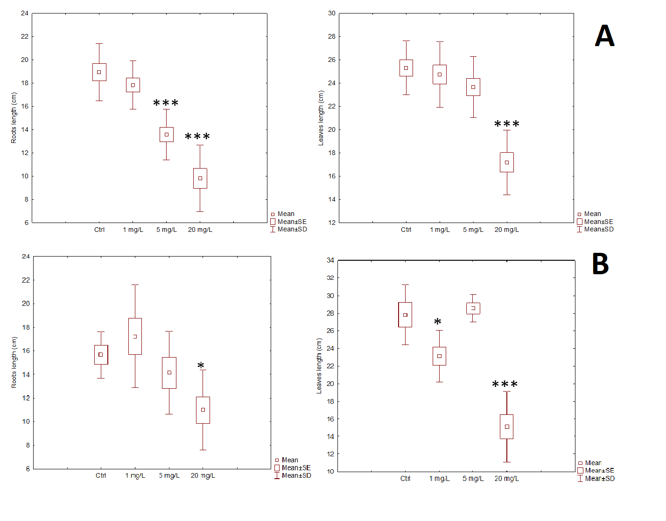
Figure 6. Graphs including information about the mean, standard error, standard deviation and difference of the means compare to the mean of the control about the length of the roots and leaves of Allium schoenoprasum (A) (n=11) and Allium cepa (B) (n=7). ***extremely significant (p < 0.001);** highly significant (0.001 < p < 0.01); *significant (0.01 < p < 0.05); not significant (p> 0.05)

4.2 Elemental analysis

For the elemental analysis a standard containing only 7.44% sulfur was used, the standard with the lowest quantity of sulfur available at the facility, however, no sulfur was detected in any of the samples using this method. The analysis was performed in duplicate.
From the other three elements nitrogen is the only element that showed noticeable differences intra and inter species, however, in case of nitrogen the average deviation is also high, reaching up to the same value as the average of the duplicates (relative average deviation of 100 %), for instance, in Allium cepa treated with 1 mg/L selenium solution the percentage of nitrogen is 1.22 ± 1.22. The highest percentage of nitrogen is registered in Allium obliquum, with values ranging from 2.54% to 3.78 % (see Table 5). The highest percentage is determined to be in samples treated with 1 mg/L selenium solution for this specie and there is a decrease of nitrogen percentage with the increase of concentration of selenium in the solution that the sample was treated with.
The carbon percentage of the samples generally stays between 38% and 41%. In case of Allium fistulosum, cepa and schoenoprsum the percentage of carbon is the lowest in the samples treated with 20 mg/L selenium solution. On the over hand, in case of Allium ampeloprasum and obliqqum the percentage of carbon is the highest in case of samples treated with 20 mg/L selenium solution with values of 39.58 % and 39.86 %. The percentage of hydrogen ranges between 5% and 6% and no changes are observed depending on the amount of selenium added to the samples. For these two elements, carbon and hydrogen, the relative average deviation is below 6 %.

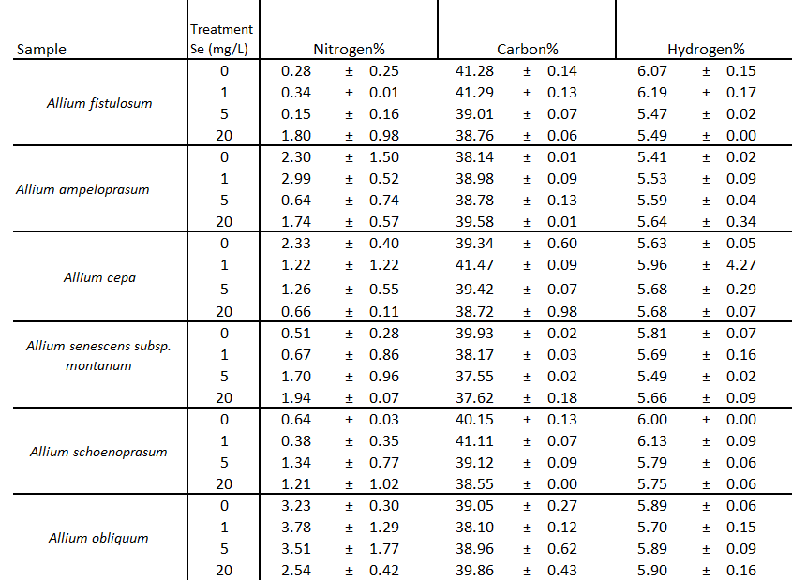
Table 5 Results of elemental analysis of six species of Allium, including percentages of nitrogen, carbon and hydrogen; no sulfur was determined (n=2)

4.3 Extraction & Total phenolic analysis

Prior starting the polyphenol analysis an optimal extraction method had to be chosen. Solvent with different ratio of methanol/water were tested and the total polyphenol content was determined. The solvent with 50:50; 70:30; and 90:10 ratio methanol to water were tested. The extraction was performed on three different sample, Allium fistulosum, Allium ampeloprasum and Allium cepa. The control (the sample not treated with selenium) from every sample was used. See Figure 7 for graphic representation of the results of total polyphenol determination or the extracts with different ration methanol. The extraction with 70:30 ration methanol water gave a higher content of polyphenols in the extract for two out of three analyzed samples. The average deviation is higher for the extracts performed with 90:10 methanol to water solvent, check Appendix IV for the exact values of the polyphenol content and average deviation. The extract with 50:50 ratio methanol to water showed the lowest standard deviation, however, the amount is lower in case of Allium fistulosum and Allium ampeloprasum. Consequently, the 70:30 ratio was chosen and used for further extractions.

Figure 7. Graphic representation of total polyphenol content expressed in mg polyphenol per g dry sample of Allium fistulosum, Allium ampeloprasum and Allium cepa. Extraction performed with 50:50; 70:30; 90:10 ratio methanol to water. Average deviation plotted on top (n=2)

To determine the total phenolic content of the samples Folin-Ciocalteu assay is used. The phenolic content is measured against gallic acid. The calibration curve with the concentration in µg/mL plotted on X axis and absorption plotted on Y axis is used (Figure 8). The method showed good linearity in the range up to 50 µg/mL with the coefficient of determination (R²) of 0.9996. The slope of 0.0746 Abs/µg/mL is used to calculate the total phenolic content of the samples.

Figure 8. Calibration curve of gallic acid using the standard range 1-50 µg/mL. Measurement done on a Tecan spectrophotometer and the absorption measured at 725 nm.
The polyphenolic content of the Allium extracts (as described in chapter 3.4) at all three levels of selenium concentration that was added to the plants during the growing period along with the control (no selenium solution was added) is determined (Table 6). Allium cepa showed a higher content of polyphenols at all three levels of added selenium and the control compared to the over samples, with the highest amount of 13.76 mg/g found at 1 mg/L concertation of selenium added. For the control samples Allium schoenotrasum showed the lowest amount of polyphenols of only 3.48 mg/g, however, the same as in case of Allium cepa, at 1 mg/L Se added the polyphenol content is higher compared to the other two levels. The extraction is performed in duplicate (n=2) and so is the measurement of the absorption. The amounts are expressed in mg of polyphenols per g of dry sample. Relative average deviation is below 8 % for all the analyzed samples.
Table 6. Overview of the total amounts of polyphenol in the analyzed samples at all three levels concentrations of selenium added and the control; RSD- relative average deviation expressed in %(n=2).
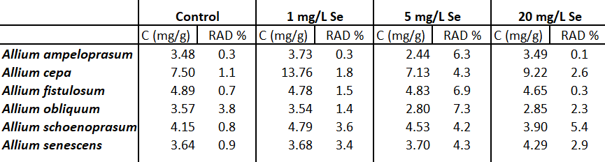
For Allium cepa it can be observed that the amount at level 5 mg/L Se added is the same as the one in the control sample where no selenium was added. There is an increase for the samples treated with 20 mg/L selenium with 9.22 mg/g compared to 7.50 mg/g for the control. In case of Allium ampeloprasum the total amount is lower, however a slight increase is observed in case of the plants treated with 1 mg/L Se solution, the same as for Allium cepa. Even though a decrease is observed for the plants treated with 5 and 20 mg/L Se solution, no significant variations are observed. The total phenolic content is expressed in mg polyphenols per g of dry sample and the standards deviation is plotted on top (Figure 9).

Figure 9. Relative amounts of polyphenols expressed in mg/g of dry sample of the two following samples: Allium cepa and Allium ampeloprasum. The results are presented based on duplicate measurements; Control - no selenium solution added; 1 - 1 mg/L selenium solution added; 5 - 5 mg/L selenium solution added; 20 - 20 mg/L selenium solution added.

4.4 Chromatographic analysis
To be able to quantify the polyphenols in the analyzed species, a standard range of standards containing eighteen polyphenols gallic acid, 3,4-dihydroxybenzoic acid, 4-hydroxybenxoic acid, chlorogenic acid, caffeic aicd, syringic acid, p-coumaric acid, ferulic acid, synapic acid, hyperoside, rutin, myricetin, rosmarinic acid, quercitrin, quercetin, luteolin, apigenin and kaempferol, with the concentrations ranging from 0.0125 mg/mL to 0.2 mg/mL is prepared. See Appendix V, Table 1 for the coefficient of determination (R²) and slope that is used to calculate the concentration of the polyphenols in the samples. The compound with the highest coefficient of determination (R²) (0.9992) is myricetin (Figure 10) where the concentration in mg/mL plotted on X axis and area mAU*min on Y axis. For the rest of calibration curve see Appendix VI. The LOD and LOQ is calculated as mentioned in previous chapter, the lowest LOD and LOQ is specific to caffeic acid and hyperoside with LOD values of 0.0055 mg/mL and LOQ values of 0.0166 mg/mL and 0.0164 mg/mL, respectively (Appendix V, Table 2 for the rest of the values).

Figure 10. Calibration curve of myricetin, using a standard range 0.0125 - 0.200 mg/mL. Analysis done on a Thermo Scientific Accela LC Systems, Thermo hypersil gold column coupled to a DAD detector. Chromatographic conditions; oven temperature 30°C, mobile phase A – aqueous solution with 0.1% TFA and mobile phase B methanol, flow rate 450 µL/min and injection volume 2 µL.

Figure 11 shows an example of two chromatograms, the one on top is a standard with the concentration of 0.1 mg/mL that contains 18 polyphenols that are marked on the chromatogram. However, no base line separation between chlorogenic (4) and caffeic (5) acid; hyperoside (10) and rutin (11); kaempferol (16) and apigenin (17) was acquired. Besides this, quercitrin and rosmarinic acid (13) co-elute, which is why these two if present in the sample are quantified as the sum of two. The chromatogram below is one of the samples, Allium cepa that was treated with 5 mg/mL selenium solution. Ten polyphenols out of 18 present in the standards are determined to be present in the sample. The nature of the compounds in the sample is determined by comparison of the absorption spectra registered by the DAD detector to the spectra of the individually analyzed standards. For the spectra of every analyzed polyphenol see Appendix VII. Another parameter that is taken in consideration when determining the polyphenol composition of the sample is the retention time, nevertheless, in case of the sample the retention time can shift due to matrix of the sample. Another phenomena that was observed is the fact that for the species that have gallic acid in their composition and have been treated with 20 mg/L selenium solution it cannot be separated from the solvent peak present at the beginning of the chromatogram, however, the absorption spectra at the end of the peak corresponds to abs. spectra of gallic acid. In case of some species including Allium cepa a peak with a high intensity shows at the retention time of 6.2 min. It elutes close to the elution time of the ferulic and synapic acid, however, when checking for the abs. spectra three different ones are registered, one at the beginning, one in the middle and one at the end of the peak, none of which match the spectra of ferulic or syringic acids.
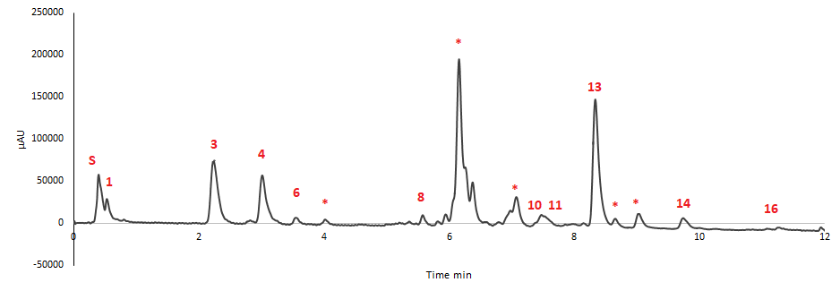
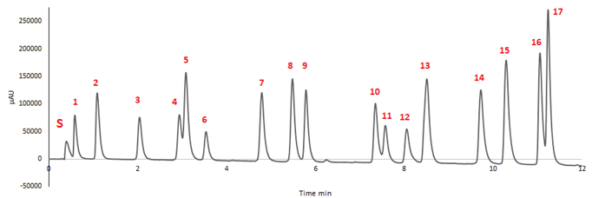
Figure 11. Example of two chromatograms of a 0.1 mg/mL standard containing 18 polyphenols, 1-gallic aicd; 2 – 3,4-dyhydroxybenzoic acid; 3 – 4-hydroxybenzoic acid; 4 – chlorogenic acid; 5 – caffeic acid; 6 – syringic acid; 7 – p-coumaric acid; 8 – ferulic acid; 9 – synapic acid; 10 – hyperoside; 11 – rutin; 12 – myricetin; 13 – quercetrin +rosmarinic acid; 14 – quercetin; 15 – luteolin; 16 – kaempferol; 17 – apigenin; and a sample, Allium cepa treated with 5 mg/L selenium solution. Analysis done on a Thermo Scientific Accela LC Systems, Thermo hypersil gold column coupled to a DAD detector. Chromatographic conditions; oven temperature 30°, mobile phase A – aqueous solution with 0.1% TFA and mobile phase B methanol, flow rate 450 µL/min and injection volume 2 µL. S – solvent peak; * - not identified.

As a result of HPLC-DAD analysis it was determined that Allium cepa regardless of the concentration of selenium added has the highest amount of polyphenols in its composition (Figure 12). It is also the species that has the most diverse composition containing ten polyphenols from the ones analyzed with the highest amounts in the control of quercitrin + rosmarinic acid and chlorogenic acid with values of 2932.7 µg/g and 1371.7 µg/g respectively, for the rest of the values see Appendix VIII. When treated with 1 mg/L selenium solution the amount the polyphenol increases in case of this specie. The amount gallic acid, 4- hydroxybenzoic acid, hyperoside, quercetin and kaempferol increases and rutin is also determined to be present. On the over hand, synapic acid that was determined to be present in the control sample is not present in the sample treated with 1 mg/L selenium. There is a decrease of polyphenol composition when the sample is treated with 5 mg/L selenium solution, and it has the lowest amount compared to the other two concentrations of selenium and control. The most abundant polyphenol in this case is 4-hydroxybenzoic acid.

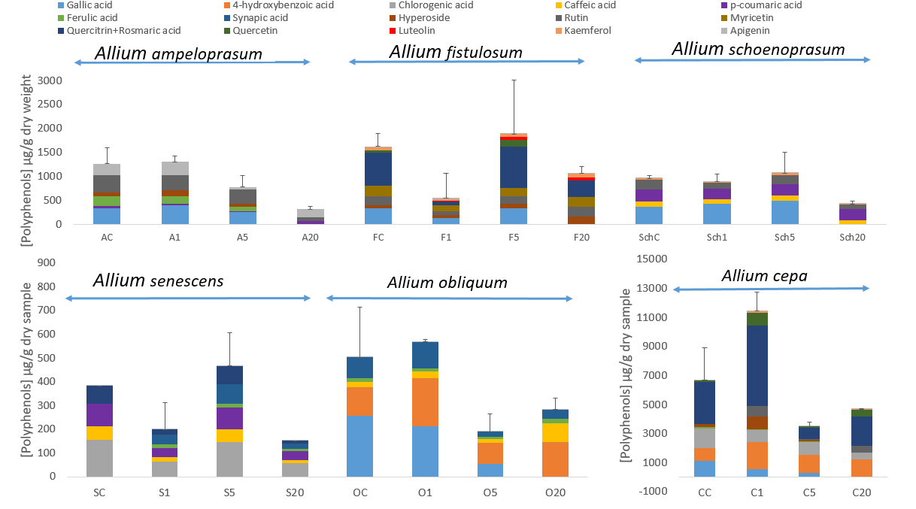
Figure 12. Relative amounts of polyphenols expressed in µg/g of dry sample in six different species of Allium at three levels of concertation selenium added; C- control; 1 – 1 mg/L selenium solution added; 5 - 5 mg/L selenium solution added; 20 – 20 mg/L selenium solution added; The results are presented based on duplicate independent extraction analysis (n=2)

On the other hand, the specie with the lowest amount of polyphenols determined by HPLC-DAD analysis is Allium senescens. In this case the amount in sample treated with 1 mg/L selenium is lower compared to the control and higher for the sample treated with 5 mg/L selenium. In case of the control the most predominant polyphenol is chlorogenic acid with the value of 156.2 µg/g. The second most abundant polyphenol is p-coumaric acid. Same tendency with the decrease in samples treated with 1mg/L selenium and increase for the ones treated with 5 mg/L is observed in case of Allium fistulosum. The most predominant polyphenol for the control Allium fistulosum is the mix quercitrin + rosmarinic acid with the value of 698.1 µg/g. Allium fistulosum is the only specie that has myricetin and luteolin in its composition, with luteolin only registered to be present in samples treated with selenium and not in the control. The concentration of luteolin also increases with the increase in selenium. Quecetin is only determined to be present in the control sample and the one treated with 5 mg/L selenium, with values of 40.9 µg/g and 136.1 µg/g. The chromatographic analysis showed a decrease of polyphenol content with the increase of selenium that was added during the growing period in case of Allium ampeloprasum This is the only specie in which composition were found higher amounts of ferulic acid and apigenin. Nevertheless, out of 6 polyphenols present in this specie only p-coumaricac acid, hyperoside and apigenin are found in the sample treated with 20 mg/L selenium.
For Allium obliquum the two most abundant polyphenols is gallic acid and 4-hydroxybenzoic acid with values of 257.4 µg/g and 121.4 µg/g in the control. The total content slightly increases when 1mg/L selenium added and decreases when 5 mg/L and 20 mg/L is added. Like for all the other samples where gallic acid is present it cannot be quantified in samples treated with 20 mg/L selenium due to co-elution with the solvent peak. However, with the increase of selenium concentration there is an increase in caffeic acid concentration. For the specie Allium schoenoprasum no significant changes in the total content and composition of polyphenols is observed when 1 mg/L and 5 m/L selenium added. Despite that, when treated with 20 mg/L selenium the total content decreases. No significant changes in composition are observed. The error bars are plotted based on average deviation between the sums of the determined polyphenols in the duplicate extracts.
Along with the amounts of each polyphenol, the total amount of determined polyphenols by chromatographic analysis is also calculated, see Table 7. The amount determined is expressed as percentage out of sample mass. Allium cepa showed the highest values, with 6.72 mg/g and 0.67% for the control and the 12.21 mg/g for the sample treated with 1mg/L selenium.
Table 7. Total amount of polyphenols determined by HPLC-DAD analysis expressed in mg/g dry weight and as percentage out of the sample dry mass. The results are presented based on duplicate measurements (n=2) 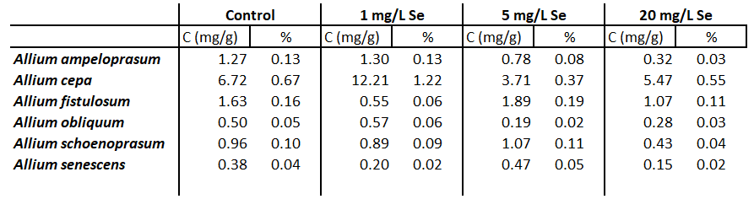

5. Discussion & Recommendations
To be able to determine the influence of selenium in growing environment on polyphenol composition of different Allium species, three different concentrations of selenium solutions were used to water the pants during the growing period. Besides the polyphenol composition, other aspects were also observed, like the influence of morphological properties and ratios of nitrogen, carbon, hydrogen and sulfur.
At the end of selenium bio-fortification (4-5 weeks) the length of the leaves and roots was measured to determine any influence and association between the amount of selenium added and the length. According to the research performed by Seppanen et al. (2010) as a result of selenium bio-fortification, plant’s morphology was affected, which was also found during this research, for Allium schoenoprasum there is a significant difference in the length of both leaves and roots of the ones treated with selenium and the control. Same phenomena is observed in case of Allium ampeloprasum. On the other hand, in case of Allium cepa the length of the roots is the highest when treated with 1 mg/L selenium solution with the average value of 17 cm, while the length of the leaves is the highest when the plants were treated with 5 mg/L selenium solution, with the average length of 29 cm. Allium senescens and fistulosum did not show any significant changes in roots and leaves length, however for the Allium fistulosum there is a decrease in length when treated with 20 mg/L selenium solution. During a research performed by Jerse et al. (2017) selenium treatment had a significant effect on height and mass of the plants that were used for the research. While this was also observed for this research in the case of some species, another factor that could have influenced this aspect is the number and the individuals that were planted in each pot. The length of the plants could have been influence by the fact that some individuals were weaker, thus growing at a slower rate, which could also influenced the results of this research. Another factor is the fact that during the growing period there was only one pot per species, per selenium concentration. Multiple individuals were planted in the same pot, however, a recommendation for future would be the use of two or three pots per same concentration of selenium, per same specie like that any additional factors that can influence the growth of plants in a certain pot can be excluded and would give a better insight of the influence of selenium on growth. This will also lead to a higher mass of sample, allowing to perform more analyses, including the ones that require high masses of samples. Another recommendation, considering the results of this research that gave in overview over different species, would be peaking one or two species where considerable changes were observed.
The main purpose of performing the elemental analysis was to determine the amount of sulfur in the samples as according to Hoewyk et al. (2008), the absorption of selenate leads to decrease in concentration of sulfur metabolites, thus reducing the amount of sulfur. Elemental analyses determines the percentage of carbon, hydrogen, nitrogen and sulfur at the same time, which also provides information of the other three compounds. An advantage of this method is the small mass that is required for the analysis, which was an issues during this project, as after freeze-drying and tissuelyzing the samples, masses bellow 700 mg were obtained, in case of the leaves, that were used for analysis. Nevertheless, a disadvantage of this method is the detection limit, as no sulfur was determined in any of the samples. According to the research provided by Rashid et al. (2013) the percentage of sulfur in Allium ranges from 0.42 % to 0.85 %. A recommendation would be the use of another method to determine sulfur that would have a lower detection and quantitation limit. An example would be the turbidimetric analysis, where sulfate ions are converted to barium sulfate and the turbidity is measured. Another method would be Inductively coupled plasma atomic emission spectroscopy (ICP-AES). Regarding the other three compounds no noticeable differences were observed for carbon and hydrogen percentages with values ranging from 38 % to 41 % and from 5 % to 6 % percentages, respectively. The nitrogen was the only compound that showed different percentages when the sample was treated with selenium, however, the average deviation was high in this case, reaching the relative average deviation of 100 %. Nitrogen is also an element of interest along with sulfur as according to Malagoli et al. (2015) selenium bio-fortification affects the production of nitrogen secondary metabolites. Running an analysis to determine the amount of selenium in the samples and comparing to the sulfur amount would also let draw conclusions regarding how the ration between these two elements varies. However, due to lack of time and low amounts of sample it was not possible to determine these within the time limits of the project.
Prior starting the chromatographic analysis of the samples the total content of polyphenols was determined by the use of Folin-Ciocalteu method. According to the research done by Bystricka et al. (2015) on Allium cepa that was treated with selenium the content of total polyphenols ranges between 500 and 600 mg/kg dry weight while the research done by Abdel-Gawad et al. (2014) found values up to 123.69 mg/g. The total phenolic determination during this research project showed the highest content in Allium cepa with the value of 7.50 mg/g in the control and 13.76 mg/g in the sample treated with 1 mg/L selenium. The lowest amount of polyphenols was found in Allium ampeloprasum and obliquum. In case of Allium cepa, ampeloprasum and schoenoprasum an increase in polyphenol content is observe when treated with 1 mg/L selenium, and also compared with the other two levels of selenium.
The composition of polyphenols in the analyzed samples was determined by the used of HPLC-DAD method. The compounds were separated on a Hypersil gold column which is a C18, silica column by Thermo scientific. From eighteen polyphenols used for this research ten are base line separated, gallic acid is not base line separated from the solvent peak, chlorogenic and caffeic acids partially co-elute, hyperoside and rutin are not base-line separated, the same is observed in case of kaempferol and apigenin, Nevertheless, quercitrin and rosmarinic acid completely co-elute, and consequently, are quantified as a mix between the two. Due to lack of time no new standard range was prepared that would contain only one of these. A recommendation would be to optimize the method and acquire base-line separation, especially in the case of chlorogenic and caffeic acids.
One of the main aims of this project was to determine if there is association between selenium enrichment of the growing environment and the polyphenol composition. According to Cheng et at. (2013) the main polyphenols present in Allium cepa are gallic and ferulic acids and quercetin. All of these three were found back in the control sample of Allium cepa, the highest amount is found to be for the mix of quercitrin and rosmarinic acid. At the concentration of 1 mg/L selenium added, the amount of gallic and ferulic acids does decrease, however, the quercitrin and rosmarinic acid and quercetin do increase. Rutin is present in the composition when the selenium is added and so is syringic acid, the last one being found only in this specie. During the chromatographic analysis of this specie it was observed that a peak with the highest intensity is eluted at retention tine 6.1 min (see Figure 11 in chapter 4). By comparing the retention time it does not match the retention time of any polyphenols present in the standard range. The detector used for this method was a DAD detector, that measures the whole absorption spectra of the of the eluted peak (Swartz, 2018), according to the same source this aids in peak identification and monitoring for co-elution, when checked for the absorption spectra of the peak found in all Allium cepa samples, there were three different absorption spectra, one at the beginning, one in the middle of the peak and one at the very end. None of the spectra matched the spectra of the analyzed polyphenols during this project, however, it was specific for the flavonoid compounds. According to Cheng et al. (2013) and Vlase et al. (2013) some polyphenols exist in the form of glycosides, especially the flavonoids (Tsao, 2010). These are compounds with sugar units attached at different positions of polyphenol backbone (Tsao, 2010). Consequently, an assumption would be that some of the flavonoids in Allium cepa are present as glycosides, thus, not matching any of the retention time or the absorption spectra. A recommendation would be to perform a hydrolysis step to be able to prevent this, which is also suggested in the research done by Vlase et al (2013) where the hydrolyzed samples showed higher amounts of polyphenols. Also the use of an MS detector coupled with the HPLC will give an insight to the composition of the sample and a considerable advantage in identification of the peaks.
According to Lachman et al. (2013) quercetin is found in considerable amounts in Allium species. However, during this study was found that quercetin is only present in Allium cepa and fistulosum. Gallic acid, on the other hand, was found in all samples, except Allium senescens. In Allium obliquum and cepa the amount decreases with the increase of selenium in the growing environment. At the same time in case of Allium schoemoprasum there is a direct co-relation, with the gallic acid content increasing with the increase of selenium concentration.
Another issue encountered during the HPLC-DAD analysis was a high average deviation between some of the duplicate extracts, even though, for the total phenolic determination this was not monitored. In some cases like Allium fistulosum treated with 1 mg/L and 5 mg/L selenium the area of all peaks in one of the duplicates being two times lower than the other one. A reason could be the extract itself, however, it is not very likely, as for the total phenolic determination the relative average deviation is below 8 %. The extracts were kept at the same conditions, for the same period of time, in between two analyses. Another problem causing his issues could be the injector in the HPLC system that injects different volumes, yet, it is observed only in a couple of samples. A recommendation would be letting the HPLC system inject a standard more time in a row and monitoring for any changes in the area of the peaks.
As a result of chromatographic analysis the total amount of the identified polyphenols was calculated, and expressed as percentage out of mass used for extraction. The highest percentage was determined to be in case of Allium cepa with values ranging from 0.37 % to 1.22 % of polyphenols in the sample. Regarding the changes in the amount depending on the selenium added, the highest amount is also found to be in the sample treated with 1 mg/L selenium solution. A slight decrease compared to the control in the sample treated with 5 mg/L selenium is also monitored. In case of Allium ampeloprasum same trend is observed, nevertheless, while the total phenolic determination showed a similar amount in the sample treated with 20 mg/L selenium and in the control sample. However, only 0.32 mg/g could be determined, by chromatographic analysis, in the sample treated with 20 mg/L selenium compared to 1.27 mg/g in the control. The lowest percentage of identified polyphenols was found to be in Allium senescens treated with 20 mg/L selenium solution with only 0.15 mg/g and 0.02 %. This can of course be caused by the presence of some flavonoids in form of glycosides that would not be identified during the chromatographic analysis. Considering the fact that there are more un-identified peaks during the chromatographic analysis an assumption would be the presence of some polyphenols that were not present in the standard range, thus, not matching any of the retention time or spectra.

6. Conclusion

During this project the influence of selenium in growing environment on biochemical composition of Allium species was investigated. Six different species were grown in environment enriched with three concentrations of selenium, 1, 5 and 20 mg/L, plus the control where no selenium was added. The total phenolic content along with polyphenol composition were determined and monitored for any changes.
A plant enriched in selenium would lead to the increase of mineral intake in feasible countries (Xu et al. 2003). According to the same source it would also increase the polyphenol content, these compounds being antioxidants agents. Consequently, finding a species that would be able to retain selenium and would have an increased content of polyphenols would represent a great advantage. While the selenium content was, unfortunately, not determined, the polyphenol analysis gave us an insight into the issue. Allium cepa showed the most interesting results, especially when treated with 1 mg/L selenium solution. The length of the roots increased from 16 cm to 17 cm, at the same time the length of the leaves decreased from 28 cm to 23 cm, which by applying the statistical t-test was determined to be a significant difference. Nevertheless, the total content of polyphenol, increased from 7.50 mg/g dry weight in the control to 13.73 mg/g, this being the highest phenolic contend determined in any of the samples. The results showed that Allium cepa as a specie had the highest amount of polyphenol compared with the other five species, where the total phenolic content ranges between 3 and 4 mg/g. Higher amount of polyphenols is also found in Allium cepa that was treated with 20 mg/L selenium compared to the control, with 9.22 mg/g. This is observed in only one other specie Allium senescens, however, in this case there are no other changes at the other two concentrations compared to the control. Besides all of these Allium cepa is also the specie that has the most diverse composition of polyphenols with ten out of sixteen polyphenols and one mix of two polyphenols investigated during this research project.
When it comes to the total phenolic content the amounts do not vary that much. Nevertheless, chromatographic analysis showed changes in composition of several species. For instance, in Allium fistulosum, luteolin is only found in samples treated with selenium solution, and not in the control. In Allium cepa, syringic acid is present only when sample is treated with 5 and 20 mg/L selenium solutions. On the other hand, the most affected species by 20 mg/L selenium in the growing environment is Allium ampeloprasum having only three polyphenols out of six found in the control from the ones investigated in this research. Allium obliquum and Allium schoenoprasum have the least diverse phenolic composition with only five present. The phenolic acid found in all of the species except Allium senescens is gallic acid.
Elemental analysis did not show the presence of any sulfur in the samples, and no influence of carbon and hydrogen percentages was observed. More research has to be done in this area.
In conclusion, this research project gave an overview and an insight on how selenium influences the phenolic composition of Allium species. Allium cepa is the specie that showed the most interesting results, showing a significant difference in total phenolic content, while in the compositions the ratio of the determined polyphenol changes.

References
A Agbor, G., Vinson, J., & Donnelly, P. (2014). Folin-Ciocalteau Reagent for Polyphenolic Assay. International Journal of Food Science, Nutrition and Dietetics.
Antonenko, K., Kreicbergs, V., & Cinkmanis, I. (2017). Influence of selenium, copper and zinc on phenolic compounds in rye malt.
Arapitsas, P. (2008). Identification and quantification of polyphenolic compounds from okra seeds and skins. Food Chemistry.
Blainski, A., Lopes, G., & De Mello, J. (2013). Application and analysis of the folin ciocalteu method for the determination of the total phenolic content from limonium brasiliense L. Molecules.
Broadley, M., White, P., Bryson, R., Meacham, M., Bowen, H., Johnson, S., . . . Tucker, M. (2006). Biofortification of UK food crops with selenium. Proceedings of the Nutrition Society.
Bystrická, J., Kavalcová, P., Musilová, J., Tomáš, J., Tóth, T., & Orsák, M. (2015). Selenium and its influence on the content of polyphenol compounds in onion (Allium cepa L.). Journal of Microbiology, Biotechnology and Food Sciences.
Chen, L., Cheng, C., & Liang, J. (2015). Effect of esterification condensation on the Folin-Ciocalteu method for the quantitative measurement of total phenols. Food Chemistry.
Dalluge, J., & Nelson, B. (2000). Determination of tea catechins. Journal of Chromatography A.
Evaluation of analytical instrumentation. Part XIX: CHNS elemental analysers. (2006). Royal Society of Chemistry .
Fadeeva, V., Tikhova, V., & Nikulicheva, O. (2008). Elemental analysis of organic compounds with the use of automated CHNS analyzers. Journal of Analytical Chemistry.
Fang, Z., Zhang, M., & Wang, L. (2007). HPLC-DAD-ESIMS analysis of phenolic compounds in bayberries (Myrica rubra Sieb. et Zucc.). Food Chemistry.
Ganther, H. (1999). Selenium metabolism, selenoproteins and mechanisms of cancer prevention: complexities with thioredoxin reductase.
González-Morales, S., Pérez-Labrada, F., García-Enciso, E., Leija-Martínez, P., Medrano-Macías, J., Dávila-Rangel, I., . . . Benavides-Mendoza, A. (2017). Selenium and sulfur to produce allium functional crops. Molecules.
Granato, D., Santos, J., Maciel, L., & Nunes, D. (2016, 6 1). Chemical perspective and criticism on selected analytical methods used to estimate the total content of phenolic compounds in food matrices. TrAC - Trends in Analytical Chemistry, 80, 266-279. Elsevier B.V.
Gupta, M., & Gupta, S. (2017). An Overview of Selenium Uptake, Metabolism, and Toxicity in Plants. Frontiers in Plant Science.
Hu, Q., Xu, J., & Pan, G. (2001). Effect of selenium spraying on green tea quality. Journal of the Science of Food and Agriculture.
Izgi, B., Gucer, S., & Jaćimović, R. (2006). Determination of selenium in garlic (Allium sativum) and onion (Allium cepa) by electro thermal atomic absorption spectrometry. Food Chemistry.
J. LACHMAN, D. PRONĚK, A. HEJTMÁNKOVÁ, J. DUDJAK, V. PIVEC, K. (2003). Total polyphenol and main flavonoid antioxidants in Allium cepa.
Jerše, A., Kacjan-Maršić, N., Šircelj, H., Germ, M., Kroflič, A., & Stibilj, V. (2017, 9 1). Seed soaking in I and Se solutions increases concentrations of both elements and changes morphological and some physiological parameters of pea sprouts. Plant Physiology and Biochemistry, 118, 285-294.
MacLeod, F., McGaw, B., & Shand, C. (1996). Stable isotope dilution-mass spectrometry for determining total selenium levels in plants, soils and sewage sludges. Talanta.
Malagoli, M., Schiavon, M., dall’Acqua, S., & Pilon-Smits, E. (2015). Effects of selenium biofortification on crop nutritional quality. Frontiers in Plant Science.
Manach, C., Scalbert, A., Morand, C., Rémésy, C., & Jiménez, L. (2004). Polyphenols: food sources and bioavailability 1,2.
Mayer, J., Pfeiffer, W., & Beyer, P. (2008). Biofortified crops to alleviate micronutrient malnutrition. Current Opinion in Plant Biology.
Miller J. N., & Miller J. C. (2005). Statistics and chemometrics for analytical chemistry.
Naczk, M., & Shahidi, F. (2006). Phenolics in cereals, fruits and vegetables: Occurrence, extraction and analysis. Journal of Pharmaceutical and Biomedical Analysis.
Rashid, M., Islam, A., Mian, M., Hossain, T., & Kabir, M. (2013, 3 31). Multivariate analysis in onion (Allium cepa L.). Bangladesh Journal of Agricultural Research, 37(4), 573-582.
Reilly, K., Valverde, J., Finn, L., Gaffney, M., Rai, D., & Brunton, N. (2014). A note on the effectiveness of selenium supplementation of Irish-grown Allium crops. Irish Journal of Agricultural and Food Research.
Reis Giada, M. (2013). Food Phenolic Compounds: Main Classes, Sources and Their Antioxidant Power. In M. Reis Giada, Oxidative Stress and Chronic Degenerative Diseases - A Role for Antioxidants.
Robert P. Rhodes. (1996). Thermal Conductivity Detector.
Scalbert, A., & Williamson, G. (2000). Chocolate: Modern Science Investigates an Ancient Medicine Dietary Intake and Bioavailability of Polyphenols 1.
Seppänen, M., Kontturi, J., Heras, I., Madrid, Y., Cámara, C., & Hartikainen, H. (2010, 12). Agronomic biofortification of Brassica with selenium-enrichment of SeMet and its identification in Brassica seeds and meal. Plant and Soil, 337(1), 273-283.
Swartz, M. (2010). HPLC detectors: A brief review. Journal of Liquid Chromatography and Related Technologies.
Thermo Scientific. (2010). Thermo Scientific Hypersil Gold Columns manual.
Toler, H., Charron, C., Sams, C., & Randle, W. (2007). Selenium Increases Sulfur Uptake and Regulates Glucosinolate Metabolism in Rapid-cycling Brassica oleracea. Lauchli.
Tsao, R. (2010). Chemistry and biochemistry of dietary polyphenols. Nutrients.
Van Hoewyk, D., Takahashi, H., Inoue, E., Hess, A., Tamaoki, M., & Pilon-Smits, E. (2008). Transcriptome analyses give insights into selenium-stress responses and selenium tolerance mechanisms in Arabidopsis. Physiologia Plantarum.
Vlase, L., Parvu, M., Parvu, E., & Toiu, A. (2013). Chemical constituents of three Allium species from romania. Molecules.
Wang, D., Lu, J., Miao, A., Xie, Z., & Yang, D. (2008). HPLC-DAD-ESI-MS/MS analysis of polyphenols and purine alkaloids in leaves of 22 tea cultivars in China. Journal of Food Composition and Analysis.
Wenzl, T., Haedrich, J., Schaechtele, A., Robouch, P., & Stroka, J. (2016). Guidance Document on the Estimation of LOD and LOQ for Measurements in the Field of Contaminants in Feed and Food 2 Editors.
Xu, J., Zhu, S., Yang, F., Cheng, L., Hu, Y., Pan, G., & Hu, Q. (2003). The influence of selenium on the antioxidant activity of green tea. Journal of the Science of Food and Agriculture.

Appendix I
Table 1. Overview of the analyzed phenolic acids, including the molecular weight and chemical structure.
Phenolic acid | Code standard | Molecular weight g/mol | Chemical structure
3,4-dihidroxybenzoin acid | 37580 | 154.12 | 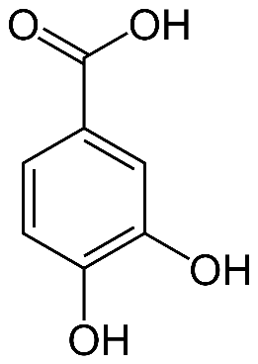
4-hydroxybenzoin acid | H20059 | 138.12 | 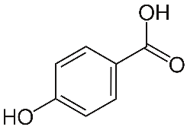
Caffeic acid | C0625 | 180.16 | 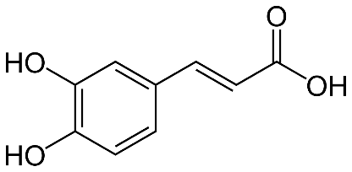
Chlorogenic acid | - | 354.31 | 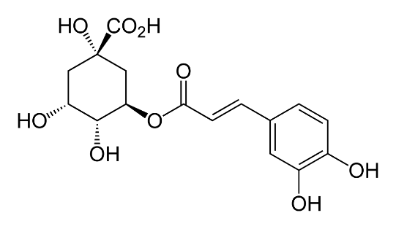
p-Coumaric acid | C9008 | 164.05 | 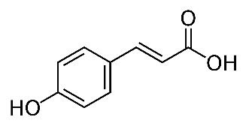
Ferulic acid | 46280 | 194.18 | 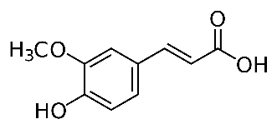
Gallic acid | A16303 | 170.12 | 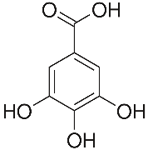
Rosmarinic acid | - | 360.31 | 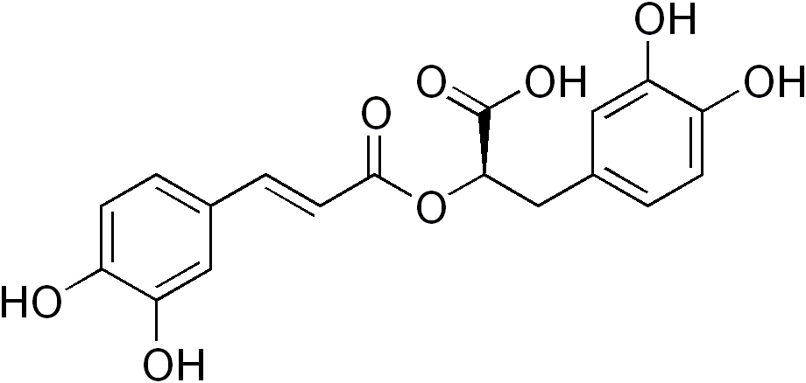
Syringic acid | S6881 | 198.17 | 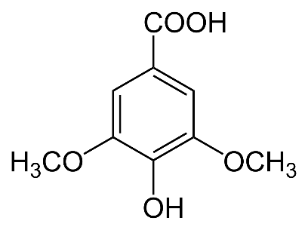
Sinapic acid | - | 224.21 | 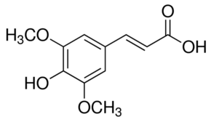

Table 2 Overview of the analyzed flavonoids, including the molecular weight and chemical structure.
Flavonoid | Code standard | Molecular weight g/mol | Chemical structure
Apigenin | 10798 | 270.05 | 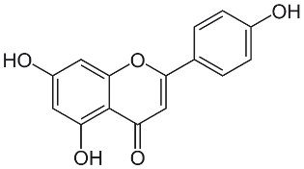
Hyperoside | - | 464.38 | 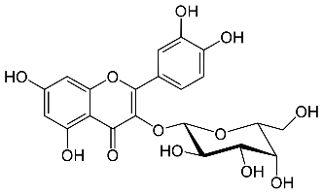
Kaempferol | - | 286.23 | 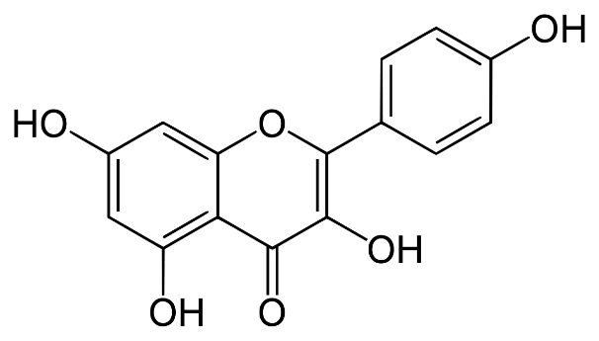
Luteolin | 62696 | 286.24 | 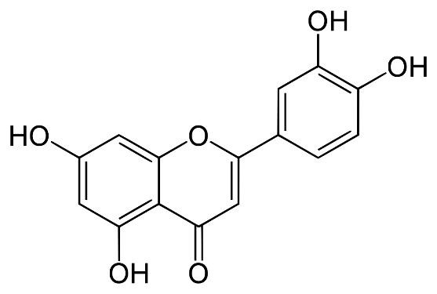
Myricetin | M6760 | 318.24 | 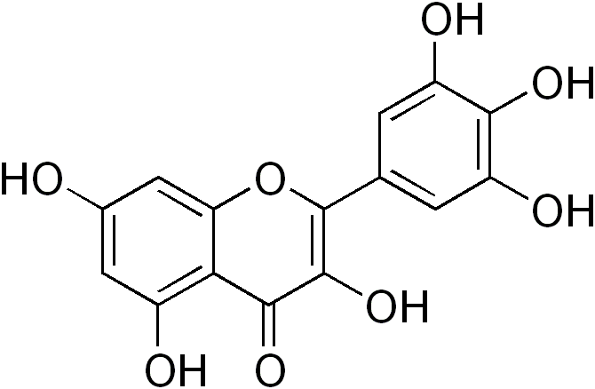
Quercetin | Q0125 | 302.24 | 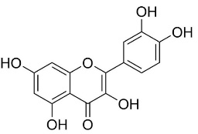
Quercitrin | - | 448.38 | 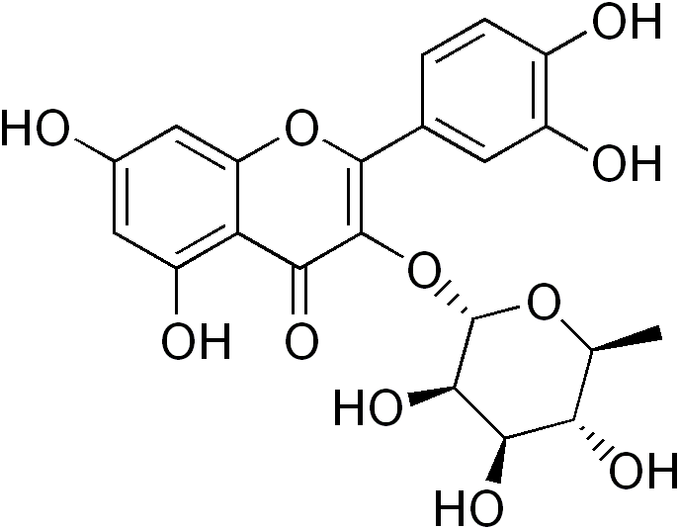
Rutin | R2303 | 610.52 | 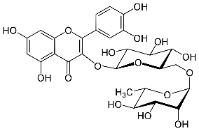

Appendix II
Table 1. Overview of results from determining the water percentage in leaves and roots of six species of Allium; 1 – 1 mg/L selenium solution added; 5 - 5 mg/L selenium solution added; 20 – 20 mg/L selenium solution added. No duplicated available.
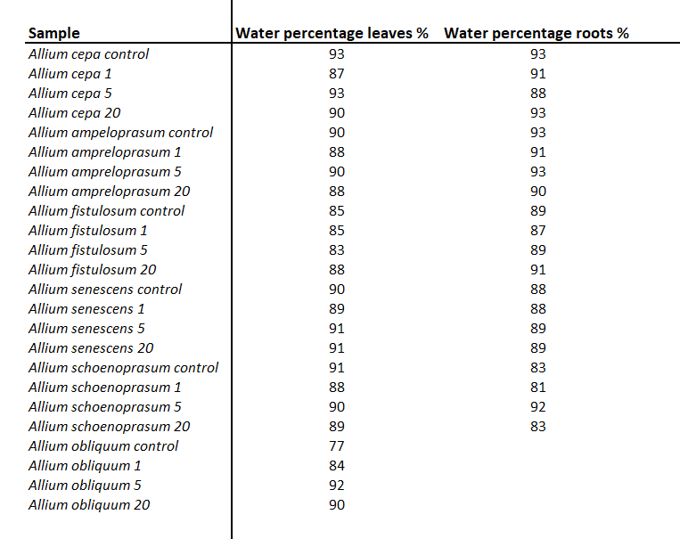

Appendix III
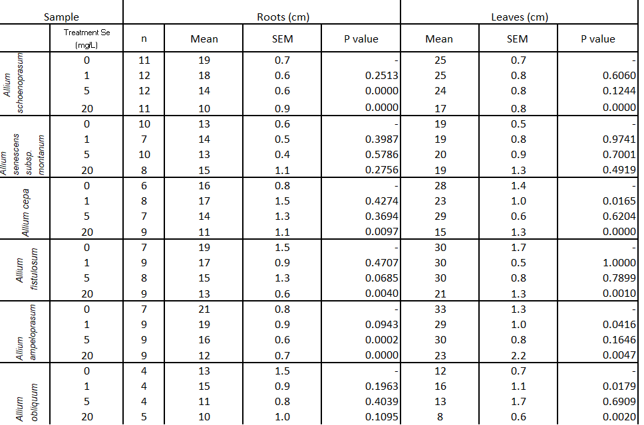
Table 1. Results on length of the roots and leaves of the analyzed sample; SEM- standard error mean; p-Value calculated using the T test
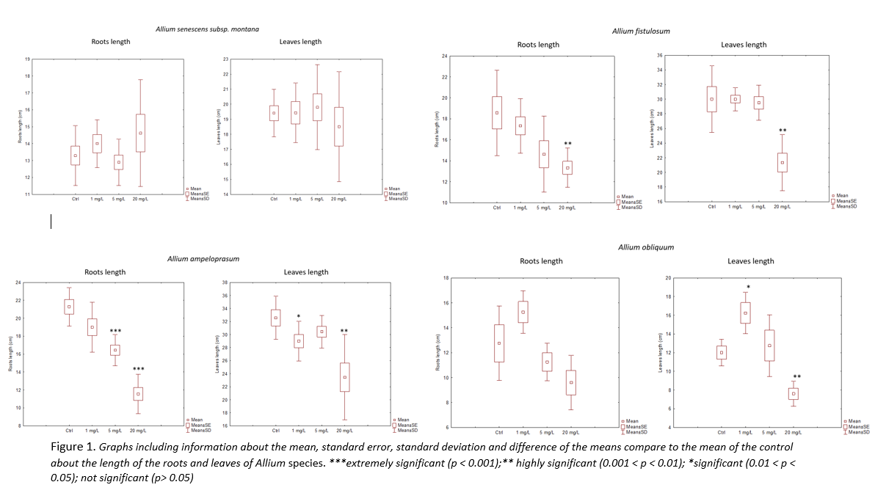

Appendix IV

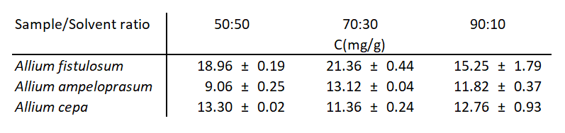
Table 1. Results from total phenolic determination from extracts with different ratios methanol: water. (n=2)

Appendix V

Table 1. Coefficient of determination (R²) and slope for each polyphenol contained in the calibration range standards. (n=6)
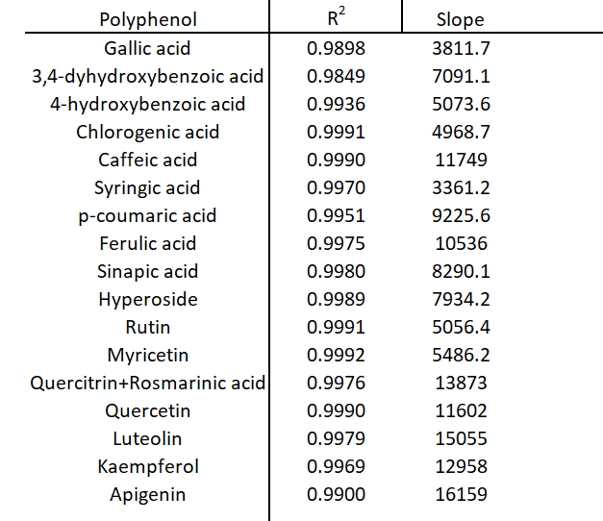

Table 2. Limit of detection (LOD) and Limit of quantitation (LOQ) expressed in mg/mL for the chromatographic analysis of polyphenols.
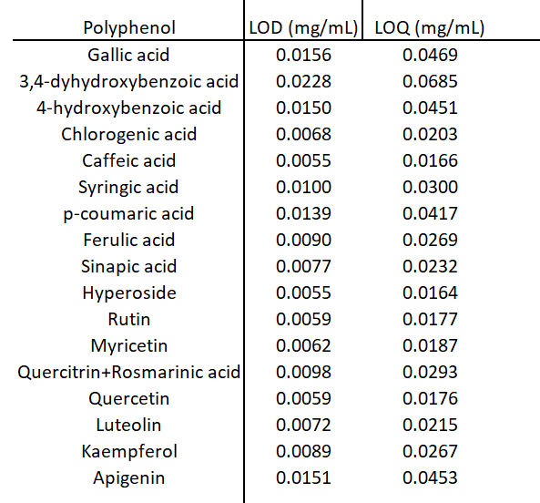

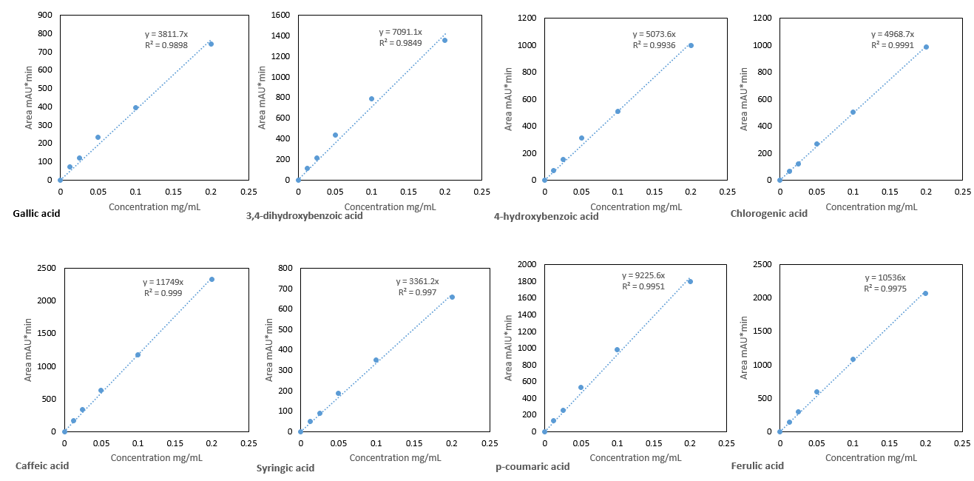
Appendix VI
Figure 1. Calibration curve of polyphenols, using the standard range 0.0125-0.2 mg/mL. Analysis done on a Thermo Scientific Accela LC Systems, Thermo hypersil gold column coupled to a DAD detector. Chromatographic conditions; oven temperature 30°, mobile phase A – aqueous solution with 0.1% TFA and mobile phase B methanol, flow rate 450 µL/min and injection volume 2 µL.
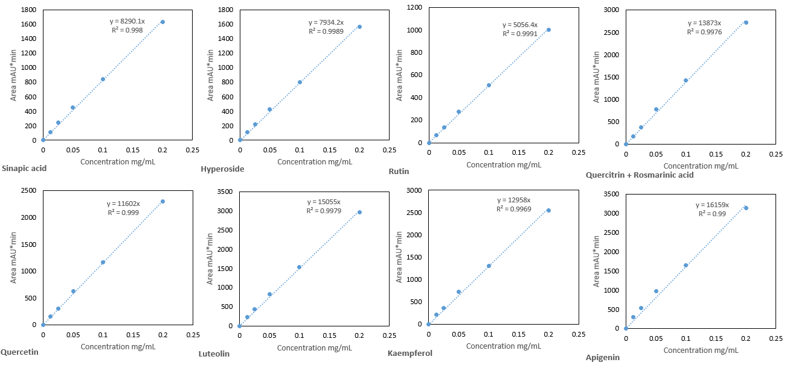
Figure 2. Calibration curve of polyphenols, using the standard range 0.0125-0.2 mg/mL. Analysis done on a Thermo Scientific Accela LC Systems, Thermo hypersil gold column coupled to a DAD detector. Chromatographic conditions; oven temperature 30°, mobile phase A – aqueous solution with 1% TFA and mobile phase B methanol, flow rate 450 µL/min and injection volume 2 µL.

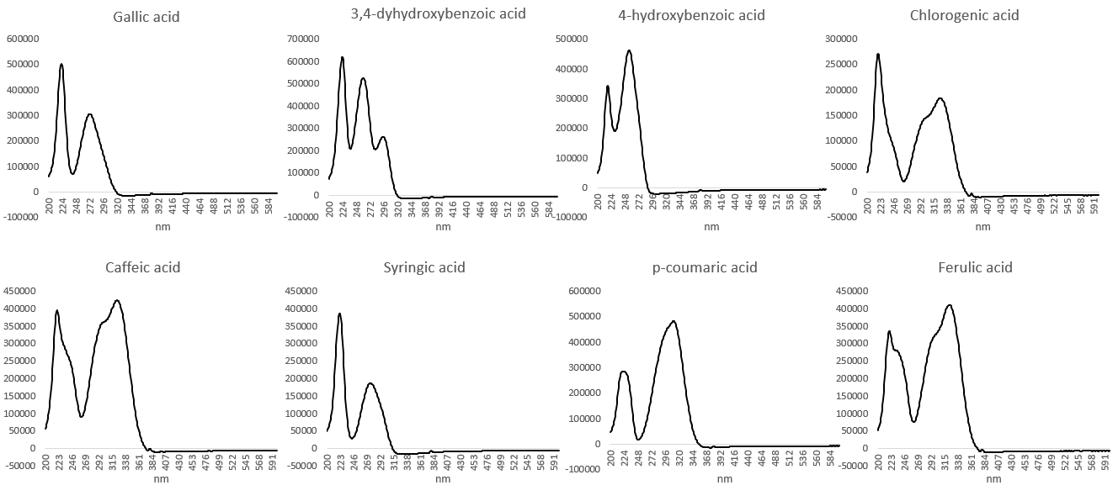
Appendix VII
Figure 1. Measured UV/VIS spectra of phenolic compounds. Analysis done by a diode array detector.

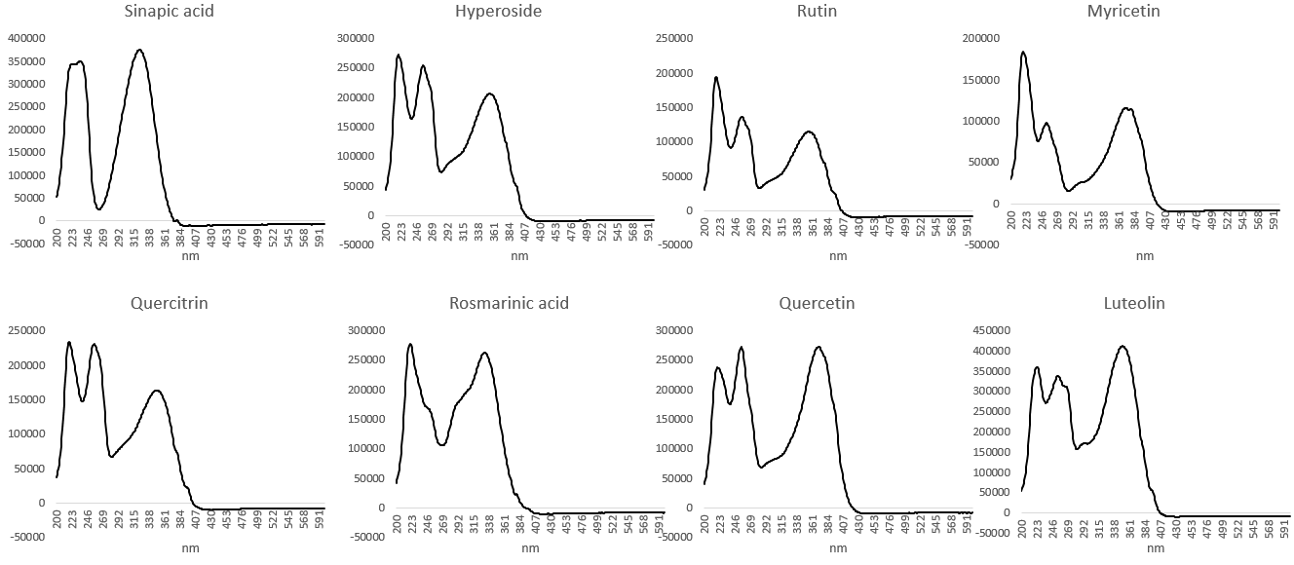

Figure 2. Measured UV/VIS spectra of phenolic compounds. Analysis done by a diode array detector.

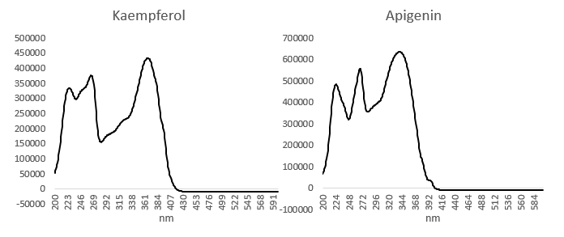
Figure 3. Measured UV/VIS spectra of phenolic compounds. Analysis done by a diode array detector.

Appendix VIII

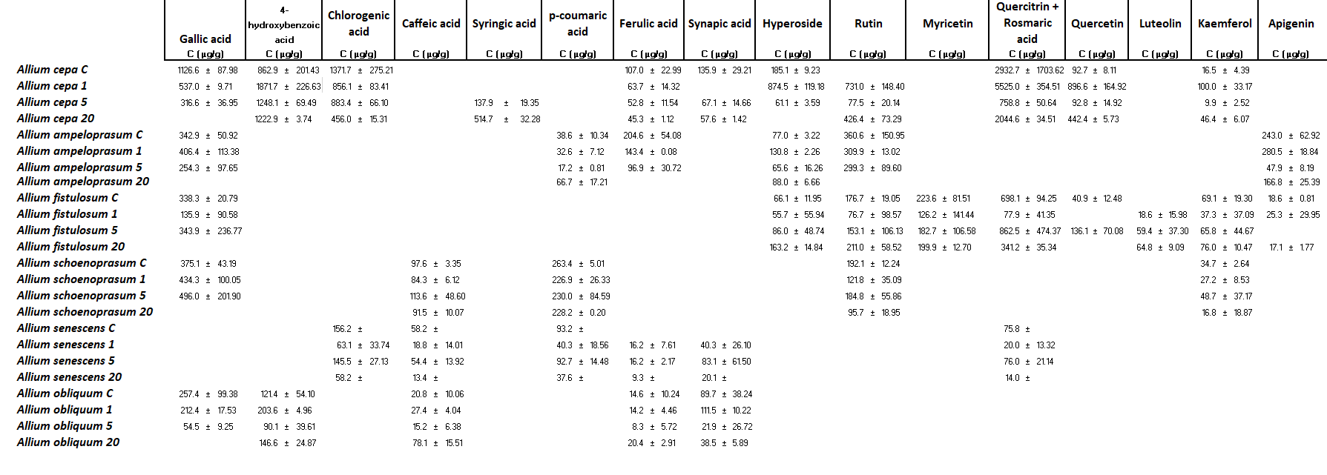
Table 1. Overview of the polyphenol composition of the analyzed species of Allium, presented in µg/g of dry sample and the standard deviation, result are calculated based on duplicate measurements. C- Control sample; 1 – 1 mg/L selenium solution added; 5 - 5 mg/L selenium solution added; 20 – 20 mg/L selenium solution added. Analysis done on duplicate independent extractions.

