

|  |
| --- |
| Increasing the profitability of Tempo-Team using international best practices in sales |
| A research dedicated to advice how the Tempo-Team, in Bergen op Zoom, can increase their revenue and profit margins. |

Author: Sjors Verbaan

Guidance consultant educational institution: S. Bakker

Guidance consultant educational institution: F. Peeters

Student Code: 0066178

Study Program: International Business and Management Studies

Graduation Section: Sales and Human Resource Management

External Organization: Tempo-Team

|  |
| --- |
| Increasing the profitability of Tempo-Team using international best practices in sales |
| A research dedicated to advice how the Tempo-Team, in Bergen op Zoom, can increase their revenue and profit margins. |

Colophon

Title: Increasing the profitability of Tempo-Team using international best practices in sales

Name Author: Sjors Verbaan

Student Code: 0066178

Study Program: International Business and Management Studies

Educational Institution: HZ University of Applied Sciences

Address: Edisonweg 4, 4382 NW

Location: Vlissingen

Guidance Consultant Educational Institution: S. Bakker

Commissioned by: Tempo-Team

Guidance consultant in-company: E. de Putter

Submission Date: 06-01-2019

Copyright 2018, University of Applied Sciences Vlissingen

Sjors Verbaan



Abstract

During the economic upturn after the housing collapse in 2018, recruitment agencies have seen their revenues increase. Companies are looking for suitable candidates to fill their staff vacancies, giving recruitment agencies the opportunity to do so with their service. However, Tempo-Team’s office in Bergen op Zoom is not following the same trend. Therefore, the management team has requested the researcher to analyze how Tempo-Team Bergen op Zoom can increase their revenue and profit margins gained from temporary and permanent recruitment, regarding external best practices in sales.

The researcher used a combination of research methods; Interviews, observational techniques, desk research and quantitative data collection of financial figures and sales activities, to find a solution for their business problem. By interviewing the recruiters of the Bergen op Zoom office and observing them during their work, their recruitment process was mapped. From here onwards, the business development section was further investigated. How can the recruiters effectively, increase their results through their sales activities and focusing on the most viable service they offer? Furthermore, the revenue streams from their clients gave an insight into which clients are most profile and which clients should be made more profitable.

The results show that the office in Bergen op Zoom can positively increase their results by increasing their core sales activities towards their clients. However, when comparing the sales and financial figures, over the number of full-time employees, the results show that they are working at a higher efficiency then the other Tempo-Team offices. Adding a full-time employee should increase their results and give room for applying focus on the most profitable targets and service. Additionally, training should be offered to the recruiters on time management, planning and how to sell permanent placements to clients.

Contents

1. Introduction 1

1.1 Terms of Reference 1

1.2 Purpose 1

1.3 Scope 1

1.4 Procedure 1

1.5 About Tempo-Team 2

1.6 Problem Statement 2

1.7 Problem Analysis 3

1.8 Research Aim 4

1.9 Research Question 4

1.10 Reading Guide 5

2. Theoretical Framework 6

2.1 Recruitment 6

2.1.1 What is recruitment? 6

2.1.2 What is Selection? 6

2.1.3 Recruitment Strategies 6

2.1.4 External Recruitment 7

2.1.5 Advantages / Disadvantages of using recruitment Agencies 7

2.1.6 Cost of External Recruitment 8

2.1.7 Difference between temporary and permanent recruitment 9

2.2 Sales 9

2.2.1 Activity based selling 9

2.2.2 Using ratios to manage sales activities 10

2.2.2 Sales funnel translated towards recruitment 10

2.2.3 Making your client portfolio profitable 11

2.2.4 Planning 12

3. Methods 14

3.1 Research Design 14

3.2 Interview 14

3.2.1 Data Collection 14

3.2.2 Data Analysis 15

3.2.3 Research Units 15

3.2.4 Operationalization 15

3.2.5 Reliability and Validity 15

3.3 Observation 15

3.3.1 Data Collection 16

3.3.2 Data Analysis 16

3.3.3 Research Units 16

3.3.4 Operationalization 16

3.3.5 Reliability and Validity 16

3.4 Finance Figures and Sales Activities 16

3.4.1 Data Collection 16

3.4.2 Data Analysis 17

3.4.3 Research Units 17

3.4.4 Operationalization 17

3.4.5 Reliability and Validity 17

4. Results 18

4.1 Recruitment process through observation 18

4.2 Interview 18

4.2.1 Permanent recruitment 19

4.2.2 Temporary recruitment 19

4.2.3 Sales activities 19

4.2.4 Business development 20

4.3 Finance 21

4.3.1 Finance Data Bergen op Zoom 21

4.3.2 Finance Data Roosendaal and Zevenbergen 23

4.3.3 Permanent Recruitment 23

4.3.4 Nominal Profit 25

4.4 Sales Activities 26

4.4.1 Sales activities value 27

4.4.7 Additional Employee 28

4.5 Client Data 28

4.6 Key Findings 31

5. Discussion 32

5.1 Business Process 32

5.2 Permanent recruitment 32

5.3 Sales Activities 33

5.4 Limitations 33

6. Conclusion 35

7. Recommendations 37

Bibliography 39

Appendix 41

1. Recruitment Process 41

2. Interview Script 42

3. Finance Results Bergen op Zoom 51

4. Finance Results Roosendaal 53

5. Finance Results Zevenbergen 57

6. Sales Activities 60

7. Bergen op Zoom’s clients 64

8. Final Data Sheet – Pivot Table 68

9. Jack Welch’s Vitality Ranking 75

**Chapter 1**

Welcome to the first chapter of this thesis. Chapter 1 will cover the reasoning behind the research and deliver a short company background.

# 1. Introduction

## 1.1 Terms of Reference

For the completion of the International Business and Management Studies program at the HZ University of Applied Sciences, students are required to follow an internship during the last phase of their diploma year. In parallel to their internship, the student is required to conduct a research project at the same company. The research report should aim at delivering a solution to an existing problem. The research process, including the purpose, research methodology, results and recommendations are included in this report. Following the policy of the university, the student must deliver it to the supervising professor whom will henceforth give their assessment. When the feedback is deemed positive, the student will be given an opportunity to defend their report.

During the period of the 1st of February 2017 and 1st of January 2018 the student interned at Tempo-Team, a Randstad Holding company, situated in Bergen op Zoom. Within this time frame, the student completed an investigation on how to increase Tempo-Team Bergen op Zoom’s revenue and profit margins regarding recruitment best practices.

## 1.2 Purpose

The employer of the student is Tempo-Team, which is part of the 2nd largest recruitment firm in The Netherlands. The company’s livelihood is to service the business industry with capable employees in exchange for payment. For Tempo-Team to remain viable within the Randstad Holding, which they are part of, their costs need to decrease, and their revenue & profit margins need to increase.

The research report will deliver an analysis and recommendations which will inform the company, Tempo-Team Bergen op Zoom, where the underlining issues are in their work process and stipulate which changes can be implemented to increase their revenue & profit margins. Tempo-Team will receive a recommendation, in form of this research paper, followed by a presentation in front of the management team. The recommendations will be based on a theoretical framework, data collected, and the analysis conducted. This will be presented in the following chapters.

## 1.3 Scope

The report investigates the clients and employees of Tempo-Team which are in the South-West of The Netherlands. The offices of Tempo-Team that will be consulted are in; Bergen op Zoom, Zevenbergen, and Roosendaal.

Furthermore, the report will focus specifically on increasing the revenue & profit margins for the Bergen op Zoom office. The report will not consider how the company should decrease their costs. However, the findings of the report will be applicable to all domestic and international offices of The Randstad Holding which follow the same work process.

## 1.4 Procedure

The report was formulated and written, following the requirements noted by the HZ University of Applied Sciences. The student utilized the books; ‘Doing in company research’ and ‘Research Methods for Business students’, written by Mrs. Arianda Bont and Mr. Mark Saunders respectively. During the internship and research period the student handed in a research proposal consisting of; the problem definition, theoretical framework, methodology and the questions which were then researched. After the initial proposal was approved, the student conducted his research included in this document. Both qualitative and quantitative research methods were used during this thesis.

## 1.5 About Tempo-Team

Tempo-Team is a business service provider that offers a full Human Resource service to clients. The services include regular temporary staffing and permanent placements of candidates. Additionally, the company offers a unique Inhouse Services concept and provide many other HR solutions, such as Recruitment Process Outsourcing (RPO), Managed Services Programs (MSP), payroll services, and outplacement (Randstad, 2016).

In 1932, the company originally launched its service under the name Mutator B.V. and changed it to Tempo-Team in 1969. Mr. Marinus Spruijtenburg, who was the owner of a marketing agency, founded the company. The agency sold bundle of address information. The database he had collected over the years formed the foundation of his next investment, namely Tempo-Team. Through this database he was able to approach potential candidates and clients, connecting the two together.

In 1984, Tempo-Team was acquired by de Randstad Holding. The Randstad Holding consists of three recruitment firms and each with their own unique label. Namely; Randstad, Tempo-Team and Yacht. Randstad and Tempo-Team are positioned parallel to each other on the market. Both companies cater to the same population and client segments and act as competitors on the market. Yacht services everything above that segment. The Randstad Holding has on average 37.930 employees on contract and daily 688.800 are being dispatched to work for them. Worldwide the Randstad Holding has 4.858 offices of which 250 offices belong to Tempo-Team in The Netherlands, Belgium and Germany. From here the Tempo-Team employees manage all related tasks to enable 28.000 flex workers to work and generated revenue. The revenue for the Randstad Holding in 2017 was a staggering 3.3 Billion euros from which 10% came from Tempo-Team.

The market Tempo-Team services is comprised of all forms of companies ranging in size. All companies are potential clients for Tempo-Team. The manner of which flex- or permanent workers work at the clients depend on the situation and needs of the company/client. The different options the client has are listed in the follow section of the report.

Company Services

Tempo-Team services the industry by means of:

* Pay-Rolling and dispatching: candidates that are placed are dispatched to companies. The candidates will be contracted by Tempo-Team and put on their own payroll. The client has the option to take over the candidate free of charge after a pre-determined number of hours of work delivered.
* Recruitment & Selection: searching and selection of professionals for long term contracts. The placed candidate will be contracted by the client directly.
* Inhouse Services: Tempo-Team employees are located at the client. From here the Tempo-Team employees perform the recruitment and planning of flex- and permanent workers.
* Employability & Re-integration: candidates are coached and trained to re-enter the work force.
* Mobility: Aiding companies with restructuring their workforce
* Outsourcing: All HR tasks are taken over by Tempo-Team (payroll, pensions, etc.)

## 1.6 Problem Statement

The Dutch economy has steadily increased after the abrupt housing market collapse in 2008. Because of the economic growth, one can see an immediate impact on the employment rate (Seyfried, 2017). In the past three months, the unemployment rate has dropped to 5.1%, and 14 thousand people have found new work (CBS, 2017). In the last four months, the amount of job vacancies has increased by 13 thousand (CBS, 2017) and will show a sustainable increase in the coming quarter.

During this economic upturn, the recruitment agencies have seen their revenues increase consequently. As companies are looking for new candidates to fill their positions, there is an increased likelihood that they will look for external recruitment services when internal hiring processes or own recruitment services fail. When comparing the turnover gained by recruitment agencies in The Netherlands of 2015 and 2016 one can see an increase of 7.6 percent. The hours worked by flex workers increased by 6.9 percent, during the same period. The growth is also reflected in the revenue generate by Tempo-Team, country wide. As the population of unemployed decreases further, suitable candidates for jobs diminishes along with it. This will lead to vacancies taking longer to be filled (CBS, 2017).

When there is an opportunity to generate income in a business sector, new companies will enter the market and companies already in the market will have to protect their market share. Therefore, Tempo-Team has increased their revenue targets in The Netherlands on average by 5 %. For Tempo-Team Bergen op Zoom the revenue target has been increased from 1.4 million euros in 2016 to 1.6 million euros in 2017. Additionally, the profit margins should also increase from 16 % to 18.3 % of the gained revenue in 2017. Since they did not manage to attain their revenue target in 2017, it has been set at 1.5 million euros for 2018 and consequently, the profit margin must increase to 19 % of the revenue.

## 1.7 Problem Analysis

To analyze the problem which was described to the student by Tempo-Team, the 5H1W analysis method (Donk, 2014) will be used. The method allows the researcher to objectively dissect the given problem and seek out the true pressure points. As the name of the method hits, the problem will be tackled using six dimensions: what, who, when, why, where and how.

*What is the problem Tempo-Team is facing?*

The problem the managers are facing is that the Tempo-Team office in Bergen op Zoom is not hitting the desired targets, which are set at the beginning of the fiscal year. Tempo-Team must defend its market share against the continues attack of newcomers and existing recruitment agencies. The managers thus require each office to increase their revenue and profit margins each year to stay ahead of the market trend. The managers however, are unsure how to increase the profitability levels of the Bergen op Zoom office.

*Where is the problem?*

The problem can be found in multiple Tempo-Team offices in the Netherlands. However, the managers specifically want the researcher to investigate the profitability of their office in Bergen op Zoom. The office in Bergen op Zoom is part of the business unit comprised of two other offices. The other two offices are situated in Zevenbergen and Roosendaal. As the other two offices did reach their targets in the previous years, the managers expect Bergen op Zoom to be able to do the same.

*When did the problem occur?*

The problem started in 2016 when the target of 1.4 million euros revenue and 16 % profit margin was reached. The new target for 2017 was set at 1.6 million euros with a profit margin of 18.3 %. In 2017, the Bergen op Zoom office was not able to attain their sales target. From the very beginning of the year, the weekly targets, to reach the eventual year target, was not attained.

*Why is it a problem?*

Tempo-Team is a part of the Randstad Holding which is listed on the stock exchange. The holding thus expects their companies to increase their profitability each year to please stock holders. Additionally, yearly and week targets are forecasted ahead of time. To maintain / increase the stock price, it is vital for each business unit to deliver expected results. When the targets are not reached, the managers and recruiters will have underperformed professionally and personally risk not receiving a bonus at the end of the year. Hence the managers are geared and incentivized at making sure all offices are hitting the expected sales figures.

*Who is involved?*

There are several parties involved in relation to the problem, directly and indirectly. The recruiters and manager working at the Bergen op Zoom officer are directly involved. Indirectly, the stakeholders of the Randstad holding are affected. Additionally, the recruiters working in Zevenbergen and Roosendaal are also affected. The recruiters working in the business unit comprised of Zevenbergen, Roosendaal and Bergen op Zoom will receive a groups bonus when the all three offices manage to attain their respective targets. The recruiters in Bergen op Zoom are directly affected and are also in the position to work on fixing the problem. However, the manager should guide them as to how this can be done. Since the manager is unsure as to how to fix the problem, the researcher will give recommendations.

*How has the problem occurred?*

How the problem has occurred is unknown to the recruiters. They suspect the new targets are set to high and are unrealistic. The managers on the other hand, believes the target can be reached and that the recruiters are underperforming in their sales efforts. According to the manager, the recruiters are lacking behind in their sales activities and are not focusing on the most profitable business opportunities.

## 1.8 Research Aim

The aim of the research is to come up with practical solutions that Tempo-Team can implement on a short-term basis; can be implemented within 1 month, quickly completed processes and with long-term positive outcome. These solutions should increase their revenue and profit margins for the Bergen op Zoom office.

## 1.9 Research Question

To understand how Tempo-Team Bergen op Zoom can increase their revenue and profit margins, the following research questions has been formulated.

How can Tempo-Team Bergen op Zoom increase their revenue and profit margins gained from temporary and permanent recruitment, regarding external best practices in sales?

The research aimed at increasing the revenue and profit margins by addressing best practices in sales and analyzing which recruitment service(s) they should focus on to achieve the desired results. Additionally, an analysis is created to determine which clients offer the most profitable sales opportunities.

To answer the main research question, sub-questions are formulated. By answering the sub-questions, the main research question will be consequently easier to answer. After the sub-questions have been posed, an explanation why the sub-questions are formulated is given.

**Sub-questions:**

1. How does the Tempo-Team’s business process look like?
2. What are the best practices in sales, which are applicable to the business process used by Tempo-Team?
3. What are the (more) profitable Tempo-Team office’s doing differently in terms of sales activities and service offering?
4. Which clients offer the most profitable sales opportunities?
5. How can less profitable clients be made more profitable?

**Sub-question A:** *How does the Tempo-Team’s business process look like?*

By understanding the business process, the researcher can pinpoint where in the process sales opportunities can be created. By being able to create more business opportunities, the recruiters could generate more sales to achieve their targets. By means of observation the process was mapped by the researcher. As the recruitment cycle is generally universal, recommendations can be implemented throughout the Randstad Holding, domestically and internationally.

**Sub-question B:** *What are the best practices in sales, which are applicable to the business process bused by Tempo-Team?*

Since the recruitment process is two-fold, recruiting of suitable candidates and applying sales towards clients, the best practices in sales should be investigated. Which best practices in sales can be beneficial for recruitment agencies.

**Sub-question C:** *What are the (more) profitable Tempo-Team office’s doing differently in terms of sales activities and service offering?*

The other two offices from the same business unit can reach their targets. Therefor the researcher wants to know what they are doing differently in term of sales. Which activities are they undertaking and which recruitment services do they offer? Through desk research the data is collected weekly.

**Sub-question D:** *Which clients offer the most profitable sales opportunities?*

The office in Bergen op Zoom wants to increase their revenue and profit margins. The previous questions have looked at the processes and sales towards clients but does not give an understanding as to which clients could generate more income. Are there clients which could be made more profitable or are there clients that are currently not attractive to offer services too?

**Sub-question E:** *How can less profitable clients be made more profitable?*

Clients which are less profitable can either be cut-loose or re-negotiated with. By altering their profitability status, the Tempo-Team recruiters could increase their revenue and profit margins accordingly.

## 1.10 Reading Guide

Chapter one introduced the purpose of the research and gave insight into Tempo-Team as a company. Furthermore, the business problem was introduced and analyzed. The analyses highlighted where the problems lay which will be researched in the thesis. This will be done by answering a set of sub-questions which will aid in aid in answering the main research question.

The proceeding chapter will present the Theoretical framework, also known as the literature review. It gives the reader in an understanding of the main concepts related to the recruitment industry and the posed research questions. The concepts will be used to investigate the results and combined in for of a discussion.

**Chapter 2**

# 2. Theoretical Framework

The following chapter will consist of a desk research needed for the further development of the research. By means of consulting previous studies, scientific papers, and other sources (sector magazines) the researcher could outline the key topics needed to conduct the research. The theoretical framework has been divided into two segments: Recruitment and Sales. The segment concerning recruitment outlines what recruitment is, why companies use recruitment agencies and the difference between recruitment forms. The second segment outlines best practices in sales which are applicable to recruitment agencies.

## 2.1 Recruitment

### 2.1.1 What is recruitment?

Recruitment is the process of seeking potential candidates and creating a willingness to submit their curriculum-vitae towards a job vacancy (Pattanayak, 2005). It is the initial step towards a short or long-term commitment between clients and employees. Ideally the recruiter can find multiple candidates to select the most suitable one. Therefore, (Stone, 2005) defines it as seeking and attracting a pool of applicants from which qualified candidates for job vacancies within an organization can be selected. The two definitions are missing one important aspect of creating awareness of the job vacancy which exists. A complete description of recruitment was formulated by (Compton R. M., 2002), that states that it is the purpose to attract suitable people to apply for employment vacancies by making them aware that such vacancies exist. Therefore, for there to be a recruitment need there must first be an existence of a job vacancy. There are several reasons why such vacancy can exist. Namely, an employee has left the organization, a specialist is required, the volume of work has increased, or the company is undergoing a restructuring of an area of the business (Epps, 1998).

### 2.1.2 What is Selection?

Where recruitment is making candidates aware of a job opportunity, selection is the process of conducting interviews, checking references, and matching candidates to the position requirements (Worthington, 1992). By applying these selection steps, one can make a judgment if the candidate is suitable for a function. This should be done in relation to the job description, company culture and personality of the candidate (Bowen, 1991). Not only must one consider the wishes of the organization but also that of the candidate. Interviews with the candidates will highlight these aspects and checking references will provide an insight into how others view the candidate. This process is known as screening. From here, a selection out of suitable candidates is made, presented to the hiring party and a candidate can be offered a position but the hiring party. When both parties match in terms of demands, or when one or two parties make a concession a fit may be created.

### 2.1.3 Recruitment Strategies

When a company is looking to fill a job-vacancy they can do this through internal recruitment and / or external recruitment strategies. Because the research focuses on external recruitment, more emphasis will be on external recruitment strategies.

Normally, the term internal recruitment is the action of when an organization wants to fulfill job vacancies out of current employees within the company. External recruitment is when the company seeks outside their own organization. In most cases this is the case since the skills needed for a vacancy cannot be found within the organization (Cook, 1998, pp. 29-30). For sake of clarity from this point forward, external recruitment will mean the use of recruitment agencies by the client to fill a job-vacancy at their organization.

### 2.1.4 External Recruitment

In some cases, an organization is not able to fulfill the requirements needed for the filling of employee functions, coaching of employees or being able to give suitable trainings. In terms of recruitment this can be the case of the organization not having the capacity for recruitment or not being able to find the right candidate which is demanded. Several factors such as efficiency, speed and costs should be considered by the company. For the success of an organization, acquiring and retaining talent is critical. In the current market environment suitable candidates are becoming a scares commodity. Poor recruitment decisions can have a long-term negative effect, in terms of costs; high training costs, development costs, reduction in turn over and in turn moral of the organization’s workforce (Richardson, 2017). These factors which will be highlighted in the following sub-sections and can explain why companies employ a recruitment agency.

A recruitment agency is specialized in selection and recruitment of employees. Through years of experience and gathering of candidate data they can service the business with a professional approach. For an agency to have a higher success percentage in terms of finding suitable candidates for the client, the client needs to have a good understanding of the employer’s selection criteria and competencies. The client must provide a clear job-description, verbally or on paper, to the recruiter (Compton R. , 2009). The recruiter will proceed, in most cases, to advertise the job vacancy, search candidates, interview them, and provide clients with a short list of suitable matches. From this point, the client will either reject or accept the candidates. The reason for the rejection will be communicated to the recruiter and the recruiter will communicate this back to the candidate. In the case of the candidate being accepted, a job interview will be planned with the client’s decision makers in terms of remuneration and employment contract details.

### 2.1.5 Advantages / Disadvantages of using recruitment Agencies

Utilizing recruitment agencies can have negative and / or positive associations. This can be in terms of service and / or costs. In short, several advantages of employing an external recruitment agency are; hiring qualified personnel search the market whom have the knowledge which is needed, wide reach of candidates in the labor market, talented candidates available through their database or headhunting activities, shorter selection process, less objectivity, and have the time to only focus on recruitment activities (Svedaite, 2013). Additionally, the client “understands that temporary employment is an opportunity to employ people without serious long-term commitment that a long-term employment contact provides (in terms of benefits)” (Cadena, 2007).

One of the two main reasons for using a recruitment agency is time / resources availability. As the process of recruitment and screening can be drawn-out, most organizations, particularly small medium enterprises, will not have the capacity and capability for this. Especially, when it comes to the initial stages of sorting out the candidates. However, the number of applicants depend on the job vacancy and the state of the job market. Recruitment agencies will do the work for you and select the most suitable candidates, assuming they do their job right. Time can then be spent on retaining employees rather than attracting them, as this “can be a good cost-saving method, when the costs involved in leaving a position vacant for a lengthy period and the potential for reduced internal inefficiencies” (J. Hor, 2008). Additionally, in fluctuating market conditions employers might opt for more flexible workforce that can be let go at lower costs versus lengthy contract hires.

Recruitment agencies have a reach that most organizations do not have. This can be in terms of their website, database or even the connections of the recruiter. Candidates will not look through individual sites of each organization and might not have heard of the company. By using the website and promotional sites of the recruitment agency, they can spread the vacancy further. Additionally, they already know allot of the candidates whom they can pitch the organization/vacancy too.

Before a candidate is at an interview with the client, they have gone through the different levels of the hiring process. This includes the pre-interviews, screening, and reference checks. The order (from the client organization to the recruiter) may vary depending on the candidate and the job function which he/she is looking for. A recruitment agency can take care of this process. This way a company will not have to worry about gaining references from former employers or check their qualifications. This way the client will only have to interview the candidate at the final stages. Moreover, the candidate sitting at the table across from the client will most likely be the best candidate available at that time. Of course, the quality of the candidate will depend on the work of the recruiter and market penetration of the recruiter company.

When a successful placement has been made at an organization, the organization will be confident that the recruiter has an understanding what the company requires. This can be in terms of quality, personality, culture fit etc. In an ideal setting, that recruitment agency will be able to service the organization with all the levels of functions. Giving the client a full package and building a long-lasting relationship. The recruiter will then know immediately after speaking to a candidate if the client could benefit from hiring him / her. However, specialisms at a recruiter can mean a limitation of services; i.e. lower qualified work, specialisms or executive qualification require different approaches. Therefore, ideally, one recruiter could service an organization but in practice multiple recruiters could be contracted.

Disadvantages could be the dissatisfaction among existing staff, long process of finding a suitable candidate, expensive, the recruiter not understanding the wishes or culture of the client and bad communication (Svedaite, 2013).

When using an external recruitment agency, one must understand that the recruiter does not know the organization from the start. They gain this understanding through meetings with the organization. Since the initial understanding may be low, it could show in the candidates delivered. The candidate may fit the hard skills but does not fit in the culture. Through multiple contact points with the client this understanding will grow, and the chances of a candidate fitting will presumable do so too.

One of the main negative associations, are the high costs which come along with external recruitment. In the next section, we will look at the costs of using ‘recruitment and selection’ through an external recruitment source such as a recruitment agency.

### 2.1.6 Cost of External Recruitment

High cost is often associated with utilizing a recruitment agency (Bambach, 2010). The costs of ‘recruitment and selection’ can lead to a high short-term direct cost, but relatively low in the long run. This being because less direct costs are made in the recruitment procedure. Indirect costs involve employees spending time to source and interview candidates, travel, making of the advertisement, selecting of suitable candidates, and interviews which take place (Monster, 2017). Additionally, the working hours spent on the recruitment process by the employees could be spent on other activities. On average the “recruitment costs of filling a vacancy, using internal or external recruitment methods is reckoned to be around 5,500. - euros. This does not yet include the costs of loss in efficiency. This why the costs effectiveness should be established and monitored by companies.

Most recruiters are left with room for giving a competitive price to the client. However, on average, in terms of permanent placements, the costs are 25% of the annual salary of the candidate hired. On top, 8% of their vacation benefit is added. This will depend on the labor law of the country the recruiter is recruiting for. Typically, “agencies take a proportion of first year salary (typically between 20 to 30 percent) from clients for candidates they provide” (D. Cooper, 2003). The height of the costs will therefore depend on the annual salary of the candidate. Additionally, the sales intermediary will analyses how high the chances are of future business with the organization or how scares the candidate is.

Depending on the organization, the costs of advertisement will be included, and a guarantee of 1-3 months is too. The guarantee means that if a candidate is hired by the client through an agency, they can receive a full reimburse or replacement candidate if they are let go within that time-frame. There must however, be a justified reasoning why the candidate is let go or leaves on own demand.

### 2.1.7 Difference between temporary and permanent recruitment

Two main forms of recruitment are temporary and permanent recruitment. Temporary recruitment is seen when a job agency dispatches a suitable candidate to work for a company. Their salary will be paid by the recruitment agency, and they in turn will bill the company for their services. The fee for a temporary worker is made up of their basic salary plus a mark-up percentage on top. If the company decides to contract that same job-seeker directly, they will have to pay the recruitment agency a percentage of the otherwise gained revenue. On the other end of the spectrum, a company can contract a job-seeker straight from a recruitment agency. This is called a permanent placement. The company will pay a percentage of the job-seekers annual wage.

## 2.2 Sales

A recruiter has job function which is two-fold. They must be able to be able to assess people for the available job vacancies but also gain these to work on from clients. Hence sales play a vital role in their day to day work. The following portion of the theoretical framework will investigate which best practices in sales are applicable for recruiters. Specifically, best practices which can make them more profitable in terms of gaining business opportunities and revenue optimization.

### 2.2.1 Activity based selling

In companies with a sales environment performance is often management based on KPI’s and sales metrics. By steering the sales representatives on their KPI’s, a manager can influence results. Performance management is “the continuous process of improving performance by setting individual and team goals which are aligned to the strategic goals of the organization, planning performance to achieve the goals” (Lee, 2005). According to the Harvard Business review, managers are unable to manage sales by looking solely at revenue (Jordan, 2014). Revenue and margins should be seen as business results, which should be used to check if a company or business unit is healthy. Instead of looking at the result, modern sales leaders want to know what is “happening within the sales organization that will lead to closing more business, so they can course correct ahead of time to keep sales on track” (Marsh, 2016). To do this one must determine and understand which sales metrics can be managed. Manageable metrics are sales activities which are undertaken to gain revenue. To be able to manage the sales activities they are required to be tracked to impact revenue (Marsh, 2016).

Sales activities have a direct cause-and-effect correlation with business results. When influencing the amount or quality of sales activities you can influence revenue and make predicative forecasts as to how many sales activities are required reach a certain target. To put this theory in perspective, if a sales department has revenue sales target of 1 million euro’s and the average deal size is worth 10,000 euros. Then they will require 100 deals to reach the target. However, to reach 100 deals, sales representatives put in sales activities. Per each sales activity stage an estimation can be created as to how many activities are needed. By using the activity-based selling management tool, a manager can forecast and adjust the controllable actions when needed.

To summarize the theory, if the managers can coach their sales representatives, for instance, to commit to making more calls, then more clients can be acquired. More sales will follow, when more customers are in the sales representative’s portfolio. Furthermore, if the sales representatives increase their quality of sales activities, they will have a higher chance of retaining and growing its clientele. By growing your clients and retaining them, revenue should increase (Jordan, 2014).

### 2.2.2 Using ratios to manage sales activities

The sales actions undertaken to close a deal can be quantified into a conversion ratio. A conversion ratio tells one how many actions are needed to generate an outcome. When taking the previous steps into consideration, a conversion ratio will show us how many calls to clients are needed for the recruiter to be able to present a candidate, schedule a meeting, or receive a job vacancy to work on. This will allow the recruiter to constantly measure their success per phase and calculate how many of each sales activity is required to gain a conversion. One must however consider that as you become more / less efficient, your rations change. Constant analysis of your sales activities is thus advised.

Once you have defined what conversions you want to track, you can calculate the conversion rate (Dick, 2018).

*The conversion rate = Total Number of Sales /Number of Leads * 100*

*Or*

*The conversion rate = Total number of sales activities / numbers of job vacancies * 100*

When knowing the conversion rate, one is additionally able to calculate the value per lead (job vacancy). By dividing the total recruitment revenue over the amount of job vacancies one gets insight into how much potential value each lead may hold. However, we know that not every lead will end in a sale. For the sake of directed focus, this research did not consider the closing of the sales. With the value of each job vacancy in mind the researcher can calculate how many sales activities are required to reach the required target.

### 2.2.2 Sales funnel translated towards recruitment

Sales can be defined as an action where “the seller or the provider of the goods or services completes a sale in response to an acquisition, appropriation, requisition or a direct interaction with the buyer at the point of sale” (wikipedia, 2018). Agency recruitment generates revenue by means of acquisition of job vacancies to fill with their candidates. They provide their services to take the recruitment process out of the hands of the client. To gain a job vacancy to work on, they conduct sales strategies towards the clients. The same strategies which are used in sales can thus be implemented. Specifically, strategies used to generate business, lead generation and maintaining relationships with clients.

A recruiter must be adept at selling his services and candidates to (potential) clients. Often this is done through multiple and short contact moments with them. The contact moments are often direct (cold) calls, presenting of candidates, and meetings. Eventually leading to a sales opportunity, they can close. In recruitment, a “close” be a match between a job seeker and job giver. To generate a match, sales people can use the sales funnel diagram to view their conversion ratios. “By using the sales funnel, and by quantifying the number of sales activities at each stage of the process, you can predict the number of sales activities you will require” (MindTools, 2018). Additionally, one can review the conversion ratios over time and adjust the weekly sales activity targets. A sales funnel is also known as a revenue funnel or sales process, which leads customers (clients) through their journey in buying a product.

In its simplest form, it will lead a buyer through the following phases (ringDNA, 2018):

* Awareness Phase: in which prospects become aware of the existence of a solution.
* Interest Phase – in which prospects demonstrate interest in a product by conducting product research.
* Evaluation Phase – in which prospects or prospect companies examine competitors’ solutions as they inch toward a final buying decision.
* Decision Phase – In which a final decision is reached, and negotiation begins.
* Purchase Phase – in which goods or services are purchased.

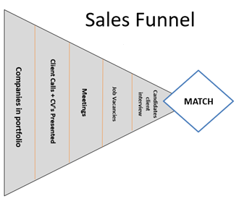

*Figure 1: Sales funnel journey* (Mcleod, 2018)*Figure 2: Sales funnel in recruitment (Sjors Verbaan)*

When translating this into the sales process recruiters often the following sales actions can be used per phase:

* Awareness Phase: cold calls to clients
* Interest Phase: Present candidates (CV’s) to clients
* Evaluation Phase: Client Meetings
* Decision Phase: Candidates are invited to interviews and contract negotiation begins
* Purchase Phase: Contract negotiated, and candidate is given job. Closing of leads

### 2.2.3 Making your client portfolio profitable

How to Make your client portfolio more profitable is a question recruiter constantly ask themselves. Are they spending the right amount of time and efforts on the correct client to achieve their targets? According to (Cokins, 2014), one needs to investigate each client separately. What are the service costs for each customer and how can they be reduced? Can the prices be increased, or can new products be offered? Furthermore, recruiters can increase activities that the customer shows a preference for.

A method which is being used in the recruitment industry is dividing your client base into three groups. Non-Performers, Average Performers, and Top Performers. The method comes from the Jack Welch Vitality Curve (Bhatia, 2016). A method used by General Electric to fire their bottom 15 % performing staff on a yearly basis (Quartz, 2015). When translating the theory into recruitment, the Average Performers are your backbone. They bring in the desired volume revenue and require minimal effort, just not as exciting to work with. The Top-Performers however, are the most profitable and recruiters enjoy working with them.

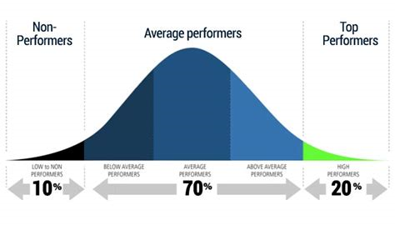

*Figure 3**: Jack Welch Vitality Curve (Bhatia, 2016)*

So how can recruiters categorize their client portfolio to fit he Vitality Curve? According to (The Recruitment Network, 2018), a list should be created with several criteria you value the most. For example:

* Brand association
* Profit margins
* Volume of revenue
* Ease to work with
* Level of exclusivity
* Payment terms

By scoring each client towards the criteria you create a value index score per client. Each criterion can be scored up to 10. 10 being the highest and 0 the lowest possible score.

Once the top 10 % is known, recruiters can consult each client to either renegotiate, adjust their service to them, or fire the customer. If the brand can be improved or the prices can be increased the score of the client will increase as well. Making them more profitable in the future. Furthermore, a recruiter can decide to spend less physical time servicing a less [profitable customer and spend more time on the Top Performers. In theory this should allow the top Perming customers to generate more revenue.

(The Recruitment Network, 2018) created the following list to follow to increase your client profitability.

* 0-34: The recruiter should fire the customer
* 35-55: The recruiter should justify why we want them as a customer
* 55-70: Recruiters should target these clients

### 2.2.4 Planning

For a salesperson to be successful, he needs to persuade his customer to buy his products. In the case of recruitment, he needs to sell his candidate and service to the client. To do so regularly a solid plan for each day and staying organized is required (Meyers, 2018). By doing so the salesperson can ensure he is on track with the required sales activities needed to reach their target. When organized and having a solid plan the salesperson can maximize his sales. There are several aspects which they can undertake to ensure this.

At the start of the day preplan what the goals are with your direct colleagues (Sales Career, 2012). The goals must be specific and ensure that revenue is gained each day. When doing so the salesperson can note down which activities are required for the goal. For example, 10 calls to clients or interview 10 candidates.

All the activities which the salesperson wants to undertake that day or week should be scheduled into their calendar. For example, when clients are called, when administrational tasks are completed, clients are interviewed, or clients are visited. According to (SalesRamp, 2018) early mornings should be used to follow up on calls. Calls should be done towards clients which you want to target. Followed up by an email with the same information. Early afternoons are said to be best for meetings, both internal and external. This will allow the salesperson for enough time to complete their sales calls daily. Any time which is left offer should be used to call clients, with the goal of arranging client meetings.

Salespeople can furthermore increase their time management and effectiveness further if they plan according to the geographical region of their clients. By booking meetings and calls of clients which are situated close to each other time is saved on commute time.

All the activities which have been planned should be noted down in a form of a checklist. When one has been completed, move on to the next. By completing tasks on the checklist, the salesperson feels motivated and has a sense of accomplishment. Additionally, seeing the tasks on your checklist can show when the salesperson is lagging and needs to increase their speed.

Preplanning is just as important as reflecting on the day and week. “At the end of the day, record your results and figure out the percentage of your sales goal you met” (Jordan, 2014). This will allow for salespeople to determine which areas they need assistance or improvement in. When the issues reoccur, it should be discussed with the manager and see where additional training could be beneficial.

**Chapter 3**

Chapter 3 will outline the method use to conduct the research. Each method will be described further in terms of data collection, data analysis, research units, operationalization and reliability & validity.

# 3. Methods

Three dimensions have been investigated. The recruiters were interviewed on their business process, sales activities and business development.

Henceforth the business unit’s financial data was tracked and analyzed. By tracking and analyzing the financial data, it could be used to compared with the sales activities of each office. Furthermore, the financial data gave an insight into which clients offer the most profitable business opportunities and which should be improved upon.

## 3.1 Research Design

The following outlines which method was used to answer each sub-question.

1. How does the Tempo-Team’s business process look like?
   1. Observational techniques and Interviews
   2. Followed by 1st hand work by the intern.
2. What are the best practices in sales, which are applicable to the business process used by Tempo-Team?
   1. Desk Research integrated into the Theoretical Framework chapter
   2. Analyzed in the results chapter
3. What are the (more) profitable Tempo-Team office’s doing differently in terms of sales activities and service offering?
   1. Collection of financial data by means desk research
   2. Collection of sales activities by means of desk research
   3. Analyzed in the results chapter and further discussed in the discussion chapter.
4. Which clients offer the most profitable sales opportunities?
   1. Collection of financial data by means of desk research
   2. Analyzed in the results chapter.
5. How can less profitable clients be made more profitable?
   1. Desk Research integrated into the Theoretical Framework chapter
   2. Analyzed in the results chapter

## 3.2 Interview

The researcher initially interviewed two recruiters of the Bergen op Zoom Tempo-Team office and one from the Dordrecht Tempo-Team office. Since the problem the manager is facing takes place in Bergen op Zoom, the researcher wants to find out how they operate. The researcher interviewed and discussed with the staff of Tempo-Team what the recruitment process looks like and where the growth opportunities are. Their opinion was asked concerning the differences forms of recruitment and how they sell this to their clients. Additionally, Tempo-Teams recruitment business model was further questioned

### 3.2.1 Data Collection

The interview was conducted by means of open questions and recorded by the interviewer (see appendix 1). The interview was in form of a semi-structured setup. Topics concerning the relevant topics were noted prior to the interview to ensure the discussion-maintained focus and stayed on subject. However, follow up questions were asked depending on the answers the recruiters gave. This provided the interviewee certain freedom and flexibility to lead the discussion onwards where more information could be gathered.

### 3.2.2 Data Analysis

After the interview, the researcher transferred the recordings into a script. This allows the researcher to code the script into four main topics.

- Permanent Recruitment (Client Contract)

- Temporary Recruitment (Tempo-Team Contract)

- Business development

- Sales activities

This will allow the researcher to formulate the key findings in the results chapter which could be used for the further analysis. An inductive approach has been used for the qualitative analysis. The data collected has been summarized into key points related to the research topics.

### 3.2.3 Research Units

The units which the researcher consulted for the interview were three recruiters of Tempo-Team. Two recruiters which work at the Bergen op Zoom office and one which works at the Tempo-Team office in Dordrecht.

* Niels Pelle: Senior Recruiter – Bergen op Zoom
* Falco van der Jagt: Recruiter – Bergen op Zoom
* Danny de Lange: Senior Recruiter – Dordrecht

### 3.2.4 Operationalization

The interview was used to give insight into Tempo-Team’s business process. Furthermore, give additional information concerning the different forms of recruitment service which Tempo-Team offers. By asking the recruiters opinion about the current business process and current issues, there answers can be used to help answer sub-question A, B, and C. The first research question can be partly answered in combination with the Observation method mentioned in the next sub-section.

### 3.2.5 Reliability and Validity

The reliability of the interview was not harbored in the sense that the researcher did not use a standard pre-written script. The researcher interviewed the recruiters by means of a topic list so that the discussion remained fluid and could slide into any direction, depending on the answers. However, by using a topic list the interview did remain on topic. Since three recruiters were conducted at once, the answers of the recruiters gave the other recruiters to add additional information of think about the topics. It allowed for different perspectives. Moreover, the interview script did not mention their names, so that the managers cannot see who said what. This ensured that the recruiters could speak more freely.

## 3.3 Observation

By joining the recruiters during their sales and recruitment activities, the researcher was able to map out the recruitment process which Tempo-Team uses. During this time the researcher got insights into the sales processes at Tempo-Team.

### 3.3.1 Data Collection

The recruitment activities involved recruiting of suitable candidates, interviews with the candidates, sending candidate proposals to clients, joining in on sales client sales meetings and internal meetings at Tempo-Team. The data was recorded per activity into a flow diagram.

### 3.3.2 Data Analysis

By creating a flow diagram of the activities which the recruiters undertake a clear picture was formed of the complete business process. Specifically, the sales and recruitment activities needed to generate income for Tempo-Team.

### 3.3.3 Research Units

The research units which were consulted for the creation of the flow diagram where the recruiters of the Bergen op Zoom office. Since the research question concerns how to increase the sales figures of the Bergen op Zoom office the researcher wants to know what they do to generate it. Additionally, the researcher joined the recruiters at client meetings, which gave an insight into the recruiter’s client portfolio.

### 3.3.4 Operationalization

The observational method used to map out Tempo-Team business process allows for the first research sub-question to be answered in full. Additionally, it will give the researcher an understanding of which best practices in sales can be applicable to the business process used by Tempo-Team, as mentioned in sub-question B.

### 3.3.5 Reliability and Validity

Since the whole range of sales and recruitment activities was observed and done by the researcher the reliability was harbored. If another researcher would observe the same activities the business process flow diagram would remain unchanged. The recruiters have the same training and follow a specific work methodology made inherent while working at Tempo-Team. However, each recruiter might do each task slightly differently, or lay more emphasis on a certain part of the business process. Since the researcher joined 5 different staff members, of the Bergen op Zoom office, the validity was addressed.

## 3.4 Finance Figures and Sales Activities

When analyzing the profitability of a company, the financial data must be known or collected. As the researcher opted to use the financial data of the same year he worked there, the data had to be collected. By collecting and reporting the weekly financial data, a reliable data set was created over a period of one year. Financial data on its own is a limited benchmark. By comparing the sales activities with the financial data, the researcher can find out what the profitable offices are doing differently

### 3.4.1 Data Collection

Every Tuesday, of a new week, the previous week’s financial data was collected in an excel sheet.

The data which was collected was:

* Revenue per office
* Recruitment & selection revenue per office
* Profit margin per office
* Nominal profit per office

Additionally, the revenue gained per client was compiled.

As Tempo-Team uses a CRM system, each recruiter must utilize the CRM system when he / she completes an action. The researcher was therefor able to collect the weekly results of each sales activities undertaken.

The data that the researcher collected was:

* The number of telephone calls with clients;
* Quantity of candidates presented to clients;
* Amount of client- meetings; and
* The number of job vacancies received

### 3.4.2 Data Analysis

By consistently compiling the financial data in one data file, the researcher could analyze the data at the end of the year. By comparing the ratios of calls per visits, visits per job vacancy obtained, the researcher could analyze how many calls to clients, presented candidates to clients and visits are required to gain a job vacancy placement. By plotting the sales activities and financial figures in pivot tables, the variables could be plotted against each other. Additionally, the revenue of the clients has been analyzed using the Jack Welch Vitality Curve as described in the theoretical framework.

### 3.4.3 Research Units

Three research units were used for the collection of the financial data and sales activities. The three Tempo-Team offices: Bergen op Zoom, Zevenbergen and Roosendaal. By addressing three offices, the results can be compared and analyzed.

### 3.4.4 Operationalization

The financial data was used to support the answers of sub-questions C and D. By collecting the financial data from the three different offices, the researcher could plot the results against the collected sales activities. Furthermore, the researcher could view which clients offer the most revenue and profit margins. Additionally, by understanding which clients are less profitable, sub-question F can be further investigated. A recommendation can be given as to what form of recruitment should receive more focus, and which sales activities are needed to reach their targets.

### 3.4.5 Reliability and Validity

Both the reliability and validity were addressed when collecting the financial data. The results were collected on a specific day of the week and three offices were consulted. Since the financial data is conciliated by the recruiters on Monday, the financial data was available on Tuesday. By recording all the data into an excel sheet, the research can be re-done with ease.

The same principle applies to the sales activities. However, it must be considered that the sales activities data is only as accurate as the recruiters input it into the CRM system. If they wrongly enter in data, the results might be skewed. As the researcher did not have a manner to control the correctness of the data, the assumption is made that the recruiters entered in the correct data weekly.

To increase the validation of the three data sets, the researcher used a triangulation method. By addressing different forms of data collection methods, the researcher can connect them and form recommendations on a solid foundation (Saunders, 2009). The data was cross verified and compared in the discussion chapter.

**Chapter 4**

In this chapter the results of the observation, the interview, financial data collection and sales activities will be presented.

# 4. Results

## 4.1 Recruitment process through observation

During the research period the researcher joined the recruiters on their daily sales activities. By joining the recruiters, the recruitment process was visualized into a diagram created by the researcher found in appendix 1. The diagram is divided into three sections: i) Business development, ii) recruitment and iii) supporting back offices activities. During the observation, it became clear that there are two sides of the recruitment process; the candidate and client side. Developing on either side, can lead to an increase in revenue. However, for the remainder of the research report, only the business development segment will be investigated. By focusing on business development through Tempo-Team’s clients an emphasis can be put on sales. How the recruiters find candidates is a standalone research.

When the recruiters talked about the ‘client side’, they mean that they work for the client (company). The company is looking for a certain candidate profile and thus the recruiter sources a fitting candidate. When talking about the ‘candidate side’, they suggest that they find a fitting company for the candidate. A recruiter must therefore not only build up a portfolio of suitable candidates but also build a relationship with clients. Clients will either approach the recruitment agencies with job vacancies or recruiters must source job vacancies. The last option is called ‘acquisition’.

According to the recruiters one can generate job sources through different methods. In the simplest form this can either be by:

* Receiving job vacancies to fill from known companies
* Receiving job vacancies to fill from unknown companies

When zooming in on the way to source jobs four main methods are most mentioned.

* Relationships with contacts at current clients
* Find new clients through acquisition
* Create contracts with known clients
* Expand into new departments at current clients

For the recruiter to maintain and acquire new clients, they must upkeep contact moments with them. This is done by calling (potential) clients, meeting with the DMU’s of the company and most importantly filling job vacancies. The later can either be done by filling job vacancies that the client has asked the recruiter to fill or by presenting candidates to clients that have a job opening, but did not ask the recruiter to fill the position. Thus, finding out what is required in terms of sales to gain job vacancies should be investigated. Additionally, how this will impact their financial figures.

## 4.2 Interview

After having determined our focus should be on business development and sales, three recruiters were interviewed by means of an open based discussion regarding four topics. The complete transcript of the Interview can be found in appendix 2, which is summarized below.

### 4.2.1 Permanent recruitment

The recruiters came to the consensus that the market in Bergen op Zoom is not optimal for gaining revenue from permanent recruitment placements. This being, that the city originates from a poor labor community and therefor the clients will pay closer attention to costs. What the clients do not realize is that the long-term costs are lower regarding permanent recruitment. One payment is done, 25 % of the candidate’s annual salary, instead of paying per worked hour. After paying a permanent recruitment fee the candidate signs a contract with the client. They will be on the client’s payroll and no longer work for Tempo-Team.

Clients can also decide to take over a temporary recruitment placement by paying a one-off fee. The way this works is that a client can take over a candidate free of charge after 1040 hours of outsourcing. If they decide to do this at an earlier stage a fee must be paid based on the remaining hours. The fee which is paid counts towards Tempo-Teams revenue from permanent recruitment. Tempo-Team sees this fee as pure profit. On the down side, permanent recruitment does not offer a steady stream of revenue income. When the recruiters focus more on selling permanent recruitment the revenue goes down, but the profit margins will increase.

To give clients an incentive to use permanent recruitment, Tempo-Team offers the clients a 1-month guarantee. Meaning, if the candidate does not perform to expectations within the first month the client can claim a refund. Unfortunately, clients are not that aware of the guarantee agreement.

To stimulate the recruiters to sell more permanent recruitment, they are given a bonus per placement. The team is given 8 % of the permanent recruitment fee. The recruiters say that they will work harder to sell permanent recruitment if they do not have to share the bonus.

### 4.2.2 Temporary recruitment

Temporary recruitment is the most commonly sold to clients. Meaning the candidate is on Tempo-Team’s payroll but works for the client. The client is invoiced per hour that the candidate works. This is made up of his hourly wage plus a fee. In most cases it involves a 20-30 % markup. Since Tempo-Team is the employer, Tempo-Team must cover all the costs involved, such as contract fees, insurance, sick leave, vacation payments, etc. When all the costs have been considered, it is less profitable compare to permanent recruitment for Tempo-Team. From here it would seem that the focus should therefore be on permanent recruitment as it delivers more profit. However, since the recruiters have a target also based on revenue temporary recruitment is has importance, as it delivers more total revenue.

For client’s temporary recruitment offers a form of flexibility. They can terminate the contract at own will, and not be bound to labor contracts. Moreover, ending the employment will come without further costs for the client. It allows the client to ‘test out’ the candidate before employing them directly. Instead of a 1-month trial period, the client has 6 months (1040 hours).

### 4.2.3 Sales activities

For the recruiters to gain business opportunities in form of permanent and temporary recruitment they must generate output. Therefor the recruiters are managed on their KPI’s. These KPI’s cover several sales activities, such client meetings, calls with clients, promotion of candidates to clients, etc. It allows the manager to view the output of each recruiter. The recruiters tell the researcher, “that it is a good thing that the managers control the KPI’s” and that the manager controls the output less when they are on track with their targets. As soon as they deviate from the target, the managers will emphasis more on the sales activities. However, according to the recruiters the managers should not solely look at the number of activities but also at the quality of the activities. They say that “the calls to clients might take longer, but in the long run this will gain more business”. Additionally, they suggest that they should contact the actual decision makers more of their clients and that creating a connection with them is key to receiving business opportunities.

The sales activities are entered manually into a CRM system. Since the recruiters enter the data in manually, it can be prone to wrongful entries. One recruiter says that some recruiters will register they made a call to a client, even when the client did not pick up. This would increase their output on paper, but will have no effect on their revenue. By feeding wrong information into the system, it becomes harder for the managers to pinpoint where recruiters can improve. Another recruiter adds that where the managers checks all the registered data for false information, their performance is higher in terms of revenue. Increasing managerial control, could be a solution to increase Bergen op Zoom’s figures.

According to the recruiters it would be wise to create a weekly / daily structure. Planning through a discussion at the start and end of each day could increase effectiveness. One of the recruiters says per “week you need to make at least one hour a day available to make sales calls”. This is however not done enough, and recruiters get bogged down with the daily work causing sales activities to be forgotten.

### 4.2.4 Business development

The last topic which was discussed during the interviews is business development. As this topic is rather broad some aspects could overlap with the previous sections. However, the contribute to our main focus of developing more and better business opportunities for the Bergen op Zoom office.

The recruiters say that permanent recruitment is not sold enough to the clients. A reason for this being the case is that during meetings the benefits of permanent recruitment is not communicated properly. One of the recruiters hints they do not discuss the contractual agreements at all. The contractual agreements involve the payment terms, service agreements, and the guarantee that the client receives. Tempo-Team is said to have a digital table which can show the client when exactly it would be more costs effective to hire a candidate through permanent recruitment or temporary basis. Additionally, the recruiters say they should communicate more that the service is on a no cure no pay basis. Meaning, if the recruiter does not find a suitable candidate for them, they are not obliged to pay a fee. More trainings accustomed to permanent recruitment selling could be beneficial.

The recruiters mention they have a focus when it comes to candidate profiles. Meaning they invite or engage with candidates that tend to be hired with higher frequency. A higher percentage of hires business opportunities being closed lead to an increase in income. Another recruiter adds that when you search for candidates you should not only focus on these profiles. Recruiters should rather invite anyone they think can be placed in the future, even if the hire percentage is lower. The recruiters could introduce the candidates to multiple clients and find out if there is interest. When there is interest in the candidate it could be converted into revenue. Moreover, the client might give the recruiter knowledge of an open job vacancy they need a candidate for instead when engaging in a dialogue. Therefor increasing the contact moments with the clients, could increase business opportunities.

In the introduction of this research the different labels are mentioned of The Randstad Holding. Each serving their own segment and operating under a different brand name. Beforehand one would assume that Tempo-Team could use this to their advantage and work closely with them. Yet, the recruiters say that the communication between the two labels is virtually nonexistent. Currently, if Tempo-Team recruiters give a job vacancy referral to Yacht or visa-versa and the recruiter managers to place a candidate, a percentage of the fee is transferred to the party giving the referral. By increasing their teamwork and successful referrals towards each other they can increase their permanent recruitment income. The referral fee which is gained counts towards a permanent placement fee. Additionally, more clients can be approached and connections can be used to their advantage.

## 4.3 Finance

Now that we have seen the views of the recruiters regarding their recruitment process, we know that they generate revenue by filling job vacancies. This is their core business. Therefor the researcher wanted to know the financial situation of the offices of Bergen op Zoom, Roosendaal and Zevenbergen. How much revenue and profit have they generated in 2017? The results can be used to compare the offices against each other and relayed back to their output (sales activities). Each week the financial data was collected to create a reliable data sheet.

The financial data includes the revenue generated per week, profit margins per week and revenue generate from permanent recruitment placements. By understanding which office is profitable the researcher could analyze which sales activities this office undertakes to achieve their results. Henceforth, finding out what the Bergen op Zoom office should do to increase their results.

### 4.3.1 Finance Data Bergen op Zoom

To start off we know that the Bergen op Zoom (BOZ) office had an annual target of 1.6 million euros for 2017 and a profit margin of 18.3 %. This means the recruiters had to generate 30,769.00 euros in revenue each week to remain on target. As one can see from the appendix 3, the recruiters were not able to generate the required total revenue. A total of 1,248,309.00 euros was obtained, and thus missing 394,409.00 euros in desired revenue.

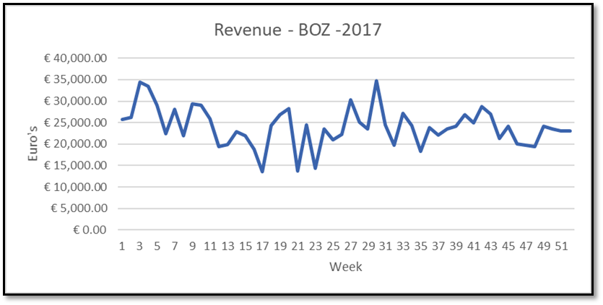

*Figure 4: Revenue per week - Tempo Team Bergen op Zoom (BOZ)*

In terms of permanent recruitment fees obtained the office generated 26,923.00 euros in profit. In the first quarter two fees were obtained, in the first week 5,800.00 euros and in the 10th week 2,200.00 euros. During the second quarter no fees were generated, but this was made up by receiving 13,207.00 euros in the third quarter. During the final quarter another 5,616.00 euros was paid by a client for a candidate. The fees can be seen in the table in appendix 3, and plotted in the graph below.

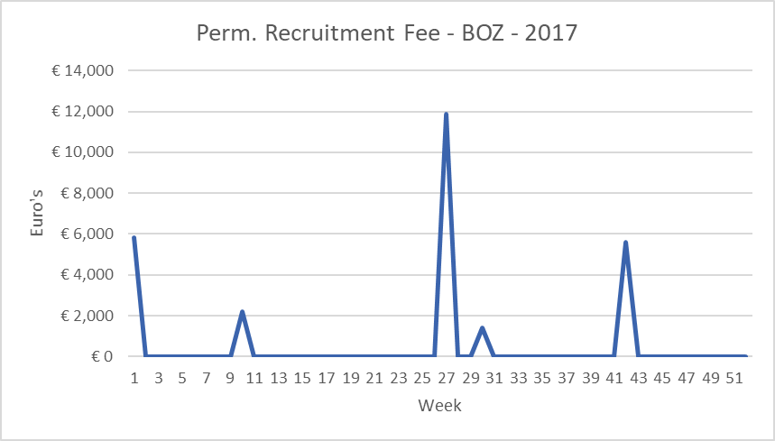

*Figure 5: R&S Fee's per week - Tempo Team Bergen op Zoom (BOZ)*

Where Bergen op Zoom did not reach the target for revenue, the target for profit margin (18.3 %) was reached. A total of 18,4 % of the revenue generated is profit. The other percentile can be regarded as costs made by Tempo-Team.

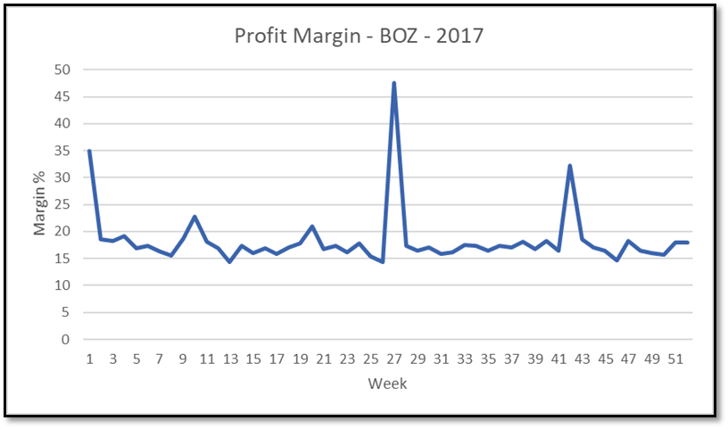

*Figure 6: Profit Margin - Tempo Team Bergen op Zoom (BOZ)*

In the graph one can see that the profit margin was not stable throughout the year. During weeks 1, 10, 27, and 42 the profit margin spikes upwards. This allows for the desired annual profit margin target to be reached since the desired target of 18.3 % was not reached weekly. The same trend can be visualized in appendix 3.2, hinting that there is a positive correlation between permanent recruitment fees gained and the profit margin. This can be explained since permanent recruitment fees are pure profit as discussed previously.

When considering the revenue and profit margins together one can calculate the nominal profit:

18.4% of 1,248,309 being 224,695 euros

### 4.3.2 Finance Data Roosendaal and Zevenbergen

The same process was repeated and completed for the office in Roosendaal and Zevenbergen and can be found in appendix 4 and 5.

To summarize:

Bergen op Zoom achieved a revenue of 1,248,309 euro’s, 26,923 euros in permanent recruitment fees and had a profit margin of 18.4%. Leading to a profit of 224,695 euro’s.

Roosendaal achieved a revenue of 1,594,535 euro’s, 45,326 euros in permanent recruitment fees and had a profit margin of 18%. Leading to a profit of 287,025 euro’s.

Zevenbergen achieved a revenue of 1,827,005 euros. 61,880 euros in permanent recruitment fees and had a profit margin of 18%. Leading to a profit of 328,860 euro’s.

The research showed that Zevenbergen and Roosendaal both scored better in terms of revenue and fees gained from permanent recruitment. Additionally, the same trend regarding the spikes in their profit margins can be traced back to their fees gained from permanent recruitment. This strengthens the position that these fees are needed to reach higher levels of profit margins in the future.

### 4.3.3 Permanent Recruitment

The following analysis of the financial data will showcase which effect the permanent recruitment had on the revenue and profit margins of the three offices. To do so, the researcher first investigated the revenue. The revenue has been split into quarters per office, as this will allow for an easier comparison of the data.

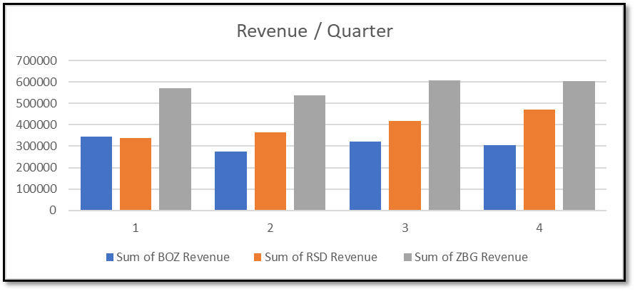

*Figure 7: Revenue generated per quarter per Tempo Team office*

Each quarter there is clear pattern as to which office generates the most revenue. Zevenbergen generates the most followed by Roosendaal and Bergen op Zoom. However, the researcher must consider that Zevenbergen and Roosendaal each operate with 3 FTE (Full time employee), whereas Bergen op Zoom has two. The data is thus recalculated to account for the discrepancy.

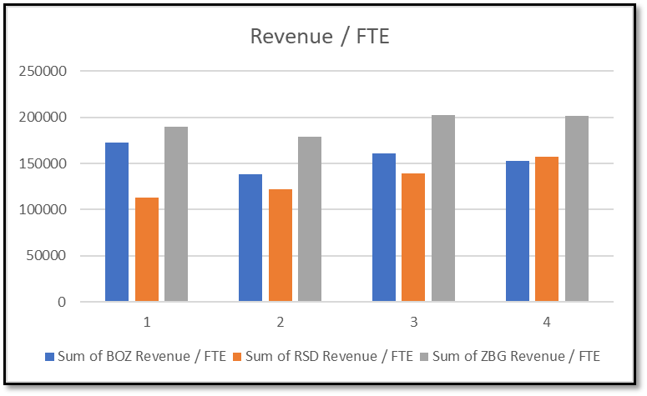

*Figure8: Revenue generated per quarter per Tempo Team office / FTE*

Per FTE, the Bergen op Zoom office scored better than initially expected, which makes one wonder if the target set by management is perhaps too high. Especially when you consider that there are two recruiters working their instead of three as in the other offices.

The revenue which was used, consists of both permanent and temporary fees and therefor still does not showcase what effect permanent recruitment has on the revenue. When combining the revenue and permanent recruitment graphs a clear trend can be seen. When there is a spike in permanent recruitment revenue, the total revenue sees a significant increase (figure 9).

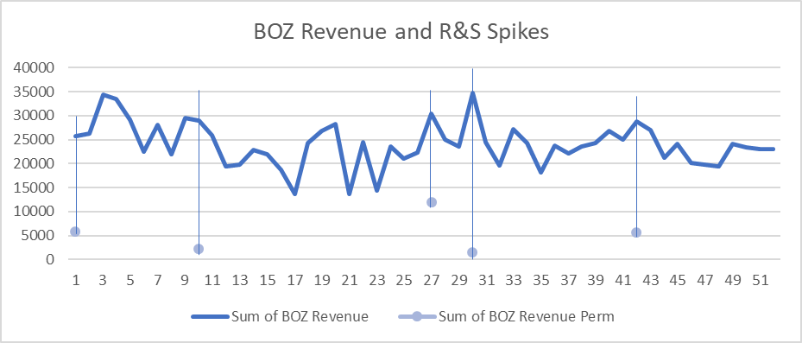

*Figure 9: Revenue and R&S Spikes Tempo Team Bergen op Zoom office*

### 4.3.4 Nominal Profit

Annually, permanent recruitment accounted for 2.16 % of Bergen op Zoom’s revenue but has a higher impact on actual profit generated. To investigate how much effect, it has on the annual nominal profit, the following graph shows is used which takes into FFE in account.

From the graph both Roosendaal and Zevenbergen show a steady growth over the course of the year. The Bergen op Zoom office on the other hand, fluctuated. When translating it to the FTE working at each office it becomes clear, that while still operating below the level of Zevenbergen, they score higher then Roosendaal. Confirming that per FTE the Bergen op Zoom office scores higher then Roosendaal.

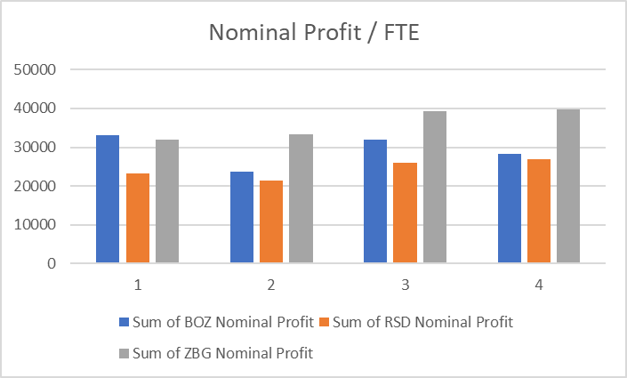

*Figure 10: Sum of nominal profit per quarter per Tempo Team office / FTE*

From the nominal profit earned the researcher wants to know what effect the permanent recruitment fees had for Bergen op Zoom. As one can see, there was no recruitment & selection fee earned during the 2nd quarter. Consequently, the nominal profit in the 2nd quarter was at its lowest point. When considering that gaining 2-3 placements in a quarter can increase your quarterly nominal profit by 10 % - 18 %, it has a large effect on nominal profit.

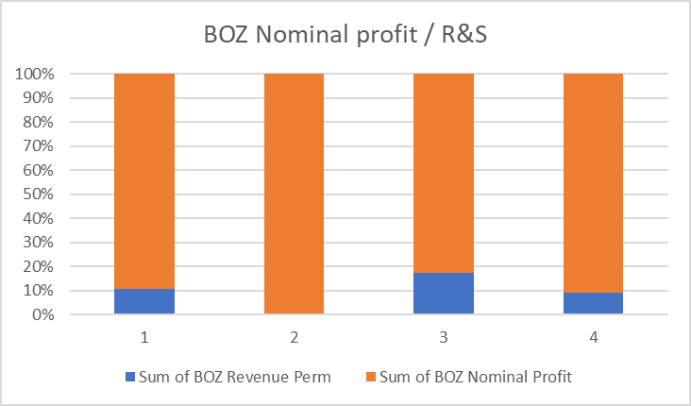

*Figure 11: Sum of Bergen op Zoom's nominal profit / sum of R&S per quarter*

In 2017, Bergen op Zoom’s permanent recruitment fees accounted for 12 % of their annual profit. For Roosendaal and Zevenbergen the percentages were higher at 16 % and 15 %. As Zevenbergen and Roosendaal scored better it could be profitable to have more focus on placing candidates on permanent basis. It increases your profit margin, revenue and most importantly, nominal profit.

|  |  |  |  |
| --- | --- | --- | --- |
| Office | Total Nominal Profit | Permanent Recruitment Fees | Percentage of Nominal Profit |
| Bergen op Zoom (BOZ) | € 228,356.00 | € 26,923.00 | 12 % |
| Roosendaal (RSD) | € 287,016.00 | € 45,326.00 | 16 % |
| Zevenbergen (ZBG) | € 409,455.00 | € 61,880.00 | 15 % |

*Table 1: Recruitment and Selection (R&S) fee / Total nominal profit of Tempo Team's offices*

To put these figures into context, if Bergen op Zoom would increase their focus on permanent recruitment to the same level as Roosendaal and Zevenbergen. The following calculation show how much fees should be earned. An additional € 7,852.00 would require 1 to 2 recruitment and selection placements.

|  |  |  |
| --- | --- | --- |
|  | 2017 | 2018 (Projected) |
| Percentage of Nominal Profit | 12 % | 15.5 % |
| Recruitment & Selection Fees | € 26,923.00 | € 34,776.00 |

*Table 2: Projected recruitment and selection fees 2018 Bergen op Zoom*

## 4.4 Sales Activities

Now that the financial data has been reviewed, we know two important aspects. One is that permanent recruitment plays a big aspect in both profit margins and revenue levels. Secondly, is that when considering the amount of FFE, Bergen op Zoom is not operating at the low levels which was previously thought by management. However, as we are investigating how to increase their results, we want to understand what the profitable office is doing differently in terms of output (sales activities). This is a factor which can be measure, and more importantly changed upon by the recruiters.

In the theoretical framework results of International best practices in sales and recruitment one saw that sales activities influence business development. Additionally, it became clear that when a recruitment agency wants to remain or become profitable they should focus on business development and generation. Moreover, for a recruiter to generate revenue one must commit to sales activities towards clients. To be able to quantify the sales output the researcher has opted to record the following sales activities for the Bergen op Zoom, Roosendaal and Zevenbergen offices.

* Calls to clients
* CV’s presented to clients
* Physical meetings with clients

By successfully filling job vacancies, revenue is generated. To gain job vacancies recruiters must undergo sales activities. Hence, these were recorded and analyzed. Daily the researcher recorded the above-mentioned sales activities of each office and recorded the data in an excel sheet. See appendix 6 for the recorded data and analysis per sales activity.

In appendix 6, the different types of sales activities were analyzed separately. Following up on that, all the sales activities per office have been combined. Being because we want to find out the amount of sales activities is required to reach a certain target. Figure 27 showcases how many sales activities were undertaken per office / quarter.

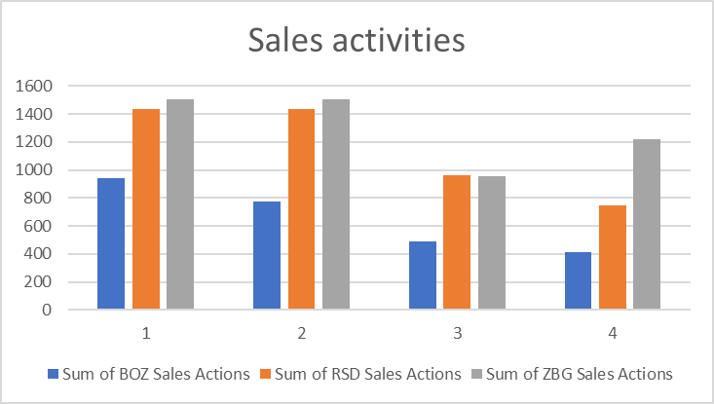

*Figure 12: Sales activities per quarter per Tempo Team office*

Zevenbergen and Roosendaal clearly undertake more sales activities compared to Bergen op Zoom. This could indicate more sales activities can lead to a higher revenue. To further investigate, the results are again divided by the amount of FTE at each office. Per FTE, Bergen op Zoom still operated below the other two offices when it comes to sales activities undertaken. In the first quarter they were relatively on par, and this can be reflected to the revenue generated in the first quarter. In the first quarter they reached the highest revenue per FTE in 2017. Suggesting that more activities lead to higher results.

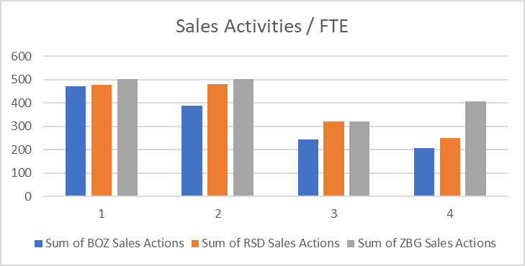

*Figure 13: Sales activities per quarter per Tempo Team office / FTE*

### 4.4.1 Sales activities value

The theoretical framework gave an insight that “the sales activities have a direct cause-and-effect correlation with business results. When influencing the amount or quality of sales activities you can influence revenue and make predicative forecasts as to how many sales activities are required reach a certain target”. To calculate how many sales activities are needed one must first calculate the average monetary value of 1 activity. This was calculated by dividing the 2017 revenue by the sales activities in 2017. Each sales activity that the Bergen op Zoom office undertook in 2017 was had an average value of 476.46 euro’s. The 2018 revenue target was thereafter divided by that amount, giving us, the projected sales activities needed to reach the 2018 target.

|  |  |  |  |  |  |  |
| --- | --- | --- | --- | --- | --- | --- |
| Office | Revenue 2017 | Sales Activities 2017 | Revenue / Activities 2017 | Target 2018 | Projected Sales Activities | |
| BOZ | €1,247,849 | 2619 | € 476.46 | €1,500,000 | | 3148 |
| RSD | €1,594,535 | 4581 | € 348.08 |  | |  |
| ZBG | €2,317,710 | 5187 | € 446.83 |  | |  |
| Total | €5,160,094 | 12387 | € 416.57 |  | |  |

*Table 3: Revenue per sales activities*

3148 sales activities are required in total to gain 1.5 million euro’s in revenue. Per week the Bergen op Zoom office must complete an average of 61 sales activities, 31 per FTE.

Zevenbergen, completed on average 99 sales activities per week. When considering that they had 1 FTE more, it compares to 33 sales activities. Roosendaal completed per FTE 29 sales activities. Therefor it is an assumption we can accept that the Bergen op Zoom office, should be able to complete them in the same period.

### 4.4.7 Additional Employee

In the previous sections it was noted that the other two offices operate with three FTE. Additionally, when considering for the different in FTE, the Bergen op Zoom runs at an average level. It would therefore be interesting to find out what effect an additional employee would have on the sales figures. To calculate for this the total Revenue of the three offices are combined and compared with the total 2017 sales activities. An average is taken of the 8 employees rather than relying on two data points.

€5,160,094.00 / 12,387.00 = € 416.57 average revenue gained per sales activity

When the new employee generates the same amount of sales activities as the current employees did in 2017, it could result in € 545,498 additional revenue, assuming no loss-time for training and learning curves. When adding this to the current revenue gained, the Bergen op Zoom office would project to generate € 1,793,807. Additionally, they are projected to generate a revenue which is close to the targets Roosendaal and Zevenbergen had in 2017, whom operated with 3 FTE.

Adding an employee could be the solution the managers should contemplate about.

## 4.5 Client Data

We now know the effects of permanent recruitment and the differences in sales activities. The next step is to find out which clients should be targeted and improved upon in the coming year. The aim by doing so is to increase Bergen op Zoom’s revenue and profit. For this reason, the revenue and profit margins were recorded of each placement made during 2017 per client. Due to information sensitivity, not all clients could be mentioned in the report and the data per placement was combined to show just the revenue gained per client.

The full data set can be view in appendix 7 followed by an analysis for further insight.

Tempo-Team is geared at increasing their revenue and profit margin and providing good customer service. From a financial perspective increasing the sales activities could lead to a theoretical increase. However, one must consider which companies are targeted. Although past results do not predict future events they do create insight. By increased targeting of clients which have been profitable in, results should increase accordingly. The following graph indicates which companies have created the most revenue in combination good profit margins.

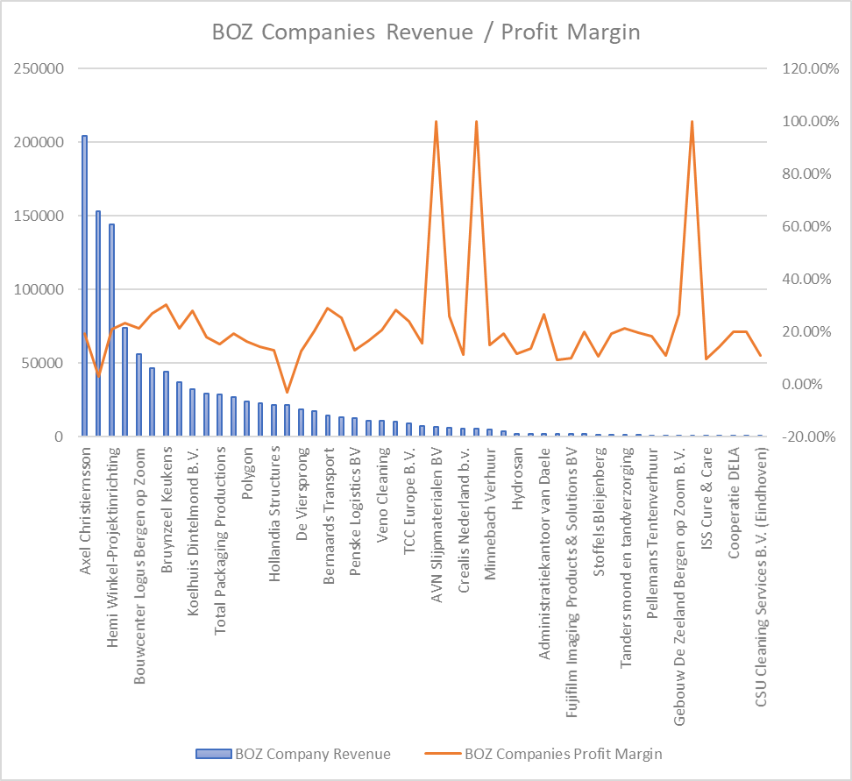

*Figure 14: Bergen op zoom client revenue / profit margins*

From figure 32 It would be wise for the Bergen op Zoom office to focus on the companies that offer the most nominal profit. Companies that offer negative profit margins should be seriously reconsidered as possible clients, as it takes up time, yet yields no positive results. Tempo-Team is in the business of making money, and should not allocate time on negative income. This time can be better spent creating extra contact moments with profitable clients or acquiring new business prospects.

When considering the absolute revenue and profit margin values, the following list was created.

List of non-profitable clients which could receive less focus:

* Mainfreight
* Crealis Nederland B.V.
* Hydrosan
* CSU Cleaning services
* ISS Cure and Care
* Culinair Kommers

List of profitable clients which could be targeted heavily:

* Axel Christiernsson
* Hemi Winkel-Projectinrichting
* Allied Mineral Products
* Insulcon
* Bouwcenter Logus
* Chugoku Paints

According the Jack Welch vitality curve however the focus should not solely be on the revenue a client brings to the table. (Cokins, 2014) states that every client should be investigated separately. To do so the researcher has ranked the Bergen op Zoom clients using the Jack Welch Vitality list of criteria. Since the researcher worked as a recruiter during the thesis period, he has enough knowledge of the clients to give them scores per criteria. However, do to some criteria not being investigated they will not be used. The criteria which were used are as follows.

* Brand association
* Profit Margins
* Volume of revenue
* Ease to work with

The two criteria which were not used are the level of exclusivity, payment terms and knowledge of decision makers. Since 4 criteria were used instead of the listed 7, it will be accounted for when ranking the clients into the three segments. Instead of ranking per point based earned, the researcher divided the clients regarding the percentages used per segment by Jack Welch.

Top 20 % will be the top performers

The next segment will consist of the middle 70 %, which is again divided into segments of 20 %

* Above average performers
* Average performers
* Below average performers

Bottom 10 % are the low tot non-performers

The top performers according to the Jack Welch are as follows:

* Hemi Winkel-Projektinrichting
* Allied Mineral Products
* Chugoku Paints BV
* Axel Christiernsson
* Koelhuis Dintelmond B.V.
* Bouwcenter Logus Bergen op Zoom
* Insulcon B.V.
* Bernaards Transport
* Bruynzeel Keukens
* AVN Slijpmaterialen BV
* Katjang Pedis PCI B.V.

These clients should receive the most attention and should be targeted on a regular basis. They do not only bring in the most amount of revenue and profit but are additionally easy to work with and bring brand value to the recruiter’s portfolio. In contrast to the top performers the low to non-performers bring neither to the table. They take up valuable time, which should be spent on the top performing client base.

The non- to low-performers are:

* Mainfreight Logistics Services
* CSU Cleaning Services (Food)
* Dingemanse Trucks & Trailers
* CSU Cleaning Services B.V. (Eindhoven)
* CSU Cleaning Services B.V. Hospitality
* ISS Cure & Care

The clients which should be also receive further attention are the below average performers. These clients are closing the danger threshold and should be revisited in terms of the recruitment offerings, contract agreements and pricing. The recruiter can do so by scheduling in meetings with their client contact to discuss further business.

During the research period the researcher noticed that the non- to low-performers also toke up valuable time. They demanded on the spot candidates, causing the recruiters to have less focus on their profitable clients. If the recruiters would stop working with these clients they would have more time to complete more profitable sales actions.

**Chapter 5**

The following chapter will reflect on the theory and research and used to answer the research question. Afterwards, the limitations of the research are discussed and how follow up research could improve on the current findings.

5. Discussion

The research which was conducted can be divided into four major categories. These are Tempo-Team’s business process, permanent recruitment, sales activities, and profitability of their clients. The four subjects formed the basis needed to investigate how Tempo-Team, situated in Bergen op Zoom, can increase their revenue and profit margins gained from temporary and permanent recruitment. The results of the research will now be combined with the literature from the theoretical framework.

5.1 Business Process

The business process which was mapped out by the researcher shows that there are two sides of the spectrum, the candidate side and job side. The candidate side is used to recruit suitable job-seekers for the clients and the job-side is used for business development strategies and gaining job-vacancies to recruit for. The recruiter has the possibility to work from both sides and use it to gain candidate placements. However, (Compton R. M., 2002), stated that for there to be a recruitment need there must first be an existence of a job vacancy. Recruiters can gain a job vacancy to work on by targeting their clients. From our observation this is seen as business development. Through business development the recruiters contact their clients and work at increasing their sales. There are several reasons why such a vacancy can exist. Namely, an employee has left the organization, a specialist is required, the volume of work has increased, or the company is undergoing a restructuring of an area of the business (Epps, 1998).

For a recruiter to contact the client at these moments, reoccurring contacts moments are required. However, the recruiters mention that working on one side of the spectrum should not cancel out the other. They state that when you have “job vacancies to work on you search for candidates specific to the client’s requirements. When you do not have many job vacancies, recruiters can search for a broad range of candidates and present them to multiple clients”. When presenting candidates to the clients, the recruiter can create interest where there might have not been one before.

5.2 Permanent recruitment

During the interview the recruiters came to the consensus that the market in Bergen op Zoom is not optimal for gaining revenue from permanent recruitment placements. This being, because the city originates from poor labor community. The results however indicate that it is however possible to sell this form of recruitment to the customer. Additionally, the offices in Roosendaal and Zevenbergen sold more permanent recruitment fee’s, while both Zevenbergen and Roosendaal originate from poor labor communities. The clients are said to pay closer attention to costs and tell the recruiters straight away that they are not interested. What the client does not seem to realize is that the long term-costs are lower than the short-term costs, making it a viable and affordable option. “One payment is done, 25 % of the candidate’s annual salary, instead paying per worked hour”. Additionally, the theoretical framework showed that even though “The costs of ‘recruitment and selection’ can lead to a high short-term direct cost” the long run costs are relatively low. “This being because less direct costs are made in the recruitment procedure”, such as “spending time to source and interview candidates, travel, making of the advertisement, selecting of suitable candidates, and interviews which take place (Monster, 2017)”. Further questioning however, revealed that the recruiters are not trained enough in selling this service to the clients. “During client meetings the benefits of permanent recruitment is not communicated enough, and some recruiters do not discuss the contractual agreements of permanent recruitment at all. The recruiters have the tools required to sell the service but fail to us them.

This is a missed opportunity since selling permanent recruitment fee’s is pure profit. The financial results also show that each permanent recruitment fee increased the profit margins and nominal revenue of the different offices. However, as the recruiters mention there is a down side to selling only permanent placements. It does not offer a steady stream of revenue since the payments are one off. Once the payment has been done, the candidate is on contract with the client and no longer works for Tempo-Team. “When the recruiters focus more on selling permanent recruitment the revenue goes down, but the profit margins increase”. Therefor an increase in permanent recruitment should be done in small increments, to retain a stream of income from temporary recruitment fees.

5.3 Sales Activities

Best practices in sales showed that “companies with a sales environment are often management based on KPI’s and sales metrics. By steering the sales representatives on their KPI’s, a manager can influence results”. Since Tempo-Team wants to increase their results for the Bergen op Zoom office, investigating their sales activities could be crucial to reaching their annual target. The recruiters also mention “that it is a good thing that the managers control the KPI’s”. When it is done by the manager, the recruiters react that they do not have the time required to complete all their sales activities. The same recruiters mention during the interview that “it would be wise to create a structure, 10 minutes every morning of planning at the start of the day and at the end would allow for more effective work”. One of the recruiters says, “you need to make at least one hour a day available to make calls to clients”. This is however not done enough, and recruiters get bogged down with the daily work that sales activities are often forgotten.

The best practices showed that top salespeople plane their day into blocks and geographical region. Additionally, activities which have been planned should be noted down in a form of a checklist. By completing tasks on the checklist, the salesperson feels motivated and has a sense of accomplishment. Additionally, seeing the tasks on your checklist can show when the salesperson is lagging and needs to increase their speed. Hence “the continuous process of improving performance by setting individual and team goals which are aligned to the strategic goals of the organization, is required by the recruiters and manager” (Lee, 2005).

The manager should set how many sales activities should be completed on a regular basis to reach the desired target. Managers use the revenue and margins to see how well the business is doing. When it is not healthy, they can influence the results by managing the sales activities, which are undertaken to gain said revenue and margins (Marsh, 2016). By knowing how many sales activities are required, the recruiters can plan how many of them they must undertake per day and make sure it is integrated in their daily routine. By means of the analysis created earlier the amount of sales activities needed to reach a certain revenue is known.

5.4 Limitations

The research however only focused on the client side and the sales activities undertaken to gain job-vacancies. It did not consider the candidate side and which effect it has for the recruiters when they do not have a suitable candidate portfolio. According to the theoretical framework this should be one of the big advantages for a client to use a recruitment agency since. Recruitment agencies have a wide reach of candidates in the labor market and talented candidates available through their database (Svedaite, 2013)”. Further research on how working on the candidate side could increase Tempo-Teams revenue could be interesting.

The analysis shows that increasing income from permanent recruitment increases the profit margins. Tempo-Team states that the income gained from this form of a recruitment is 100 % profit. However, it does not consider the tradeoff costs between two too recruitment offerings. When a candidate is placed on a permanent recruitment fee, you lose the steady income if the candidate was placed still on contract with Tempo-Team.

The analysis of the sales activities did bring along limitations. Since the sales activities were entered into the CRM system manually by the recruiters every week, it was prone to false data. There was a discrepancy as to what each recruiter saw as a viable entry. Some recruiters entered a sales activity when they spoke with their contact person, others entered it even though their contact person did not pick up the phone. Additionally, there might have been double entries. When a recruiter visits a client with their colleague, they entered the same visit in twice. Furthermore, the recruiters often forgot to enter in the data after each sales activity. They would enter it into the system at the end of the day or week and could have forgotten several sales activities. Accounting for these possible errors was not possible. Hence the researcher assumed that the data was correct.

The last limitations concern how to make the Tempo-Team Bergen op Zoom’s clients more profitable. The study showed which clients are least profitable and which should be renegotiated with but does not indicate how this could be done. How meetings are conducted, and contracts are set up with clients is a standalone study and would be an interesting study for Tempo-Team.

**Chapter 6**

This chapter will answer the research question based on the results of the research. Afterwards practical recommendations will be given.

# 6. Conclusion

In this study, an answer was sought to the question:

*How can Tempo-Team Bergen op Zoom increase their revenue and profit margins gained from temporary and permanent recruitment, regarding external best practices in sales?*

To answer the question, the existing literature of the use of recruitment agencies and best practices in sales was investigated by means of desk research. Additionally, quantitative data was collected by means of an interview followed by quantitative data collection of the financial data and sales activities.

The theoretical framework gave the reader an insight into the different forms of recruitment and why companies opt to use recruitment agencies, such as Tempo-Team. There are two dominant forms which can be categorized as short-term and long term. Short-term suggesting that clients need to fill their employment gaps for a short period and long-term suggests clients seek candidates to stay at their company. The later can be filled by offering permanent placements, meaning the candidate receives a contract from the client. Clients often have an opinion that the costs are too high and less aware that the long-term costs are less. The recruiters should therefor receive training from Tempo-Team how they can convince their clients that this is not the case. By addressing to the client what the benefit is of permanent recruitment they could increase their chances of selling this type of service offering.

Both forms of recruitment offer Tempo-Team the opportunity to generate income from their clients. Where temporary recruitment generates the bulk of the revenue, the results show that more nominal profit can be earned through permanent placements. This type of recruitment service is seen to generate 100 % profit and when gained by Temp-Team increases their profit margins more relative to temporary recruitment. Both Tempo-Team offices, situated in Zevenbergen and Roosendaal sell permanent recruitment at a higher frequency and this is reflected in their sales results. If the Bergen op Zoom office were to increase their sales regarding permanent recruitment, they would ensure their profit margin target can be reached. However, the recruiters must keep in mind to also keep selling temporary recruitment and not focus solely of permanent recruitment.

The recruitment process of Tempo-Team was mapped and analyzed where opportunities can be created, which can over income. From mapping, one can see that there is a clear distinction between the client and candidates since. The candidate side focuses on generating a candidate pool, from which candidates are presented to clients. The opportunities however, come from gaining job vacancies to work on from clients. These opportunities are generated by committing to sales activities towards their clients.

The explored literature has shown that managers can influence the results of the recruiters if they look at the sales activities which are undertaken. This being because the revenue and profit margins cannot be changed by telling the recruiters to do so. Rather the managers should budget how many sales activities are required to reach the desired target and instruct the recruiters. By careful planning of the daily activities and ensuring the goals are known, the recruiter can reduce the amount wasted time and focus on what is needed to gain revenue. Both Roosendaal and Zevenbergen had completed a larger amount of sales activities when compared to the Bergen op Zoom office. When comparing it to their weekly revenue and nominal profit it was made clear that Bergen op Zoom should focus on increasing it too. The more contact moments one has with their clients, the more chances there are to gain a job-vacancy to work on. In turn the job-vacancies offer an opportunity to increase the revenue. However, when comparing the number of sales activities per FTE, Bergen op Zoom scores better then Tempo-Teams office in Roosendaal. Increasing the sales figures should therefore go hand in hand with increasing the quality of each contact moment (sales activity).

Lastly the client portfolio of the Bergen op Zoom office, should be investigated and evaluated on a regular basis. The research used the Jack Welch Vitality ranking to analyze which clients should be renegotiated with or which should be cut off. Low performing clients should be contacted, and contracts should be revisited in terms of prices and agreements. By removing the non-profitable clients, the recruiters will have more time to focus on the clients which could increase their sales figures.

**Chapter 7**

# 7. Recommendations

*How can Tempo-Team Bergen op Zoom increase their revenue and profit margins gained from temporary and permanent recruitment, regarding external best practices in sales?*

For the Tempo-Team office to become more profitable in terms of their revenue and profit margins, there are several options the office could undertake. The recommendations should support the findings of the research. Therefore, practical recommendations are given on the following topics: permanent recruitment business development and sales activities. These topics formed the basis of our research and used as a reoccurring theme in our results. Doing so will in turn support the main research question

Permanent Recruitment

The results show that permanent recruitment fees have a large impact on the total profit made by each office. It has a positive effect on profit margins and revenue. An increase in focus on this type of service offering will aid the recruiters in reaching their targets. However, increasing the focus should come in hand in hand with training. The recruiters have mentioned that the clients are not aware enough of this service offering and that the recruiters themselves do not know how to sell the service well enough. If Tempo-Team offers their recruiters training on permanent recruitment and create a marketing campaign geared at creating client awareness they could increase their sales.

Training and marketing campaign do come at a cost. HR magazine counters this argument by stating that “companies that invest **$1,500 on training per employee can see an average of 24% more profit than companies who invest less”** (HR Magazine, 2018)**. Additionally, if the recruiters can increase their permanent recruitment by two placements, the stand to increase their nominal profit by almost eight-thousand euro’s. Making the training feasible.**

**In combination of increased focus and proper training, Tempo-Team should seek out collaboration with Yacht. Yacht is part of the Randstad Holding, and services a different segment. By giving them leads for job opportunities in their range, they can receive additional revenue. Asking the clients for these job opportunities during their own visits will come at no extra costs.**

Sales activities

During the interview, the recruiters mention that when the manager controls the KPI’s to a higher extent the recruiters score better. Additionally, the results show that the offices that output more sales activities generate more revenue and profit. Thus, increased managerial control on the recruiters KPI’s should be key for Tempo-Team. The manager should analyze the sales activities weekly, and set how much sales activities the recruiters should deliver. Implementation can be done immediately and will not require additional resources. Theoretically if they boost their sales activities to 61 per week, they will generate 250,000 euro’s more in revenue.

Moreover, the theoretical framework showed that planning can increase the effectiveness of sales people. For a salesperson to be successful, he needs to persuade his customer to buy his products. In the case of recruitment, he needs to sell his candidate and service to the client. To do so regularly a solid plan for each day and staying organized is required (Meyers, 2018). Therefor the researcher advises Tempo-Team to implement a mandatory pre- and end day meeting and schedule the recruiters work agenda’s in sections as mentioned in the theoretical framework. It can be implemented on a short-term notice and should allow the recruiters to become more efficient.

The following should be considered:

* Morning: Day planning, goal creation in form of a checklist
* Morning: Sales calls to clients
* Early afternoon: Internal meetings
* Early afternoon: Meetings with clients
* Afternoon: Recruiting of candidates
* Late afternoon: Administration

Additionally, salespeople can furthermore increase their time management and effectiveness further if they plan according to the geographical region of their clients. By booking meetings and calls of clients which are situated close to each other time is saved on commute time.

At the end of the day the recruiter should evaluate their checklists / goals. Which of their goals have they completed and which should be done the next day?

Business Development

Lastly, for the Bergen op Zoom office to be more profitable and solve their business problem, they should look closely at their client portfolio. The results indicated that some of the clients are running at a negative yield or costs more time than actual profit is generated. To make sure that the recruiters increase their focus on clients which generate more income, it is advised to create a benchmark per quarter. The Jack Welch’s Vitality benchmark can be used as shown in the results. It is a long-term solution and will take time to see the desired results. More focus can be geared at profitable clients, and more importantly the recruiters will understand which clients should be contacted for renegotiation.

The recommendations listed above can be implemented both at Tempo-Team and other recruitment firms. They should generate more focus, better time management, and seek out the most profitable opportunities.

# Bibliography

Bambach, M. (2010). *Effective Recruitment and Selection Practices 5th edition.* CCH Australia Ltd.

Bhatia, T. (2016, 05 24). *Use of Bell Curve in Performance Appraisals – Good or Bad?* Opgehaald van Empxtrack : https://empxtrack.com/blog/bell-curve-for-performance-appraisal/

Bowen, D. L. (1991). Hiring for the organization, not the job. *Academy of Management Executive*, 107.

Cadena, C. (2007, 05 21). Temporary employment advantages. Why many American workers are seeking temporary work.

Cokins, G. (2014, 12 02). *How to Make Less-Profitable Clients Profitable*. Opgehaald van GAA Accounting: http://www.gaaaccounting.com/how-to-make-less-profitable-clients-profitable/

Compton, R. (2009). *Effective recruitment & selection practice.* Sydney: CCH Australia Ltd.

Compton, R. M. (2002). *Effective recruitment and selection.* Sydney: CCH Australia Limited.

Cook, R. (1998). *Recruitment, selection & induction in Australia & New Zealand: A work.* Sydney: Prentice Hall.

D. Cooper, I. T. (2003). *Recruitment and Selection: A Framework for Success.* London: Thomson.

Dick, J. (2018, 06 05). *How to Calculate Sales Conversion Rate & Lead Value*. Opgehaald van Venturi: https://venturi-web-design.com/calculate-sales-conversion-rate/

Donk, C. v. (2014). *Praktijkonderzoek in zorg en welzijn.* Bussum: Coutinho.

Epps, S. (1998). *Selecting and managing personnel.* Londen: Telegraph Publications.

J. Hor, L. K. (2008). *How to attract and retain great employees.* Australia: Kluwer.

Jordan, J. (2014, 01 08). *In Sales, Can You Manage What You’re Measuring?* Opgehaald van Harvard Business Review: Harvard Business Review

Lee, C. (2005). Rethinking the goals of your performance management system. *Employment Relations Today*, 53-60.

Marsh, B. (2016, 11 30). *Why Managing Sales Performance Means Measuring Activities*. Opgehaald van Sales Force: https://www.salesforce.com/blog/2016/11/managing-sales-performance-activities.html

Meyers, J. (2018, 10 9). *How to Organize a Day in Sales*. Opgehaald van Chron: https://smallbusiness.chron.com/organize-day-sales-34900.html

MindTools. (2018, 06 05). *The Sales Funnel Tool and Tips, Keeping Control of Your Sales Pipeline*. Opgehaald van MindTools, essential skills for an excellent career: https://www.mindtools.com/pages/article/newLDR_94.htm

Monster. (2017, 05 21). *What are the general costs of using recruitment agencies?* Opgehaald van Monster: https://hiring.monster.co.uk/hr/hr-best-practices/recruiting-hiring-advice/managing-hiring-costs/what-are-the-general-costs-of-using-recruitment-agencies.aspx

Pattanayak, B. (2005). *Human Resources Management.* New Delhi: Prentice Hall.

Quartz, M. (2015, 08 18). *How Millennials Forced GE to Scrap Performance Reviews*. Opgehaald van The Atlantic: https://www.theatlantic.com/politics/archive/2015/08/how-millennials-forced-ge-to-scrap-performance-reviews/432585/

Randstad. (2016). *annual reports archive.* Opgehaald van Randstad: https://www.ir.randstad.com/~/media/Files/R/Randstad-IR/annual-reports/annual_report_randstad_2016.pdf

Richardson, M. A. (2017). *Recruitment Strategies: Managing / Effecting the Recruitment Process.* Opgeroepen op 05 1, 2017, van Unpan: http://unpan1.un.org/intradoc/groups/public/documents/UN/UNPAN021814.pdf

ringDNA. (2018, 06 05). *What is a sales funnel?* Opgehaald van ringDNA: https://www.ringdna.com/inside-sales-glossary/what-is-the-sales-funnel

Sales Career. (2012, 12 12). *3 Things to Do to Organize Your Day as a Sales Professional*. Opgehaald van Sales Career: http://salescareer.com/3-things-to-do-to-organize-your-day-as-a-sales-professional/

SalesRamp. (2018, 10 09). *Best Practices: A Day in the Life of a Sales Development Rep*. Opgehaald van SalesRamp: http://salesramp.com/best-practices-a-day-in-the-life-of-a-sales-development-rep/

Saunders, M. L. (2009). *Research methods for business students.* England.

Stone, R. (2005). *Human Resource Management.* Milton, John Wiley & Sons Australia Ltd.

Svedaite, E. (2013). *Investigation of the advantages and disadvantages of temporary employment.* Siauliai: Socialiniai tyrimai / Social Research. Opgeroepen op 05 18, 2017, van http://www.su.lt/bylos/mokslo_leidiniai/soc_tyrimai/2013_30/svedaite_tamosiunas.pdf

The Recruitment Network. (2018, 10 2). *Trimming The Fat – How Recruiters Can Find Profitable Customers*. Opgehaald van The Recruitment Network Club: https://www.therecruitmentnetworkclub.com/recruitment/find-profitable-customers/

wikipedia. (2018, 06 05). *Sales*. Opgehaald van Wikipedia, The Free Encyclopedia: https://en.wikipedia.org/wiki/Sales

Worthington, J. (1992). *Small business consulting: Developing and improving clients' recruitment, selection, and orientation programs.* New York: American Institute of Certified Public Accountants Inc.

# Appendix

## 1. Recruitment Process

The following diagram was created by the researcher. The process was mapped out through observation of the recruiters and joining in on their activities.

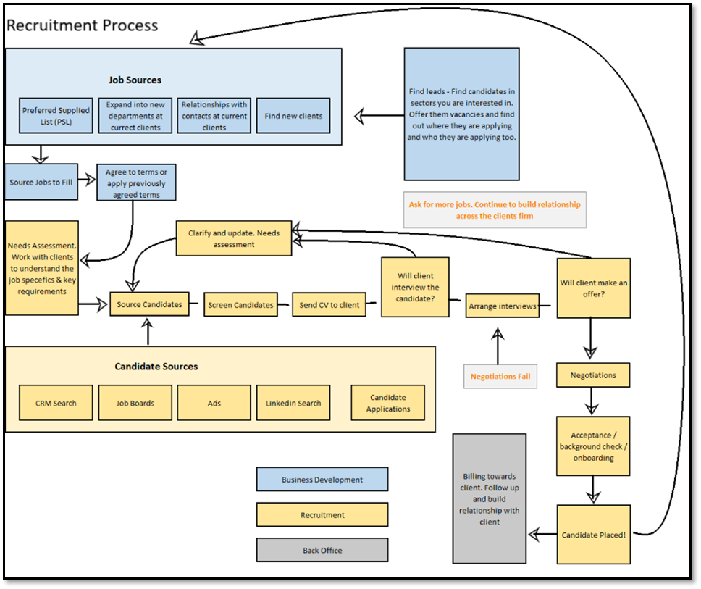

*Figure 15: Recruitment Process at Tempo-Team (created by Sjors Verbaan)*

## 2. Interview Script

Interviewer: Sjors Verbaan

Function: Graduation Intern

Interviewee: Employee A, B and C

Function: Sales intermediary

Location: Bergen op Zoom

Date: Monday April 10th ‎2017

Topic: Recruitment

Sjors:

Thank you for taking the time to answer some questions I have concerning recruitment. This interview is dedicated to answering my research question; how Tempo-Team can increase their revenue gained on perm vacancies. More specifically recruiting for permanent contracts where the candidate is contracted by the client directly.

Beforehand I would like to point out that the recording will remain confidential and that your name will not be used in the report. You will be known as employee A in the report.

To start of I would like to hear your opinion about how it is going momentarily with regards to this kind of recruitment in general. After which we will segment the different processes in the recruitment cycle and go into more detail.

Employee A:

We are currently working hard to increase our revenue gained from recruitment. We are offering candidates to practically all the companies in the area. What I think is that Bergen op zoom not the market is for recruitment on fixed bases.

Why? Because Bergen op Zoom is from origin a poor labor community, and this is still seen in the organization currently operational in this area.

They pay attention to costs, while the cost for fixed base recruitment is cheaper in the long run. This scares them, and then it is done.

I must say that in the last two years the companies have started to understand the concept fixed basis recruitment, but we will never be as successful as Breda or any other bigger cities.

Sjors:

Is this based purely on the market?

Employee A:

Yes

Sjors:

At the beginning of this year a target for fixed bases recruitment has been set. Per region (cluster) a certain revenue must be gained. From this revenue a certain percentage must be profit. The managers of the cluster then proceed to allocate a target per office within the cluster in terms of both revenue and profit. By gaining fixed basis fee’s the profit margins go up, since this is practically pure profit.

Do you know why the managers want you to focus more on fixed basis recruitment?

Employee B:

Yes, this is since this form of payment by the client involves practically no service costs and thus almost pure profit. If the client decides to opt for the other possibility, the candidate works at the client but is paid by Tempo-Team. Tempo-Team must then cover all the costs involved, such as contract fees, insurance, sick leave, vacation payments, etc. When all the fixed costs have been subtracted less profit is remaining. So, when a company pays one fee to Tempo-Team, normally 25% of candidate’s yearly salary, Tempo-Team has no further costs. On the down side is that you have no steady stream of income. Thus, this form of payment is extremely beneficial for the profit margin.

If you focus more on fixed based recruitment the revenue goes down, but profit margins increase

It becomes a tradeoff between the two, as you both revenue and profit are important for the Tempo-Team.

Sjors:

Are you aware how many hours you must outsource to achieve the same amount of profit?

Employee B:

We not. This is made difficult by the fact that sales intermediaries can decide what the hourly outsource fee is per candidate that that the client must pay. Calculating the exact trade off point is thus not possible for me.

For us, we know that outsourcing brings us more revenue. This is a target we must achieve and thus has our priority. That is why we focus more on this form of recruitment since our managers will evaluate us on this.

What might be interesting to find out is how much the profit is for a candidate per hour on outsource basis and compare this to the hourly profit fixed bases recruitment brings.

Sjors:

In the past year, how much revenue was gained through fixed based recruitment fee’s?

Employee B:

In 2016 and the start of 2017, we received 20,000 euros. Mostly gained by clients taking over a candidate after a certain time of outsourcing. The way this works is that a client can take over a candidate free of charge after 1040 hours of outsourcing. If they decide to do this at an earlier stage a fee has to be paid based on the remaining hours. This counts towards the fixed based recruitment fee target too. Recently we did notice that clients are taking over candidates before the 1040 hours have been fulfilled.

Sjors:

Why do you think this is? Is it because the labor market is diminishing and less candidates are available for positions?

Employee B:

Yes, I think so. They want to give a candidate the security of having a job. By giving a contract straight at the client they do just that. But on the other hand, clients also want to remain flexible. By having Tempo-Team outsource the candidate to the client they can terminate the employment whenever the client wants. This will then be done without any further costs involved for the client. If the candidate has a contract straight with the client this cannot be done as easily.

Also, by outsourcing the client can additionally ‘test out’ the candidate before employing them directly.

Sjors:

Thank you for clearing that up for me. I presume this also has to do with the fact that the economy has been increasing. More jobs have been made available and thus less job people are looking for a job. Due to that available labor has become scares. You then have to offer security to employees and attach them to your company.

Sjors:

In terms of selection and recruitment process, what could be improved?

Employee C:

That is a good question

I find it difficult to answer that

Sjors:

Let’s start with the contract agreement that tempo-team uses. We offer 1-month guarantee on the candidate, right?

Employee C:

Yes, we offer our clients 1-month guarantee on the candidate that starts to work on contract with the client. If de client decides the candidate is not fit within that month we will find a suitable replacement candidate or refund the paid fee.

Sjors:

Are there items in the agreement contract which reduce your competitiveness compared to other recruitment agencies?

Employee C:

No, I don’t think so, I think our agreement are solid.

I also have noticed that companies are not aware of agreement. We have come across cases where the candidate did not get through the first month and then the client did not ask for a replacement or their money back.

When this happens, we will not promote that this is part of the agreement.

Sjors:

Does that mean that the sales intermediaries don’t communicate this well enough to the clients? This seems to me like an important service that Tempo-Team offers in relation to the competitors.

Do you communicate this during meetings with clients?

Employee B:

Well, normally my colleagues and I do not discuss the contractual agreements during meetings. Such as payment terms, services we offer, guarantee.

Sjors:

Do you think you should do this in the future?

Employee B:

I believe so. This is communicated to us from higher up during trainings but not done enough in practical situations.

Sjors:

When you go to a client for a meeting. How do you go about it? Imagine the first meeting with a client.

Employee A:

We tell them there are two possibilities. On outsource basis or a one-off fee. In most cases the client tells us straight away they are not interested in paying the one-off fee. They think it is too much to pay in one go.

Sjors:

I have noticed that Tempo-Team has a table that can show the client exactly when it is more cost effective to give a candidate a contract. Do you show this to your clients? This could perhaps stimulate them to think again about which option they decide to do business with you.

Employee A:

This happens a bit, but we should do that more. Another thing we must communicate more is that the service we give is based on ‘no cure no pay’. If we do not find the candidate, the client wants then no fee will be charged. Only when the clients want the candidate we propose.

Sjors:

Perhaps more trainings can be given on how to convince the client to opt for recruitment and selection?

Employee A:

No, I believe the trainings that are given should be sufficient. On top of that Tempo-Team also gives employees the possibility to follow trainings online. Perhaps this could be done more by the employees. But it is true that we have not received trainings yet about how to sell this service better.

Sjors:

After the meeting, hopefully, you will receive a job vacancy to work on. How do you go about finding the candidates for this function? Do you pro-actively look for candidates before you receive vacancies, or do you start searching when you receive a job to work on?

Employee C:

We have focus candidate profiles and vacancies that are always requested by our clients. These however are production and logistics profiles of the lower segment. In most cases the selection and recruitment vacancies are office functions, which we do not actively look for beforehand.

So, when we receive a vacancy, for example a for an inside sales employee, we only then start looking for candidates.

Sjors:

Do you think you should search and speak candidates beforehand? So that you have the ‘product’ in your portfolio already. That way you can service the client quicker and you know who is available. Additionally, you can use these profiles to stimulate the client to do business with you.

Employee A:

Yes, I believe you are right. But when you search for candidates beforehand you should not focus on profiles but rather invite anyone that you think could be placed in the future.

IF you find a good profile. Invite them. Interview them.

Sjors:

As we both know the recruitment sector is twofold. On one side you work for the client and on the other side you give a service to the job seekers. Do you work more from the client’s side or that of the candidate?

Employee A:

This differs. Now we have vacancies to work on. When that is the case we work more from the client side. We try to find candidates that fit each vacancy.

When you have less vacancies, you take the candidate and try to bring them under the attention with clients. To try stimulating them to invite the candidate, even when you don’t have a vacancy to work on from the client.

Sjors:

So, when the economy increases you work more from the client side and when the economy shrinks you start working from the candidate side?

Employee A:

Exactly

Sjors:

But would you not agree with me that when the labor market shrinks you need to find the suitable candidates beforehand? Then when you have the vacancy to work on your already know which candidate to present to the client.

The manager wants to increase new business. Meaning that we service a wider range of clients and not just the momentarily active ones. Does that mean we should then work more from the candidate side?

Employee A:

Yes, this should be the case.

Sjors:

You have noticed that it is easier to ask selection and recruitment fee’s when looking for higher educated candidates. Companies won’t opt for the option when looking for a production employee in most cases. Does that mean Tempo-Team should maybe look for higher function vacancies when wanting to increase their revenue from recruitment and selection? Or do you then cross-over to Yachts market. Yacht is part of the Randstad Holding group that services clients that seek such candidates.

Employee B:

Ah that is hard to answer. There is a certain grey area as to who services which type of vacancies. Perhaps a small company in a small town is looking for a manager. Will Yacht service them? Probably not. So, it all depends on the situation at that time. But yes, it is so that higher roles are easier to sell on recruitment and selection fees.

Additionally, if we do land such a job that Yacht could service better we send that to them. If they managed to service, the client we receive a percentage of their fee. I must say that we do not do this enough. Actively asking clients about vacancies they could service and then sending them to the right Yacht employee.

Sjors:

Does that count towards your recruitment and selection target?

Employee B:

Yes, it does

Sjors:

Have you ever received a call from Yacht saying they have a vacancy for you to work on?

Employee C:

No, never. We always send it to yacht. Randstad does the same. But who does Yacht send it to? Randstad or Tempo-Team. It’s a shame, this could be improved. Probably if you look at the culture of Yacht it resembles that of Randstad more than Tempo-Team. I presume, if they send out vacancies, they would send it to Randstad first.

Sjors:

Currently you have about 20 vacancies you are yet to fill in. You share this responsibility with your co-sales colleague. How is it to share this responsibility?

Employee C:

We work well together. I do however think there should be a clearer focus per person. It is easy to think now: “I do not have a candidate that fits, perhaps my colleague will do it”, instead of actively pursuing to find the right match.

If you are responsible for your own vacancies, you will work harder. That is my opinion.

Beforehand it must be made clear who will work on what vacancy. But having someone that is responsible for the same portfolio also gives good cooperation. When I cannot fill a vacancy, know the right candidate, or be able to help the client in any shape or form, he can take over where needed. For example, if I am not able to come to the office, or when I am sick he can take over. If you have your own focus vacancies and on a regular basis talk to each other about the procedure.

Sjors:

You two share the bonus received that is allocated to filling a recruitment & selection vacancy. Do you believe you will work harder if you had your own vacancies and the bonus would go only to you?

Employee A:

Yes definitely

Sjors:

Why?

Employee A:

Well if it is your job vacancy that you manage to fill on recruitment and selection base you gain twice as much bonus. Imagine if that recruitment and selection fee is 6000 euros, you will receive 8 % of that on top of your salary instead of 4 %. This makes a big difference. You will work harder if that is the case.

Sjors:

Does that also mean you will work harder to convince the client to hire on recruitment and selection basis?

Employee B:

Hmm. no, I do not think so. This will only reflect when filling in the vacancies.

Sjors:

To fill the vacancies, you must speak to candidates. Interview them at the office to know who the candidates are on the market. Currently about five candidates are invited per week. Is this enough or should there be more candidate interviews?

Employee B:

No, I believe this is about right. The more candidates you speak the less focus will be on getting that candidate a job. It also depends what type of candidate you invite. Lower educated candidates that work in the warehouse for example are easier to place and thus should be invited more. A candidate that is for example a customer service employee will not be that easy to place. You should invite maybe two of those caliber candidates per week. If you invite too many of those candidates, you can also disappoint them if you do not find them a job.

Sjors:

Currently the Tempo-Team employees are controlled on their KPI’s. These KPI’s cover how many client meetings you have per week, calls with clients, promotion of candidates to clients, etc. What is your view on the KPI’s and do you believe this is in balance?

Employee C:

I think the idea is good. There are allot of algorithms behind the KPI control, so it should be beneficial. It is all based on ratios. It used to be 15 calls per week, and from that you will gain a certain amount of business, and from that you fill in several vacancies. These days its more about promoting candidates to the client. So, the ratios have changed a bit.

I think if you work 40 hours a week you need to take at least 1 hour per day to make calls to clients.

Sjors:

Is this done enough when you look at the different offices?

Employee C:

No this is often not done. Why this is the case, I do not know. You hear everyone say, I do not have time for all the calls. However, if you would film the office during the day, only 5 out of 8 hours employees work effectively.

Sjors:

Good point. It must however be said that in general this is true for the labor force. We as a population do not work effectively the whole work day through. But it does show that there is time to make those calls that are ask for.

Sjors:

So, if tempo-team wants to increase their business they should just conduct more candidate calls?

Employee A:

No. It is easy to say that if you look at the ratios. it should be a combination of more calls plus looking at the way we call. Being able to get more out of the calls you make. Your calls might be longer if you do them well, but in the long run this will gain you more.

I can imagine, as a client, you are called maybe 5 times a day by a recruiter from different agencies. Who are they going to give their business to? That is why creating a connection with the company is key to receive that vacancy to work on.

I notice now that when I know certain decision makers at a company and I ask them if I can assist them in finding candidates for a vacancy they will be more inclined to say yes. If I do not know the company and call them, I really must convince them of my service.

Sjors:

It has come to my attention that certain registrations of client calls, promoting of candidates etc. are not always registered correctly. Is this since tempo-team employees feel the stress to reach the KPI’s?

Employee A:

Yes, this is true. It happens. During a meeting one evening with the managers we were told that all the KPI’s and registered activities are monitored by the managers. They told us that some activities didn’t make any sense at all. Such as a client meeting with a Chinese takeaway. This activity was of course made up and was not a real activity. So, no need to enter it into the system. You do not only fill the database with information we do not need but also mess with the ratios. If we keep entering such activities the managers will ask us to do even more since the ratio’s do not make sense anymore. The KPI targets will be increased even more.

This is an important thing to investigate. If the input delivered is actual instead of filled with ‘nonsense activities.

Same with calls to clients. If a client does not pick up, tempo-team employees should not register a call but rather try it again at another time. Some employees will simply register someone does not pick up the phone. It might seem like they make allot of calls but, these calls have limited input.

Sjors:

Is it up to the managers to control this?

Employee B:

No, it’s up to the Tempo-Team employees to act responsible and think before they act.

Sjors:

Might this be since Tempo-Team works with allot of inexperienced employees, as many people start their careers here and then move on after a couple of years.

Employee C:

Yes, could be. They have less experience.

When an office is reaching their targets, the manager will not control the input of the employees. As soon as they do not reach their targets, they will monitor it. They will then as you to deliver more input. It is then easy for the employees to enter in data which might not even be real data.

I can give an example of a region that does have strict management in terms of registration of inputs. Zeeland has a manager that checks all the registered activities to see if no false information is fed into the system. Perhaps it’s a coincidence, but they perform well. I think this is due to the control the manager has over the employees there.

Sjors:

So, when the input is good, the results will increase?

Employee C:

Yes. For me personally it’s about quality and not quantity. If you work on the quality, then it will eventually show in the results and consequently less quantity input is demanded by management.

Sjors:

In terms of communication. Do you sit with your college daily to discuss the planning for the day or week?

Employee C:

No this is done while it happens. Straight away when we conducted an interview, you will tell your college about the candidate and which steps you will undertake. Or when you have had a meeting how it went.

But yes, I do think there should be better planning. Even if it is just for 10 minutes at the start of the day and at the end. That way you keep each other sharp as to what to do, and then evaluate how it went.

Better planning will allow for effective work.

## 3. Finance Results Bergen op Zoom

3.1 Table Financial Data Bergen op Zoom

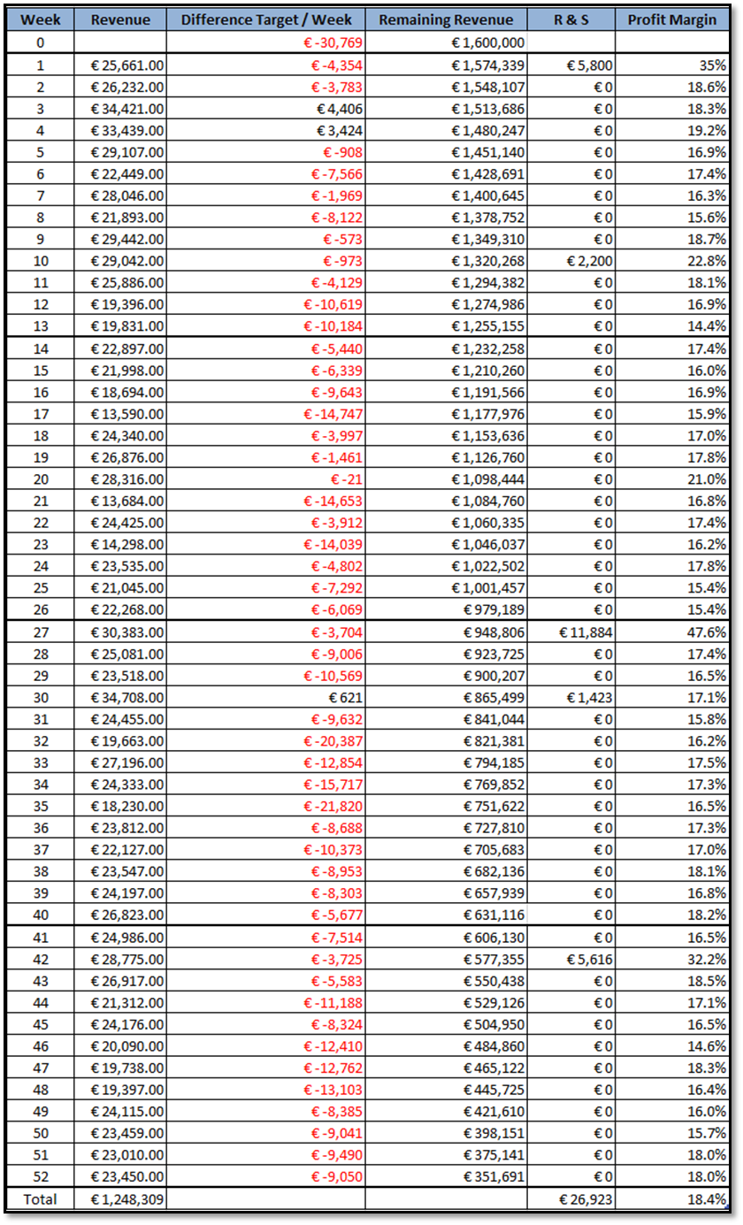

3.2 Permanent Recruitment Fee’s Bergen op Zoom



*Figure 16: R&S Fee's per week - Tempo Team Bergen op Zoom (BOZ)*

3.3 Profit Margin Bergen op Zoom



*Figure 17: Profit Margin - Tempo Team Bergen op Zoom (BOZ)*

## 4. Finance Results Roosendaal

4.1 Table Financial Data Roosendaal

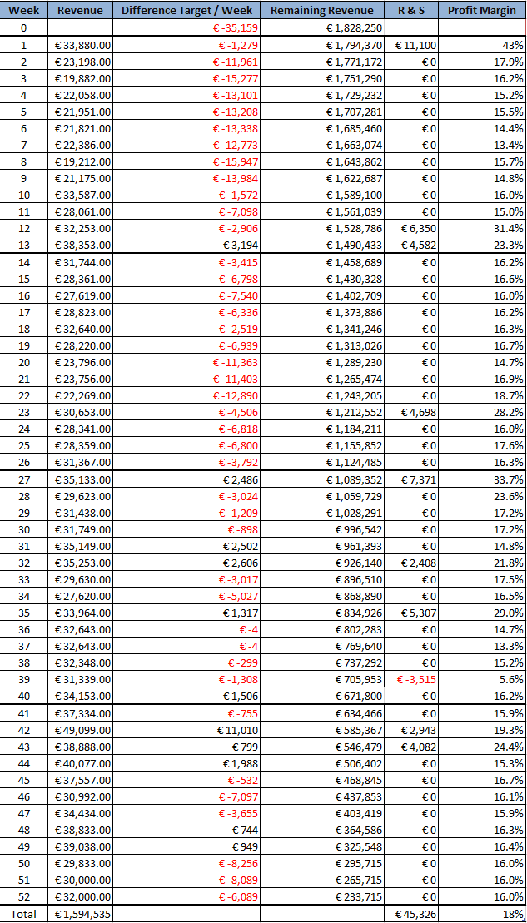

4.2 Financial Analysis Roosendaal

Tempo-Team’s office in Roosendaal had a target of 1,828,250.00 euros for 2017 and a profit margin target of 17.3 %. In terms of profit this means the recruiters had to generate on average 35,159.00 euros per week to reach their revenue target for that year. At the end of the year the office achieved a revenue of 1,594,535.00 euros, which is 233,715.00 euros shy of their target. One can view the complete data set in appendix 3. During the first quarter the recruiters were only able to reach the weekly average needed during the last week. In the second quarter they did not obtain the deserved weekly average. The third and fourth quarter saw better results, where the recruiters saw an increase in revenue obtained compared to the first two quarters. Compared to the Bergen op Zoom office their revenue gained is 346,226.00 euros higher.

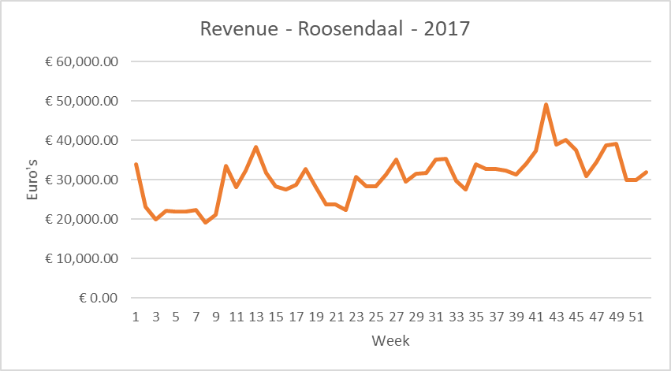

*Figure 18: Revenue per week - Tempo Team Roosendaal (RSD)*

In terms of permanent recruitment fees, the office generated 45,326.00 euros. During each quarter the recruiters could generate permanent placements with their clients. The result was 18,403.00 euros higher than that of the Bergen op Zoom office.

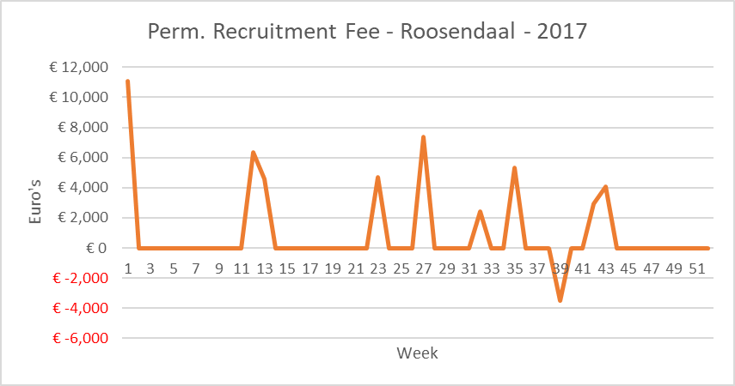

*Figure 19: R&S Fee's per week - Tempo Team Roosendaal (RSD)*

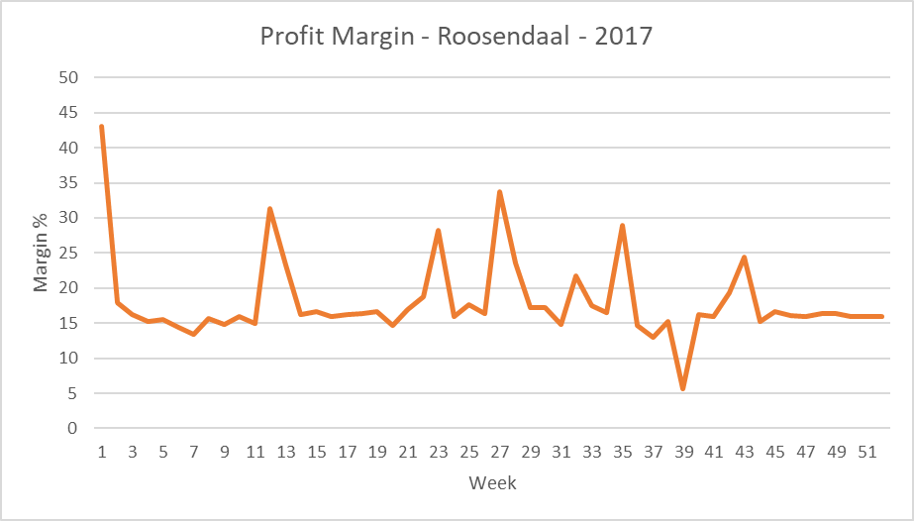

*Figure 20: Profit Margin - Tempo Team Roosendaal (RSD)*

The profit margins fluctuated heavily during the year. After the first week the profit margin was up to 43 % after which is declined. In week 12, one can the next spike after which it falls again. From there we see several spikes in week 23, 27, 32, and week 35. Interestingly, the researcher recorded the office’s lowest profit margin point in week 39. The profit margin was only 5.6% of the revenue gained. At the end of the year however the office had an average of 18 % profit margin which secured their yearly target. Compared to the Bergen op Zoom office their average profit margin was 0.4 % lower.

When considering the revenue and profit margins together one can calculate the nominal profit. 18% of 1,594,535.00 being 287,025.00 euros. This is 62,330.00 euros higher compared to that of the nominal profit of the Bergen op Zoom office.

## 5. Finance Results Zevenbergen

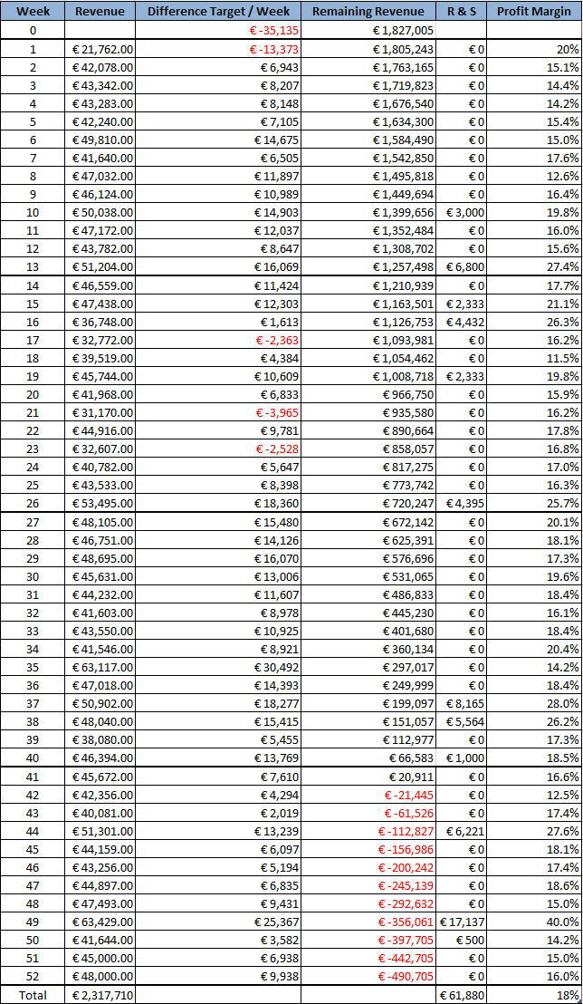

5.2 Financial Analysis Zevenbergen

Zevenbergen saw better results compared to that of Bergen op Zoom and Roosendaal. View appendix 4 for further data. In terms of revenue and fees gained from permanent recruitment placements they outperformed their counter parts. Zevenbergen had a revenue target of 1,827,005.00 euros for 2017 and a profit margin target of 20 %. To obtain their yearly revenue target the recruiters had to generate on average 35,135 euros per week. Only in week 1, 17, 21, and 23 this was not reached. Zevenbergen reached a total of 2,317,710.00 euros which is 490,695.00 euros above their target. Additionally, this is 1,069,406.00 euros higher than that of the Bergen op Zoom office.

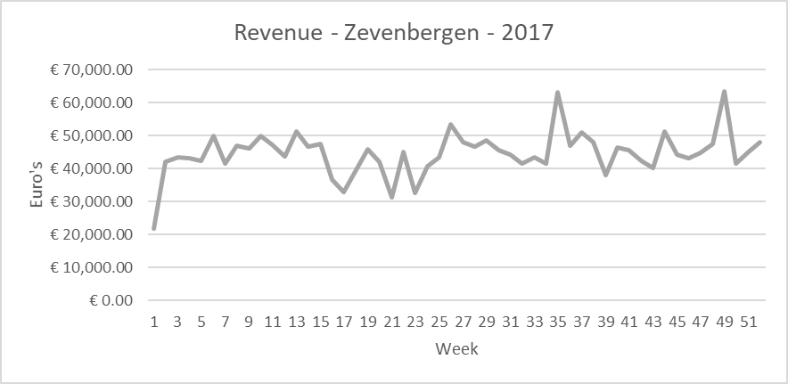

*Figure 21: Revenue per week - Tempo Team Zevenbergen (ZBG)*

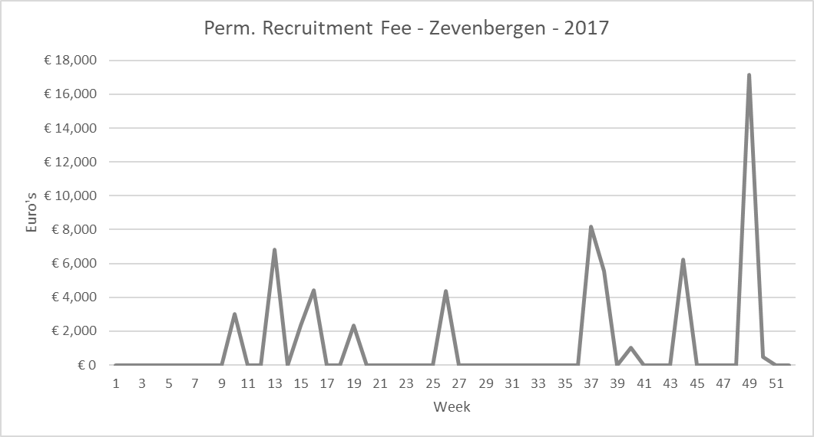

*Figure 22: R&S Fee's per week - Tempo Team Zevenbergen (ZBG)*

Nine permanent recruitment fees were booked during 2017. The lowest being 1,000.00 euros and the highest 17,137.00 euros. In total the office generated 61,880.00 euros which is 34,957.00 euros higher that of the Bergen op Zoom office. In all three collected data sets, Zevenbergen outperformed their counterparts.

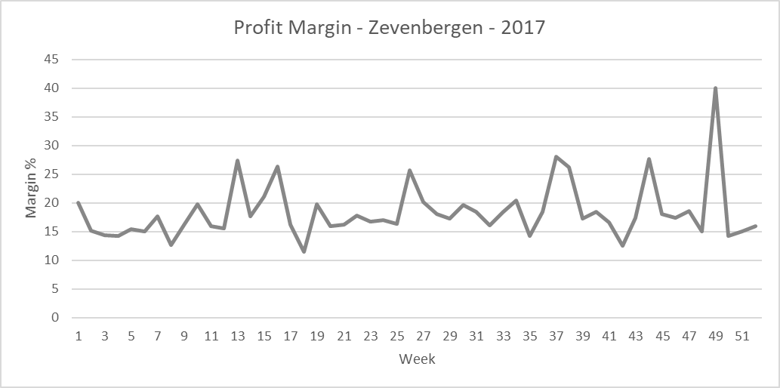

*Figure 23: Profit Margin - Tempo Team Zevenbergen (ZVB)*

## 6. Sales Activities

6.1 Sales activities Data Table

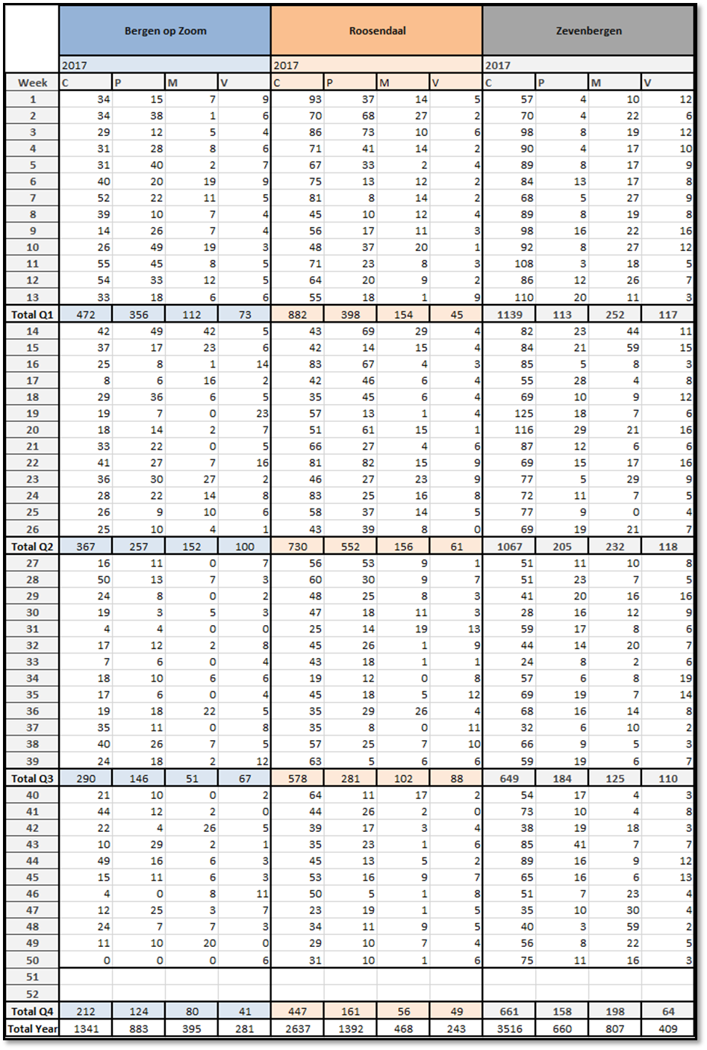

6.2 Calls 2017

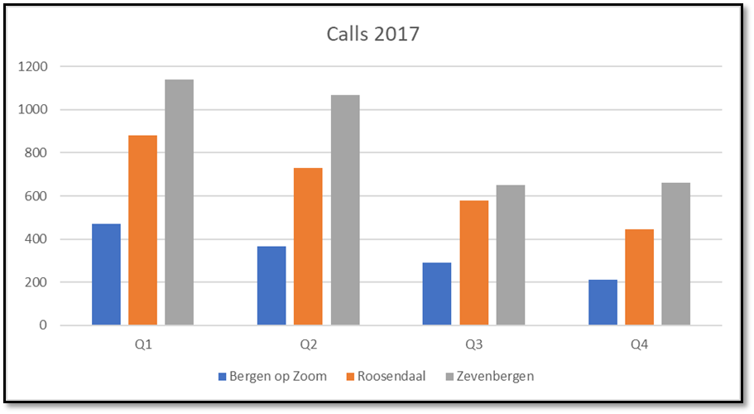

*Figure 24: Client calls made per office per quarter*

Figure 23 represents the telephone calls made to (un)known clients. The calls that are recorded are calls composed of recruiters approaching the clients on their own accord, or companies which call the recruiters of Tempo-Team. The calls are then registered into Tempo-Team’s CRM system.

Starting in the first quarter looking right towards the fourth quarter, we can see a downward trend. Less calls have either been made or registered by the recruiters. Zevenbergen registered the most amount of client calls each quarter, whereas Bergen op Zoom recorded the least. This amount recorded by Bergen op Zoom is three times less than that of Zevenbergen throughout the quarters. In Q1, Bergen op Zoom recorded 472 calls versus 1139 calls of Zevenbergen. In Q4 the difference was even larger being 212 calls vs 661 calls.

Roosendaal remained in-between the two offices, but still recorded twice as much calls compared to Bergen op Zoom.

6.2 Presented CV’s

Presented CV’s are those that are presented to clients without their own consent through either phone calls or during physical meetings with the clients. CV’s that are shared to clients for a job vacancy, that the client has agreed to let the recruiter work on, were not recorded in the data. This being because the job vacancy has already been allocated to the recruiter and thus does not generate new business. By presenting CV’s to clients, the recruiter hopes to be granted the possibility to work on a new job vacancy a client has. Additionally, presenting CV’s to clients that do not have a job vacancy, or the recruiter is not aware that it exists, can lead to new business generation. The client could invite and hire the candidate, which is presented to them, through Tempo-Team even though at that moment there is not a job vacancy open.

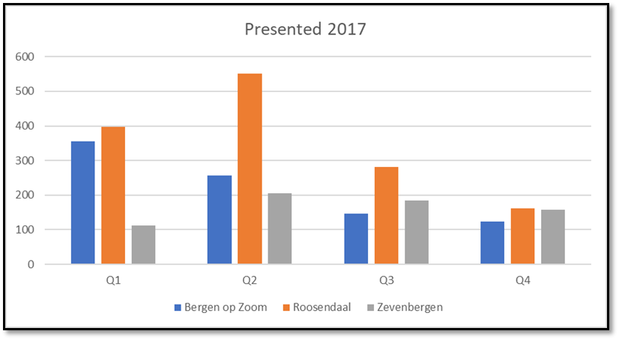

*Figure 25: Presented candidates per quarter per Tempo Team office*

The ‘presented 2017’ graph showcases the CV’s presented to clients. The Bergen op Zoom office presented three times as much CV’s during Q1, compared to Zevenbergen. Roosendaal however presented the most CV’s during every quarter. In Q2 Roosendaal presented twice as many CV’s compared to Bergen op Zoom and Zevenbergen. Overall Q1 and Q2 saw higher results in recorded CV’s presented then Q3 and Q4.

6.3 Client Meetings

The next sales activity which was recorded daily, was the number of physical meetings the recruiters had with (un)known clients. Meetings that are recorded may consist of one-on-one meetings planned with clients, unplanned visits of recruiters with clients, and contact moments where a recruiter meets a client. These contact moments can be at an event, gathering etc. When a recruiter visits a client together with another recruiter this is counter as two visits.

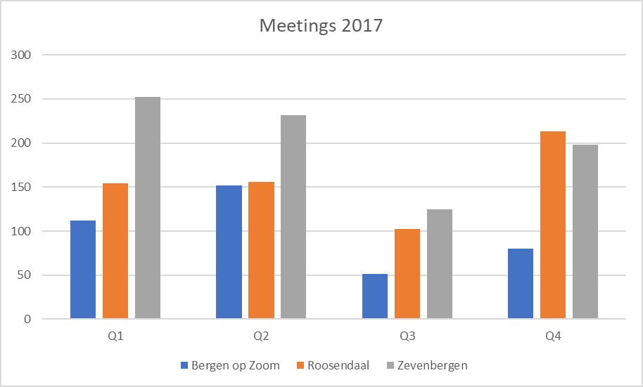

*Figure 26: Meetings with clients per quarter per Tempo-Team office*

During 2017, Bergen op Zoom’s recruiters visited their clients 395 times, Roosendaal 468 times and Zevenbergen scoring 807 meetings. Again, Bergen op Zoom was at the lower range of the spectrum scoring twice as few meetings as Zevenbergen. During Q3 one can see a reduction of meetings for all the offices. This can be explained by the summer holiday period when client contacts are frequently away. In Q4 the number rises again to adjust for the previous quarter.

6.4 Job Vacancies

The previous variables should cause for an increase in obtained business. The obtained business is translated into job vacancies which were received from clients by the recruiters. One can view Zevenbergen again scores the most job vacancies in 2017 (409), whereas Bergen op Zoom and Roosendaal score 281 and 243 respectively. In Q1 and Q2 Bergen op Zoom found itself in-between Zevenbergen and Roosendaal but fell short again during the last two quarters. Roosendaal started at the bottom of the spectrum and claimed the 2nd most job vacancies during the last two quarters.

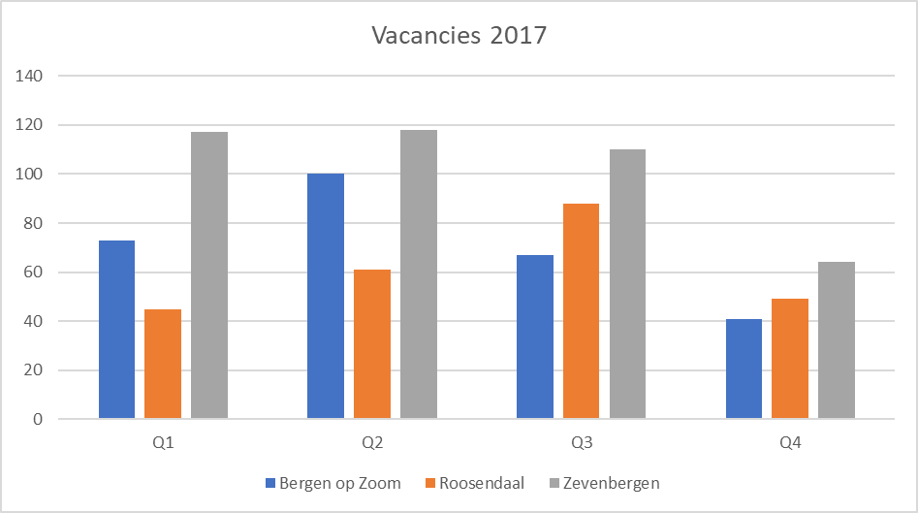

*Figure 27: Vacancies obtained per quarter per Tempo Team office*

## 7. Bergen op Zoom’s clients

7.1 Client Data Table

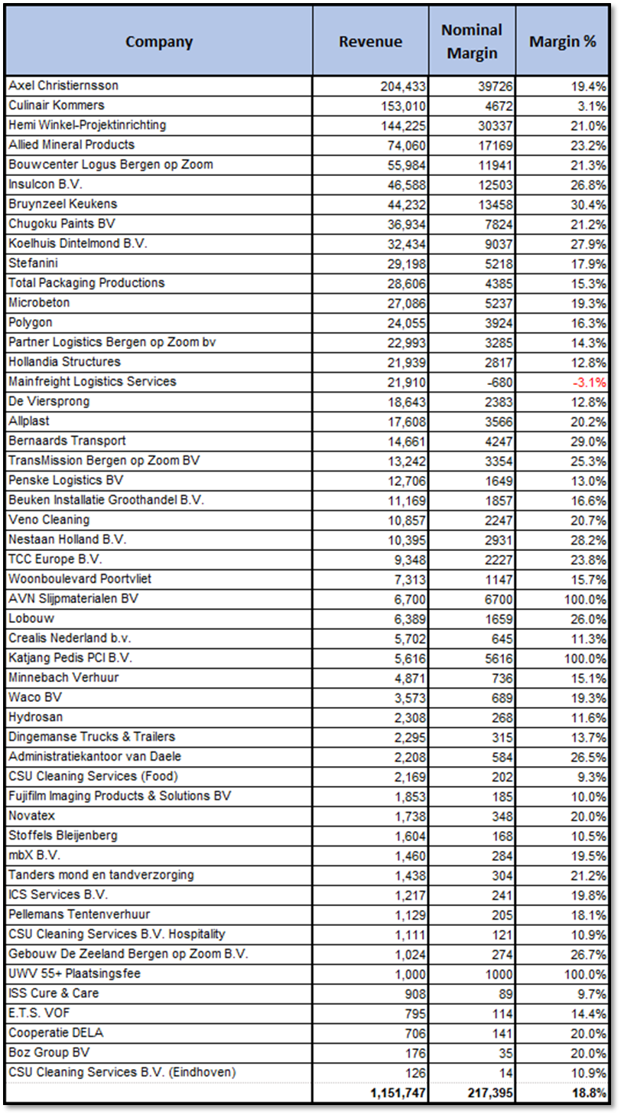

7.2 Client Revenue

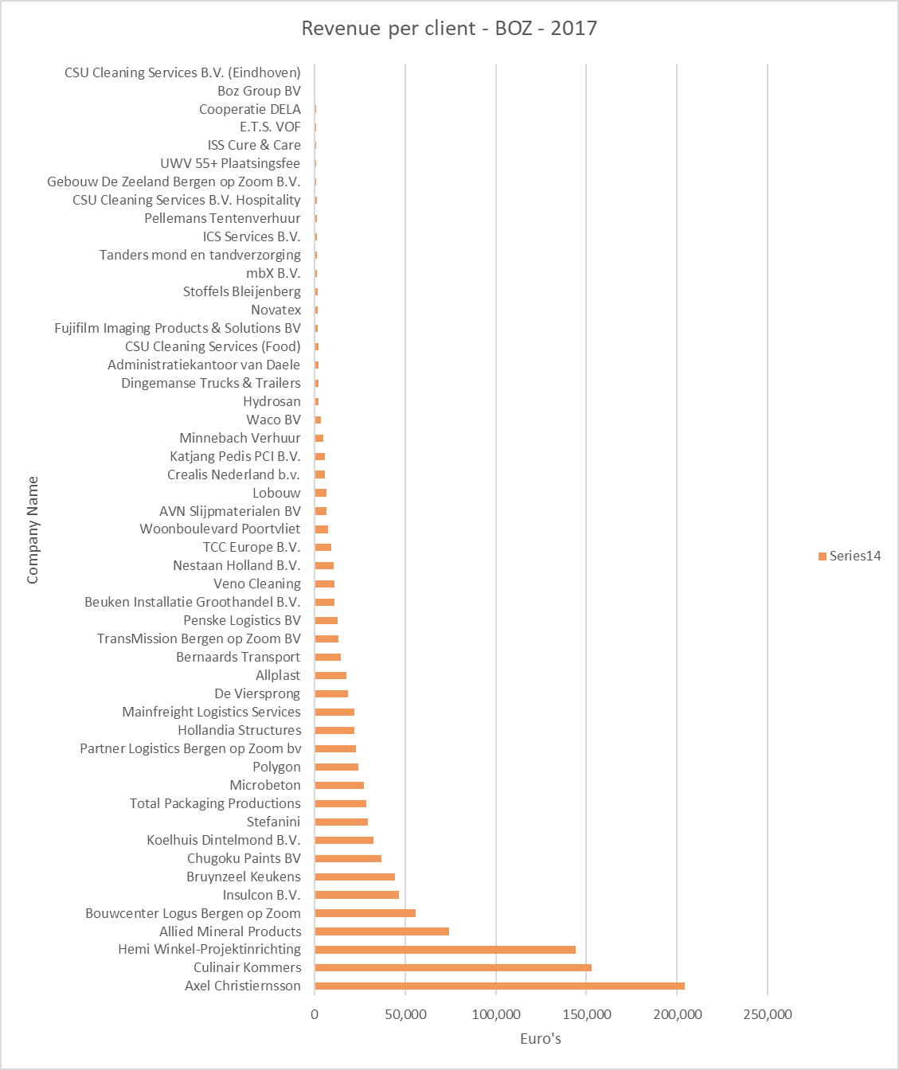

Figure 28: Client revenue Bergen op Zoom Tempo Team’s office

When consulting the data regarding revenue gained per client one can divide the clients into three groups. The large accounts; Axel Christiernsson, Hemi-Winkel-Projektinrichting and Culinair Kommers. Combined they generate 501,000.00 euros in revenue. The 2nd group is compiled of smaller companies where multiple placements have been made. This group consists of Allied Mineral Products, Bouwcenter Logus, Bruynzeel, Koelhuis Dintelmond B.V. up till Bernaards Transport. They generate combined 530,172.00 euros for the Bergen op Zoom recruiters. The last group are companies where single placements have been made in 2017, combining a revenue of 119,906.00 euros.

7.3 Client Profit Margin

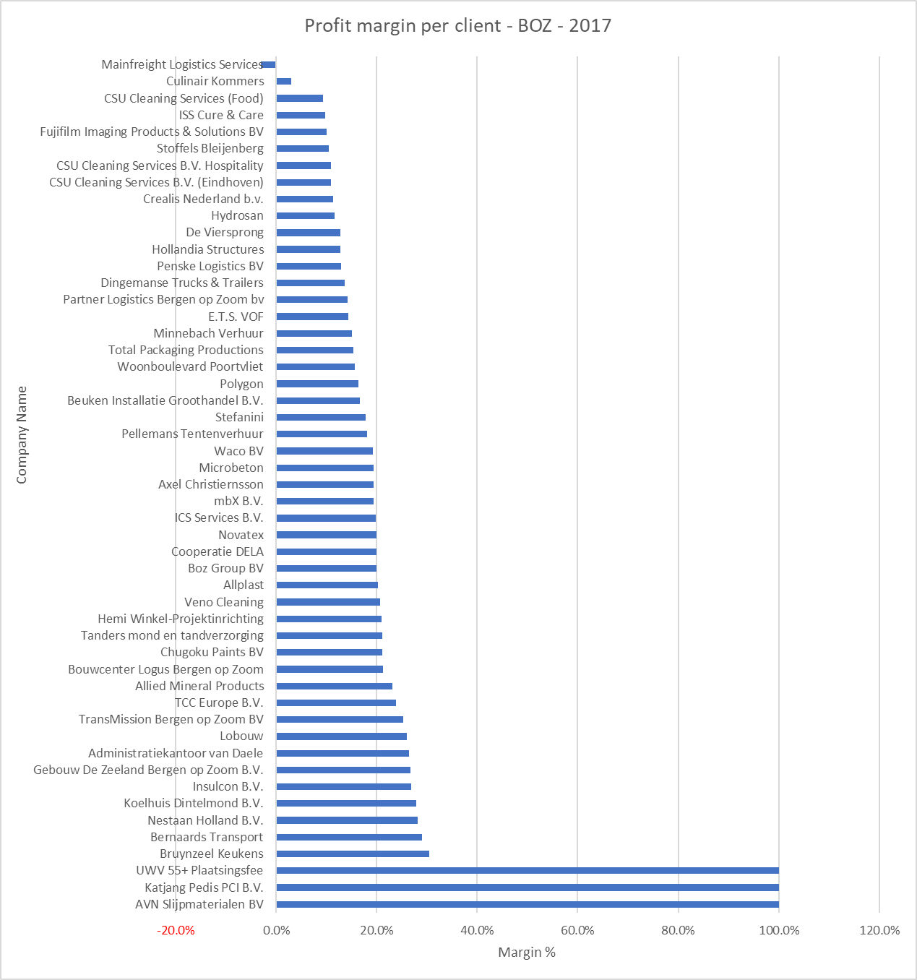

Figure 29: Client Profit Margin Bergen op Zoom Tempo Team’s office

In terms of profit margins, one can spot a different radical change in client ranking. The high revenue generators are now to be found in the middle of the graph, with an average profit margin of 18-20%. AVN Slijpmaterialen BV, Katjang Pedis, and UWV have a 100 % profit margin. All the clients ranked below Stefanini generate revenue at a 18 % or lower profit margin. Mainfreight Logistics even generates a negative profit margin and is costing Tempo-Team income.

7.4 Client Nominal Profit

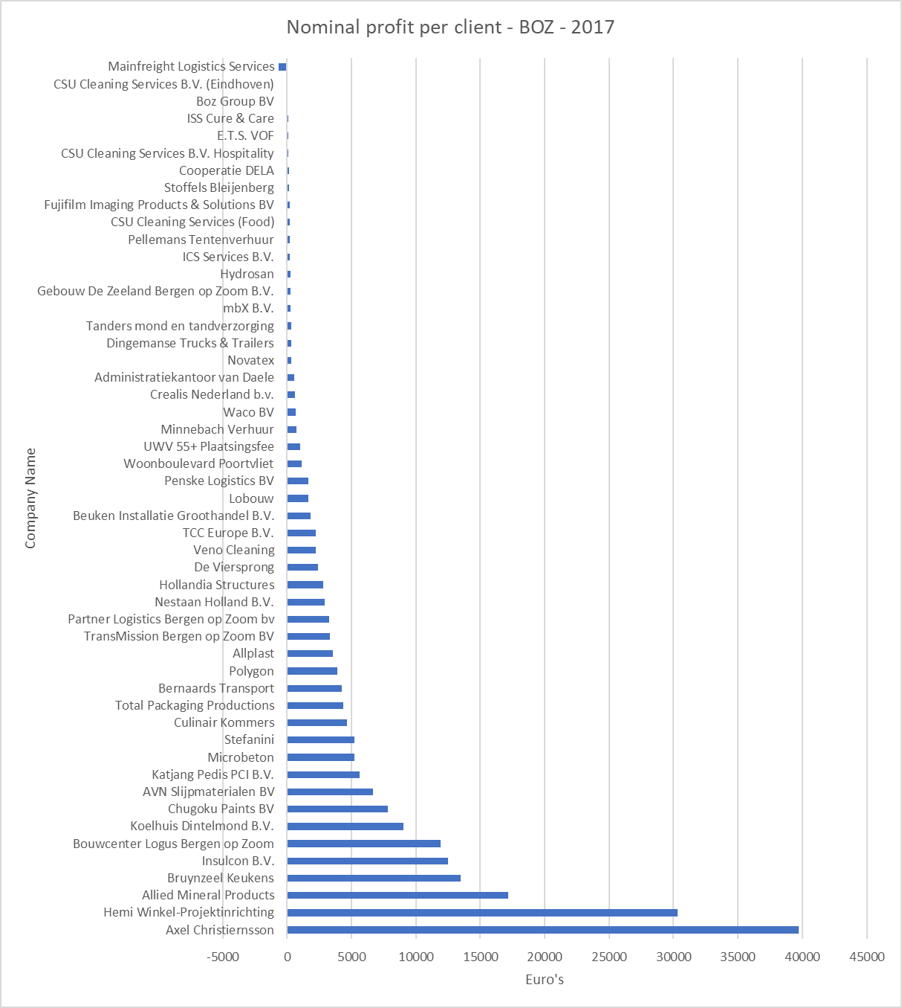

Figure 30: Client Nominal Profit Bergen op Zoom Tempo-Team's Office

Revenue and profit margins tell half the story. When one combines the two, the researcher can visualize how much profit a company truly generates. In terms of finance one needs revenue and cash flow to be healthy. But for the sake of the research one will solely look at which company generates the most profit for Tempo-Team Bergen op Zoom.

From the above table one can see that Axel Christiernsson generates the biggest amount of nominal profit in euros (39,726.00 euros). As expected the following companies are from bottom to top; Hemi-Winkel-ProjectInrichting, Allied Mineral Products and Bruynzeel. They do not only generate the most revenue but also the most nominal profit. Culinair Kommers, which was one of the highest revenue generators disappoints, bringing in only 4,672.00 euros in nominal profit

## 8. Final Data Sheet – Pivot Table















## 9. Jack Welch’s Vitality Ranking

