The effects of developing low-dynamic intertidal areas on ecology: The occurrence of wading birds in relation to benthic macro-fauna

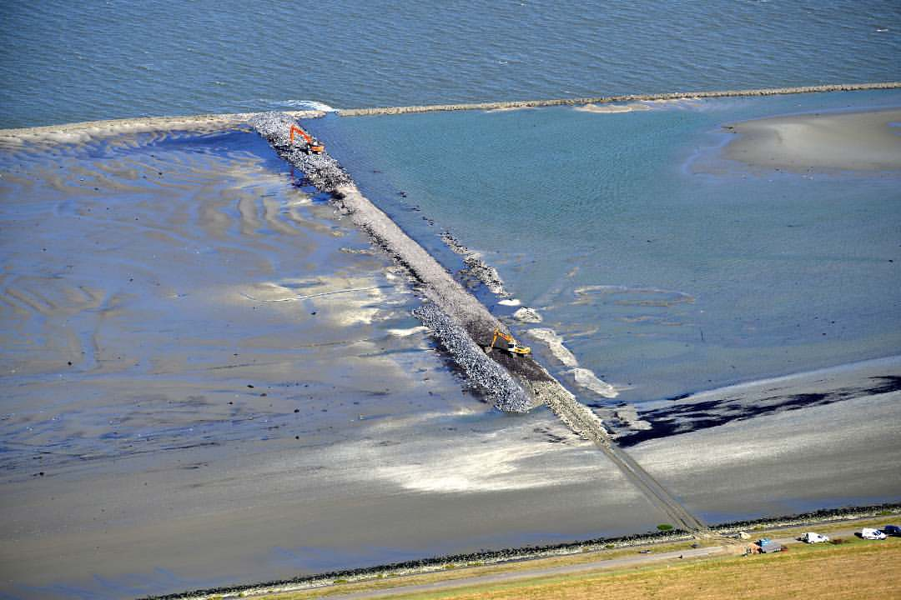

Image from Provincie Zeeland

|  |  |
| --- | --- |
| **Student:** | Mike Hoeder |
| **University:** | HZ University of Applied Sciences |
| **Research Institute:** | Wageningen Marine Research (WMR) |
| **Location:**  **Date:** | Yerseke, the Netherlands  1st of August 2018 |
| **Supervisors:** | Dr. Anneke van den Brink (HZ)  E-mail: [brin0023@hz.nl](mailto:brin0023@hz.nl)  Dr. Brenda Walles (WMR)  E-mail: [brenda.walles@wur.nl](mailto:brenda.walles@wur.nl) |
| **Version:** | Final |

# Abstract

Coastal soft-sediment habitats are some of the most valued ecosystems due to their high productivity, sustaining coastal food webs. However, coastal soft-sediment habitats are under pressure due to human activity and sea level rise. To preserve or restore soft-sediment habitats different management strategies are tested, like tidal flat nourishments and groins. The tidal flat of Knuiterhoek located in the Westerschelde (The Netherlands), has eroded till an un-erodible peat layers low in benthic life. Groins were constructed to reduce flow velocities stimulating sedimentation in order to creating a mud layer full of benthic species which serve as food for waders. This research describes the ecological state of this tidal flat just after implementation of the groins. Benthic samples were taken at the area under influence of the groins (project area) and a reference area. At this stage, a lower species richness, abundance and biomass is expected in the project area compared to the reference area just after completion of the groins. Monthly low water bird counts are executed to give insight in changes in habitat use. The research showed that the current ecological state of the project area harbours less benthic macrofauna, has a lower diversity, and lower abundance. This is reflected in less waders foraging in this area. No relations between benthic macrofauna and abiotic parameters and benthic macrofauna and wading birds were found. Long-term monitoring is needed to test if groins can improve the quality of the tidal flat in terms of macrofaunal community and feeding ground for waders.

Contents

Abstract 4

1. Introduction 7

2. Theoretical framework 9

2.1 Geomorphological and hydrodynamic development 9

2.2 Ecological development 9

2.2.1 Benthic macro-invertebrates 9

2.2.2 Waders 10

3. Research questions 11

4. Methods 12

4.1 Study area 12

4.2 Data collection 15

Macro-invertebrates 15

Flow velocity and sediment characteristics 15

Sediment organic carbon 15

Waders 16

Oyster reef development 16

4.3 Data analysis 17

5. Results 18

5.1 Benthic macro-invertebrates 18

5.2 Abiotic parameters 20

5.3 Waders 21

5.4 Oyster reef development 23

6. Discussion 26

7. Conclusion 28

8. Recommendations 29

Acknowledgements 30

Works cited 31

Appendix 35

*I Data collection – oyster condition index* 35

*II Data collection – Occurrence of waders* 36

*III Data collection – Abiotic parameters* 37

*IV Data collection – benthic macro-invertebrates* 38

*V Data analysis – biomass and abundance of benthic macro-invertebrate species per area* 39

# Introduction

Coastal soft-sediment habitats such as intertidal flats are productive systems that harbour high biomass of benthic organisms which makes them some of the most valued ecosystems that sustain coastal food webs (Costanza et al. 1997). They are an important foraging area for waders that feed on the benthic macrofauna. However, coastal soft-sediment habitats are under heavy pressure from human activity such as dredging, shipping, land reclamation and alterations to flow regimes, which has led to a dramatic depletion of habitat and species (Poff et al. 1997; Lotze et al. 2006; Cozzoli et al. 2017). Furthermore, rising sea level due to climate change threatens to alter current coastal habitats even further, reducing foraging areas for waders (Austin & Rehfisch, 2003).

To protect threatened species and habitats, areas are designated by national governments to be developed and maintained under Natura 2000 legislation (European Commision, 2016). The Westerschelde estuary (figure 1) is classified as habitat type H1130 of which it is one of two left in the Netherlands (Feringa, 2016). One of the habitats that have declined in the Netherlands are the low-dynamic intertidal areas. The flow regime of the Westerschelde estuary has been altered since the middle ages when tidal flats were reclaimed for agricultural, industrial, and urban developments (Meire et al. 2005), and is still altered regularly by maintenance activities with regards to keeping the navigation channel accessible, such as dredging, dumping of sediments, and land reclamation (de Vriend et al. 2011). Dredging and land reclamation, combined with sea level rise, can influence the tidal regime which is already observed in the tidal amplitude. Near Antwerp, the tidal amplitude is about twice as much than at the mouth. This also influences discharge of the river and can lead to increases in flow velocities (Meire et al. 2005).

Currently, valuable low-dynamic intertidal areas are under pressure in the Westerschelde due to human activities. Benthic life is usually poor in high-dynamic intertidal areas as not much animals are adjusted to the circumstances. The low-dynamic intertidal areas have a relatively low flow velocity (<0.8 m s-1), and therefore provide the opportunity for fine sediments such as silt to settle. They also provide an attractive environment for benthic species, such as macro-invertebrates and algae. These species are preyed upon by several species of fish and birds. Examples of benthic species common to low-dynamic intertidal areas (according to Bouma et al. 2005) are *Cerastoderma edule, Limecola balthica, Mya arenaria, Peringia ulvae, Corophium sp., Bathyporeia sp., Crangon crangon, Arenicola marina, Scoloplos armiger, Pygospio elegans, Nepthys hombergii,* and *Lanice conchilega*. Mussel beds (*Mytilus edulis*) and oyster reefs (*Crassostrea gigas*) form eco-elements in the system. The actual composition of species is dependent on several factors including flow velocity, soil characteristics, and inundation time. The population of birds using the intertidal areas also dependents on a multitude of factors such as quality of the food, inundation time, disturbances but also the availability of other habitats such as breeding area or resting places during high-tide.

By changing the environment, and therefore the benthic community, oyster reefs can attract birds. Some birds tend to prefer foraging near the oyster reefs, especially birds with specific prey requirements. Birds that are more general feeders tend to more uniformly forage in the available area (van der Zee et al. 2012). The oyster reefs can provide shelter for epi-fauna such as *Littorina littorea* and *Carcinus maenas,* which can be a source of prey for birds.

At Knuitershoek, a location in the Westerschelde, the intertidal area can be characterised as high dynamic with flow velocities exceeding 0.8 m s-1. These high flow velocities have led to the exposure of an organic peat layer low in benthic biodiversity and abundance. To restore low-dynamic intertidal areas, two breakwaters were enlarged, and one was introduced at Knuitershoek (Provincie Zeeland, 2018). Due to the breakwaters, a reduction in tidal flow is expected, resulting in low dynamic intertidal area with flow velocities below 0.8 m s-1. Sediment accumulation is expected to occur. The breakwaters were constructed in 2017 and the project area is monitored for at least 5 years to increase knowledge on the development of such areas (Geerts, 2015). It is expected that changes in flow regime will result in a macro-benthic community comparable to other low-dynamic intertidal areas in the Westerschelde. This study is focussed on the macro-invertebrate occurrence and the use of the area by birds.

The aim of the research is to create insight in the current macro-benthic species composition and abundance as well as its relation to birds in the area at Knuitershoek in the Westerschelde, the Netherlands. The effects of sedimentation on the area, in particular on the oyster reefs, and its development due to the introduction of breakwaters is monitored. The purpose is to increase knowledge on the development of this particular area that can be used to examine similar areas elsewhere. The use of the area by wading birds is of particular interest as some species are in decline or near threatened (IUCN, 2017). The development of the oyster reefs and the use of these reef areas by wading birds is studied to assess their ecological importance for the area. This research is the start of a long-term monitoring which will provide insight on the long-term development of this area.

# Theoretical framework

## Geomorphological and hydrodynamic development

Sediment accumulation or depletion is mainly caused by littoral transportation of sediments (Birben et al. 2007). Net erosion occurs when the total energy in the environment is high (Jones & Jaffe, 2013). Breakwaters have the capacity to reduce the hydraulic energy emanating from currents and waves, although the porosity of the design can have implications for the effectiveness (Widagdo, et al., 2015). Callaghan et al. (2010) have shown that wind-driven waves have a higher impact on the bed sediment than tidal- or wind-driven currents. Due to the reduction of hydraulic energy from breakwaters, the opportunity arises for sediment to settle. Therefore, implementation of off-shore breakwaters is a strong countermeasure for coastal erosion (Birben et al. 2007).

Marine sediments on an underlying peat layer are characterised by extremely low contents of sand and coarse silt while, in contrast, the contents of middle- and fine silt as well as clay are rather high (Giani & Giani, 1990). Grain size can differ between locations within an area, because of the influence that hydrodynamics has on the sedimentation or erosion process (Jones & Jaffe, 2013). The altitude of the seabed influences the shear stress resistance as well as the grain size. Both parameters are found to decrease according to the elevation of the seabed in relation to the shore (Ponsero et al. 2016). Hydrodynamic forcing also decreases by a significant amount when getting closer to the shore (Callaghan et al. 2010). There is an interaction between sediment dynamics, biology, and hydrodynamics. A relation between micro-Phyto benthos and sediment stability is shown by Brouwer et al (2000).

## Ecological development

### Benthic macro-invertebrates

Benthic macro-invertebrate species are a link between primary producers and predators on top of the food chain (Hairston et al. 1960). They also have a profound effect on the condition of the benthos by influencing various processes such as bioturbation, denitrification, benthic respiration, and nutrient fluxes. These processes are related to the abundance of benthic animals (Braeckman et al. 2010) of whom the buried ones are usually clustered (Dias et al. 2009; van der Wal et al. 2017). A variety of benthic macro-invertebrate species feed on phytoplankton, however, a reduction in biofilm, which forms the base of the mudflat community food-web (Cheverie et al. 2014), due to changes in sedimentation did not have a negative effect on the communities on a mudflat in the Westerschelde (Brouwer et al. 2000). This suggests that food scarcity is not the limiting factor for benthic macro-invertebrate communities near the research location. Decreasing salinity has a negative effect on the abundance, biomass, and diversity of benthic species in the Westerschelde. The abundance of species is dominated by deposit feeders, while suspension feeder abundance tends to decrease relatively with decreasing salinity (Ysebaert et al. 2003).

Sediment dynamics can have a serious impact on the benthic macro-invertebrate communities. At sites with moderate or low disturbance, there is less dominance by structural species over other species present at these locations (Diaz & Puente, 2008). Not all species can easily adapt to these changes. Therefore, the means of adaptation a species utilizes, has a major influence on the survival during regime shifts (Lytle & Poff, 2004). Sediment characteristics, such as mud or sand content, effects benthic macro-invertebrate species composition as well (Ysebaert et al. 2003).

### Waders

Waders feed on benthic macro-invertebrates in inter-tidal areas. Their foraging behaviour can result in a top-down control on the ecosystem by reducing the number of herbivores and, therefore, increasing the abundance of primary producers (Hairston et al. 1960). However, this is not always the case as shown by Cheverie et al. (2014). The foraging area is not evenly distributed between species as certain species tend to forage at specific patches in the area (Ponsero et al. 2016). This could also be the result of sediment composition and prey speciality of the wader (Quammen, 1982). A shift in benthic species composition or size in an area does not necessarily result in a decrease of waders present, as they tend to adapt by changing to other prey available to them. However, some species are not capable of adjusting to other prey if the preferred prey is not available (Bowgen et al. 2015). Specialist behaviour can occur within species as well, as is the case with black-tailed godwits (*Limosa limosa*), with individuals specializing on bivalves or polychaetes (Catry et al. 2014). Therefore, it is difficult to draw conclusions based on the species present. Even though, the benthic composition can be an important indicator for expected waders because of the preferred prey they might have (Roomen et al. 2012).

Waders face a large variation in the supply of prey between season and years. Although it is species dependent, winter biomass of benthic macro-invertebrates is about half of that in summer. Other difficulties arise for waders foraging in winter because of decreased activity of macro-invertebrates. Therefore, waders tend to prefer warmer sites for foraging (Zwarts & Wanink, 1993). Foraging effectiveness is based on prey availability and activity and tends to be lower on a restored mudflat compared to an already existing mudflat as the area might not be colonized to its fullest yet by benthic macro-invertebrate species (Mander et al. 2013).

# Research questions

Several questions are to be answered to achieve the desired product. The main question is:

*What is the current ecological state of the intertidal area just after the adjustment of existing and implementation of new breakwaters at Knuitershoek, located in the Westerschelde estuary?*

The hypothesis is that the ecological state is better in the reference area than in the project area in terms of diversity and abundance of benthic macro-invertebrates and waders.

The following questions are to be answered to answer the main question:

*Is there a difference in the benthic macro-invertebrate composition between the project area and the reference area?*

The hypothesis is that the macro-faunal composition will vary greatly between the project area and reference area due to differences in sedimentation rate and current velocity.

*Is there any correlation between organic carbon fraction, and chlorophyll-a content and species abundance?*

The hypothesis is that there is a positive relation between the organic carbon fraction, chlorophyll-a content and macro-invertebrate abundance.

*Are there differences in wader foraging on the project area and the reference area? And how will the populations be affected by the changes in habitat?*

The hypothesis is that the abundance and diversity of waders differs between the project area and reference area. Furthermore, an increase in abundance and diversity is expected at the project area, because new habitats are created within the area with differences in prey composition, availability, and abundance, facilitating the foraging needs of different species.

*What is the effect of sedimentation on the oyster reefs?*

The hypothesis is that the oyster reefs will not be able to keep up with sedimentation rates and will therefore disappear over time.

# Methods

## 4.1 Study area

The Westerschelde, located in the South-west of The Netherlands, is the Dutch part and lower estuary of the River Scheldt which is connected to the North Sea (figure 1). It is a funnel shaped coastal plain estuary with tidal flats, marshes, artificial rocky shore habitats (dikes, groins), deep gullies, and shallow water areas. The estuary is a multi-channel system with a main (navigation) channel. The Westerschelde morphology displays a consistent pattern of mutually evasive meandering ebb channels and straight flood channels. Subtidal and intertidal shoals separate these channels which are linked by connecting channels. It has a length of approximately 60 km and a width of approximately 6 km at the mouth of the estuary and 2 km at the border with Belgium. The tidal range increases from 3.5 m near the mouth to 5 m near the border. The Westerschelde is a meso-tidal system with an average discharge of roughly 100 m3 s-1 (de Vriend et al. 2011). Water retention time in the estuary is between 2 to 3 months, depending on the river discharge (Zwolsmana & van Eck, 1999). Salinity varies between approximately 5.7 and 31.6 with Knuitershoek being in the transition zone between polyhaline (average salinity >18) and mesohaline (average salinity 10-18 and 5.5-10, respectively) (Ysebaert et al. 2003).

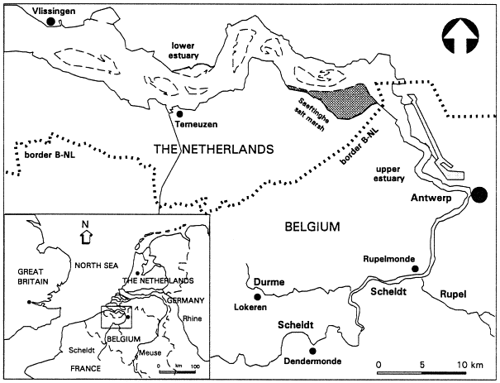

Figure 1 The Scheldt river with the Westerschelde estuary. Studie area indicated by red regtangle. Image retrieved from Zwolsmana & van Eck (1999)

The Westerschelde is currently one of the busiest waterbodies worldwide (Zeeland Seaports, 2018) and an access route to various harbours, of which the port of Antwerp (Belgium) is the largest. In 1970 the navigation channel was deepened for the first time by 2.5 m. A second deepening was carried out in 1997/1998 during which the depth was increased by 1-1.5 m. This has led to an increase in maintenance dredging from less than 0.5 million m3 y-1 to volumes in the range of 7-10 million m3 y-1 (de Vriend et al. 2011).

A picture containing indoor

Description generated with high confidence

Figure 2 A top view of the Westerschelde showing the location of Knuitershoek within the estuary. Images retrieved from: https://www.satellietdataportaal.nl/

Estuarine intertidal flats are high productive areas. Herman et al. (2001) cite research by Underwood and Kromkamp (1999) showing primary production by benthic microalgae in the sediment surface to typically be in the order of 100g C m-2 yr-1. Spring blooms of phytoplankton decrease the lithogenic elements such as trace metals (for example Cu, Zn, and Ag) in favour of biogenic elements such as POC (Particulate Organic Carbon), nitrogen and phosphorus due to dilution of mineral particles by phytoplankton which has lower levels of trace metals (Zwolsmana & van Eck, 1999). Phytoplankton forms a benthic biofilm which is the basis of the food web (Cheverie et al. 2014). As such, the processes of sedimentation and erosion are important for benthic life as they influence the flux of organic content to and from the ecosystem (Herman et al. 2001).

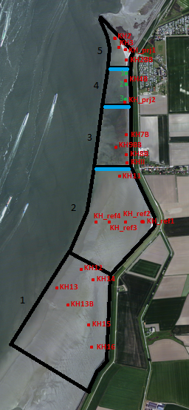Figure 3 Study area with sample locations. The reference area consists of compartments 1 and 2, and the project area of compartments 3, 4, and 5. Breakwaters adjusted or implemented are indicated by the blue lines. Monitoring locations for oyster reef conditions are indicated by green dots. Original image retrieved from https://www.satellietdataportaal.nl/

Sediment in the estuary is mainly sandy, although on parts of the intertidal areas mud can be found. Sand mining in the estuary in recent decades as well as sea level rise have led to a loss in sediment as the import of sediments at the mouth of the estuary cannot keep up with the losses (de Vriend et al. 2011). Partially due to the loss of sediment in the estuary some intertidal flats have eroded to a peat layer which, due to compression of the previously deposited sediment on top, has become unerodable (Koster et al. 2018). This peat layer is poor in benthic life as the organisms are unable to penetrate the dense material because of their body size (Anderson, 1988).

Estuaries serve as important life-supporting systems as they are some of the most productive biomes of the world (Meire et al. 2005). The Westerschelde is an important feeding area of migratory birds due to the high primary production on intertidal areas (Underwood & Kromkamp, 1999) during spring and summer which constitute the transfer of organically unavailable nutrients higher up the food-chain.

To increase the productivity of such intertidal areas, breakwaters are implemented to reduce the flow dynamics and trap sediment, creating low dynamic intertidal areas. Knuitershoek and Baalhoek are examples of locations with high current velocities. Groins are constructed to lower the current velocities to create low dynamic intertidal area, which is characterised by high benthic live.

The top soil layer at Knuitershoek consisted mainly of peat which was exposed by erosion due to high flow velocities. These high flow velocities affect the benthic species abundance and composition, in turn affecting the entire ecosystem.

This study focus is on the current ecological state of the intertidal flat of Knuitershoek (Figure 2). The study area is divided in two parts, a project area and a reference area (Figure 3) which are subdivided in 5 compartments. In the project area two breakwaters are changed and one is implemented. The reference area is expected to not be influenced by the implementation of the breakwaters.

## 4.2 Data collection

### Macro-invertebrates

To investigate the abundance, species richness and biomass of the benthic community, benthic macro-invertebrate samples were taken according to the MWTL method (Dekker, 2010) at 21 sampling stations in the project area (figure 3). Within 1m2, three cores (10cm $Ø$) were taken from the top 35cm of the sediment and sieved over a 1mm sieve. Samples were stored in bottles, labelled, and brought to the lab where they were fixed with formaldehyde.

In the laboratory, samples were coloured with Bengali red to colour the animal protein an hour prior to further processing of the samples. The samples were subsequently washed over a set of sieves with mesh sizes of 1mm, 500µm, and 100µm and sorted. The species in the samples were either immediately identified or stored in a small sampling bottle with ethanol to preserve them for later identification. Identification was done with the use of binoculars or, if necessary, a microscope. The main key used for identification was Marine Species Identification Portal, an online key (ETI Bioinformatics, n.d.). Other keys were used as additional support.

The number of species present in the sample was determined by counting the heads per species. The wet weight was determined by weighing all body parts after adsorption of excess water on a piece of cloth. Biomass, which is the total wet weight converted to the total ash free dry weight in g m-2, was determined by using species specific conversion factors as described in Craeymeersch and Escaravage (2014). The abundance was then converted to g m-2.

### Flow velocity and sediment characteristics

Flow velocity was measured by Deltares with the KnuBa model based on the hydrodynamical properties of the Westerschelde in April 2016. This data was used and includes the breakwaters in their current form.

Sediment dynamics were measured daily by NIOZ (Netherlands Institute for Oceanic Research) with SED-sensors at set locations spread throughout the project area. The sensitivity of these sensors was 2mm (Geerts, 2015). Furthermore, sediment characteristics (%silt and bulk density) was determined.

### Sediment organic carbon

Organic carbon content in the sediment was determined according to ASTM D 2974-87 method C (ASTM, 1993). Sediment samples were taken and bottled in the field, after which they were freeze dried. Heat resistant cups were placed in a desiccator with activated silica for an hour to assure they are dry. The cups were then weighed on an analytical balance (0.0001g accuracy). A minimum of 4g of each sample was transferred to a heat resistant cup and dried in a stove at 70 °C for at least 24 hours. After the drying process the cups were placed in a desiccator with activated silica gel to cool for approximately 1 hour. The cups were weighed again to determine the dry weight. Afterwards the cups are placed in a muffle furnace at 440 °C for at least 2 hours. After cooling for an hour, the ash-free dried weight (AFDW) was measured with the analytical balance. Organic carbon content was calculated with the following formula:

$$Organic carbon \left(m\%\right)=\left(\frac{DWcup-AFDWcup}{DWcup-Wcup}\right)*100$$

where DWcup is the dry weight of the cup filled with sediment, AFDWcup the ash-free dry weight of the cup filled with sediment, and Wcup the weight of the cup.

### Waders

The counting of birds was carried out by volunteers of the bird working group “De Steltkluut”. The birds were counted per compartment twice a month, once with low tide and once with high tide, over the period August 2017 – March 2018. Counting during high tide was to examine if the birds were using the high water resting places. However, the resting use of the area by birds is not of interest for this study, therefore, only the data from counting with low tide was used.

### Oyster reef development

#### Sedimentation on the oyster reefs

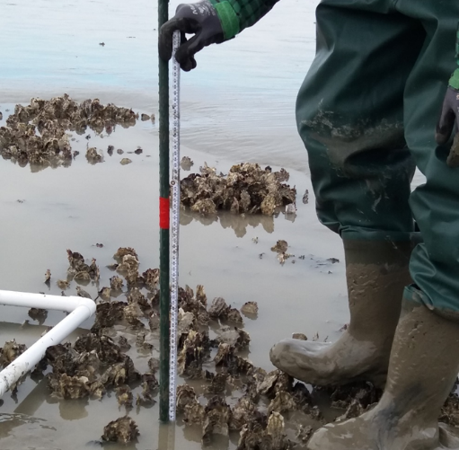Oyster reefs were monitored for a period of approximately 6 weeks at three locations within the area between two breakwaters. The monitoring locations are shown on figure 3. These locations were selected based on their placement and the expected sediment dynamics within the area. At each of these locations three sticks were placed in the ground and the distance of the sediment to the top of the stick was measured to indicate the sediment accumulation or depletion at the location (figure 4). The length above the sediment of 10 oysters near each stick was measured to see if the oysters can keep up with the sedimentation. The top layer of the reef (shells visible above the sediment) within a 0.25 m2 quadrant was collected to determine the condition of individual oysters within the reef.

Figure 4 Measuring of sediment accumulation on top of the oyster reefs

#### Condition and diversity of the oyster reefs

The condition of 20 oysters per sampling location was determined to give an indication of the reefs general health. This attributes to the adaptability of the reefs to the environmental changes due to the breakwaters. After collection the oysters were placed in a freezer for conservation. The shell length, width and height were measured in mm. The shell is air-dried over a period of 24 hours and the weight was measured in g. The condition index (CI) was calculated according to Lawrence and Scott (1982) with the following formula:

$$CI \left(\frac{g}{ml}\right)=\frac{AFDW (g)}{ICV (ml)}$$

in which AFDW is the ash-free dry weight and ICV the internal cavity volume. The oysters were dissected by separating the flesh from the shell. The flesh was dried at 70 °C until a constant weight was achieved. The ash-free dry weight was determined by weighing the samples at room temperature after incinerating the flesh at 540 °C for 4 hours. The shells of the oyster are submerged in water while pushing the valves tightly together. This allows the empty shell to retain water. The retained water was transferred to a container and weighed in g. Afterwards it was translated to the internal volume of the oyster shell cavity in ml (Walles et al. 2016).

The biodiversity on the oyster reefs was examined within 50 by 50 cm quadrants (n=3) representable for the location. The species within this quadrant were counted and collected when unknown to identify in the laboratory. This was done in triplicate at each location to provide proper insight in epi-fauna present on these reefs.

## 4.3 Data analysis

Data analysis was carried out with Microsoft Excel (Office 365). Correlations were tested with the independent two-tailed T-test. Standard errors were calculated with the following formula: $$SE =\frac{Standard deviation}{√n}$$

# Results

## Benthic macro-invertebrates

Thirty-two species of macro-invertebrates were found in the samples taken at Knuitershoek of which 7 species occur in more than half of the samples (figure 5). Species richness and total abundance per sampling point are visualized in figure 6. The most common species are polychaetes and bivalves. Crustaceans occur less often within both the reference area and project area. The project area and reference area show significant difference in the species richness (p = 0.03). Though not significant, mean abundance (p = 0.61) and biomass (p = 0.24) were lower in the project area compared to the reference area (figure 7).

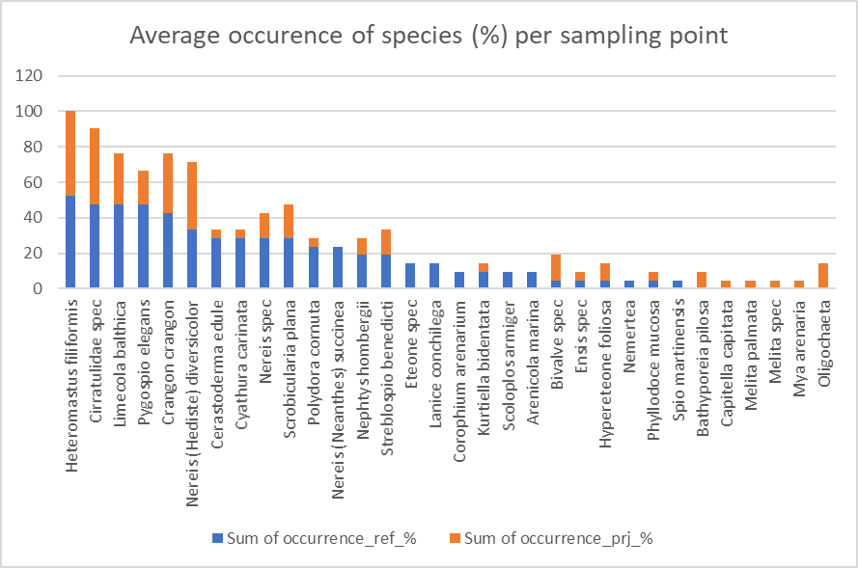

Figure 5 Occurrence of species in reference area (blue) and project area (orange) based on total abundance in the two areas. Samples were taken in autumn 2017.

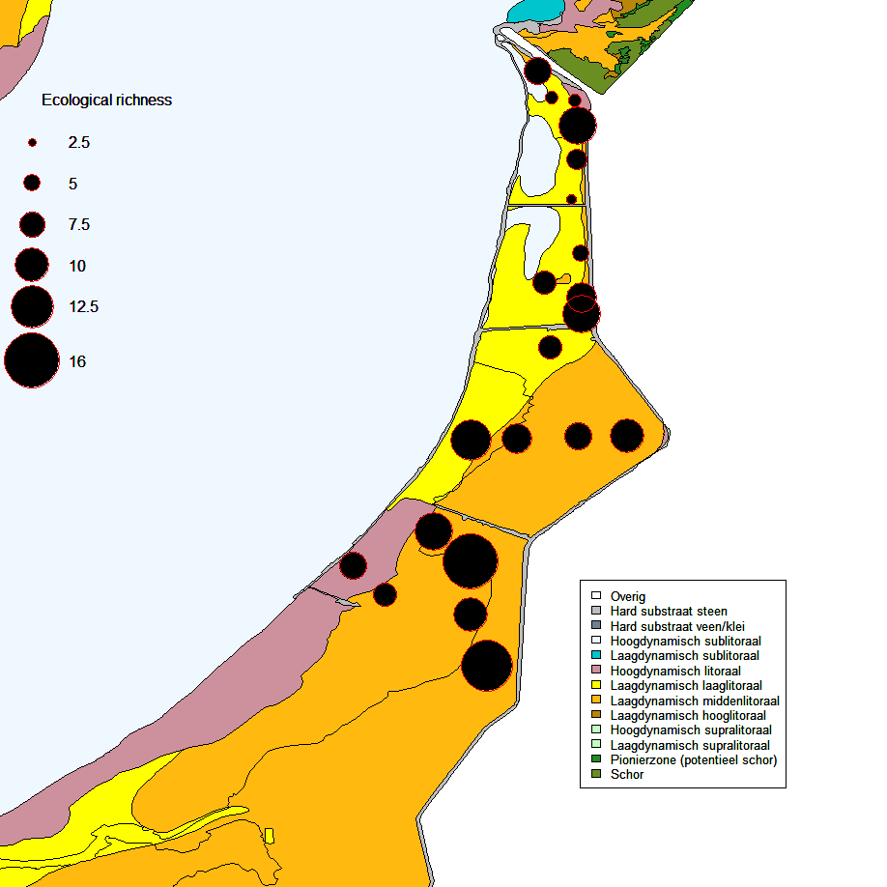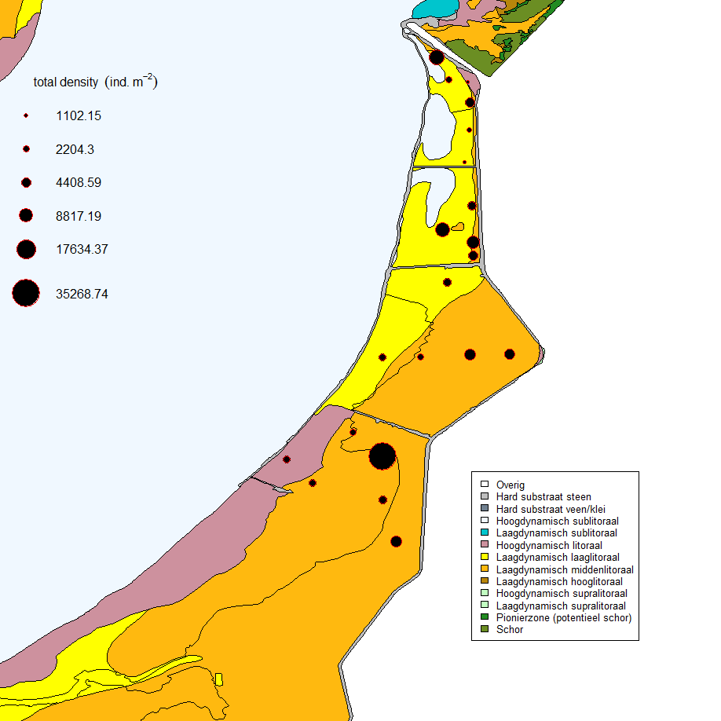

Figure 6 Ecological richness and total abundance/density (ind. m-2) of macro-invertebrates per sampling station in autumn 2017.

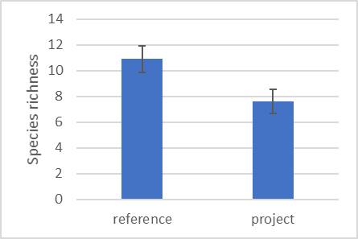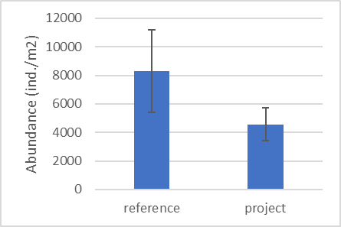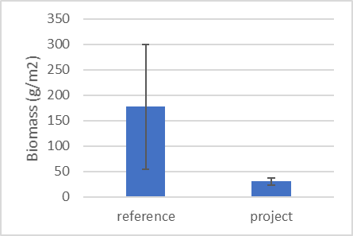

Figure 7 Species richness (mean ± se), abundance (ind.m-2 mean ± se) and biomass (g m-2 mean ± se) differed between the project area (n=10) and the reference area (n=11) (Species richness, p = 0.03; abundance, p = 0.61; biomass, p = 0.24).

## Abiotic parameters

Percentage organic content was higher and bulk density lower in the project area, however not significantly different from the reference area (figure 8). Bulk density (p = 0.23) and organic content (p = 0.29) do not show a significant relation.

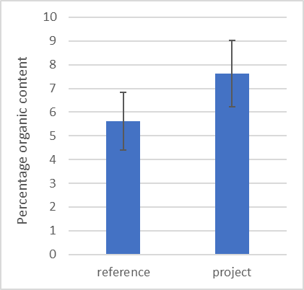 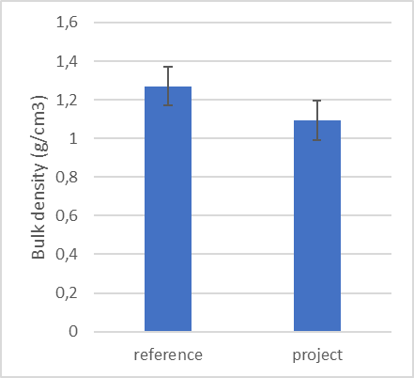

Figure 8 Percentage organic content and bulk density at the reference area (n=11) and project area (n=10).

Average flow velocity occurring at least 50% of the time is higher in the reference area than in the project area (figure 9). Peak flow velocities are quite similar between the reference area and the project area.

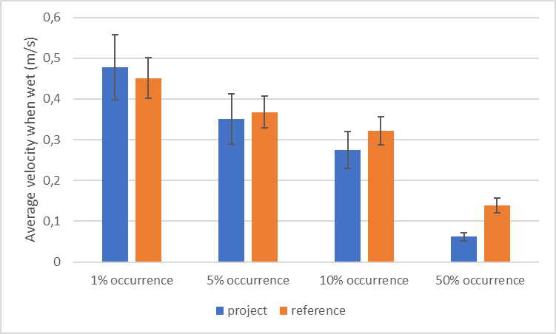

Figure 9 Average flow velocity and percentage of time this velocity occurs within the area when water is present, calculated with the KnuBa model from Deltares. Hydrodynamical properties of the Westerschelde in April 2016 were used for this simulation.

## Waders

There were 16 species of birds observed at Knuitershoek between August 2017 and March 2018 (figure 10). The area was highly dominated in presence by *Haematopus ostralegus* (Eurasian oystercatcher) which occurs in over 80% of the counting’s done per area and has the highest abundance per ha (figures 10 and 11). *Numenius arquata* (Eurasian curlew) has the highest occurrence in the area; they are the species that is observed most often during counting. Most species are observed occasionally and are present in low densities.

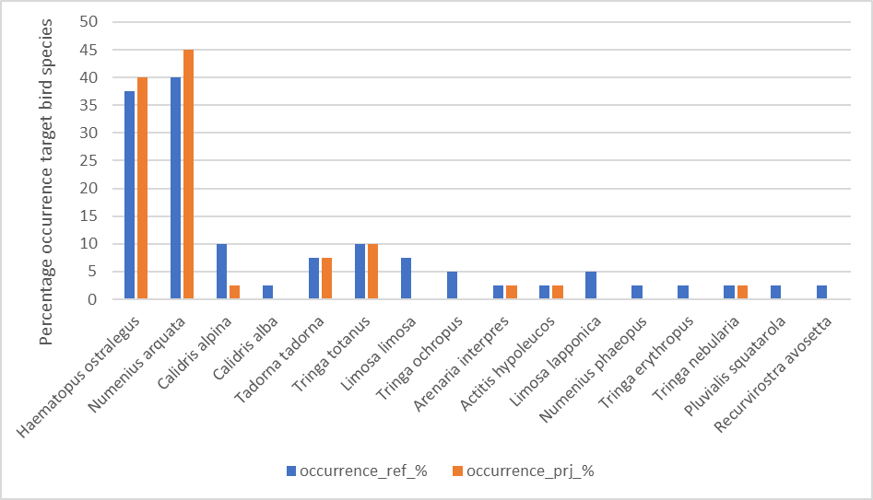

Figure 10 Low water counts of the occurrence per compartment over the counting campaign based on the total occurrence in the study area of target bird species at reference area and project area of Knuitershoek.

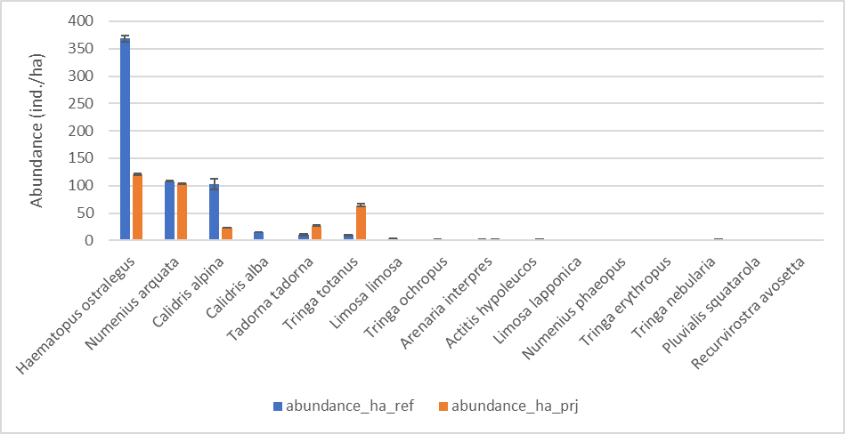

Figure 11 Average abundance (mean± se) during low water counts of abundance of the target bird species at reference area and project area of Knuitershoek. The abundance is averaged over the entire counting period (August 2017 – March 2018).

Birds were counted in five compartments (figure 3). Characteristics of the five compartments are presented in figure 12. The abundance of birds as well as the biomass of benthic macro-invertebrates seems to be higher in the reference area (compartments 1 and 2) than in the project area (compartments 3,4 and 5). The abundance of birds per compartment does not show a relation with the density of benthic macro-invertebrates within that compartment. Organic content and bulk density also do not show any relation with the abundance of birds.

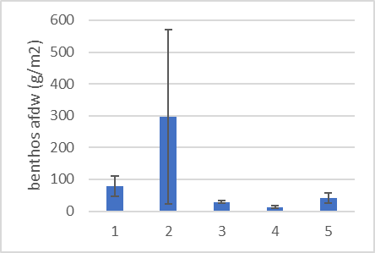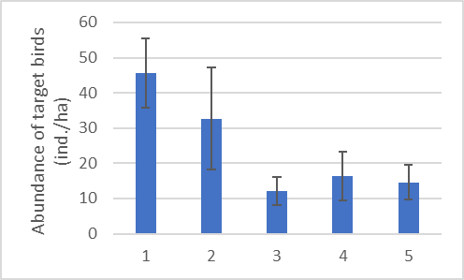

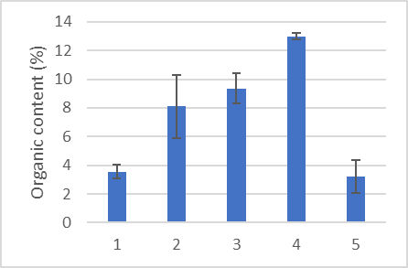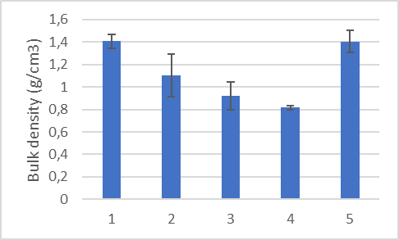

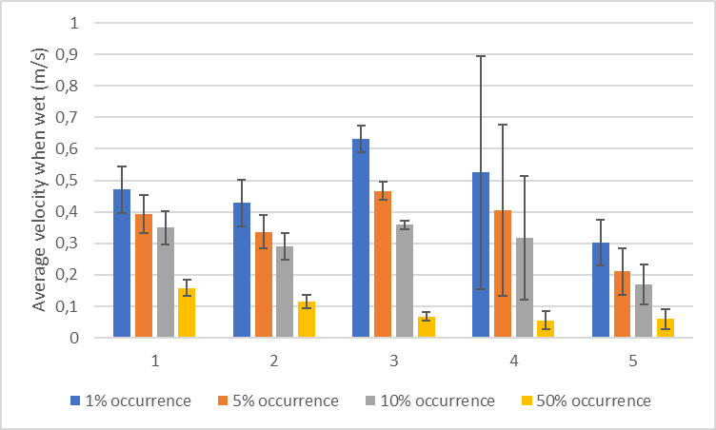

Figure 12 Characteristics of the compartments at Knuitershoek. Compartment 4 shows large variation in error bars (n=2).

## Oyster reef development

#### Sedimentation

The oyster reefs at Knuitershoek are subjected to rapid sedimentation and are being buried at some locations (figure 13). The accumulation of sediment occurs in the areas where the largest changes in flow velocity were predicted by the Deltares KnuBa model.

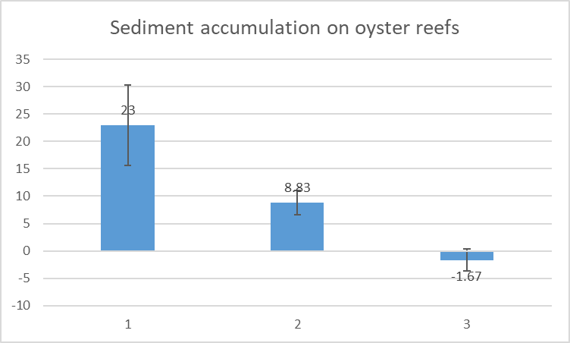

Figure 13 Accumulation of sediment, measured in cm, on oyster reefs in compartment 4 at Knuitershoek. Measurements were done 6th of March and 19th of April 2018.

#### Biodiversity

The abundance of most species on the oyster reefs has decreased between the 6th of March and 19th of April 2018 (figure 14). However, Amphipoda sp. tend to be present in higher abundance on the oyster reefs after sediment accumulation increased. Measuring station 1 had no visible reef left to sample biodiversity on the 19th of April due to sediment burial (figure 16).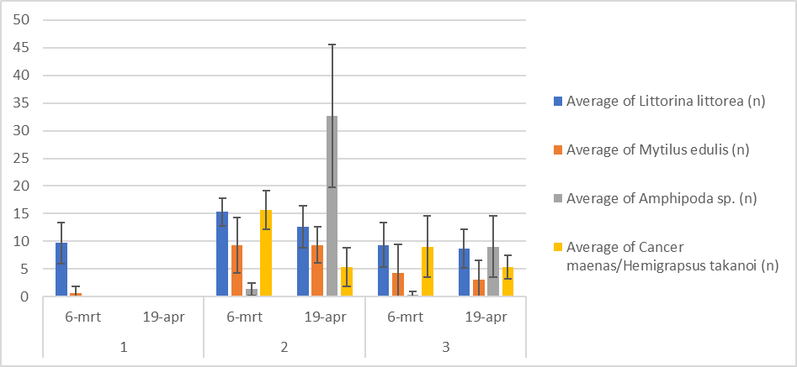

Figure 14 Development of biodiversity on the oyster reefs at Knuitershoek between 6th of March and 19th of April 2018.

#### Condition index

The condition of the oysters within the oyster reefs in compartment 4 improved between 6th of March and 19th of April 2018 (figure 15).

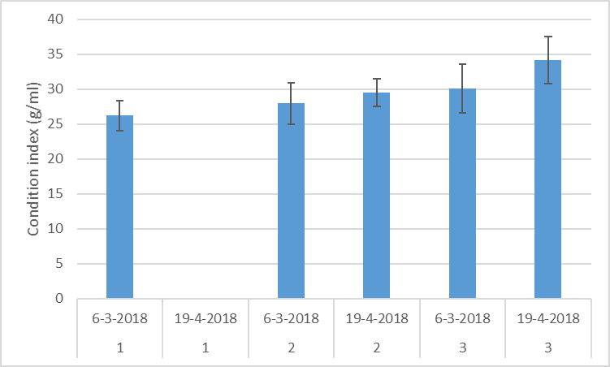

Figure 15 Condition index of individual oysters in compartment 4 at Knuitershoek, Westerschelde. Per sampling station 20 oysters were dissected and analysed.

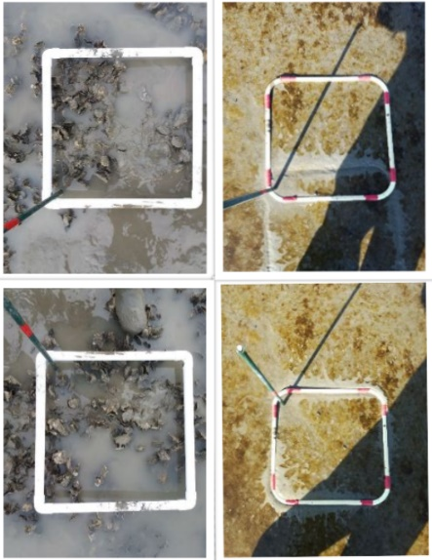**1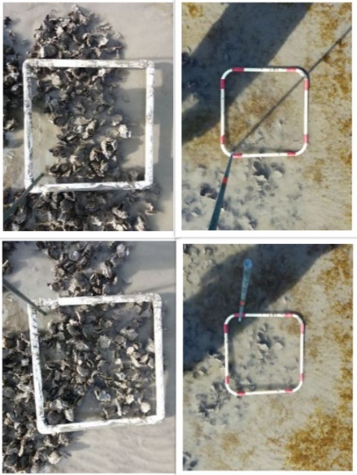2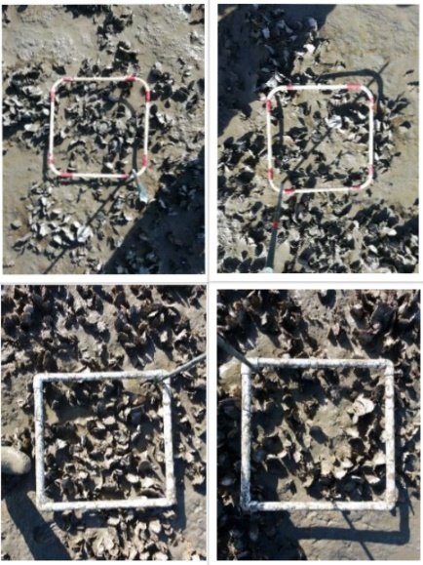3**

Figure 16 Top view images of the oyster reefs sampled at Knuitershoek. Pictures are taken per measuring station (1, 2, and 3) with the left top and bottom pictures taken on the 6th of March and the right top and bottom pictures taken on the 19th of April 2018.

# Discussion

Knuitershoek in the Westerschelde, the Netherlands, is currently a fast-changing area due to the implementation of a new breakwater and the adjustment of the two already existing ones. This results in an extremely dynamic system in which it can be considered very difficult for species to settle and maintain themselves. It is expected that the ecological state of the area, with regards to macro-invertebrates and wading birds, will improve when the system stabilizes over time.

The benthic macro-fauna community significantly differed in species richness between the reference area and project area. Abundance and biomass between the reference area and the project area did not snow any significant differences. However, biomass seems to be higher in the reference area than in the project area. An explanation for this could be that the reference area has established communities in a stable system whereas the project area is changing at a rapid rate, disturbing the existing benthic communities.

The abundance of polychaetes was higher than the abundance of bivalves. Suspension feeders dominate in the polyhaline zone and abundance decreases with decreasing salinity (Ysebaert et al. 2003). Knuitershoek is influenced by discharge from the Scheldt river and tends to have a lower salinity than further downstream of the Westerschelde. This could explain the higher occurrence of polychaetes than bivalves in the area. Also, *Cerastoderma edule* (common clam), a bivalve that buries itself relatively shallow with regards to *Mya arenaria* and *Limecola balthica* (Zwarts & Wanink, 1993), occurs more in the reference area than in the project area. This is probably due to the high rates of sedimentation in the project area as well as the lower bulk density, increasing the difficulty for individuals to maintain themselves in the top soil layer.

Bulk density seems to be slightly lower in the project area compared to the reference area. This could be because of fine sediments trapped in the project area. These fine sediments tend to hold high water contents due to the very slow settling rates driven by current velocities. The construction of the breakwaters was finished in July 2017. Therefore, the newly deposited fine sediment in the project area did not have sufficient time to subside and create a dense substrate.

Waders tend to forage more in the reference area than in the project area. Macro-invertebrates in the project area often were smaller in body size than those in the reference area. Birds tend to forage on larger prey because of higher profitability (Zwarts & Wanink, 1993) which could be a reason for the higher abundance of birds in the reference area.

Oyster reefs in the project area are partially being buried by sedimentation processes. However, condition index of individual oysters at the sampled locations which are not fully buried suggest that individual oysters are not influenced heavily by the high rates of sedimentation. As such, it is more likely that the condition of individual oysters has improved due to seasonal influences such as increased availability of food and temperature.

*Amphipoda sp*. are present in higher abundance at the disappearing oyster reefs than elsewhere in the area. This could be due to higher protection from predation within the oyster reefs. It was noticed during sampling in the area that foraging by birds on the oyster reefs was limited to a few individuals of the species *Larus argentatus* (European herring gull) which prefers larger prey. Species living on the oyster reefs were crustaceans and bivalves. Species of these classes are preyed upon by *Calidris alpina* and *Haematopus ostralegus* (Bowgen et al. 2015), as well as *Larus argentatus*. However, these species are capable of feeding on other prey as well (Bowgen et al. 2015). Therefore, disappearance of the oyster reefs is not expected to have a large effect on the bird populations at Knuitershoek.

Chlorophyll-a content was not analysed in time to be considered for this research. As an indicator of primary production, chlorophyll-a content is an important parameter to understand the ecosystem. It could have been helpful in examining the condition of oysters as well as the differences between the reference area and the project area at a fundamental level.

# Conclusion

The benthic macro-invertebrate composition at separate locations in the area at Knuitershoek tends to be uniform with some species being sporadically present only at one sampling location.

The current ecological state of the intertidal area after the adjustment of existing and implementation of new breakwaters at Knuitershoek, located in the Westerschelde estuary, is currently poorer in the project area than in the reference area in terms of diversity and abundance of benthic macro-invertebrates and waders. This is indicated by the use of the area by wading birds. Sedimentation is observed, and long-term monitoring should provide more insight in the changes occurring in the area.

# Recommendations

This research has been carried out at the start of a five-year monitoring project. Therefore, seasonal influences as well as migration patterns could not be considered. A longer period of monitoring could improve the reliability of the results of this type of research. Sampling locations were not representative for the entire area as some parts were not safely reachable. Sampling locations more evenly distributed throughout the area could improve the knowledge on the benthic macro-invertebrate communities. Also, benthic macro-invertebrate composition was determined only based on the samples collected on the 12th of September 2017 which can only serve as an indication of the composition of this community as it does not provide detailed information on the year-round composition or on the changes due to the implementation of the breakwaters. It is recommended that additional samples over time are analysed to provide insight in changes in the area. At last, chlorophyll-a content could provide essential knowledge about the ecosystem at Knuitershoek but was not determined in time to be considered for this research. It is therefore recommended to consider chlorophyll-a content in future studies.

# Acknowledgements

I would like to thank my supervisors Dr. Brenda Walles and Dr. Anneke van den Brink for their guidance during the final thesis period. Also, I would like to thank Emiel Brummelhuis for helping with the identification of benthic macro-invertebrates, and Willy Baaten and Marian Sponselee for counting the birds and showing how this was done. Lastly, I would like to thank my parents, co-workers, friends, and fellow students for the moral and professional support.

# Works cited

Anderson, J. (1988). Invertebrate-Mediated Transport Processes in Soils. Agriculture, Ecosystems and Environment, 5-19.

ASTM. (1993). Standard Test Methods for Moisture, Ash, and Organic Matter of Peat and Other Organic Soils. In A. S. Materials, Annual Book of ASTM Standards (pp. 31-33). ASTM.

Austin, G. E., &amp; Rehfisch, M. M. (2003). The likely impact of sea level rise on waders (Charadrii) wintering on estuaries. Journal for Nature Conservation, 43-58.

Birben, A. R., Özölçer, Í. H., Karasu, S., & Kömürsü, M. Í. (2007). Investigation of the effects of offshore breakwater parameters on sediment accumulation. Ocean Engineering, 284-302.

Bouma, T., de Vries, M., Low, E., Peralta, G., Tánczos, I., van de Koppel, J., & Herman, P. (2005). Trade-offs related to ecosystem engineering: a case study on stiffness of emerging macrophytes. Ecology, 2187-2199.

Bowgen, K. M., Stillman, R. A., & Herbert, R. J. (2015). Predicting the effect of invertebrate regime shifts on wading birds: Insights from Poole Harbour, UK. Biological Conservation, 60-68.

Braeckman, U., Provoost, P., Gribsholt, B., van Gansebeke, D., Middelburg, J. J., Soetaert, K., . . . Vanaverbeke, J. (2010). Role of macrofauna functional traits and density in biogeochemical fluxes and bioturbation. Marine Ecology Progress Series, 173-186.

Brouwer, J. d., Bjelic, S., Deckere, E. d., & Stal, L. (2000). Interplay between biology and sedimentology in a mudflat (Biezelingse Ham, Westerschelde, The Netherlands). Continental Shelf Research, 1159-1177.

Callaghan, D., Bouma, T., Klaassen, P., Wal, D. v., Stive, M., & Herman, P. (2010). Hydrodynamic forcing on salt-marsh development: Distinguishing the relative importance of waves and tidal flows. Estuarine, Coastal and Shelf Science, 73-88.

Catry, T., Alves, J. A., Gill, J. A., Gunnarsson, T. G., & Granadeiro, J. P. (2014). Individual specialization in a shorebird population with narrow foraging niche. Acta Oecologica, 56-65.

Cheverie, A. V., Hamilton, D. J., Coffin, M. R., & Barbeau, M. A. (2014). Effects of shorebird predation and snail abundance on an intertidal mudflat community. Journal of Sea Research, 102-114.

Costanza, R., d'Arge, R., de Groot, R., Farber, S., Grasso, M., Hannon, B., . . . van den Belt, M. (1997, May 15). The value of the world's ecosystem services and natural capital. Nature (387), 253-260.

Cozzoli, F., Smolders, S., Eelkema, M., Ysebaert, T., Escaravage, V., Temmerman, S., . . . Bouma, T. J. (2017). A modeling approach to assess coastal management effects on benthic habitat quality: A case study on coastal defense and navigability. Estuarine, Coastal and Shelf Science, 67-82.

Dekker, R. (2010). Macrozoobenthosonderzoek MWTL, voor- en najaar 2010, waterlichaam: Waddenzee (Balgzand en sublitorale westelijke Waddenzee). Nederlands Instituut voor Onderzoek der Zeeën. Texel: NIOZ.

De Vriend, H. J., Wang, Z. B., Ysebaert, T., Herman, P. M., & Ding, P. (2011). Eco-morphological problems in the Yangtze Estuary and the Western Scheldt. Wetlands, 31(6), 1033-1042.

Dias, M. P., Granadeiro, J. P., & Palmeirim, J. M. (2009). Searching behaviour of foraging waders: does feeding succes influence their walking? Animal Behaviour, 1203-1209.

Diaz, R. J., & Puente, A. (2008). Is it possible to assess the ecological status of highly stressed natural estuarine environments using macroinvertebrates indices? Marine Pollution Bulletin, 1880-1889.

ETI Bioinformatics. (n.d.). Marine Species Identification Portal. Retrieved 2018, from Key to Nature.

European Commision. (2016, June 8). Natura 2000 - European Commision. Retrieved from European Commision: http://ec.europa.eu/environment/nature/natura2000/index_en.htm

Feringa, R. (2016). Beschermde natuur in Nederland: soorten en gebieden in wetgeving en beleid. Retrieved from Ministerie van Landbouw, Natuur en Voedselkwaliteit: https://www.synbiosys.alterra.nl/natura2000/gebiedendatabase.aspx?subj=habtypen&groep=1&id=1130

Geerts, M. (2015). Offerte verdiepende monitoring Buitendijkse maatregelen Baalhoek & knuitershoek. Zeeland, the Netherlands.

Giani, L., & Giani, D. (1990). Characteristics of a marshland soil built up from marine and peat material. Geoderma, 151-157.

Hairston, N. G., Smith, F. E., & Slobodkin, L. B. (1960). Community Structure, Population Control, and Competition. The American Naturalist, 421-425.

Herman, P. M., Middelburg, J. J., & Heip, C. H. (2001). Benthic community structure and sediment processes on an intertidal flat: results from the ECOFLAT project. Continental Shelf Research, 21(18-19), 2055-2071.

International Union for Conservation of Nature and Natural Resources. (2017, March). The IUCN Red List of Threatened Species. Opgehaald van The IUCN Red List of Threatened Species: http://www.iucnredlist.org/

Jones, C. A., & Jaffe, B. E. (2013). Influence of history and environment on the sediment dynamics of intertidal flats. Marine Geology, 294-303.

Koster, K., Stafleau, J., Cohen, K., Stouthamer, E., Busschers, F., & Middelkoop, H. (2018). Three-dimensional distribution of organic matter in coastal-deltaic peat: Implications for subsidence and carbon dioxide emissions by human-induced peat oxidation. Anthropocene, 1-9.

Lawrence, D., Scott, G. (1982). The determination and use of condition index of oysters. Estuaries and Coasts, 23-27.

Lotze, H. K., Lenihan, H. S., Bourque, B. J., Bradbury, R. H., Cooke, R. G., Kay, M. C., . . . Jackson, J. B. (2006). Depletion, degradation, and recovery potential of estuaries and coastal seas. Science, 1806-1809.

Lytle, D. A., & Poff, N. L. (2004). Adaptation to natural flow regimes. TRENDS in Ecology and Evolution, 94-100.

Mander, L., Marie-Orleach, L., & Elliot, M. (2013). The value of wader foraging behaviour study to assess the succes of restored intertidal areas. Estuarine, Coastal and Shelf Science, 1-5.

Meire, P., Ysebaert, T., Van Damme, S., Van den Bergh, E., Maris, T., & Struyf, E. (2005). The Scheldt estuary: a description of a changing ecosystem. Hydrobiologica, 1-11.

Poff, N. L., Allan, J. D., Bain, M. B., Karr, J. R., Prestegaard, K. L., Richter, B. D., . . . Stromberg, J. C. (1997). The natural flow regime. Bioscience, 769-784.

Ponsero, A., Sturbois, A., Desroy, N., Le Mao, P., Jones, A., & Fournier, J. (2016). How do macrobenthic resources concentrate foraging waders in large megatidal flats? Estuarine, Coastal and Shelf Science, 120-128.

Provincie Zeeland. (2018, February 15). Natuurherstelmaatregelen middengebied Westerschelde. Retrieved from Provincie Zeeland: https://www.zeeland.nl/natuur-en-landschap/natuurpakket-westerschelde/natuurherstelmaatregelen-middengebied-westerschelde

Quammen, M. (1982). Influence of Subtle Substrate Differences on Feeding by Shorebirds on Intertidal Mudflats. Marine Biology, 339-343.

Roomen, M. v., Laursen, K., Turnhout, C. v., Winden, E. v., Blew, J., Eskilden, K., . . . Ens, B. J. (2012). Signals from the Wadden sea: Population declines dominate among waterbirds depending on intertidal flats. Ocean and Coastal Management, 79-88.

Underwood, G.J.C., Kromkamp, J. (1999). Primary production by phytoplankton and microphytobenthos in estuaries. Advances in Ecology Research, 29, 93-154.

Van der Wal, D., Lambert, G. I., Ysebaert, T., Plancke, Y. M., & Herman, P. M. (2017). Hydrodynamic conditioning of diversity and functional traits in subtidal estuarine macrozoobenthic communities. Estuarine, Coastal and Shelf Science, 80-92.

Van der Zee, E. M., van der Heide, T., Donadi, S., Eklöf, J. S., Eriksson, B. K., Olff, H., . . . Piersma, T. (2012, June). Spatially Extended Habitat Modification by Intertidal Reef-Building Bivalves has Implications for Consumer-Resource Interactions. Ecosystems, 15(4), 664-673.

Walles, B., Troost, K., van den Ende, D., Nieuwhof, S., Smaal, A. C., & Ysebaert, T. (2016, February). From artificial structures to self-sustaining oyster reefs. Journal of Sea Research, 108, 1-9.

Widagdo, A. B., Hidayat, R., Setiawan, J., Purwoko, A. S., Gumbira, G., Ispandiari, A. R., & Murtiaji, C. (2015). Behaviour of wave induced current around the head of breakwater. Procedia Earth and Planetary Science, 193-199.

Ysebaert, T., Herman, P., Meire, P., Craeymeersch, J., Verbeek, H., & Heip, C. (2003). Large scale spatial patterns in estuaries: estuarine macrobenthic communities in the Schelde estuary, NW Europe. Estuarine, Coastal and Shelf Science, 335-355.

Zeeland Seaports. (2018, May 25). Zeeland Seaports - shipping. Retrieved from Zeeland Seaports: http://www.zeelandseaports.nl/en/shipping.htm

Zwarts, L., & Wanink, J. H. (1993). How the food supply harvestable by of waders in the Waddensea depends on the variation in energy density, body weight, biomass, burrying depth and behaviour of tidal-flat invertebrates. Netherlands Journal of Sea Research, 441-476.

Zwolsmana, J. J., & van Eck, G. T. (1999). Geochemistry of major elements and trace metals in suspended matter of the Scheldt estuary, southwest Netherlands. Marine Chemistry, 91-111.

# Appendix

## *I Data collection – oyster condition index*

Note that this is just a fraction of the total dataset used for determining the condition index.



## *II Data collection – Occurrence of waders*

Note that this is just a fraction of the data used to analyse the occurrence of waders.



## *III Data collection – Abiotic parameters*



U (flow velocity in m/s) occurring 1%, 5%, 10%, and 50% of the time while submerged (wet).

## *IV Data collection – benthic macro-invertebrates*

Note that this is just a fraction of the total data collected.



## *V Data analysis – biomass and abundance of benthic macro-invertebrate species per area*

