ALUMNI RELATIONSHIP MARKETING
A focus on the relationship and communication between Raleigh International and its Dutch alumni

BY
Sophie Tigges
1554566

GRADUATION ASSIGNMENT SUBMITTED IN PARTIAL FULFILLMENT OF THE REQUIREMENTS FOR THE DEGREE OF BACHELOR OF COMMUNICATIONSYSTEMS OF THE INSTITUTE OF COMMUNICATION AT THE UTRECHT UNIVERSITY OF APPLIED SCIENCES

UTRECHT
4 June, 2012

SUMMARY

This paper examines the importance of relationship marketing in the non-profit organisation, specifically focused on the alumni. Embracing the existing customers in an organisation is regarded to be more profitable in the long run. As non-profit organisations face limited amount of resources, they rely more heavily on the relationship with its customers.

This so-called shift from transactional marketing, as in relying on a customer at one specific time, to relationship marketing is more evident in today’s market. Several elements linked to relationship marketing have been studied extensively by researchers, and these have been summarised in this paper. The elements are all interrelated to each other, starting with the organisation’s product or service offered to the customer for the first time. In the case of alumni, then the element of the current product or service follows. With providing good quality of service, good communication and adding superior value, an organisation will have a satisfied alumnus. Satisfied alumni lead to trust in the organisation, consequently leading to commitment and ultimately to loyalty. Loyalty is the ultimate goal of an organisation, as it brings the alumnus back to the organisation, in whatever way possible.

This paper tested the relationship marketing elements on the relationship between Raleigh International and its Dutch alumni. Raleigh is a youth and sustainable development charity, which organises expeditions to young people between the ages of 17-24. Raleigh was founded on the four challenges principle, of which the first is to be selected, the second is to prepare for expedition, the third is the actual expedition and the fourth is to make a difference once the volunteer returns from expedition. This so-called fourth challenge addresses the volunteers who have already done an expedition. They are called Raleigh alumni and are part of a global alumni community of more than 35,000 alumni. Within this global alumni community, an increasing number of Dutch alumni is evident. Currently 260 Dutch alumni have done an expedition. This research looked into the question whether there lies an opportunity for Raleigh to advance the relationship with the Dutch alumni and how this would be possible.

The research results suggest that Raleigh does not meet all the of relationship marketing elements. According to the Dutch alumni, the alumni activities organised by Raleigh are not meeting the wishes of the Dutch alumni. In other words, Raleigh does not take the Dutch into account. What has been communicated by Raleigh to its Dutch alumni is more a one-way of communicating, highlighting the fact that it seems they are more traditionally marketing focused rather than looking at the benefits of relationship marketing. The communication does not provoke any dialogue with Raleigh’s Dutch alumni, meaning Raleigh does not receive much feedback from the Dutch. The information given through the communication tools are not interesting for the Dutch, as they suggested that more activities should be organised in the Netherlands. Overall, it was concluded that Dutch alumni are not much aware of what Raleigh offers, which emphasizes the gap between Raleigh objectives and results booked with regards to its Dutch alumni.

Both Raleigh and the Dutch alumni were asked what could be a future goal, and given the fact that Raleigh has a limited amount of resources, it was advised to support the Dutch alumni with setting up an International Society. The Dutch alumni have indicated to be interested in organising alumni activities in the Netherlands, where Dutch alumni could regularly meet and inspire others around them. This is in line with Raleigh’s overall vision, which is:

To create a global community of inspired and inspiring young people committed to working together regardless of age, social background, culture and nationality, building strong sustainable communities and making a difference to their world.

By nurturing the relationship with its Dutch alumni to a certain extent, Raleigh will create a favourable relationship. This will lead to an even larger global alumni community who will continue to live and breathe Raleigh’s vision.

ACKNOWLEDGEMENTS

I want to take this opportunity to deeply express my gratitude for the support received from Raleigh International, lecturers, friends and family. First and foremost I would like to thank Raleigh International for giving me the opportunity to be part of the Marketing and Sales team during my internship and offering me a lifetime experience by joining a Raleigh expedition to Borneo. Without these experiences, the topic for this graduation assignment would have never arisen. Thank you to R. Palliser and S. Bajelvand who were willing to answer all my questions and give me an insight into the matter. I hope to make a positive contribution to the development of the relationship between Raleigh and its Dutch alumni.

Secondly I would like to thank Theo Bors, my graduation coach, who has supported me throughout this journey. I appreciate his guidance and feedback, which has given me the strength to achieve my goals. Furthermore I would like to thank all other lecturers of ICM for sharing and teaching their knowledge over the four years I have studied ICM. This final assignment was a great learning curve for me.

To all my family and friends, thank you for keeping me on track and being supportive throughout my ICM journey. I could not have done this without you.

Utrecht, 4 June 2012

Sophie Tigges
TABLE OF CONTENTS

SUMMARY I
ACKNOWLEDGEMENTS III
LIST OF FIGURES V
1 INTRODUCTION 1
1.1 Problem description 2
1.2 Research questions 2
1.3 Research purpose and objective 3
1.4 Definitions of terms 3
1.5 limitations 4
1.6 Structure of the paper 4
2 CONTEXT 5
2.1 Raleigh International 5
2.1.1 Operation Drake, Operation Raleigh and Raleigh International 5
2.1.2 Mission, vision and values 6
2.1.3 The Four Challenges Model 6
2.1.4 Internal structure 7
2.1.5 International Societies 8
2.1.6 Priorities of growth 8
2.1.7 Alumni community 9
2.2 The Dutch alumni 9
3 THEORETICAL FRAMEWORK 11
3.1 Marketing 11
3.1.1 From the product concept to the marketing concept 11
3.2 Relationship marketing 13
3.2.1 Benefits of relationship marketing 13
3.2.2 Elements of relationship marketing 14
3.2.3 Conceptual framework 18
3.3 Relationship marketing in the non-profit organisation 19
3.4 Alumni relationship marketing 19
3.5 Summary 20
4 METHODOLOGY 21
4.1 Application of relationship marketing 21
4.2 Mixed methods 21
4.3 Desk Research 22
4.4 Case Studies 22
4.5 Interviews 23
4.6 Questionnaire 23
4.7 Focus Group 24

5 Results 25
5.1 Raleigh International 25
5.1.1 Background information 25
5.1.2 The expedition experience 27
5.1.3 The alumni and activities 28
5.1.4 The communication 29
5.1.5 The participation of Dutch alumni 31
5.1.6 Wishes and goals for the future 31
5.2 The Dutch alumni 33
5.2.1 Background information 33
5.2.2 The expedition experience 35
5.2.3 The alumni and activities 37
5.2.4 The communication 42
5.2.5 The participation of Dutch alumni 43
5.2.6 Wishes and goals for the future 45
5.3 Comparison of the results 46
5.3.1 Background information 46
5.3.2 The expedition experience 47
5.3.3 The alumni and activities 47
5.3.4 The communication 48
5.3.5 The participation of Dutch alumni 48
5.3.6 Wishes and goals for the future 49
6 CONCLUSION AND ADVICE 50
REFERENCE LIST 52
APPENDICES 56

LIST OF FIGURES

Fig. 2.1: The Raleigh International Four Challenges model 11
Fig. 2.2: Internal structure of Raleigh International 12
Fig. 3.1: Conceptual framework summarizing the relationship between 22
the elements of relationship marketing
Fig. 5.1: The gender of Dutch alumni, in % 38
Fig. 5.2: The age of Dutch alumni, in % 38
Fig. 5.3: The employment status of Dutch alumni, in % 39
Fig. 5.4: The employment status in comparison to the age of Dutch alumni 39
Fig. 5.5: How did Dutch alumni hear about Raleigh, in % 40
Fig. 5.6: Year of expedition 40
Fig. 5.7: Period of expedition, in % 41
Fig. 5.8: Length of expedition, in % 41
Fig. 5.9: Country of expedition, in % 42
Fig. 5.10: Expedition experience, in % 42
Fig. 5.11: How many Dutch alumni heard of what alumni activity 43
Fig. 5.12: Comparison between Dutch alumni who heard about the 43
information evening and how they heard about Raleigh
Fig. 5.13: Dutch alumni’s perspective on statements given about Raleigh, 44
in %
Fig. 5.14: Comparison between employment status and awareness of 46
alumni benefits
Fig. 5.15: Comparison between employment status and level of agreement 47
about having more activities in the Netherlands
Fig. 5.16: Frequency table about communication read/checked by Dutch 47
alumni, in %
Fig. 5.17: Alumni activities Dutch alumni participated in, in the past 48
Fig. 5.18: Alumni activities Dutch alumni will participate in, in the future 49
Fig. 5.19: Reasons Dutch alumni to not participate in alumni activities, in % 50

1 INTRODUCTION

In the past few years, the embracing of alumni became more present in the overall communication strategy of organisations and institutions. The noted importance of alumni developed through the world of (American) universities. Not only universities have a large network of alumni, also organisations now experience the importance and benefits of the relationship with its existing customers. It has been suggested by several researchers that non-profit organisations should embrace their existing customers more than for-profit organisations do.

Raleigh International (hereafter Raleigh) is one of those non-profit organisations. Raleigh is a youth and sustainable development charity, which offers expeditions to Borneo, India and Costa Rica and Nicaragua (joint expedition). These expeditions are offered to young people between the ages of 17-24. Since its foundation in 1978, Raleigh has built up a community of more than 35,000 alumni worldwide. What these people have in common is an expedition that has provided them with an experience of a lifetime.

It is a fact that Raleigh has grown, and is still growing, a global community of people from all walks of life. Originally, Raleigh is a UK based organisation, but many more nationalities have joined the organisation to contribute to worthwhile projects over the years. Within this group of people, a rising number of Dutch volunteers is present. Currently ten percent of each expedition group is Dutch, which makes the Dutch the second largest group of volunteers, following the British (R. Palliser, personal communication, 2012). This significant number cannot stay unnoticed, as this number makes up a large share of the total of venturers on expedition. This consequently leads to a larger number of Dutch Raleigh alumni, part of the Raleigh global community.

Raleigh has created a strategic document for the years 2011-2013, which includes four different priorities to grow their global community. Two of these priorities stand out, as these are relevant for the purpose of this paper. One of these priorities is called ‘Widening Participation’. This priority focuses on broadening the mix of young people taking part in Raleigh expeditions from all over the world. Raleigh wants to achieve this by having several goals, of which one is “increasing the diversity of countries represented on Raleigh’s expeditions through building partnerships with overseas universities or educational agencies” (Raleigh International, A Strategic Framework for 2011-2013, 2011).

One of the other four priorities of Raleigh is to “engage Raleigh alumni as part of the Raleigh global community to make a difference”. Raleigh highlights the fact that, since its foundation, it has been their duty to support this passion and commitment of making a difference. Raleigh has also developed goals that will contribute to this priority, such as increasing the level of alumni participation and developing opportunities for alumni to get involved in activities to support Raleigh’s widening participation ambition.

1.1 Problem description

During the researcher’s internship at Raleigh Head Office from February until July 2011, the organisation had just started their new overall strategy for the period 2011-2013. One focus, as just described, in this strategy is to engage Raleigh alumni more as part of the Raleigh global community. Because the researcher of this paper is Dutch, and has the experience of working at the Raleigh Head Office and doing an expedition herself, the interest for the topic of this paper arose naturally. As most of the alumni activities organised by Raleigh are based in the UK, it could be said that the communication to the alumni has a rather UK-centric approach. Due to this, an opportunity might be missed as the Dutch alumni could have an interest in staying involved. However, they might not feel as if they get a chance to stay involved. The researcher believes that, looking at the number of Dutch alumni, which is growing every year, Raleigh is missing an opportunity by not seeing the Dutch alumni as a “profitable” customer. There is a gap between the objectives set by Raleigh and the results ultimately booked with regards to the relationship with its Dutch alumni. Thus, there lies a difference between what Raleigh wishes to achieve and what actually is accomplished with the Dutch alumni.

1.2 Research questions

Based on the problem description the following advisory question has been formulated in order to advice Raleigh on this matter:

How could Raleigh International advance the relationship with its Dutch alumni through their alumni relationship marketing strategy?
Derived from the advisory question and the problem description, a research question has been formulated to address what needs to be researched to formulate the advice:

What are the gaps between Raleigh International’s objectives and results with regard to its Dutch alumni?

From this research question, the following sub-questions have been designed to assist the research and answer to the research question:

- What is Raleigh International?
- Who are the Dutch alumni?
- What is relationship marketing for the non-profit?
- How do Raleigh International’s Dutch alumni and employees experience the communication and relationship between Raleigh International and its Dutch alumni?

1.3 Research purpose and objective

This paper will focus on Raleigh’s relationship with its Dutch alumni. The researcher will study what Raleigh wishes from its Dutch alumni and to what extent the Dutch alumni are willing to commit to Raleigh’s alumni options offered after their expedition. Based on this research, the researcher will form an advice that will hopefully make a positive contribution to the development of the relationship between Raleigh and its Dutch alumni. The research objective reads as follows:

To gain insight into the question how Raleigh International can advance the relationship with its Dutch alumni through the alumni relationship marketing strategy in order to advise Raleigh how to improve this relationship.

1.4 Definitions of terms

Following are the definitions of terms used in this paper:

Advancement | An act of moving forward or improving a relationship.
Alumni | Plural for alumnus, which is a former associate, employee, member, or the like of an organisation or institution.
Commitment | A customer believing that an on-going relationship with the organisation is important.
Communication | The dialogue between the organisation and the customer.
Expedition | The product/service Raleigh offers to young people between 17-24 years old. During expedition, the young person works on environmental, community and/or adventurous projects.
Gap | A difference or disparity, as in attitudes, perceptions, character, or development.
Loyalty | A customer’s commitment for the long-term.
Non-profit organisation | An organisation that does not have the aim of making profit but provides health, education, and social welfare to underprivileged people all over the world.
Relationship marketing | An interactive process of attracting, maintaining and enhancing customer relationships.
Satisfaction | A customer’s overall evaluation of the performance of a product/service to date.
Trust | The confidence in the reliability and integrity of an organisation.
Value | The total of the entire product or service offered by an organisation, which includes quality of service and communication.
Venturer | A Raleigh volunteer.
Quality of service | A customer’s perception of how good the product and service is and the degree to which the service meets expectation.

1.5 Limitations

There were a number of limitations when conducting the research. First and foremost was the limited amount of resources from Raleigh Head Office, leaving the researcher to work with the best results she could get from the applied methodology. With regard to the questionnaire, there was a miscommunication about sending two reminders to the Dutch alumni. Therefore, the assembling of the results of the questionnaire was delayed, which eventually led to rescheduling the planning for the remainder of the research. Also the response on e-mail contact with Ms Bajelvand was limited, therefore some questions remain unanswered.

1.6 Structure of the paper

The structure of this paper will be as follows: in chapter 2 the context of the topic for this paper will be described, giving an answer to the first sub-question. This will include a section about Raleigh, as well as a section about the Dutch alumni and what their profile is. Therefore, also the second sub-question will be answered. In chapter 3 the theoretical framework, concerning the topic of this paper, will be illustrated to answer the third sub-question. The next chapter, which is chapter 4, will explain the methodology used for this research. After that, in chapter 5, the results of the research will be analysed and explained to answer the final sub-question. Eventually, in chapter 6, a conclusion will be drawn, giving an answer to the research question. This will ultimately lead to the advice to Raleigh, by which the advisory question will be answered.

2 CONTEXT

This chapter provides the context of the research, which gives an answer to the sub-question “What is Raleigh International?” and “Who are the Dutch alumni?”. First, in paragraph 2.1, the organisation Raleigh International will be described. Within this paragraph, a small history about Raleigh will be outlined together with its foundation principles. Also the internal structure of the organisation and its priorities of growth will be highlighted. Then, in paragraph 2.2, the Dutch alumni community of Raleigh will be portrayed, which will include a sketch of the general Dutch alumnus. It will also include an illustration of the market and competitors Raleigh faces in the Netherlands.

2.1 Raleigh International

Raleigh International is a youth and sustainable development charity, which was founded by HRH the Prince of Wales and Colonel John Blashford-Snell in 1978. Raleigh organises voluntary expeditions to India, Borneo and Costa Rica and Nicaragua for a period of five, seven or ten weeks (the volunteer can choose the length of his or her expedition). The expeditions are for young people between the ages of 17-24 from all over the world. These young people join the expeditions as so-called venturers. During these expeditions the venturer spends his or her time on worthwhile projects, such as environmental and community projects. The third type of project, called adventure, is more focused on the personal development of a volunteer by seeking one’s personal boundaries whilst trekking through remote areas. Once the volunteer is finished with the expedition, he or she becomes a Raleigh alumnus.

2.1.1 Operation Drake, Operation Raleigh and Raleigh International

In 1978 Colonel John Blashford-Snell and HRH the Prince of Wales started with Operation Drake. Their vision was to give young people the chance to explore the world and discover their potential as leaders and members of a team working together to make a difference. In 1984 Operation Raleigh was created. This originally started as a four-year project, involving 4000 volunteers and nearly 1600 staff on the renovated Sir Walter Raleigh ship. But because of its success, it continued permanently, with a focus on land-based expeditions.

Then, in 1992, Operation Raleigh became Raleigh International with its name emphasizing the number of volunteers from all around the globe. This is still the case today, as Raleigh works with young people, youth agencies and membership organisations. Raleigh wants to inspire people from all walks of life; meaning people from any nationality and background joins Raleigh to get out there and do something positive.

2.1.2 Mission, vision and values

Raleigh’s mission, as stated in the Strategic Framework for 2011-2013 (2011), is

To inspire people to make a positive difference throughout their lives by exposing them to adventurous expeditions and challenging programmes of practical, diverse team-based community and environmental service in partnership with non-governmental organisations, governments, conservationists and marginalised communities around the world.

In other words, Raleigh’s mission is to encourage and stimulate people to make a difference in their lives, in whatever way Raleigh could contribute to that by offering its voluntary expeditions.

In the Strategic Framework for 2011-2013 (2011) Raleigh’s vision is stated as well:

To create a global community of inspired and inspiring young people committed to working together regardless of age, social background, culture and nationality, building strong sustainable communities and making a difference to their world.

Thus, Raleigh’s vision puts an emphasis on the creation of a global community with a diverse group of people making a difference to others and themselves.

As stated in the Strategic Framework for 2011-2013 (2011), the values of Raleigh – courage, integrity, drive and discovery – are becoming more relevant in the world in which we now live. Raleigh’s volunteers are putting those values into action by joining a Raleigh expedition. Next to the expedition, volunteers are becoming more active after expedition as well (Raleigh, Celebrating 25 years of Raleigh, 2009). This means that Raleigh has far more impact than suggested, and this is why Raleigh wants to grow their global community to continue making a difference.

2.1.3 The Four Challenges Model

Since its foundation, Raleigh International is based upon four different challenges (see figure 2.1).

Figure 2.1. The Raleigh International Four Challenges model (Raleigh, A Strategic Framework For 2011-2013, 2011)

The first challenge for the volunteer is the signing up process for a Raleigh expedition. The second challenge is raising the funds to do an expedition with the help of Raleigh International (if wanted by the volunteer). The third challenge is the actual expedition and the fourth is to make a difference after the volunteer has returned from the expedition (Raleigh, A Strategic Framework For 2011-2013, 2011). For this fourth challenge, Raleigh International offers different options for an alumnus after expedition to keep on making a difference (Raleigh International, 2012). As stated on the website this could be done via promoting Raleigh through word-of-mouth and encouraging others to make a difference with Raleigh. Another option is to volunteer locally, in whatever way possible. Next to these options, Raleigh also offers several activities and events for its alumni (Raleigh International, 2012).

2.1.4 Internal structure

Raleigh currently operates in four different departments, under the CEO (see figure 2.2). These departments all have a separate function. For instance, the Marketing and Recruitment department is mainly focused on the first challenge ‘getting selected’. After the first challenge, a volunteer is mainly in contact with the Operational Support department, as they help and give out information about the expedition, fundraising, etc. If a problem occurs with the payment or donations, one will be in contact with the Finance and Administration department, however, this will not be the case for every volunteer. Within the Operational Support department operates the In Country Staff, which will mainly deal with the volunteer during the volunteer’s expedition. Once the volunteer is finished with the expedition, the Fundraising and Development department will stay in touch with the volunteer, who will be an alumnus by then.

Figure 2.2. Internal structure of Raleigh International based on old organogram and Meet the Team section website Raleigh International (Sophie Tigges, 2012).

Based on the organogram and the “Meet the Team” section on the website it can be said that a relative small number of people work in each department (Raleigh International, 2012). In total, this would make Raleigh a small non-profit organisation.

2.1.5 International Societies

Over the years since Raleigh’s foundation, International Raleigh Societies have started globally. These societies are set up and run by Raleigh alumni. These alumni are, just like every other alumnus, part of the Raleigh global alumni community. Raleigh itself actively remains involved with these societies as “they deliver real benefits to the local communities and environments where we work” (Raleigh, Celebrating 25 years of Raleigh, 2009). For example, Raleigh Singapore has sent 100 young people to build a health clinic for a rural tribal group in India. Raleigh Hong Kong has continued building schools in rural areas.

2.1.6 Priorities of growth

As previously described, Raleigh aims at growing their global community. Raleigh’s strategy for the years 2011-2013 is to “reach an even broader group of young people, helping them to develop as active global citizens and to successfully make that transition from education to work” (Raleigh, A Strategic Framework For 2011-2013, 2011). To achieve this, Raleigh will focus upon four priorities of growth for the years 2011-2013 (as cited in Raleigh, A Strategic Framework For 2011-2013, 2011):
- Further enhance the diversity of our volunteers by recruiting and supporting those from a broader cross section of society from the UK and internationally,
- work in partnership to deliver practical action to support the development of sustainable communities and to conserve biodiversity in protected environments,
- engage Raleigh alumni as part of the Raleigh global community to make a difference,
- and build the evidence and recognition of the impact of Raleigh.

For the purpose of this paper, only priority two and three will be referred back to, as there is no relationship between the other two priorities and the topic of this paper.

2.1.7 Alumni community

Since its very first set up, “Raleigh wants to get people together from all different nationalities to work together and from that you then have a global network of people all working together” (R. Palliser, personal communication, 2012). After the volunteer finished the expedition, he or she becomes a Raleigh alumnus. Over the years, Raleigh had built up a community of more than 30,000 alumni worldwide, which is still rising every year (Raleigh International, Alumni, 2012). Raleigh International is involved throughout the volunteer’s process (i.e. the four challenges), and tries to “[e]ncourage alumni to participate in Raleigh activities and/or get involved with their local communities” after their expedition (Raleigh, Communication Strategy, May 2011). This is part of the fourth challenge.

2.2 The Dutch alumni

Within the global community of Raleigh alumni, a large share of Dutch alumni is present. Currently there have been 260 Dutch venturers on expedition (R. Palliser, personal communication, 2012). These Dutch venturers can now call themselves Raleigh alumni and this number of Dutch alumni is increasing by the year.

The growing number of Dutch venturers on expedition started in 2006, when Raleigh started their partnership with Weg-Wijs. This educational agency (which will be further explained later) gives many Dutch young people advice on what they could do during a gap year. One of their options is Raleigh, which attracts many of these young Dutch people. Most of these young people have just finished high school and are taking a break before starting university. Based on this fact, together with desk research, it can now be said that the average Dutch alumnus is a fulltime student around his or her twenties. This is confirmed by R. Palliser, who is the Recruitment Manager at Raleigh Head Office.

Looking at this, it can be said that Raleigh should not look at its direct competitors concerning the alumni. Specifically for the Dutch, the real competitor for Raleigh is the Dutch alumnus’ student life. A general observation can be made about Dutch students, and students in the Netherlands are quite active when it comes to sororities, fraternities, committees, clubs and student associations. Weg-Wijs, who has a lot of experience with young people and specifically with the ones who did a Raleigh expedition and are now a student, highlights this as well. “The Dutch are different on that matter, compared to the British. The Dutch become busier with their student life after expedition and meet lots of new people. For Raleigh and their Dutch alumni, the biggest rivals are the student clubs” (Weg-Wijs, personal communication, 2012).

Kuperus (2005), who has written about the Dutch association culture, states that the Netherlands is a country full of associations. Not only students are member of an association, almost half of the Dutch population is member of two or more organisations. Five out of ten students between 18-25 years old is actively involved in an association (CBS, 2010). This confirms the observation made about Dutch Raleigh alumni who are currently students and that Raleigh should look at this as a direct competitor to Raleigh concerning its Dutch alumni.

3 THEORETICAL FRAMEWORK

Before outlining what to expect for this chapter, it is important to remember that the purpose of this research is to explore how Raleigh International applies its relationship marketing strategy to its Dutch alumni. As this is an existing target audience, it is not the case that a new marketing strategy needs to be developed for a new product or service to a new target audience. However, relationship marketing is best understood within the context of the historical development of marketing. Therefore different scholarly literature will be examined about marketing in general in paragraph 3.1. After that, relationship marketing and its relating concepts will be examined in paragraph 3.2. Then, the application of relationship marketing in non-profit organisations will be explored in paragraph 3.3. Paragraph 3.4 studies relationship marketing specifically focused on alumni. Eventually, in paragraph 3.5, a summary will give the answer to the second sub-question: “What is relationship marketing?”.

3.1 Marketing

Many definitions of marketing exist. Philip Kotler, the “guru of marketing” according to the Economist (“Guru Philip Kotler”, 2008), defines marketing in its simplest sense as “managing profitable customer relationships” (Kotler, Armstrong, Wong, & Saunders, 2008). This definition highlights that customers are an essential element of marketing. According to the same authors, marketing has two goals: to attract new customers by promising value and to keep and grow current customers by delivering satisfaction (Kotler, Armstrong, Wong, & Saunders, 2008).

Creating customer value and satisfaction is at the very heart of modern marketing thinking and practice (Kotler, Armstrong, Wong, & Saunders, 2008). Today marketing is not just about persuading customers to buy what an organisation has already produced (“telling and selling”), but moreover to satisfy customer needs (Kotler, Armstrong, Wong, & Saunders, 2008; Schiffman, Kanuk, & Hansen, 2008).

3.1.1 From the product concept to the marketing concept

According to Kotler, Armstrong, Wong and Saunders (2008) there was little need for concerns about customer relationships or satisfaction in the past. The Industrial Revolution, or in other words the large-scale production of standardised products, changed the character of marketing (Chaffey, Ellis-Chadwick, Mayer, & Johnston, 2009). Marketing during the Industrial Revolution, as described by Gordon (1998), only focused on selling low-value products to high numbers of customers (as cited in Kelleher, 2011). There was a large demand worldwide for the goods and services the market could produce, so there was little need to focus particularly on consumer needs. “Whereas marketing had previously been largely by word of mouth and based on personal relationships, it became an impersonal mass-marketing monologue” (Chaffy, Ellis-Chadwick, Mayer, & Johnston, 2009, p. 333). Organisations from that time could therefore be regarded as production oriented (Sargeant, 1999).

However, with the recession of the 1920s and 1930s, the demand in products and services dropped (Kotler, Armstrong, Wong, & Saunders, 2008). Since then, organisations had to develop new ways of thinking in order to respond to the changing circumstances in markets. That is when the discipline marketing started as a communication approach by organisations (Cornelissen, (2009). Still, the focus was largely on how best to sell what the organisation could produce and therefore the organisations at that time were more sales oriented (Sargeant, 1999).

During the late 1950s, world trade developed, intense competition in the marketplace increased and mass media made consumers more aware of what purchase options were out there with different organisations (Sargeant, 1999; Agariya & Singh, 2011). “Consumers are becoming more educated and demanding, and their quality expectations have been raised by the practices of superior manufacturers and retailers” (Kotler, Armstrong, Wong, & Saunders, 2008). The customer’s needs and wants become the organisation’s primary focus (Schiffman, Kanuk, & Hansen, 2008). This consumer-oriented focus of organisations came to be known as market oriented (Sargeant, 1999), or what is now widely known as the marketing concept (Sargeant, 1999; Schiffman, Kanuk, & Hansen, 2008; Chaffy, Ellis-Chadwick, Mayer, & Johnston, 2009; Kotler, Armstrong, Wong, & Saunders, 2008).

The marketing concept “involves building profitable, value-laden exchange relationships with customers” (Kotler, Armstrong, Wong, & Saunders, 2008). Thus, the marketing process within this concept, as described by the same authors, is that organisations “create value for customers and build strong customers relationships in order to capture value from customers in return” (Kotler, Armstrong, Wong, & Saunders, 2008). This happens through exchange relationships, which is the act of obtaining a desired object from someone by offering something in return. In marketing this is measured through transactions, which is the trading of values between two parties (transactional marketing). However, transactional marketing still consists of only attracting new customers and creating short-term transactions.

3.2 Relationship marketing

Within the marketing concept there has been a shift from transactional marketing to relationship marketing. With transactional marketing, the emphasis is on the individual exchange, getting customers to act in a way the organisations desires at one time (Andreasen & Kotler, 2008). With relationship marketing the organisation is more focused to build a long-term relationship with its customers. This type of marketing is more dedicated to the maintenance and development of on-going relationships with the customers. Relationship marketers want to build strong relationships by consistently delivering higher customer value (Kotler, Armstrong, Wong, & Saunders, 2008). Value is one of the important elements of relationship marketing and “adding value” to the product or service is a means of increasing customer satisfaction, which results in stronger customer relationships and customer loyalty (Ravald & Grönroos, 1996).

The term relationship marketing was introduced for the first time in a paper written by Berry in 1983, although the importance of retaining customers has been pointed before that moment (Berry, 2002; Agariya & Singh, 2011). He defines relationship marketing as “attracting, maintaining and – in multi-service organisations – enhancing customer relationships” (Berry, 2002, p. 25). He looks at relationship marketing from the customer’s perspective, as organisations need to understand their customers (Kelleher, 2011). Since then many definitions of relationship marketing have been identified, but they all have in common that it is defined in terms of the acquisition and retention of customers and the resulting profitability (Agariya & Singh, 2011).

According to Grönroos (1999) relationship marketing is a mindset, which includes more than exchanges. Relationship marketing is an interactive process and not a transaction exchange. This is an important distinction, because the marketing concept, as described earlier, is founded on the principle of exchanges and transactions. Relationship marketing, however, is all about interaction and activities: “it is co-production and co-consumption in which time, location and identity boundaries between the supplier and the customers are blurring into one extended supply-and-demand chain of management” (Sheth & Parvatiyar, 2002, p.10).

3.2.1 Benefits of relationship marketing

Increasingly, marketing is shifting from trying to maximise the profit on each individual transaction to maximising mutually beneficial relationships with customers (Kotler, Wong, Armstrong, & Saunders, 2008). Eventually an organisation wants to create a unique marketing network that consists of the organisation and its supporting stakeholders (e.g. customers). Thus, competition is not between organisations, but between their entire networks. The ultimate organisation has built the best network. Underlying here is the simple operating principle: build a good network of relationships with stakeholders and returns in whatever way will follow (Kotler, Armstrong, Wong, & Saunders, 2008).

The objective of relationship marketing is to “increase customer’s commitment to the organisation through the process of offering better value on a continuous basis at a reduced cost” (Sheth & Parvatiyar, 2002, p. 10). For an organisation this investment may seem costly in the short run, but it will have an effect on the target audience in the long run (Andreasen & Kotler, 2008). Once an organisation has lost a customer, it is more costly and inefficient to ‘replace’ one than to keep current customers satisfied (Reichheld, 1993). Next to that, as Reichheld and Sasser (as cited in Berry, 1995) have demonstrated in their research over a variety of service organisations, profits climb when organisations lower its customer defection rate, which is the loss of customers to another organisation of a similar or the same service (Kotler, Armstrong, Wong, & Saunders, 2008). Based on an analysis of more than 100 organisations, the researchers found that, by reducing customer defections with only 5 percent, organisations could improve profits from 25 percent to 85 percent (Berry, 1995).

Next to the benefits for the firm, relationship marketing also has benefits for the customer. One of them is that, when there is continuous personal communication, customers will desire to be relationship customers. High-involvement will appeal to customers (Berry, 1995). In addition, social benefits play a major role in the appeal to be a relationship customer. Especially in the service industry, customers may want to form friendships with the service providers, for example the employees of an organisation (Berry, 2002). Berry (1995) argues that through relationship marketing the organisation addresses the significant need for customers to feel important.

3.2.2 Elements of relationship marketing

With relationship marketing the organisation is more focused to build a long-term relationship with its customers. It is focused on the maintenance and development of on-going relationships with the customers (Berry, 2002). It is essential to understand the core elements of relationship marketing when used to strengthen the relationship between an organisation and its customers. According to Kotler and Armstrong (2009) the key to building lasting customer relationships is to create superior customer value and satisfaction. Consequently, satisfied customers are more likely to be loyal customers and to give the company a “return on investment”.

Morgan and Hunt (1994), on the contrary, developed a model that illustrates commitment and trust as the key variables of relationship marketing. On the other hand, Berry (2002) would position core service(s), service quality and trust as the central elements of relationship marketing. Other researchers have named several (additional) elements in other research papers and these have all been reviewed and summarised to one set of elements by Agariya and Singh (2011). They have identified and analysed 146 defining elements of relationship marketing in many research papers and concluded six identical elements that have been mostly cited. These elements are trust, satisfaction/experience, loyalty, commitment, service quality and communication. For that reason, it is important to review scholarly work of similar concepts, which are quality of service, commitment, loyalty, trust, satisfaction, communication and, added by Kotler and Armstrong (2009), value.

Quality of service
Building strong customer relationships is fundamental in relationship marketing. Berry (2002) states that when enhancing customer relationships, providing good quality of services that consistently meets the quality requirements of the customers is an important factor. Hence, if an organisation wants to differentiate itself from its competitors, it is an idea to integrate certain ‘extras’ into the service offered to the customer (Berry, 2002). Today, according to Gummeson (2002) quality is interpreted as customer perceived quality, which links itself to customer satisfaction. Ravald and Grönroos (1996) note that increasing the benefits of the product or service (that is adding something to the product or service that the customer finds important) will increase the customer perceived quality. Customer perceived quality is determined by customers’ perception of how good the product and service is and the degree to which the service meets expectation (Kelleher, 2011). Gustafsson, Johnson and Roos (2005) argue that customer satisfaction is similar to the evaluation of the quality of the product or service. It can therefore be assumed that by improving the quality of products or services, an organization tries to improve customers’ satisfaction (Ravald & Grönroos, 1996). As Kotler, Armstrong, Wong and Saunders (2008) clearly state, better quality results in greater customer satisfaction.

Communication
Interaction between the staff of an organisation and its customers is an important element, as Reichheld (1993) found that this communication could have an important impact on customer loyalty. MacMillan, Money, Money and Downing (2005) build on this and state that communication must be a two-way process, which involves listening to customers. Thus, next to the quality of service, an organisation should also note the importance of delivering good communication to its customer. Employees are the key to delivering good communication to an organisation’s customers (Reichheld, 1993). Employees who stay longer in an organisation are automatically more familiar with the business and could therefore deliver better communication. Eventually, good communication leads to trust and trust to relationship commitment (Morgan and Hunt, 1994). Customers build a bond of trust and expectations with the employees of an organisation, so when an employee leaves, that bond is broken (Reichheld, 1993).

Value
One way of creating trust and better customer expectations by organisations is to deliver superior value to the customers (Reichheld, 1993). Customers buy from the organisation that, according to them, offers the highest customer delivered value (Kotler, Armstrong, Wong & Saunders, 2008). The authors explain that customer delivered value is the difference between total customer value and total customer cost. Total customer value means the total of the entire product or service, which includes the quality of service and communication from employees. Total customer cost means the total of all the monetary, time, energy and physical costs associated with the product or service. The research results of Gounaris, Tzempelikos and Chatzipanagiotou (2007) suggest that delivering superior customer value by an organisation results in favourable customers’ behaviour. This, of course, depends on how the customer perceives the delivered value. When the customer-perceived value exceeds the individual’s expectancy, the customer is satisfied (Gounaris, Tzempelikos & Chatzipanagiotou, 2007). Thus, a satisfied customer depends not only on to what extent an organisation delivers value to a customer, but also on how much a customer perceives this as a benefit and if this exceeds the sacrifice they have to make to receive this benefit.

Satisfaction
As mentioned earlier, good quality service leads to higher customer’ satisfaction. As quality of service goes hand in hand with good communication, it could therefore be said that good communication will also lead to customer’ satisfaction. Next to that, satisfaction depends on value, as just mentioned above. Satisfaction is considered as crucial for organisations that have a focus on having long-term relationships with its customers (Arnett, German, & Hunt, 2003). Johnson and Fornell (1991) state that customer satisfaction is defined as “a customer’s overall evaluation of the performance of an offering to date” (as cited in Gustafsson, Johnson and Roos, 2005, p 210). They argue that because the overall evaluation is built up over time, satisfaction typically follows up on the quality of service. Customer satisfaction depends on the customer’s expectations (Kotler, Armstrong, Wong, & Saunders, 2008; Schiffman, Kanuk, & Hansen, 2008). These are based on the customer’s experiences with the product or service in the past, but also based on the opinions of friends and the information the market and its competitors offer. It should therefore be noted that a past experience of a customer has an influence on the current level of satisfaction. The past experience includes the quality of service and communication of the organisation to the customer. According to Ravald and Grönroos (1996) satisfied customers will stay loyal to an organisation for a longer period of time. A satisfied customer could eventually also have a positive influence on the behaviour of that customer, such as positive word-of-mouth and repurchase (Gustafsson, Johnson and Roos, 2005).

Trust
Satisfied customers are more likely to trust an organisation, as they have confidence in the reliability and integrity of the organisation (Morgan & Hunt, 1994). Trust is the key to build a relationship between an organisation and a customer (MacMillan, Money, Money, & Downing, 2003). Customers will only seek trustworthy organisations before committing to that organisation, as it shows uncertainty and vulnerability when one buys a product or service for the first time (Berry, 1995). Trust is built over time, through the history of a relationship. This means that trust develops through quality of service, communication and shared values (MacMillan, Money, Money, & Downing, 2003). If this has a positive effect on the customer, it will lead to positive behaviour of the customer. This positive behaviour could be described as a satisfied customer. Consequently, trust is a major determinant of relationship commitment, as customers who have developed trust for an organisation have good reasons to remain in the relationship (Berry, 1995).

Commitment
Morgan and Hunt (1994) state that commitment is an important outcome of trust. They define relationship commitment as “an exchange partner believing that an on-going relationship with another is so important as to warrant maximum efforts at maintaining it; that is, the committed party believes the relationship is worth working on to ensure that it endures indefinitely” (p. 23). Thus, relationship commitment exists only when the customer considers the relationship important. Next to that, based on different findings by Gustafsson, Johnson and Roos (2005), commitment is a desire to maintain a relationship and indicates continuity between the customer and the organisation. If a customer feels committed to an organisation, he or she is likely to be loyal to the organisation (Kelleher, 2011).

Loyalty
The benefits of customer loyalty are enormous and, in many industries, explain the difference in profitability amongst competitors (Reichheld, 1993). Customer loyalty is what every organisation eventually desires. However, as just described above, loyalty cannot simply be achieved. According to Reichheld (1993) loyalty is about earning a customer’s commitment to a relationship that will improve the relationship for the long term. Gustafsson, Johnson and Roos (2005) say commitment and satisfaction are both touchstones for creating customer loyalty. To improve customer satisfaction, more value should be added to the product or service. This is to strengthen the bonds and to achieve customer loyalty (Ravald & Grönroos, 1996). Thus, an organisation must deliver good service, which includes communication, and constant superior value to its customers. Only then a customer might be satisfied with the product or service and could trust the organisation. Trust leads to commitment, which will lead to customer loyalty in the end.

3.2.3 Conceptual framework

To summarise, Kotler, Armstrong, Wong and Saunders (2008) say that customer value and satisfaction are important ingredients in the marketer’s formula for success. Customer satisfaction and company profitability are linked closely to the service quality and communication delivered though the whole value chain. By delivering superior value, customer satisfaction will increase. In turn, a satisfied customer is more likely to trust an organisation. This trust leads to customer commitment. Gustafsson, Johnson and Roos (2005) define that the difference between satisfaction and commitment is that satisfaction is more ‘backward looking’; that it, is the customer looks at past experiences he or she had with the organisation. Commitment, on the contrary, is more forward-looking by focusing on the strength of the relationship in order to decide whether or not to proceed with the relationship in the future. Both are major standards of customer loyalty, which is the ultimate goal of an organisation using relationship marketing principles (see figure 3.1). Ultimately, a loyal customer will come back for the same product or service of an organisation.

Figure 3.1. Conceptual framework summarizing the relationship between the elements of relationship marketing, based on the findings in the theoretical framework (Sophie Tigges, 2012).

3.3 Relationship marketing in the non-profit organisation

Non-profit organisations perhaps need to embrace relationship marketing more than for-profit organisations (Toker & Kankotan). Arnett, German and Hunt (2003) state that relationship marketing is a worthwhile strategy in non-profit organisations. Non-profit organisations are bodies that play an important role in the world nowadays (Sargeant, 1999). Their goal is to help provide health, education, and social welfare to underprivileged people all over the world. Andreasen and Kotler (2008) say in their book Strategic Marketing for Nonprofit Organizations: “Non-profit organisations are created and funded because individuals, corporations and sometimes the government believe that some social challenge needs to be addressed” (p. 6). Most non-profit organisations, and more specifically charities, are not focussed on making profit for the organisation. Instead, they are engaged in the provision of a certain need of people. This begins with an understanding of the needs of the organisation’s customers, and this is relevant to all types of non-profit organisations (Sargeant, 1999).

Especially in services organisations, the customer is an essential part of the service. Without the customer’s presence and active participation, the service cannot be performed well (Berry, 2002). As these organisations rely on their customers, it is therefore beneficial to focus on strengthening the relationship with them (MacMillan, Money, Money, & Downing, 2003). As mentioned before, by not simply attracting new customers but moreover focusing on the nurturing of existing customers, an organisation will save costs. It may seem costly in the short run, but in fact it is more cost efficient in the long run. Especially for a non-profit organisation this is beneficial, as it has limited (financial) resources.

Arnett, German and Hunt (2003) argue that relationship marketing is more meaningful in the non-profit sector. This does, however, involve slightly different characteristics of relationship marketing. They suggest that past experiences with the organisation will influence the customer’s perception, i.e. identity, of the organisation. For example, a student who has actively joined University activities during his or her student time will most likely identify themselves more with the organisation. In turn, this will increase the likelihood of future commitment by, for example, donating to the University as an alumnus.

3.4 Alumni relationship marketing

More and more organisations pay attention to relationship marketing specifically for its alumni (Slagter, 2007a). Alumni relationship marketing started in the world of universities. Especially American, but lately also European, universities are partly dependent on the gifts and donations from old-students (Slagter, 2007a, 2007b). As Sargeant (1999) elaborates, relationship marketing is critical in fundraising donations. He states that, for example, universities have shifted from an interest in only attracting students to enrol in their institutions, to a realisation that these students could be lifetime customers. These alumni students could be of service in other important ways in the future, such as mentors or recruiters who will maintain having positive word-of-mouth about the university (Weerts & Ronca, 2007). Or, as described earlier, alumni could give donations to the university.

Nowadays, alumni relationship marketing is part of other organisations’ policy as well. Corporate organisations like McKinsey and Procter & Gamble apply this concept and formed influential and worldwide alumni networks (Slagter, 2007a, 2007b). Such organisations have understood and recognized the benefits of relationship marketing by not simply looking at its customers to act in a desired way at one time, but to actively stay involved with its customers. Weerts and Ronca (2007) state that there is a strong link between how alumni view their organisation, the degree of satisfaction based on their experiences and their level of engagement in alumni activities. This could be associated to the conceptual framework (see figure 3.1) linking the relationship marketing elements. In this case, the customer would be the alumnus and the elements would suggest the experience an alumnus had with the organisation. To engage the alumni more, organisations must find out what the alumni desire and how their desires can be met by the organisation (Kelleher, 2011).

3.5 Summary

To summarise, an organisation must be customer oriented to win in today’s markets (Kotler, Armstrong, Wong, & Saunders, 2008). According to the traditional marketing concept, an organisation could lose 100 customers a week, but gain another 100 a week later. This is considered sales satisfactory, however, this involves higher costs than an organisation retaining all its 100 customers instead of losing them. Relationship marketing orientates on the retention of the customer, i.e. it focuses at the long term. This could be more beneficial for non-profit organisations than for-profit organisations, as non-profits rely heavily on a limited amount of resources. The goal of relationship marketing is to maintain established relationships with an organisation’s customers. Such existing customers could be alumni, as they have already had a certain experience (or more) with an organisation. Organisations should focus on the different elements of relationship marketing (see figure 3.1) in order to improve the relationship with its alumni.

4 METHODOLOGY

This chapter specifies the methods used to conduct this research. The research was approached with mixed methods. Arguments in favour of this mixed method focus will be given and explained in paragraph 4.1. Then, in chronological order, the methods of this research will be outlined: (4.2) the desk research, (4.3) the case studies, (4.4) the interviews with Raleigh and Weg-Wijs, (4.5) the questionnaire, and (4.6) the focus groups.

4.1 Application of relationship marketing

As outlined in the previous chapter, the theoretical framework illustrated the relationship marketing principles and its elements. These elements are linked in such an order that if one falls out, consequently the other elements cannot be reached (see figure 3.1). The theoretical framework further explored this by applying it specifically to non-profit organisations, with the customer being an alumnus.

In the theoretical framework, the elements of relationship marketing are summarised in figure 3.1. The first five elements (the organisation, the product or service, the quality of the service, the communication and the superior value) are focused on what the organisation does, which has a direct influence on the other remaining elements. These elements (satisfaction, trust, commitment and loyalty) could therefore be regarded as customer focused. As this paper wants to give an advice to Raleigh on how to improve its alumni relationship marketing strategy with regard to its Dutch alumni, the methods for the research were more focused on the elements of relationship marketing that could be improved by the organisation. Based on these elements, the research was divided into two perspectives, that of Raleigh and the other being of the Dutch alumni. To accomplish this, several methods were needed to be able to research both perspectives focused on the relationship marketing elements.

4.2 Mixed methods

To make this research complete, both a qualitative and a quantitative approach was necessary. “By utilizing quantitative and qualitative techniques within the same framework, mixed methods research can incorporate the strengths of both methodologies” (Johnson & Onwuegbuzie, 2004, p. 23). Using both methodologies can “provide alternative perspectives that, when combined, go further towards an all-embracing vision of the subject than could be produced using a mono-method approach” (Denscombe, 2007, p. 110). In this research, the qualitative part exists of the case studies, the interviews with Raleigh International and Weg-Wijs, and the focus groups. The questionnaire directed at the Dutch alumni covers the quantitative part of this research.

4.3 Desk Research

Prior to the field research (i.e. the case studies, interviews, questionnaire and focus groups), the researcher has performed desk research to gain input about the context of the matter. Much of the data, resulting from the desk research, has already been outlined in the context (see chapter 2). For this chapter, the following documents and facts have been analysed:
- The Strategic Framework for 2011-2013
- The 25th anniversary magazine of Raleigh
- Existing data, such as the total number of Dutch alumni, collected via e-mail with R. Palliser (summary can be found in the appendices)
With the analysis of the documents and facts listed above, the researcher was able to describe the context of Raleigh. This context refers back to the first element of the conceptual framework (see figure 3.1): the organisation. The results of the desk research, i.e. the context chapter, explains what Raleigh stands for, what the alumni have already experienced with Raleigh and what the situation is concerning Raleigh and its Dutch alumni.

4.4 Case Studies

The field research started with interviewing two Dutch alumni who both have done a Raleigh expedition. This was to gain a first insight in the Dutch alumni’s perspective and has contributed, together with the interviews with Raleigh, to the design of the questionnaire. The first interview was on 3 April 2012 with a male Raleigh alumnus. The second interview was on 22 April 2012, with a female Raleigh alumnus. Recordings have been made of both interviews, these can be found on the CD attached to this paper. It must be noted that both interviews are in Dutch, so a brief summary of the interviews can be found in the appendix. Also, the recording of the second interview stopped halfway, due to technical problems.

The case studies were valuable and useful for the remainder of the research. However, the results of these two case studies could not be generalized to represent the entire population. Therefore, more research methods have been applied.

4.5 Interviews

The interviews with Raleigh and Weg-Wijs were all conducted in an unstructured approach. Several questions were prepared beforehand, however, during the interview the researcher was open to let the interview take its own course. This technique has been chosen purposely, as the respondent might want to make its own contributions (Verhoeven, 2011).

On 11 April 2012, the first interview with Raleigh employee R. Palliser was conducted in London. The second interview with S. Bajelvand was conducted the following day, on 12 April 2012. Both interviews lasted ±35 minutes and were fully recorded. These recordings can be found and listened to on the CD attached at the back of this paper.

On 15 May 2012, a telephone interview was conducted with Weg-Wijs as well. The researcher felt that it was important to get a Dutch perspective on the matter, as this paper specifically focuses on Dutch alumni. Because Weg-Wijs has been involved in many of Raleigh’s processes, both before and after expedition, it was reckoned that their insights would make a contribution to the research. This interview lasted ±15 minutes and no recordings were made. Therefore, a brief summary of the questions asked and answered is included in the appendices.

4.6 Questionnaire

By means of the results of the interviews for the case studies together with the results of the interviews with Raleigh, the researcher was able to design a questionnaire with more specific and in depth questions addressed to the Dutch alumni.

The questionnaire was designed on the online platform ‘thesistools’ as the researcher wanted to reach as many alumni as possible. Before the questionnaire went online, it was tested first to avoid any errors. An e-mail was drafted, which included the link to the survey, and sent to Raleigh as they had access to the names and e-mail addresses of the Dutch alumni. Given the total number, it was decided to send the online questionnaire to all of the 260 Dutch alumni. Hence, this number includes the researcher herself, therefore there the total number of Dutch alumni is 259. Raleigh has sent two more reminders to all Dutch alumni and for both of the reminders a new e-mail was drafted by the researcher to address the Dutch alumni personally (see appendices). Eventually, the questionnaire was online for three weeks.

The questions of the questionnaire were based on the elements of relationship marketing. As most of the respondents were likely to be quite young, the questions were formulated in an informal manner. The first few questions required demographic information, i.e. gender, current employment status, expedition year and country, etc. The questions that followed were about the expedition experience, which could be linked to the relationship marketing element ‘organisation’ as this is about the past experiences the alumnus had with the organisation. Other questions were linked to the ‘product/service’ Raleigh currently offers, which are the alumni activities. The ‘communication’ element was also highlighted as well as the element ‘quality of service’. The questionnaire in full can be found in the appendices.

Extra attention was given to the size of the questionnaire, in order to not worry the respondents of a too time-consuming questionnaire. The questionnaire was written in Dutch, as this is the native language of the Dutch alumni. In total 65 alumni responded, giving the results a reliability of 95% with an error rate of 10.5%.

4.7 Focus Group

To back up the quantitative statements made about the perspective of Dutch alumni, more qualitative research was necessary. Through the means of a focus group the view of the Dutch alumni on Raleigh, including past and current experiences, have been researched. This focus group was selected from the list of respondents for the questionnaire. Unfortunately it was difficult to find the right mix of Dutch alumni that could represent the total population. For example, only female alumni participated in the focus group.

Because not everyone was able to do the focus group at one specific date and time, it was decided to organise two separate focus groups. The first one was held on 23 May and the second focus group was on 24 May. Both lasted one hour and were held at a neutral and comfortable place. The first focus group, of which two female alumni participated, was held at Maria’s, a café in Utrecht. For the second focus group, of which four female alumni participated, a different location was used because of the (sunny) weather. Therefore the second focus group was held at the researcher’s home.

Both focus groups have not been recorded, due to possible discussions in the group and not specifically letting one person speak at a time. This made it impossible to record and listen back to, therefore only a brief summary is included in the appendices.

5 Results

In this chapter the results of the applied methodology will be analysed and explained. This chapter will be divided into two sections: the organisation Raleigh, and the alumni. Both sections will be set up in a certain order: (1) background information, (2) the expedition experience, (3) the alumni and activities, (4) the communication, (5) the participation of Dutch alumni, and (6) wishes/goals for the future. These themes could eventually be referred back to the relationship elements ‘organisation’, ‘product/service’, ‘quality of service’, ‘communication’ and ‘value’. This chapter will give an answer to the final sub-question: “How do Raleigh International’s Dutch alumni and employees experience the communication and relationship between Raleigh International and its Dutch alumni?”.

First, in paragraph 5.1, the perspective from Raleigh will be described. For this part the interviews with Raleigh Head Office and the interview with Weg-Wijs will be used. In paragraph 5.2 the Dutch alumni perspective will be portrayed. This will be done by analysing and comparing the results of the questionnaire, case studies and focus groups. Eventually, in paragraph 5.3, the two perspectives will be compared and a conclusion will be drawn.

5.1 Raleigh International

For the analysis of Raleigh’s perspective, the interviews with two employees from Raleigh Head Office will be analysed. In addition, a telephone interview with Weg-Wijs will also be evaluated. Because the interviews with Head Office were moreover from a UK perspective, it was important to get a Dutch perspective as well. As Weg-Wijs is involved in most of Raleigh’s procedures, both before and after expedition, it was essential to get their (Dutch) perspective on the matter as well.

5.1.1 Background information

As mentioned in the methodology chapter, both R. Palliser and S. Bajelvand from Raleigh Head Office were interviewed. Ms Palliser works for the Marketing and Recruitment Department and is active as the Recruitment Manager. Ms Bajelvand works for the Fundraising and Development Department and has the title Global Youth Coordinator.

Weg-Wijs is a Dutch organisation, based in The Hague, specialised in giving advice and guidance to young people who are seeking for an educational experience in the Netherlands or abroad. According to Ms Palliser, the partnership with Weg-Wijs started in the year of 2007. Weg-Wijs, however, could state with 100 percent certainty that the partnership started in 2006. Weg-Wijs selected Raleigh as it felt that they both share a mutual aim of personal development for young people.

Since Raleigh’s partnership with Weg-Wijs, as Ms Palliser mentions, the number of Dutch venturers on expedition has grown and is still growing enormously. Before, internationals were never considered as a separate group. The Dutch, however, were the first internationals that were seen as a specific group. Dutch venturers go through a different process, because an information evening is organised in the Netherlands annually. This evening is organised by Weg-Wijs and Raleigh together and is the only information evening organised outside the UK. What can be concluded from this, is that Raleigh does view the Dutch as an important group, otherwise it would not make the effort to organise an information evening outside the UK.

Not every venturer got acquainted with Raleigh through Weg-Wijs. Because of the growing number of Dutch venturers on expedition, more friends and family are becoming familiar about this. The number of people that are hearing about Raleigh through word-of-mouth is therefore increasing. What Ms Palliser indicates is a growing problem of new Dutch venturers who do not fully understand what the expedition is about. As Ms Palliser says: “the important issue is making sure that everyone understands what the expedition is and what to expect before they go”. Ultimately, a venturer whose expectations about the expedition are not met might not lead to positive word-of-mouth.

Ms Palliser also highlights another concern, as diversity in projects group is an important issue. Because of the growing number of Dutch venturers on expedition, Raleigh is worried that project groups are becoming a subdivision of British and Dutch venturers. That is why Raleigh has agreed not to have more than two Dutch venturers per project group. Thus, in a project team of twelve people only two would be Dutch.

In comparison with the Strategic Framework of 2011-2013, this development is in contrast with one of the four priorities described in that document. One of the priorities is on increasing diversity on expedition, which involves attracting more young people from different nationalities. As this is not in line with the limitations set on the number of Dutch venturers, Ms Palliser was asked why this is.

In a way we want to increase it, yes, because we want to increase numbers in general. So overall yes, you would want to increase the number coming from the Netherlands, in the same way we want to increase it from everywhere because the purpose of our business is to grow and to have more numbers every year.

However, one would wonder why there is not a limitation on British venturers, if diversity is of such importance in the Raleigh’s overall strategy for 2011-2013. Here definitely lies a contrast with what Raleigh’s official objective is, and to what extent this objective is actually met.

5.1.2 The expedition experience

As described in the beginning of this paper, Raleigh was founded on the four challenges model, which include: (1) the signing up process, (2) the fundraising and preparations for expedition, (3) the expedition itself and (4) the time after expedition. With the expedition experience, the title of this paragraph, it is meant to highlight the first three challenges of Raleigh and thus the first relationship marketing element ‘organisation’. Hence, Ms Palliser is more involved in all four challenges. Ms Bajelvand is mainly focused on the “after” part of the expeditions, i.e. the fourth challenge. Therefore, mainly Ms Palliser’s view on this topic was studied.

As mentioned earlier, the Dutch have a somewhat different process compared to other (international) venturers. According to Ms Palliser the Dutch are slightly more privileged, in comparison to other international venturers, as Raleigh runs the open events in the Netherlands annually. This open event is organised in partnership with Weg-Wijs. As Ms Palliser mentions:

Most people who are going on expedition will attend that event. So they do find out a lot and that should hopefully manage expectations or give a lot of information. We get previous volunteers back to talk about their experiences. So we do engage them to a small extent but potentially, possibly, I would want to say for definite, not as much as those from the UK.

By saying this, it is already clear that there is a difference when it comes to Dutch and UK venturers. This also comes forward when discussing the official Pre-Expedition Training Events (PETEs) run in the UK. These events are compulsory for anyone from the UK that is going on expedition. This is, however, not compulsory for internationals. Thus, a Dutch venturer is not obliged to attend this event. This means that only venturers that live in the UK are trained, which consequently results in the fact that Dutch venturers are not informed to the extent Raleigh wishes them to be. Even though most of the Dutch venturers have attended the open event in the Netherlands, as Ms Palliser mentions, there remains a large number of Dutch venturers that does not attend this event. How large this number exactly is will be part of the results of the questionnaire.
As Ms Palliser mentions, “once they have applied for expedition they are like any other venturer”. So like every other venturer, the Dutch venturers get the same information pack which describes the expedition country and what one needs to prepare (e.g. kit, vaccinations and flights) before going on the actual expedition. According to Weg-Wijs, there is a concern when it comes to the quality of information and communication prior to expedition. It was noted that the English is sometimes very difficult to understand for a Dutch volunteer, especially when one would speak to someone from Raleigh Head Office over the telephone. Although the information given is quite UK focused, thus far the Dutch have managed to understand everything.

This UK-centric approach is also visible during expedition, based on what Weg-Wijs receives as feedback from the Dutch venturers who heard about Raleigh through Weg-Wijs. In conclusion, before and during expedition there are noticeable differences between the Dutch and UK.

5.1.3 The alumni and activities

Once the venturer is finished with the expedition, he or she becomes a Raleigh alumnus. According to Raleigh’s four challenges model, the Raleigh alumnus now faces the fourth challenge. Both Ms Palliser and Ms Bajelvand explained the four challenges model similar to how the model is described in the Strategic Framework of 2011-2013. Both explain the fourth challenge as “making a difference on your return” as an alumnus. Ms Palliser further explains it as: “You are going to care about the world, you are being passionate and you want to do something”. Ms Bajelvand describes it as Raleigh not just being a ten-week experience:

It is something that stays with you for life. Everything you have come inspired about and all the new skills you have gained from that and experienced, you would use that to some sort of positive good when you return back home and continuing taking positive social action when you return.

With the fourth challenge, according to Ms Palliser, Raleigh encourages the alumni to volunteer and get involved with other activities, or they have the opportunity to stay involved with Raleigh. Ms Bajelvand mentions that, indeed, Raleigh facilitates the possibilities for the young alumni to do something positive on their return.

Examples of these facilities are the Global Ambassadors programme, which was a three-year programme that recently came to an end, the employability workshop, supporting Raleigh at open or training events (such as PETE) and the International Alumni Conference. All of these events are UK based. Thus, this confirms the UK-centric approach by Raleigh in the alumni activities as well. Only one event is organised in the Netherlands, where specifically Dutch alumni are needed to assist Raleigh, and that is the annual information evening in The Hague organised together with Weg-Wijs. According to Ms Palliser this could be regarded as an alumni activity, as it is all about spreading the word about Raleigh.

5.1.4 The communication

The Global Ambassador programme was first set up when Ms Bajelvand had just started working at Raleigh Head Office. According to her, the first thing she did was placing it on the website and clarify what it was about. Next to that, she clarified the alumni information on the website. Ms Bajelvand mentions that, after having done research, the fourth challenge does not mean that much to alumni. She states:

When we say about the fourth challenge ‘undertake your fourth challenge’, are we talking about asking our alumni to come and help at open events or is it when volunteers go out there and do some volunteering themselves? Which one is the fourth challenge?

Hence, alumni are somewhat confused about the fourth challenge. Ms Bajelvand stresses the fact that it does not hold for the international alumni. To illustrate, Ms Bajelvand points out that volunteers from Asia would often take the fourth challenge before the other challenges. Thus, the model is not in one specific order, meaning one – two – three – four. It could be one – two – four – three, or one – four – two – three. This led to defining the offer of the fourth challenge by being clearer on Raleigh’s website. Ms Bajelvand: “there is a page on there which clearly says about volunteering with us, what exactly the volunteering opportunities are and who to contact”. What can be concluded is that one communication tool of Raleigh for its alumni is the website, which is more used as giving information rather than interacting with its alumni.

Raleigh also sends out regular e-mails to its alumni. Ms Bajelvand explains that when a venturer comes back from expedition, he or she will receive a ‘welcome back’ e-mail within two or three weeks. However, not all the venturers get the same e-mail. Ms Bajelvand explains that Raleigh has segmented the group in UK and international venturers. So, if you are from the UK you get one, and if you are an international you get a different e-mail. Thereby, internationals are not invited to join a Global Ambassadors weekend, because that is based in the UK. However, it does give information about the International Societies and, as Ms Bajelvand explains further,

It is also a bit of a call out sort of saying: ‘if there is not one in your area, do you want to set one up? We want to increase our international alumni but we do need their help. We mention to them: ‘you understand your communities better than we do and you help us recruit more people from your community’.

This certainly shows the stimulus of Raleigh to actively motivate alumni to stay involved in a certain way. It can therefore be stated that international alumni, including Dutch alumni, are encouraged to stay engaged with Raleigh.

Unlike the website, the regular e-mails sent out to the alumni do provoke a response. However, Ms Bajelvand does not indicate actual interactivity between Raleigh and its alumni. She could also not say how the Dutch specifically have responded, as Raleigh never saw a reason to look at how the Dutch are responding compared to the other nationalities. What can be assumed is that, concerning the communication, Raleigh has not considered starting a dialogue with its Dutch alumni. This dialogue, though, is one significant factor of relationship marketing.

Ms Palliser, on the other hand, did have direct contact with some Dutch alumni. This was specifically focused on finding Dutch alumni to present their expedition experiences at the annual information evening in The Hague. Ms Palliser mentions that the initiative mostly came from her part. She did point out that there were Dutch alumni who occasionally initiated contact themselves. This, again, was mainly with regard to the information evening in The Hague. Overall, Ms Palliser would say the communication has been more proactive from Raleigh’s part. Thus, the communication between Raleigh and its Dutch alumni is more one-way communication rather than two-way communication.

Raleigh also sent out a survey, which was confirmed by both Ms Palliser and Ms Bajelvand, to find out if there was any interest in a Dutch alumni reunion amongst the Dutch alumni. Ms Bajelvand mentions that they had quite a good response on that, and that the plan was to do this reunion around New Year. According to Ms Bajelvand, Ms Palliser was the one managing this, but when Ms Palliser was asked about it she said that Ms Bajelvand was the one in charge. Thus, nobody had taken the actual responsibility for organising this event.

Eventually, Weg-Wijs told Raleigh not to come around that time, as it would overlap with a national holiday. It has been rescheduled to another time this year, but Ms Bajelvand was not sure when exactly. Ms Palliser could not say much about this either as she mentioned that she is more involved in getting people onto the expedition rather than what happens to them afterwards. And, as Ms Bajelvand mentioned, due to some changes at Raleigh Head Office (they have received a funding programme called ICS) it is not a top priority at the moment. What can be determined here is that the idea was evident, however, the execution did not occur.

5.1.5 The participation of Dutch alumni

Looking back at the alumni activities mentioned earlier, Ms Bajelvand mentions there was a good response from the Dutch alumni on the Global Ambassador programme. She points out that, when it initially started, there were two or three people who flew over from the Netherlands to join a Global Ambassador weekend. Thus, according to Ms Bajelvand, this programme was the most appealing to Dutch alumni. She could not say if there was any more involvement from Dutch alumni to other activities, such as the International Alumni Conference. So, overall, only two or three Dutch alumni were present at a Raleigh alumni activity. However, this is only one percent of the total number of Dutch alumni.

When asked if the alumni activities offered are perhaps more UK focused, Ms Bajelvand mentions that opportunities such as ‘recruit for us’, ‘volunteer for us’, ‘help us spread the word’, ‘do positive things in your communities’ are the same for everyone. So Dutch alumni could get involved with this the same way UK alumni would do. Still, these are not actual alumni activities offered by Raleigh. As mentioned earlier, these activities are UK concentrated, as they are physically located in the UK.

Ms Palliser mentions that the alumni activities currently offered should be attractive to Dutch as well, because “if Dutch people are interested in their expedition and if they are interested in networking with other people that are also the same, then that should appeal to them”. She does see the fact that the location, for example the International Alumni Conference in London, might put some people off. Given this opinion, this could also be regarded for the other alumni activities, as they are all based in the UK.

5.1.6 Wishes and goals for the future

When asked if they, both Ms Bajelvand and Ms Palliser, see an opportunity to do more alumni activities with the Dutch they both said yes. However, as Ms Palliser points out, it is difficult because there are not many resources at Raleigh to necessarily organise what they would like to do. Ms Bajelvand explains that it needs to be realistic, as Raleigh as an organisation does not get funded to do alumni activities. Looking at the organisation, 50% of Ms Bajelvand’s time is spent on alumni, and 50% on the Global Ambassador’s programme, which is funded by the UK Government. Thus, everything Raleigh does with its alumni is the best they can do. Ms Bajelvand mentions that they keep asking themselves ‘what is the outcome of this enabling us to reach our vision?’. Raleigh does not have enough resources to do it. However, internationally, Raleigh does support its alumni, but they support the alumni for their International Societies.

So when we do have the energy and the time and resources we do go there. But the International Societies are independent from us, but they are living and breathing our vision. So they are recruiting people to go on expedition. They are keeping young people in their teams engages with sort of proactive, positive volunteering work.

If Raleigh would have more resources, as Ms Bajelvand states, they would like to do more activities with its alumni, both in the UK and internationally.

5.2 The Dutch alumni

For the analysis of the perspective of the Dutch alumni, the results of the questionnaire, the two case studies and the results of the two focus groups will be evaluated. The same structure as the previous paragraph will be maintained, so in paragraph 5.2.1 the background information will be explained. Then, in paragraph 5.2.2 the expedition experience will be highlighted. In paragraph 5.2.3 the alumni and activities from an alumni perspective will be described. After that, in paragraph 5.2.4 the communication between Raleigh and its Dutch alumni, according to the alumni, will be addressed. Then, paragraph 5.2.5 will point out the level of participation and eventually, in paragraph 5.2.6 the wishes and goals of the Dutch alumni will be explained.

5.2.1 Background information

The questionnaire gave 65 respondents in total. Out of the 65 respondents, 42 are female and 23 are male (see figure 5.1). It can therefore be concluded that more females than males have joined a Raleigh expedition. This clarifies the qualitative research methods, where only one out of the eight was a male alumnus. Concerning the age, most respondents have indicated that they are around 19-20 years old (see figure 5.2). This is in line with the general age of the respondents, which is 20 years old.

Figure 5.1. The gender of Dutch alumni, in %. Figure 5.2. The age of Dutch alumni, in %.

From the 65 respondents, 57% specified that they are currently a fulltime student (see figure 5.3). The second largest group, which consist of 25%, is the group that chose for the option ‘other’ in the questionnaire. When choosing this option, the respondent had to specify what he or she is doing at the moment. From all the respondents that chose this option, they all described their current situation as ‘traveling’ or ‘still in a gap year’. This information is in line with the case studies and focus groups, as the two people interviewed for the case studies are both student. From the six people interviewed for the focus group, two were still in their gap year and the other four were fulltime students.

Figure 5.3. The employment status of Dutch alumni, in %.

Comparing the employment status to the ages of the respondents, it can be said that most of the respondents who are between 19-20 years old are fulltime students (see figure 5.4).

Figure 5.4. The employment status in comparison to the age of Dutch alumni.

Therefore it can be concluded that the average Dutch alumnus is a 19-20 year old fulltime student. This generalisation will be further applied when cross-analysing the results of the remaining questions of the questionnaire.

Figure 5.5. How did Dutch alumni hear about Raleigh, in %.

The majority of respondents heard about Raleigh through Weg-Wijs. The second largest group got acquainted with about Raleigh through word-of-mouth. Both people who were interviewed for the case study came to Raleigh through Weg-Wijs. From the five people interviewed for the focus group, three also heard about Raleigh through Weg-Wijs and two heard about it via word-of-mouth. This is quite similar to the percentages illustrated above. The percentages above confirm the fact that, even though a large percentage joined Raleigh through Weg-Wijs, there is still quite a large group of Dutch alumni that did not.

5.2.2 The expedition experience

Figure 5.6. Year of expedition.

As you can see in figure 5.6, most of the respondents have been on expedition in the year 2011. This might have to do with the fact that the researcher has reminded the Dutch alumni from her expedition to fill out the questionnaire. These alumni all have taken part in the Borneo autumn 2011 expedition.

Concerning the people interviewed for the case studies and focus groups, one has been on expedition in 2008, two have been on expedition in 2009, one in 2010, two in 2011 and one only recently in 2012. This does not match the results from the questionnaire, whereas it does give a good qualitative perspective on a mixed group of Dutch alumni.

In the following two figures it can be noted that most of the Dutch alumni have been on expedition during spring or autumn/winter. This could be clarified with the fact that most of the Dutch alumni were on a gap year during their expedition. Both the case study and focus group interviewees confirmed this, as they were all having a year off between secondary school and university.

Also, even though more options were given concerning the length of the expedition, the respondents only opted for either seven weeks or ten weeks. By looking at the percentages, it is clear that the majority has been on expedition for the longest period. The case study and focus group interviewees have confirmed this, as they have all been on expedition for the full length, i.e. ten weeks.

Figure 5.7. Period of expedition, in %. Figure 5.8. Length of expedition, in %.

The next two figures on the next page present the country of expedition (figure 5.9) and the expedition experience (figure 5.10).

Figure 5.9. Country of expedition, in %. Figure 5.10. Expedition experience, in %.

All the Dutch alumni on expedition to Borneo in autumn 2011 were part of the researcher’s own expedition. Most probably they were reminded more often about the questionnaire than other alumni. This could clarify why there is a larger percentage of Dutch alumni that have been on expedition to Borneo. Looking at the interviewees from the case study and focus groups, four have been to Borneo, one has been to India and two have been to Costa Rica. The Dutch alumni interviewed for this qualitative part were randomly selected, so in this case it cannot be said that they were chosen based on the researcher’s connections. Thus, it can be confirmed that more Dutch alumni have been on expedition to Borneo in comparison to India and Costa Rica according to these results.

In figure 5.10 the respondent was asked how he or she would describe the expedition experience. Five options were given (horrible, bad, neutral, good and great), whereas only two out of the five options were chosen. Observing the percentages in the figure, it is clear that all the respondents have had a positive experience during their expedition. The majority states the experience was great. Only a small percentage would describe the experience as good. Still, none of the more negative options were chosen, which stresses the fact that all of the Dutch alumni had a positive experience with their Raleigh expedition according to the questionnaire.

5.2.3 The alumni and activities

The respondents of the questionnaire were asked if they are aware of about the alumni activities organised by Raleigh (see figure 5.11 on the next page).

Figure 5.11. How many Dutch alumni heard of what alumni activity.

What can be said about the numbers above is that, except for the information evening, more people answered ‘no’ to each activity than ‘yes’. What specifically draws the attention is the employability workshop. 60 out of the 65 respondents never heard of this activity before. As mentioned, the information evening is the only activity that over 50 percent of the respondents heard about. This is probably because only one specific Dutch alumni activity is organised by Raleigh and Weg-Wijs, which is the open event in The Hague. If we cross-examine this, most people who have heard about Raleigh through Weg-Wijs have also heard about the information evening (see figure 5.12). When asked if they have heard about any of the alumni activities, most interviewees of the case study and focus group also heard about the information evening only.

Figure 5.12. Comparison between Dutch alumni who heard about the information evening and how they heard about Raleigh.

On the next page you will find figure 5.13, which presents the opinion of the respondents with regard to several statements.

Figure 5.13. Dutch alumni’s perspective on statements given about Raleigh, in %.
The respondent was given several statements, which he or she was asked to agree with or not. First of all, before describing the results, some of the respondents left the answer to the statement open, meaning they were neutral about the given statement. These have been included in the graph as well. Secondly, most of the statements are linked to the relationship marketing elements, for example satisfaction. This will be highlighted in the conclusion section.

What can be derived from the figure is that most agreements were given to the statements about giving positive word-of-mouth, helping Raleigh when asked, and trusting Raleigh as a charity. With the last statement one of the interviewees for the case study agreed as well:

What Raleigh told us, and this what we asked them as well, is that a large share of our money goes into the projects. But if you look at the places we go to, and how remote these areas are, it is no wonder that it costs a lot to organise a safe expedition (male, 21 years old).

This trust might have led to a majority of Dutch alumni agreeing to the statement that they would always give positive word-of-mouth about Raleigh. As one of the interviewees of the focus group says:

Raleigh has given me an amazing experience and I will always tell everyone around me, thinking about doing something worthwhile abroad, that they should look into Raleigh. Before I went on expedition not many people heard about it, but now I constantly hear the name Raleigh everywhere around me (female, 20 years old).

Fewer respondents agreed with the statement about the information given. This will be further elaborated on in the communication paragraph. What is surprising is that, even though relatively quite a large percentage disagrees with the statement that they are satisfied about the information given, a small percentage would want to receive more information about the alumni activities. This might have to do with the next statement, concerning the awareness of the benefits, as only a small percentage is aware of the benefits of the alumni activities organised by Raleigh.

This statement stands out, as it has the largest percentage of disagreement. Therefore, it is interesting to check which alumni, looking at their employment status, mostly disagree with this statement.

Figure 5.14. Comparison between employment status and awareness of alumni benefits.

What can be derived from the figure above is that the majority of the Dutch alumni, who are currently students, disagree with the statement about awareness of the benefits. Looking at the other employment statuses, for each there is a majority of disagreement to this statement, except for the parttime employees, where more alumni agreed.

Concerning the fact if Raleigh takes the Dutch alumni into account, the majority disagrees. Still a large percentage would like Raleigh to organise more activities in the Netherlands. This definitely came forward in the focus group, as they all agreed that if, for example, a reunion would be organised by Raleigh in the Netherlands, all would attend. Everyone was positive about this. As stated earlier, the focus group was a mix of students and alumni who were still in their gap year. Whether this is similar to the questionnaire will be presented in the next figure. This figure presents the statement about ‘more activities should be organised in the Netherlands’ in comparison with the employment status of the alumni.

Figure 5.15. Comparison between employment status and level of agreement about having more activities in the Netherlands.

Indeed, the majority of the students and alumni who are still in their gap year agrees with the statement that more activities should be organised in the Netherlands. This highlights the potential for Raleigh to be more actively involved with the Dutch, as the majority responds positively towards the thought of more activities

5.2.4 The communication

When it comes to the communication between Raleigh and its Dutch alumni, questions were placed in the questionnaire concerning the communication tools Raleigh currently applies. Next to the communication tools, the respondent was also asked to what extent he or she still has contact with expedition friends (see figure 5.14).

Figure 5.16. Frequency table about communication read/checked by Dutch alumni, in %.

Observing the figures above, for every communication tool Raleigh uses to reach its alumni, the majority of respondents responded that they never use or look at it. Concerning the Raleigh website, a large percentage does check the website every 2-4 months, and some even do once a month. One of the interviewees in the focus group mentioned that she noticed the International Alumni Conference on the Raleigh website. However, when asked if she saw it for the first time that moment, she said that she first heard of it through someone working for Raleigh in Costa Rica.

Regarding the alumni newsletter, it is clear that more than 50% never reads it. Only 15% reads the newsletter every 2-4 months and only 10% reads it once a month. When this was double checked in the focus group, nobody could recall ever receiving a newsletter. They could only remember one welcome back e-mail, which for most of them was a long time ago.

Raleigh also has a Facebook page, which is updated frequently. Next to the regular updates, specific alumni updates are sometimes posted. However, again with this communication tool, the majority never looks at it. Nearly 20% checks it once a month, and a couple of people in the focus group stated they did so as well.

5.2.5 The participation of Dutch alumni

For this section, the questionnaire included questions about activities participated in as an alumnus in the past (figure 5.15) and activities the respondent will participate in, in the future (figure 5.16).

Figure 5.17. Alumni activities Dutch alumni participated in, in the past.

What immediately stands out in the figure above is the large percentage of respondents responding they have participated in none of the activities in the past. Only a small percentage has participated in the information evening, which is the event Raleigh annually organises with Weg-Wijs in The Hague. As they would only need a small number of alumni to speak at this event, it is obvious that only a small percentage was able to reply to this question with a ‘yes’.

Another small percentage has joined PETE, while it is impossible for a Dutch alumnus to participate in PETE as an alumni volunteer. Even though this was clearly stated in the question, the respondents that answered ‘yes’ probably thought the question was about joining PETE as a venturer.

One of the interviewees of the focus group joined a Global Ambassadors weekend a few years ago, however, she did not mention anything more about it.

Figure 5.18. Alumni activities Dutch alumni will participate in, in the future.

What should be noted is that the questionnaire was distributed when the Global Ambassador and International Alumni Conference were still to happen. At the time of finishing this paper, both activities have already taken place.

As noticable in the figure above, when the respondent was asked if he or she will participate in one or more of the alumni activities, the employability workshop stands out. This is surprising, because in figure 5.11 a large percentage said they had never heard of this alumni activity before.

Concerning the other activities, for every one only a relatively small percentage is willing to participate in them, meaning most of the respondents will not want to participate. The reason for this will be explained by the following figure (5.19).

Figure 5.19. Reasons Dutch alumni to not participate in alumni activities, in %.

What can be noted is that location, costs and time are the main reasons for not participating. What is interesting is that, when asked earlier, the majority was not aware of the benefits of the alumni activities. Still, only a small percentage chose this as a reason for not participating. Therefore it can be concluded that the other reasons, thus location, costs and time, are more important reasons to the respondents.

In the last section of the questionnaire, the respondent was asked to give his or her reasons why participation in one or more of the alumni activities is not an option. Most of the respondents, as illustrated above, states this is due to the location and the costs. This also came forward in the focus group, as they all agreed to the fact that alumni activities in the UK take too much effort. One of the interviewees agrees with the reason ‘time’ as he finds it “too time consuming to go to the UK. If the activities would be organised in the Netherlands I would immediately jump on the train and be there just like that” (male, 21 years old).

5.2.6 Wishes and goals for the future

Regarding this last section, the qualitative parts of the questionnaire, together with the outcomes of the case studies and focus group will be used.

In the questionnaire the option was given to the respondents to write any extra comments. Some of them used this opportunity and shared some extra thoughts. Most of these cannot be used for this paper, as some comments were made about specific details during expedition (e.g. that the food policy was not good), whereas some comments are useful to mention.

Quite a few respondents mentioned something about the fact that they are willing to help out as a Dutch Raleigh alumnus if more activities were organised in the Netherlands. As one says: “I think that is, besides for us, a good thing is for Raleigh to have Dutch participants who could help out” (female, 20 years old).

Another person commented about having received a survey a while ago but has never heard back from it. He was surprised and wonders what happened. This is most probably the questionnaire Ms Palliser and Ms Bajelvand sent out to see if there was any interest in a Dutch alumni reunion.

Someone else mentioned the fact that she is surprised that there is not some sort of Raleigh office in the Netherlands to make it more accessible and attractive for the Dutch alumni, so the Dutch could also help out. This is what also came forward in the focus group, as they all agreed that it would be nice to create some sort of Dutch Raleigh Alumni committee. Some even got so enthusiastic that they are actually planning on going through with organising this. Thus, there is definitely interest from the Dutch alumni side to organise more alumni activities in the Netherlands.

5.3 Comparison of the results

This paragraph will compare the results of Raleigh’s and the Dutch alumni’s perspective. The paragraph will be set up in the similar order as the previous two paragraphs: (1) background information, (2) the expedition experience, (3) the alumni and activities, (4) the communication, (5) the participation of Dutch alumni, and (6) wishes/goals for the future.

5.3.1 Background information

Concerning the strategy of Raleigh and what is actually done, there is a clear contradiction when it comes to increasing the diversity of project groups on expedition. The strategy states that it wants to increase numbers and increase diversity of nationalities. However, there is a limit action when it comes to accepting Dutch on expeditions. The reasoning behind this sounds obvious, as Raleigh does not want the project groups to be too segmented between two large nationalities: the Dutch and the British. However, one would wonder why Raleigh then only puts a limit to the number of Dutch nationalities in project groups and not limiting the number of British. Now, the majority of venturers in project groups remains British. This emphasizes the UK-centric approach from Raleigh.

This limitation is also in contradiction with increasing numbers on expedition, as stated in one of the four priorities in the Strategic Framework 2011-2013. There is an increasing number of Dutch participants and this number is still growing. It is contradictive to put a hold on this number when one of the four priorities is to increase the number of participants.

5.3.2 The expedition experience

Since the partnership with Weg-Wijs, Raleigh is receiving an increasing number of Dutch participants. The young people who have heard about Weg-Wijs have the privilege to hear about the annual information evening as well. However, looking at the numbers of the questionnaire, a fair percentage has not heard about Raleigh through Weg-Wijs. Therefore, the majority of this group does not hear about the information evening. This consequently leads to the conclusion that these people are receiving less information than the ones coming through Weg-Wijs.

What one would propose as a solution is that Raleigh should give the same information to all Dutch venturers, instead of going through Weg-Wijs. Everyone who applies for Raleigh, whether they heard about it via Weg-Wijs or via word-of-mouth, will be in Raleigh’s internal system of records. However, the PETEs are based in the UK, leaving the information evening of Weg-Wijs as the only event in the Netherlands where a participant could get informed and ask questions. This, again, shows a UK-centric approach from Raleigh.

5.3.3 The alumni and activities

After expedition, every venturer faces Raleigh’s fourth challenge. According to Raleigh, this fourth challenge could be anything. It could be volunteering in your own community or giving positive word-of-mouth about Raleigh to friends and family. Raleigh does facilitate the options to the alumni by organising certain alumni activities and does promote this to all alumni. Nevertheless, most of these activities are organised in the UK. The only activity specifically organised for Dutch alumni is the annual information evening in The Hague. Dutch alumni are asked to help with this event, as Raleigh would like them to share their experiences to new possible venturers.

What is interesting is that, looking at the results from the Dutch alumni’s perspective, the majority of them had never heard of most of the alumni activities before. Given the statements about certain alumni perspectives, a large percentage is not aware of the benefits of these alumni activities. They also feel that Raleigh does not take Dutch alumni into account. When put forth the statement if they would like to be actively involved as a Raleigh alumnus, the majority agreed. They are willing to help Raleigh when asked, and will remain positive about the organisation to their friends and family.

What can be concluded is that the willingness to be active Dutch alumni is present, as they are positive about Raleigh as an organisation. The UK-centric approach from Raleigh confirms the disagreement from the Dutch alumni on the statement whether Raleigh takes the Dutch into account. Thus, there lies a gap between what Raleigh offers to its Dutch alumni and to what extent the Dutch alumni feels involved in these activities.

5.3.4 The communication

Raleigh uses the website and the targeted e-mails as communication tools to its alumni. Both tools do not trigger any interactivity between Raleigh and the alumni; therefore the communication can be regarded as one-way. Referring back to the theoretical framework, it could be argued that Raleigh still operates in the traditional marketing concept. Raleigh has not embraced the relationship marketing approach to its alumni. Consequently this leads to less awareness about the preferences and wishes of Dutch alumni, meaning Raleigh does not know what the Dutch alumni want.

From the Dutch alumni’s perspective, the majority never reads the e-mails nor do they visit the website. Another large percentage of the Dutch alumni only checks the website every 2-4 months, reads the alumni newsletter every 2-4 months and checks the Raleigh Facebook page once a month. Thus, Raleigh is not reaching the Dutch alumni in its full, which explains the lack of awareness by Dutch alumni about the alumni activities.

5.3.5 The participation of Dutch alumni

When discussing the level of participation of Dutch alumni, Raleigh could only highlight two or three cases in the past. Raleigh calls this a good result, but in fact this is only one percent of the total number of Dutch alumni. This is in compliance with the low number of involvement in alumni activities from Dutch alumni.

From the Dutch alumni’s point of view, the absence on alumni activities came forward with a majority of alumni that has never participated in the activities before. The main reasons for not participating are the location, costs and time. These are naturally associated to each other, as the location of the alumni activities is usually in the UK. To travel to the UK, it takes more time and money to fly over from the Netherlands. Thus, the low level of participation is again due to the UK-centric approach by having the activities organised in the UK.

5.3.6 Wishes and goals for the future

What can be concluded from both perspectives is that the willingness of participating more actively is present. Raleigh definitely wishes to be more actively involved with its Dutch alumni, however, it has been highlighted that they struggle due to the lack of resources.

Dutch alumni are also willing to be more actively involved, if the activities would be more attractive for them. The main argument given by most respondents as well as the alumni from the focus group was to have activities in the Netherlands as flying over to the UK is not really an option. All of the alumni in the focus group were enthusiastic towards organising more activities in the Netherlands, and were all willing to help with the planning and execution of activities. They do, however, need the help of Raleigh as they would require the names and e-mail addresses of all Dutch alumni.

The conclusion is that there is definitely an opportunity here for Raleigh to be more involved with its Dutch alumni and close the gaps between its objectives and its results booked.

6 CONCLUSION AND ADVICE

To repeat, the research question for this paper was:

What are the gaps between Raleigh International’s objectives and results with regard to its Dutch alumni?

What has been outlined in chapter three is a theoretical framework on which the applied methodology for the research was based. In order to plan and execute the research, the theoretical framework around relationship marketing has been explored. What has been concluded is that non-profit organisations should embrace their existing customers more than for-profit organisations. Elements linked to relationship marketing have been studied to find a constructive sequence to how an organisation should look at its customer relationships. As illustrated, relationship marketing starts with the organisation, i.e. what product or service did it offer to its customers for the first time. Then, the relationship marketing framework follows with the product or service it currently offers, what the quality of the service is, how the level of communication to its customers is and how much value they offer to the existing customer. If the customer positively experiences all of these elements, it will consequently lead to customer satisfaction, trust, commitment and, ultimately, loyalty. A loyal customer will come back to the organisation, and that is the fundamental objective of relationship marketing.

This theoretical framework resulted in a methodology where the perspectives from both Raleigh and its Dutch alumni were examined. The applied methodology looked at the elements of relationship marketing, especially the elements that would eventually result in customer satisfaction. Both perspectives have been analysed and compared, and what can be concluded is that Raleigh offers a unique experience to its customers, which remains positive for years. The Dutch customer, who is now a Dutch alumnus, would call it a once in a lifetime experience. However, after the expedition, the Dutch alumnus is not too satisfied about the other elements of relationship marketing. They feel that the quality of service, which could be regarded as the alumni activity, does not meet their expectations. What came forward is a UK-centric approach from Raleigh, which leads to Dutch alumni who do not want to participate in alumni activities. The communication tools Raleigh uses are based on traditional marketing principles, which is one-way of communicating. As there is no interactivity with the Dutch alumni, Raleigh is unfamiliar with what the Dutch alumnus desires. Understanding your customer is the fundamental principle of relationship marketing, as this will eventually lead to a “profitable” relationship where the organisation can build and rely on its existing customers.

If Raleigh would have put more emphasis on having a dialogue with its Dutch alumni, it would have observed that the communication used for alumni is not always reaching the Dutch alumni. Most of the Dutch seldom read the alumni newsletter, which consequently leads to less awareness about the activities. Even if they do read the newsletter, they indicated that the information given about the alumni activities does not take the Dutch alumni into account. Next to that, most of the Dutch alumni are currently students, meaning they are busy with other groups of people or student’ association.

Overall, what can be concluded is that Raleigh has not categorised the Dutch alumni as being a separate group of alumni. Even though the alumni newsletters have been segmented in to UK and to internationals, Dutch alumni cannot be regarded the same as another group of international alumni. Cultural differences exist, leading to different desires. Therefore Raleigh’s overall objectives for its alumni do not match the desires and wishes of the Dutch alumni.

This leads to the advisory question of this paper, which was:

How could Raleigh International advance the relationship with its Dutch alumni through their alumni relationship marketing strategy?
After analysing and comparing the literature on relationship marketing, Raleigh’s strategy and perspectives and the perspective of the Dutch alumni, it can be concluded that Raleigh is a non-profit organisation with a limited amount of resources. Therefore, Raleigh is not able to actively involve all its alumni with the activities and events offered.

However, there is potential with regard to its Dutch alumni. As the number of Dutch alumni is increasing, the significance of this group is becoming more visible. Most of the Dutch alumni have indicated to be willing to do more as a Raleigh alumnus, and what came forward during the focus groups is that there is a definite interest in creating an International Society in the Netherlands. This, of course, will ultimately rely on the input and motivation of the Dutch alumni. Still, what relates these Dutch alumni is the Raleigh experience of an expedition. Raleigh has inspired them to continue making a difference. Raleigh’s support is needed to make something out of this opportunity. The input and energy may seem large in the beginning, however the return on investment will ultimately make up for it. By nurturing its Dutch alumni, Raleigh will create a favourable relationship. This will ultimately lead to a larger global alumni community of inspired Raleigh alumni who will keep on inspiring others around them, which corresponds with Raleigh’s overall vision.

REFERENCE LIST

Andreasen, A.R., & Kotler, P. (2008). Strategic Marketing for Nonprofit
Organizations. New Jersey: Pearson Education.
Agariya, A.K., & Sing, D. (2011). What Really Defines Relationship Marketing? A
Review of Definitions and General and Sector-Specific Defining Constructs. Journal of Relationship Marketing, 10(4), 203-237. doi: 10.1080/15332667.2011.624905.
Arnett, D.B., German, S.D., & Hunt, S.D. (2003). The Identity Salience Model of
Relationship Marketing Success: The Case of Nonprofit Marketing. Journal
of Marketing, 67(2), 89-105.
Berry, L.L. (1995). Relationship Marketing of Services – Growing Interest
Emerging Perspectives. Journal of the Academy of Marketing Science, 23(4), 236-245.
Berry, L.L. (2002). Relationship Marketing of Services Perspectives from 1983
and 2000. Journal of Relationship Marketing, 1(1), 59-77. doi:
10.1300/J366v01n01_05.
CBS (March 2010). Veel jongeren actief in de maatschappij. Retrieved June 2, 2012,
from http://www.cbs.nl/nl-NL/menu/themas/dossiers/jongeren/publicaties/artikelen/archief/2010/2010-3057-wm.htm.
Chaffey, D., Ellis-Chadwick, F., Mayer, R., & Johnston, K. (2009). Internet
Marketing. Strategy, Implementation and Practice. Pearson Education Limited.
Cornelissen, J. (2009). Corporate Communication. A Guide to Theory and
Practice (2nd ed.). London: Sage Publications Ltd.
Denscombe, M. (2007). The Good Research Guide. Maidenhead: Open
University Press.

Gounaris, S.P., Tzempelikos, N.A., & Chatzipanagiotou, K. (2007). The
Relationships of Customer-Perceived Value, Satisfaction, Loyalty and Behavioral Intentions. Journal of Relationship Marketing, 6(1), 63-87. doi: 10.1300/J366v06n01_05.
Grönroos, C. (1999). Relationship Marketing. Journal of Business Research, 46,
327-335.
Gummesson, E. (2002). Relationship Marketing in the New Economy. Journal of
Relationship Marketing, 1(1), 37-57. doi: 10.1300/J366v01n01_04.
Guru Philip Kotler. (2008). Retrieved May 5, 2012, from
http://www.economist.com/node/12210481/.
Gustafsson, A., Johnson, M.D., & Roos, I. (2005). The Effects of Customer
Satisfaction, Relationship Commitment Dimensions, and Triggers on Customer Retention. Journal of Marketing, 69(4), 210-218. doi: 10.1509/jmkg.2005.69.4.210.
Kelleher, L.A. (2011). Alumni Participation: An Investigation Using Relationship
Marketing Principles (University of Nevada). Retrieved from University Libraries.
Kotler, P., Armstrong, G., Wong, V., & Saunders, J. (2008). Principles of
Marketing: European Edition (5th ed.). Essex: Pearson Higher Education.
Kotler, P., & Armstrong, G. (2009). Principles of Marketing: Global Edition (13th
ed.). Essex: Pearson Higher Education.
Kuperus, M.C. (2005). De Vereniging op Survival. Overlevingsstrategieën voor
hedendaagse verenigingen. Caraval Publishing.
Johnson, R.B., & Onwuegbuzie, A.J. (2004). Mixed Methods Research: A
Research Paradigm Whose Time Has Come. Educational Researcher, 33(7), p. 14-26. doi: 10.3102/0013189X033007014.
MacMillan, K., Money, K., Money, A., & Downing, S. (2003). Relationship marketing in the
not-for-profit sector: an extenstion and application of the commitment-trust theory. Journal of Business Research, 58(2005), 806-818. doi: 10.1016/j.jbusres.2003.08.008.
Morgan, R.M., & Hunt, S.D. (1994). The Commitment-Trust Theory of
Relationship Marketing. Journal of Marketing, 58(July), 20-38.
Raleigh International. (2011). A Strategic Framework for 2011-2013. London.
Raleigh International. (May 2011). Communications Strategy. London.
Raleigh International (2009). Celebrating 25 years of Raleigh. London.
Raleigh International (n.d.). Alumni. Retrieved 1 February 2012, from
www.raleighinternational.org.
Raleigh International (n.d.). Meet the Team. Retrieved 1 February 2012, from
www.raleighinternational.org.
Ravald, A., & Grönroos, C. (1996). The value concept and relationship marketing.
European Journal of Marketing, 30(2), 19-30. doi: 10.1108/03090569610106626.
Reichheld, F.F. (1993). Loyalty-Based Management. Harvard Business Review,
71(2), 64-73.
Sargeant, A. (1999). Marketing Management for Nonprofit Organizations. New
York: Oxford University Press Inc.
Schiffman, L.G., Kanuk, L.L., & Hansen, H. (2008). Consumer Behaviour. A
European Outlook. Essex: Pearson Education Limited.
Sheth. J., & Parvatiyar, A. (2002). Evolving Relationship Marketing into a
Discipline. Journal of Relationship Marketing, 1(1), 3-16. doi: 10.1300/J366v01n01_02.
Slagter, J.M. (2007, April 2007). Alumnimarketing meer dan alleen de jaarlijkse
borrel; Reputatie Bedrijven leggen oudgedienden in de watten voor hun netwerk en imagowaarde. De Tijd, In Bedrijf, p. 12. Retrieved from LexisNexis database.
Slagter, J.M. (2007, March 2007). Nooit meer afscheid nemen. Het Financieel
Dagblad, Carriere, p. 10. Retrieved from LexisNexis database.
Toker, A., & Kankotan, E.I. (2008). Member Relationship Management in
Nonprofit Organizations: The Case of an Alumni Organization (University of
Istanbul). Retrieved from Google Docs.

Verhoeven, N. (2011). Doing Research. The Hows and Whys of Applied Research. The
Hague: Eleven International Publishing.
Weerts, D.J., & Ronca, J.M. (2007). Profiles of Supportive Alumni: Donors,
Volunteers, and Those Who “Do It All”. International Journal of Educational
Advancement, 7(1), 20-34.

APPENDICES

A) Questionnaire

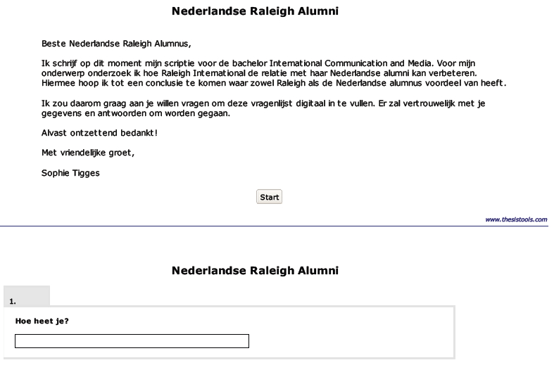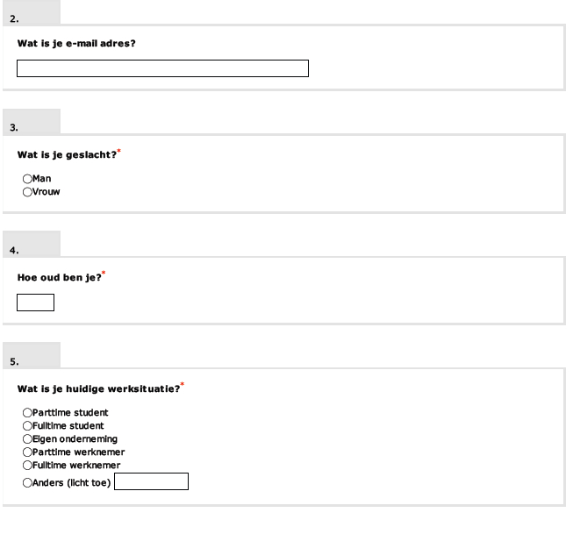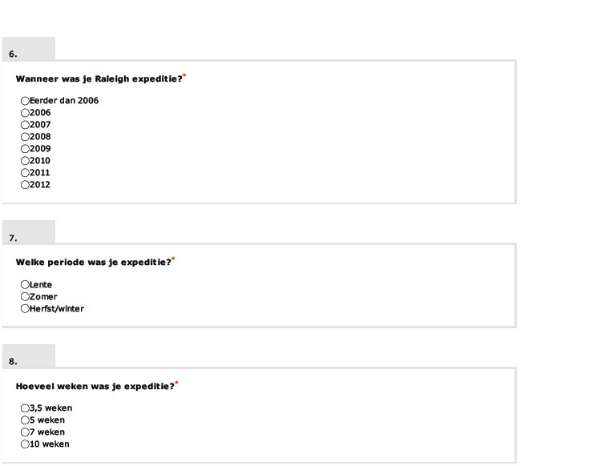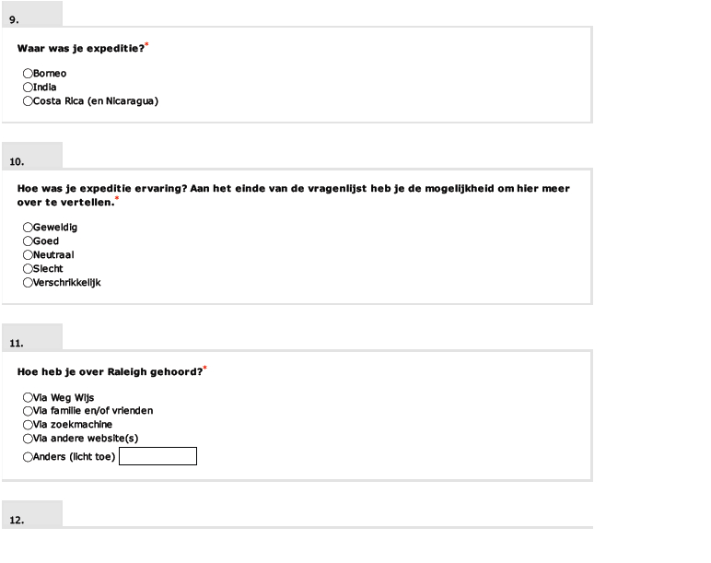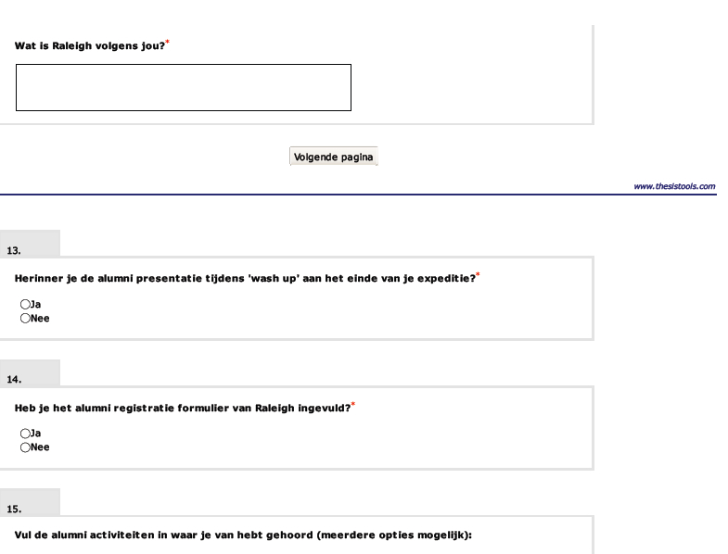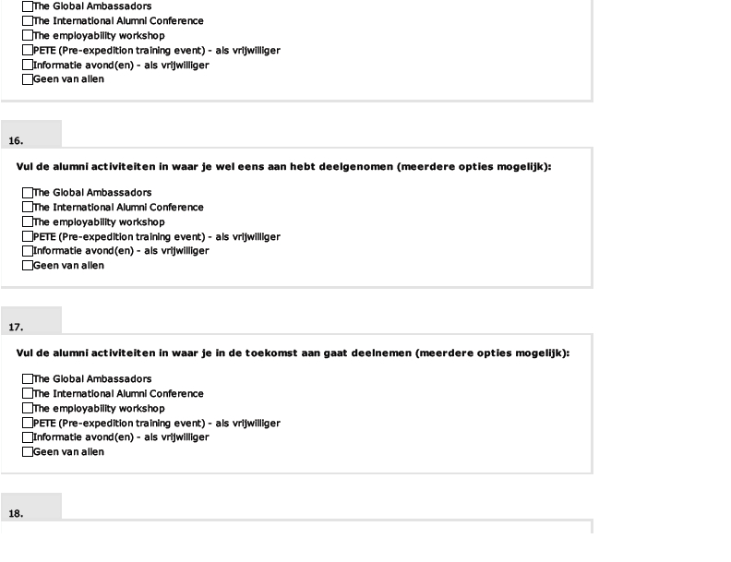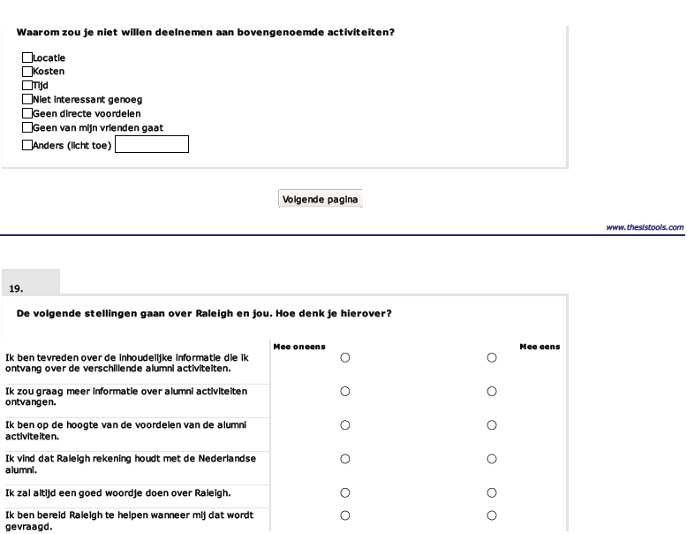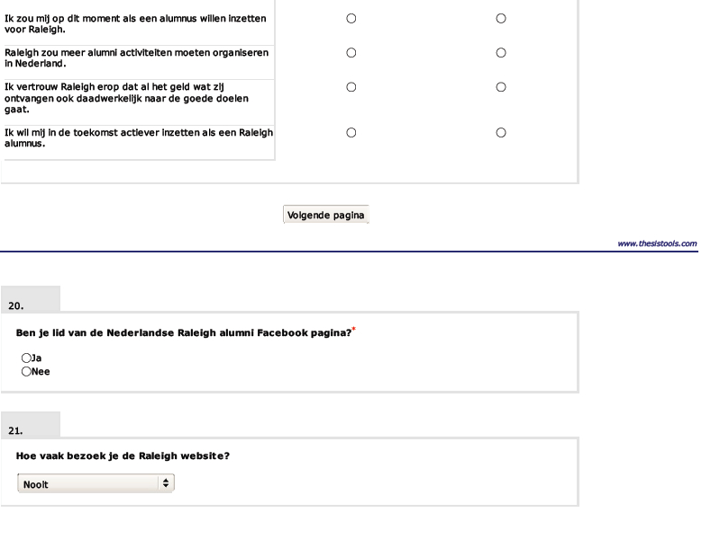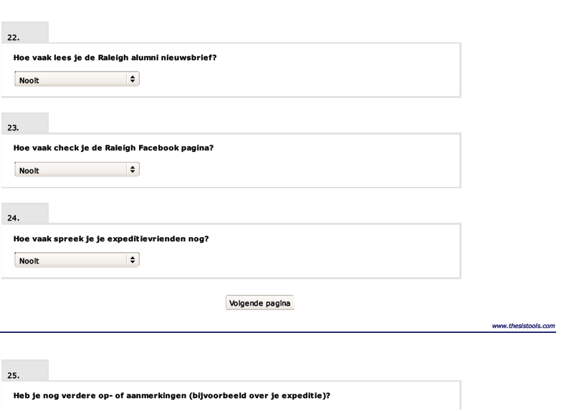

B) Summary case study male, 21 years old

For this interview, a male Raleigh alumnus was interviewed. He is currently a student living in Delft, studying ‘werktuigbouwkunde’. He has done an expedition to Borneo in spring 2009. He had heard about Raleigh through Weg-Wijs, where he planned he entire gap year with. Before he went on expedition, he fundraised the amount of money that was necessary to do the expedition. He could clearly emphasize that this is quite unusual in the Netherlands, and that fundraising is more a UK specialty.

During his expedition he has worked with many nationalities and did not find this difficult. He did not have too many Dutch per project group, about one or two. He notes that he never had problems with the other cultures and adjusted automatically to speaking English full time. He was not aware of the fact that he would become a Raleigh alumnus once the expedition was finished. He had never heard of it before.

After expedition Weg-Wijs contacted him, as they remembered that he had fundraised. They asked him to tell about this during one of their information evening and that is how he came in touch with R. Palliser. Together they have discussed the potential for Dutch Raleigh alumni as she told him they would like to do more with the Dutch alumni. Thus he came up with the idea to set up a Facebook group for the Dutch alumni. However, he has not recently been actively involved with this, which he finds a pity. His reasoning for this is that he is busy with studying and his student life.

This busy schedule also explains why he does not commit to any of the activities Raleigh offers. He also finds it a barrier that the activities are mainly organised in the UK, as it takes much more time and costs much more to go to England. In the Netherlands he would catch a train and be there in a flash. He agrees that Raleigh should organise an alumni activity in the Netherlands as well, as he knows many Dutch Raleigh alumni that are interested in joining. He feels loyal to Raleigh so when an event is organised in the Netherlands he would definitely help out.

C) Summary case study, female 22 years old

For the second case study, a female Raleigh alumnus was interviewed over Skype. For her expedition, she went to Borneo in 2009. She is currently studying in Groningen. After her VWO (high school level), she went to Weg-Wijs to talk about the possibilities for a gap year. One of the options proposed was Raleigh International and so she decided to do an expedition in the spring of 2009.

She is very positive about her expedition and can still recall many moments. She has been in contact with many nationalities and has been friends with most of the UK venturers. After expedition she travelled with quite a few of them, and only then felt the language barrier of English and Dutch. She could not recall the presentation at the end of her expedition and she suggested that Raleigh should perhaps present the fourth challenge options somewhere during expedition. At the end of expedition she was not really focused.

She still is in contact with the other Dutch venturers who were on her expedition. But she does not feel very connected with Raleigh anymore, as it does not live on in the Netherlands. She is aware of the e-mails she is receiving from Raleigh, about certain alumni possibilities, but she does not really read them. She is, however, interested in doing another expedition. After her own experience she wants to be a project manager on one of the expeditions, to be a leader of a group of about thirteen 18-20 year olds.

When asked if she would like to be more involved in the alumni activities she clearly mentions that she is not sure as student’s life offers many possibilities as well, such as associations, workshops and master classes.

D) Telephone interview Weg-Wijs, 15 May 2012

- When did the partnership with Raleigh and how did this happen?
Weg-Wijs exists since 2005 and we started the partnership with Raleigh in 2006. We heard about Raleigh through one of their clients, who had an experience with them. So we started researching into the organisation and felt that the mission and vision of Raleigh matches Weg-Wijs’ aims of personal development. What must be noted is that the partnership has never had the purpose of making profit. There has never been an official contract.
- Were the Dutch young people interested in these types of programmes quite quickly?
No, we were always the one who pointed Raleigh out to these young people. Only later did we start organise information evenings specifically about Raleigh, which was about four years ago. So the first information evening was in 2008.
- For these information evenings you have had Raleigh alumni to come in and present or tell their Raleigh experiences. Did you arrange this or did Raleigh do that?
The organising and planning of Dutch alumni to come and speak at the information evening has always been somewhat unstructured. But Raleigh was responsible for this.
- Do you still speak to Dutch Raleigh alumni?
Yes sometimes we do, but this is mainly at the information evening. We even once had a mother tell her experiences during such an evening.
- Do you see an opportunity for Raleigh to undertake more activities in the Netherlands with its Dutch alumni?
I am not sure, as I would not know how the contact is between the Dutch alumni. I would say that the first year, after coming back from expedition, is difficult as they start a busy student’s life with new experiences. Dutch are in that case different compared to the English. Dutch students are quite busy and meet loads of new people. But there are also difference between Dutch and English when it comes to the Raleigh projects during expedition. There is quite a cultural difference.
- So how do you feel the communication is going between Raleigh and its Dutch volunteers? Does it help to have you as a contact person in between?
We never really had complaints, but sometimes they do have difficulties when it comes to medical issues. I have to say that the information given by Raleigh is quite English.
- What opportunities do you see for the future when it comes to Raleigh and its Dutch volunteers?
Perhaps there should be set moments for training events prior expedition. The training event Raleigh already has, PETE, should be organised in the Netherlands as well. This could be done with the help of Dutch alumni.
- Who, would you say, are Raleigh’s biggest competitors in the Netherlands concerning their Dutch alumni?
In the case of Dutch alumni it would be the student associations and sororities/fraternities. Those are the major rivals for Raleigh.

E) E-mail contact Raleigh Head Office

R. Palliser, 12 March 2012:

Hi Sophie,

I like the sound of your thesis and hope I can help, please see below for answers to your questions:

Perfect Dutch alumnus – would be the same from my perspective as any alumnus from around the world – I would want them to engage in community action on their return in their own countries, making a difference to the world in whatever way they can, as part of the Raleigh 4th challenge. I would like them to spread the word about their experiences and encourage others to take part in volunteering with Raleigh, I would also love them to come back once a year to the Raleigh open event in Holland if they can (and I hope you will be able to come this year?!) so they can speak to others about their experiences and encourage them to apply.

With the years you are thinking, 5 years ago is quite a long time for our Dutch alumni – we started getting lots of Dutch on our expeditions from 2009, (although we did have a few in 2007 and 2008) In total, we have around 50-70 per year, so should be a good number for you to work on.

Finally I would agree about the age-range of Dutch applicants, of all the Dutch applicants I know about over the years, only 7 were aged 20 and over when they applied to go away (although we are missing some data for a number of applicants). Equally we ask them what ‘stage of life’ they are at, and the high majority of them describe themselves as “taking time between school and university”.

Speak soon,

Rosie

R. Palliser, 30 April 2012:

Hi Sophie,

Average age is 17-18 at the time of applying, so probably 18-19 once on the expedition. There have been a very small number of Dutch applicants aged 20-22, but this is very small. They are indeed the second largest group at the moment! Followed by our Malaysian HCVs.

Speak soon,
Rosie

F) Background information interviews Raleigh Head Office

Ms Palliser started working for Raleigh in the summer of 2008, after she had done two Raleigh expeditions to India. Through a friend she heard about a job position at Raleigh, which she applied for whilst she was still in India. She got the job and started working in the Alumni team straight after she came back. After six months she switched to another position within Raleigh Head Office, which was as a Recruitment Coordinator in the Marketing and Recruitment department. Over the years she has developed and grown in that department and she now is the Recruitment Manager.

Ms Bajelvand started working for Raleigh in the summer of 2009. She did not do a Raleigh expedition before she started working at Head Office. She heard about a job position at Raleigh through her own research, i.e. via job sites. Her first role at Raleigh was working on a funded programme by the UK Government, which is called Global Ambassadors. Only later did she start working on alumni, when her (ex-)colleague set up the official alumni programme in 2007. When she moved to another position within the team, Ms Bajelvand stayed involved with the alumni, i.e. monitoring the relationship and the communication.

G) Summary focus group one, 23 May 2012

For this focus group two female Raleigh alumni were interviewed. One of them is currently still in her gap year, the other is studying in Groningen. One has been to Borneo, the other to Costa Rica.

Both agreed that the Raleigh expedition was a great experience. They would not have wanted to miss this opportunity. It was a learning curve for both of them. One said she would have never done the committee she is currently doing without the experience of Raleigh. The other mentioned that it is now a lot easier to be around other people with different personalities. They both will stay positive about Raleigh to other people.

One of them only came through Weg-Wijs, the other one had never heard of it before. It was observed that the one who heard about it via Weg-Wijs was more aware of Raleigh activities than the other, such as the information evening. That person has also been to the International Alumni Conference, and it surprised her that she was the only Dutch alumnus present. Both agreed that Raleigh could organise more for the Dutch alumni, but this should not be a reunion for every expedition group. It is specifically interesting to meet other alumni, to share each other’s experiences.

Both came to the conclusion that the fourth challenge could be set up in the Netherlands in some sort of society. They think it is interesting to bring Dutch alumni together and organise interesting and fun evenings. To set this up, they agreed that it is important to have a small number of people committed to create this society. They even had ideas about how it should be promoted, i.e. not sending e-mails as these will not be read. Eventually the goal of this society is to lower the barrier and make it more accessible.

H) Focus group two, 24 May 2012

For the second focus group, three female Raleigh alumni were interviewed. They all went to a different expedition country in different years. One of them was still in her gap year, the other two are both students. One studies in Amsterdam, the other in Utrecht.

This focus group mainly talked about the experience of the expedition, prior and during. They were not very satisfied about the given information; for example, the packing list was too extensive. They were positive about the communication, as they found the English very helpful. During expedition they all had a positive experience, and talked a lot about this, sharing memories. It was their best experience ever.

When asked about the alumni activities, they all agreed that everything is UK based. One finds this more special, as she does not mind going to London if she wanted too. She has already been in England twice before but is now mainly in contact with the Dutch alumni from her expedition. They still organise a reunion every three months.

One wondered why there is not a Dutch society, such as the other Raleigh International Societies. The others agreed with her that some sort of committee would be attractive for Dutch alumni. They think a reunion for Dutch alumni should be organised first, to lower the barrier for alumni to join. They were all willing to help out when necessary.

