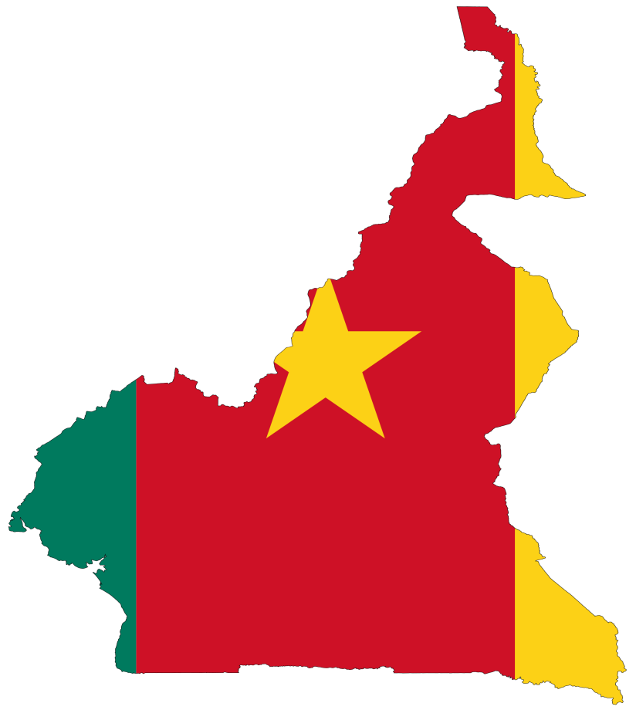
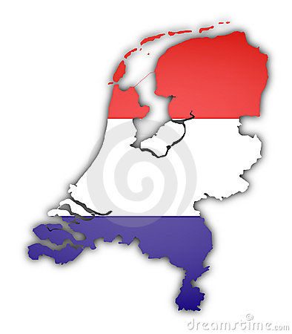

Incorporating Social Media Tools For Migrant Homeland Development: BY celina eno
The Case of Highly Skilled Cameroonian Migrants Living in the Netherlands

INCORPORATING SOCIAL Media TOOLS FOR MIGRANT HOMELAND DEVELOPMENT

THE CASE OF HIGHLY SKILLED CAMEROONIAN MIGRANTS LIVING IN THE NETHERLANDS

BY

CELINA TABOKO ENO (1530219)

GRADUATION ASSIGNMENT SUBMITTED IN PARTIAL FULFILLMENT OF THE REQUIREMENTS FOR THE DEGREE OF BACHELOR OF COMMUNICATION SYSTEMS OF THE INSTITUTE OF COMMUNICATION AT THE UTRECHT UNIVERSITY OF APPLIED SCIENCES

UTRECHT, 06 JUNE 2011

Summary

There are many Cameroonian graduates in the Netherlands who have acquired great competencies in different professional fields but have decided to stay and work abroad. Some that were interviewed during field work said there are no jobs in Cameroon, so they prefer to live abroad where graduates have more career prospects. However, social media platforms create brand exposure, provide room for quick feedback and also facilitate information exchange across the world. That takes us to the main purpose of this research, which is aimed towards creating an online platform where highly skilled Cameroonians can utilise new media tools for knowledge exchange between the Netherlands and Cameroon. Therefore, in order to fully exploit the numerous opportunities embedded in social media platforms; this research makes use of the following research questions:
Research question
To what extend can social media be incorporated by highly skilled Cameroonians living in the Netherlands for the development of Cameroon?
Policy question
How can the AfroEuro organisation mobilise the skills of Cameroonian graduates living in the Netherlands for homeland advantage?
Sub Questions:
- What is social media?
- What are social media tools?
- What is the difference between offline social networking and online social networking?
- How can highly skilled Cameroonians living in the Netherlands use social media to share knowledge with Cameroon?
- Why should highly skilled migrants use social media for knowledge exchange?
- What can Cameroonian migrant organisations do to encourage graduates to share knowledge with Cameroon?
- Which social media platforms are most suitable for the knowledge exchange process between Cameroonians living in the Netherlands and those in Cameroon?
- How can the government of Cameroon facilitate the knowledge exchange process for Cameroonians via social media?
- What kind of social network sites are most suitable for knowledge exchange between highly skilled Cameroonians living in the Netherlands and Cameroon?
- What is the influence of social media on Cameroonians who are living in the Netherlands?
To make this research more tangible and relevant, some methods were applied. This research makes use of both primary and secondary data and at the same time applies both quantitative and qualitative data collection techniques. Many authors nowadays love writing about social media, therefore, looking at their material helps to concretise personal research findings during field work. Some of the secondary data sources that were consulted are: books, news papers, the internet, journals, articles and thesis from the Hogeschol Utrecht library. A systematic observation of findings was done through direct interviews because it is believed that no other form of research is more valid and reliable than conducting a face-to-face interview. Moreover, this paper is suppose to be unbiased and objective, hence, the need for different research methodologies.
In addition, quantitative research was done to get a general analysis of the research question plus expert theories on the subject of social media. Whereas the qualitative data was used so the policy and research questions can be verifiable, empirical and valid. After all, it is easier to probe for more answers in a face-to-face interview than on a survey, but it is also worth noting that answers from surveys can sometimes be deceitful or difficult to check for accuracy. Whereas, secondary data collection on the other hand often has the capacity to provide a clear concept definition and also clarifies research question in a way that a few months of primary data may not be liable to do.
To proceed, the following results were obtained during field work, first, analysing the gender of participants was important as they also constitute the primary target for this paper, therefore findings showed that 61.5% of the respondents are female and 38.5% are male, implying that there are more highly skilled Cameroonian women in the Netherlands than men.
On the other hand, 53.8% of the respondents are between the ages 25 and 30 with 46.2 % being high school graduates followed by 30.8% for bachelor degree holders.
Most importantly, 76.9% of all respondents are social network users, implying that they are already familiar with the tool that is intended for knowledge exchange between the Netherlands.
Therefore, sharing knowledge via online platforms will be the ultimate way for highly skilled Cameroonians living in the Netherlands to give something valuable to Cameroon. Most respondents are already familiar with online social networking; therefore the process of exchanging knowledge through an online platform will be less demanding. Hence, online knowledge exchange will benefit Cameroon whereas their daily jobs in the Netherlands will continue to benefit the Netherlands where they live.
More so, the research that was conducted during field work proved that Facebook is the most preferred social network by respondents. Most of them believe it is very user-friendly and can be easily updated.
Subsequently, the success of this research will depend on how highly skilled Cameroonians in the Netherlands use Facebook and other social networks to share knowledge. Many have confessed to visiting and using social networks almost every time they are free, this is therefore the time to grasp the opportunity to use it for something that can go a long way to development the knowledge capacity and skills of all Cameroonians living in Cameroon!
In a nutshell, the following recommendations can be made based on research results:
- The AfroEuro organisation for which the policy question was posed should be in control of the online platform for highly skilled Cameroonian migrants in the Netherlands giving that they already have an online presence. This online platform is already created by the student during field work which can be improved by the AfroEuro organisation.
- Secondly, employers in Cameroon will no longer have to look for foreign experts on Google or employ experts from different country, this platform will serve as a liaison between companies in the Netherlands and Cameroon who are looking for Cameroon experts, and in the future, African experts.
- Thirdly, the AfroEuro organisation should also use this platform to promote its brand awareness because many Cameroonians and Africans will make use of this platform, hence increasing brand awareness for the organisation.
- Furthermore, the AfroEuro Organisation already has a Facebook account, but this account must be made more interactive, especially because most of respondents are already members who visit this social media platform more regularly.
- Lastly, most Cameroonian highly skilled migrants might not know how to take the initiative to share knowledge, therefore the AfroEuro organisation that has been in the field of helping developing countries for many years, can organise trainings for highly skilled migrants.

“The Internet has a great deal to offer the people of the African continent, with its ability to break the bounds of isolation and bring remote communities in touch with the rest of the world.”
Dr Pekka Tarjanne, ITU Secretary.

Acknowledgement

This research was inspired by all Cameroonian graduates living in the Netherlands; their professional expertise inspired the student to find out ways through which they can share knowledge with Cameroon.
God has been the author and finisher of all the strength that was required to carry out this research. However, without the help of people, my wisdom would have been limited; therefore, this dissertation was made possible with the thoughtful guidance and supervision of my supervisors Ms. Elvira Joldersma and Mr. Fon Bruno. Their constructive feedback was the spice that moulded my research paper. Again, thanks to the Hogeschool Utrecht and the professors for imparting professional competencies in me through the last four years. Their comments and lessons sharpened my thoughts tremendously and I am very thankful. In addition, I will like to thank my fellow classmates for their team work and feedback, their criticisms have been an enormous help through the study program. I sincerely appreciate the Afro Euro foundation for accepting to be consulted during this research paper. Their organisation gave me an opportunity to be creative and independent; they let me spread my wings and taught me how to become a professional communicator. Moreover, I thank them so much for their great work geed towards the development of Africa, I am sure they will be highly rewarded. In addition, I want to say a huge thank you to my colleague Miss. Maria Charles whose design skills made this paper more attractive for readers. Also, I acknowledge the moral support from my family and friends, especially that of my incredible and loving partner Mr. Tambe Franklin, my sister Florence and my daughter Brielle Pearl whose gentle and calm composure gave me space to write my dissertation. In addition, my utmost gratitude goes to my bosom friend professor Ekale Esambe, whose constant feedback gave my work a finishing touch. Please, if you do not see your name, still know I appreciate your support in any form, you know yourself and I will forever be grateful. I thank you all immensely.

Table of Contents
1 Introduction 9
1.1 AfroEuro 10
1.2 Research Justification, problem statement and Limitations 11
1.3 Background information and the situation analysis 13
Structure of the Report 17
Limitations of the Report 17
1.4 Relevance to Communication Studies 18
2 Research Methodology 19
2.1 Desk Research 19
2.2 Survey 19
3 Theoretical Framework 22
3.1 Social Media Definitions 22
3.2 Guarav Mishra’s 4Cs of Social Media 30
3.3 The continuum theory of social media 32
4 Research Results 34
4.1 Survey for highly skilled migrants 34
4.2 Expert interviews 38
5 Conclusions and recommendations 43
5.1 Conclusions 44
5.2 Recommendations 50
References and Appendixes 54
Appendixes 55
Survey Results 59
Appendix 2 Expert interviews and images of interviewees 67
Appendix 3 AfroEuro background information 69
References 71

List of Tables

Table 1: SWOT analysis of AfroEuro ……………………………………. ………. 10
Table 2: Quick facts about social media…………………………………… ………. 25
Table 4: SWOT analysis for AfroEuro ………………………………………………... 51

List of Figures
Figure 1: Image of HIV/AIDS Orphans in Sub-Sahara Africa……………….………..15
Figure 2: The Social Media Pyramid- Hierarchy of needs …………………..................25
Figure 3: Social media landscape ……………………………………………………….27
Figure 4: The 4 Cs of Social Media …………………………………………………... .30
Figure 5: the two sides of the continuum ……………………………………………….32
Figure 6: Three skills needed by highly skilled Migrants …………………………….. .49
Figure 6: Three skills needed by highly skilled Migrants ………………………………49
Figure 1 of appendix 1: Pie chart of respondent’s gender ………………………………34
Figure 2 of appendix 1: Pie chart on respondents’ age group…………………………. .34
Figure 3 of appendix 1: pie chart on nationality ……………………………………... .. 35
Figure 4 of appendix 1: Pie chart on respondents ………………………………………35
Figure 5 of appendix 1: Pie chart on professional statues of respondents ………….... ..35
Figure 6 of appendix 1: pie chart of familiarity with social media ……………………..35
Figure 7 of appendix 1: pie chart on registration on social networks …………………..36
Figure 8 of appendix 1: Pie chart on social network usage…………………………… .36
Figure 9 of appendix 1: pie chart on frequency to social networks…………………… .36
Figure 10 of appendix 1: Pie chart social network …………………………………….. 36
Figure 11 of appendix 1: Pie chart on the most effective social network ………………37
Figure 12 of appendix 1: Pie chart on reason for visiting social networks ……………...37
Figure 13 of appendix 1: Pie chart on sharing knowledge with Cameroon ……………..37
Figure 14 of appendix 2: Most easy communication tool ……………………………….38
Figure 15 of appendix 2: Participation in a social network ……………………………...38
Figure 16 of appendix 2: A pie chart on where to share knowledge …………………….38
Figure 1 appendix 2: Interviewee ……………………………………………………….. 40
Figure 2 appendix 2: Expert: Mr. Ako Egbe of 4 another ……………………………… .41
Figure 3 appendix 2: Expert: Sylvie Wanda ……………………………………………...41

List of Acronyms/Abbreviations

ITU International Technology University
NGO Non-governmental organisation
USA United States of America
ECA Economic Commission for Africa
IDCRA International Development Research Centre
UNICEF United Nations Children’s Funds
WHO World Health Organisation
BBC British Broadcasting Corporation
UNESCO United Nations Education, Scientific and Cultural Organisation
CBS Centraal Bureau Voor de Statistiek
ALCEC Association for the Fight against Illegal Immigration
UNFPA United Nations Population Funds
CNN Cable News Network
NUFFIC Netherland Organisation for International Cooperation in Higher Education
TV Television
CSA Cameroon Student Association
CIA Central Intelligence Agency
CAMNED Cameroon Association in the Netherlands
SPSS Statistics Products and Service Solutions
CAMTEL Cameroon Telecommunication

1 Introduction

This chapter begins with a general introduction about the organisation that was consulted for this research which will be clarified with a SWOT analysis. More so, there are other parts that will unfold, namely; justification of the research and policy question, a problem definition, and a general situation analysis of the research problem. Additionally, the structure and limitations of this dissertation will be outlined. Finally, the relevance of the research and policy question within the field of communication and media will also be included.

1.1 AfroEuro
In order to make this research more relevant and useful, an organisation in The Hague was approached to act as a consultant for the student. The following paragraphs outline what the organisation does but very briefly. More information about the organisation can always be seen on their company website (AfroEuro.org), and on appendix 3 of this report.
AfroEuro foundation is a young migrant NGO that was founded more than five years ago with the aim of creating a forum for inter-cultural exchange between migrants from Africa and their hosts’ nations in the spirit of promoting the identity of African – Europeans (AfroEuro.org). This young dynamic organisation operates in different areas: migration and development, communication and media (online magazine), health insurance scheme, language lessons for migrant children and much more.
Though this assignment is completely the student’s idea, the AfroEuro foundation was consulted for advice during research because the organisation has an in-depth knowledge of African communities and how to reach them.

AfroEuro SWOT Analysis
SWOT analysis of the internal and external issues that are influencing AfroEuro from creating more awareness in the Dutch community via its online magazine.

STRENGHTS | WEAKNESSES
- The magazine has a unique selling point because being online creates more brand awareness.  - The magazine is free  - Low costs of advertising space  - Product is environmentally friendly because it has shifted from a printable version to an online magazine.  - Very informative for Africans because of the daily news presented on the website. | - The brand name is not recognizable amongst the target group as intended.  - The magazine does not have enough revenue to expand.  - The magazine doesn’t have any assets so far.  - There are no qualified professionals working on the magazine, as content is mostly created by voluntarily sources and interns.  - The magazine often produces news that is not up-to-date because of a shortage in content writers.  - Promotional tools are not being used, which negatively affects brand recognition.
OPPORTUNITIES | THREATHS
- Subsidies from the government for social projects  - Getting new advertisers and sponsors interested in the magazine content.  - Updating the magazine according to new trends. Giving an additional value to it  - Targeting new market(s)  - Promotional campaigns will help improve brand recognition | - Economic downturn  - No or limited possibilities of subsidizing the magazine  - Target group may not be interested in the content of the magazine  - The costs of production and distribution outweigh the sales profit  - New entrants on the market  - Consumers start using other media tools.
Table 1: SWOT analysis of AfroEuro (source: 2011 field work)

1.2 Research Justification, problem statement and Limitations
The following paragraphs outline why the student believes that there is a need to conduct this research. Perhaps others might not find this interesting, but the only way to convince them that this topic is worth researching is by giving some justifications. The second section explains why the research topic is an issue, followed by limitations that could be faced during the research process.

Research Justification
There is an obvious inadequacy in Cameroon’s public service; most of the people employed are usually relatively not academically qualified to do their jobs, leaving the country with insufficient qualified workers. A research conducted by Cameroon’s National Order of Physicians stated that four-fifths of the country’s 5,000 qualified physicians travel abroad to search for jobs, leaving behind just one doctor for every 30,000 inhabitants in the country (www.Cameroonechoes.org).
Further, state universities in Cameroon produce approximately 5,000 graduates per year, many of which end up frustrated in the country because they cannot find jobs (Cameroon Echoes). Therefore, it is difficult to question the decision of most Cameroonian graduates abroad to remain there; rather, one must cajole them to share acquired competencies and skills with their homeland, thereby helping the country to extract foreign expertise. If Cameroonian graduates cannot go back to invest in human capital, they can at least seek alternative ways to ensure transfer of skills and knowledge to their country of birth.
Specifically, this research is justified because recent studies on African diaspora mainly focus on issues of: poverty, migration and development, but this research focuses on the transfer of skills and knowledge to Cameroon by Cameroonian students studying abroad for homeland development. Therefore, the research distinguishes itself from other discourses on related issues, especially by incorporating tools of social media in the process. Through this research, migrants can start seeing social media as the main bridge that can pave the way across international boundaries, hence, reuniting Cameroonian experts abroad with those in Cameroon, thus benefiting both the host country and Cameroon.
Most importantly, Cameroon is a country where people think as a group and are concerned for the well being of others, implying that group success is more valued than individual achievements. This phenomenon can be linked to Geert Hofstede’s theory which states, - that, our world today is one where the interest of the group prevails over the interest of the individual (Hofstede et al 2010c, p.90). Therefore, Cameroonians who have graduated abroad, have a responsibility to give something in return. This is because Cameroon is a country where the power of the group prevails over that of individuals (collectivist), unlike in the Netherlands where the power of the individuals prevails over that of the group (individualistic). In a nutshell, highly skilled Cameroonian graduates are obliged to share their acquired skills with their nation; otherwise, the country will blame them for not having enough skilled workers.

Problem Statement
Without a problem, there will be no need for research; this research is being carried out in order to give answers to the following questions:

Research question
To what extend can social media be incorporated by highly skilled Cameroonians living in the Netherlands for the development of Cameroon?

Policy question
How can the AfroEuro organisation mobilise the skills of Cameroonian graduates living in the Netherlands for homeland advantage?

Sub Questions:
- What is social media?
- What are social media tools?
- What is the difference between offline social networking and online social networking?
- How can highly skilled Cameroonians living in the Netherlands use social media to share knowledge with Cameroon?
- Why should highly skilled migrants use social media for knowledge exchange?
- What can Cameroonian migrant organisations do to encourage graduates to share knowledge with Cameroon?
- Which social media platforms are most suitable for the knowledge exchange process between Cameroonians living in the Netherlands and those in Cameroon?
- How can the government of Cameroon facilitate the knowledge exchange process for Cameroonians via social media?
- What kind of social network sites are most suitable for knowledge exchange between highly skilled Cameroonians living in the Netherlands and Cameroon?
- What is the influence of social media on Cameroonians who are living in the Netherlands?

There has been a flux of Cameroonians going abroad for many decades, but a critical look at the knowledge capacity of the country shows that most of them remain abroad after studies. This poses a problem because receiving countries then benefit more from the skills students have acquired during their studies, leaving sending countries void of highly skilled professionals. Dr Lalla Ben Barka of the Economic Commission for Africa (ECA) warns that “In 25 years, Africa will be empty of brains”. This warning reflects a cry of desperation by the people of Africa for the loss of human capital (IDRC.net). However, all hope is not lost because social media has marred international boundaries, broken geographical barriers and has created new tools for knowledge exchange. Knowledge can be exchanged across long distances, thereby creating windows of opportunities for Cameroonian graduates abroad to expand their knowledge horizon. This leads us to the target group for this research.

Target group
This research is targeted towards highly skilled Cameroonians who came to study in the Netherlands but have decided to live and work in the Netherlands after graduating. This group was selected because the primary targets can be easily reached via Cameroonian student associations. More so, the research would have been too generalised if the student had chosen to focus on all highly skilled Cameroonian migrants. Narrowing the target also helps to provide adequate and more specific results.

1.3 Background information and the situation analysis
Benjamin Franklin states that ‘’ without continual growth and progress, such words as improvement, achievement, and success have no meaning’’ (wisdom quotes.com). This part outlines the current economic atmosphere in Cameroon; it also provides figures and images to clarify the current economic climate of Cameroon which makes it difficult for highly skilled migrants to return to their country of origin. Therefore, the above quote by Benjamin Franklin acknowledges the fact that there is a need for change, for without it, it will be impossible to improve.
Cameroon is a Sub-Saharan African country situated in the West of African where studying has become employment for many youths. Going to school keeps people dreaming of a better future, but upon graduation, it finally dawns on many that the possibility of procuring a job is hopeless; hence the desperation to travel abroad becomes the ultimate option available. The following paragraphs portray the current situation in Cameroon according to different sources that were consulted during desk research.

Situation of Employees in Africa
This topic is relevant for the situation analysis because it allows the reader to understand why there is a need for highly skilled migrants to share knowledge with Cameroon.
Research conducted by the International Organisation for Migration proved that since the year 1990, Africa has been losing 20.000 professionals annually (IOM). African countries have invested so much in education, but they get no return from trained experts because they either travel abroad or decide to stay abroad after studies. If one must take a look at the professional sector, it is very evident that African institutions are most increasingly relying on foreign expertise to fill the human resource gap created by brain drain. There are about 150.000 expatriate professionals employed in Africa, costing the continent US$4 billion a year (International Organisation for Migration). More so, there is a shortage of medical personnel in several Sub-Sahara African countries where basic health and social needs cannot be delivered. Thirty-eight of the 47 sub-Saharan African countries have been unable to meet the minimum World Health Organisation (WHO) standard of 20 physicians per 100,000 people because most of the experts work abroad. The World Health Organization also added that in the Central African Republic, the ratio is less than 10 nurses per 100,000 people, compared with more than 2,000 per 100,000 in countries such as Norway and Finland.
Moreover, Africa’s percentage of global scientific output has dropped from 0.5% in the mid 1980s to 0.3 % in the mid 1990s, giving that, there are more African scientists and engineers in the United States than in the entire African continent (IOM).
Similarly, health care is one of the most affected sectors as earlier mentioned. There is a massive outflow of midwives, nurses and doctors from poorer to wealthier countries and this is one of the most difficult challenges posed by international migration according to the United Nations Population Funds (UNFPA). In addition, the report by the UNFPA also added that skilled men and women leave their homeland in search of greener pastures to improve their lives and that of their family members.
Africa’s plight and a lack of skilled workers can come to an end if western countries learn to develop ways of giving back trained experts to the continent, instead of depriving the continent of experts. There is so much money going to Africa for health purposes, the United States alone sends billions to this continent, most of it for health purposes.
Therefore, the current situation in Cameroon rather scares highly skilled migrants from returning to Cameroon after studying abroad, instead of attracting them. Hopefully, this thesis will come up with some solution will affect the current lack of skilled workers in the country. However, Cameroon is not the only African country facing this plight.
There are many African countries where people do not have daily meals and clean water to drink, the image below is a symbol of the current situation in Africa.

The following image is a piece of the iceberg when compared to other images that CNN shows daily.
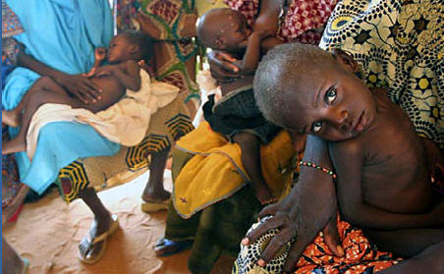
Figure 1: Image of HIV/AIDS Orphans in Sub-Sahara Africa (source: www.cozay.com)

Useful Facts about Africa
It is difficult to grasp the current economic and health problems that make the African continent so repulsive for inhabitants, but the following facts can broaden people’s knowledge of what is going on in Africa at the moment:
Poverty has been an epidemic that has stricken the Africa continent for decades; the economic situation in Cameroon is no different from that of many Sub-Saharan African countries. The above figures are a piece of the iceberg when it comes to figures and facts about poverty in sub-Saharan Africa. Poor governance is accountable for the increase rate of poverty in Africa. Ideally the wealth and natural resources in Africa should be used to provide better livelihood for all, but presidents and leaders live in mansions whilst the masses live in slums and abject poverty.
Moreover, this phenomenon called Poverty, has transformed many intelligent youths to armed robbers and has rendered many families hopeless, hence, travelling out of the country has become a dream many strive to achieve by all means. Getting a visa to travel out of Cameroon is very difficult, but that has not stopped people from leaving. Most rush out of the country as if there is a plaque around the atmosphere that will infect all those left. More so, many Cameroonians travel out of the country to look for a better future, but the most legal way to leave the country is by obtaining a visa to study abroad.
Foreign education is a great asset and investment for the human capital of any nation, especially for developing countries where there are fewer entrepreneurs. Having graduates from abroad has a huge impact on the knowledge capacity of the country, but that depends on whether the students return or remain abroad. It is no secret that developed countries have better career opportunities for graduates; this often explains why many developed countries retain highly skilled migrants from Africa.
However, of what benefit is foreign knowledge to Cameroon if students who travel abroad do not return home to invest in the nation? There are two major problems that arise as a result of studying abroad: the host countries retaining Cameroonian graduates often benefit from their professional skills, whereas, their country of origin is deprived of skilled workers with international professional competencies. There are millions of Cameroonian graduates abroad who have become great assets towards the development of their host countries. Recent statistics show that there are approximately four million Cameroonians living abroad, most of whom are graduates with expertise knowledge in domains such as: communication, health, research, engineering and business (Cameroon echoes.org).
More so, a study carried out by the United Nations Educational, Scientific and Cultural Organization (UNESCO) in 2006, stated that students from sub-Saharan Africa seeking education are the most mobile in the world. This study found out that 1 out of 16 students in sub-Saharan Africa study abroad compared to North American students who have just one out of every 250 students who study abroad- making it the least mobile group according to UNESCO institute for statistics. If there are so many students from Sub-Sahara Africa studying abroad, why is the continent still lacking in technological knowledge?
Moving on, another report published by UNESCO’s institute Global Education Digest 2006, stated that between 1999 and 2004, the number of mobile students worldwide increased to 41% from 1.75 million to 2.5 million. This figure shows that the number of African, Arab and Chinese students studying out of their countries outnumbers those from other continents. In 1999, East Africa sent about as many students abroad as Western Europe. And just within four years, students from the region outnumbered those from Western Europe by a third.
Moreover, the Central Bureau of Statistics (CBS) revealed that there were 150.000 migrants in the Netherlands in the year 2010. Also, the Dutch Volkskrant stated that there were approximately 76.500 foreign students in the Netherlands in 2010. Though there are no figures on the exact number of students from Africa, one can still see that students constitute a great portion of migrants in the Netherlands.
Therefore, Cameroon is not excluded from the list of migrants in the Netherlands. It is likely that many Cameroonians have been going abroad to study for decades. Talking to most Cameroonian youths who have completed high school, one hears a voice of desperation from most, promising to leave the country by all means. Also, most do not feel compelled to return, hence, starving public services of qualified professionals.
Furthermore, another study conducted by the Association for the fight against illegal immigration, (ALCEC), interviewed Cameroonian citizens about travelling out of the country and 83 percent of 15-35 years old said they planned to leave the country. This paper is not about migration, it is about highly skilled migrants and their contribution to their homeland. However, the subject cannot be properly analysed without touching on migration because of the link thereof.

Structure of the Report
This research paper is divided into five chapters excluding the appendix chapter. Chapter 1: outlines the background context of the research problem, highlights the research justifications and problem statement. In addition, it also adds information on the relevance of the research within the field of communication. Chapter 2: discusses different data collection techniques that were applied during field work whereas chapter 3 looks at the theoretical framework from experts in the field of social media; concepts such as: social media, social networking, the social media continuum, the 4Cs of social media and the social media pyramid will be used.
Furthermore, chapter 4 showcases all research results obtained from field work and chapter 5 draws conclusions and give recommendations that can help enhance the AfroEuro organisation.
Moreover, there will be an appendix of extra research findings that cannot be incorporated into the main text such as: questionnaire, expert interview and figures from SPSS statistics software. Finally, there will also be a list of works that were cited and referenced in the whole document
in a referential list.

Limitations of the Report
Constant increase in tuition for non European students has limited the number of students coming from Cameroon to study in The Netherlands. This has also reduced the percentage of possible respondents because this research targets Cameroonians who have graduated in the Netherlands.
Secondly, the economic atmosphere in the Netherlands has created high unemployment rates in the country, giving room for employers to choose just the best, which makes Dutch graduates more attractive to employers than migrants. This situation has pushed many skilled Cameroonian migrants to move to other countries after graduation, hence, making it difficult to find many people to interview. Moreover, many of the migrants that are highly skilled too do not have jobs, therefore, limiting the number of suitable people for this research.
Time also posed a major setback to this research. The number of people that were consulted for interviews continued to postpone meetings, but the student had just a few months to complete her dissertation, hence, limiting the number of responses that came in.
It is important to point out that the use of the internet was not available in Cameroon until 1992, whereby the use of traditional media outlets - press, radio, television and mobile phones was the norm of the day. Therefore, the use of social media is a gradual process that has to be incorporated into the society at a pace somehow slower than what is happening in Europe. Some people in Cameroon might want to use social media tools as often as it is used here in Europe, but they are somewhat constraint by a lack of internet connection or money to go to a cyber café. Moreover, most of those who have internet access at home do not have the knowledge to use some of these tools, which also limits their ability to reach out to the rest of the world. These limitations could be encountered by highly skilled migrants in their effort to share knowledge via social media.
Finally, many highly skilled Cameroonian migrants on social networks use different names, so it is very hard to find targets via social networks, giving that one can only know their nationality from their real names, as the researcher is familiar with names originating from Cameroon.

Relevance to Communication Studies
Online communication is a fantastic way to build and maintain relationships, businesses, exchange knowledge, and share information. Through different social media tools, web users can communicate from the comfort of their homes, at their own place, schedule, pace, and time (Manuel 2011, p.11). The whole idea of this research is how to use social media tools such as online social net work platforms to exchange and share knowledge with Cameroon. According to Shannon and Weaver, communication begins with an information source, which goes through a transmitter, then sent via a signal to the receiver (Shannon & Weaver, 1949). This definition clarifies the purpose of this research. Potentially, through the use of social media tools, knowledge will be shared from highly skilled migrants (sender) to other Cameroonians back home (receiver), hence, making this subject relevant to communication studies.

Research Methodology
This chapter is about the different methods used in collecting data. The first part of the chapter will define different methods that were used and will also site situations where such a method was applied.
The research makes use of both primary and secondary data thereby combining quantitative and qualitative data collection techniques.
Quantitative research was done to get a general analysis of the research question, whereas the qualitative data was used so the policy and research questions can be verifiable and valid. After all, it is easier to probe for more answers in a face-to-face interview than on a survey, but it is also worth noting that answers from surveys can sometimes be deceitful or difficult to check for accuracy. Whereas, secondary data collection on the other hand often has the capacity to provide a clear concept definition and also clarifies research questions in a way that a few months of primary data may not be liable to do.

2.1 Desk Research
Social media is the 21st century hype and a favourite topic for many authors and media experts; therefore, looking at their material helps to concretise personal research findings during field work. Some of the secondary data sources that were consulted are: books, news papers, the internet, journals, articles and thesis from the Hogeschool Utrecht library. The student made use of many books in order to come up with an objective and unbiased thesis namely; the good Research Guide, the Social Media Bible, Twitter Power, Internet based learning, Cultures and Organisations, The Back Channel and some other books.
In addition to the books that were used were some relevant internet sources. The internet provides one with many sources and findings that add substance to research findings. Most of the sources were also checked for validity by comparing similar information with other sources.

2.2 Survey
Internet questionnaire
An internet questionnaire was created because of its visual appeal (Denscombe 2007, p.160). When something is presented in an attractive way, it becomes more readable and easy to respond to than when posted or otherwise. In order to obtain answers from respondents, a survey was carried out. Also reference was done from one person to the other (Denscombe 2007, p17) because through that, the researcher could reach more people in the primary target.
Moreover, the questions posed in the questionnaire also incorporated sub questions earlier posed in this research. This will intend give the researcher an in-depth knowledge of what respondents think, thereby creating an objective opinion of the research question which could be different from the researcher’s personal opinion.
Face-to-face Interviews
A systematic observation of findings was done through direct interviews because it is believed that no other form of research is more valid and reliable than conducting a face-to-face interview. Moreover, this paper is suppose to be unbiased and objective, hence, the need for different research methodologies.
During field work some respondents answered questions hastily and also avoided to give a direct answer, but by applying good persuasive and communication skills, the researcher conducted semi structured interviews which ensured depth of information from respondents; therefore allowing flexibility and flow of conversations with respondents. It gave the researcher the opportunity to identify key informants relevant to the study while on the field.
Most importantly, an expert group discussion also contributed to the research findings on knowledge exchange across countries, thereby giving the researcher ample opportunity to use different research techniques.

Purposive Sampling
In addition to the above methods, purposive sampling whereby the researcher handpicks respondents because of fore knowledge of participants (Denscombe 2007, p.17) was also applied in choosing interviewees. Some got mails about the research and were asked to forward it to any highly skilled Cameroonian migrants that they knew.

Snowballing
Furthermore, snowballing was another research method that was applied during field work. Finding highly skilled migrants from Cameroon is not very easy, giving that the number of people from the target group known by the researcher are very few, however, through snowballing-where interviewees were requested to forward questions to their friends, the researcher was able to reach more people ( Denscombe 2007,p.17).

Sample size
Choosing the primary target for this research was not a problem because the student had the right target in mind before formulating the main research question. However, the problem was locating possible respondents from the target group.
The student found targets from Cameroonian student associations in the Netherlands and some friends who also fell within the category of highly skilled Cameroonian migrants were selected. The questionnaire was sent to about 30 Cameroonian migrants but only 13 people responded. These 13 are therefore used to analyse research findings. The size is not very big but sufficient for this paper because most highly skilled Cameroonians have similar views about sharing knowledge and helping to develop Cameroon. In addition, three in-depth interviews were done with other highly skilled migrants as a way to concretise the questions that could not be well clarified in the questionnaires. The sample size would have been bigger if highly skilled Cameroonians had a platform where they could be located more easily. Hopefully, this research will solve the problem of locating and finding all Cameroonian highly skilled migrants living in the Netherlands on one platform.

3 Theoretical Framework

The chapter of the theories applied for this paper incorporates definitions of social media and social media tools with expert theories and concepts on social media. More so, there are three main theoretical frameworks that will be analysed, namely the 4Cs of social media, the social media pyramid and the social media continuum.

3.1 Social Media Definitions
Under these section theories such as social media, social media tools, online networking and social network sites will be explained and defined.
Creation of content has never been as easy as it is nowadays. Social media has as many content creators as content consumers. Social media is an era of participation from different web users, making it very difficult for ethical norms to be adhered. On the other hand, giving that social media platforms provide tools for content to be created by all web users has led to more creativity and innovation in organisations- marketers can predict consumer trends while consumers also compare products and information via online platforms. Alexander Osterwalder, an expert in the field of social media states that ‘’collective intelligence is often superior to expert knowledge’’ (Osterwalder slide share online). Before moving to the different theories on social media, it is wiser to first of all start by defining what the term ‘’social media’’ really implies.
Definitions of social media
Jane Bozarth, a social media strategist, defines social media as online material produced by the public, usually different from content created by professional writers (Bozarth 2010:11).
Secondly, another media analyst says social media is media that people use to be social (Safko 2010b, p.3). Lon Safko fails to mention the platform where the people socialise as in the first definition. Readers could interpret it as being a physical location where people come to socialise instead of a virtual community. However, one should proceed with other more detailed definitions to broaden the scope on the concept.
Thirdly, Alexander Osterwalder’s definition is more in-depth than the above definitions because it includes the tools used in social media. He sees social media as a category of online media that facilitate discussions, participation, and sharing of various forms of content in a very convenient way by using blogs, wikis, social networking platforms, micro-blogs, and other online platforms (Social Media online business Model).
In contrast to the three definitions above is Laura Porto’s definition of Social Media. She looks at it from the stand point of organisations and not consumers. Social media— such as blogs, forums, twitter, Facebook and online social networks in her opinion will expand the marketing reach of organisations and strengthen consumer relationships (Porto, 2007).

Types of Social Media
Social media operates in many ways, via different platforms for different target audiences. Here is an online list of the most prominent ones so far (source: kevinmcintosh.com)

Social bookmarking – Digg, Delicious, Reddit, StumbleUpon

Social bookmarking applications permit users to share their favorite online content with others. Bookmarks often count as votes; implying content with more votes goes to the top of the community page.

Blogs – WordPress, TypePad, Posterous, Tumblr, Blogger as well as non-branded blogging platforms

Blogs are online journals where authors write on their interests. It is up to the author to choose what he or she wants to write, and people browsing similar content online can stumble on their blogs. Some bloggers also collect content from other websites to share with their readers.

Wikis - Wikipedia
Wikis are made of content created online as a result of multiple users who are working on the same content, but users usually do this from different places and time.

Photosharing - Flickr, Photobucket
Photosharing sites are online platforms where people can upload and share photos either privately with only selected friends or publicly.

Geolocation-Gowalla, Foursquare, FacebookPlaces
Geolocation sites are mostly accessed through the user’s smart phone. These sites feature “check-in” options so that users can inform others of their location. This area of social media is fast growing because it has high marketing possibilities.

Video Sharing - YouTube, Vimeo, iMemories

Similar to photosharing users upload can also upload video content to a site where everyone watch their videos or make it private for chosen friends.

Presentation Sharing - Slideshare.net, Scribd, Issuu

This is a professional setting where experts often uploaded files as PDF’s and they are then converted to work with the online presentation applications.

Meetups/Events – Meetup.com and Facebook Events
Meetup.com and Facebook event invites for example allow users to plan and organize events and send out invitations via the social network.

Defining Social Media
Human desire to constantly be in touch with others has perpetuated the web. People are tired of individualism and the need to create a virtual community has driven many to an online world. Time has placed constraints on many people, it is impossible to be in several places at once; work, meet with friends on week days, go to church, go dancing and so on. Nowadays, the drum has taken a new rhythm, through social Media- one can do all these things from his office without moving an inch. Social Media is the 21st century panacea that has come to heal the bonds of isolation by making a global world one small village. Taking a look into the past where the internet started, the main thing people did was to send mails and search for information online. During the early 90s online communication was basically that of sending and receiving messages, however, the story has changed since the introduction of a new technology known as Web 2.0 also known as Social Media.
The advent of Web 2.0 has ignited explosive outburst in the use of social media tool and social networking activities (Bozarth, 2010,).Social media in its very simplistic form can be defined as media people use to be social. What distinguishes social media from other conventional media is the fact that it is a multifaceted communication tool unlike print media which is more from senders to receivers, giving readers no opportunity to give feedback (Safko 2010, p.5). In order to broaden our scope on this concept, we will look at some expert definitions and theories on Social Media under the theoretical frame work. This research will also look at some Social Media tools and how they can be incorporated by Cameroonian highly skilled migrants for the benefit of their country of origin.

Figure 2: The Social Media Pyramid- Hierarchy of needs (Source: Hanah Paramore, January 2011)
This is a social data tool to help entrepreneurs manage and measure their campaigns.
The social media hierarchy of needs pyramid explains the various stages in human conversation and communication needs. It always begins with a craving to just have a conversation with someone, followed by sharing content through a particular platform, which could be a social network. Then it proceeds to the point where people demand for feedback and react on what has been sent to them by others.
In order to get a general picture of social media, the following figures can be helpful:
- Facebook is a $10 billion business
- Facebook has more than 350 million users
- Flickr has over 3 million messages uploaded everyday
- There are 900.000 blogs posted daily
- More than 27 million tweets posted on Twitter daily
- More than 1 billion videos are served on Youtube

Table 2: Quick facts about social media (Source: www.internetinnumbers.com))

Online Social Networking
A network consists of like-minded people who have come together in a common place to share information (Safko 2010, p.21). In an effort to belong to a community, small rural groups are often being created. Daily, people socialise through different ways. The concept of social networking has been around for decades on end. In some places people have community halls where they meet to drink coffee, dine together, dance with each other, or make urban planning. In the western world, people have golf clubs, dancing clubs, women fellowships, and teenage groups. More so, most companies nowadays have outings for employees and events aimed at creating a social atmosphere around the working place, which is a way to motivate employees to be more creative.
However, the situation has turned a new page in this century. Social networking is an online way of enjoying family and work life without travelling to different places. Online Social Networking usually functions like an online community for web users. Though many social network sites vary, most of the online community members share common interests.
In order to gain full access to a social networking site, users usually have to create an account before belonging to these sites. Once that is done, socialising can commence. Social networking has several advantages to users:
New friends can be made through social networking sites. This is one of the most important advantages of being part of a social network. Users can find; old class mates, colleagues, lost friends and relatives. There are even testimonies of people who met their current partners via social networks.
Secondly, belonging to a social network opens a platform of diversity to users because they are exposed to different information sources. Cameroonians may not have a lot of knowledge about the internet, but most of them have joined different social networks which will expose them to a broader audience, hence, giving them the opportunity to share and exchange ideas.

Online Social Networks
Social networks have been around since the beginning of mankind, even when people were still living in caves, travelling in clans and tribes; they trusted each other to walk together for a common goal (Safko, 2010b, p.23). The groups counted on each other for protection and confided in each other and these groups had different goals and objectives. This is exactly what is happening on social networks.
There are 60 million emails sent daily around the world, MySpace alone has over 186 million users (Comm 2010, p.16), implying people practically spend most of their time communicating online. Joel Comm further explains that advances in technology have given consumers more relationships, but there is less time to deepen them. If human relationships do not have quality, then people’s lives too are same (Comm 2010. p.16). There are many social networking sites, but this research will take a look at six of them. Before looking at those six, here is a figure with almost all social networks:
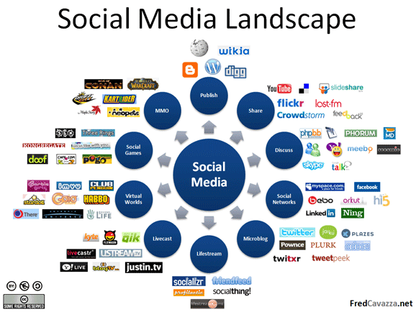
Figure 3: Social media landscape (source: www.fredcavazza.net)

Twitter
‘’ Twitter is a micro blogging tool that allows users to publish chronologically ordered ‘’tweets’’ which are of 140 characters or less’’ (Bozarth 2010, p. 23). These tweets feed into a public space where users can view content generated by others. Twitter is a wonderful tool for sharing information with experts from different fields in the world, with a single feed available for all users.
According to comScore, more than 50 million people worldwide visited the Twitter website in June 2009 (Atkinson2010, p.30). Twitter has changed the way people communicate, television channels such as CNN permit viewers to send tweets to the network, exchange opinions and feedback. Twitter is a phenomenon that has created an interactive communication platform for users, as people use it in every conceivable situation. Life feedback is one of the strongest assets of Twitter, making it a very valuable tool for organisations and individuals.
Moreover, Twitter is an interactive tool of the moment, it invites users to post tweets at the spot, which makes it fun and challenging, as users have to react to tweets without so much time to go and think.
In addition, Twitter has distinctive features that are not available on other social networking sites. For instance, Facebook system only works within the site, whereas, Twitter gives users the option to broadcast their tweets to mobile phones as well (Comm 2010, p.16).
However, it has some limitations as acclaimed by Cliff Atkinson in the Backchannel:
- Messy.
- Difficult to carry on a conversation, because posts are not threaded.
- Unmanageable when too many people post on a topic.
- It sometimes causes confusion because of the use of abbreviations and jargon that some users are not familiar with.
- It often lacks the context of the original source.
- Twitter is redundant when followers receive multiple posts from people attending the same event.
- Some users find it frustrating to follow a conversation. (Atkinson 2010, p. 35)

Blogs
A blog provides an online space for posting chronologically ordered ideas that can include photo, text, video, audio and links to other sites, blogs or documents. It allows readers to respond to comments and place new posts (Bozarth 2010, p. 83). Most blogging tools are easy to use and provide experiences that are less connected than social networking sites such as Facebook and Twitter. In addition, there is less one-to-one interaction, blog posters do not spend time creating friends and blogs provide links for users to read their posts or other related blogs.
Blogs are also a form of social media. People post blogs on different topics and get feedback, arguments and debates. Blogging is truly a part of social media because it is most often a free tool for users, having internet access is the gateway to using blogs (Comm 2010, p. 10)

Facebook
Most often when the word social media comes up, people immediately think of Face Book. Facebook is an American social networking site that has existed since 2004. It is a site that aggregates many forms of social media, such as messages, photos, videos, events, conversations and links (Bozarth 2010, p:53). Furthermore, Facebook can be seen as a platform where users interact with friends, some create groups and others join groups with common interests. Information is very open and clear, every user has a wall where others can see what has been posted on the wall by other friends or users. Moreover, it is very easy for users to manage their own content and it cancels the problem of space and time because users worldwide having internet access can use it. Summarily, Facebook is very user friendly as new users can easily see the fun in connecting with friends just by glancing.
However, Facebook is not void of short comings. Many organisations have stopped internet access during working hours because they fear employees can be easily lured to waste useful time chatting with friends and posting comments.

MySpace
MySpace is another social network with about 186 million users (Comm 2010, p.9).
Chris DeWolfe founded MySpace in 2004 but the network was later on acquired by Fox Interactive Media in October 2005.Here are some quick facts about MySpace from www.webStrategist.Com):
- MySpace is one of the fastest growing websites of all times
- It has 100 billion rows of data
- There are 14 billion comments on the site
- Approximately 20 billion mails on the site total
- Moreover, it has 50 million mails per day (more than Yahoo, Hotmail,
or Google)
- With some 10 billion friend relationships
- In addition, there are 1.5 billion images
- People upload 8 million images per day
- The net work has 60,000 new videos being upload to MySpace TV each day
- MySpace has more than 8 million artists and bands on MySpace Music (Web Strategist.com)
Looking at the above facts, one can conclude that MySpace has a very broad audience. People love music, romance, friendship and relationship, and MySpace embodies all these aspects, making it more appealing to different categories of people.

LinkedIn
LinkedIn is a virtual social network that was created in 2003, with about 100 million members since the end of March 2011 (Wikipedia). What differentiates LinkedIn from other social networks listed above is the goal. It is a website for professionals, just like Facebook, users get updates on what is happening with other members. It is different from other social networks in that it is career oriented. However, it is still meant for colleagues and friends to discuss their social and professional lives, hence, making it a social network.

YouTube
YouTube can be considered as a free vehicle for storing and distributing videos (Bozarth 2010, p.130). It is however worth noting that videos cannot be uploaded, stored and shared without a user account. Content can be consumed by every web user, but it takes someone with an account to upload and share videos. After videos have been uploaded, users can have a piece of HTML code generated by YouTube for each video, thereby giving viewers a link that enables the content on an external site (Bozarth, 2010, p. 131).

3.2 Guarav Mishra’s 4Cs of Social Media
The 4Cs of social media constitute the value system of Social Media. A thorough analysis of these four theories explains how social media tools can be evaluated. This model is chosen by the student because it embodies four components that explain the true meaning of how social media functions.
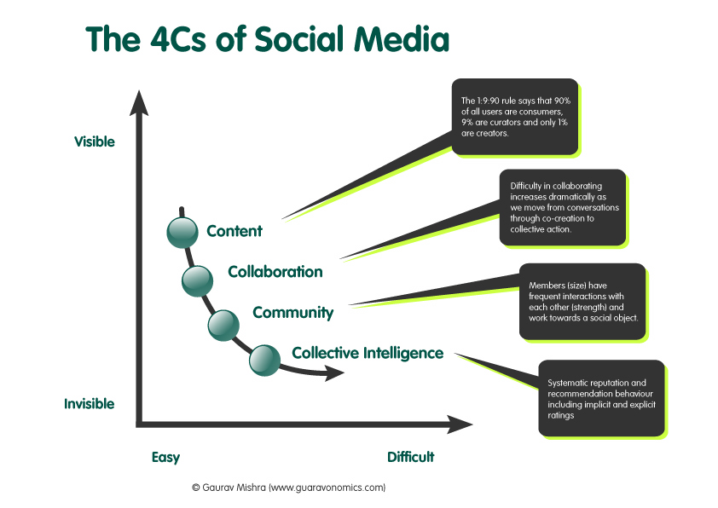
Figure 4: The 4Cs of Social Media (source: www. businessmodelchemist.com)

Content
Content is the first ‘’C’’ of Mishra’s model. It compares content from traditional media such as print and television to the internet and new media tools such as social media.

According to this model, media that existed before the advent of the internet has always been one sided because content was created by different people to be consumed by others. Consumers had to read what was provided in print media with absolutely no room to give feedback or react instantly. Social media on the other hand, has provided tools that can be used by the public to create and share content. The difference between content creators and consumers has ceased to exist, making it more fun and interactive. Therefore, social media tools permit everyone to become a content creator. Online content creation through social media tools is very user friendly and free, publishing content on social media sites is usually free for web users (www.businesschemistmodel.com).

In addition, user generated content is now at the core of most business models because marketers can monitor consumer trends and tailor products to targeted consumers based on the content provided online (Gauravonomics online blog). Moreover, user generated content has transformed amateur users to journalists who comment on news and provide useful information to other networks. Nonetheless, the fact that content can be created by all doesn’t mean all web users create content, most of them still prefer to visit blogs, read articles and leave comments. The 1:9:90 rules created by researchers state that, 90% of all users are consumers, 9% are curators while only 1% of the users are creators (Mishra 2009).

Collaboration
Collaboration is Mishras’s second C. It elaborates the link between people who use online platforms.
The second C, collaboration refers to the idea of bringing together skills, knowledge and experiences of web users to contribute to the development of a common goal. This goal in the context of social media could be to facilitate the transformation of individual actions to meaningful results that can benefit many social media users (Mishra 2009).
Mishra states that there are three levels of collaboration: conversation, co-creation and collective action. He further explains that content produced by consumers becomes the centre of many conversations that occur online. Looking at what is happening on social networks; one recognizes that conversations are mere stepping stones for co-creation. Therefore, the value in co-creation lies both in the individual contributors and the web content organisers. Some perfect examples of co-creation are Wikis, Open group blogs, Photo sharing and video collages and Wikis are a perfect example of co-creation.
On the other hand, collective action takes a step further and uses online engagement to initiate meaningful performance, which often takes the form of online petitions, fundraising, organising offline protests and signing online petitions (Mishra 2009).
Implicitly, Cameroonian migrants can create content for their homeland by collaborating with the Cameroonians who are registered on social networks to find out what their needs are.

Community
In this ‘’C’’, the author explains the shift between the concept of community in real life and that which is experienced online.
Social Media is defined as ‘’media that people use to be social’’ (Safko 2010b, p.3), it is impossible for people without a common goal to socialise. Social media facilitates sustained collaboration that revolves around the same idea over time and space (Mishra 2010). The concept of a community is very complicated because every web page is a latent community that needs to be activated. More so, every vibrant community has size and strength, and is usually built around a meaningful social object. In other words, it is often perceived that a community that is populated with strong relationships and constant interactions between members is better than a community void of those attributes. On the other hand, there is more to a community than its size and the relationship between its members.
Moreover, people need a social object that is meaningful to its members before they can build a vibrant community. That social object can be a person, an idea, a place or a thing. One good example of a social object can be a social network site for professionals (LinkedIn). Most of the members on this website are professionals or students who want their classmates to see their current activities and achievements. This network thereby becomes a social platform for sharing useful work related information and ideas. Anyone joining LinkedIn knows that it has different goals from a social network site such as Facebook. This is a website where people can find old friends, new ones and get updates about other people’s lives, making it different from LinkedIn which is work related. Therefore, colleagues can build online relationships on a social object which in this case is a social network site.

Collective Intelligence
Mishra’s fourth C, Collective Intelligence, refers to the idea that the social web enables users to combine individual actions while at the same time running sophisticated algorithms on them (Mishra 2010).
Collective intelligence can be internal (implicit) and external (explicit) actions. What makes collective intelligence very useful for social media is the fact that it gets easier to extract meaning from a community as the size and strength grows, because more value can be found in a larger than a smaller group, hence leading to a virtues cycle (Mishra 2010).
In sum, the 4Cs create a hierarchy of what social media can do. As one moves from Content to Collaboration, to Community and Collective Intelligence, it becomes harder to observe the different social media layers.

3.3 The continuum theory of social media
The continuum theory of social media holds the view that the concept of social media is about two distinct features-social and media that can never work well when considered as one. In other words, these theory looks at social as something completely different from media.

Figure 5: the two sides of the continuum (Source: student’s version).
From what the author of this theory explains, one can see that social and media work together but are completely two separate words that people use as though they are referring to one thing. The following distinctions can be noted when looking at both words separately.

The social side of the continuum
Social media often covers 99% social for small businesses and just 1% paid media for small businesses while media only covers 1% (www.Dannybrown.me). Nowadays, there are so many conversations going on at the same time making it possible for one person to manage, so there is need for assistance to help people manage conversations (www.Dannybrown.me). Also, the world of social networks such as Twitter, Facebook and FriendFeed can be time consuming (www.Dannybrown.me)
More so, Danny Brown believes social media works brilliantly for small consultancies because they are relationship businesses where managers always take an informal approach to reach their target. Therefore, the intimacy of scale matches the intimacy of sale. However, it is difficult to measure success because so much time is invested in socialising while payback shrinks.

The media side of the continuum
Big companies produce huge amounts of products that need to be dispatched within a short period of time. Doing that requires speed in marketing and communication, because in order to survive selling to millions of people, you will need millions of conversations to do that. Therefore, big companies producing consumer packaged goods need to consider buying social media in a big scale. In this case, the media will be 99% and 1% will go for the social because it is more difficult to reach the right target without paying more for media. In other words, marketers need to buy space next to other people’s conversation which is then considered advertising (Dannybrown.me).

What’s the currency of social media?
Human conversation takes time both offline and online, but the currency of online social media is human conversation. Through shallow conversations, millions of people create an online presence and brand awareness which requires hours and hours of conversation though it takes time for intimacy to develop.

4 Research Results
This chapter covers results from the survey that was sent out during field work as well as results and questions from the expert interview that the student had with three respondents. The results of the questionnaire that was sent to highly skilled Cameroonians in the Netherlands has been analysed with data generated from the SPSS 17.0 software. Therefore for purposes of clarity, an attempt has been made by the student in presenting an overview of all the research variables and their descriptive frequencies in well explained pie charts. However, the pie charts will be placed on appendix 1 of the appendix of the report.

4.1 Survey for highly skilled migrants
The questionnaire had a total of 16 closed questions, posed to highly skilled Cameroonian migrants as a way to answer the main research questions and sub question. The next section will start with the survey results, from 1 to 16 respectively.

What is your gender?
The student wanted to find out whether there were as many highly skilled Cameroonian women as men. This question was posed so the researcher will be able to draw the right conclusions with regard to the gender with the highest percentage of highly skilled Cameroonians living in the Netherlands. The following results came back:
Figure 1 of appendix 1: Pie chart of respondent’s gender (Source: SPSS)
Figure 1 of the research results of appendix 1 shows that there are more female highly skilled Cameroonian migrants living in the Netherlands from all the 13 respondents. It was noted that 61.5% of them are female and 38.5 are male, hence a great disparity in gender percentages.

What is your age?
With this question, the student wanted to find out if more social network users were younger or older; this too will be helpful in drawing conclusions and writing the right recommendations for the Afro Euro foundation. In addition, every organisation has a target market and knowing the age of respondents also facilitates the process of creating the right content or products for people within a certain age group. The research results showed that 7 out of the 13 respondents were between the age of 25 and 30, which sums up to 53.8% out of a 100.
Figure 2 of appendix 1: Pie chart on respondents’ age group (Source: SPSS)

Are you Dutch or a Cameroonian?
The main research question makes mention of highly skilled Cameroonian migrants living in the Netherlands, it would have been impossible to categorise the respondents as highly skilled Cameroonians without knowing whether their country of origin is the Netherlands or Cameroon. In this note, the following results were sent in: 84.6% of respondents which equals 15 people answered yes for Cameroon whereas just 15.4% answered yes to being Dutch. However, those that were Dutch were also born by Cameroonian parents, but this research focuses on highly skilled Cameroonians who came to study in the Netherlands and not on those who were born in the Netherlands.
Figure 3 of appendix 1: pie chart on nationality (source: SPSS)

What is your highest level of education?
The fourth question of the survey was to find out whether respondents fell within the target group which requires that they have higher qualifications. This question had four answers: high school, bachelor, masters and PHD. Most respondents have high school education (46.2%), followed by a bachelor degree with a 30.8%.
Figure 4 of appendix 1: Pie chart on respondents’ level of education (Source: SPSS)
Also, during the situation analysis, it was stated that there is a shortage of qualified workers in Cameroon based on desk research; therefore it was imperative to find out if respondents were already working in the Netherlands by posing the following question;

Are you currently employed?
For this question, 9 out of 13 respondents said they were employed whereas 4 said no, implying a 69.2% and 30.2% respectively.
Fugure 5 of appendix 1: Pie chart on professional statues of respondents (source: SPSS)

Having had a background check on respondents, the student had to find out whether respondents were familiar with the term social media. This question is relevant for this research because it will give answers to the main questions and sub questions.

Are you familiar with the term social media?
Out of 13 respondents 10 answered yes to being familiar with the term social media and 3 said no. The percentage of those who answered yes was 76.9% and 23.1% for those who said no. One of the sub questions for this research is about the meaning of the term social media-asking this question helps the student to know if the target group is accustomed to social media tools which will be used as a platform for the knowledge exchange process. The pie chart below shows the statistics of respondents.
Figure 6 of appendix 1: pie chart of familiarity with social media (source: SPSS)

Are you registered in any social network?
There are many people who visit social networks, watch people’s profiles that are open to the public, but they never feel like registering on any particular social network. This research is about using social media tools as a platform for knowledge exchange, hence, the need to find out whether respondents are registered on these networks or not. Up to 76.9% of respondents said they were registered and 23.1% said they weren’t as can be seen on the pie chart below:
Figure 7 of appendix 1: pie chart on registration on social networks (source: SPSS)

Do you use social network to connect with your friends?
Web users visit social networks for different reasons, but to find out whether people truly use these networks to connect with their friends is relevant because it will facilitate the process of sharing knowledge. It will be similar to connecting with friends, only if it is for something much serious than just networking. In this regard, 76.9% of the 13 respondents said they were users and 23.1% said no, this is also the percentage of those who are not registered. These figures are visible on the pie chart below:
Figure 8 of appendix 1: Pie chart on social network usage (source: SPSS)

How often do you visit and use social networks?
Frequency shows interest, anyone who frequents a particular location must have love or passion for it. Users have different reasons for visiting and using social networks, but for this research, it is vital to know whether respondents love networking or not. If they do not love networking, then it will be more difficult for them to want to participate in an online knowledge exchange exercise. Out of the 13 respondents, 55% said they use social networks whenever they are free, 24% said they can’t tell, 16% said daily and 5% said more than once a day as explained on the figure below:

Figure 9 of appendix 1: pie chart on frequency to social networks (source: SPSS)

On which of the following social networks are you registered? Please choose just one
While giving recommendations to the AfroEuro foundation on the platform that can be used for sharing knowledge, it will be good to know which platform most highly skilled migrants are already using so far, hence, the need for this question. The following results were noted from respondents: 38.5% are registered on Facebook, 23.1% are on Twitter, 23.1% said the social network they use was not on the list, and there was a 7.7% for MySpace and LinkedIn as well.
Figure 10 of appendix 1: Pie chart social network (source: SPSS), shows the above results.

Which of the following social networks do you rate as user-friendly and most effective?
If eventually there is going to be an online platform where highly skilled migrants can share knowledge, it is better to know which social network will be suitable for linking and connecting Cameroonians in the Netherlands with those in Cameroon. Facebook was the most favourite with 53.8%, some 23.1% said their most favourite network was not on the list, whereas 15.4% went for LinkedIn and 7.7% for Twitter. Perhaps the results are based on the goal of each social network. Facebook is mainly for finding friends and connecting with people, whereas linkedIn is for professionals, hence making the former more appealing to many target groups.
Figure 11 of appendix 1: Pie chart on the most effective social network (source: SPSS) shows the above results.

What is the main reason why you frequent social network sites?
This question is relevant for this research because the student wanted to find out the percentage of respondents who visit social network because they want to share information. If networking is the only or main reason, then it might be difficult to change that.
Figure 12 of appendix 1: Pie chart on reason for visiting social networks (source: SPSS).
However, the following answers were given:61.5% said they come to social networks to connect with friends, 23.1% said they go to social networks to share information and 15.4% said they come to social networks just to look at people’s profiles.

Would you like to share knowledge with your friends in Cameroon?
One of the reasons why the student posed the main question was because there is a shortage of skilled workers in Cameroon, therefore, in order to create a solution for that gap, respondents must have a sense of responsibility towards sharing knowledge with Cameroon, but if they do not feel obliged, it will also help to answer some of the sub questions. Results showed that 92.3% of respondents will like to share knowledge with Cameroon and 7.7% said no
Figure 13 of appendix 1: Pie chart on sharing knowledge with Cameroon (source: SPSS)
Most social network sites are free, the only currency as mentioned under the social media continuum is human conversation. It is difficult to measure the time people spend online and the value. Nonetheless, many people are prone to saying ‘’time costs money’’. If this is the case, the time spent online could be spent making money, hence, the need for the following question:

Which of the following communication tools do you think is most easy and cheaper for knowledge exchange?
Sharing knowledge is something that is very good for the society, but anything that is costly usually scares people who do not have enough income. Buying media space on TV can be very costly, so is the cost for printing information in magazines and newspapers, however, everybody prefers one communication medium from the other for personal reasons, as outlined on the pie chart below. 53 % of the respondents think using social network sites to share knowledge is much cheaper and easy, in the second place, 23.1% said they prefer Newspaper, then 15.4% said email and 7.7% said Television.
Figure 14 of appendix 1: Most easy communication tool (source: SPSS)

If there was a platform where you could share knowledge with people from Cameroon, would you participate?
Under theoretical framework, there was a model on the 4Cs of social media; one of these Cs was community. For the above question, 46.2% of respondents said yes, 38.5 % said may be, and 15.4% said they did not know.
Figure 15 of appendix 1: Participation in a social network (source: SPSS)

Which do you prefer; going to Cameroon to educate people or sharing knowledge via an online platform?
Within the part on the situation analysis, it was mentioned that the economic situation in Cameroon does not make the country very conducive for Cameroonians, which perhaps explains why many have decided to remain abroad after graduation. This question answers part of the main research question on incorporating social media tools for migrant homeland development. If respondents prefer using an online platform instead of going to Cameroon, then it imply that sharing knowledge via social media tools will be very possible.
Figure 16 of appendix 1: A pie chart on where to share knowledge (source: SPSS)
The results were as follows: 76.9% of respondents prefer using an online platform to share knowledge whereas 23.1% prefer going to Cameroon.

4.2 Expert interviews
It was imperative to carry out an in-depth interview with a group of highly skilled migrants that are already working in the Netherlands. The student chose people who have lived in the Netherlands for many years, some of them are already involved in projects aimed towards the development of Cameroon, but the student wanted to find out if sharing knowledge via social media platforms will be something interesting for them.
The questions that were posed to this group of three candidates were open and therefore could not be analysed on SPSS statistics software, therefore, the questions and responses will be stated in this section. One of the candidate works with Shell, another is an engineer who has started a health insurance scheme for Cameroonian migrants abroad and the third is the secretary to the Cameroonian ambassador to the Netherlands. The questions and results of all three interviews are as follows:

Expert Interview Questions
The interviews were categorised under three parts: background information of the interviewees, information about their knowledge of social media and the last part was to find out if they were willing to share knowledge.

Profile
- Name
- Age
- Country of origin
- Level of education
- Field of studies
- Profession
- How long have you lived in Holland?

Social Media knowledge and use
- Are you familiar with the term social media, and what do you think it means?
- Which social media tools do you use?
- What do you think about online social networking?
- Why do you use social networks?
- Which of those you have listed do you think is most effective?

Knowledge
- Why did you decide to stay in the Netherlands after graduation?
- Do you have any plans to return for your career?
- Now that you are not sure of returning, have you ever thought of using your professional expertise to do something that can benefit Cameroon?
- Are you currently involved in any projects involving Cameroon?
- So how do you communicate with your targets?
- What is your opinion about using social networking sites to share knowledge?
- What are some of the factors that can hinder the process of sharing information with Cameroon?
- Do you plan to relocate to Cameroon?
- How would you feel if you were asked to participate in an online platform where highly skilled migrants as yourself could share knowledge with Cameroon?

Results
Figure 1 appendix 2: Interviewee 1: Mr. Jean Patrice KOE Jr (source: field work)
Mr. Jean Patrice Koe Jr is the second secretary at the Cameroon embassy in the Netherlands.
Mr. Koe is a Cameroonian with a background in international affairs before coming to the Netherlands.

Social media use
‘’One of the greatest things that has happened to the embassy is having an internet website, yes I know what social media is and we have actually linked our website to some social media sites so more Cameroonians can get information about Cameroonian activities in the Netherlands from all over the world’’.
Secondly, Mr. Koe said they use Facebook and he is personally registered in LinkedIn.
Thirdly, he admitted that Facebook is very effective for connecting people though LinkedIn is the place for like minded people.
More so, he added that online social networking is good because it reconnects people and also helps to provide information to targets.
However, he cannot say which social network is best because so far, he has just tried Facebook, so saying it is most suitable for sharing information will be bias. But he ended this point by saying Cameroonians need to exploit more new media tools such as bringing their organisations on platforms where other Cameroonians frequent such as having an internet website and a social network account.

Knowledge sharing
In response to the question on why he decided to stay in the Netherlands after graduation, he said he was employed from the ministry of international affairs to come and work here. So before coming to the Netherlands, he was already a skilled worker. He also added that after the end of his office, he may leave to another country or back to Cameroon.
For the next question on using his knowledge for the benefit of Cameroon, he said working at the embassy is already serving his country. Sure they will help to support dreams and goals from migrants but they do not have particular projects other than standard consular affairs.
‘’Social networking sites can be good for sharing knowledge because participants have nothing but time to lose’’ said Mr. Koe, but he added that time can be deceptive and also a problem for users without self control. Another issue he mentioned was that the rate of internet here is far cheaper and easier than in Cameroon, so the connection with online experts could be hindered or interrupted. In sum, Mr. Koe said working at the embassy already makes him a knowledge sharer because he provides Cameroonians with updates about Cameroon and organises events that reunite Cameroonians. Though sharing knowledge through online platforms is something he has never thought about but will surely be interested.
Figure 2 appendix 2: Expert: Mr. Ako Egbe of 4 another (source: attachment from interviwee)

Profile:
Mr. Egbe is a 40 year old Cameroonian who has lived in the Netherlands for more than twenty years. He is a construction engineer but also has his own company which is 4another insurance scheme. Mr. Egbe lives in the city of Rotterdam the Netherlands and his passion is football. Moreover, Mr. Egbe has a bachelor’s degree in engineering and has been working for over ten years.

Social Media Use
Mr Egbe said he was familiar with the term social media because his daughter talks about it all the time. That she was the one who even placed his company on a social network site. He is familiar with Facebook but his professional profile is on LinkedIn. But he did add that the Facebook account is not functional because since his daughter placed his company information on his Facebook profile, he has not been using it or going there to create connections. However, he believes that he will make use of social media in the future because it is becoming a good marketing tool.
Mr. Egbe said he is very disappointed with Cameroonians because they do not like change, they lack trust and can never learn to be innovative. That since he started his project only two have families have registered with his health insurance scheme which was founded four years ago. Hopefully, he might try using social network sites to create awareness about his company, but for now, he is discouraged by Cameroonians.
In sum, Mr. Egbe does not have any intentions of residing in Cameroon, but he will visit frequently to promote his business. Sharing knowledge online will be a good thing because many Cameroonians need an awakening in the way they think, therefore, he will willingly participate in an online platform for sharing knowledge.
Figure 3 appendix 2: Expert: Sylvie Wanda (Source: attachment from interviewee)

Profile
Miss. Wanda studied information and communication management at Hagse Hogeschool, The Hague - The Netherlands where she had her bachelor’s degree. She has been living in the Netherlands for over ten years. Miss Wanda did her internship with Shell, and was employed immediately after she graduated by the same company. She currently lives in Utrecht and was born in Cameroon.

Media Use
Miss. Wanda is familiar with social media as she uses social networks to share photos. She added that the process of photo sharing with family and friends is easier on these networks. She is an active user of Facebook network and she uses it to connect with friends. Miss. Wanda Sylvie believes social networks are also good for sharing information.

Knowledge Sharing
Miss Wanda has never thought of sharing knowledge with Cameroon but will certainly consider it. ‘’The government can encourage small IT businesses, which means making internet access price to be affordable. (Most Cameroonian are willing to stay 24hrs on the net but this is not the case at the moment’’, confessed Miss Wanda. In her opinion, even if Cameroonians abroad are willing to share knowledge, lack of internet access will be a problem for Cameroonians who are willing to learn from highly skilled migrants.

Focus Group Discussion
During a trade fair organised by AfrEuro , business men came from Ghana to meet prospective business associates in the Netherlands. On the second day of the meeting, there was a match making process where discussions came up about many Africans having business ideas but very low brand awareness. Then the student asked the members there if they were aware of social media, some from Africa were not familiar with the concept, but those living in the Netherlands said they did. In sum, from the discussions, it was very clear that Africans need to change the way they communicate; many still believe in using snowballing to reach more people. They do not believe in spending much for advertisement, hence, they use friends to reach others. The main result from the focus group discussion was that Africans need trainings on using the right communication tools to create brand awareness around their businesses.

5 Conclusions and recommendations

This chapter is divided into two main parts; the first part will conclude findings, answer sub questions based on results from field work research, whereas the other part will give recommendations to the AfroEuro organisation based on findings.

5.1 Conclusions
At the beginning of this research paper, there was a main question, a policy question and some sub questions that were posed by the student. The reason for asking sub questions is to enable the student to answer the main question. Under this part, those questions will feature and will be answered with results from field work, thus:

Main Question
To what extend can social media tools be incorporated by highly skilled Cameroonians living in the Netherlands for the development of Cameroon?

Policy question
How can the AfroEuro organisation mobilise the skills of Cameroonian graduates living in the Netherlands for homeland advantage?

Sub Questions:
- What is social media?
- What are social media tools?
- What is the difference between offline social networking and online social networking?
- How can highly skilled Cameroonians living in the Netherlands use social media to share knowledge with Cameroon?
- Why should highly skilled migrants use social media for knowledge exchange?
- What can Cameroonian migrant organisations do to encourage graduates to share knowledge with Cameroon?
- Which social media platforms are most suitable for the knowledge exchange process between Cameroonians living in the Netherlands and those in Cameroon?
- How can the government of Cameroon facilitate the knowledge exchange process for Cameroonians via social media?
- What kind of social network sites are most suitable for knowledge exchange between highly skilled Cameroonians living in the Netherlands and Cameroon?
- What is the influence of social media on Cameroonians who are living in the Netherlands?

Answering sub questions

Base on literature and results, the following sub questions will be answered respectively:

Research Question
To what extend can social media be incorporated by highly skilled Cameroonians living in the Netherlands for the development of Cameroon?
Through the questions that were sent out and the responses which have been outlined in the previous chapter, this question has been partially answered; answers about what social media implies, and how to use social media tools for knowledge exchange have all been answered. However, for the sake of clarity, all sub questions will be answered respectively.

Policy question
How can the AfroEuro organisation mobilise the skills of Cameroonian graduates living in the Netherlands for homeland advantage?

Sub Questions
- What is social media?
- What are social media tools?
- What is the difference between offline social networking and online social networking?
- How can highly skilled Cameroonians living in the Netherlands use social media to share knowledge with Cameroon?
- Why should highly skilled migrants use social media for knowledge exchange?
- What can Cameroonian migrant organisations do to encourage graduates to share knowledge with Cameroon?
- Which social media platforms are most suitable for the knowledge exchange process between Cameroonians living in the Netherlands and those in Cameroon?
- How can the government of Cameroon facilitate the knowledge exchange process for Cameroonians via social media?
- What is the influence of social media on Cameroonians who are living in the Netherlands?

What is social media?
Under the theoretical framework, it was stated that human desire to be in touch with others has moved to the web. There were many definitions of the term social media, but from the results gathered during field work, one realises that many people define social media by the tools and not the term. Alexander Osterwalder who was cited under the theoretical framework, defines social media as online media that facilitates online activities such as; sharing information, participation and much more.
Also, from the social media continuum, the author explained that the words social and media must be viewed as separate and not one. Which leads us to another definition which said social media is media that people use to be social, hence, the two words work hand in hand. The platform where people use to meet has shifted from a physical place and location to a virtual world- social network sites.

What are social media tools?
From field work; desk research and qualitative research, this question has been clarified. According to the main findings social media tools are the different components that characterise social media, such as the platforms where people meet to socialise. One of the definitions before about social media defined it as ‘’media that people use to be social’’, Furthermore, there were social media tools that were mentioned earlier in the report, amongst which we had ‘’YouTube’’-a tool that can facilitate video sharing.

What is the difference between offline social networking and online social networking?
To begin, factors such as globalisation and technology have changed the concept of community- Howard Rheingold in his book called the virtual community states that ‘’ People use computers to communicate form friendships that sometimes form the basis of communities’’ (Rheingold, 1998). He also adds that these online communities are different from real life communities (Rheingold, 1998). Online social networking is different from what people do offline or in real life because of several reasons:
- Online social networking reaches a broader audience than real life social networking
- People who meet online to socialise can communicate with people from different countries at once
- Social networking facilitates communication and minimizes time, whereas in real life, if one has to visit friends, it takes more time and more money
- Real life social networking happens in a place that is real and tangible, whereas, online social networking happens in a virtual community that is created by people who communicate online
- The thing about both offline and online social networking is the fact that communities are being created in both cases, though it goes faster and easier online
- Finally, one must also take into consideration that real life social networking often last, though it takes time to create. Whereas, online relationships often end within a short period of time and are shallower.
Therefore, both offline social networking and online social networking are good in creating communities, especially because online social networking makes the world one global village.

How can highly skilled Cameroonians living in the Netherlands use social media to share knowledge with Cameroon?
Main research findings from the survey and expert interviews shows that 53.8% of respondents believe social network sites are most easy and cheaper for sharing knowledge. Therefore, the most cost effective way to share knowledge with Cameroon is via social network platforms.

Why should highly skilled migrants use social media for knowledge exchange?
A greater percentage of respondents are already social media users-76.9% are familiar with the term and the same percentage are already users, therefore social media platforms will be most suitable for sharing knowledge with Cameroon. Secondly, the previous question already says it is cheaper and easy to use.
Further, under the situation analysis of this report, a clear picture of Africa’s poverty was painted, which proved that living conditions are very bad in Africa and many are unemployed. Therefore, using a communication tool that is less costly is an advantage for both Cameroonians in the Netherlands and those in Cameroon.

What can Cameroonian migrant organisations do to encourage graduates to share knowledge with Cameroon?
Migrant organisations represent migrant communities and therefore should set examples for other migrants to emulate. There are many Cameroonian migrant organisations in the Netherlands that can set examples for others to imitate, here is a list of those that were discovered during field work:
C.S.A (Cameroon Student Association Netherlands). C.S.A was founded in 2007 with the aim of uniting Cameroonian graduates and students in the Netherlands. On their website, other students can get links to useful websites such as NUFFIC and scholarship offers for students from developing countries.
OBOSO (Cameroon Students in Einthoven). OBOSO is somehow different from C.S.A in that it is limited to graduates from Fontys Eindthoven in the Netherlands, but is also informative for Cameroonian graduates.
CAMNED: (Cameroon Association in the Netherlands). This association was also founded in 2007 with the mission of uniting Cameroonians in the country.
4another- a health insurance scheme for Cameroonians in Cameroon. In other words, Cameroonians in the Netherlands can buy health insurance for their families in Cameroon to get medical care back home.
Perhaps there are more Cameroonian migrant organisations that have not been mentioned above, but they are enough to start giving trainings to Cameroonian graduates. Many graduates might not feel compelled to share knowledge, but sending a message to them that sharing knowledge with Cameroonians is to their own advantage because their families live there will make them more willing. After all, working together will provide chances for knowledge and professional skills to be exchanged; those in Cameroon will discover new ways of marketing and communicating that could enhance their business acumen for a better and more promising future.
Moreover, there is a lack of trust and innovative thinking amongst Cameroonians as stated by one of the interviewees (Mr. Ako Egbe) during field work. The researcher interviewed the founder of the health insurance scheme (4another) earlier mentioned, about his vision and success so far. He stated that the main issue stopping Cameroonians from growing business wise and developing is a lack of trust between Cameroonians. He further explained that most Cameroonians in the Netherlands do not trust each other; therefore making it impossible for them to work together. Therefore, trust is lacking amongst the Cameroonian migrant society in the Netherlands.
Also, when the secretary to the Cameroonian ambassador Mr. Koe was interviewed, the student asked him to provide a list of Cameroonian migrant organisations so she could get in touch with them, but he provided a list without contacts. More than 90% of the organisations that have registered at the embassy did not state any contact details, thereby making it difficult for anyone to reach them. This also hinders the expansion of such groups because there are no formal communication channels.

Which social media platforms are most suitable for the knowledge exchange process between Cameroonians living in the Netherlands and those in Cameroon?
During field work, respondents were asked to state which social network site they consider to be most user friendly and 53.8% rated Facebook as being most suitable; hence, the best website to link Cameroonians in Cameroon and those in the Netherlands to the expert platform will be Facebook.

How can the government of Cameroon facilitate the knowledge exchange process for Cameroonians via social media?

Desk research via online sources showed that there is an inadequacy of internet providers in Cameroon.
There are already projects coming up in Cameroon to solve the problem of electricity, AES SONEL expects to add about 50,000 new electricity connections each year in Cameroon over the next 15 years (www.TDworld .com). If this project plans are materialised every year for the next fifteen years, then there is hoping that many homes will have internet. After all, social media is about adapting and innovating conventions (Ricardo 2009, p.51).
Therefore, making internet access available in all major cities of Cameroon with universities will be a good start to facilitate knowledge exchange between Cameroon and the Netherlands.
More so, if there are more internet providers in Cameroon; competition will also come in, which then influence the prices people will pay to get internet access, thus resulting to cheaper internet costs. If this happens, more people will connect online and many will probably register on social network sites, hence, knowledge exchange can commence.

What is the influence of social media on Cameroonians who are living in the Netherlands?
Research findings proves that 61.5% of respondents use social network sites to connect with friends, but some 23.1% also go to these sites because they want to share information. One can then conclude that social media helps Cameroonians living in the Netherlands to maintain affinity with the country of origin. By connecting with their family members and friends in Cameroon, the concept of home then disappears because social media platforms now become their common home.

In conclusion, highly skilled migrants already have these skills and if the skills are well utilised, the knowledge sharing process will be very easy. There are three major components to be considered here; knowledge skills, qualifications, and competencies.

The three concepts below are already instilled into highly skilled migrants; they have the qualifications which are descriptive educational learning objectives thought in schools (Schneckenberg 2008, p. 194). They also have acquired qualifications which are directly measured through knowledge and skills, and finally, they have the dispositional ability to efficiently act in complex situations Schneckenberg 2008, p. 194). Therefore, Cameroonian highly skilled migrants are well equipped to share knowledge internationally.

Figure 6: Three skills needed by highly skilled Migrants (Source: Dirk Schneckenberg 2008)
Furthermore, there were some social media tools that were mentioned earlier on in this report, amongst which we had ‘’YouTube’’. This tool can be a very good tool for sharing videos. Trainers may direct learners to watch videos (lessons) anywhere in the world where internet can be accessed ( Bozarth 2010,p.131). Jane Bozarth also adds in her book on social media that YouTube videos play well on many mobile phones, thereby facilitating the tasks of highly skilled Cameroonian migrants who may want to share knowledge through YouTube. Cameroonians back in Cameroon can watch these videos when they want.
In addition to YouTube, highly skilled Cameroonian migrants in the Netherlands can also train fellow Cameroonians through the use of another social media tool known as ‘’skype’’. Skype is a tool that allows users to make free voice and video calls via the internet. Additionally, with a small amount charged by Skype, users can also call friends on land lines and mobiles all over the world. Therefore, there are limitless opportunities to share knowledge. Hence, knowledge sharing via social media tools from every indication will not be a difficult task for highly skilled migrants.

5.2 Recommendations
The main reason for this report was to find out how highly skilled Cameroonian migrants can incorporate social media tools for the development of Cameroon. In a nutshell, results have been analysed from research findings and sub questions have been answered, but who can take the message to highly skilled migrants-the AfroEuro organisation. There are two major already realised recommendations for AfroEuro that will feature under this section namely, a SWOT analysis and a website where Cameroonian experts can register to share knowledge which will be linked to social network sites. In addition to those two are more recommendations that can change the current situation facing Cameroon today as narrated under the situation analysis of this report.

A recommended SWOT analysis
AfroEuro has been given the mandate to carry out this project for highly skilled migrants to share knowledge via social media platforms, starting with Cameroon. They need to adapt the following SWOT analysis in order to facilitate the knowledge exchange process; after all, one of their main objectives is to build a bridge between migrant communities in the Diaspora with their countries of origin.
STRENGHTS | WEAKNESSES
- The magazine has a unique selling point because being online creates more brand awareness. Linking the magazine to a social network platform creates more brand awareness and invites more readers.  - There is no revenue required for advertising on social network sites.  - More businesses can buy ad space on the online magazine if the website is linked to major social media platforms; linkedIn, Facebook, Twitter and MySpace  - Free advertising campaigns on social network sites  - Product is environmentally friendly because it has shifted from a printable version to an online magazine.  - Very informative for Africans because of the daily news presented on the website. | - The brand name is not recognizable amongst the target group as intended.  - The magazine does not have enough revenue to expand.  - The magazine doesn’t have any assets so far.  - There are no qualified professionals working on the magazine, as content is mostly created by voluntarily sources and interns.  - The magazine often produces news that is not up-to-date because of a shortage in content writers.  - Promotional tools are not being used, which negatively affects brand recognition.
OPPORTUNITIES | THREATHS
- Subsidies from the government for social projects  - Getting new advertisers and sponsors interested in the magazine content by actively updating new projects via social networks.  - Updating the magazine according to new trends. Giving an additional value to it by writing about news from different African countries  - Targeting new market(s) such as creating a training curriculum for migrant communities about the use of social media.  - Promotional campaigns will help improve brand recognition, especially if organisation registers on about five social networks | - Economic downturn  - No or limited possibilities of subsidizing the magazine  - Target group may not be interested in the content of the magazine  - The costs of production and distribution outweigh the sales profit  - New entrants on the market  - More migrant communities start using social media platforms too
Table 4: SWOT analysis for AfroEuro (source: 2011 field work)
Using the above SWOT will create more brand awareness, increase the number of readers for the magazine, and expand the product line as more ad buyers will use the magazine. It will also be a platform for highly skilled migrants with expert knowledge.

Website for highly skilled migrants (http://sitebuilder.yola.com/en/ide/index.jsp?siteid=8a4986cb2ffb1903013002a09a6b241b)
Cameroon is not the only country that needs expert skills. Having a website for highly skilled Cameroonian migrants, the AfroEuro organisation will be creating a platform that will be utilised by many countries in the future. However, a vivid website has been created during field work as a guide for the organisation.

New way to communicate
The research results proved that most highly skilled Cameroonian migrants are between the ages 25 to 30, what this means for AfroEuro is that there is a defined target group to be considered when developing communication campaigns to reach highly skilled migrants. Most youths love social networking and new experiences. If the organisation sells something they can buy, they will be willing. The process of sharing knowledge has to be made interesting.

Content has to change
The content that is written on the AfroEuro magazine has to meet the target group. Giving that AfroEuro has all Africans living in Europe as its target; there can be a narrower section for youths on the magazine that will make the content more appealing. The youths that have to share knowledge need a column in the magazine that updates them on the need to share knowledge. They need a reminder of the fact that Africa has a shortage of skilled workers.
Also, young people do not like complicated messages that need so much understanding to figure things out. It will be better for the content that is addressed to highly skilled migrant to be very simple and clear. It must be unambiguous and has to communicate in a language that appeals to that particular target.

Trust
Moreover, there is a lack of trust and innovative thinking amongst Cameroonians as stated by one of the interviewees (Mr. Ako Egbe) during field work. The student interviewed the founder of the health insurance scheme (4another) earlier mentioned, about his vision and success so far. He stated that the main issue stopping Cameroonians from growing business wise and developing is a lack of trust between Cameroonians. He further explained that most Cameroonians in the Netherlands do not trust each other; therefore making it impossible for them to work together, perhaps migrant organisations can change this by working together with each other to create more trust.
To proceed, Mr. Egbe added that Cameroonians are narrow minded, that they lack innovative thinking, which is a shame because it will always hinder progress, hence giving room for more graduates to remain stagnant and dependent on foreign aid.
One of the things that AfroEuro can do is to try to communicate unity and trust. If migrants cannot trust each other, the process of sharing knowledge will not work. Without trust, most participants will not want to work on the website for highly skilled migrants.

The problem of internet
Online sources that were consulted before proved that internet could pose a problem for sharing knowledge with Cameroon. Perhaps the AfroEuro foundation can use highly skilled Cameroonian migrants who are living in the Netherlands to get internet providers in the Netherlands to work with them. In other words, internet providers can partner with Dutch companies to create more internet connections in Cameroon. More so, if this is not possible, AfroEuro can stand as a back-up for highly skilled migrants so they can get aid from the Dutch government to create more internet networks in Cameroon, thereby, aiding the communication process via social networks.

Awareness
The SWOT analysis shows that AfroEuro has limited brand awareness; this problem can be resolved by creating a link on Facebook or any other social network sites that can take visitors straight to the AfroEuro website. However, the AfroEuro account on social media platforms should include newsfeed with headings about interesting upcoming events that may interest youths. This way, they get them to rush to the AfroEuro website, hence, creating more viewers and visitors. The more people come to the AfroEuro website, the higher the possibility that they can advertise with the magazine, which will also lead to more sales.

‘’One of the key beliefs of knowledge management is the notion that information becomes more valuable when it is share’’ (Quinn 2002, p. 96)

References and Appendixes

Appendixes

This part incorporates all material that could not be placed in the body text plus a list of references that were used in the report.
There are three appendixes to this report that will fall under this section: appendix 1 will cover the survey questions and answers from SPSS, then appendix 2 will cover expert interviews and the results and appendix 3 will cover some background information about the organisation.

Appendix 1 Survey and results for highly skilled migrants
- What is your gender?
Male
Female
- Please mark an x on your age group
25-30
30-35
35-40
40-45
- Are you Dutch or a Cameroonian?
Cameroonian
Dutch
- What is your highest level of education?
High school
Bachelor
Masters
PHD
- Are you currently employed?
Yes
No
- Are you familiar with the term social media?
Yes
No
- Are you registered on any social network?
Yes
No
- Do you use social networks to connect with your friends?
Yes
No
- How often do you visit and use social networks?
 | Whenever I am free | More than once a day | Daily | I can't tell
- On which of the following social networks are you registered?
Facebook
MySpace
Twitter
LinkedIn
Not on the List
- Which social networks do you rate as most user friendly and effective? Please choose one.
 | Facebook | KinkedIn | Twitter | Other
- What is the main reason why you frequent social networks?
To connect with friends
Look at people's profiles
share information
other
- Would you like to share knowledge with your friends in Cameroon?
Yes
No
- Which of the following communication tools do you think is most easy and cheaper for knowledge exchange?
Television
News Paper
Social media
Email
- If there was a social media platform where you could share knowledge with Cameroon, would you participate?
Yes
May be
I don't know
- Which do you prefer, going to Cameroon to educate people or sharing knowledge through an online platform?
Online platform
Going to Cameroon

Survey Results

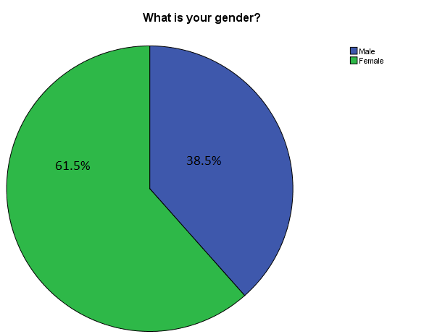
Figure 1: Pie chart of respondent’s gender (Source: SPSS)
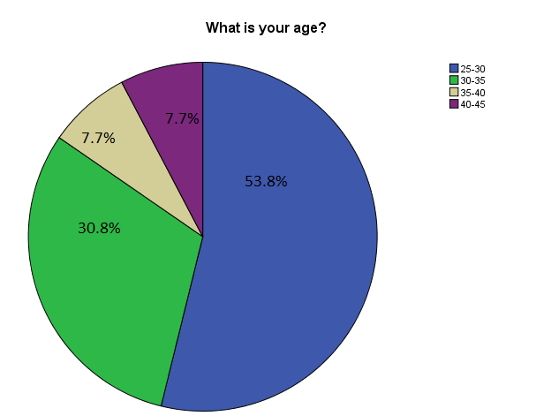
Figure 2 : Pie chart on respondents’ age group (Source: SPSS)

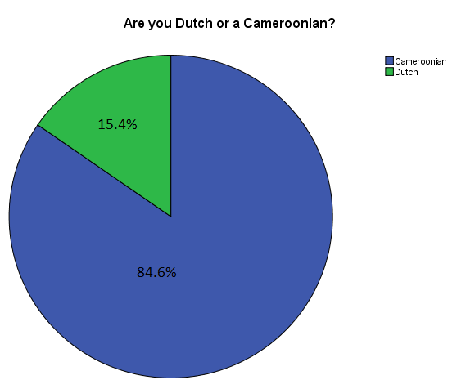
Figure 3: pie chart on nationality (source: SPSS)
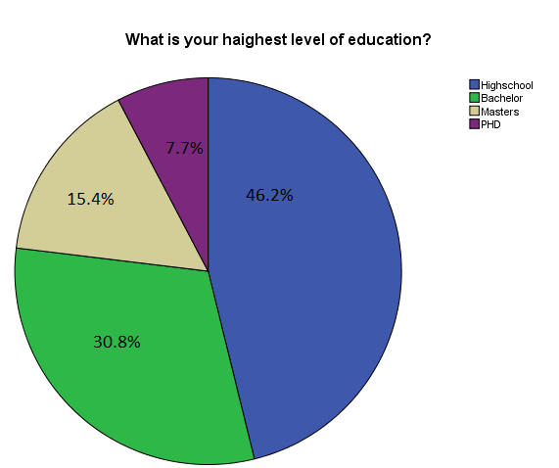
Figure 4 : Pie chart on respondents’ level of education (Source: SPSS)

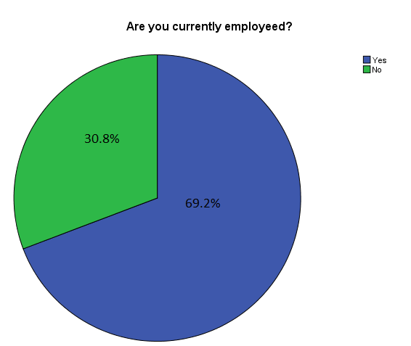
Figure 5 : Pie chart on professional statues of respondents (source: SPSS)

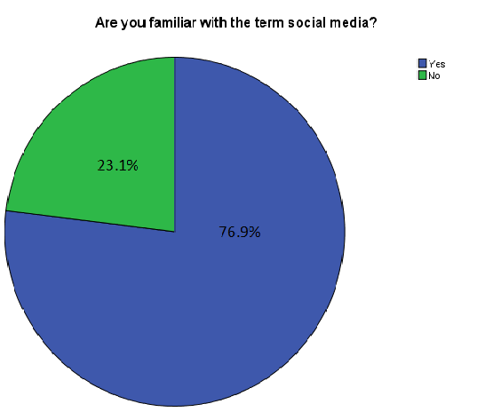
Figure 6 : pie chart of familiarity with social media (source: SPSS)

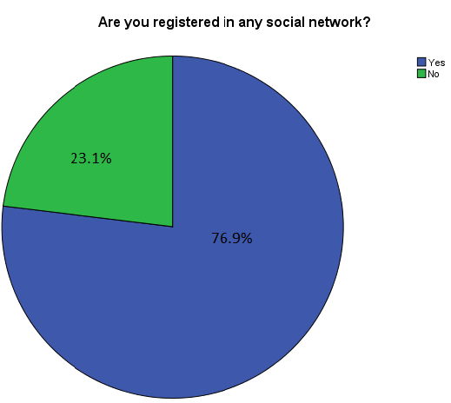
Figure 7 : pie chart on registration on social networks (source: SPSS)
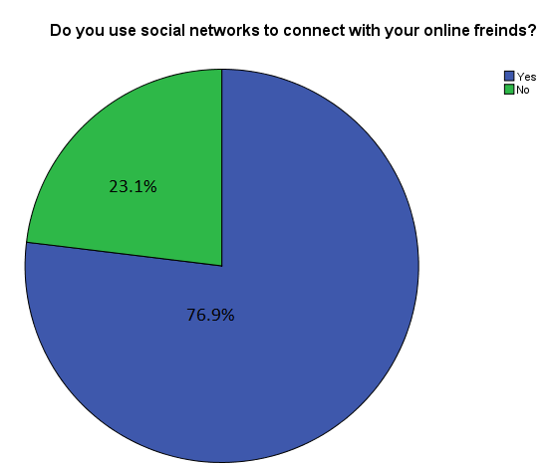
Figure 8 : Pie chart on social network usage (source: SPSS)

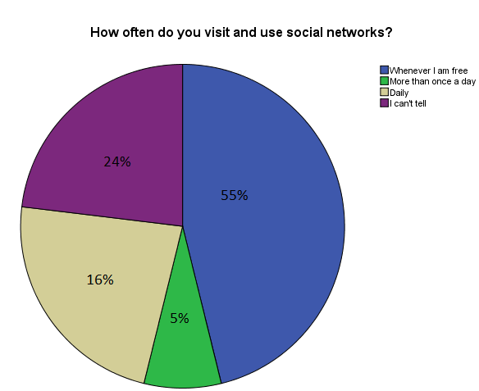
Figure 9 : pie chart on frequency to social networks (source: SPSS)
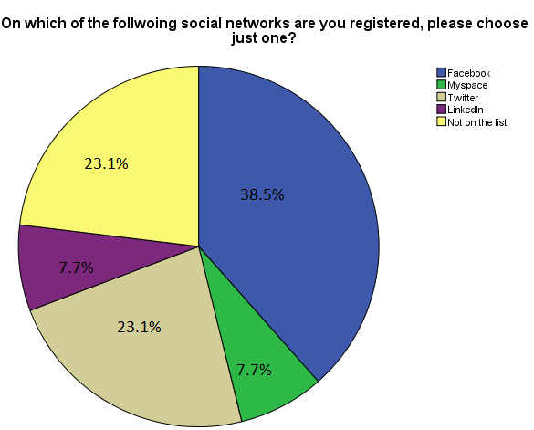
Figure 10 : Pie chart social network (source: field work by student)

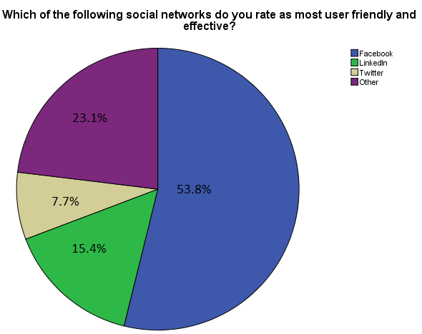
Figure 11 of appendix 1: Pie chart on the most effective social network (source: SPSS)
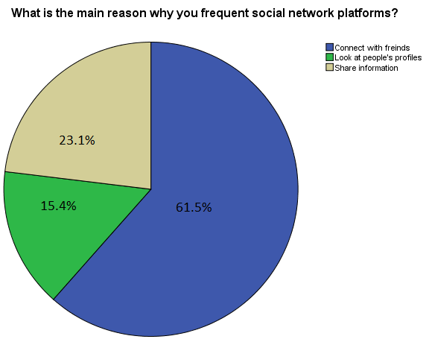
Figure 12: Pie chart on reason for visiting social networks (source: SPSS).

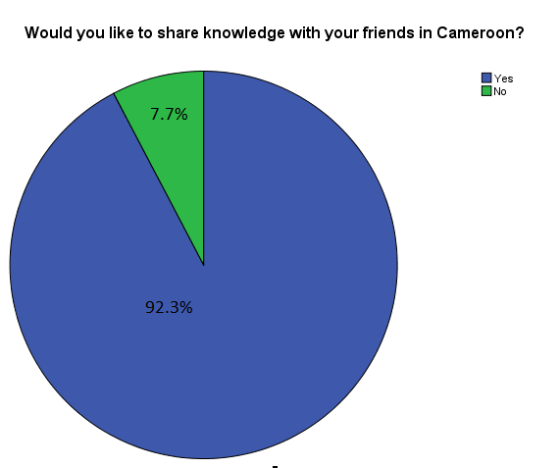
Figure 13: Pie chart on sharing knowledge with Cameroon (source: SPSS)
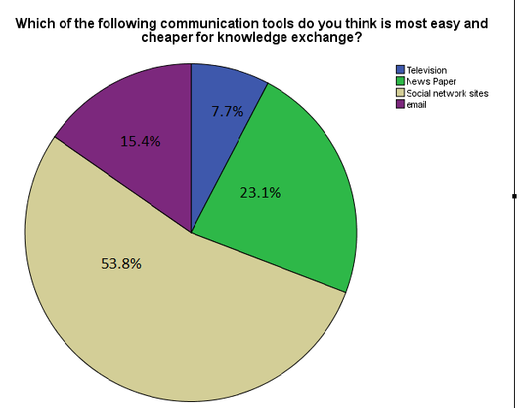
Figure 14 : Most easy communication tool (source: SPSS)

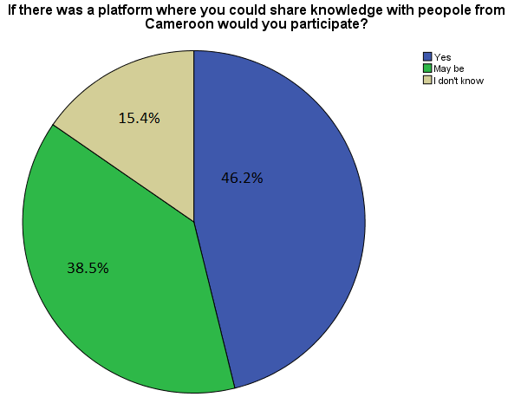
Figure 15: Participation in a social network (source: SPSS)
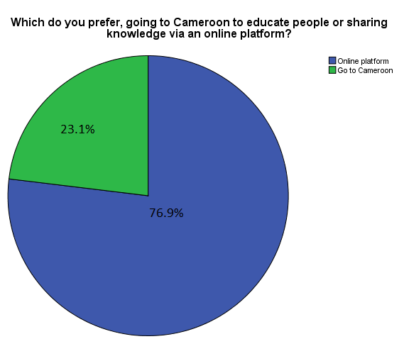
Figure 16 : A pie chart on where to share knowledge (source: field work by student)

Appendix 2 Expert interviews and images of interviewees

Profile of expert
- Name
- Age
- Country of origin
- Level of education
- Field of studies
- Profession
- How long have you lived in Holland?

Social Media knowledge and use
- Are you familiar with the term social media, and what do you think it means?
- Which social media tools do you use?
- What do you think about online social networking?
- Why do you use social networks?
- Which of those you have listed do you think is most effective?

Knowledge sharing

- Why did you decide to stay in the Netherlands after graduation?
- Do you have any plans to return for your career?
- Now that you are not sure of returning, have you ever thought of using your professional expertise to do something that can benefit Cameroon?
- Are you currently involved in any projects involving Cameroon?
- So how do you communicate with your targets?
- What is your opinion about using social networking sites to share knowledge?
- What are some of the factors that can hinder the process of sharing information with Cameroon?
- Do you plan to relocate to Cameroon?
- How would you feel if you were asked to participate in an online platform where highly skilled migrants as yourself could share knowledge with Cameroon?
Figure 1appendix 2 : expert: Mr. Jean Patrice KOE Jr (source: field work by student
Figure 2 appendix 2: expert, Mr. Ako Egbe of 4 another (source: www.LinkedIn.com)
Figure 3 of appendix 2: expert : Miss Sylvie Wanda (source: www.facebook.com)

Appendix 3 AfroEuro background information

ORGANISATIONAL STRUCTURE

Afro Euro Foundation

Upper management
1. Board of Directors
2. Management Board
3. Advisory Board (consultancy, legal affairs, etc)

Middle management
- ICT Manager
- Human Resource Manager
- PR Manager
- Project Manager
- Marketing Manager
- Finance Manager

Operational staff
- Layout and Design Editor
- Online Editor
- HR Assistant
- PR Assistant
- Project Officer
- Project Assistant
- MC Assistant
- Sales Assistant
- Finance Secretary

NB: Interns and Volunteers could serve at any of the administrative levels depending on qualifications, project need or goal of internship or professional goals.

Planning
- Strategic policy of the org
- Strategic policy of the functional units
- Operational policy

Projects’ Focus
- Education and Training
- Empowerment
- Promotions
- Research
- Media Developme

References
There are two categories of references that were used: books and online sources from the internet.

Books
Martyn Denscombe. (200). The Good Research Guide. Mc Graw Hill New York.
Kameshnee Naido. (1998). African Media Online. Institute Panos Dakar publisher

Joel Comm- Twitter Power 2.0, Wiley 2010 publications

Deanie French, Charles Hale, Charlse Johnson and Gerald Fair. (1998). Internet based learning. London: Kogan Page publishers

Claude Elwood Shannon & Warren Weaver, The Mathematical Theory of Communication, 1948, Shannon publications

Geert Hofstede, Jan Hofstede and Micheal Minkov. (2010).’’ Cultures and Organizations.’’ Software of The Mind. McGrow Hill United States Publications.

Jane Bozarth. (2010).Social Media for Trainers. Wiley United States publications

Lon Safko. (2010). Social Media Bible, second edition. Wiley publications

Cliff Atkinson. (2010). The Backchanel. United States: New Riders Publishing

Micheal A. Peters, Simon Marginson and Peter Murphy. (2009). Creativity and the Global Knowledge Economy. New York: Peter Lang Publishing, Inc.

Dirk Scheneckenberg. (2008). Educating Tomorrow’s Knowledge Workers. The Conncept of eCompetence and its Application in International Higher Education. Euburon academic publishers, the Netherlands

Howard Rheingold's . (1998). The Virtual Community

Marianne Dainton and Elaine D, Zelley. (2005). Applying Communication Theory for Professional Life. Sage Publications, Inc, London.

Gerbner, G.(1998). Cultivation analysis: An overview. Mass Communication & Society

Gerbner, G. Gross, L., Morgan, M., & Signorelli, N. (1980). The ‘’mainstreaming’’ of America: Violence profile no. 11. Journal of Communication, 30, 10-29
Stephen Quinn. (2002). Knowledge Management in the digital Newsroom. Oxford: Focal Press

Websites
www.keithmurphy.info/1102/question.htm
http://cozay.com/
http://www.cameroonechoes.org/exodus-brain-draining-in-cameroon/
http://www.un.org/apps/news/story.asp?NewsID=18693&Cr=educat&Cr1
http://www.cbs.nl/nl-NL/menu/themas/bevolking/cijfers/default.htm
http://www.volkskrant.nl/vk/nl/2686/Binnenland/article/detail/1052618/2010/11/16/Nederland-telt-47-000-buitenlandse-studenten.dhtml
http://www.oncameroon.com/community/blog/Tobias/16/inside_cameroon/IRIN-Report%3A-Brain-drain-hampers-public-services.html
http://royal.pingdom.com/2010/01/22/internet-2009-in-numbers
http://paramoreredd.com/blog/entry/social-therapy-roi/
http://www.cameroonechoes.org/exodus-brain-draining-in-cameroon/
http://www.dibussi.com/2008/06/cameroon-brain.html
http://www.cameroononline.org/2011/03/12/recruitment-of-25000-youths-the-modalities-and-31-fields-identified/
http://tdworld.com/projects_in_progress/announcements/aes-electricity-cameroon/
http://www.csanetherlands.com
http://www.web-strategist.com/blog/2008/01/09/social-network-stats-facebook-myspace-reunion-jan-2008/
http://nl.wikipedia.org/wiki/LinkedIn
http://www.cameroon-embassy.nl/index.php/nl/news-and-media/news/3-newsflash/249-implementation-of-pres-biyas-decision-to-recruit-25000-certificate-holders.html
http://www.obosso.org/index.php/user/index?langue=en
http://www.camned.nl/home
http://www.4another.com/
http://www.newsfromafrica.org/newsfromafrica/articles/art_11649.html
http://statline.cbs.nl/StatWeb/publication/?VW=T&DM=SLEN&PA=80479ENG&D1=4-5,10-13&D2=0&D3=0&D4=(l-25)-l&HD=100712-1629&LA=EN&HDR=T&STB=G1,G2,G3
https://www.cia.gov/library/publications/the-world-factbook/geos/cm.html
Guarav Mishra. http://www.gauravonomics.com/blog/the-4cs-social-media-framework/
http://www.slideshare.net/Alex.Osterwalder/social-media-for-communicators-web20-iabc
http://www.businessmodelalchemist.com/2010/02/social-media-and-business-models.html
http://www.ihmctan.edu/PDF/notes/Research_Methodology.pdf
http://www.nembot.com/news6EN.htm
http://www.tempestcom.com/guide/guide.aspx?Id=34
www.wisdomquotes.com
http://www.nuffic.nl/nederlandse-organisaties/nieuws-evenementen/nieuws-archief/persberichten/het-aantal-buitenlandse-studenten-groeit-duitsland-blijft-de-belangrijkste-leverancier
http://publicwebsite.idrc.ca/EN/Resources/Publications/Pages/ArticleDetails.aspx?PublicationID=704
http://www.hrhresourcecenter.org/node/1246
http://www.gauravonomics.com/blog/the-4cs-social-media-framework

