**Juliet Ojeaga 1564237**

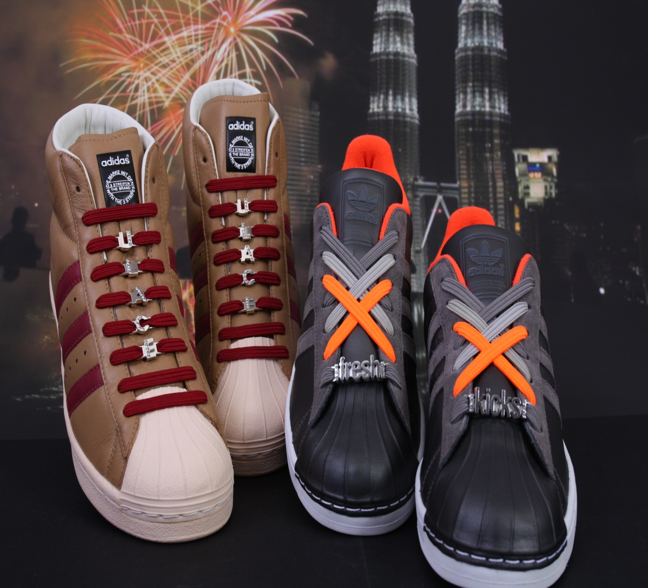

**Entering The United Kingdom’s Footwear Market**

**Entering the UK Footwear market: “How Str8 Casuals can raise brand awareness and increase customer’s responsiveness for U-lace in the UK’s Footwear Market”**



**Juliet Ojeaga 1564237**

**Year 4: International Marketing Management (IMM)**

**Hogeschool Utrecht, University of Applied Sciences**

**Utrecht, June 2013**

# Foreword

I give thanks to God almighty for giving me wisdom, knowledge and understanding during the course of my study.

However, special thanks go to my company supervisor, Mr. Gerard van de Beek, for his support all through the period I was working at the company. I equally want to say thank you to U-lace CEO Tim Tally for his immeasurable help throughout my internship period.

I specifically want to say a very big thank you to my supervisor, Mr. Bart Toering for his invaluable assistance and guidance before, and during the course of my project.

I will also like to use this opportunity to thank the internship office of the HU, University; particularly Ms. Arlene Phelipa-Lopes and Ms. Eline Hofman for their helping hand during my search for a company.

And finally, I would like to thank all members of my family and friends who have always been of immerse help to me all through this period.

# Executive Summary

The following report presents the findings of a project conducted at Str8 Casuals B.V. in the Netherlands. Str8 Casuals is a young and dynamic Dutch company that operates in the sport fashion industry. Str8 Casuals is the sole distributing presence of four different America brands in the Netherlands and throughout Europe. The brand ranges include, New Era, Majestic, U-lace and Radii Footwear. It provides customers with varieties of sport apparels such as; Baseball caps, clothes, shoes and shoe laces. The company operates in over 14 countries of Europe and is aiming at expanding its presence and market reach by covering most parts of the continent with its carried brands. Due to the company’s aim, Str8 Casuals has identified the United Kingdom as a new market to penetrate with its U-lace brand; therefore, the company is laying emphasis on entering the market. U-lace is a modular quick-change customizing lacing system for sneakers. This project is conducted to address the issue with the goal of providing a market analysis using various combinations of research techniques to provide the most relevant entry strategy for entering the market with U-lace and subsequently, generate ideas on how marketing efforts can be used to raise brand awareness for the product, and increase customer’s responsiveness respectively. The scope of this project is restricted to the United Kingdom. The project result is expected to generate an insight on the problem.

The methodology used in this report is the export planning process. This method is used because it best fits in the standard of the company’s requirements. The export planning process provides Str8 Casuals with a structured and detailed internal and external analysis for entry and conquering the market, the implementation of the entry plus possible ways of raising brand awareness for the brand. Three phases of the export planning process are determined. The first and second is determined by analyzing the export policy and export audit plan, which determines the success of the market entry strategy using various market research techniques to look at the most prominent entry strategy/ modes of entry, the strategic options to use, and how they can be tackled. The third and final phase of the export planning process is executed by generating the marketing efforts and or activities for raising brand awareness.

The findings of this report show that the United Kingdom is an attractive market for Str8 Casuals to penetrate with U-lace. In addition, the findings also show a large market size with a high level of differentiation amongst respective sellers. Further, the findings lead to several interpretations of strategies. There are two strategic options that Str8 Casuals should use, which are SO “*offensive*” option and ST option “*strengthen*”. The report findings also shows the solutions/ strategies for growing U-lace in the market, they are; product development and market development. This project however generated several recommendations for answering the research questions; they are: the choice of entry modes/ strategy and export plan which is the actual implementation plan. These two recommendations are needed in order to effectively enter the market and efficiently raise awareness for the brand.

Table of Contents

Foreword 3

Executive Summary 4

1. Introduction 8

2. Methodology 11

3. Internal/External Analysis 13

3.1. Export policy plan 13

3.1.1 External Factors of the United Kingdom 15

3.1.2 Footwear Market in the United Kingdom 17

3.1.3 Business strategy definition 20

3.1.4 SWOT analysis and TOWS Matrix 23

3.2 Strategic Options 27

3.3. Conclusions 31

4. Export Audit 33

4.1. Entry strategy 33

5. Recommendations 35

6. Implementation Plan or Export Plan 37

6.1. Research 37

6.1.1 Target Market and Size 37

6.1.2 Segmentation 38

6.1.3 Potential Target group of U-lace 40

6.2. Targeting 41

6.3. Competitive Positioning 42

6.4. Proposed Marketing Mix 44

6.4.1 Recommendations for raising brand awareness 49

6.5. Logistics 56

7. Marketing Budget Plan 57

8. Final Conclusion 59

Afterword 60

*Review of advice to Str8 Casuals* 60

Bibliography 62

Appendix 1 UK’S External Factors (DESTEP Analysis) 64

Appendix 2 Five Force Analysis 68

Appendix 3 Weighted SWOT Matrix 69

Appendix 4 Questionnaire Responses 70

Appendix 5 Lists of Potential Distributors and Retailers 74

Appendix 6 Analysis to the Application of the Marketing Mix to the Target Group 79

Appendix 7 Marketing Budget Costs Analysis 80

Appendix 8 Facts about Footwear Today Magazine 83

9. Internship Report 84

9.1. Overview of Work Completed 84

9.2. Assessment of Graduation Project 92

9.3. Competencies 95

# 1. Introduction

Str8 Casuals B.V. is a young and dynamic Dutch company that operates in the sports fashion industry. They are the sole distributing presence and seller of four different America brands such as New Era, Majestic Athletic, Radii Footwear and U-lace in the Netherlands and throughout Europe. The product includes a variety of sports apparel, such as baseball caps, clothes, shoes and shoe laces. Str8 Casuals B.V. is operating in over 14 countries of Europe and has hundreds of customers across Europe. Str8 Casuals sells its products in Europe through agents and sub-agents who are thereby paid on commission by percentage over sales. Str8 Casuals has an annual turnover of about 20 million Euros and has over 15 distributors that carries and sells its brand Europe wise.

As a distributing company, Str8 Casuals B.V. is striving to expand its presence in most European countries with her sport brands by going into new markets. They are presently laying emphasis on entering the United Kingdom’s (UK) footwear market with the new shoe lace brand called U-lace. U-lace is a modular, quick-change customizing lacing system for sneakers. It is an individual, stretchable and modular lace segments designed to comfortably span just a single set of eyelets. U-lace was developed in the United States of America (USA), and is sold by only authorized distributors in over 65 countries across the globe of which; Str8 Casuals B.V. is the sole distributor of the brand in Europe. U-lace has presence in 5 countries of Europe. The current U-lace sales zones, distributors, sub-distributors and sales agents across Europe are shown in Figure 1.

Figure 1: Str8 Casuals U-lace sales and European zones

Str8 Casuals is aiming at expanding its market reach by covering most part of Europe with the U-lace brand. This research project discusses the company’s ability to introduce its U-lace brand in the United Kingdom market, with the implementation of marketing activities to raise brand awareness among the target audience. The tiny blue line from figure 1 represents the scope or focus country for this project. The other regions are not included because; U-lace is already functioning in the various markets. Additionally, other European countries are not included in this project due to time constraints and project density. However, the same strategy can be implemented in the various EU countries when necessary. The implementation of a market entry plan would ensure that U-lace is effectively introduced to the UK footwear market, while the implementation of a strong marketing communication mix should enable an effective communication of the brand to the target audience.

The **problem definition can be formulated as:** *‘How can Str8 Casuals enter the UK footwear market with its U-lace brand and how can brand awareness be raised in order to increase customer’s responsiveness and sales?’*

Moreover, U-lace is a completely new brand that has not yet been recognized amongst respective consumers in the market, sales have also not been actualized due to this same reason. Therefore, actual sales are not measured in this report. Nevertheless, awareness needs to be raised so as to attract these prospective buyers, and by so doing, will eventually lead to actual sale of the brand.

In order to arrive at a concrete and achievable solution for the problem, information’s are needed to be gathered from data; therefore, research questions are formulated. These questions are divided into questions on entry strategy/ modes and Marketing communication mix. The research questions are as follows: (1) How can U-lace be effectively introduced to the UK footwear market? (2) Are there any risks of entrants? (3) What choice of market entry is most favorable for the entering of U-lace to the UK shoe market? (4) Who are the potential target groups of Str8 Casuals U-lace brand in the potential market? And (5) How best can Str8 Casuals position U-lace in order to raise brand awareness in the potential market?

After the gathering of relevant data, the answers to the various research questions are provided and interpreted, discussed to give possible solutions to the problem defined.

The main goal of this project is to evaluate the targeted country using various combinations of research techniques to sort out the most relevant entry strategy of introducing U-lace to the UK’s footwear market and subsequently generate new ideas on how the company can use effective marketing efforts to achieve brand awareness for the product and consequently attract the target group to purchase U-lace. Moreover, previous studies served as the basis of this project. In addition, the distributed questionnaires to the end users provided data about the perceptions and behavior of buyers which is valuable when devising the marketing strategy for boosting brand awareness for U-lace.

However, the research is considered to be of significant importance to the company as it is aimed at investigating various approaches to entering a new market and also raising brand awareness. It is equally significant because, when consumers are not aware of a company’s brand, the company’s sales effort tend to drop. While several researches have shown that a company’s success lies basically in how good and effective its marketing communication is (Chandon, P. 2003). This is because, using the right communication instrument will ensure that the brand is easily recognized by potential customers whilst the intention to buy a product cannot be formed without brand awareness first occurring. Thus, brand awareness is expected to increase customer’s responsiveness and boost the sales of U-lace in the market, which is however the goal of the project.

The research task assigned for this project is related to the International marketing management studies in the sense that, it relates specifically to the most marketing courses I have done. The marketing models from the courses; Market entry strategy, Global market research, Export management and International marketing communication strategy; are used to answer the questions and find the most effective solutions for this project.

# 2. Methodology

The main purpose of this research as earlier stated is to discuss Str8 Casuals ability to introduce U-lace to the UK market with the marketing ability of raising brand awareness for the brand. According to the research purpose, this research is based on a policy making research nature. A policy making research is a special type of research that involves the provision of useful recommendations and possible actions for resolving a fundamental problem (Dukeshire and Thurlow 2002). A policy making research always begins with a problem that has already been identified, it evolves around the process of data collection of relevant information’s and actions for dealing with the problems are developed. In order to solve the problem of Str8 Casuals, the data collection method is mostly secondary data which is imperatively relevant for such an organizational research. Secondary data are gathered from sources such as school databases and company database and other governmental statistics. In addition, desk research is used in order to find appropriate theories about market entry and other relevant topics on international marketing communication. Additionally, data from administered questionnaires is used to grasp the perceptions of the customers.

Further in this research project, the 4 steps of the policy making process is used. This is a methodology that shows a step by step analysis from how to identify a problem, to finding the solution. Figure 2 shows how the policy research cycle relates to the main structure of this report. The pink boxes are the policy making processes while the blue boxes represents the report structure:

**Policy Research** Cycle

Conduct Research

Problem Recognition

Take Actions & Control

Propose Strategy

Problem Definition

Internal/external analysis

Conclusions/ Strategic Options

Recommendations/ Implementation plan

Figure 2: Policy research cycle

Each step in the research cycle process is required to ensure that this report is well structured.

Although the research cycle plan method has been used, it is however a guide on how to structure the report. The main methodology used for this project is the export planning process. The export planning process involves a detailed internal and external analysis, international marketing planning and the implementation of market entry (Leeman, 2010). The process is divided into four different phases with a (10 step structure). The four phases are shown in figure 3. Each step in the export planning process is necessary to ensure the best possible results required in entering a market and as well, raising brand awareness for a product. Also, the steps defined the potential market, the trends, the external factors of the country for internationalization and what the options are for market entry. It also defines who the customers are, the target groups, defines the positioning of the brand and the type of distribution channels to distribute or sell the brand, analyzing the market and planning the international market entry. The following frame work provides the base in executing this project.

Figure 3: Export planning process (adapted from) Leeman, 2010. (Research frame work)

# 3. Internal/External Analysis

This chapter presents the results of the export planning process. The analysis determined the success of the market entry strategy and gives a clear understanding in achieving the relevant information needed to solve the problem. This first process to be discussed is the export policy, followed by the export audit, and thereafter the export plan.

## 3.1. Export policy plan

The first analysis is the export policy process or international strategy definition process. The aim is to gain an insight into Str8 Casuals base for expanding its shoe lace brand’s reachability to the UK footwear market. The following elements will be analyzed in the export policy process.

Figure 4: Elements of the export policy process

The highest level in the pyramid which is, company overview, deals with the analysis of the vision, mission and business definition of the company. Third level of the company overview is dealt with in this paper as it directly explains the business of Str8 Casuals with respect to U-lace. Business definition describes in what business the company is active, to whom they service and how they do the servicing. Further, Str8 Casuals targets men, women and children who are unable to tie their shoe laces, persons who love to customize their shoes and persons wearing sneakers for the purpose of sport activities. Furthermore, the business definition of U-lace is represented using the model of Derek Abell; which is divided into three dimensions. This dimension focuses on three elements; they are: needs of customers/ functions, the customer groups which have the needs, and the technologies to fulfill these needs. Below is an overview of U-lace business definition; described based on the three dimensional elements of Abell respectively.

Functions

Young men, women and Children

Shoe Customizers

Sports and Leisure Footwear

Retailers

Recreation of lacing patterns

Transformation of Lace-up sneakers

Strechable sneaker customing lace

Quick change lacing systems

Consumer segment/ groups

Technologies

Outer material

Patented nesting aglets

Engineered Elastic

Figure 5: Business definition of U-lace

The next level is external analysis which comprises of consumer analysis and general environmental analysis and the last phase of the export policy plan is the business strategy definition; which represents the analysis of the competitive forces in the market and explains the attractiveness variables of the market. Consequently, a link is needed to be made to determine the introduction of U-lace to the UK market with the aim of raising brand awareness, and for the purpose of increasing sales and customer’s responsiveness. Therefore, the next step is to further analyse the external factors surrounding the business of Str8 Causals U-lace brand in the market. In other to reduce complexity, only external factors, SWOT analysis and the overall business strategy are used. The highest level in the pyramid is not analysed with respect to this project because of the high level of density. However, information about the company can be found in the introduction chapter of this report. To begin, Str8 Casuals B.V. have to be aware of the external factors surrounding the market they are operating, therefore; subsequent analyses are required to answer the following research questions:

* How can U-lace be effectively introduced to the UK footwear market?
* Are there any risks of entrants?

In order to answer the research questions above; the footwear market, the strategic options for the company and the competitive forces in the market needs to be analyzed. The classical way to analyze the market is to do a DESTEP analysis of the selected country, a SWOT confrontation matrix for the strategic options and a competitive environment using Porter’s 5 force model.

A DESTEP analysis is used to translate the outer environment into an organizational world. In addition, the 5 force model of Porter is used to determine the competitive structure of the market while SWOT analysis is used to measure the internal potentials and limitations and the opportunities and threats from the external environment. In order to find out the impact of external environment on the market entry, external analysis is run; this is the second phase of the export policy plan.

### 3.1.1 External Factors of the United Kingdom

The United Kingdom of Great Britain and Northern Ireland consists of, England, Scotland and Wales. The United Kingdom is an influential and active member of the European Union and one of the world’s largest economies. The United Kingdom has a population of 63,047,162 million as of July 2012, and stand in the position of 22nd in the world ranking. Please refer to appendix 1, for more details on the DESTEP analysis of the United Kingdom. Moreover, the table below shows the DESTEP factors in the UK.

|  |  |
| --- | --- |
| **Demographic Environment**   * The UK has total population of 63,047,162 million inhabitants * The median age of the population is 40.2 years; with male being 39 years and female 41.2 years * Urban population- more than 80% of the residents live in the cities * Good and high literacy level * Average household income increased by 69 pounds | **Economic Factors**   * Highly developed economy - The UK is the 6th largest country in the world and second largest economy in the EU * High standard of living * High GDP level in the European Union in terms of purchasing power parity after Luxembourg and the Netherlands * High unemployment rate * Highly competitive economy- favourable climate for investment * Low level of inflation |
| **Socio-cultural Factors**   * High standard of living * Good educational and health care systems * Values Christianity and thereby open to doing business with other international countries * The very individualistic nation- the children are taught how to contribute positively to the society | **Technological Factors**   * Strong in both scientific and research and development platforms * Has the world’s largest aerospace industry |
| **Ecological Environment**   * Has global influence over environmental issues * The UK continues to reduce greenhouse emissions | **Political Environment**   * The UK has a parliamentary system of government * There is a high level of control over corruption * The United Kingdom is regarded the most successful nation in terms of the application of the rule of law * Has strong ties with emerging market |

Table 1: DESTEP Analysis United Kingdom

To summarize the DESTEP analysis, it can be seen that the United Kingdom has a large population of 63,064,162, and has a strong economy in the EU; with a strong reputation in terms of living standards, social welfare etc. the UK is the 6th largest economy in the world and 2nd largest in the European Union and likewise havestrong capabilities in both scientific and research and development platforms.

In order to analyze the UK market effectively, the Footwear market will be used as a base line for the project, reason being that, there has not been any research conducted on shoe lace. However, with the help of the footwear market analysis, it will be feasible to understand the market of footwear in general and from thence; deduced the relevance, and implement the strategies in the shoe lace sector as both are complements of each other. Next section describes the footwear market in the United Kingdom.

### 3.1.2 Footwear Market in the United Kingdom

The United Kingdom’s footwear industry has experienced a high level of growth in the year 2011 after suffering a decline in the previous year. The footwear market is consisting of all the total revenues generated from selling men, women and children’s shoes. However, the market for footwear in the UK is fairly saturated and highly fragmented. UK is the third largest footwear market in the EU after Germany and France. The market grew in line by consumer spending however, due to the rise in UK’s unemployment rate in the year 2009; there was continuous fall in market value which brought about relative low cost of footwear. Nevertheless, there was no implication that the demand for footwear was affected negatively due to the economy downturn. Consumers in the UK tend to purchase even more than they regularly do because of the low cost of footwear; female consumers, specifically. In addition, the total market size of UK’s footwear market was valued at € 8.2 billion in the year 2007 which was recorded in terms of retail sales whereby, the UK accounted for 16% of all footwear sales in the EU.[1]

**UK’s footwear market value**

According to the survey from MarketLine, the United Kingdom footwear market grew by 15.8% in 2011 to reach a value of $9,419.1 million, the compound annual growth rate of the market between the periods of 2007 up till 2011 was 1.7%. However, the market performance is expected to rise with an anticipated compound annual growth rate of 2.5% from 2011 up to 2016, which will in turn boost the market value of $10.2 billion by the end of 2016 (MarketLine, 2012).

The reproduced table is adapted from MarketLine data and found on page 8.

|  |  |  |  |  |
| --- | --- | --- | --- | --- |
| **Table 2:** | **United Kingdom footwear market value: $ million, 2007-11 (e)** | **Column1** | **Column2** | **Column3** |
| Year | $ million | £ million | € million | % Growth |
| 2007 | 8,791.5 | 5,481.5 | 6319.5 |  |
| 2008 | 8,962.9 | 5,588.4 | 6442.7 | 2 |
| 2009 | 8,828.5 | 5,504.6 | 6346.0 | -1,5 |
| 2010 | 8,136.0 | 5,072.8 | 5848.3 | -7,8 |
| 2011 (e) | 9,419.1 | 5,872.8 | 6770.6 | 15,8 |
|  |  |  |  |  |
| CAGR: 2007-11 |  |  |  | 1.7% |

Source: MarketLine data

**UK’s footwear market trends**

The demand of footwear in the United Kingdom is influenced by some major trends in the market see table 3 for reference. The main trend that can be found are seasonal trends, this is a situation whereby footwear are produced according to the climate situation. There are different footwear made to suit a specific weather condition, therefore consumers are compelled to purchasing footwear that can be used for different climate conditions. This is particularly true about women who buy shoes to fit every occasion. Another trend in the market for footwear is the buying attitude of consumers as a result of the economic downturn. The economic situation has made some consumers buy less expensive footwear while others buy less but chose to buy more comfortable and long lasting footwear; and also that, which fits them well. Despite the fact that there is a slowdown on economic, fashion still continues to be an increasingly important aspect of buying footwear.

In addition, the internet is now a new trend for young people to find the latest fashion and footwear from blogs and thereby spreading the results through word of mouth to friends and so on. This was previously done by media and celebrities who dictate how the fashion trend would be. The last market trend for footwear in the UK is ethical fashion, which has now become mainstream and glamorous.

|  |
| --- |
| Market Trends |
| Seasonal trends |
| Different footwear for different climate conditions |
| Buying attitude as a result of economic downturn |
| Internet trend |
| Ethical fashion |

Table 3: United Kingdom’s footwear market trends

**Sports footwear**

The demand for sports footwear increased drastically as a result of the increase in sports participation in most EU countries. The market is however divided into various segments such as, outdoor pursuits, for fitness activities, football, golf, racket sports, and other sport specific and general use. Moreover, the general usage sector has become a representative of the all-purpose footwear, leading to high value of more than 20% share of the UK’s footwear market for trainers in the second half of the year 1980; which has become a standard leisurewear (Keynote, 2001). This segment has subsequently become the largest and fastest growing sector in all EU countries. Because sports footwear are being worn as leisure wear, there has now been rapid growth in the market. However, there is an oversupply of cheaper wear in the country especially in the general sports footwear which includes; sneaker being sold out at discounted prices. Also, the sneakers are becoming more and more acceptable in the society, clubs and bars that do not normally allow people wear trainers when entering, are now given people access to entering the bars, despite the fact that, they have sneakers on. Additionally, the sports footwear market will continually be the most relevant aspect of the overall footwear market in the next coming years.

***Trends in the United Kingdom’s sports footwear market segment***

The first trend is that, sports footwear is worn as fashionable leisure footwear. Sneakers however remain popular among young people with various designs available. Secondly, the sale of footwear is an on-going shift from formal to casual footwear. Below is the market trends based on user segment. Here men are divided into two categories; see table below.

|  |  |  |
| --- | --- | --- |
| **User segment** | | |
| **Market Trends** | **Women** | | **Men** | | |
|  |  | | *Younger* | *Older* | |
| * Leisure footwear * Shift from formal to casual footwear | * Style * Design * Fashion | | * Fashion * Brand conscious | * Comfort * Quality * Design | |

Table 4: United Kingdom sports footwear market trend variables

It can be seen from the above table that, women prefer more fashionable, stylish footwear and are design conscious. However, their male counterparts are divided into two groups; young and old men. Younger men are more fashion oriented and are equally brand conscious whereas the older men believe and seeks comfort and regard quality more important. This group are likewise design conscious. The following section goes further to discuss the business strategy definition.

### 3.1.3 Business strategy definition

The third level of the hierarchy in the pyramid represents the business strategy definition. This phase analyzes the competitive forces in the market, the market attractiveness factors etc. the first step to be analyzed here is the competitive determinants in the United Kingdom’s Footwear market.

**3.1.3.1 Competitive environment**

As earlier mentioned, the five force model analysis of Porter is a tool to analyse and determine the competitive forces and structure in a market; in this case, the United Kingdom’s footwear market. The five forces comprises of the threat of potential new entrants to the market, secondly, the bargaining power of supplier and bargaining power of buyers, threats of substitute product and finally, the degree of competitive rivalry. These five factors are significant and important; they are used to determine the solutions and conquering of entry strategies. The following figure shows the competitive determinants in the UK’s footwear market using the five forces model of Porter.

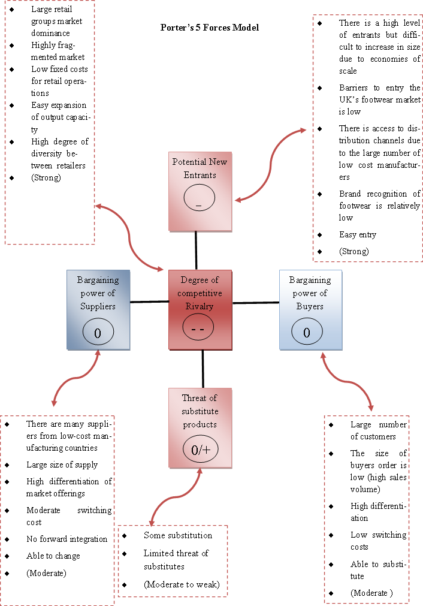

Figure 6: Competitive Forces in the UK’s Footwear Market

The above figure analyses each competitive factor found in the United Kingdom footwear market respectively. The barriers to entering a market are very important tools in determining how high or low the threat of new entrants is to an industry or market. However, there is no or Low barrier to entry the UK’s footwear market which makes entry very easy. There are therefore potential entrants which makes the threat of new entrants strong. Moreover, it can be seen from this analysis that there is economies of scale based on the fact the footwear market has a high level of entry that is however difficult to increase in size. All of these factors made the threat of potential entrant to this market strong. More details of the five forces can be found in appendix 2:

The points to take into consideration after analyzing the competitive environment of the footwear market in the United Kingdom, is however:

* The threat of new entry is quite strong: new competitors can easily enter the footwear market when it seems that companies are making profits
* The degree of competitive rivalry is also strong because there is a high degree of diversity among retailers in the market etc.
* Power of buyers is moderate which means they are able to switch and substitute one shoe for another. For instance, customers can easily switch from purchasing sports footwear for other footwear types and vice versa.

Following, the analysis shows that the market for footwear is very competitive and everyone differentiates their market offerings to gain power in the market.

Although the market may seem non attractive for footwear manufacturers and sellers but for a shoe lace manufacturers as Str8 Casuals B.V., the market is rather attractive because; there is first and foremost no barriers to entry, there are lots of footwear producers in the market with different offerings that U-lace will benefit from. In addition, the high growth rate in the market of footwear as a whole means that, there is a high chance of U-lace to be sold; coupled with the fact that U-lace is a patented brand, competitors will find it difficult to make exact replica of the product and as such, reduce the competition of rivals.

**3.1.3.2 Market attractiveness matrix**

|  |  |  |  |  |
| --- | --- | --- | --- | --- |
| **Market attractiveness matrix for UK’s Footwear Market** |  |  |  |  |
| **Factors** | **Weight** | **Rate** | **Score** | **Value** |
| Market size | 16% | Big | 1 | 0,16 |
| Market growth rate | 15% | High | 1 | 0,15 |
| Potential differentiation | 10% | High | 3 | 0,3 |
|  |  |  |  |  |
| Intensity of competitive rivalry | 20% | High | 3 | 0,6 |
| Threat of substitute products | 5% | Moderate to weak | 1 | 0,05 |
| Power of buyers | 10% | Moderate | 2 | 0,2 |
| Barriers to entry | 15% | Strong | 5 | 0,75 |
| Environmental factors | 9% | Good | 2 | 0,18 |
| Total | 100% |  |  | 2,39 |
|  |  |  |  |  |
| 1 = Attractive |  |  |  |  |
| 3= Moderate |  |  |  |  |
| 5 = Unattractive |  |  |  |  |

Table 5: Market Attractiveness matrix for UK’s footwear

The analysis from the market attractiveness matrix shows that the United Kingdom footwear market has a value of 2.39 which is considered attractive and therefore a compelling market to penetrate and for the sale of U-lace. The market has high potential level of differentiation and a high growth rate, coupled with the fact that the market size is appealing for the sales of such a product. The next section will discuss the SWOT and TOWS using matrix.

### 3.1.4 SWOT analysis and TOWS Matrix

The next phase to be discussed is the SWOT analysis. Here, the internal capabilities are analyzed in line with the external factors to form a base for the strategic options. This analysis is conducted using the SWOT analytic tool. First and foremost, the SWOT is an acronym which stands for Strengths, weakness, opportunities and threats. Moreover, the table below summarizes the strengths, weaknesses of U-lace and the opportunities, and threats of the external factors in the United Kingdom that could pose a threat, and equally create an opportunity for possible entrants to the market, respectively. The following table presents the SWOT analysis of U-lace:

|  |  |  |
| --- | --- | --- |
|  | **Favourable** | **Unfavourable** |
| **Internal** | **Strengths**   * Good management systems * Expansion capabilities: have the ability of thinking globally * Creative and innovative abilities in research and development and in marketing in the US zone * It is the first original modular sneaker customizing shoe lace * Has the ability of creating well over 40 lacing patterns * U-lace has the ability of turning lace-up sneakers into slip-ons * U-lace can make exact matching of team school, club and fashion colours possible * 8. Is the one and only shoe lace that yields well over trillion possible colours and pattern combinations * U-lace is an affordable and accessible modular sneaker customizing lace on the market | **Weaknesses**   * U-lace does not work with every single sneaker style * The product usage needs to be explained to every customer the first of purchase * There is lack of awareness among prospective customers because; the brand is not yet recognized by many consumers in market * Weak marketing expertise in the European market |
| **External** | **Opportunities**   * The United Kingdom has strong ties with emerging markets * There is an opportunity of corporate tax reductions; which is a great opportunity for Str8 Casuals, as people would have some left over money to buy a pair of shoe and a lace to accompany it * The UK has strong capabilities in R&D platforms * Sustainable environment * Rapid growth in the footwear segment of the market | **Threaths**   * Economic slowdown may reduce the demand * There could be the threat of counterfeits: that is, the probability that competitor would produce the same type of product is high * The UK’s regulation is not in sync with EU * Moderate buyer power |

Table 6: SWOT analysis for Str8 Casuals U-lace brand

In order to find out the strategic options for Str8 Casuals, a TOWS matrix analysis is run. A TOWS matrix is also called a confrontation matrix. It is a tool that is used to analyse the output derived from a SWOT analysis. The aim is to identify the most important strategic issues the organization is facing and with that, formulate the strategic options for the company.

The higher the score the more an attention should be paid to that option. This is done in order to generate the best strategy for Str8 Casuals in the UK fashion Footwear market. One advantage of using a confrontation matrix is that, it aids in the decision process of analysing the strategic options that are important and the ones to be taken into consideration. Additionally, it ensures that the strategic options are represented and also, the most interesting options are less likely to be overlooked. The analysis work as follows:

A 100% = Full confrontation

0% = No confrontation

Before a full analysis is drawn, it is however feasible to have an explicit picture of the different strategic options and as such, the confrontation matrix grid is made. The different options are combined with another factor and thereby resulting to the assessing of the options whether the options chosen are positive or negative. The following figure shows the SWOT confrontation matrix analysis of U-lace:

Figure 7: SWOT Confrontation matrix analysis for Str8 Casuals U-lace brand

The above figure presents the confrontation matrix of U-lace using the SWOT analysis from the preceding paragraph as the baseline. The individual factor in the matrix is combined with another factor for instance, option (S1) combined with option (O1) in order to make an assessment of whether the factor is favourable or not favourable. In addition, based on this matrix the strategic options that Str8 Casuals B.V. would take into considerations are given in the strategic option chapter of this report. See appendix 3 for more details on the weighted confrontation matrix. Finally, the conclusion of all of this analysis is the answer to the research questions asked previously. The next section interprets the strategic options data and transforms them into solutions.

## 3.2 Strategic Options

After combining each individual factor, the strategic options Str8 Casuals should take into consideration is now clear, and can now be determined based on the confrontation matrix analysis of figure 7. An overview of the options to use and what to do are presented below:

Strategic options formulation for Str8 Casuals U-lace brand

* **SO option**: *“offensive”.*

The analysis shows that, column S2-O4 and S4-O5 of figure 7 should be taken into consideration. This has full confrontation that can be considered and dealt with. That is, making use of being the first, original modular sneaker customizing lace and uses the innovative abilities in R&D in order to serve the growing markets in the UK.

* **ST option**: *“Strengthen”.*

Str8 Casuals should take into account column S2-T2. The threat of counterfeits product can actually be turned into an opportunity for Str8 Casuals U-lace brand in the UK as a result of the creative abilities. The abilities to bring and create new designs and easy installing shoe lace would strengthen the brand and will therefore increase customers purchase.

Therefore, Str8 Casuals should focus on being more creative and innovative in order to maintain stable market position especially in the area of counterfeits products in the UK.

Besides, a weighted confrontation analysis is used to grasp a visual representation of the strategic options factors respectively. The following pie chart shows the outcome of the weighted confrontation matrix after the analysis was made:

Chart 1: Outcome of the weighted confrontation matrix

Looking at the above graph from the weighted confrontation matrix, the result shows a 56.64% on the offensive factor and 11.72% on the defensive factor.

Therefore the remark on the strategic option is that, Str8 Casuals would need to focus on expansion, and should therefore use the offensive strategy which is to “attack and grow” the business. Conclusively, the rapid growth rate of the United Kingdom’s footwear market indicates that there is a glamorous future and opportunities for U-lace; so, Str8 Casuals should keep designing U-lace that suits the target segments, and also, implement a strong marketing communication campaign in order to raise brand awareness, and as well compete against the competitors in the market.

Further, in order to find a possible solution as per how U-lace can grow in the UK’s market, the growth strategy needs to be implemented. In order to grow U-lace, the growth model of Ansoff is used to find the best and suitable strategy needed.

|  |  |
| --- | --- |
| Market development | Diversification |
| Market penetration | Product development |

Figure 8: Ansoff’s growth strategies model

The growth strategy of Ansoff is a management tool that links a company strategy to its general strategic direction. The rationale behind Ansoff’s growth strategy is to decide where an organization lies with competition on a global stage and to review how companies can grow their business. However, it is important to know where a company stands currently in the marketplace before taking steps for growth.

Str8 Casuals uses mainly, the market development Strategy to expand its market and sells its carried brands across Europe. New products are introduced and sold in existing markets through the same distribution channels. In addition, new markets are developed by introducing their already existing products to gain more market position.

**Recommended strategies for growth of U-lace**

Using the Ansoff’s growth model for Str8 Casuals U-lace brand, two strategies to grow are recommended. They are: **“*product development and market development”:*** Str8 Casuals B.V. should use product development strategy for U-lace. It means the developing of U-lace in the existing footwear market. This can be done by persuading current customers of Str8 Casuals other footwear brands to buy its U-lace brand; which is new and thus, more product lines of Str8 Casuals will be sold to the same customers.

Besides, the second strategy the company should use is the; market development strategy. This then means that, Str8 Casuals would develop the existing U-lace regular and the new Mix-N-Match in the new UK footwear market. Str8 Casuals is to retain and further develop the markets in which it already has strong presence by increasing customer satisfaction and consequently its market share. Moreover, U-lace has the financial and competitive ability to aggressively pursue expansion in other attractive countries and regions within Europe customizing its strategies and products with respect to the national and cultural peculiarities of demand. In addition, the UK which is the potential market in this case would be a good choice for Str8 Casuals to expand U-laces’ brand reachability.

Subsequently to the growth strategy, Str8 Casuals would need to know the strategic alternative to be ahead of competitors in the new market, and this can thus be derived from the generic competitive strategies of Porter. The following figure shows the generic competitive strategies of Porter:

**Competitive advantage**

|  |  |
| --- | --- |
| **Differentiation Strategy** | **Cost Leadership** |
| **Concentration on Niches** | |

Broad Market Scope

**Competitive Scope**

Narrow Market Scope

Differentiation

Lower cost

Figure 9: Porter’s generic competitive strategies

Although U-lace is classified premium and sold at cheap rates; the low price alone cannot give Str8 Casuals B.V. competitive advantage over the fierce competition in the UK’s footwear market. However, Str8 Casuals seeks to compete based on the uniqueness of its U-lace brand. The ability for U-lace to turn lace-up sneakers into slip-ons, coupled with the fact that, it is the only modular sneaker customizing lace that looks like an actual shoe lace when installed, its creative and innovative abilities in research and development so as to keep up with design trends, plus; the ability to allow customers create well over 40 lacing patterns with different lace colours on their sneakers, makes U-lace a premium and unique product brand.

Considering all of these characteristics, Str8 Casuals should definitely use the differentiation strategy to differentiate U-lace from other competitors shoe laces in the UK’s market. Also with this strategy, U-lace can effectively compete among others in the fierce UK’s market.

Therefore, the proposed competitive strategy for U-lace according to Porter’s generic model; is the differentiation strategy. Reason being that, U-lace can be differentiated with the unique elements it possess.

## 3.3. Conclusions

Although the United Kingdom’s footwear market is used as a base line for this project, it is still feasible to implement the same theories on the shoe lace market; being that there is no first hand data regarding shoe lace itself. However, it is crystal clear that without first analysing the market of footwear, it will not be handy to go off with that of shoe lace; as both sneakers footwear and shoe laces are both related to each other or rather complementary products.

The United Kingdom as mentioned in the report has a strong growing economy and doing business in the country is very easy. Living standards are strong and also, the country has strong capabilities in R&D areas. Further, the competitive environment in the footwear market shows that the market is highly competitive, saturated and fragmented, thus, easy for new entrants to penetrate the market. Moreover, looking at the market attractiveness matrix which shows a score of 2.39 level of attractiveness; indicates that, the market is favourable and attractive. Thus, the market is considered an attractive market choice for the entrance of Str8 Casuals B.V. with its U-lace brand.

*In order to arrive at an effective conclusion, the question of what this analysis all mean with regards to shoe laces needs to be answered?*

It is seen from the above facts that the market for footwear is competitive and may seem non-attractive for producers of footwear due to market saturation and competitive forces. However, it can be concluded for shoe lace; that there is a moderate level of competitive rivalry in the United Kingdom because; there are already some global producers and or manufacturers of various kinds of shoe laces which consumers can easily switch to. Also, the threat for substitution of shoe lace is moderate for the same reason. The competitor’s shoelace can be a substitute for U-lace and vice versa in the area of price and other functionalities. U-lace is a lace type that is not to be tied to the sneaker but rather to be inserted. If consumers think of maybe price or other differences; they might substitute U-lace for other regular shoe laces of competitor. Therefore, Str8 Casuals B.V. would have to differentiate U-lace by competing based on being the best and no 1 modular customizable shoe lace for sneakers and equally compete on price.

Following, the result of the strategic options indicated that Str8 Casuals should focus on expansion by using the offensive strategy to attack and grow the business of U-lace and to further develop the product and market so as to enable the brand grow effectively. Furthermore, a distinction is made between the various choices of market entry. It is discovered that, Str8 Casuals B.V. already operates with both direct and indirect mode of entry, and uses exporting as the entry option. Str8 Casuals, channels its product using sales agents, distributors and sub-distributors.

In conclusion, the United Kingdom is an attractive market for Str8 Casuals B.V. to enter with U-lace brand, as it would be profitable, plus the opportunity to sell the brand in this market is high.

The next chapter discusses the second phase of the export planning process which is the export audit.

# 4. Export Audit

The next phase in the export planning process is the export audit. The aim is to analyze the market entry strategy, options and modes that Str8 Casuals could use while entering the UK footwear market with its U-lace brand. One research question regarding the choice of entry strategy/ mode that Str8 Casuals could use is formulated previously in order to start this research. Therefore, the research question is as follows:

* What choice of market entry is most favorable for the entering of U-lace to the UK shoe market?

## 4.1. Entry strategy

In order to answer the research question above; the factors that influences the choice of entry mode needs to be stated. These are the organizational characteristics, the industry characteristics and foreign country characteristics (Leeman, 2010). These characteristics will aid in determining the most appropriate entry mode for Str8 Casuals. Following, is a figure showing the elements defining the export market entry strategy.

Decision

Figure 10: Elements defining the export market entry... Source: Leeman, Export planning, 2010.

In the case of Str8 Casuals U-lace brand, the element that defines the market entry strategy is basically the three elements mentioned in the above figure, the organizational, industry and foreign country characteristics. These factors have previously been analyzed in the export policy phase of this project. Considering that, Str8 Casuals has many agents and distributors in most parts of Europe that sells their products. In order to decide which strategy to be used, it is however important to analyze the different types of market entry modes available and which one has to be taken into account. Nevertheless, only the most important options for the case are chosen to reduce the density of the research.

Further, in order to know the choice of entry for Str8 Casuals, a distinction is made between the choices of entry by classifying the entry options available. Str8 Causal is already using both direct and indirect mode as a choice of market entry in the various European markets they are functioning in with exporting as their main entry option; and as such, would keep the same strategy for entering the UK shoe market with its shoe lace brand U-lace.

Modes

Choices of entry

Direct and Indirect Exporting

Equity mode/ non-equity Joint venture, Acquisition and direct Investment

Figure 11: Classification of market entry choices and modes

Furthermore, the company channels its products through direct and indirect type of entry modes and sells through sales agents, distributors and sub-distributors in the Netherlands and other sales regions they are operating in. The same strategy can as well be used for the UK.

Finally, the result of the entire export policy and audit plan, gives a base to draw several recommendations on how to enter the UK market with U-lace effectively.

# 5. Recommendations

The main goal of this project is to determine the best solution on how to introduce U-lace to the UK market effectively and as well implement marketing activities in order to raise brand awareness. The recommendations for addressing the problem are proposed. The proposed recommendations are: Choice of entry modes/ strategy and Export plan. The details of the solutions are as follows:

**1) Choice of entry mode / strategy**

Having analyzed the company, the footwear industry and the potential country; in this case, the United Kingdom, it is now feasible to develop an entry strategy for Str8 Casuals U-lace in the UK’s footwear market.

The proposed market entry mode for Str8 Casuals U-lace brand in the UK market is, exporting. Although, the United Kingdom’s is not a completely new market to Str8 Casuals as they are already operating some of their carried brands in the country; however, the UK’s footwear market is unknown to them and the demand of the product might be equally uncertain; therefore, exporting would be the safest and easiest strategy to penetrate the UK’s footwear market as the financial risks involved are significantly lesser than that of other entry modes. In addition, exporting can be done either directly and indirectly. In the case of U-lace, the proposed entry strategy approach to be used should be both direct and indirect channel.

Choosing for a direct entry mode, Str8 Casuals would have to sell U-lace through retail channels. Selling through this type of channel would mean that the company would have control over of all the trading activities. Moreover, Str8 Casuals could as well, sell U-lace through distributors and sales agents an indirect mode of entry. The agents would be paid on commission basis. Consequently, these agents would stand as intermediaries between the company and the customers in the market. One outstanding drawback of this channel is that, finding the right agent could be very difficult; therefore, Str8 Casuals would have to invest heavily in researching for the right sales agent that could sell U-lace in the market. Moreover, the chosen channel would then be wholesale channel. These possible distributors would buy and sell the brand to other retailers in the market.

Finally, using exporting as an entry strategy will enhance the sales of U-lace by allowing the channel members to use the market know how and expertise they have acquired to sell the product. Further, this strategy will also mean that Str8 Casuals will benefit from their market know-how. However, the strategy will equally yield to low investment as Str8 Casuals would not be starting up a new business structure in the country. Therefore, Str8 Casuals B.V. could export to the United Kingdom without having to pay any export duties as the UK is a free trade zone.

**2) Export plan**

The export plan is the implementation plan which finally shows the way Str8 Casuals B.V. could implement marketing in realizing the goals of the export proper. Nevertheless, the available plan did not make any reference to actual sales that could be achieved by implementing the solutions. It requires further research to estimate the sales that will be generated by the solutions from this project.

# 6. Implementation Plan or Export Plan

The export plan is the third phase of the export planning process. The aim of the plan is to gain an insight into the development and planning of the international marketing plan. The plan consists of the formation of the target group of U-lace in the target market, the proposed marketing mix and positioning of Str8 Casuals U-lace brand in the UK market, and budgeting for the marketing activities is analyzed. The first step to be discussed is the target group formation, followed by the proposed marketing mix for Str8 Casuals U-lace brand.

## 

## 6.1. Research

The questionnaire is designed in order to evaluate the effectiveness of brand awareness for U-lace. It is designed to gain an insight into the buying behaviour and perception of the targeted audience. The information about the perceptions of the consumers are drawn and derived from the analysis of the questionnaire. The research therefore serves as the baseline for forming the target group of U-lace in the potential market, and also deriving opinions that serves as the base for developing the marketing communication mix for this project.

**Description of the respondents**

Number of respondents: 53

Number of responses: 53- 100%

### 6.1.1 Target Market and Size

Considering the population growth rate of the targeted country for this project- the United Kingdom. Around 71% of the people are at an age between 14 and 54 with a number of females almost equals that of males. Looking at the different ethnic groups recognized in the United Kingdom, apart from the 92.1% of the UK inhabitants, there are also immigrants coming from other countries European countries and as well as others from India, Nigeria, Pakistan and mixed which do not only take a significant part of the target market but likewise represents the different needs and wants that can be satisfied by Str8 Casuals.

From a geographical perspective, the United Kingdom is not just a country, but a country of country. The full name is called “The United Kingdom of Great Britain and Northern Ireland” and abbreviated as The UK. The UK is divided into 4 different countries namely; England, Wales, Scotland and Northern Ireland. With a population of more than seven million residents, the UK’s capital city, London cannot be measured among other UK countries. The next British city with a population of one million is Birmingham, while others are less than a million inhabitants.

Looking at the market structure of the United Kingdom, it can be deduced that more than six million young inhabitants can be said to be prospective buyers of U-lace. The buyers will be reached through various retailers Str8 Casuals is hoping to make partnership with, likewise through other marketing efforts the company is implementing e.g. Customers can be reached through the active presence of U-lace on Facebook media.

### 

### 6.1.2 Segmentation

The segmentation variable that is most appropriate for this project is geographic, demographic, psychographic and behavioral segmentation,

Geographic

Instead of targeting just one or two countries of the United Kingdom, Str8 Casuals is focusing on targeting the whole UK territory with U-lace. The main aim is to focus marketing campaigns on the most dynamic and important cities. However, the promotional activities for U-lace will be concentrated on all the regions, by creating a social media account for U-lace; whereby potential customers can take a glance at the products and features coupled with information on how to use the product. Besides, it will ensure that the brand is not only sold in the targeted market but in other parts of the market that cannot be reached directly. Subsequently, the promotional activities will concentrate mainly on the potential end users of the product as they need to be aware of the brand’s existence.

Demographic

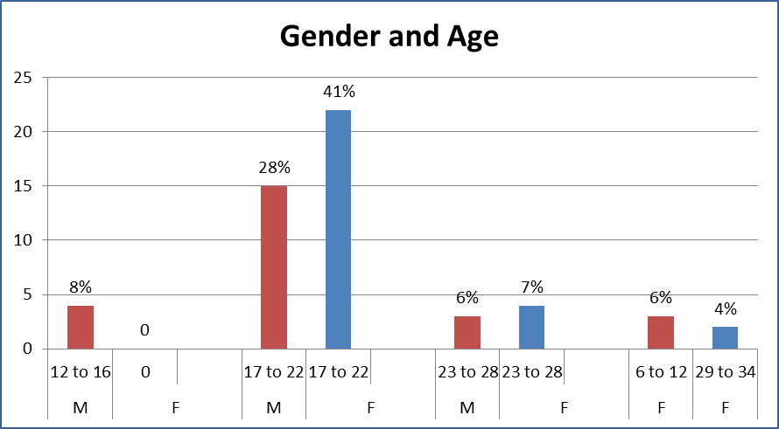

Chart 2: % Gender of respondents

Graph 1: Gender and age structure

Chart 2 shows that of the 53 respondents that filled in the survey, 31 are females while, 22 are male respondents. Moreover, graph 1 shows the percentages of respondents according to their age structure. 6% of the total responses are females between the ages of 6 to 12, 41% are females between 17 to 22 years of age, 7% are females between 23 to 28 years old, and 4% are females between the ages of 29 to 34, totaling 58.5% of all responses received. However, 8% are males between the ages of 12 to 16, 28% are males between 17 to 22 years of age and 6% are males between the ages of 23 to 28 years old, with a total of 41.5% of all responses collected with the largest age group between (17-22), comprising both male and female. In addition, the average age of the respondents is 20 years old with the youngest being 7 years old and the oldest 34 years old. This is apparently the group Str8 Casuals B.V. is aiming to target with U-lace.

Psychographic

The lifestyle and social status of the customers are taken into consideration. Thereby, the targeted categories are middle and upper-middle class, not leaving out their various personalities. In addition, those people who are open to new ideas and innovative product and can appreciate the values and motives of the brand are of a surety part of the target group.

Behavioral

The most relevant and important opportunity within the market is to know the purchasing behavior of the end users of a product. The behavioral variables discussed as a result of the survey conducted are as follows: benefits sought, awareness readiness state, attitude towards product and communication channel preference. Find more details and graphs in appendix 4.

### 6.1.3 Potential Target group of U-lace

* Who are the potential target groups of Str8 Casuals U-lace brand in the potential market?

Based on the questionnaire analysis, the following characteristics of the consumers are established based on the behavioral and demographic variables. Thus, the highest scoring variables for the formation of the target group of U-lace are displayed below. These target groups are formed based on the most reoccurring variables and characteristics, given by the respondents. See appendix 4 for more details.

Considering the outcome of the questionnaire, it is now apparent and explicit the variables with which the target group of Str8 Casuals U-lace brand is formed. The majority of the consumers are seeking quality as the benefit sought, followed by, color and trend. Str8 Casuals is targeting and attracting first time potential users both male and female who are supposed to be in the awareness readiness stage as U-lace can be considered a new brand on the UK market. Apparently, the outcome of the questionnaire states that the majorities are not aware of the brand; therefore, the awareness of U-lace existence has to be developed through various marketing communication instruments. The company is focusing its efforts on attracting loyal customers which will not only make it easier to establish long-term relationships with the current customers but may eventually lead to new ones joining the target market because of positive responses and reviews through the word-of mouth.

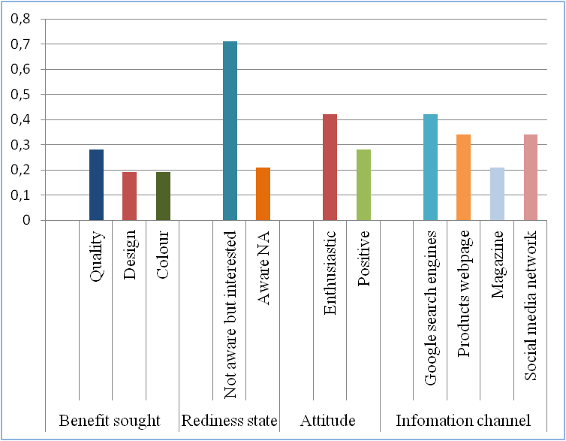

Graph 2: Variables for the formation of the target group

In conclusion, the recommended target group for U-lace in the potential market are men, women and (children; who are unable to tie their shoe laces). The preferred target group consists of those with enthusiastic and positive attitudes towards purchasing, who can easily acknowledge creative and innovative brand that adds value to their various lifestyles; likewise those, in search of high quality products. The target market include a large age group between 7 - 34 years old with no gender preference as U-lace is intended to be worn by both Males and females with an income that is above average. Consequently, the target groups are of course those who are receptive to all forms of communication channel either online marketing tools or the traditional ways of advertising.

## 6.2. Targeting

Undifferentiated targeting strategy is the most appropriate choice for U-lace, as it is a new brand that needs awareness. Undifferentiated targeting strategy will be used to approach potential customers because; it is by far the most affordable strategy. The cost is low and can the reach can be realized in the most efficient and effective way. In addition, using undifferentiated marketing will ensure that Str8 Casuals communicate the benefits of U-lace to everyone in the target market, by distributing the same promotional materials containing same messages to them. An advantage that makes such a promotion easy and efficient is that, the reach is far greater than any other marketing types. Consequently, any activities done with respect to promotion will represent a combination of marketing appeals that can successfully reach out to the different prospective consumers and will be executed based on the diverse lifestyles of the audience.

## 6.3. Competitive Positioning

* How best can Str8 Casuals position U-lace in order to raise brand awareness in the potential market?

Positioning according to Kotler, et al (2008), refers to the place a product occupies in the minds of the consumers. Before answering the research question above, it is important to know where U- lace is positioned in the minds of consumers when placed among other competitors’ brands. For this, the positioning map is used. Figure 12 shows the positioning of U-lace among other competitor’s lace brands.



Figure 12: Positioning map: Shoe laces' brands

The circles in the map indicate the brand positions based on price and product uniqueness in relation to the product’s quality. The relative market share of each brand is represented based on the size of each circles. The price is based on the price the products are sold in a pack; as some are sold just one pair in a pack and others, 4 pairs in a pack. Therefore, the price for one pair is multiplied by 4 pairs to give the price in the map. Thus, the map indicates that, Mr. Lacy has the highest market share in the accessory market. The Mr. Lacy brand is positioned in the map as expensive, although the product is being sold at 4 pounds per pair with just one pair of lace in a pack. The map position is 16 pounds. The Shoe-String brand is sold at 2 Pounds a pair of lace which makes the position in the map 8 pounds for 4 pairs of lace, as the product comes in just one pair. Moreover, U-lace is classified a premium brand. Four pairs of U-lace come in a pack and are sold at 6.69 pounds per pack. It is therefore positioned in the map at 6.69 pounds. As can be seen, the map indicates that Mr. Lacy is the biggest competitor of U-lace in the market, followed by Shoe- String. Mr. Lacy is positioned as one who cares about high quality product; the brand is built around fun and happiness with his colorful and charming character that attracts people around the globe. Mr. Lacy offers a wide range of quality shoe laces and sells through several distributors and other internet dealers across the globe. However, the shoe-string counterpart is positioned on the high priced side in the map, with a moderate quality level when compared with the other brands. Its market share comes second in the map. Shoe-String equally offers wide range of products and sells through retailers across the UK and Europe.

Although, the competitors’ brands are expensive, they are however positioned based on quality. Thus, U-lace would have to compete mainly with these large brands that are already well known and have established a strong position with customers on the market. Moreover, recognizing the competitive advantage of U-lace and the insight into the other competitors, Str8 Casuals can position the brand on the market.

The diagram above depicts that U-lace is expected to gain a considerable market share in a few years after its introduction on the market and so, it is quite important to differentiate the brand and select the most appropriate positioning strategy. Consequently, Str8 Casuals B.V. would have to position and differentiates U-lace based on the other unique features it possesses. Therefore, the way U-lace is going to be perceived by potential customers and positioned in their minds is very crucial. Thus, the positioning statement of U-lace should be:

*“To sneakers wearers who love to customize their sneakers, U-lace is the world’s first, original, quick change modular sneaker customizing shoelace, that allows you to customize your sneakers with as many colors as possible. With U-lace, you can turn lace-up sneakers into slip-ons. It is the most accessible and affordable modular sneaker customizing lace on the market”.*

## 6.4. Proposed Marketing Mix

Marketing mix is defined according to Kotler, et al. (2008) as the set of controllable tactical marketing tools that are combined by firms, with the aim of producing the desired responses from the established target groups. The marketing mix is however applied in order to present an overview of the target groups needs and wants. Moreover, the analysis is useful for setting up the strategies with which the target groups can be reached. The marketing mix covers the 4ps, which are:

* Product is the actual goods that are offered to a market for attention or consumption.
* Price is the actual sum of values that consumers exchange for the benefits of using a product.
* Place refers to the activities that makes products available to customers e.g. point of sale.
* Promotion refers to the promotional activities performed in order to raise awareness for the product and also activities to persuade buyers to buying the product.

After the application of the marketing mixes, Str8 Casuals B.V. can use the analysis as a base in setting up strategies to boost brand awareness for the target groups.

***Product:*** **Adaptation vs. Standardization**

As earlier mentioned, Str8 Casuals is the sole distributor and seller of various America sports brands in the Netherlands. Str8 Casuals has a wide range of products that includes baseball caps, clothes, shoes and shoe laces. The company does not actually manufacture the brands it carries. The products are manufactured by the different brands’ owners, who have their production facilities located in China. The products are later sold to Str8 Casuals, who then imports the goods to the Netherlands and sells through other sales channels across Europe. The products of Str8 Casuals are basically universal and standardized.

Notwithstanding, U-lace is a product brand made of high quality materials. Its creative and innovative abilities ensure that new trends are quickly reacted to. The creative designers of U-lace are everyday scanning through the market for latest trends and are current with new designs and innovations. The product designs and colors remains the same for every country and for every distributor selling the brand. It is designed to meet the expectations of fashion lovers which mean that, Str8 Casuals B.V. would not need any product adjustment in the target market.

Therefore, the proposed approach would be a standardize approach in the UK market. Str8 Casuals B.V. should ensure the product, meet the expectations and demands of the target group and as well, ensure that the creativity of the product remains the same.

***Price:***

Buying its products from owners that manufactures in low cost China, enables Str8 Casuals B.V. to sell its product at an attractive and competitive price. Therefore, price is not the most important factor to consider; even though, some of the respondents did say that, price is important when choosing a shoelace. (See appendix 4, questionnaire response, question, 11). In addition, the majority of respondents said price do not at all and does not affect their purchasing decisions, this then means that, price is not an influential factor whether or not an item is to be purchased. Str8 Casuals B.V. can therefore continue to use the set price for the items sold, moreover, the exchange rate should be considered as well before setting up the price in the target market, as the target country is using a different form of currency (Pounds).

***Place/ Distribution channels:***

Str8 Casuals should use the selective type of distribution for U-lace in the new market. As earlier stated, Str8 Casuals B.V. mainly sells through sales agents, distributors and sometimes directly to retailers in all the countries they operate in. The same strategy could be used in the UK. These wholesalers would ensure that the product is delivered safely to the consumers in time. Selling through this form of distribution channel means that, Str8 Casuals B.V. would be saving a lot of cost on transportation, as they would not be delivering in smaller quantities but rather in larger quantities, and will also be ensuring the product availability to the market. As most British residents reside in urban cities, it is however, important for Str8 Casuals to focus and be selective in choosing the distributors and retailers. The channel members should be selected from big cities of the UK, beginning with the largest city, London, the capital of the United Kingdom; and Str8, should also consider the size and image of these channel members before selecting them.

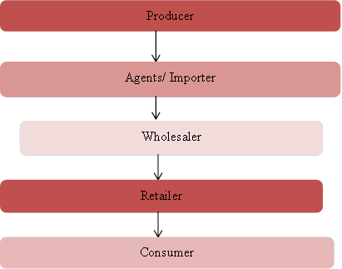

Figure 13: Distribution channel of Str8 Casuals U-lace brand

Moreover, a brief overview of some possible distributors and retailers Str8 Casuals B.V. could use to sell U-lace in the UK market is given below. The contact details and advice as per which company to start with is likewise given. It is however important that Str8 Casuals B.V. contact these potential clients one after the other, thereby, using the contact details provided.

*Advice:*

The first company that should be contacted could be ***UK Distributors Footwear Ltd;*** a distributor and exporter of various kinds of footwear including sports and leisure. The company is open to making partners with other international companies who wants to sell their products across the UK. Secondly, Str8 Casuals B.V. could contact ***SportsDirect.*** SportsDirect is the UK’s largest and number one sports retailer. The retail group has well over 470 stores that include the SportsDirect.com, Field and Trek, Hargreaves Sports, Gilesports and Donnay International stores.[2]

Moreover, more list of recommended distributors and retailers, Str8 Casuals B.V. could use as distribution channels, can be found in the appendix. (See appendix 5 for more lists on the proposed distributors and potential retailers for U-lace).

***Promotion/ Marketing communication***

Ensure that the target groups and distribution channel members are well informed and aware of the brand. The proposed promotional activities for raising the awareness of U-lace in the target market are discussed in more details in the recommendations for raising brand awareness part of this report.

Further, the table below shows the application of the marketing mix to the target group of U-lace based on the outcome of the questionnaire, while the analysis can be found in appendix 6:

|  |  |  |  |  |  |
| --- | --- | --- | --- | --- | --- |
| Target Groups | Behaviors | Product | Price | Place | Promotions |
| Young Men  Women/ Children | Enthusiastic and quick  Positive and relaxed | High quality  Designs/ styles  Colorful  Easy to use | Standardize | Availability  Selective  Convenience | Online  Receptive to other forms of advertising |

Table 7: Marketing mix applied to target group

Now that the marketing mix has been applied to the target group, the next phase is to determine the marketing communication instrument for raising brand awareness for U-lace in the target market. Marketing communication is a strategy that helps in the development of brand awareness; it translates product’s information into perceptions about the attributes of the product and its position within the market. To begin with, marketing communication means, getting in touch with trade and/ or consumers in order to influence their knowledge, attitudes and behavior in a direction favorable to marketing policy (Floor, van Raaij. 2011).

As earlier mentioned, the aim of this research is to raise brand awareness for U-lace in the UK footwear market. Brand awareness is an important goal of the marketing communication activities of an organization, Macdonald, E. and Sharp, B. (2003). The company’s success lies basically in how good and effective their marketing communication is. This is because; using the right communication instrument will ensure that the brand is easily recognized by potential customers. Additionally, without brand awareness occurring there are no other communication effects that can occur. “Brand attitude cannot be formed and the intention to buy a product cannot occur unless brand awareness has occurred” (Chandon, P. 2003). This notion is supported by Hossain, E. (2008) research; who argued that brand awareness may have influence on the choice of consumers (Hoyer, S.P. and Brown, W.D. 1990).

Although, Str8 Casuals B.V. makes use of agents, distributors and to some extent retailers, the marketing communication for this project is not centered on business to business (B2B) communication but rather on the consumers (B2C). Therefore, the marketing communication is directed to the main target group of U-lace as a result from the questionnaire responses. However, the best promotional strategy to use is the pull strategy whereby Str8 Casuals is focusing their marketing activities on customers rather than focusing directly on channel members. Hence, the promotion mix is selected based on the criteria’s below:

Figure 14: Marketing communication mix

In order to raise brand awareness and increase customers’ responsiveness for U-lace in the targeted market, Str8 Casuals B.V. would have to invest heavily on marketing communication activities. By so doing, the number of sales of U-lace would be enhanced, thereby resulting in brand equity.

### 6.4.1 Recommendations for raising brand awareness

The recommended marketing communication instruments and media for raising brand awareness for U-lace in the United Kingdom’s footwear market are as follows:

**1. Advertising**

Advertising is any paid medium of marketing communication, aimed at persuading and encouraging audiences to purchase a particular goods, services or even ideas. Advertising also allows companies to reach large audiences through mass marketing.

Promotional materials for Advertising

The recommended material for advertising U-lace in the target market is Poster ads. Str8 Casuals could use poster ad to boost the awareness of U-lace. The posters should lay emphasis on the quality of U-lace, in combination with other functional attributes it possesses. The posters should be able to grab the attention of buyers that is; should follow the AIDA model by being able to, (grab the Attention, develop an Interest in the brand, create a Desire and Action to buy U-lace). These posters should be hung around the major cities of the UK; which as a result, will boost brand awareness for the brand and increase sales simultaneously; as most consumers will have the privilege to see and read the message the ad is conveying. Below is an example of how the posters can look:

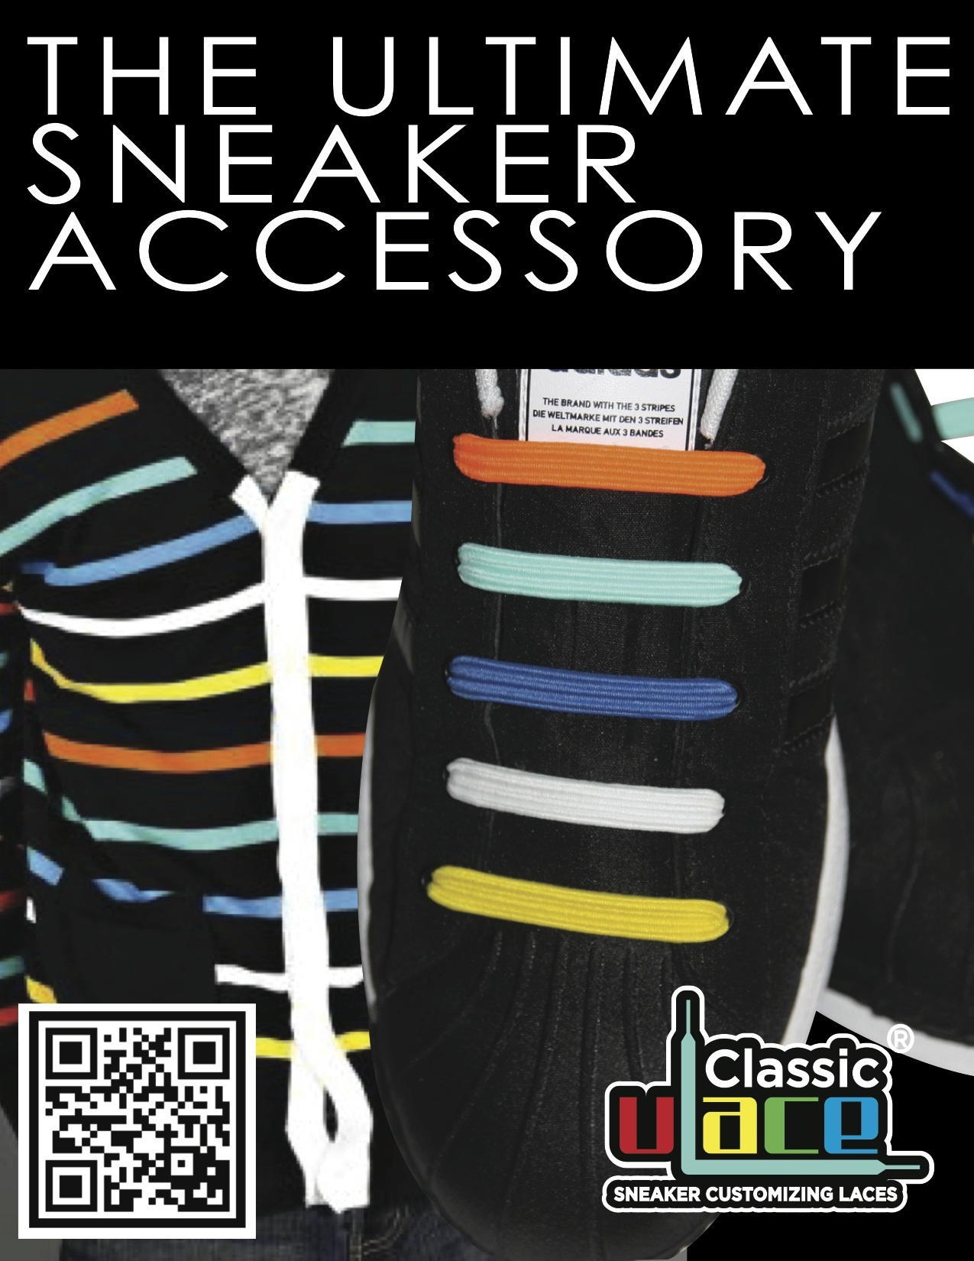Image 1: Example of a Poster ad for U-lace.

**2. Direct Marketing communication (DM)**

Direct marketing stands between advertising and personal selling. It is a marketing form, aimed at obtaining and maintaining sustainable relationship between suppliers and customers (Floor and van Raaij. 2011). The type of direct marketing communication that should be focused on is direct advertising.

Recommended materials for DM communication of U-lace

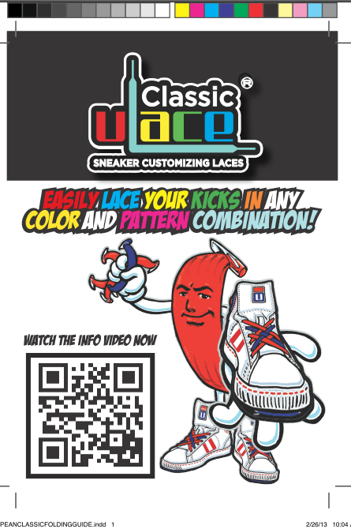The recommended materials for direct advertising of U-lace are: Flyers or leaflets***,*** brochures, stickersandmagazines. Str8 Casuals B.V. should use these direct advertising media to reach out to potential consumers, as this will create an avenue for the brand to be well- known. Moreover, this type of communication mix is a great way to enhance the appearance of U-lace among the target audience, as they are interested in knowing about the brand. The goal of using this media is to make DM activities creative, especially in the start-up phase; so the target group will remember the brand and the as result, enhance brand awareness for U-lace.

In addition, next to this text, is the front cover example of a brochure. Str8 Casuals should use the slogan on the cover, while the content of the back cover can contain the directions of how to use the product; since it is one of the weaknesses to always explain how the product can be used each time a purchase is made. More so, with the help of the directions on the back page of the brochure, the consumers will find it easy and be more attracted to buying the brand.

Image 2: Example of U-lace Brochure (Front cover)

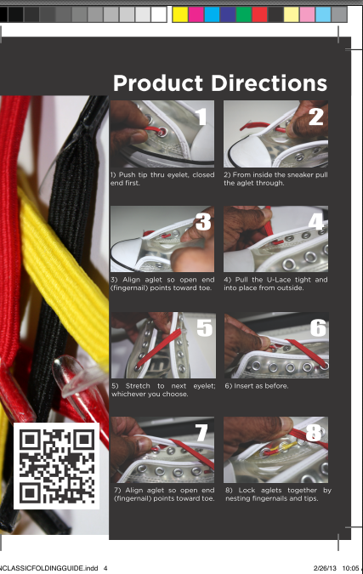Following, the flyers and leaflets can be distributed door to door to consumers via various means, either through agents and distributors or via the retailers that will buy from the distributors. This will equally aid in the spread of the awareness of U-lace through word-of–mouth. Ads can be placed in trade magazines to attract retailers and other readers within the target group of U-lace in as much as to raise the awareness and boost recognition of the brand. Fashion magazine should be used as well to attract decision makers. Example of such magazine could be; Footwear Today, which is the main trade publication for the footwear industry in the UK. More information on this magazine can be found in appendix 8. Prima magazine is a monthly magazine that attracts women who loves fashion. Ads can be placed on this magazine to attract the mothers who are decision makers of those in the target group that do not make purchase themselves. Moreover, stickers should be used as well. It is a great way to boost the awareness and recognition of a brand. The stickers should be printed as U-lace tattoos that can be sticked on the hand and on any object. Str8 Casuals should use U-lace tattoo as a tool for raising brand awareness among the target group. The tattoo should be the logo of U-lace.

Image 3: Example of U-lace Brochure (Back cover)

**3. Online marketing communication**

Online marketing is one of the biggest and most influential means of marketing. Using online marketing as a communication tools ensures that brand, information’s about product are available every hour of the day and every time of the year, and as such, consumers can easily find the brands or products they require, at any moment in time. Hence, Str8 Casuals B.V. should concentrate mainly on using online marketing as a marketing tool to reach out to customers in the target market.

Moreover, the outcome of the questionnaire also indicated that the target group are very much flexible, they tend to purchase products online and, when in need of product information, they likewise uses Google search engine; which is however, an online marketing tool.

Promotional activities for U-lace, using online media

The proposed online marketing media for the purpose of raising brand awareness for U-lace in the United Kingdom footwear market are: website, SEO optimization, online marketing PR, YouTube and other viral campaigns.

1. ***Interactive media- Website***

As mentioned earlier in the report, the target group appears to search for products through the product web page, therefore, Str8 Casuals B.V. could invest heavily in building either a brand site or transaction site for U-lace in the future, as it is of importance to have a face on the internet. The brand site should be aimed at providing information about where customers can purchase U-lace and on this site; all advertising campaigns will be seen by the different consumers. Additionally, the transaction site should be used as an online store for the purchase of U-lace; here all transactions can be made. Building such a site will enable consumers order U-lace directly from the comfort of their homes or on the road. Both websites should be interactive, and would need a whole lot of time, and investment in constructing. Thus, Str8 Casuals B.V. should equally advertise on other websites for instance, through Google sponsor links, and as a result could attract many more potential buyers in the market.

1. ***Online advertising- SEO optimization and SEA advertising***

As the name implies, SEO means, search engine optimization means the process of getting traffic from lists of search engines. It is a free marketing tool. Therefore, Str8 Casuals would not be needing, any financial investment but rather, invest in an SEO consultant, who would handle the activities. Examples of such search engines; Str8 Casuals B.V. could use for U-lace, are Google search engines, Bing and Yahoo. Using SEO will drastically get U-lace to the top ranking of Google and other search engines and also increase sales.

Consecutively, Str8 Casuals B.V. could use search engine advertising (SEA) such as Google Adwords to promote U-lace in the target country because; it is highly important to be recognized by ones’ target consumers on the internet. Ultimately, SEA is a paid form of internet marketing. The payment is however done per click not per display. Further, purchases are made based on search words containing just a few line of text, which has link to the actual landing page of the brand site.[3]

Using search engine advertising will make it easier to reach out to as many potential customers as possible, and the chance of being recognized by many prospects is high. This same strategy is used for U-lace America and has attracted lots of customers for the brand.

Therefore, SEO and SEA are good and important marketing tools for raising brand awareness for U-lace in the target country.

Next, is the third online marketing communication instrument recommended to promote U-lace in the UK footwear accessory market is, online marketing PR.

1. ***Online marketing PR***

Str8 Casuals B.V. should use the online marketing PR as a technique for promoting U-lace in the target market. This form of marketing communication is unpaid, and very significant in the daily lives of the target group. Nevertheless, the marketing PR that the company should use is social media networks, which is however a good opportunity for attracting potential customers. Moreover, social networking means, a social structure made up of individuals and or organizations that are connected by specific type of interdependency. Thus, the recommended social media network Str8 Casuals should invest time in is Facebook. Facebook is an interesting marketing tool that can be used to find potential customers as well as, stay in touch with existing clients and is equally used to promote new products. Therefore, Str8 Casuals should use invest intensively in Facebook advertising so as to get the brand out there in the market.

Moreover, there are several ways in achieving the aim of using Facebook to attract customers. Firstly, Str8 Casuals should create a Facebook page for U-lace. Creating a Facebook page for U-lace will ensure the pages are included in search engine results. If used accordingly, the result will be an increase in the amount of traffic generated on the page, as potential customers looking for similar products are attracted through the search engines research. In addition, Str8 Casuals B.V. should design and customize the page the way it suits the brand’s business.

Further, Str8 Casuals should also use paid advertising on Facebook. Facebook ads can be used as a strategy for raising brand awareness for U-lace and as well as, targeting new customers. The ad can be displayed on the Facebook page. Subsequently, an advantage of using Facebook ad is that, Str8 Casuals will be able to reach out to target audience who shares similar interests with U-lace brand.

In summation, in order to be effective in using this form of marketing communication, Str8 Casuals would have to invest heavily on time and, in employing someone that would be active in using the page to reach out to consumers, answering questions from customers, posting new business ideas and reacting to comments. Facebook is a very good and effective marketing media when used accordingly. It will enhance the presence of the brand which in turn will create and increase the sales of the product.

1. ***Communication networks***

Furthermore, Str8 Casuals B.V. should equally use YouTube as another platform for spreading the brand name among the target audience within the target market and beyond. Str8 Casuals would have the opportunity to upload videos of U-lace on the YouTube site with demonstrations of how the product works and other interesting ads could be posted to attract the target audience as well.

## 6.5. Logistics

An essential requirement for the smooth functioning of any business is to have a good logistics system. Logistics makes it easier for products to be delivered in time and also makes it easier to restock out of stock products. There are no special rules guarding logistics from the Netherlands to the UK, other than the current European laws. The most popular means of transporting goods to the UK from the Netherlands are water, air, train and road.

Str8 Casuals B.V. usually delivers its goods to distributors and retailers, using DPD a shipping and logistics company. The supply chain represented in the figure below, shows that the goods are picked up by DPD at Str8 Casuals warehouse using trucks as the transportation mode. The goods are then stored and sorted out at the port of loading of DPD. Notwithstanding, DPD uses either air transportation or ship to deliver the goods at the destination of the buyers. In addition, the goods are discharged at the port and delivered directly to the buyer by means of truck. Hence, the transportation modes used by Str8 Casuals are road, air and water.

Therefore the same logistics system can be applied to U-lace in the UK. Notwithstanding, the main reason for using these means of transportation is due to delivery locations, speed and accessibility. Further, fast delivery could help in improving the services rendered to end users likewise increase the satisfaction of the customers.

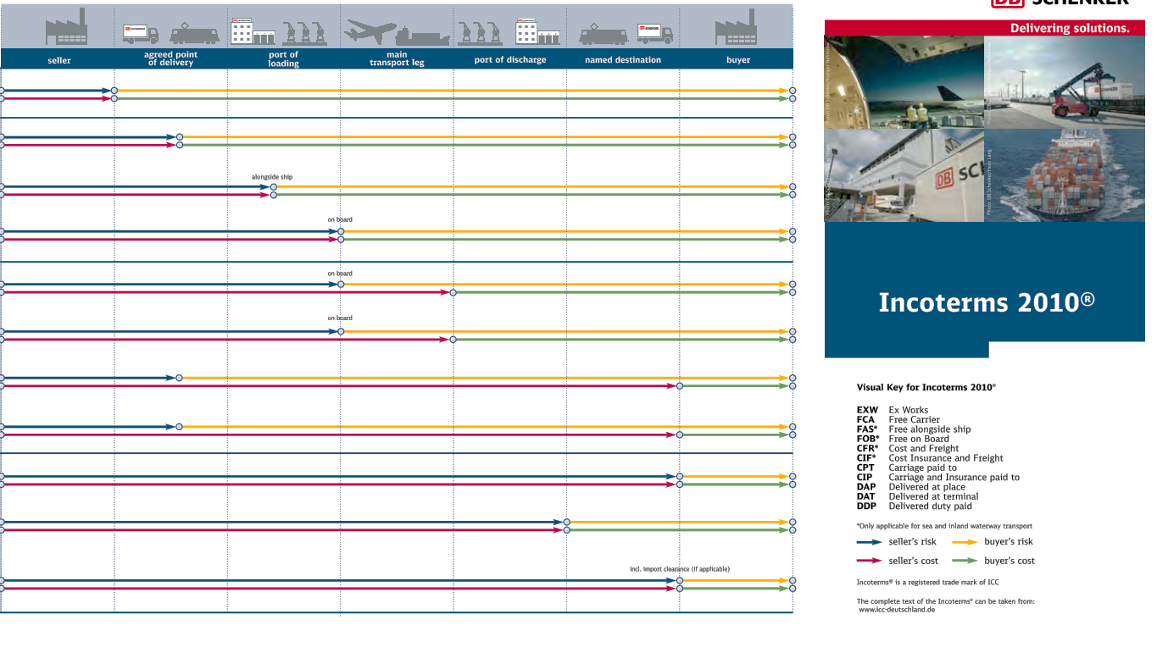Figure 15: Str8 Casuals supply chain

# 7. Marketing Budget Plan

The marketing communication budget is calculated in the following table. It is calculated based on a three years planning scale or rather time frame and in quarters. Total sales are calculated based on 15% rate of turnover for every first quarter, 40% for each second quarter, 30% for third and 15% of turnover for every fourth quarters. Grand total sales are the sum of all the sales from 2013 up till 2015. Moreover, the grand total earning is derived after deducting all marketing communication expenses of 3 years from the grand total turnover of 3 years.

Table 8: Marketing Budget 3 Years Planning

Subsequently, the cost Str8 Casuals will be spending quarterly, on marketing activities is shown in the graph below:

Graph 3: Marketing communication costs per quarter

The following table shows the specific amount that will be spent on marketing activities per year:

|  |  |  |  |
| --- | --- | --- | --- |
| Costs | 2013 | 2014 | 2015 |
| Q1 | € - | €1.500,00 | €6.998,00 |
| Q2 | €2.038,85 | €10.355,53 | €3.083,50 |
| Q3 | €3.843,61 | € 2.234,90 | €3.873,75 |
| Q4 | €5.466,63 | €3.219,81 | €1.150,00 |
| Total cost per year | €11.349,09 | €17.310,24 | €15.105,25 |

Table 9: Total marketing communication costs per year

Conclusively, the ways the marketing communication costs for each communication materials were calculated and derived, can be found in the appendix, marketing budget cost analysis.

# 8. Final Conclusion

In response to the research questions and problem definition, the findings of the export plan indicate that the United Kingdom is an attractive market for Str8 Casuals to penetrate with its U-lace brand. The findings also shows that there is a high growth rate in the market of footwear as a whole, and consumers are purchasing sneakers at a very high speed. This implies that, there is a high chance for U-lace to be sold. Moreover, the findings also shows that, exporting is the most effective, safest and easiest way for Str8 Casuals to enter the UK market because the financial risks involved is however lesser than that of any other entry modes. In addition, exporting will equally enhance the sales of the brand by actually allowing channel members use the expertise they have acquired all through the years to sell the brand to the end consumers.

Therefore, the entrance of U-lace by Str8 Casuals B.V. to the United Kingdom’s market is considered very effective and beneficial, and in the long run; yield profits and long lasting relationships between the company and potential clients.

Further, the findings indicate that brand awareness can be raised for U-lace in the target market by investing heavily on marketing communication activities. When this is done effectively, the awareness of the brand will be boosted; while customer’s responsiveness will likewise increase. All of this will eventually lead to the actual sales of U-lace; which thereby will lead to brand equity.

# Afterword

## *Review of advice to Str8 Casuals*

Here are some specific recommendations that could be of great relevance to Str8 Casuals B.V. in terms of raising brand awareness for U-lace in the United Kingdom’s Footwear market. They are:

**1)** As a means of raising brand awareness for U-lace, Str8 Casuals could decide to use the strategy of approaching primary schools. The strategy to be implemented, would be to, attract the attention of teachers who are could also be influencers in the buying decision process. This can be done by cutting off the shoe laces the children have on and replace s them by installing U-lace. This strategy will aid in letting the teachers know the ease with which U-lace is being installed and how effective it actually is. As a result of this, brand awareness will be boosted among the teachers who later on, will pass the information to parents (Word of mouth).

**2)** Secondly, before contacting the companies listed as the potential buyers of U-lace in the UK, Str8 Casuals should think of ways to get these companies attention on what they are selling, either by offering to sell U-lace to them at discounted prices or to give away items. The giving away of items to these retailers could be another way to get them to reconsider buying the brand. Nevertheless, Str8 Casuals B.V. would need to invest in these promotional materials for attracting the retailers to buying the brand. The items to be given could be pen with U-lace logo and slogan printed on it and a bottle opener with the same features. There will not be any additional cost as the costs have been included in the marketing budget plan; that is, other marketing costs.

**3)** In order to have an effective result in all the online marketing activities, it is wise that Str8 Casuals B.V. hire a marketing expert with a lot of experience in the field of marketing to handle all marketing activities the company will be engaging in.

**4)** Advertising in a magazine is a good way to attract potential customers and, or decision makers. It is of importance for Str8 Casuals B.V. to advertise in trade magazines wherein potential customers are fund of reading. After several research, the most interesting and relevant magazine that fits in the profile and requirements of U-lace is Footwear Today. Facts about the magazine can be found in appendix 8. Moreover, it is certainly very vital and crucial that Str8 Casuals advertise U-lace in this particular magazine. The most effective way to boost the brand’s awareness is to publish frequently. Haven contacted the journal manager and publishing director of the company, using the full marketing package for one year, is the best option to choose from. The benefit of using the full marketing package is that, it contains most of the packages mentioned. That is, sponsorship of the front cover of the digital issue, (the ad to face the front page and sent to approximately to 4500 digital subscribers each issue). This will ensure that 4500 digital subscribers get to read about the brand. Secondly, it contains quarter (¼) page classified advertisements in the printed and digital issue each issue and is run 3 times in a year. The persons to be contacted whenever Str8 Casuals is ready to advertise U-lace in the Footwear Today magazine is found in appendix 8.

**5)** Str8 Casuals could use the link provided below to find some possible distributors and wholesalers in the UK. The link directs the company to the UK directory home page for distributors, wholesalers of footwear. These companies listed on these site could be potential customers of U-lace in the UK market.

<http://www.thewholesaler.co.uk/trade/distributor/Footwear_and_shoe_UK_wholesale_suppliers_directory/>

# Bibliography

Albaum, G. & Duerr, E. (2008). *International Marketing and Export Management.* Essex,

London: Pearson Education Limited

Ashley, S. (2005). *Graduation Assignment Training Reader* (6th ed.). Utrecht.

Chandon, P. (2003), *‘Note on measuring brand awareness, brand image, brand equity and*

*brand value*’, INSEAD, vol. 19, mkt.

CIA, (2009). *The World Factbook.* [Online] Available at:

https//www.cia.gov/library/publications/the-world-factbook/geos/uk.html [Accessed 3 March, 2013]

Dukeshire, S. & Thurlow, J. (2002). *Understanding the link between research and policy*

*[pdf]:* Rural Communities Impacting Policy Project. Available at: <http://www.ruralnovascotia.ca/documents/policy/research%20and%20policy.pdf, [Accessed 23 May, 2013]

Hossain, E. Md. (2007). *An Evaluation of Brands Image, Product Attributes and Perceived*

*Quality of a Selected Consumer Non-durable Product.* Administration and management review, vol. 19, no. 2 (Aug).

Hoyer, W.D., & Brown, S.P. (1990). *Effects of brand awareness on choice for a common,*

*repeat-purchase.* Journal of Consumer Research, 17, 141-148.

IndexMundi, (2013). *Historical Data Graphs Per Year.* [Online] Available at:

<http://www.indexmundi.com/g/g.aspx?v=66&c=uk&1=en> [ Accessed 4 March, 2013]

Kotler, P., Amstrong, G., Wong, V., & Saunders, J. (2008). *Principles of Marketing*. Essex:

Pearson Education Limited

Leeman, J. (2010). Export planning. Amsterdam: Pearson Education Benelux B.V.

Macdonald, E. & Sharp, B. (2003), *Management Perceptions of the Importance of Brand*

*Awareness as an Indication of Advertising Effectiveness.* Marketing Bulletin, vol. 14, no.2, pp. 1-15.

MarketLine (2012), *“Industry profile: Footwear in the United Kingdom”,* Ref (0183-0619).

Retrieved March 10, 2013, from HU University of Applied Sciences library information database

OECD (2013), *"Country statistical profile: United Kingdom",* Country statistical profiles:

Key tables from OECD. doi: [10.1787/csp-gbr-table-2013-1-en](http://dx.doi.org/10.1787/csp-gbr-table-2013-1-en)

Searce, (2009), *CBI Market Survey: The Footwear Market in the United Kingdom*. CBI

Market Information Database. Available through: [www.cbi.eu](http://www.cbi.eu) [Accessed 11 March, 2013].

Van Raaij, F & F. (2011). *Marketing communication strategy (1st ed.)*. Groningen/Houten:

Noordhoff Uitgevers bv.

Westwood, J. (2006). *How to write a marketing plan (3rd ed.).* London & Philadelphia: The

Sunday Times

# Appendix 1 UK’S External Factors (DESTEP Analysis)

***Demographic environment***

The UK has a population growth rate of 0.553% as of July the same year, ranking 146th in the world. UK is urbanizing with 80% of the total population as of 2010; that means that, 50,451,329 people live in the city. Following, the urbanization rate was 0.7% annual rate of change (CIA world-Factbook, 2013). The literacy rate in the United Kingdom is however good, total population: 99%, Male: 99% and Female: 99%.

|  |  |
| --- | --- |
| Table 1: The United Kingdom Demographic |  |
| Total Population | 63,064,162 |
| Population growth rate | 0.553% |
| Median age: | 40.2 years |
|  | Male: 39 years |
|  | Female: 41.2 years |
| Urban population | 80% of tatal population =50,451,329 |
| Urbanization rate | 0.7% of annual rate of change |
| Literacy rate | 99% of total population |
|  | Male: 99% |
|  | Female: 99% |
| Life expantancy | Total population: 80.17 years |
|  | Male: 78.05 years |
|  | Female:82.4 years |

Source: The world Fact-book, Central Intelligence Agency (CIA)

***Economic environment***

The UK’s economy was in recession in the first quarter of 2012 when GDP contracted by 0.2%. The euro crisis held back investment and consumption which thereby led to the country attaining a poor growth rate of 0.8% in the year 2011. The creation of jobs was affected by the slowdown of the economy thereby, increasing the rate of unemployment. In the year 2011, the unemployment rate in the UK was 8.1% and was expected to reach 8.3% by the year end 2012 as per MarketLine data forecast. Almost 2.5 million people were unemployed in 2011, which was however the highest number in 16 years.

Moreover, the United Kingdom is the 6th largest economy of the world and one of the world’s 10 manufacturers. The UK is equally the second largest economy in the European Union and has strong reputation in the areas, standard of living, social welfare, unemployment rate, interests’ rates, inflation and outward foreign investment. However, the rise in the constant debt from the government has reached a stage that is appalling, and has been constantly rising since the year 2011 which will bring about challenge to the UK’s economy in the short middle term. Further, the high debt level and unemployment rate will mean that there will be a constrained in consumer spending. Nevertheless, low level of inflation; will consequently ease the pressure on household incomes that add constrained growth in late 2011 and early 2012. Following this, the United Kingdom has the highest GDP level in the European Union in terms of purchasing power parity after Luxembourg and the Netherlands (MarketLine, 2012 and Index mundi, 2011).

***Social cultural environment***

First and foremost, the United Kingdom has a high standard of living in comparison with other developed countries. However, income inequality is somehow apparent. Secondly, the UK has a good and standard health care and educational system which ranks among others in the developed countries. The country is numbered 28th in terms of human development; allowing most of the citizens to live in urban cities. As earlier stated, the percentages of those living in the urban areas are 80% of the total population. The UK is divided into different ethnic groups amongst which 83.6% white are English, which is however accepted as general business language. Most people in this nation are Christians while the others are divided into other religious categories; therefore, the country is open to doing business with other international countries.

Based on the Hofstede cultural dimensional level, the UK scores 89 in terms of being individualistic which is amongst the highest of other individualistic countries, the people are known to show off their success by the lifestyle they live. Children are taught the way to live a purposeful life at a very tender age and how they can contribute immensely to the society. According to 2009 data of the CIA, the expenditure on education totalled 5.6% of GDP and people from age 15 and above have completed five or more years of schooling. This then means that, the educational system in the United Kingdom is very good and prized high.

***Technological environment***

The United Kingdom has strong capabilities in both scientific and research and development platforms. The government has taken serious efforts in boosting competitiveness, such that, the development of technologies will enable the country stand out in the time of increasing competition from emerging countries. Research and development and IT are crucial factors in the growing of an economy; however, there is a challenge of not being able to balance between the distribution of indigenous technology profitable and maintaining a competitive advantage. In 2010 the UK’s gross domestic expenditure on research and development was 1.82% of GDP, up from 1.87% in 2009 and as such, the government must monitor closely the developments of such industries and decide on its export policy with regards to technology.

In addition, the United Kingdom has the world’s largest aerospace industry besides the United States; the UK’s government aim is to raise the level of knowledge intensity which stood at 19% in the year 2004, to the 2.5% mark by 2014.

***Ecological environment***

The UK continues to reduce greenhouse gas emissions. It has global influence over environmental issues however there is a concern for the high level of pollution. Change in climate and sustainable development are continually viewed as a trend globally. The UK has a major role in ensuring that other countries adhere to the cause of sustainability moreover, the air pollution in London the UK’s capital, is the highest and is counted among the worst air pollutant countries in the world. In addition, according to CIA world Factbook, the country (has met the Kyoto protocol target of 12.5% reduction from 1990 levels and intend to meet the legally binding target, move towards domestic goal of 20% cut in emission by 2010); the amount of commercial and industrial waste was educed and dispose in landfill sites to 85% levels and recycled or composed at least 25% of household waste, increasing to 33% by year 2015.

***Political environment***

The United Kingdom has a democratic parliamentary system of government. This system ensures that there is a separate power distribution among the branch executives led by the prime minister, the judiciary and the bicameral legislature. Although the parliament has strong members, there is however diverse opinion of the coalition parties regarding strong government austerity measures, the cutting of the top income tax rate the continuous euro zone crisis have placed a strain on relations. The United Kingdom is regarded the most successful nation in terms of the application of the rule of law; which is therefore an important factor to consider when entering a market, there is a high level of control over corruption, successful in government effectiveness and the regulatory quality. According to research, the UK is one of the most influential countries of the world. Although the UK decided to remain outside the Economic and Monetary Union (EMU), it is still an active member of the EU; the UK is a founding member of the North Atlantic Treaty Organization and a member of G8. In addition, the prime minister of the UK, David Cameron has taken a host of measures to reduce the fiscal deficit, including a 26% decrease in the central government's contribution to local councils by 2015, a 24% cut to the foreign and commonwealth office, and another 24% cut to the Department for Culture, Media, and Sport.

Further, the relationship that exists between the Netherlands and the United Kingdom is very strong. Both countries are important partners both politically and economically[4]. They work closely together with the EU foreign policy, social and employment policies. Both countries shares commitment to global trade and have promoted strong trans-Atlantic links in the past respectively and they likewise have same international interests and have thereby launched a study together that will help developing countries adapt to climate change[5] .

These factors will therefore make export easier as the countries involved are good trade partners. The following table presents some key facts of the United Kingdom:

|  |  |  |
| --- | --- | --- |
| **Table 2: Some United Kingdom Key Facts;** | **2011** | **2012** |
| GDP (PPP) | 35686,58 | 36510,78 |
| GDP growth rate | 0.8 | 1.1 |
| Population in (millions) | 62,698,360 | 63,064,162 |
| Inflation | 4.5 | 2.432 |
| Total income |  | 238000 |
| Unemployment rate (%) | 8.1 | 8.3 |
| Cultural dimension | Individualistics (89%) | Individualistics (89%) |
| Religion | 78% Christains | Same |
| Language | English | Same |

Source: CIA, Trading economics, MarketLine data, Indexmundi

# Appendix 2 Five Force Analysis

The footwear manufacturers in this case are defined as the suppliers for this analysis. Considering the fact that there are many suppliers of footwear entering the UK footwear market from low cost countries, both domestic and western countries suppliers lack the ability of competing within this industry. Although there are many suppliers from low cost countries entering the UK’s footwear market and are competing with domestic and western countries operating in the market. There is a high level of differentiation of market offerings which has made many suppliers gain some level of market power. This also resulted to switching due to the large number of manufactures from these low-cost regions. Supplier power in this regard is weakened as a result of the large number of suppliers from low cost regions plus the economic advantage held by western retailer which as a result made the bargaining power of suppliers to the United Kingdom’s footwear market to be considered moderate[6].

Subsequently, the buyers in the case are referred to as end users of footwear while players in the market as retailers. Because footwear is a necessity, and there is however a high sales volume which reduces the buyer power. Individual consumers are unable to influence prices of footwear in the market. Due to the new fashion way of dressing, and the various varieties of footwear categories, there is therefore a high level of differentiation so; customers have more choices to search for suitable product that suits their needs which as a consequence boost the power of retailers over individual buyers as they are able to target even a wider customer range. With respect to this analysis, it can be deduced that the bargaining power of buyers in the United Kingdom’s footwear market is moderate.

Furthermore, the threat for substitute product is limited in the case of footwear, considering that it is a basic necessity. However, there are some levels of substitution between other areas of the market, being that, footwear is divided into different market segments. The consumers can easily substitute sneakers for other regular or normal footwear. Therefore, in the case of UK’s footwear industry, the threat for substitute product is between moderate to weak. The final analysis is the degree of competitive rivalry. The UK’s footwear market is highly fragmented and saturated; however, large retail group and players hold the market. In addition, there are low fixed costs for retail operations therefore; smaller companies exist within the market. Therefore, it can be concluded that the degree of rivalry between footwear retailers is assessed as being strong.

# Appendix 3 Weighted SWOT Matrix

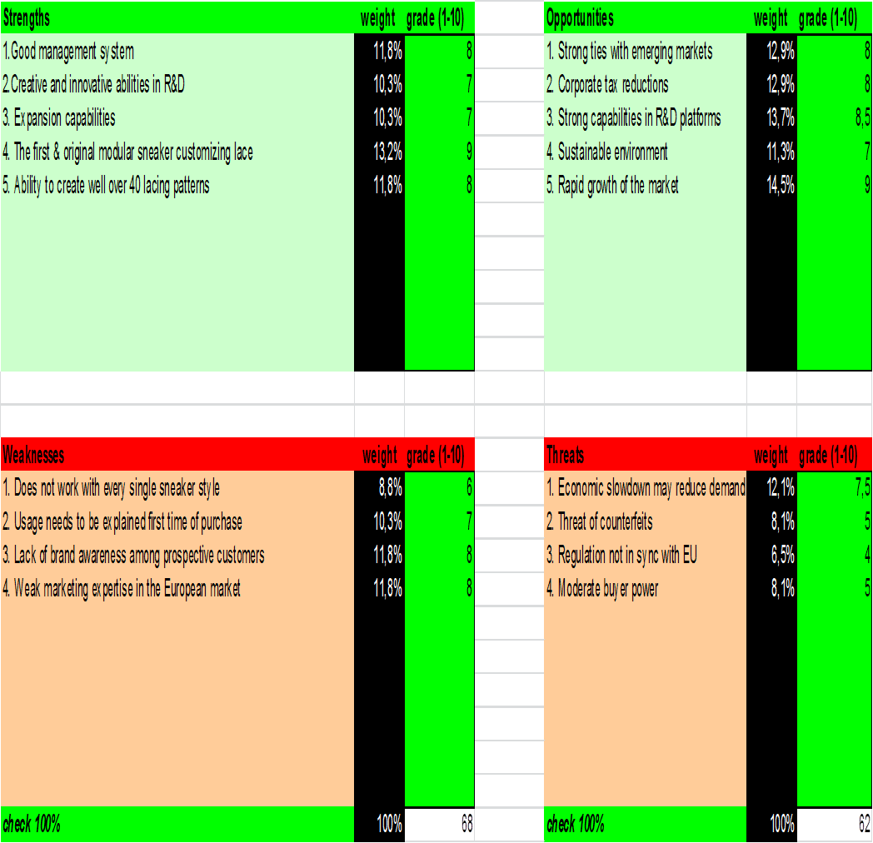

# Appendix 4 Questionnaire Responses

**Benefits sought:** The graph below shows a representation of the result of the variable derived from the questionnaire.

Graph 1: Benefit sought variables

The graph indicates that 19% of respondent like the colors, 28% of respondents said they like the quality of the lace, while 6% of the respondents would like their laces to be a little more practical. The graph shows the same result for design and easy variables, which means that the consumers would like the design of a lace and a shoelace that is easy to install. According to the result from the graph, the highest score of the benefits that the targeted consumers are expecting to seek are above all, quality.

**Awareness readiness state:**

Chart 1: Awareness readiness state

Graph 2: Awareness readiness state

The graph and chart above, indicates that 72% of respondents are not aware of the brand U-lace while, 28% claim they are aware of the brand U-lace. However, when asked how they first heard of the brand, 3.8% of the respondents said through the store and 9.4% indicated they heard through word of mouth advertising by friends. Moreover, 26.4% of all respondents claim they are quite familiar with the brand but have never used it. This analysis is related to questions, 6 and 7 of the questionnaire responses.

Graph 3: Preferred channels of information.

The graph above combined two variables to form the base for the communication strategy. It indicates that, 28% of respondents do not all purchase products online while 26% of the respondents purchase moderately often online. More so, when asked, how they would like to be informed about a shoelace brand, the graph indicated the highest score to be Google searches followed by social media and the products web pages, which are all online marketing tools. Consequently, other forms of information search are also relevant to these target groups who are very receptive to various forms of communication channels.

**Attitudes towards purchase**

Graph 4: Buying behaviour

The graph shows the determinants of the purchasing behavior of the respondents. It indicates that 60.4% of responses go to quality being the determinant of their buying behaviors. The graph equally indicates price as the second highest determinant of the behavior of the respondents with the score of 53%, following by style, color and trend which scored, 49%, 36% and 34, respectively. The store location and brand name both have similar responses and are both not the least scores. Price is also a determinant of the buying behavior of the respondents with a score of 53% from all responses. In addition, an extra question was asked on what attitude the respondents go out for purchasing. The following graph shows the result collected:

Graph 5: Attitude towards purchasing

The graph indicates that 42% of respondents go out to shop in an enthusiastic and quick manner; it also indicates that, 28% of respondents are quite positive and relaxed when shopping. Moreover, there was no score recorded for a hostile attitude while go out to shop.

# Appendix 5 Lists of Potential Distributors and Retailers

***1. UK Distributors Footwear Ltd***

UK Distributor Footwear Ltd is a distributor and exporter of various kinds of footwear including sports and leisure. The company is open to making partners with other international companies who wants to sell their products across the UK. They have are Account managers located in South London and South-East England.

***Contact details:***

Churchill Way

Fleckney

Leicester, Leicestershire

LE88UD

United Kingdom

Tel: +44 116 403232

Fax: +44 116 240 2762

Website: <http://www.ukdistributors.co.uk/aboutUKD.asp>

***Area Account Managers contact details***

South London and South-East England:

***Contact person:*** Don Brenner: 07960518699

***2. SportsDirect.com***

SportsDirect is the UK’s largest and number one sports retailer. The retail group has well over 470 stores that include the SportsDirect.com, Field and Trek, Hargreaves Sports, Gilesports and Donnay International stores. They offer the biggest brands of sports clothing, footwear and other equipments.

***Contact details:***

Greenwich shopping park

Bugsbys way

Charlton, London

SE7 7SR

United Kingdom

Tel: 0844 330 5183

Website: <http://www.sportsdirect.com> or

**SportsDirect.com**

Level 2 Retail

Tel: 0844 3325413

Website: <http://www.sportsdirect.com>

***3. JD Sports***

JD Sports has been in business for over 30 years now. They are the leader in trainers and branded sports fashion retailer and distributor in the United Kingdom. Their carried brands are Adidas, Nike, Converse, Mckenzie etc. JD Sports has hundreds of stores scattered across the UK, which can be beneficial to Str8 Casuals U-lace brand.

***Contact details:***

Edinburgh House

Hollins Brook Way

Bury, Lancashire

BL9 8RR

United Kingdom

Tel: +44 161 7671000

Website: [www.jdsports.co.uk](http://www.jdsports.co.uk)

***4. 1stKids/ Rai Fashions Wholesale:***

Is a London based Wholesaler and Manufacturer of High Quality Children Clothing, Shoes and Accessories. They specializes in children wears ranging from the age of new born up to16 years old. The company has been in business for the past 23 years and has lots of experience in their field of operations with many retailing stores from across the country, buying from them, within and outside the country. However, the contact details of 1stKids Wholesale/Rai Fashions is the following:

89/91 New Road

White chapel

London

E1 1HH

United Kingdom

Tel: +44 207 375 1666/ +44 20 7377 8653

Email: [sales@1stkidswholesale.co.uk](mailto:sales@1stkidswholesale.co.uk)

Website: <http://www.1stkidswholesale.co.uk/>

***5. U-Go Sports***

Is a wholesaler of sportswear and footwear with a long time experience of over 16 years. They specialized in sportswear from men, women and children and infants. Their carried brand ranges from Adidas, Nike, Puma, Reebok, etc.

***Contact details:***

22-24 Hospital Street

Birmingham

B19 3PY

Tel: 0121 233 0442

Fax: 0121 233 1517

Website: <http://www.ugosports.co.uk/footwear-c-28>

***6. Size?***

Size?, is among the most popular place for the launch of sneakers in the UK. The chain store has stores scattered across various locations. Size? carries several sneaker brands and all sneaker related goods that includes magazines, collectible etc.

***Contact details:*** Size? Head office address

Hollinsbrook Way

Pilsworth, Bury

Gtr. Manchester

BL9 8RR

United Kingdom

Website: <http://www.size.co.uk/home?cm_re=Home-_-nav-_-home>

***London office:***

33-34 Carnaby Street,

London

W1F 7DW

United Kingdom

Tel: 0207 287 4016

Website: <http://www.size.co.uk/page/stores/>

***7. Foot locker***

Foot locker is the world’s leading sports- fashion retailer with well over 2,500 Foot lockers stores spread across the globe. The company has been in business for about 30 years. Foot locker has so many stores in the UK that sells sneakers and other sneaker accessories. The contact details of some of the shops are provided and if Str8 Casuals are able to get at least one of the store to buy and sell U-lace, it will create an opportunity to get the other stores as well to buy the brand.

***Contact details:***

House of Hoops  
363-367 Oxford Street  
London  
Tel: 0044/2075144030

Foot Locker

118 Kilburn High Road  
London

Tel: 0044/2076252152

Foot Locker  
423 North End Road  
London  
Tel: 0044/2073867028

Foot Locker  
299 Walworth Road  
London  
Tel: 0044/2077017488

Main websites: <http://www.footlocker.eu/nl/en/default.aspx>

# Appendix 6 Analysis to the Application of the Marketing Mix to the Target Group

***Product:*** The target consumers are interested in a product that has high quality, design, colorful and easy to use. This means that the consumers are seeking a product that can fulfill the need of looking trendy and hippy. The product must satisfy not only the need for quality but satisfy the need for changing styles. In addition, the consumers expect the product to be more durable and can be used for different seasons and occasions, in different styles and still maintain the innovative and creative aspect of the brand. However, these same consumers are curious of the product and are interested and willing to buy.

***Place:*** The product availability is quite important to the target group as they are knee to knowing more about the brand, these consumers are selective, as they are seeking for convenience. They are interested in store locations where they can easily purchase a product and equally be directed how to use the product.

***Promotion:*** Considering the outcome of the questionnaire, the target groups are trendy and hippy in nature and are looking for highly innovative product. They are highly exposed to the world of IT innovations. Their attitudes towards purchasing is very positive and relaxed, they are enthusiastic and quick to receiving information’s about a product or brand. It can be assumed that the majority of these consumers tend to use the internet as a means of searching for information about a product although being receptive to other forms of advertising. Ultimately, this will further be used as a baseline in raising brand awareness for U-lace in the target market.

# Appendix 7 Marketing Budget Costs Analysis

**EBITDA** means earnings before interest tax depreciation amortization.

The analysis of how all marketing costs are derived is calculated below:

* **Advertising Posters**- 10,000 copies =

Price per copy= 0.1 euro cents x 10,000 copies= €1.067 ex. VAT + 21% VAT= Total of €1291.07 incl. VAT

* **Flyers**- 20,000 copies=

Price per copy= 0.03 euro cents x 20,000 copies= €690 ex. VAT + 21% VAT= Total of €834.90 incl. VAT

* **Brochures**- 40,000 copies=

Price per copy= 0.03 euro cents x 40,000 copies= €1280 ex. VAT + 21%VAT= Total of €1521.58

* **Stickers**- 20,000 copies=

Price per sticker with required shape of U-lace logo= 0.08 euro cents x 20,000 copies= €1685 ex. VAT + 21% VAT= Total of €2038.85

* ***SEA (Google Adwords)***

SEA Advertsing cost per click (CPC)- the cost is calculated on a Monthly budget basis

€150/30= €5 (Monthly campaign budget / Average number of days per Month= Daily campaign budget).

Average number of days per Month= 30 x € 5 Daily campaign budget= Total of €150 per Month

€150 x 3 Months in a quarter= 450 for one quarter.

Therefore, Str8 Casuals should invest in using Google Adwords the whole of second quarter in order to generate traffic to the website that will be built.

* ***Trade magazine***

Using full marketing package will cost a total of £3750 for one year that is € 4.375,97 converted as at the time the budget is calculated. This includes digital, quarter page print and editorial advertisement. Front cover (DPS cover story) is run 10 times in a year, ¼ page and editorials- 3 times. The normal rates of Advertisement and for each size are shown in the following table:

**Advertisement Rates Sizes**

|  |  |  |  |
| --- | --- | --- | --- |
| **Number of insertions** | **1 5 10** | | |
| Front cover (include DPS cover story editorial) | £ 1950 |  |  |
| Double page spread | £2450 | £2000 | £1750 |
| Full page (Premium positions 15%) | £1350 | £1200 | £1000 |
| Half page | £720 | £595 | £400 |
| Quarter page | £450 | £375 | £295 |
| Classified SCC | £15 |  |  |
| 7cm x 2 columns | £210 | £750 | £1200 |
| 13cm x 2 columns | £390 | £1250 | £1700 |

|  |  |  |
| --- | --- | --- |
| All sizes in mm | | |
| Front cover | Bleed  Trimmed | 235 x 312  229 x 306 |
| Double page | Bleed  Trimmed  Type area | 464 x 312  458x 306  420 x 265 |
| Full page | Bleed  Trimmed  Type area | 325 x 312  229 x 306  195 x 265 |
| Half page | Vertical  Horizonta | 94 x 265  195 x 135 |
| Quarter page | Vertical  Horizonta | 94 x 135  195 x 66 |
| Classified | 1 column  2 columns  3 columns  4 columns | 42  93  144  194 |

Sizes of Advertisements

Price per publication. Rates are excluding VAT, in full colour

**DPS means- Digital, print and editorial advertising**

* ***Marketing personnel***

If a full time worker starting from the age of 23 and upwards with marketing expertise is paid nothing less than €2500 monthly. To hire a new part-time personnel, that will only work 2 days in the week and handles all the online marketing activities for Str8 Casuals will cost, €1000 monthly.

**Calculations:**

€2500 / 5 working days in the week= 500 x 2 days that the personnel will work= 1000. The cost is therefore, €1000 monthly.

* ***Facebook Ads***

Payment for Facebook ad is usually made in U.S Dollars. However, Str8 Casuals would be paying using Euros. Therefore, the cost in that table is calculated and converted based on the current exchange rate as at the time the project is being written. Nevertheless, the strategy of the planning remains the same and if by the time the marketing communication proposal of Facebook ad is about to be carried out, Str8 Casuals B.V. would have to convert the currency; that is, Euros to the exchange rate of Dollars at the particular moment the plan is to be implemented.

**Costs calculations:**

To advertise per day on Facebook cost US$ 5 converted to Euros €3.87 as of now:

So, if Str8 Casuals would advertise for 2 days, the cost will then be €3.87 x 2= €7.74

For the ad to be more and more effective and to get as many people to like your page, the ad will have to run for a couple of weeks or Months. Hence, the ad is calculated for 4 weeks and the cost of Facebook ad for Str8 Casuals U-lace page is:

€7, 74 x 4 weeks = €30, 96 per Month.

For 3 Months in a quarter, the cost is then €30, 96 x 3 Months= €92, 88 per quarter.

* ***Others:***

The cost of other marketing activities, Str8 Casuals will use to promote U-lace in the target market. The company may decide to use more copies of the marketing materials proposed, or may even decide to do other promotional activities such as giving away of promotional items that includes; pen, usb sticks etc.; and other outdoor marketing activities. If this is the case, the extra cost is then applied and used for the promotional activities.

# Appendix 8 Facts about Footwear Today Magazine

|  |  |
| --- | --- |
| Footwear Today has a strong and well-known reputation in the UK | Online & digital advertising |
| Has been a good source of information for footwear industry for over 21 years now | Published each Monthly and on yearly basis |
| The site receives well over 5000 unique visitors each Month | Customers have control over their own advertising |
| The magazine is supported by some prominent industry associations | The British Footwear Association (BFA) and Independent Footwear Retailers Association (IFRA) |
| The magazine is also promoted by the Society of Shoe- Fitters | Promote the magazine to students and advertise the publication on their members newsletter |

Facts about Footwear Today Magazine

**Contact details of Journal manager of Footwear Today Magazine**

Sue Wiseman. Contact: Sue Wiseman, Datateam Business Media Limited, Tel. +44 (0)1622699185, Email: [swiseman@datateam.co.uk](mailto:swiseman@datateam.co.uk) or Samatha Baughan, Tel. +44 (0)1622699162, Email: [sbaughan@datateam.co.uk](mailto:sbaughan@datateam.co.uk). For editorial enquiries Str8 Casuals B.V. would have to contact, Cheryl Taylor via footwear@datateam.co.uk.

# 9. Internship Report

## 9.1. Overview of Work Completed

My internship activities have been divided into two distinctive parts, that is; work-related activities and project-related activities. I am able to get myself some daily tasks at the company, due to my initiative of creating a Facebook page for the actual brand I am working on. The page is called U-lace Europe. I was practically made an administrator after creating the page which then means that I am actually responsible for all marketing activities associated with Facebook. In addition, I am responsible for uploading images of the brand, videos and so on… I am equally writing and posting important informations relating to brand usage, and benefits, with the aim of raising awareness. Moreover, the number of likes to the page has increased tremendously in just a few weeks of the page creation. Many people who were never aware of the brand have been making inquiries on how to get U-lace and are eager to know more about the brand.

Subsequently, I make sure that I post on the page and regularly, I upload new pictures. The presence of U-lace on social media has been a plus to raising the brand’s awareness and has increased my profile tremendously as I am standing between the customers and the company by acting and contributing to customer service. All of this is achieved by me helping customers out with answering the necessary questions they have and directing them to the main website of U-lace. In addition, I am the one in charge of finding and contacting respective companies that offers printing services for the various promotional materials for U-lace. Additionally, I have just been assigned to doing the work of an SEO consultant. I am responsible for using the Google search engine to search for key words that are used for the website of Radii Europe. Radii is a footwear brand from the company; although the brand is not a part of my internship project, it was given to me so I can enlarge my scope of knowledge of actually working with a website and adding keywords next to the stocks.

Considering my project, a lot has been done on how the company can effectively enter the United Kingdom’s market with it U-lace brand and how marketing efforts can be used to effectively raise brand awareness for the product. Research has been conducted on the external factors of the market, and I made an analysis of the brand’s position using various marketing techniques and models. The entry strategies/ modes and implementation plan have all been completed and proposed. Subsequently, the target group has been defined and the marketing channels for raising brand awareness for the target group have also been completed.

**Overview of work- related activities and project-related activities**

|  |  |
| --- | --- |
| **Week 1 –11-02-2013** | **Project-related tasks**   * Getting to know the brand * Researched customers and competitors of the brand * Made an outline for research activities * Contacted the CEO of U-lace in the US and asked for more brand details * Researched for interesting articles on the topic of the graduation assignment   **Work-related tasks**   * No work-related tasks for this week |
| **Week 2 –18-02-2013** | **Project-related tasks**   * Reviewed literature on brand awareness and other effective marketing tools * Worked on research proposal * Researched further for more materials for the project * Concluded * Discussed my plan of action with school supervisor at the HU   **Work-related tasks**   * Researched printing possibilities for promotional materials (choose top 3, compared costs and delivery terms per company) * Contact companies to request samples and discuss offers with company supervisor |
| **Week 3 – 25-02-2013** | **Project-related tasks**   * Made theoretical framework for market entry and communication strategy from textbooks * Edited research proposal and added new findings * Worked on research methodology review for structural purposes * Made questions and designed questionnaire for survey and sent it to peers for review and feedback * Researched the footwear market in the UK * Completed research proposal and sent to school supervisor for feedback * No company visit due to busy schedules of both school and company supervisors   **Work-related tasks**   * Discussed outcome and offers of research for printing companies with company supervisor |
| **Week 4 – 04-03-2013** | **Project-related tasks**   * Met with sales agent of U-lace in the Netherlands to discuss the brands success in the Dutch market * Further research on the project topic * Read through the requirements of the thesis and made an outline for the graduation report * Started writing external analysis of the new market * Revised and finalize research proposal according to feedback and emailed the final version to 1st supervisor including results of my weekly progress, and also to my 2nd examiner   **Work-related tasks**   * Received samples of brochures from new printing company and discussed the offer with company supervisor |
| **Week 5 – 11-03-2013** | **Project-related tasks**   * Distributed out questionnaire via email and Facebook to respondents and asked that they pass it on to their friends * Further research and writing of internal and external analysis * Filled in self-assessment booklet of my progress and gave a copy to company supervisor to fill in * Redefined research question based on feedback from school supervisor   **Work-related tasks**   * Placed order for marketing materials from printing company attached with the material to be printed * Received first confirmation of order quotation with a sample of the brochure to be printed and discussed it with CS and send a confirmation email to print the materials * Received final confirmation of order from printing company with pay slip for making the payment |
| **Week 6 – 18-03-2013** | **Project-related tasks**   * Finished with researching external and internal analysis * Started with incorporating the results of my findings in my thesis * Discuss the outcome of assessment with my company supervisor and received feedback on some areas of improvement. Worked on the assessment feedback by developing definite actions to be taken * Compiled research and met with school supervisor to discuss my research thus far and what the next line of action would be   **Work-related tasks**   * No work-related tasks this week |
| **Week 7 – 25-03-2013** | **Project-related tasks**   * Worked on SWOT analysis of the brand and made a list of the brand’s value propositions * Emailed result of the first self-assessment to supervising lecturer * Researched for the most effective ways of market entry * Did research into the most effective strategic options to use * Analysing the information gathered from survey * Included the result of my findings of both the survey, SWOT and other models in my thesis report   **Work-related tasks**   * No work-related tasks this week |
| **Week 8 – 01-04-2013** | **Project-related tasks**   * Worked on the report * Finalized the first part of my report which is the internal and external analysis ( Export Policy Plan)   **Work-related tasks**   * Contacted the marketing people in the US to ask for more insight into what they have been doing with marketing in the country |
| **Week 9 – 08-04-2013** | **Project-related tasks**   * Worked on the conclusion of my analysis * Worked on defining the strategic options and solutions for the company’s brand * Jotted down facts for drawing recommendations   **Work-related tasks**   * No work-related tasks this week |
| **Week 10 – 15-04-2013** | **Project-related tasks**   * Started on the second part of my report (Export Audit plan) * Finalized the export Audit plan * Scheduled my oral exam with both 1st and 2nd examiners * Incorporated the audit plan in my thesis report   **Work-related tasks**   * No work-related tasks this week |
| **Week 11 – 22-04-2013** | **Project-related tasks**   * Discussed with company supervisor on the new marketing budget * Started with the next phase of my report (Export plan) * Defined the potential target group of the brand based on the results of the survey conducted, the market, segmentation and positioning * Started with implementing the marketing mix   **Work-related tasks**   * No work-related tasks for this week |
| **Week 12 – 29-04-2013** | **Project-related tasks**   * Continued working on the marketing mix * Made the marketing budget plan * Presented the progress of my work with company supervisor   **Work-related tasks**   * Created a Facebook page of U-lace as a way of raising brand awareness |
| **Week 13 – 06-05-2013** | **Project-related tasks**   * Researched for more articles on raising brand awareness * Scheduled a date for the company’s visit with both school and company supervisors * Completed the marketing budget plan and recommend promotional activities for raising brand awareness for the brand * Incorporated all findings and conclusions in my thesis report   **Work-related tasks**   * No work-related tasks this week. Could not work on the Facebook page because I have to been made the page admin |
| **Week 14 – 13-05-2013** | **Project-related tasks**   * Company’s visit by my school supervisor, discussed my progress and how to structure my presentation * Researched possible distributors and retailers of the brand in the UK * Contacted agencies for information on the right database to be used * Made the logistics plan   **Work-related plan**   * Posting information of the brand on Facebook and inviting people to like the page |
| **Week 15 – 20-05-2013** | **Project-related tasks**   * Put all research in the thesis report * Revised whole report and * Sent the first draft to school supervisor for first feedback   Work-related tasks   * Kept updating the Facebook page |
| **Week 16 – 27-05-2013** | **Project-related tasks**   * Started with writing internship report activities * Completed remaining parts of thesis (wrote the foreword, references, afterword, executive summary and put all appendices together) * Filled in second self-assessment booklet, printed and gave a copy to company supervisor and close colleague   **Work-related tasks**   * Continued posting on Facebook, editing posts and replying questions from people regarding the brand and its usage |
| **Week 17 – 03-06-2013** | **Project-related tasks**   * Met with my supervisor at school to discuss my work. Received feedback on the work done * Made changes to report according to the feedback received * Revised whole thesis report and sent it to supervisor for final feedback * Discussed self-assessment with CS and close colleague * Develop definite objectives based on the assessment   **Work-related tasks**   * Posting pictures and videos of U-lace on Facebook page |
| **Week 18 – 10-06-2013** | **Project-related tasks**   * Received a go ahead feedback to print out thesis report from supervisor * Printed and handed out thesis report to both 1st and 2nd supervisors * Handed out a copy of thesis report to company supervisor * Finished up internship report * Signed appraisal form with company supervisor   **Work-related activities**   * Worked on U-lace Facebook page * Assigned to do more daily activities by company supervisor. * Learnt about how to search for keywords on Google for another brand of the company Radii’s website |
| **Week 19 – 17-06-2013** | **Project-related tasks**   * Uploaded final thesis report on graduation internship site on SharePoint * Filled out evaluation form on the same site   **Work-related tasks**   * Keep updating U-lace Facebook page and increasing the amount of likes daily * Continued with working on searching for keywords for Radii website |
| **Week 20 & 21–**  **24-06-2013** | **Project-related tasks**   * Oral exam defense * Wrap up graduation internship at the company   **Work-related tasks**   * Wrap up internship at the company * Work on both the website and Facebook page of the company’s two brands |

## 9.2. Assessment of Graduation Project

9.2.1 Learning experiences during graduation project

During the period of my internship at Str8 Casuals, I had learned to adapt to uncertain situations. Considering the difficulties of entering a business environment that is quite different from my experience in the educational setting, I have learned that the way of life and reasoning of a student is far more different than that of a business man or woman. In the beginning of my internship, I had the opportunity to talk with my supervisor regarding the company’s policy on time whereby, I got to learn that, time is a key factor at the company; that is, arriving on time to the office is a crucial factor. It was not quite easy for me in the beginning but after my first encounter with my boss, I had learned to adapt to this policy.

Moreover, during my internship period, I have been able to communicate with some customers, agents and other respective people doing business with the company. This has increased my level of understanding on how businesses are being handled. In addition, I was privilege to talk with one of the sales agents of the brand I was working on, the attitude with which he approaches prospective clients was shared with me, henceforth, I can now say that I have also gained some experiences in the area of sales. My communication with these people in business has taught me a lot and I consider it a valuable and immeasurable experience.

Further, I have discovered that my level of interaction has changed drastically; this changes occurred because I ensured that I communicated more frequently and openly with my colleagues by asking questions that can help me understand the company, its brands, and therefore the project I was working on at all times. Thus, I have now adopted a business like behavior which has helped me realized my goal of contributing to the success of the brand.

In addition, my work at the company has improved my planning skills immensely. As a person from a polychronic cultural background, I tend to focus my gaze on results I would like to achieve during my stay at the company. However, I noticed in the early stage of writing my research proposal that I would be needing a planning or time schedule that will show all activities to be done, how to do them, and the specific time/ hours assigned to each activities. Working according to the particular plan I made, has consequently helped me a lot to be more professional, both at work, and in my personal activities; as I am now able to keep track of my work in progress and since I am not closely supervised, I devised a strategy of how to work and other activities to keep me busy during the day.

Finally, I have learned a lot about the company, the brand U-lace and the new market for expansion which is the “United Kingdom” and how brand awareness can be achieved in the market.

What to do differently next time

Actually, everything turned out to work as planned except for the fact that, I was not given much daily tasks to do at the company, that is, tasks related directly to the company’s business. Nevertheless, the main task I did was when I had to research printing companies for promotional materials for U-lace, one of the carried brands. Besides that, I was basically working the whole time on my project, which consequentially made me work ahead of plan. Consecutively, due to my personal initiative, I was able to get myself some daily tasks by working daily on the Facebook page I created.

However, next time, I would be more confident in sharing my ideas at the early stage of my work. If this had been done earlier, it would not have been that there was no daily task for me to do at the company. Another thing I would do differently next time would be to approach the people or person in charge of the organization the moment I discover there is nothing to do. I would ask if there is any specific task in the company they would like me to be doing for them. Besides, I strongly believe that the earlier I know in time that there will not be much activities, the better it is for me; as there will be enough time to think outside the box, and also to map out something effective that will be beneficial both to me and the company respectively.

What turned out better than expected

The use of social media as a marketing tool for raising brand awareness for U-lace has really turned out to be effective; it actually turned out better than I had anticipated. The Facebook page has generated more than twenty likes in just 2 and a half weeks of creation, which is an amazing spin off. The end result of my graduation report is another factor that turned out to be better than expected. Considering that I was struggling in the beginning with how to structure my work which however turned out to be very good. Conclusively, there have not been any disappointments thus far.

9.2.2 My Performance

During the course of my internship, I have been able to work effectively and efficiently. The core strengths I developed during this period are my ability to solve problem. I have been able to take initiative, tackle and separate major problems with caution, in addition, My performance at the company actually reflects a pro-active action; considering that I was not closely supervised. I devised a strategy with which I work and started with devising my own tasks and organizing them. I have equally been able to adapt to the company’s cultural norms and believes.

In addition, it is however impossible to work for more than eight hours a day without going through the day being stressed out. I had learned to deal with this stress by basically putting first things first which is the ability of actually planning effectively and making decisions that will enable me feed opportunities and starve problems. I had learned to say no to things that are of less important and make first important things my priorities. This is the way I had dealt with stress all through the course of my internship. Moreover, my collegiality skill has improved because I adjusted to the way of interaction at the company. The relationship between me and my colleagues is very open and friendly, we have respect for each other’s working abilities. Our open communication has improved my performance with respect to my work.

Subsequently, my performance has improved a lot as a consequence of the learning goals set during my internship. Based on the first assessment learning goals, I devised development actions to be taken in order to see improvements in the areas that needed significant changes. The goals were be more confident and decisive while be open to advice and feedback, to acquire more professional way of communicating with people in business world, to tackle and separate major problems and to see criticism as not being personal. However, I have been able to improve in these areas by actually following the development strategy I formulated. As mentioned earlier in the text, I had adopted the right ways of selecting relevant issues from irrelevant ones and not drowning myself in the pit with too much information.

Further, my written skill has seen improvement and I have likewise improved in the area of thinking alongside people by asking questions and their opinions on issues.

## 9.3. Competencies

The research task assigned to my internship is based in the field of marketing and related to international marketing management studies, therefore all marketing related courses I have had during my studies have come in useful. The acquired knowledge all throughout my study period has really prepared me to a great extent for the work I am doing at the company. In addition, I have learnt a lot by applying theories from courses I have learned during the four years of my study. Theories from courses such as; Market entry strategy, export management and International communication strategy have been used as a strategy for this whole project. The implementation of the strategies was used as the baseline for answering the research questions and subsequently used for drawing recommendations for the company. considering that my internship is focused on marketing, I have been able to diversify as well, considering that I am working with other colleagues who are specialist in other areas of the business, I have now learnt a lot and have gained some experience in the area of logistics, sales and finance.

Moreover, my reaction to the new working environment was not a shock as I am already accustomed to the Dutch way of doing business. Being that I am an immigrant who now lives, studies and works in the Netherlands, and as such; have experienced a lot of cultural differences that is very much different from that of my culture, I had adapted quickly to my new working environment and the way of doing business. Most importantly, the working environment is very interactive and everyone is cooperative with each other. Information flow in the company is very efficient; you can easily reach whomever you want to get across to with information, as the company is very small. In addition, the norms and values of the company and its employees are guided with integrity and everyone has respect for each other’s views or opinions. On the other hand, I have been able to adapt to the company’s policy in most areas when it comes to coming early to work, I have now gained the eight to five mentality which is a great added value to me in the future.

Further, doing my graduation internship at Str8 Casuals B.V. has made me realize how to actually apply theoretical concepts from previous studies to real life practice, with the aim of generating possible solutions for the company. I recently wrote an export plan for Str8 Casuals B.V. whereby, I had to investigate a new market, use theoretical models from marketing courses to analyze the market and select the best strategies with which the company can introduce the brand into the market. The plan also includes an analysis of the most effective and relevant marketing communication channels for raising brand awareness for the company’s brand U-lace. In addition, the export plan is written and all necessary recommendations have been proposed and the result is outstanding.

Furthermore, my pro-active attitude was displayed throughout the internship period, considering the rate at which my internship project went, coupled with the fact that I took the initiative of creating a Facebook page for the company brand I worked on, is an added value to my capabilities and competencies. Conclusively, I can now say that I have the competency of writing an export plan that can be used for professional purposes. While consequentially, the internship assignment has proven my capability in the area of doing research and customer service related positions. Most importantly, my internship at the company has made me realize my career prospect as to what I would like to do in the future.

9.3.1 Personal learning goals

In addition, my first learning goal is to keep being pro-active in everything I do. I have learned that being pro-active makes me the creator of invents and at the same time, makes me in charge of situations. I have equally learned that being pro-active has made me an anticipator of the future because; I anticipate what to do ahead of time which eventually made me respond more effectively and efficiently to situations regarding my graduation project and other work-related projects in a better way.

Secondly, according to Goethe’s quote “Things which matter most must never be at the mercy of things which matter least”. This is one quote that keeps me relaxed whenever I tend to be in a confusing situation. I learned to put first things first by making the most important things my priority while the least important, I tend to say no to. I have been practising this habit all through the years of my study and it has improved a lot from the start of my internship at the company. I tried not to focus only on daily activities but rather plan ahead by making a weekly schedule of things to be done. In that schedule, I planned to do first things first. That is, the most important task to be done comes first in the plan before the others. My goal is to always keep planning ahead because; when you plan, you will never again be confused with whatever you have to do while, disorganization of your mind and work will eventually disappear.

Moreover, my third learning goal is dealing with uncertainties. I have learned to always leave my comfort zone in order to confront an entirely new situation. As earlier stated in this paper, I have improved in the way deal with unknown situations, working in a company that is entirely different from the educational system I came from was challenging at first; when I had to cope with the fact that timing in the company is crucial. I have learned that in business life, the way time is handled is different from the way it is handed in the educational system. Therefore, my goal is to always keep to time anywhere I am whether it be at work, school or other social gatherings.

Finally, my goal is to always envision, see potentials and to create with my mind what is difficult for me to see with my optical eyes. This is because; it will help me realize my capabilities, goals, dreams and aspirations in life.

1. CBI market information database (2009), www.cbi.eu
2. See appendix 5 for the contact details of these companies.
3. Floor and van Raaij, 2011
4. http://ukinnl.fco.gov.uk/en/about-us/
5. http://cordis.europa.eu/fetch?CALLER=NEWSLINK_EN_C&RCN=28850&ACTION=D
6. MarketLine (2012),Footwear in the United Kingdom