Abstract

The goal of this study was to explain various measurements of atmospheric methane on Mars performed by the PFS instrument on-board the European Mars Express mission and from ground based observations. In order to reach this goal a layer of methane was assumed to exist in porous near surface layers of Mars. Simulations using varying sets of parameters with respect to the subsurface composition of Mars have indicated that a scenario where subsurface methane ice is found is most likely to be present at a methane concentration of 2%.
In order to explain the measured gas flux of 4 gs⁻¹ using earlier measurements as a reference, the total surface area of the subsurface methane deposits has been found to be about only 25,000 square metres. After 55 orbits, the methane ice deposits within the subsurface are found at > 75 metres depth. These deposits have been evaluated in their long-time stability. It has been found that methane gas flux over the Martian surface decreases with an order of magnitude in a time span of 300 years. The stability of ice deposits is thus still contested.
Whilst the introduction of a larger surface area for methane sources increases the gas flux, the methane would still disappear within a time span of 10,000 years. Therefore it is concluded that methane is not stable over geological time scales and that the measurements can only be explained by a very recent excavation of such an area below the surface.

Table of contents

Abstract II
Table of contents IV
1. Introduction: the search for methane on Mars 1
1.1 Possible sources of the high methane concentration on Mars 2
Cometary impact to Mars may lead to emission of enormous amounts of methane 3
Volcanic activity contributes to elevations of methane concentration in the atmosphere 3
Serpentinisation is a hydrothermochemical process resulting in methane emission 4
Martians? A new perspective on life on Mars yields an explanation for airborne methane 5
2. Thermodynamics of the Martian surface 6
2.1 Gas flux modelling using the Berlin Mars near-surface thermal model 7
Describing the heat flux caused by the sun as a function of time 8
2.2 Sublimation of methane ice in the dust-ice matrix of the Martian surface 9
3. The Berlin Mars near Surface Thermal Model 11
3.1 Calculating a mass balance to predict the outflow of methane from any layer 13
3.2 Setting up an energy balance to describe the flow of mass in the BMST model 14
4. Initial parameters and boundary conditions for the model 16
4.1 Postulated cases of various parameters to be simulated 17
5. Analysis of data and interpretation of results 19
5.1 Describing the temperature profile of the Martian subsurface 21
5.2 Evaluating the position of a sublimation front by comparing methane density 25
5.3 Assessing the locality of sources by considering methane flux to the atmosphere 26
5.4 Methane flux as a function of composition, conductivity, and pore size 29
6. Observing methane sources on Mars: linear trends 33
7. Assessing methane clathrate formation from water data 35
8. Conclusions and outlook 37
References 39
Acknowledgements 40
Appendix A: Methane diffusion through porous canals 1
Appendix B: temperature profiles of Martian subsurface (50 m) 1
Appendix C: temperature profiles of Martian subsurface (200 m) 1
Appendix D: signs of sublimation fronts in temperature graphs 1
Appendix E: methane density as a function of time and depth 1
Appendix F: methane flux as a function of various parameters 1
Appendix G: linear regression of methane flux over time 1
Appendix H: clathrate formation study by means of water density 1
Appendix I: water vapour flow over time 1

1. Introduction: the search for methane on Mars
Traces of methane have been found to exist within the thin atmosphere of Mars. The importance of this finding cannot be denied, for methane would not be able to exist in the Martian skies permanently as it is subject to a bombardment of ultraviolet radiation from the sun, continuously destroying any methane molecules in the atmosphere. Therefore it has been stated that the atmospheric methane must have a certain origin. Multiple theories exist, every single one still rendered as a plausible case. As will be shown in the following section, however, some of these theories are preferred over the others.
All of the present theories do agree on a single factoid, namely that the airborne methane must have a source, be it a constant biotic cycle or the remnants of a meteoric impact thousands of years ago.
The main goal of this study is to determine whether or not there is a methane sink hidden deep in the crust of the Martian surface, henceforth to be called the subsurface. The numerical tool that is used to build up data to either prove or disprove the statement that there are methane deposits in the subsurface is known as the Berlin Mars near surface thermal model, or BMST-model. This thermophysical, mathematical toolkit has its roots in describing the (nuclear) composition of comets in order to explain coma measurements, and has since its creation in the 1990s been altered to predict the prevalence of various ice species in the near surface layers of planets. As will be seen in the following chapters, the model assumes a conservation of energy and mass of the Martian surface, subsurface and atmosphere to determine the ground temperature in respect to the depth of the surface [1, 2].

The search for methane in the subsurface of Mars is of vital importance in assessing the habitability and the plausibility of the existence of life on Mars. Indeed, after the results of measurements describing a high concentration of methane in the Martian atmosphere, speculations began of microbial life within the inner layers of the crust.
On Earth, about 80% of methane emitted is to be found due to biotic processes, being human or cattle emission or bacterial conversion of water and carbon dioxide to methane and carbon monoxide. This proves to be a stable backbone for supporters of methane being produced on Mars by living systems [2, 3].

Unfortunately, due to the loss of communication with Beagle 2, definitive results concerning the composition of the Martian subsurface will have to be put on hold until such time as another rover can be deployed that is equipped with a drilling tool. Scientists were much enthusiastic about the Beagle 2 project because it was able to both excavate to depths in the order of several decimetres and analyse the substrate using a range of on-board spectrometers [5].
The Curiosity rover does, however, come equipped with a drilling arm that may be used to further map the subsurface of the planet. Not much is yet known of the composition of the planet’s rocky exterior altogether, save from the fact that is shares similarities with our own blue planet Earth in the form of rocky outcrops, poles covered in (water) ice and a hot inner core probably made up of molten metals such as iron and nickel.

1.1 Possible sources of the high methane concentration on Mars
There are currently four large competing theories for explaining the source of the airborne methane on the red planet. Each will be discussed and substantiated shortly with arguments both in favour of and against that theory. It should be noted that, however none of these can be totally eliminated as of yet, there is significant reason to believe that a combination of the following explanations is applicable to stand for the higher-than-expected mixing values of the methane compound in the atmosphere.
Fig. 1.1 illustrates the various possible sources of methane in the air.
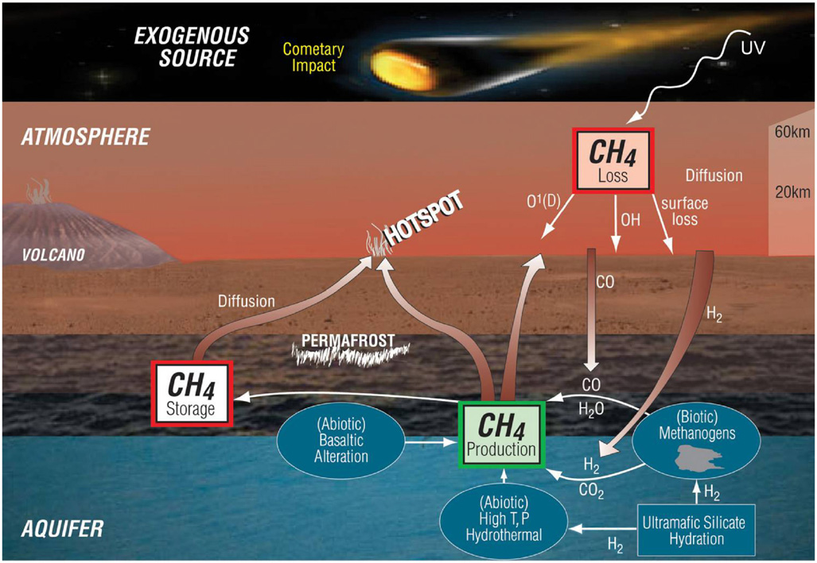
Figure 1.1: The four main competitors for explaining the raised methane levels in the atmosphere. Pictured are a cometary impact, volcanic activity, biotic synthesis and serpentinisation.
Also pictured is the destruction of methane by UV radiation.
Picture courtesy of Formisano et al., 2004.

As is seen in figure 1.1, the four competing theories include an impact of a comet that is highly enriched with organic matter, thus spreading methane over a prolonged period of time. The second theory to be discussed finds its roots in volcanic activity; methane is then discharged from Martian volcanoes into the planet’s atmosphere. Both of these theories are not considered to be sufficient to explain the set question, but can be used as a reference to show a comparison with Earth.
The two other theories, being the emission of methane due to biotic or geothermal processes, are the most frequently discussed and scientifically plausible ones, the reason of which will soon be explained. Serpentinisation is a chemical process describing the hydration of certain mineral compounds, producing serpentine (a mineral). The other reaction products include molecular hydrogen, which is highly reactive and subject to the forming of methane when encountering carbon compounds.

Cometary impact to Mars may lead to emission of enormous amounts of methane
Indeed, if a comet composed of mostly organics would impact Mars, this would lead to a distinct rise in methane concentration on the planet. A comet is a small solar system body comprised of dust and ices that may orbit the Sun if it is situated close enough. As with any other astronomical body, thermodynamic and chemical processes cause emission of certain substances to the surface. Unlike planets, though, comets aren’t massive enough to hold on to this matter, thus leaving a triplet of cometary tails where planets gather an atmosphere built up of these gases. The difference between a comet and a planet is further elaborated in the following chapter, where the BMST model is examined and the changes to the aforementioned model that was applied to estimate cometary nucleus composition are pointed out [1].
Assuming the impacting comet’s composition is within lengths of average comet compositions as measured by Gibb et al., 2003, in the Oort cloud comets, that is to say the cometary ring making up the outer boundary of the solar system, there should be about 1% by weight of methane. As stated by Atreya et al., 2007, a comet with a radius of about 130 metres can be expected to have impacted about a hundred years ago in order to completely explain the observations made by PFS, whereas a comet describing a radius of four hundred meters can be expected to have impacted around two thousand years ago, assuming that the cometary impact is the source of all of the airborne methane on Mars. The mixing value of CH₄ on Mars is at 10 parts per billion volume, according to various measurements. The photochemical lifetime of methane is in between 300 and 600 years. These two facts combined result in a methane exhaust per year of 126 metric tonnes. Since only a fraction of the micrometeoritic dust is expected to actually reach the surface, and cometary impacts on Mars only occur around once every 62 million years, there is but a relatively small chance that the high levels of methane concentration are caused by meteoric impact [2].

Volcanic activity contributes to elevations of methane concentration in the atmosphere
Within the safety of our home planet, volcanoes are still quite active. Volcanoes are defined as openings within the surface of a planet that allow hot subsurface material such as gases or magma to escape. They have been found to exist because of tectonic conversion and divergence. Not all volcanoes carry magma as popular belief suggests. Indeed, some outlets produce gases exclusively whilst others excrete mud and dust. About 0.2% of Earth’s methane mixing values comes from volcanic activity, and even some of that may be due to fossilised matter. Large-scale volcanic activity has not been observed on Mars for millions of years, according to Formisano et al., 2004.
Finally, terrestrial measurements point out that, next to methane, sulphur dioxide should be found in higher concentrations. As per Walker, 1997, a mixing value of SO₂ amounting in 1-10 parts per million is to be expected should the source of the atmospheric methane be volcanic activity. However, no SO₂ has as of yet been detected on Mars, and only a very low trace of the species has been derived by observations from Encrenaz et al., 1991 and 2001. Following these statements, it is to be said that a volcanic origin of airborne methane on Mars is possible, yet unlikely [2, 3].

Serpentinisation is a hydrothermochemical process resulting in methane emission
In the deep blue oceans that we know to exist on Earth, black smokers preside. These hydrogeothermal vents produce methane as a product of a chemical process where the mineral serpentine is formed from magnesium- and iron-rich silicates in a process that has already been called on by name, being serpentinisation. In the chemical reaction formulae stated below, the process is explained in depth, but a more physical approach will be given to the subject.
Black smokers have been observed for the first time in 1977 by scientists from Scripps institution for oceanography. These thermal vents exist at depths under water of about 2100 metres and are found in an environment with a temperature range of about 592 K and a pressure of around 400 bar as per Foustouskos and Seyfried, 2004. [2, 3]
In the Martian subsurface, similar conditions are found at a surface depth of roughly 30 kilometres. The process requires there to be liquid water, for the reagents must be in the aqueous phase for serpentinisation to take place. At such depths, however, finding liquid water is highly improbable [2].
Other hydrothermal vents have been found closer to the surface of Earth, called “Lost Cities”. Kelley et al., 2005, have observed such structures and encountered an elevated concentration of methane in its direct vicinity. If this elevation is due to the serpentinisation process is as of yet unknown. Should serpentinisation be found to take place in these “Lost Cities”, then by Martian analogy it could well take place in the subsurface of the red planet: where on Earth, these structures exhibit temperatures of 313-363 K, this corresponds to a depth below the Martian surface of about two kilometres. Liquid water is found to be theoretically stable at these depths, so it can be said that the hydrothermochemical explanation is a plausible one for the high methane concentrations in Mars’ atmosphere [2].
The chemical reactions that are associated with serpentinisation are as follows:

The hydration of ultramafic silicates yields the production of the mineral serpentine and molecular hydrogen along with other compounds via

$6Fe_{2}SiO_{4}+7H_{2}O→H_{2}\left(aq\right)+ 3Fe_{3}Si_{2}O_{5}{\left(OH\right)}_{4}+Fe_{3}O_{4}$,

and $2Mg_{2}SiO_{4}+3H_{2}O→Mg_{3}Si_{2}O_{5}{\left(OH\right)}_{4}+Mg{\left(OH\right)}_{2}$,

followed by

$2Fe_{3}Si_{2}O_{5}{\left(OH\right)}_{4}+6Mg{\left(OH\right)}_{2}→2H_{2}+2Mg_{3}Si_{2}O_{5}+2Fe_{3}O_{4}+4H_{2}O$.

The molecular hydrogen that is then produced reacts with either grains of carbon, carbon dioxide and possibly higher order hydrocarbons. Methane is a reaction product in a number of these reactions:

$C+2H_{2}\left(aq\right)→CH_{4}$,

$CO_{2}\left(aq\right)+4H_{2}\left(aq\right)→CH_{4}+2H_{2}O$,

$CO_{2}\left(aq\right)+\left[2+\left(m/{2n}\right)\right]H_{2}\left(aq\right)→\left(1/n\right)C_{n}H_{m}+2H_{2}O$.

Martians? A new perspective on life on Mars yields an explanation for airborne methane
At the turn of the century before last, people started getting suspicious of their planetary surroundings. Around the 1930s, people were told to be abducted by Martians or other so-called space scum. Although the vast majority of Earth’s inhabitants now know better than to suspect Martians of these reported abductions, the measurement of elevated methane concentrations in the Martian atmosphere shines with a new light in respect to the beliefs and claims to there being other life in the solar system.
The hydrothermal vents discussed in the previous section require liquid water in order to be of fundamental relevance in the search for methane deposits. Liquid water is known to be the source of life on earth at least. If liquid water can be found on Mars, there could just as easily be a group of organisms of sorts that are producing a constant flow of methane to the surface. Life could of course not be found on the planetary surface itself due to the thin atmosphere letting through ultraviolet radiation from the sun [3].

Microorganisms that exhibit chemical reactions yielding methane could maintain a metastable state by means of the following chemical processes:

$4CO+2H_{2}O→CH_{4}+3CO_{2}$

and $4H_{2}+CO_{2}→CH_{4}+H_{2}O$,

where in the above equation carbon monoxide is consumed together with water, yielding methane and carbon dioxide. In the lower equation methane and water are formed from elementary hydrogen and carbon dioxide.

Such could the biological diversity be, that different species of organisms utilize either carbon monoxide or water to produce methane. Comparisons with terrestrial life show that a biological origin of the methane in the Martian atmosphere is plausible since on earth about 80% of methane emissions are caused by biotic processes.
The reasoning behind the biogenic origin does not imply, however, that recent biological activity must be found on the planet to confirm this theory; methane that was produced during Mars’ possible wet and warm phase could be stored in methane-hydrates [2].

2. Thermodynamics of the Martian surface
The surface of our neighbour planet is a very secretive business by means of its composition and dynamics, for there are currently no measurements available that can determine anything about the elemental composition of the deeper surface layers. Current assumptions of the Martian surface and subsurface structure are based upon similarities with Earth. On this basis, Mars is said to have a hot core composed of molten metals such as iron and nickel. Whilst the surface composition is understood by means of measurements performed by rovers such as Viking and Curiosity, this is only true for some regions. There, the surface has been found to be comprised of silicates and metals, both being building blocks for rocky outcrops, such as can be seen in areas like Anseris Mons. For the model that is being used to be productive, however, these areas with great range in elevation should be avoided as much as possible [4].

For the simplicity of calculations concerning thermal dynamics, plains and plateaus such as Isidis Planitia can be considered to eliminate differences in altitude. The surface of these plains is assumed to be composed of several layers, each with a different composition thus describing different geophysical properties such as thermal conductivity and crystal structure [5].
In assessing the depth where methane ice is stable over both day-and-night cycles and the orbit Mars describes around the sun, a lot of parameters are considered. The only available measurements of methane that are available are related to the mixing values within the atmosphere, as performed by Formisano et al., 2004 and Krasnopolsky et al., 2004. Having found that these methane levels are due to the production of methane elsewhere, the model suggests that over the course of Mars’ orbit, methane is sublimated from the subsurface, where it exists in solid form. Then the sublimate is diffused to the surface and released into the atmosphere, accounting for the elevated mixing values [5].

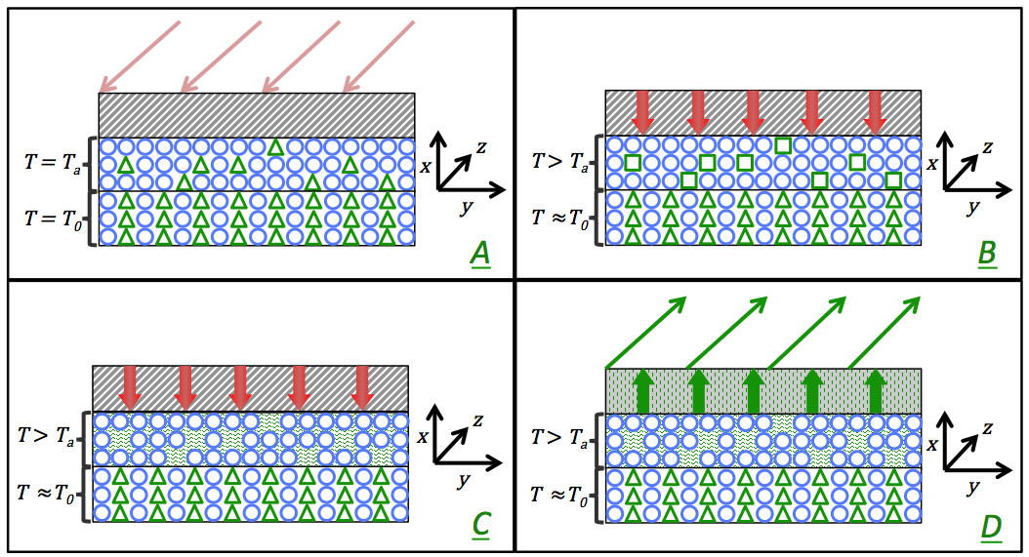
Fig. 2.1 depicts the various processes that take place, starting with a heat flux accounted for by solar irradiation and concluding in the release of methane vapour into the atmosphere. Not depicted is the destruction of the vapour by UV radiation.
Figure 2.1: the four thermodynamic processes that subsurface methane is involved in. [A] Depicts the solar heat flux from the sun while [B] and [C] show the heating and sublimation of the ground methane, respectively. Shown in [D] is the release of that sublimate into the atmosphere.

2.1 Gas flux modelling using the Berlin Mars near-surface thermal model
The BMST model, as described in Helbert and Benkhoff, 2004, makes use of thermodynamic conservation and equilibriae of energy and mass in order to assess the temperature at certain depths into the surface. As stated before, the various processes that take place are the radiation of heat from the sun onto the surface, followed by the conduction of this heat into the subsurface, where it heats the various compounds that are present there. In addition, the incoming energy is also consumed by sublimation of different ice species assumed to be present in near surface layers. The sublimation of these species depends on temperature as well as pressure. Some ice species will already sublimate at very low temperatures (e.g. carbon monoxide). The temperature of the layers themselves varies both in times of day and of season.
Finally, sublimates of these ices travel to the surface by means of diffusion through porous canals, thereafter being released into the atmosphere. The amount of gas released at the surface is the main outcome of this model. Results gained can be compared to spacecraft measurements. By fitting modelled fluxes onto measurements, one is able to constrain the physical and chemical parameters of the near surface layers [5, 6].

The model is based upon an earlier version that was used exclusively for studying the composition of comets. To illustrate the differences and similarities between planets (Mars especially) and comets, consider the following: where a planet is comprised of a massive bulk and a gaseous atmosphere, a comet is best described as a small solar system body that is not quite massive enough to hold on to its gas exchange products, but rather leaving them behind in tails of gases, dust and plasma [1].
The size of the comets that have been studied making use of the earlier model are in the order of 10-100 kilometres in radius, as per Keller et al., 1990, where Mars has a diameter of 6792.4 km, presenting a second difference between the two. Although many differences can be found between planets and comets, a distinct similarity is the elemental composition: both in comets and on Mars, silicates are found to exist. A simplification is made in the model, assuming that Mars is built up of exclusively silicates, dust, and ices. Cometary dust is only prevalent in traces on the actual comet, because most of it escapes and forms a tail. A top layer on the surface therefore represents the Martian dust layer [1, 7].

As stated before, the Berlin Mars model is applied to plains and plateaus for the sake of simplicity: there are no irregularities in altitude of the surface that need to be accounted for in the model. The choice has been made to seek out Isidis Planitia for a proposed landing site for future Mars rovers by Helbert and Benkhoff, 2003, because there are also very little traces of rocky outcrops, thus eliminating the need for inclusion of these formations of high thermal conductivity from the model [1, 6].

The equation that describes the energy balance of the surface is comprised of a number of terms, namely one term pointing out the flux of energy as is delivered to the surface by the sun, one term that accounts for the latent heat released in the sublimation of ice, one term describing the emissivity of the Martian surface itself, a term accrediting the transport of sublimate to the surface, and one term describing the heat conduction to lower subsurface layers. These consecutive terms are derived in the following paragraphs, leading to the energy- and mass balance equations stated in chapter three.

Describing the heat flux caused by the sun as a function of time
The subsurface ice can only be sublimated after the energy is transported across various surface- and subsurface layers. This incoming heat (energy) is radiated by the sun onto the planetary surface in the first place. The heat flux as is caused by the sun can be determined as a function of Mars’ orbit like in the equations below. Other terms are included in the final energy balance with respect to the surface. These quantities are derived in a later state [1, 6].

The heat flux within a layer of the surface of thickness $dr$, as caused by the sun, is defined as follows

$F\left(r\right)= -κ dT/dr,$ [2.1.1]

where $F\left(r\right)$ the heat flux as a function of surface depth [Wm⁻²],
$κ$ the (mean) thermal conductivity of the bulk [Wm⁻¹K⁻¹],
$T$ the absolute temperature at depth $r$ [K].

The solar energy input varies due to both the rotational and orbital motion of the planet, which is represented in equation 2.1.2 that uses characteristics from Earth’s orbital and rotational movements and applies these to the properties of Mars.

$F=\left(1-A\right)\frac{F_{⊙}}{r_{H}^{2}(t)}\cos{ζ}$, [2.1.2]

where $A$ the surface albedo of Mars [0.170],
$F_{⊙}$ the solar constant, heat flux at a distance of 1 AU [$1.361$kWm⁻²],
$ζ$ the local zenith angle [˚].

The distance to the sun ($r_{H}$) is given by the following equation:

$r_{H}=a\left(1-e\cos{E}\right)$, and $τ=\sqrt{\frac{a^{3}}{GM_{⊙}}}\left(E-e\sin{E}\right),$ [2.1.3]

where $a$ the semi major axis of Mars’ elliptic orbit [1.52 AU],
$e$ the eccentricity of the planet’s orbit [0.093],
$E\left(t\right)$ the eccentric anomaly of the described ellipse [AU],
$τ$ the period of rotation of Mars around the sun [s],
$G$ Newton’s constant of gravitation [$6.67×{10}^{-11}$ m³kg⁻¹s⁻²],
$M_{⊙}$ the sun’s mass [$1.99×{10}^{30}$ kg].

These equations build up to form a solid algorithm for specifying the solar flux through the surface at any time during Mars’ orbit. This is, of course, the input energy that is first transported to the subsurface layers before heating the ice and sublimating it. Along with that there are several other processes that are benefited by this input such as the diffusion of sublimate along channels to the surface, and the heating and consequent sublimation of other ice species such as H₂O or CO₂ [6].

2.2 Sublimation of methane ice in the dust-ice matrix of the Martian surface
The energy input from the sun provides a certain amount of heat to the planetary subsurface, leading to the heating and sublimation of various ices such as methane. As is depicted in figure 2.1, heat energy is first transmitted to the methane particles by means of conduction before sublimation takes place. After sublimation, gaseous methane diffuses to the surface before being released into the atmosphere. Diffusion takes place with certain prevalence due to crystal structure, as a close packed lattice consists of smaller spaces in between the individual molecules (the pores), thus making diffusion either easier or more difficult [1, 8].

The energy input as per the previous paragraph only reaches the ground methane deposits by conduction mechanisms. A heat flux can be defined as the product of thermal conductivity (which is a material constant), and a temperature gradient as follows:

$q=-k∇T,$ [2.1.4]

where $q$ the local heat flux of a substrate [Wm⁻²],
$κ$ the thermal conductivity of the substrate [Wm⁻¹K⁻¹],
$∇T$ the local temperature gradient [Km⁻¹].

The thermal conductivity of the substrate is further defined as a function of the contact area of the particles, as well as the ratio between matter and vacuum known as the porosity. These values are dependent on the crystal structure of the surface layer. The basic assumption is that the subsurface can be described as a mesh of particles (matter) and porous canals (vacuum). These canals make up a certain part of the volume of the unit cell, represented by the porosity. Furthermore, the canals can be contorted rather than straight and aligned in a parallel manner. This is described by the tortuosity. Contact area between particles is also considered to be of importance for conduction processes, and is expressed in the Hertz factor. Details can be found in Appendix A [1, 8].
The equation below shows the thermal conductivity as a function of crystal structure:

$κ=\frac{3}{2}\left[Ψ-\frac{1}{3}\right]f_{H}\hat{κ}$, [2.1.5]

where $Ψ$ the porosity of the surface layer [-],
$f_{H}$ the so-called Hertz factor for contact area [-],
$\hat{κ}$ the conductivity of a silicate-core particle [Wm⁻¹K⁻¹].

The change in enthalpy of sublimation is given in equation 2.1.6. The so-called latent heat can be calculated from the Clausius Claperon equation as per Fanale and Salvail, 1948:

$\frac{1}{P}\frac{δP}{δT}=\frac{L}{T^{2}R_{g}}$, [2.1.6]

where $P$ the saturation pressure [Pa],
$L$ the latent heat of sublimation [Jkg⁻¹],
$R_{g}$ the universal gas constant [8.314 Jmol⁻¹K⁻¹].

As stated before, the methane sublimate is diffused across the subsurface layers both up and downward. For the sake of simplicity, only the upward flux is considered. After all, the question that needs to be answered does not draw immediate attention to the flux toward the core, rather the complete opposite. Thus, considering only upward flow of methane sublimate, and all the previously described factors, the methane flux through a porous canal can be described as a thermodynamic quantity depending on the temperature among other things [1, 6].

Given a system consisting of porous canals, the mass flux of methane is

$j=-\frac{8r_{p}^{3}}{3ξ}\sqrt{\frac{πμ}{2R_{g}}}\frac{d\left(P/√T\right)}{dx}$, [2.2.1]

where $j$ the mass flux of methane through the layer $dx$ [kgs⁻¹],
$r_{p}$ the radius of the porous canal [m],
$μ$ the molecular mass of methane [16.04 u],
$x$ the burial depth of the layer in question [m].

The total mass flux is then given by summation of all the pores that exist within a layer, coexisting alongside a property called permeability. This property describes the extent to which gases can travel through the canals. Permeability depends on tortuosity, pore radius and crystal structure by means of porosity [1, 6].
The following equations can be used to describe an entire subsurface layer with respect to the mass flux of methane:

$J=\sum_{i=1}^{n}{N_{i}j_{i}}≡\frac{Ψj^{'}}{π}\sum_{i=1}^{n}{f_{i}}\frac{r_{i}}{ξ^{2}}$ , [2.2.2]

where $j^{'}=jξ/r_{p}^{3}$, [2.2.3]

$φ=Ψ\overline{r_{p}}/ξ^{2}$, [2.2.4]

so that $J=-\frac{8}{3}φ\sqrt{\frac{μ}{2πR_{g}}}\frac{d}{dx}\left(\frac{P}{\sqrt{T}}\right)$ , [2.2.5]

where $N$ the number of particles with radius $r=r_{i}$ [-],
$ξ$ the tortuosity of a porous canal [-],
$φ$ the permeability of the substrate layer [m],
$J$ the total mass flux of methane through the layer [kgs⁻¹].

3. The Berlin Mars near Surface Thermal Model
As stated before, the Berlin Mars near Surface Thermal model makes use of initial conditions to simulate a number of planetary orbits around the sun until a stable state is reached, that is to say until the profiles of temperature versus surface depth and temperature versus time remain within certain boundaries over the course of time.

Fortran is used as a programming language, because of the apparent ease of working with a UNIX based system whilst gathering data from a running program. As will be seen shortly, the program assumes a mass- and energy balance based on criteria either stated in a module or subroutine that goes before any calculation, or criteria as are the input from the user. As the program continues to run, variations in time are simulated by a change in certain parameters such as solar flux (taking the effects of seasonal and diurnal change into account).

Results are given in a number of .ASCI files representing simulated data belonging to a certain set of variables. For instance, if one should be interested in the temperature variations as a function of time to see the effects of seasonal changes, these are given in one file, whilst one could find the position of the methane sublimation front as a function of time in another file. Many of these files contain useful information and the data stored there will be used in the final analysis from chapter five and on.

The cartoon below gives an indication of the program’s outcome: as time progresses the layers near the surface become depleted of methane due to the diffusion of the gas through the subsurface and into the atmosphere. Diffusion also occurs in the other direction as methane sublimate condensates in deeper subsurface layers. At some point in time, a stable situation will occur where the sublimation front, that is to say the point where methane is no longer heated enough in order to sublimate, will not move down any further. This is the depth where stable methane ice deposits occur.

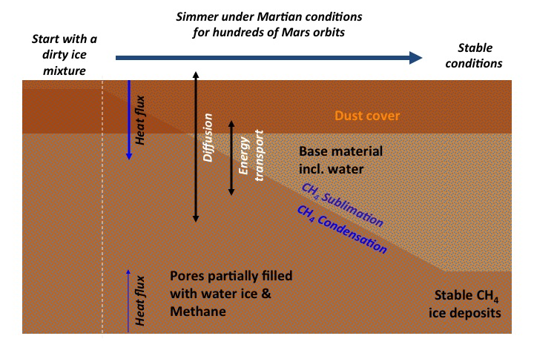Figure 3.1: starting with a dust-covered, layered surface comprising water ice, dust, and methane ice, the program runs for 55 Mars orbits. All the while, the surface and subsurface are subject to an energy input from the sun. This heat flux is passed on and methane ice is sublimated, diffuses both up and down the subsurface, and either is released into the atmosphere, or condenses in deeper subsurface layers. At some point, the heat flux from the sun loses too much energy to convection to sublimate the methane that is situated deep within the subsurface. From that point on, a stable situation has been established.

Given in the following sections is an in-depth look at the mass- and energy balances that the BMST model uses for its computations.

3.1 Calculating a mass balance to predict the outflow of methane from any layer
In order to create a model that can be used to predict the temperature of any layer inside the Martian surface, a combination of mass and energy balance is used continuously. The BMST model simulates several planetary orbits around the sun until such a state is reached that geophysical properties do not suffer high magnitude changes, such as a change in temperature.

The mass balance that is used states that the amount of substance that leaves the system is equal to the amount of substance that is introduced into the environment; the system being Mars’ planetary surface and the environment being anything other than that, but mainly the Mars’ atmosphere. In the simplest scenario, water and methane are the only substances that are transported from the subsurface. Of course, this simplified reality would not yield satisfactory results. Various other substances can therefore be introduced into the simulated environment, such as dust, carbon monoxide, nitrogen, or carbon dioxide. The time dependent partial differential equation below describes the situation as it takes all the other terms into account [1].

$\frac{∂ρ}{∂t}+∇∙\left(J_{CH_{4}}+J_{H_{2}O}+\sum_{i}{J_{i}}\right)=0$, [2.2.1]

here, $ρ$ the density of the material [kgm⁻³],
$J_{CH_{4}}$ the mass flux of methane [kgs⁻¹],
$J_{H_{2}O}$ the mass flux of water [kgs⁻¹],
$J_{i}$ the mass flux of an i-th element [kgs⁻¹].

The various components that make up the Martian subsurface have relatively low densities, allowing for the mass balances to be set up individually. The processes taking place that are incorporated in the model are the formation or sublimation of amorphous ice, the mass flux of dust, and the escape of vapour from the system. Amorphous ice only exists at extremely low temperatures (below 136 K), the likes of which are not normally encountered on Mars. As a result, the formation of amorphous ice can be neglected with respect to the mass balance [1, 9].

3.2 Setting up an energy balance to describe the flow of mass in the BMST model
As previously stated, the method used to determine the burial depth of stable methane ice is based upon thermodynamic equilibriae. In order to be able to calculate the next mass balance in a certain state in time, the various parameters need to be calculated, as some are a function of temperature. Therefore, both the mass and energy balance coexist to the point where values are somewhat constant in time (being the number of iterations).

A number of energy sources and sinks can be defined. The heat flux as from the sun was already introduced in chapter 2.1.1 and the latent heat that is paired with the sublimation of methane is given thereafter in chapter 2.1.2. Of course, there are numerous processes that make use of the energy from the sun, but there are also some exothermic processes that deliver an extra input of energy to the system. Radioactive decay, for instance, serves as a source of energy in comet nuclei as stated in Helbert and Benkhoff, 2006. However, this term is not incorporated in the adjusted model for Martian conditions since there is no known knowledge of high concentrations of radioactive substances within the subsurface [1].

The various sinks and sources of energy that contribute to the energy balance are as follows:

$\frac{∂}{∂t}\left(ρu\right)+∇\left(F+\sum_{n}{u_{n}J_{n}}\right)=-\sum_{n}{q_{n}ΔH_{n}}+λ\left(T\right)ρ_{a}\left(1-\sum_{i}{f_{i}}\right)ΔH_{c}$ , [2.2.7]

where $u$ the mass-specific internal energy [Jkg⁻¹],
$F$ the heat flux through the subsurface layer [Js⁻¹],
$ΔH_{n}$ the latent heat of conduction [J].
This equation, along with the previously discussed sections, converges in a number of equilibrium equations that describe the state of the crust and that of the porous, icy layer. Equations 2.2.8 and 2.2.9 describe the equilibriae in the crust and the ice-dust layer, respectively.

$ρc\frac{∂T}{∂t}+Ψρ_{g}c_{g}v∙ΔT=Δ∙\left(κ_{m}ΔT\right)+\sum_{i=1}^{n}{ΔH_{i}q_{i}}$ , [2.2.8]
and $ρc\frac{∂T}{∂t}+Ψρ_{g}c_{g}v∙ΔT=Δ∙(κ_{d}ΔT)$, [2.2.9]

where $c$ the average specific heat capacity of the matrix [Jkg⁻¹K⁻¹],
$Ψ$ the porosity of the matrix [-],
$c_{g}$ the average specific heat capacity of the gas [Jkg⁻¹K⁻¹],
$v$ the mean velocity of the evaporate [ms⁻¹],
$κ_{m}$ the thermal conductivity of the matrix [Wm⁻¹K⁻¹],
$κ_{d}$ the thermal conductivity of the dust matrix [Wm⁻¹K⁻¹],
$ΔH$ the change in enthalpy of sublimation [J],
$q$ the specific mass release rate per unit volume [kgm⁻³s⁻¹].

Finally, combining the mass and energy equilibriae, the temperature of the layer can be calculated using equation 2.2.8, as shown below, demonstrating the boundary condition that is used for the calculation of the surface temperature.

$\frac{F_{o}\left(1-A\right)\cos{ζ}}{r^{2}}=ϵσT_{s}^{4}+κ_{d}ΔT_{s}+\sum_{i=1}^{n}{ΔHQ_{i}}$ , [2.2.10]
where $F_{o}$ the solar constant, heat flux at a distance of 1 AU [1.36 kWm⁻²],
$A$ the surface albedo of Mars [-],
$ζ$ the local zenith angle [˚],
$r$ the heliocentric distance [AU],
$ϵ$ the infrared emissivity of the Martian surface [-],
$σ$ the Stefan Boltzmann constant [$5.67×{10}^{-8}$ Jm⁻²s⁻¹K⁻¹],
$T_{s}$ the surface temperature [K],
$Q$ the gas production rate at the surface [kgm⁻²s⁻¹].

The respective temperatures of the subsurface layers are calculated in a similar fashion, negating the input from infrared emissions;

$Q_{in}=κ_{d}ΔT_{s}+\sum_{i=1}^{n}{ΔHQ_{i}}$ , [2.2.11]

where $Q_{in}$ the gas production rate at the subsurface layer [kgm⁻²s⁻¹].

4. Initial parameters and boundary conditions for the model
The parameters that are included in the BMST model need to be provided in a separate ASCI file. The actual goal of this research is to map the methane gas flux as a function of time and subsurface layer depth, as well as some other conditions that shall be introduced in the next chapter. In order to be able to run the Fortran program for these simulations, however, assumptions must be made concerning the more consistent and predictable quantities such as thermal conductivity of Martian dust or the specific heat of the dust-ice matrix. Numbers for some of these quantities have been given as they have been hypothesised or calculated before, e.g. [11].

The model assumes a layered structure where every surface layer has a different composition. The first layer is initially comprised of dust exclusively and is assumed to have a density that is similar to a typical value for coarse sand, namely 1750 kgm⁻³.
As per Ruff and Christensen, 2001, the dust coverage in Isidis Planitia specifically is not very high and is simulated to be 100 centimetres. Assuming a basaltic composition, the specific heat capacity for the base material is said to be equal to 795 Jkg⁻¹K⁻¹, yielding a mean value for the thermal conductivity of the material equal to 0.17 Wm⁻¹K⁻¹, as per Helbert and Benkhoff, 2003 and Helbert and Benkhoff, 2006.
The surface albedo of the studied area is found to be equal to 0.22 as a mean value for Isidis Planitia. An infrared emissivity of 0.78 is assumed for the dust layer. For fine (Martian) sand, Christensen, 1986, derived a value for the thermal conductivity of 0.123 Wm⁻¹K⁻¹, using typical values for fine (terrestrial) sand; a density of 1500 kgm⁻¹ and a specific heat capacity of 795 Jkg⁻¹K⁻¹.
As presented by Mellon et al., 2000, the thermal conductivity of near-surface layers of depths down to 100 metres have been found equal to 0.17 Wm⁻¹K⁻¹ by means of measurements from the TES instrument on the Mars Global Surveyor [5, 6].

In the model, the porosity is stated to be 0.5, which is based upon the value for the porosity of a cubic packed-lattice of particles. For further examples and explanation about crystal structure, see Appendix A.

The heliocentric distance from the sun, as well as the local zenith angle, vary as a function of time due to Mars’ orbital motion around the sun. The surface temperature is set at a minimum value of 50 Kelvin and the tortuosity is set at 1.5, meaning that a pore describes a length of one-and-a-half times the distance it penetrates the surface with. Further quantities are given in the next section, with their respective point of view. In that section, the various cases that are studied shall be described more in-depth.

4.1 Postulated cases of various parameters to be simulated
Based on the assumptions that are made, which were discussed in the previous section, a series of interpretations about the Martian subsurface can be made: either the particles are very closely packed, supporting a higher value for thermal conductivity, or they are further apart, thus inversely yielding a lower conductivity. Also, based on earlier interpretations of measurements of atmospheric methane by Atreya et al. and Formisano et al. there is still much discussion on-going about the prevalence of methane within the subsurface. On these bases, a number of different scenarios have been computed in order to reflect on the methane flux from the surface and into the atmosphere.

In order to study the influence of the surface composition with respect to the amount of methane that is diffused out of the surface and into the atmosphere, a series of ten simulations is performed with a percentage of methane in the surface assumed to be anything from one half per cent to five per cent, in steps of one half per cent. Other substances making up the subsurface are water, set at fifty per cent, and dust. These simulations will be run under so-called standard conditions elsewise, meaning that the Hertz factor is set to a value of 0.025, the pore radius is set to a value of one millimetre, and the latitude is set to zero degrees, meaning that the simulation is performed as if on the Martian equator. Ten simulations are chosen in order to be able to make an assumption about the kind of relation there is between the subsurface composition and the methane flux into the atmosphere.

In order to understand the influence of the thermal conductivity with respect to the methane outlet, a series of five sets of simulations are performed where both the Hertz factor for particle contact area and the surface composition are altered. Whilst the surface composition is set to one, two, or three per cent methane, for every value a number of five simulations are performed where the Hertz factor takes on a value of 0.0025, 0.0033, 0.0050, 0.0075, 0.0250, or 0.0330. For the rest, standard conditions are applied. Using this set of data, a conclusion may be drawn about the influence of the Hertz factor on the methane output. Furthermore, these conclusions may be verified by checking to see the influence of changes in the Hertz factor for other forms of surface composition.

A third set of simulations is performed in order to assess the relation between the sizes of the porous canals and the methane gas flux. Whilst under standard conditions, three cases are studied with respect to surface composition in order to substantiate any conclusions that may be drawn. These cases assume once again a methane volume percentage of one, two, or three. Various pore radii are considered, being 0.10 millimetres, 0.50 millimetres, 1.0 millimetre, 3.3 millimetres, 5.0 millimetres, and 10 millimetres. Using this set of simulations allows for conclusions to be drawn about the influence of both the pore size and the surface composition with respect to the methane flux.

As a final study, it has been proposed to investigate if the latitude where the simulation is said to take place, is of an influence to the methane flux. If this is the case, then assumptions may be made with respect to the distribution of methane not only as a function of penetration depth into the surface, but also as a function of latitude. In order to investigate this, four cases have been proposed under standard conditions, but with a methane concentration of two per cent, and with latitudes of zero, twenty, forty, sixty, and eighty degrees.
The table overleaf summarises these cases and introduces their abbreviations.
Table 4.1: case studies that will be performed with respect to their properties
Case | [CH₄], [%] | $r_{p}$ [mm] | $f_{H}$ [-] | L [˚]
C01 | 2.0 | 1 | 0.025 | 0
C02 | 5.0
C03 | 1.0
C04 | 4.0
C05 | 3.0
C06 | 3.5
C07 | 4.5
C08 | 1.5
C09 | 2.5
C10 | 0.5
P11 | 2.0 | 0.1
P12 | 5.0
P13 | 1.0
P21 | 2.0 | 10
P22 | 5.0
P23 | 1.0
P31 | 2.0 | 5
P32 | 5.0
P33 | 1.0
P41 | 2.0 | 0.5
P42 | 5.0
P43 | 1.0
P51 | 2.0 | 3.3
P52 | 5.0
P53 | 1.0
H21 | 2.0 | 1 | 0.0025
H22 | 5.0
H23 | 1.0
H31 | 2.0 |  | 0.0050
H32 | 5.0
H33 | 1.0
H41 | 2.0 |  | 0.0075
H42 | 5.0
H43 | 1.0
H51 | 2.0 |  | 0.0330
H52 | 5.0
H53 | 1.0
H61 | 2.0 |  | 0.0033
H62 | 5.0
H63 | 1.0
L11 | 2.0 |  | 0.025 | 20
L21 | 2.0 |  |  | 40
L31 | 2.0 |  |  | 60
L41 | 2.0 |  |  | 80

5. Analysis of data and interpretation of results
When an iteration of the Berlin Mars near Surface Thermal model is complete, a set of seventy-one files containing either starting values or computed data is formed. The interpretation of this data should be elaborated before presenting the data itself. Only a small amount of the resulting files are used for actual analysis, the others being either input- or supporting output files. The files of interest are presented in the shape of an ASCI extension and can be interpreted using the IDL programming language. In some cases, the collected data consists of multiple regions of interests, being different orbits, since the temperature profile of the subsurface layers should be computed at different times in orbit as well as for a number of orbits. In these cases, the procedure is scripted directly. Otherwise, collections of data can more easily be plotted using the intelligent tools that IDL offers (the iPlot function).

First of all, the time span of any iteration can be evaluated by plotting the time against the distance from the sun, or by plotting the time against the average surface temperature.
A choice has been made to use the former because the surface temperature is not a set quantity from the beginning, whilst the distance from the sun is. The figure below describes the distance from the sun as a function of time. This has been depicted specifically for case C01. The number of orbits has been assessed to be equal to fifty-four point five. Further investigation states that this value is the same for other iterations.

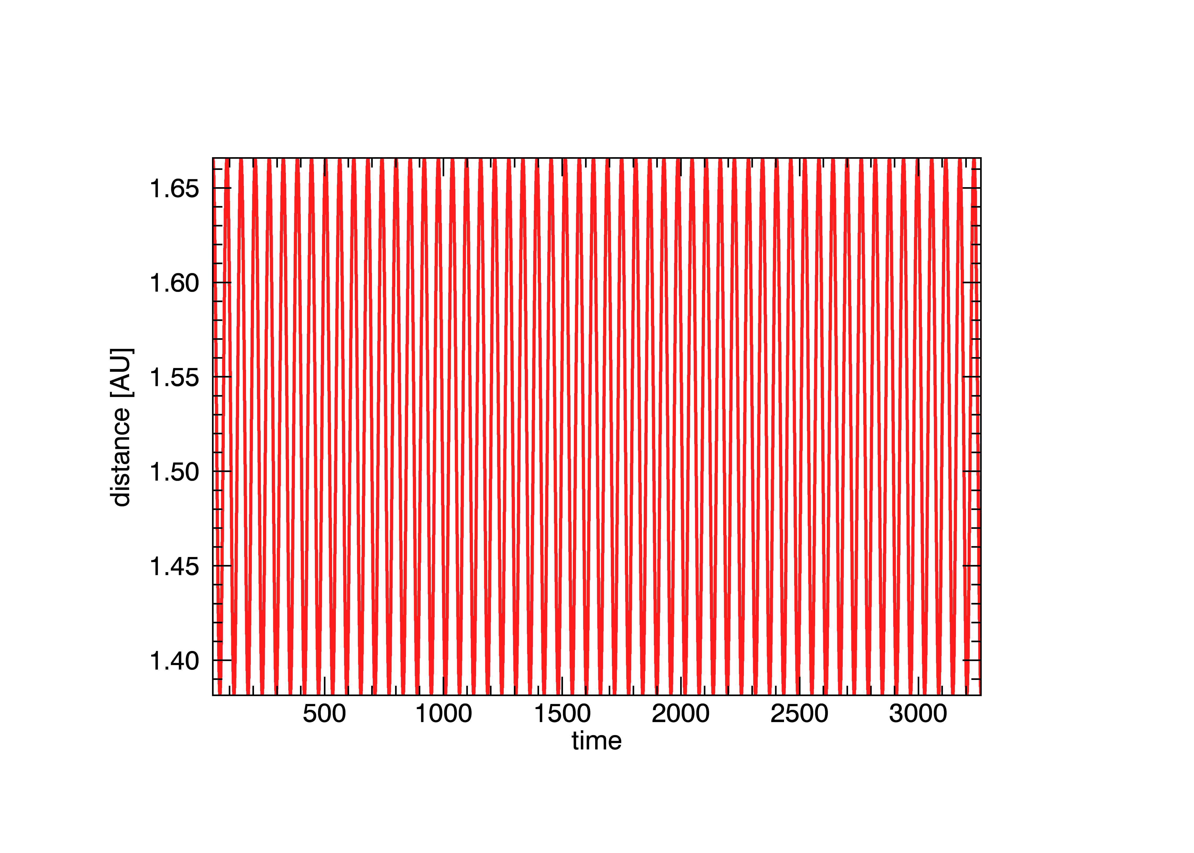
Time [Ms]

Figure 5.1: assessing the number of Mars orbits by plotting the time versus the distance from the sun, where, by counting the maxima in the chart, a number of 55 orbits has been calculated for the entire simulation.

It must be said that the time scale in figure 5.1 is given in millions of seconds. Calculating the time scale is done by taking the amount of Mars orbits (54.5) and the amount of data points (437417) and dividing them by one another, yielding a value of 8026 data points per orbit. Since one Mars orbit takes place over 687 days, this yields a value of about twelve data points per day. This is shown in figure 5.2 by taking an interval of several days and plotting the time versus surface temperature (day temperatures are higher than those at night).

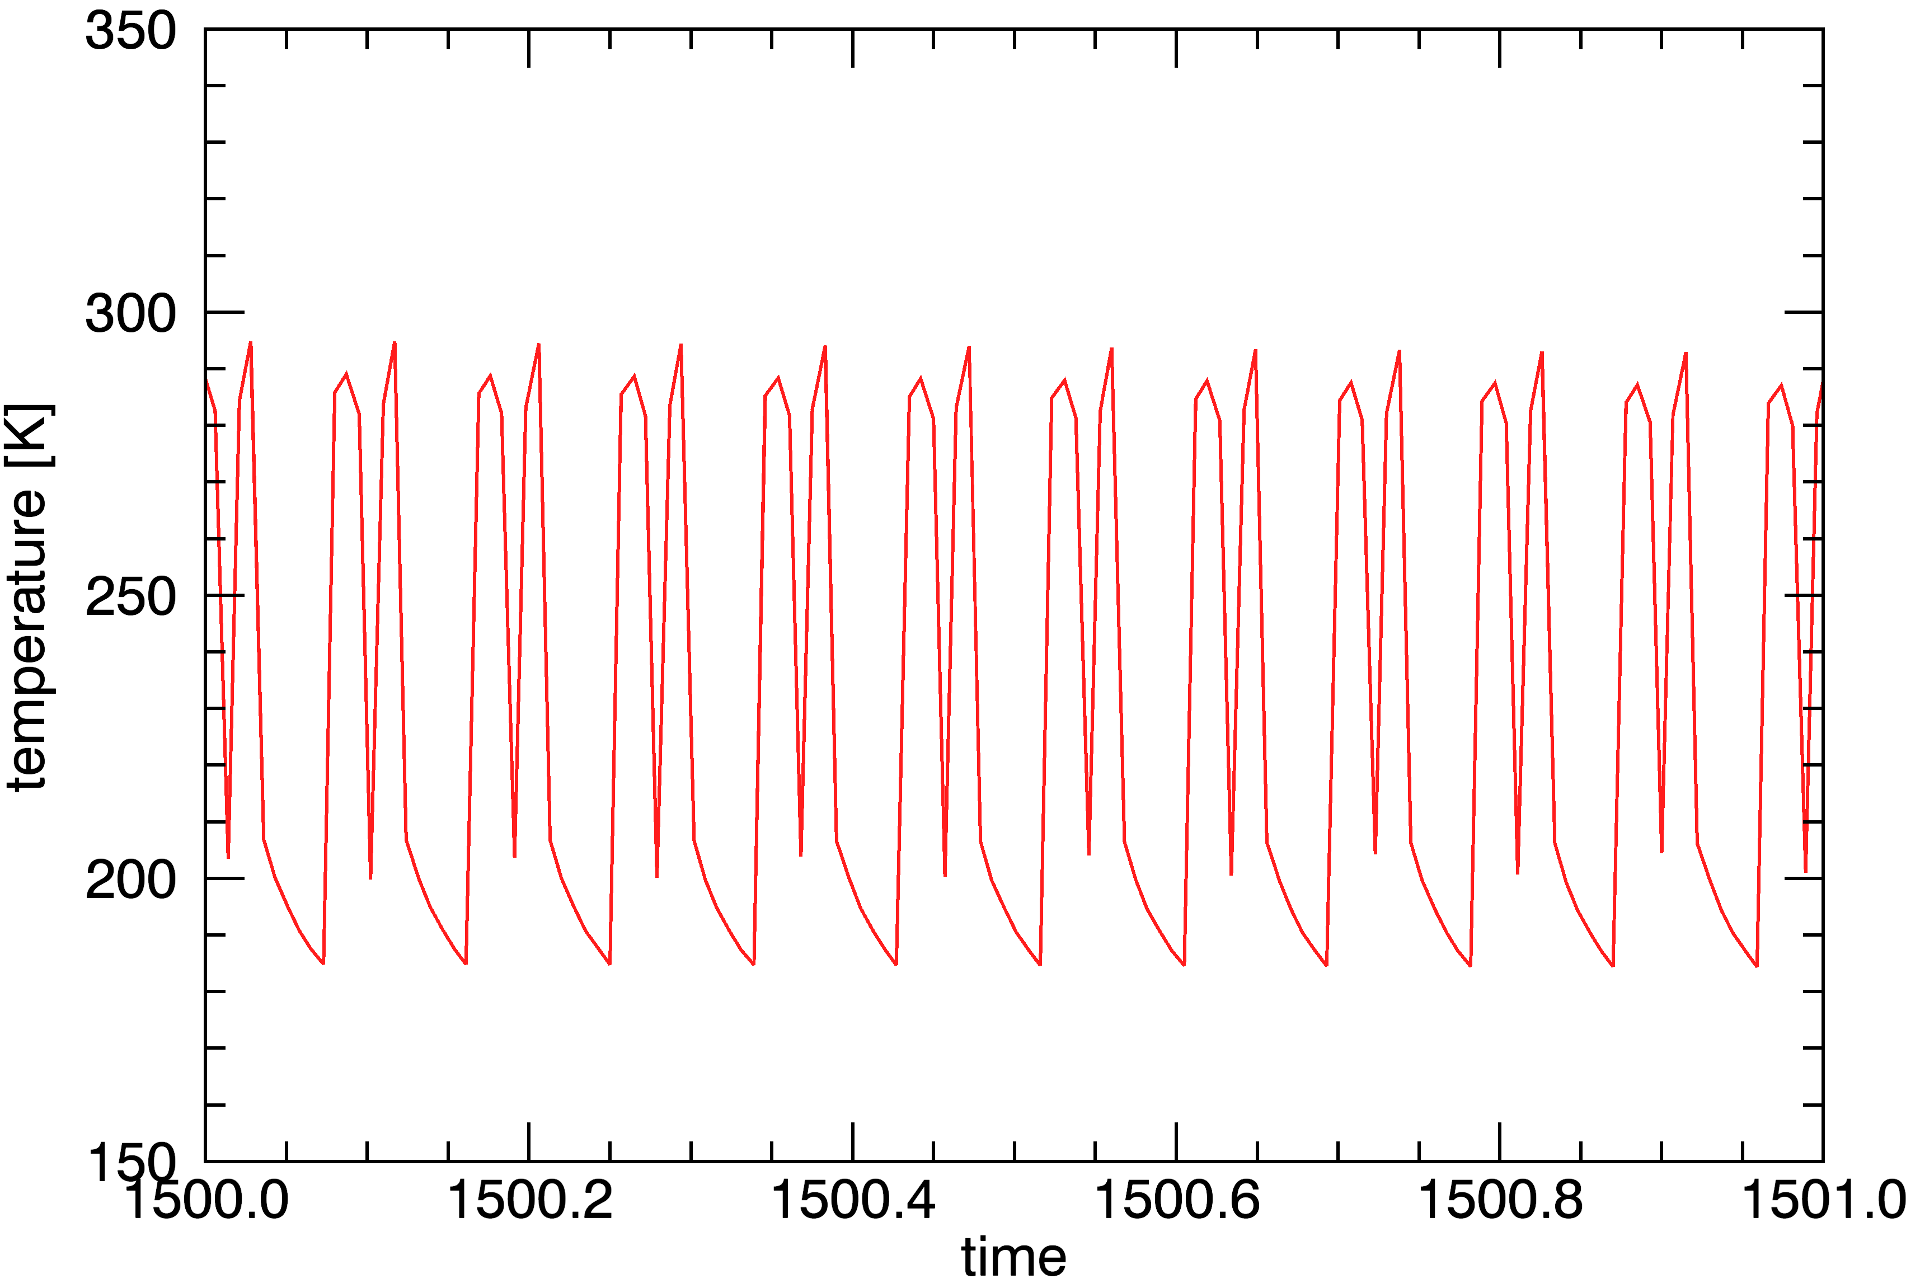
Time [Ms]

Figure 5.2: describing the duration of one rotational period in units of time by plotting the time in millions of seconds versus the temperature. By distinguishing daytime from night, the number of units of time per day can be set to 0.08.
The two things that are of interest are the position of the sublimation front of subsurface methane, and the temperature profile of the Martian subsurface. In order to compute these connections, two files containing data that is relevant to the posed questions are considered, the first describing the temperature of subsurface layers with a set thickness as a function of time, the second including the densities of the various components that the subsurface is said to be comprised of (in this case being water, dust, and methane).

The subsurface is viewed to a depth of fifty metres, where for every time-based computation results in 2000 values, meaning that the distance in between data points is equal to 0.025 metres. The data is presented in 550 tables where every table describes a different moment in time. Since the total orbits have been found equal to 54.5, there are about ten tables per orbit, meaning one measurement per seventy days.

5.1 Describing the temperature profile of the Martian subsurface
As a first attempt to evaluate the temperature gradient of Mars’ subsurface layers, the cases that have been discussed previously in section 4.1 have been iterated using the Berlin Mars near Surface Thermodynamic model, each run of the program taking about four hours’ time. After the program had finished, plots were made of the data collected concerning the temperature of a surface layer as a function of layer depth, as well as a function of time. Using the iPlot tool, the result that was acquired for the case of C01 can be seen below in figure 5.3. However, the procedure took a very long time to complete, being about three hours per iteration. Also, as can be seen in Fig. 5.3, a very dense signal is given. Making use of the known time intervals, a choice was made to script a procedure that would plot the same data in a less dense set of lines, by taking every tenth value rather than every value, thus compensating for seasonal changes of parameters. The result of this for case C01 can be seen overleaf.

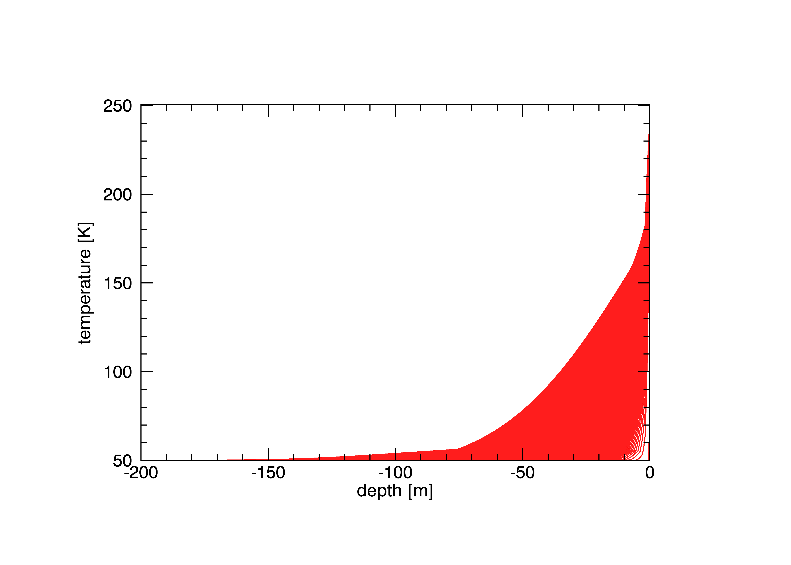
As can be seen in the figure below, the Martian subsurface indeed experiences very cold temperatures according to this first simulation, thus supporting the prevalence of methane ice within it. Every tenth data set in time is graphically pictured in the structure of 550 time-based simulated measurements as to account for the orbital condition of the planet and the change of solar flux that goes hand in hand with seasonal changes. This was explained in the previous section of this chapter. Similar graphs for the other cases stated in section 4.1 can be found in Appendix B.
Figure 5.3: describing the temperature profile of the Martian subsurface, not taking into account the heating of the subsurface from the interior. A dense signal can be seen, being the effect of seasonal and orbital variations.
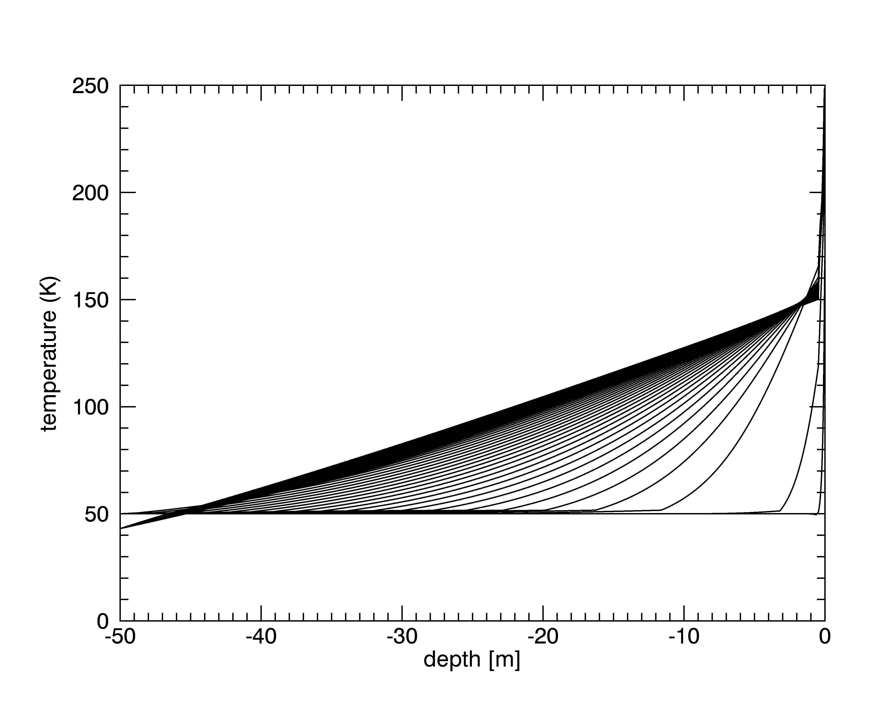
Figure 5.4: a temperature profile of the Martian subsurface where seasonal changes have been taken into account. Analysis of this chart can be found in the text.
In the figure above, a diagonal “swipe” can be seen that gives reason for pause. In continuation of the later simulations, it has been proposed that fifty metres depth is not yet enough to visualize a methane sublimation front within the Martian subsurface. The choice has therefore been made to look deeper into the surface layers, and every case described in section 4.2 is repeated with a maximum depth describing 200 metres.
The graph below depicts the temperature profile as it has been constructed from the data from the aforementioned case C01, with a maximum depth of 200 metres. This in turn allows for slightly thicker layers than before, as per the calculation in the close of the introductory section of this chapter, holding a layer thickness of 10.5 centimetres. However, since there is no more diagonal line to be seen in the visualisation, this is proposed to mean that the chosen maximum of 200 metres is satisfactory. Further cases have also been plotted in such a way, and can be found in Appendix C.

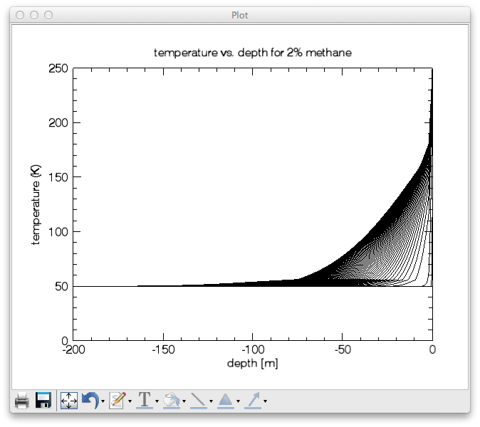
Figure 5.5: a profile of the temperature of the subsurface of Mars to a depth of 200 metres.
Upon inspecting figure 5.5 further, a kink in the lower temperature regions can be seen. The kink in the lower regions symbolises the point where methane ice undergoes sublimation: the lower part describes ice, whilst the higher describes sublimate. Methane travelling down the pores is condensed in the deeper layers thus raising the temperature there. The movement of the kink shows, in fact, the movement of the sublimation front in time.
As can be seen below, all three cases exhibit a kink in their graphs for the temperature profile of the Martian subsurface. It is postulated that this kink is due to the prevalence of methane in the concerning layers, thus meaning that the layers situated above the kink are deprived of methane. In other words, the kink described the location of a methane sublimation front within the subsurface.
For the three cases below, the position of the sublimation front that is described by the kink in the graph is at a depth of -70, -75, and -65 metres for methane concentrations of one per cent, two per cent, and five per cent, respectively. These values are further justified by the plotting of the density of methane versus the surface depth, as can be seen for these three cases in figure 5.7. Further zoom-ins of all cases are found in Appendix D.

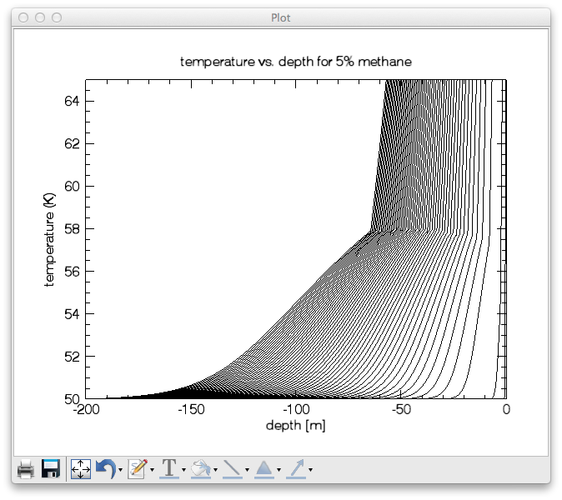
Figure 5.6: the comparison of three cases where each case describes the temperature profile of the subsurface layers for a different composition of the Martian subsurface. On the left is depicted the case of C03, for a methane concentration of 1%. In the middle there is the case of C01, for a concentration of 2%, and on the right, describing a methane concentration of 5%, there is the case C02. The movement of the sublimation front in time is also shown here. Comparisons are made in the text.

5.2 Evaluating the position of a sublimation front by comparing methane density
In another file, a record is kept of the amount of methane that is still present underneath the surface, relative to the initial ice density of 14 gcm⁻³. This quantity is called the density, and it is given in kilograms per cubic metre. Given below is an example of a chart where the methane density is given as a function of both time and layer depth. The case depicted is that of a methane concentration of two per cent, C01.

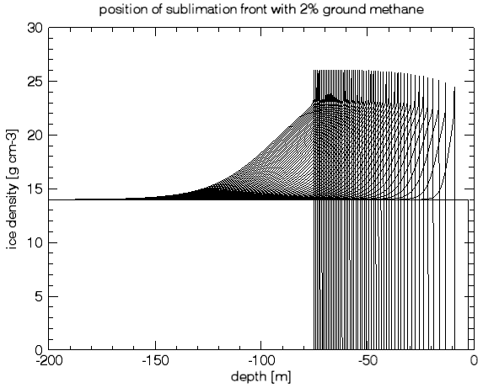
Ice density [gcm⁻³]
Figure 5.7: the amount of methane relative to the total amount of matter in a certain subsurface layer. For every moment in time, the maximum in the curve shows the first subsurface layer where methane ice can be found.
From figure 5.7, it can be said that the ice heaps up at around 75 metres after 55 orbits. The ice density increases as methane sublimate travels down the pores and condenses in deeper subsurface layers as a result of being sublimated. As the rest of the methane sublimate diffuses upward and into the atmosphere, it deprives that region of any methane, being depicted as a density of zero. Other cases are depicted in Appendix E.

5.3 Assessing the locality of sources by considering methane flux to the atmosphere
Now that the manner in which the results are interpreted has been explained, a choice needs to be made for evaluating the most likely set of parameters. As can be seen in Appendices C, D, and E (when comparing between graphs), the pore size is of minor influence to the position of the methane sublimation front, whereas the composition of the surface takes on an important role when it comes to describing the burial depth of ground ice deposits. The manner in which is decided what set of parameters is best used to describe the most probable location of solid methane on Mars, will now be discussed.

As per the introduction in chapter one, various measurements have been performed concerning the mixing values of methane in the Martian atmosphere. While there is a number of measurements and no two seem to settle on the same concentration, the sheer order of magnitude is something that all researchers have agreed on, being in the order of parts per billion. As stated by Atreya et al., 2006, this corresponds to a constant exhaust of methane gas of 4.1 grams per second.

The flux of methane gas through the surface and into the atmosphere is a quantity that is also documented by the BMST model’s programming. This yields the possibility to assess the various cases introduced in section 4.1 and find out what scenarios share the best resemblance to the various performed measurements of Mars’ atmospheric methane.
Given below is an example of such a chart with on the $x$-axis the simulated amount of time in millions of seconds, and on the $y$-axis the gas flux through the surface into the atmosphere in kgm⁻²s⁻¹. The case that is depicted is that of C01.
On the following page, a table is presented with the different values of methane flux at the concluding time value. In other words, the amount of methane that is released when the model has finished running is presented there.

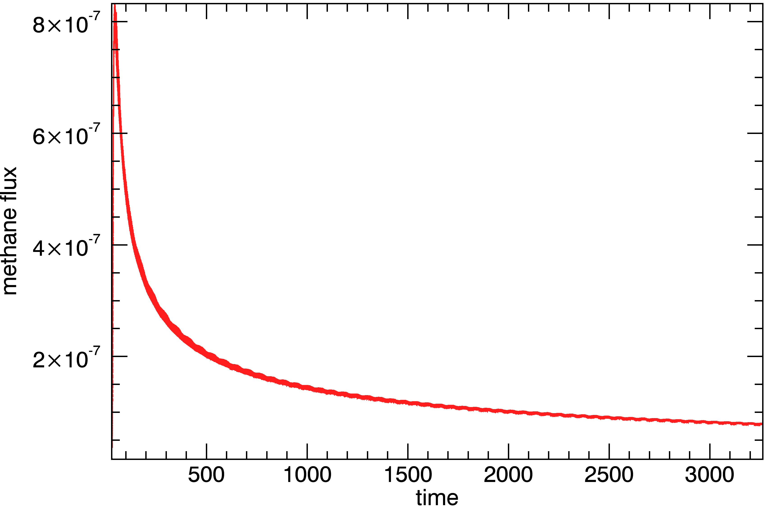
Figure 5.7: the methane flux through the surface and into the atmosphere as a function of time. The graph exhibits asymptotic behaviour, meaning that a state of equilibrium is reached. As a result, there is to be found a ground methane deposit at a certain depth, to be assessed for specific cases that show resemblance to on-site measurements. The initial high values are due to the fact that methane concentrations are initially high near the surface. As the sublimate escapes over time, the higher subsurface layers become depleted of methane. Graphs for other cases can be found in Appendix F.
Table 5.1 shows the results of the various simulations that have been performed, being the amount of methane that is diffused across the subsurface and into the atmosphere for every studied case, given in micrograms per square metre per second. Further on, these values will be translated to a total mass flux of methane that is to be compared to the performed measurements with respect to atmospheric methane by Atreya et al., 2006. The values shown in the table are those of the simulations after 55 orbits.

Table 5.1: outgoing methane flux as a function of various geothermophysical parameters
Case | $Φ_{{CH}_{4}}$ [$μ$gm⁻²s⁻¹] | Case | $Φ_{{CH}_{4}}$ [$μ$gm⁻²s⁻¹] | Case | $Φ_{{CH}_{4}}$ [$μ$gm⁻²s⁻¹]
C01 | 168 | P22 | 489 | H31 | 160
C02 | 367 | P23 | 149 | H32 | 349
C03 | 77 | P31 | 208 | H33 | 88
C04 | 305 | P32 | 436 | H41 | 162
C05 | 240 | P33 | 121 | H42 | 352
C06 | 272 | P41 | 160 | H43 | 89
C07 | 335 | P42 | 351 | H51 | 165
C08 | 133 | P43 | 88 | H52 | 374
C09 | 206 | P51 | 195 | H53 | 98
C10 | 53 | P52 | 406 | H61 | 176
P11 | 145 | P53 | 117 | H62 | 343
P12 | 321 | H21 | 155 | H63 | 88
P13 | 89 | H22 | 337 | L11 | 170
P21 | 321 | H23 | 87 | L21 | 171
L31 | 168
L41 | 163

The various cases that have been examined allow for an analysis of methane flux as a function of various parameters: subsurface composition, pore size, thermal conductivity, and latitude. With the information provided by tables 4.1 and 5.1, a number of charts can be composed where the influence of these parameters to the methane flux is shown. Figures 5.8 through 5.11 depict these relations.

Given the outcomes of the various simulations, the locality of methane deposits can be assumed by taking the order of magnitude of what is released according to the model, and comparing this to the measured amount as per Atreya et al., 2006. This accounts for a locality of about 25000 square metres for methane sources, or 0.025 square kilometres. In the table below, the expected amount of gas flowing out of the surface is given and compared to the above-mentioned result, which is set at four grams per second.
Whilst assuming that after 55 orbits a locality of 25000 m² can be assumed for methane deposits, it must also be said that if the model were to run for longer periods of time in the order of a thousand orbits, a different locality would have to be assumed, leading to different results.

Table 5.2: plausibility testing of various scenarios according to the comparison of hypothesised and measured values for the amount of atmospheric methane gas, with a literature value of four grams of methane per second on the entire planet
Case | C01 | C02 | C03 | C04 | C05 | C06 | C07 | C08 | C09 | C10
Flux [gs⁻¹] | 4.2 | 9.2 | 1.9 | 7.6 | 6.0 | 6.8 | 8.4 | 3.3 | 5.2 | 1.3
Case | P11 | P12 | P13 | P21 | P22 | P23 | P31 | P32 | P33 | P41
Flux [gs⁻¹] | 3.6 | 8.0 | 2.2 | 2.3 | 12.2 | 3.7 | 5.2 | 10.9 | 3.0 | 4.0
Case | P42 | P43 | P51 | P52 | P53 | H21 | H22 | H23 | H31 | H32
Flux [gs⁻¹] | 8.8 | 2.2 | 4.9 | 10.2 | 2.9 | 3.9 | 8.4 | 2.2 | 4.0 | 8.7
Case | H33 | H41 | H42 | H43 | H51 | H52 | H53 | H61 | H62 | H63
Flux [gs⁻¹] | 2.2 | 4.1 | 8.8 | 2.2 | 4.1 | 9.4 | 2.5 | 4.2 | 8.6 | 2.2
Case | L11 | L21 | L31 | L41
Flux [gs⁻¹] | 4.2 | 4.3 | 4.2 | 4.1

From the calculations above, it can be said that the main contender for a suitable scenario in composition is such where the Martian subsurface contains about two per cent methane. The other parameters cannot yet clearly be separated, but a number of simulations combining the different parameters will show what set of conditions best suits the scenario as stated above.

5.4 Methane flux as a function of composition, conductivity, and pore size
The influence of methane levels within the subsurface with respect to the amount of methane that is released into the atmosphere can be seen in fig. 5.8, where the concentration of methane within the subsurface (an initial condition) is plotted against the amount of methane that flows out of the subsurface at the end of the simulation. A linear regression analysis was performed over this series of simulations, resulting in a formula that describes the methane flux as a function of the methane mixing value.

Figure 5.8: a linear relation has been assumed for the dependence of methane flux with respect to the amount of methane that has been postulated to exist within the subsurface. Ten different cases have been evaluated, resulting in a series of ten data points.
Displayed in fig. 5.8, the methane flux is proportional to the methane concentration within the subsurface by means of a linear relation,

$Φ_{CH_{4}}=77×[{CH}_{4}]$, [5.1]

where $Φ_{{CH}_{4}}$ the flux of methane into the atmosphere [$μ$gm⁻²s⁻¹],
$[CH_{4}]$ the initial subsurface methane concentration [%].

The influence of the pore size with respect to the methane flux is hypothesised as follows: for small pores, methane flow will be lower since less of the sublimated methane molecules are able to diffuse across the subsurface at the same time, so there is a limited flux. Should the pores be smaller in size, this problem is averted. Should the pores be too small, however, the methane molecules could also start diffusing down the pores, and condensate further into the subsurface, as has been stated before in section 5.1.

A number of simulations has been performed where the pore radius was set as a variable with respect to the methane flux. The result of these case studies can be seen in figure 5.9. For three different methane concentrations, a number of six cases have been simulated with a different pore size. The pore size of standard conditions was set to be 1 mm, and cases have been studied for both larger and smaller pores in order to draw conclusions about the aforementioned hypotheses. As can be seen below, the methane flux has been found proportional to the square root of the pore radius. The simulations for a methane concentration of one per cent show a lot of noise, however, and should be ignored until further studies have been performed with respect to intermediate pore radii.

$\sqrt{r_{p}}$ [mm^{1/2}]
Figure 5.9: Two series of simulations with respect to the pore size produced a viable result, that is to say a result with which a distinct conclusion could be made. For these series, being the ones with methane concentrations of two per cent and five per cent, a linear regression analysis has been performed where the square root of the pore radius has been said to be proportional to the methane flux.
For the methane flux out from the subsurface and into the atmosphere, a relation has been shown to exist with respect to the pore radius. Further research concerning intermediate methane concentrations should show the influence of both methane concentration and pore radius to the outflow of methane on Mars.

A third series of simulations was meant to focus on the influence of thermal conductivity to the methane flux into the atmosphere by means of the Hertz factor for contact area in between particles. In theory, a higher thermal conductivity would yield more energy in order for the methane ice to sublimate. On the other hand, a lower thermal conductivity would result in a decline in the sublimation rate of the methane and in turn having a negative effect on the methane flux.

Three different methane concentrations have been evaluated for various values for the Hertz factor. In fig. 5.10, it can be seen that the Hertz factor is not of influence to the flow of methane across the subsurface and into the atmosphere for the assumed cases. This is verified for all three different methane compositions, where a set of six simulations has been performed. Whilst there are minor variations to be seen in the methane flux as a function of the Hertz factor, it should be emphasised that these values fall within the standard deviation of the simulated variables, thus ruling out the effect of the Hertz factor on the methane flow.

Figure 5.10: Three series of simulations with respect to methane concentrations in the subsurface show that there is not a significant change to be seen in the methane flux with respect to the Hertz factor for contact area between particles. As a result, it may be said that the thermal conductivity of the particles is not of an influence to the methane flow into the atmosphere.
Given the conclusion that the thermal conductivity by means of the Hertz factor is not of an influence to the methane flow, it raises the question if the outcome is sensitive to differences in porosity or silicate thermal conductivity, which are both of them properties of which the thermal conductivity of the substrate depends as per eq. 2.1.5. Further study of this subject should show the relation between these properties and methane flux out of the surface and into the atmosphere.

Finally, a series of simulations has been performed where the latitude of the occurrences is varied between taking place at the Martian equator, and close to the polar caps. This set of case studies has been performed in order to answer the question of where the methane sources are most likely to be found over the planetary surface. So, at the end of this analysis, something can be said about both the burial depth of the subsurface methane, and of the probability of locating them at any surface point along the polar axis. Of course, this is given a simplified assumption that there are no altitude differences along the polar axis, and that the subsurface is homogenously distributed with respect to dust, water ice, and methane ice.

Displayed in fig. 5.11 is the result of the case study with respect to the latitude of the simulation along the Martian polar axis. Note that the differences are minor compared to the other series that have been examined, but also note that a relation can indeed be found between the location of the simulation and the methane flux. It should be noted that, although the expectation that temperatures would be higher along the equator, seasonal changes may have affected the values that are shown below.

Figure 5.11: In this chart, the methane flux has been plotted as a function of the latitude where the simulation has been said to take place. The latitude is of an influence to both annual as diurnal cycles, so it is to be expected that some differences occur with respect to methane gas flux. However, the differences are minor in comparison with the other graphs that have been discussed above.

As a conclusion to all of the above-mentioned cases, the methane flux depends greatly on the amount of methane that is prevalent in the subsurface, as is to be expected. The size of the porous canals is of some influence also, whilst the Hertz factor for contact area, partly defining the thermal conductivity, showed not to be of an influence. The amount of methane that is released into the atmosphere appears to be greatest at the latitude of forty degrees, being about halfway up between the Martian equator and the Martian North Pole.

6. Observing methane sources on Mars: linear trends
It is of importance that the results that have been found be evaluated further in order to assess the possibility of there being stable methane deposits in the Martian subsurface. In order to do this, linear trends are made from the gas flux from the surface into the atmosphere and a half-value time is presented for every case. In this way, there should be something to say about whether or not stable ground ice deposits exist on Mars.

Figure 5.7 exhibits a curve that appears to end in a linear relation that describes the methane flux over the years. Shown below is a zoomed-in version of figure 5.7 that shows the linear relation in a clearer manner. 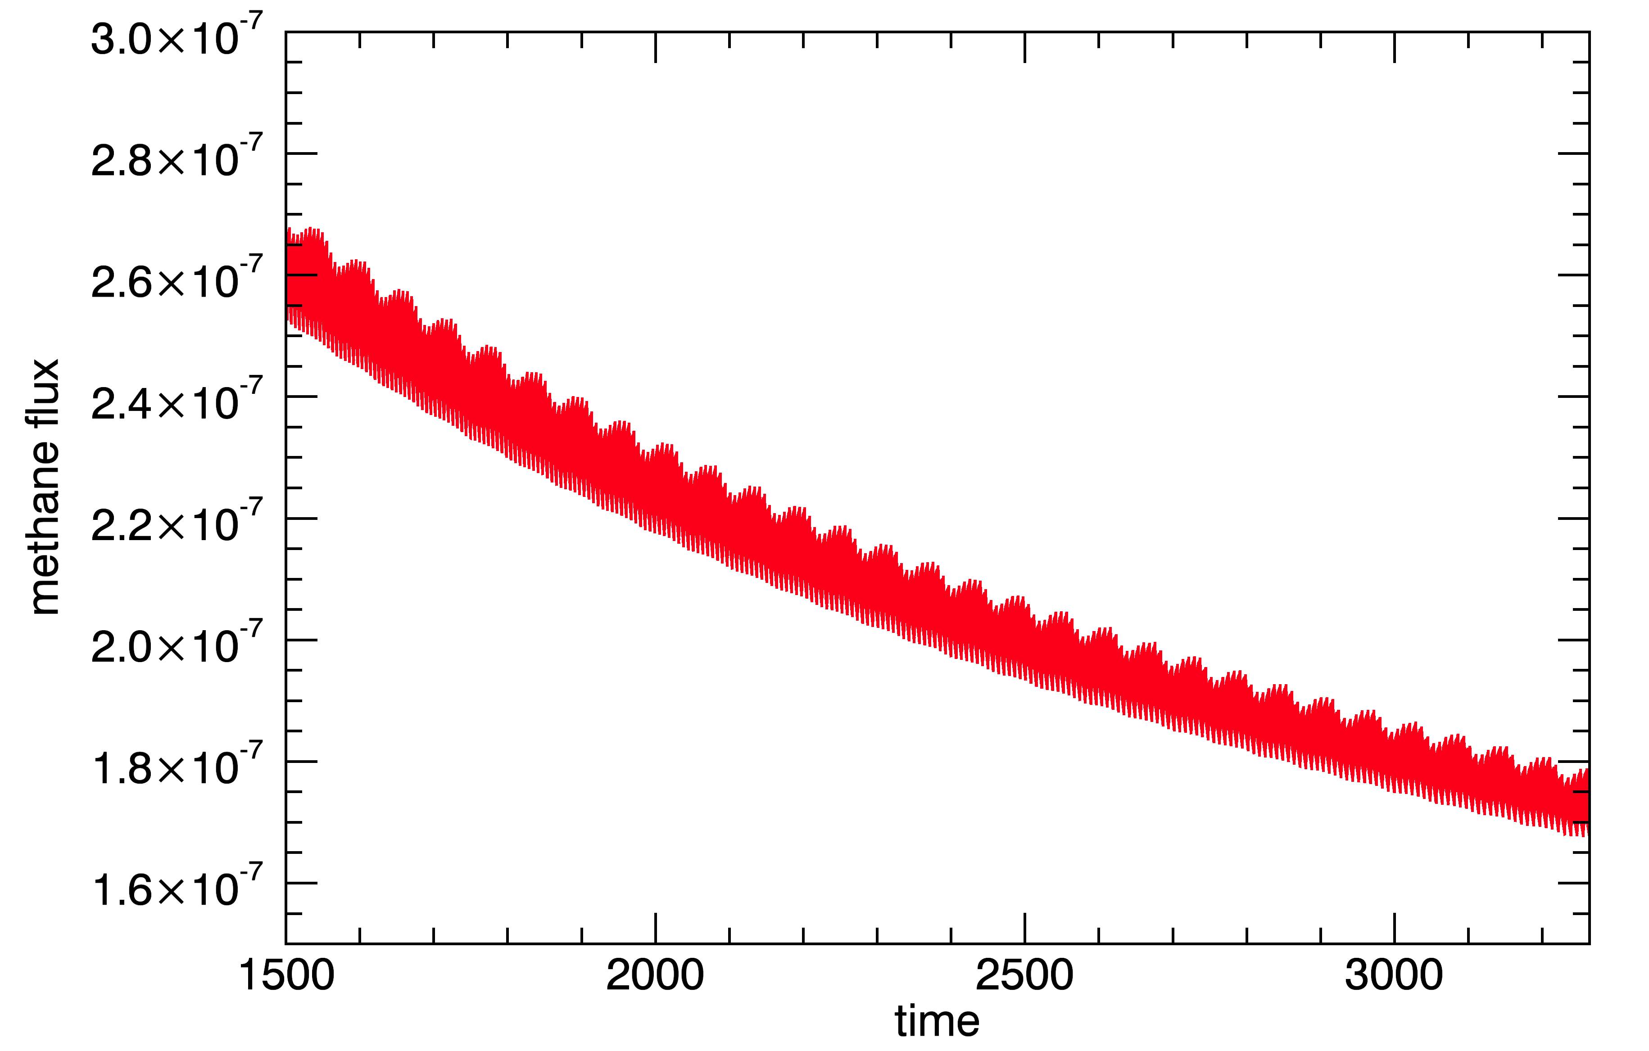
Methane flux [kgm⁻²s⁻¹]

Time [Ms]

Figure 6.1: the equilibrium-nearing methane exhaust is evaluated by means of a linear regression in order to be able to process the stability of the methane deposit over longer (geological) periods of time. A slope can be defined, and the time until a change in order of magnitude can be computed. Orbital influences can clearly be seen in this graph for case C01.
Linear regression allows for a conclusion concerning the long-time stability of the methane deposits: a slope number is found for the relation and a drop in order of magnitude is processed with a linear formula. The output of the formula is the amount of time until the next order of magnitude is reached. For the specific case that is discussed, being case C01, the slope number is equal to -3$×{10}^{-11}$, resulting in a line describing the formula $Φ_{CH_{4}}=-3 × {10}^{-11} × t+3 × {10}^{-7}$.
This formula can then be evaluated for a flux value of 10⁻⁸, yielding a value for the amount of time of 6,679 Ms, thus meaning that it takes about two hundred years for the methane flux to drop an order of magnitude. The other cases confirm this number, as can be seen in Appendix H, and in the table overleaf. Two hundred years is not a very long time in geology, leading to believe that the methane is synthesised rather than released from an underground deposit.
The interval over which linear regression analysis takes place is a short one, being the final one thousand measurements of the simulation. This is done because there is no certainty of a thermodynamic equilibrium before the end of the simulation has been reached.
Figure 6.2: linear regression of the last 10,000 values for case C01 shows that the slope number for the methane flux over time equals -3$×10^{-11}$, resulting in a time span of about two hundred years before the flux has dropped by an order of magnitude. Plots for other cases are displayed in Appendix G.
The values for the slope number of the various cases that have been examined are displayed in table 6.1. Also shown in this table is the time it takes for the methane flux to drop by an order of magnitude.

Table 6.1: results of linear regression analysis with respect to methane deposit stability over time
Case | C01 | C02 | C03 | C04 | C05 | H21 | H22 | H23 | P11 | P12
$a$ [10⁻¹¹ kgm⁻²s⁻²] | -3 | -7 | -1 | -6 | -5 | -3 | -4 | -1 | -3 | -5
$b$ [10⁻⁷ kgm⁻²s⁻¹] | 3 | 6 | 1 | 5 | 4 | 2 | 5 | 1 | 2 | 5
$t(Φ=1×{10}^{-8})$ , [Gs] | 9.7 | 8.4 | 9.0 | 8.2 | 7.8 | 6.3 | 12 | 9.0 | 6.3 | 9.8
Case | P13 | P21 | P22 | P23 | L11 | L21 | L31 | L41
$a$ [10⁻¹¹ kgm⁻²s⁻²] | -2 | -4 | -9 | -3 | -3 | -3 | -2 | -2
$b$ [10⁻⁷ kgm⁻²s⁻¹] | 1 | 4 | 8 | 2 | 3 | 3 | 2 | 2
$t(Φ=1×{10}^{-8})$ , [Gs] | 4.5 | 7.8 | 8.8 | 6.3 | 9.7 | 9.7 | 9.5 | 9.5

7. Assessing methane clathrate formation from water data
Until now, the assumption has been made that methane deposits that present themselves in the Martian subsurface present themselves as basins of methane ice, isolated from other ices. However, it is possible that methane molecules are trapped in a lattice of ice crystals. Such structures are known as clathrate hydrates and are known to form under certain temperatures or pressures. Methane hydrates are formed in the chemical structure of $\left({CH}_{4}⋅5.75 H_{2}O\right)$, meaning that for 5.75 mole of water, one mole of methane is trapped. When the water ice that makes up the clathrate lattice sublimates or melts, the methane vapour is released. It should be said that a homogenous structure is by no means assumed: the amount of methane is set to be much less than the amount of water. [10]

To assess the influence or prevalence of clathrate hydrates, the prevalence of water in the subsurface layers is studied in the various simulations that have been performed. Figure 7.1, below, depicts the water sublimation front as a function of both time and subsurface layer depth, as has been performed before in section 5.2.
Ice density [kgm⁻³]
Figure 7.1: the prevalence of water ice as a function of time. The density is given in kilograms per cubed metre, and progress in time can be seen from left to right as the amount of water ice near the surface becomes zero, as it is sublimated. Graphs for other cases can be found in Appendix H.
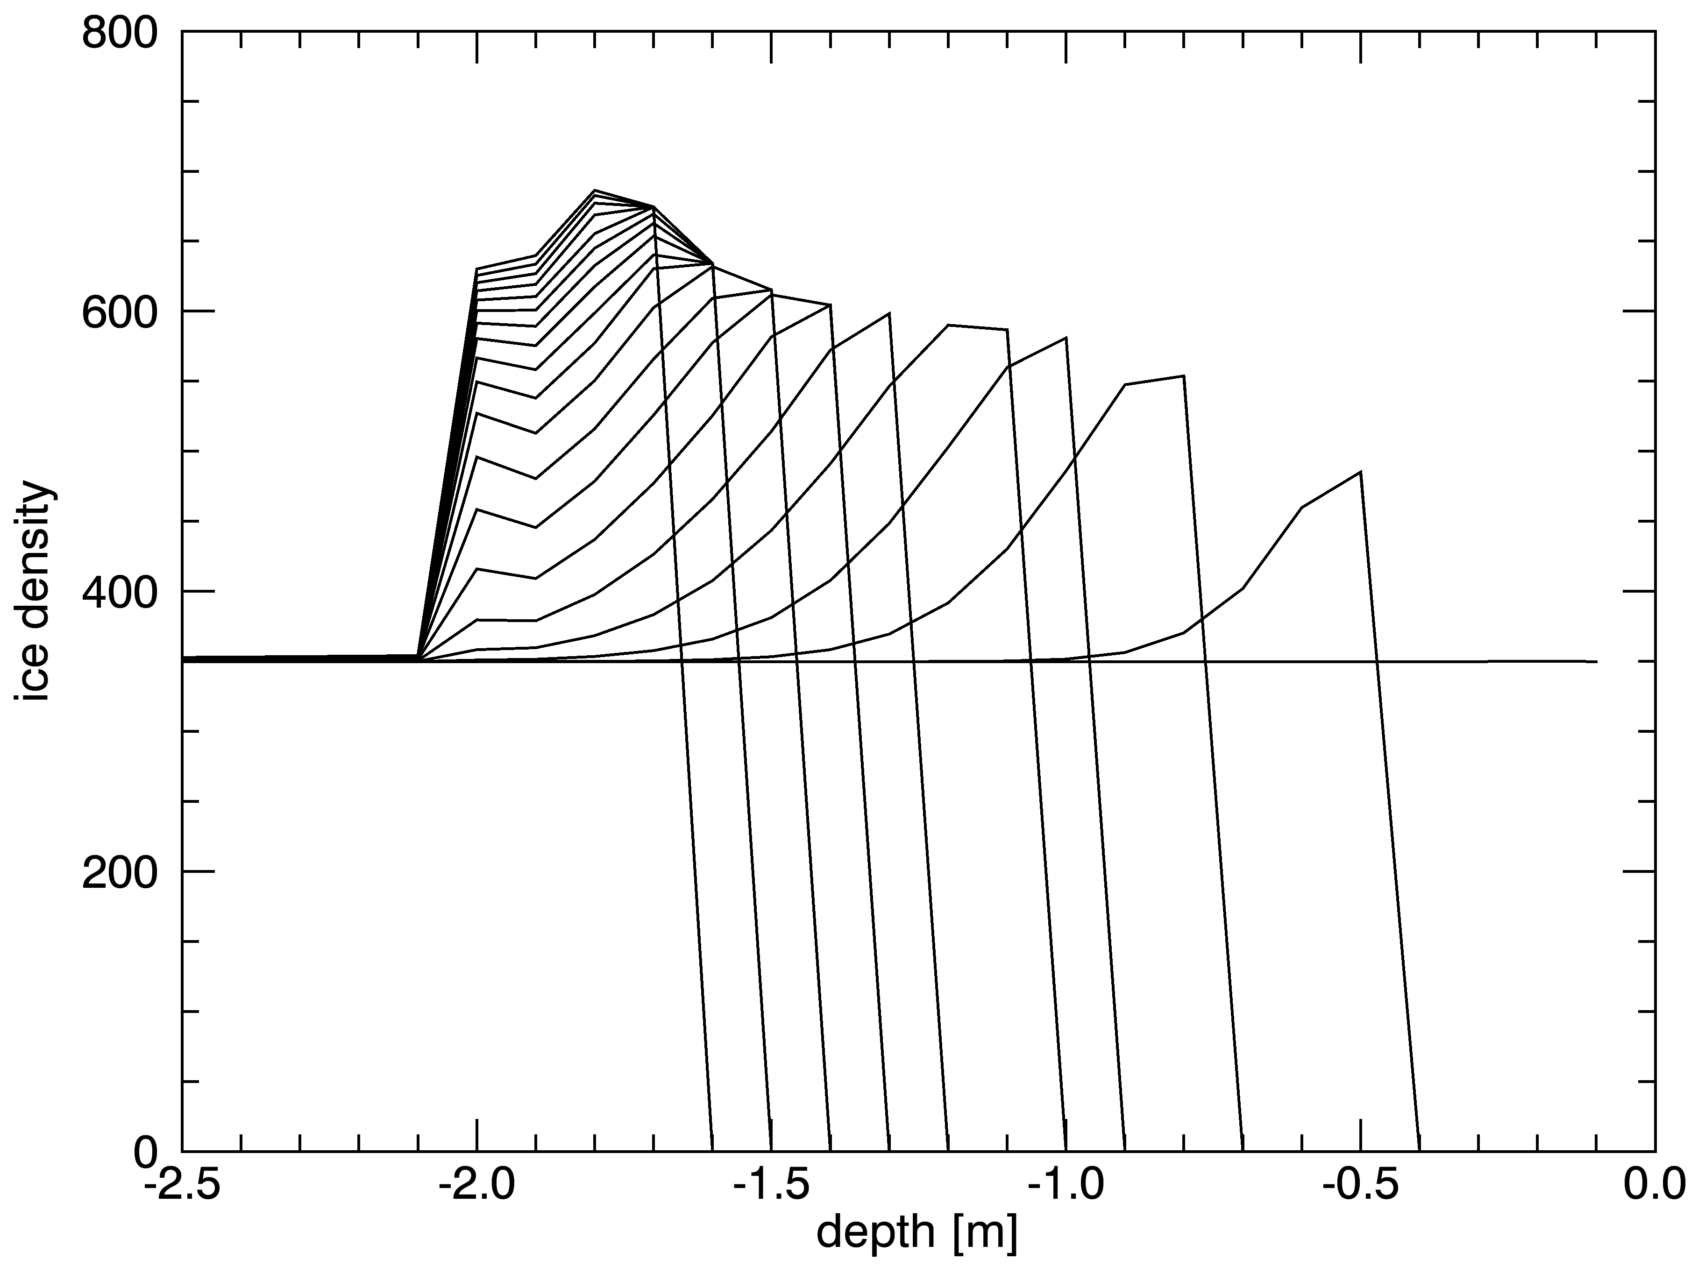
Notice how the sublimation front for water ice is positioned only slightly below the surface, whilst methane ice is not found in the near surface layers. This can be explained by the latent heat necessary for the sublimation of the two ices: where for methane, this value equals 9.7 kJmol⁻¹ (according to Chickos and Acree, 2002), for water, this value is 46.7 kJmol⁻¹, meaning that water ice is more stable than methane ice, thus water ice may be found closer to the surface than methane ice.
It is also interesting to consider the flux of water vapour into the Martian atmosphere: this value should be compared to the methane gas flux over time to assess the prevalence of methane clathrate hydrates in the subsurface layers. Since water ice that is sublimated or molten releases any methane that is trapped within, a correlation between water vapour flux and methane gas flux would indicate that at least some of the methane within the subsurface could be assumed to present itself in a clathrate hydrate form. The figure below depicts the water vapour density over time for case C01. Further plots for other cases can be found in Appendix I.

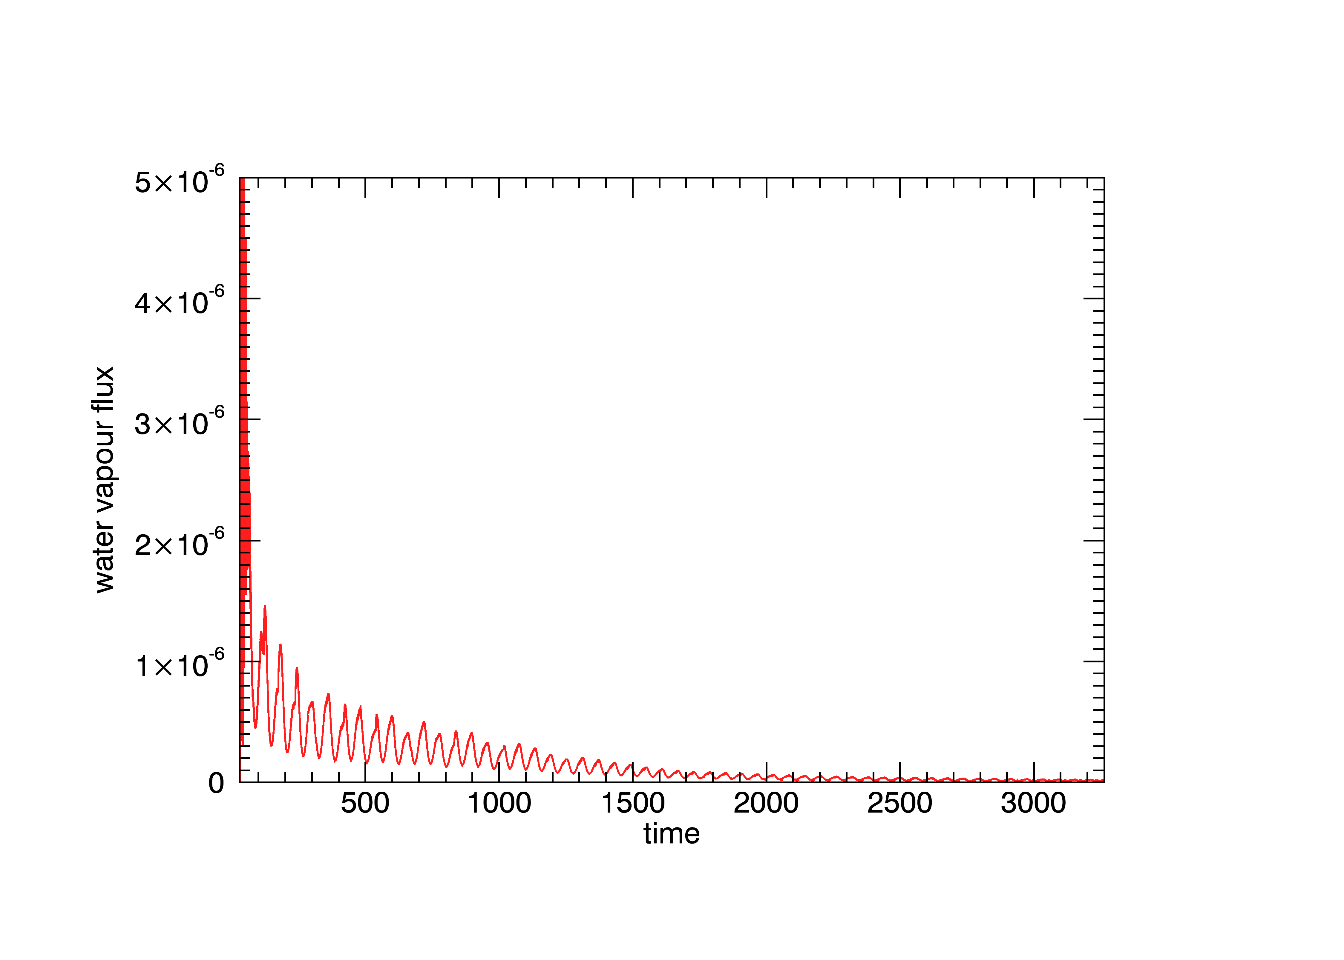
Water flux [kgm⁻²s⁻¹]
Time [Ms]

Figure 7.2: the outgoing water vapour as a function of time. Water vapour flux is given in units of kilograms per squared metre per second, whilst time is given in units of millions of seconds. Upon comparing the methane flux and the water flux and computing the amount of particles by means of their respective molecular weights, the ratio between their numbers can be computed.
In order to assess the presence of methane clathrate hydrates, the ratio between the water vapour flux and the methane flux is considered. As stated previously, one mole of methane can be found in a clathrate hydrate lattice with 5.75 moles of water ice. The final water vapour flux and methane flux through the surface and into the atmosphere are $2.10×{10}^{-8}$ kgm⁻²s⁻², and $0.2×{10}^{-8}$ kgm⁻²s⁻¹, respectively. Since the flow rate for methane is lower than the flow rate for all the cases discussed before, it can be concluded that, whilst some of the subsurface methane could be bound in clathrate hydrates, certainly the most part isn’t, and is thus stored otherwise.

8. Conclusions and outlook

The goal of this research was to gain information concerning the origins of the atmospheric methane on Mars: methane was not expected to be prevalent in the atmosphere due to the constant barrage of the planet by UV radiation from the sun.
An assumption was made that methane deposits are prevalent in the subsurface of Mars alongside dust and water ice, and the Berlin Mars near Surface Thermal model was used to come to conclusions about the possibility of methane ice being prevalent on Mars, and the depths under the surface where it might be found.

Through a series of simulations using different parameters in the model, being subsurface composition with respect to methane percentage, thermal conductivity as a function of contact area (Hertz factor), and the size of the pores through which subsurface methane sublimate would diffuse up through the surface and into the atmosphere, the locality of methane sources on Mars has been assessed to an order of magnitude of 10⁴ squared metres. Furthermore, based on these simulations, one could assume that the subsurface at these sources holds about two per cent methane, given a comparison with a measured methane gas flux of 4 g/s. For simulations with such a subsurface composition, the burial depth of the methane ice has been found equal to 75 metres.
A fourth series of simulations where the latitude of observation was varied between zero degrees (Martian equator) and eighty degrees (close to the Martian north pole) has pointed out that methane ice is slightly more likely to be found in between the equator and the North Pole. This could, however, have been a seasonal effect.
Whilst the introduction of a larger surface area for the occurrence of methane sources gives a greater value for the gas flux after 50 orbits, methane would still not be stable over longer periods of time.

The study of various cases with different parameters also allowed for analysis to take place with respect to the methane flux as a function of these parameters: initial methane concentration within the subsurface, Hertz factor for contact area between particles, and the radius of the pores through which methane sublimate diffuses through the surface and into the atmosphere.
Initial subsurface composition turned out to be of the greatest influence on methane flux, resulting in a linear trend over ten simulations. Pore size, too, turned out to be of an influence to the methane flux, resulting in two series of simulations with useable data. These series, with differences in subsurface composition, showed that the methane flux is proportionate to the square root of the pore radius. A third series with a lower methane concentration was also evaluated, but this resulted only in a noisy relation that was not relevant for linear regression analysis.
Contrary to the expectations, the differences in Hertz factor showed no differences in methane flux. Other values that contribute to the thermal conductivity of the substrate have yet to be studied on their influence, being the porosity of the matrix and the thermal conductivity of the silicate particles.

By means of the decline of methane ice within the subsurface, the probability of methane ice deposits that are stable over geological time scales has been studied. Linear regression analysis has been performed on the methane flux through the subsurface and into the atmosphere over time, and it has been shown that the flux declines in an order of magnitude within two hundred years, destabilizing the possibility of long-time ice deposits.
Finally, the prevalence of methane clathrate hydrates has been researched. It has been found that the amount of methane trapped in the water is not high enough to support the theory that methane is stored in clathrate hydrates: some of the methane might well be, but surely not all of the methane is stored in such a way.

The goal of this study was to explain various measurements of atmospheric methane on Mars performed by the PFS instrument on-board the European Mars Express Mission and from ground based observations. It has been found that methane gas flux over the Martian surface decreases would still disappear within a time span of about 10,000 years. Therefore it is concluded that Methane is not stable over geological time scales and that the recent measurements can only be explained by a very recent excavation of a methane rich area close to the surface.

Further evaluation of intermediate scenarios should bring more clarity to the relation between the various parameters in the model, and continuing measurements of atmospheric methane on Mars should provide a more reliable literature value for the gas flux.

As a final note, it should be said that even though the NASA Curiosity rover has searched for atmospheric methane on Mars and found none. Taken our results into account it may not be a surprise at all. However, it has not yet had a possibility to make use of all of the various tools that are available to it, such as the enrichment cell.

References

[1] Heat and Gas Diffusion in Comet Nuclei
W. F. Huebner, J. Benkhoff
ISSI Scientific Report SR-004, August 2006
[2] Methane and related trace species on Mars
S. K. Atreya, P. R. Mahaffy, A-S. Wong
Planetary and Space Science 55, February 2006
[3] Detection of Methane in the Atmosphere of Mars
V. Formisano, S. Atreya, and T. Encrenaz
Science reports 306, December 2004
[4] Early Crustal Evolution Of Mars
F. Nimmo, K. Tanaka
Annual Review Of Earth And Planetary Sciences, 2004
[5] Digging deep for ice in Isidis Planitia – New constraints on subsurface volatile concentrations from thermal modeling
J. Helbert, J. Benkhoff
Planetary and Space Science, February 2006
[6] A new approach to assessing the burial depth of ground ice deposits and its application to proposed MER landing sites in Isidis Planitia
J. Helbert, J. Benkhoff
Journal of geophysical research, October 2003
[7] The Martian Surface: Composition, Mineralogy, and Physical Properties
J. F. Bell
Cambridge University press, 2008
[8] Understanding Materials Science: History, Properties, Applications
R. E. Hummel
Springer, August 2004
[9] Estimation of water-glass transition temperature based on hyperquenched glassy water experiments
V. Velikov, S. Borick, C. Angell
Science, 2001
[10] Direct Measurement Of Methane Hydrate Composition Along The Hydrate Equilibrium Boundary
S. Circone, S. Kirby, L. Stern
United States Geological Survey, March 2005
[11] Mars fact sheet
D. Williams
NASA, 2004

Acknowledgements
First and foremost, I would like to thank all of the teachers who have taught me over the years, be it at my High School, Blaise Pascal, in Spijkenisse, my University teachers at both Hogeschool Rotterdam and The Hague University, or my various internship coaches. I would like to thank Mr Johannes Benkhoff, for allowing me to work with him at the European Space Agency for a while; it has really shown me in what way science is evolving. From ESTEC, I would also like to give special thanks to Mr Olivier Witasse and the rest of the SRESM group for allowing me to work with them and letting me share their experiences. I give thanks also to Lauranne Fauvet who has included me in the Planck Conference and thus given me a very exclusive look behind the screens of the Agency.
My thanks go out especially to Mr Lodewijk Arntzen, who has provided me with guidance from within The Hague University when possible. I would also like to give thanks in advance to Mrs Marlia Vloemans and the other members of the committee to be announced, for they shall be present during my thesis defence. Not in the slightest is it that I give thanks to Mr Arjen Lock, my mentor from the University who has helped me along the way in any way he could. Special thanks are in order for Mr Swarts, Mr Van Der Houwen, Mr Van Woggelum, Mr Vellekoop, and Mr Van Yperen for teaching me the skills needed to conclude my educational processes, both theoretical and practical.
I also think thanks are in order to my loving family, who have always been supportive of me chasing my goals from the moment I decided upon studying physics. I could not have made it through the years of studying without your constant pushing me, and I thank you for it. I also thank my girlfriend Astrid for all the support she has given me during the years that I’ve known her.

The Planetary Fourier Spectrometer, an instrument mounted on Mars Express.
As per equation 2.1.5

