The future of cinematography

Name: Rewienkumar Sahibdin Class: ES4 – 4A
Student Nr: 09032118
Supervisor: W.B. van Dam
Hand in: 20 December 2012
School of European Studies
The Hague University of Applied Science

.

Executive summary
In the last few years, the phenomenon of piracy has grown tremendously, with special regards towards movies. In the past, a great number of film industries and other companies made huge losses or even went bankrupt. With the increasing interconnectedness of people, different networks have been developed to satisfy people with free materials such as software, games and movies. In the past it could already be seen that huge film concerns, such as Pathé in The Netherlands had to cope with film piracy. Therefore, this dissertation will focus on answering the following main question ‘“How would Pathé be able to make cinematography more attractive for customers, and at the same time, compete against film piracy”?
In this dissertation the phenomenon of film piracy will be applied to Pathé. This company is one of the biggest film concerns and distributors in The Netherlands. Currently, the situation of the company is stabilised. However, the fear is there that eventually cinematography would become a victim of the increasing amount of film piracy in The Netherlands. This dissertation, will therefore also focus on creating a marketing plan for Pathé. While creating the marketing plan, the internal as well as the external situation of the company will be outlined and discussed. The implementation of new strategies will be discussed in the last part of this report. Desk and field research was conducted in order to answer all the sub questions of the dissertation. Furthermore, a questionnaire as well as an interview have been performed to collect all the necessary information. Eventually all the information was gathered and processed within the contents of this dissertation.
The results of the questionnaire performed in this dissertation, were quite remarkable. The majority of respondents prefer downloading a movie more, than visiting the cinema. This group of respondents is also fully convinced, that the current prices of Pathé are too expensive. Therefore, making cinematography a little bit cheaper would eventually attract more customers.
Pathé is currently recognised as a market leader within the film industry. However, since other branches of the film industry had to cope with huge financial losses and even bankruptcy, the fear arises of eventually becoming a victim of film piracy. Therefore, Pathé has to become more competitive in order to safeguard their situation. The most essential strategy the company should implement, is becoming more price competitive. Pathé is indeed making a lot of profit. However, the profit eventually goes back to the own company. Therefore, in order to act more competitive, Pathé has to invest back in the customers, by investing in cost reductions. Furthermore, this dissertation will present more adjustments in Pathé’s system, in order to become more competitive. Cooperating with certain anti-piracy organisations will eventually benefit the company.

Table of contents

Executive summary 2
1.Introduction 6
Problem definition 6
2. Methodology 8
Research method 8
Abbreviations 9
Theoretical word use 9
Business models 9

3. Regarding piracy 11
3.1 Introduction 11
3.2 What is piracy 11
3.3 Digital audio piracy 11
3.4 Computer piracy 12
3.5 Video and movie piracy 12
3.6 Conclusion 13

4. Developing networks 14
4.1 Introduction 14
4.2 Tools for trading 14
4.3 Using Bit Torrent 15
4.4 The Pirate Bay 15
4.5 Legal issues 16
4.6 Conclusion 17

5. Development in The Netherlands 18
5.1 Introduction 18
5.2 In the early years 18
5.3 Developments in 2009-2011 19
5.4 Conclusion 19
6. The internal analyses 21
6.1 Introduction 21
6.2 Company description and history 21
6.3 Pathe in The Netherlands 22
6.4 Company’s vision 23
6.5 Mission 23
6.6 Culture 23

6.8 Current marketing mix 24
6.8.1 Product 24
6.8.2 Price 24
6.8.3 Place 25
6.8.4 Promotion 25
6.8.5 Current strategy of Pathe 25
6.8.6 Product availability 26
6.8.7 Finances 26
6.8.8 Website and application 27
6.9 Company’s strengths 27
6.9.1 Market leader 27
6.9.2 Wide variety of service 27
6.9.3 Brand name 27
6.9.4 Innovation 27
6.9.5 Uniqueness 28
6.10 Company’s weaknesses 28
6.10.1 Expensive costs 28
6.10.2 Focus on core business 28
6.10.3 Less people during week 28
6.10.4 Competitiveness of networking 28
6.11Conclusion 29
7. The external analyses 30
7.1 Introduction 30
7.2 Meso environment 30
7.3 Customer analyses 30
7.3.1 Target groups 30
7.3.2 Dutch cinematography market 30
7.3.3 Future prospects 32
7.3.4 Customer expectations 32
7.3.5 Customer care 33
7.4 Distribution analyses 33
7.4.1 Distribution chain 35
7.5 Industry analyses 35
7.5.1 Forces of Porter 35
7.5.2 Threats of new entrants 35
7.5.3 Power of the buyer 36
7.5.4 Power of the suppliers 36
7.5.5 Threat of substitute products 36
7.5.6 Competitive rivalry 36
7.6 Competitor analyses 37
7.6.1 movie uploaders 37
7.6.2 Wolff, JT, Cineworld and Utopolis 38
7.6.3 Independent film concerns 39
7.6.4 Home cinema 39
7.6.5 Product positioning 39
7.7 Macro environment 40
7.7.1 Introduction 40
7.7.2 Results of questionnaire 40
7.8 Conclusion 42

8. The Swot and Confrontation matrix 43
8.1 Strengths vs. opportunities 43
8.2 Strengths vs. threats 44
8.3 weakness vs. opportunities 44
8.4 Weakness vs. threats 44
9. New marketing mix strategy 45
9.1 Introduction 45
9.2 Product and service strategy 45
9.3 Price strategy 46
9.4 Place strategy 48
9.5 Promotion strategy 49
9.5.1 Advertising from a different angle 49
9.5.2 Cooperation with Brein 50
9.5.3 Securing distribution channel 50
9.5.4 Promotion of price competitiveness 50
10. Conclusions 51
11. Recommendation 54
Referencing 55
Appendix 58

1 Introduction

Nowadays, the internet has become a very important information sharing tool. Friends and families are able to share all their collected information on social media websites such as Twitter, Youtube and Facebook. With the increasing amount in the sharing of information, the occurrence of film piracy became a global phenomenon. Piracy is the unauthorised duplication of an original recording for commercial gain without the consent of the rights owner. Different network- applications and servers have been set up in order to provide people with different kinds of files and other materials such as music, software, games and music. Since different societies are so much connected with one another, all the information is again being shared to third parties. Therefore, piracy is recognised as a huge danger for a lot of companies and industries. This dissertation will mostly focus on film piracy, occurring in The Netherlands. In the past, different film concerns in The Netherlands had to deal with the problem of piracy in the film industry. Eventually, producers of movies and a huge number of cinemas made financial losses. Therefore, this report, will make a link between the occurrence of piracy, and apply the phenomenon to a specific film concern in the Netherlands.
The dissertation will be divided in two main parts. The first three chapters of the dissertation, will be mainly descriptive and serve as background information. In this part, the concept of piracy will be discussed as well as the situation of film piracy in The Netherlands. Eventually, the background information will form a foundation towards the second part. Chapter four till seven, which is the second part of the dissertation will discusses the actual marketing plan for Pathé. Pathé is one the biggest companies, active in the film industry and is therefore recognised as market leader in The Netherlands. Besides holding a huge share in the market, the company holds a lot of affiliates in different regions. However, with the increasing amount of download activity in the past years, the film industry fears the downfall of cinematography. People already recognise the advantages of downloading movies from for instance torrent websites. Downloading from a network such as ‘The Pirate Bay’, are for free of costs. Consequently, film concerns such as Pathé will have to become more competitive. The main objective of this thesis is to find out, how Pathé would be able to make cinematography more attractive towards customers, and at the same time compete against film piracy, in The Netherlands. Besides that, finding out which new strategies should be implemented in order to act more competitive, will also be relevant.
Problem definition
According to the official year report of the ‘Dutch Organisation for Cinema Operators’, Pathé was very successful in the last few years, with special regards to the increasing number of visitors. As explained previously, with a huge market share, the company was recognised as a market leader in The Netherlands. However, the chairman of this organisation is fully convinced, that the increasing amount of movie downloading will eventually have a profound negative effect towards the film industry. Pathé and a lot of other cinemas, already dealt with huge financial losses, because of film piracy in The Netherlands. Therefore, Pathé as well as the Dutch film industry fears of eventually becoming a victim of film piracy in The Netherlands. The symptoms can already be found in other branches of the film industry. A great number of film stores and DVD rental stores went bankrupt. Therefore, in order to prevent the situation of falling back in the previous situation where film piracy will become a market leader, Pathé needs to rectify as well as implement new strategies.
The main question:
“How would Pathé be able to make cinematography more attractive for customers, and at the same time, compete against film piracy”?
Sub questions:
- ‘What is the core problem of film piracy and how does it affect movie concerns’?
- ‘What is the situation of film piracy in The Netherlands’?
- ‘Which strategy is Pathé currently using in attracting customers’?
- ‘Who are the competitors of Pathé’?
- ‘Which new strategies should Pathé introduce, in order to be more competitive’?

2 Methodology

Desk and field research
In order to answer the main question as well as the sub questions in a systematic way, a lot of desk and field research have been conducted to provide all the necessary answers. In order to understand how desk and field research were performed, it is first relevant to understand these two definitions. Desk research involves the summary of existing research rather than primary research, where data is collected from, for example, research subjects or experiments. In this regard, reports, articles and specific websites on film piracy were consulted to answer the sub questions. Therefore, to get a solid image of the film industry as well as the phenomenon of film piracy, a lot of desk research was mainly conducted. The second type of research conducted in this dissertation was field research. Field research involves the collection of information outside of a laboratory or workplace setting. The approaches and methods used in field research varies across disciplines. Field research involves a range of well-defined, although variable, methods: informal interviews, direct observation, participation in the life of the group, collective discussions, analyses of personal documents produced within the group, self-analysis, results from activities undertaken off- or on-line, and life-histories.

Research method
The research method was divided in two important aspects: desk and field research. In the first three chapters of the dissertation, desk research was mainly conducted. Specific websites were consulted to gather all the information on concept of film piracy in the past. The second part of the dissertation, which was recognised as the actual marketing plan, desk research was also the prominent research method. The internet was used as a main source for desk research. In every chapter, desk research was therefore performed in order to collect all the information. After collecting all the information from different websites and articles, the information was processed. In this way, the answers on the sub questions were provided. The year report of the ‘Dutch Organisation for Cinema Operators, was a very important report to collect a lot of information on the present situation on Dutch cinematography. Several statistics were also used to get a better insight of film piracy. Figure 1, on the download activity in the first part of the dissertation was therefore an example of qualitative research. The website of Pathé was also important in collecting information of different categories. Most of the information was therefore collected from the website, and again processed in the dissertation.
The second research method was field research. A very essential aspect of field research was performing a questionnaire. First of all, an online questionnaire was created at the following website: www.thesistools.com, in order to gather specific information from a group of 75 people. After creating all the questions, the questionnaire was first send by email to students of The Hague University. Students were able to click on the link that would direct them to the actual questionnaire. In the email, it was requested to forward the questionnaire to friends, family, parents and other students. The results of this questionnaire could be found on the database of the website. The results were eventually processed in the dissertation. A copy of the questionnaire with all the full results can be found in the appendix. Furthermore, an interview became also an important aspect for field research. An interview was performed with the general manager of a Pathé affiliate in The Hague. The manager provided a lot of essential information on different topics. Specific questions were first created before the interview took place. Eventually, the findings of the interview were very essential in collecting information on the marketing plan. A short report with all the highlights of the interview, can be found in the appendix.

Abbreviations
- P2P: Peer to Peer
- IRC: Internet Relay Chat
- MPAA: The Motion Picture Association of America
- NVF: The Dutch Organisation for Film distributors
- NVB: The Dutch organisation for film operators

Theoretical word use
- Downloading: to receive data to a local system from a remote system.
- Uploading: transferring a file to or from another computer or network.
- Torrent: a computer file that contains metadata about the files to be shared.
- Piracy: unauthorized copies are made of music, movies and similar works.
- The Pirate Bay: a Swedish file-sharing website founded in 2003.
- Bit Torrent: used for distributing large amounts of data over the Internet.
- P2P: allowing shared access to various resources such as files.
- IRC: a protocol for real-time Internet text messaging.
- Income statement: financial statement that indicates how the revenue in transferred into the Nett income.

Usage of business models
Five forces of Porter model
This business model indicates the importance of power with a certain company. The model is briefly explained as follows:
- Threat of competition: Profitable markets that yield high returns will attract new firms. This results in many new entrants, which eventually will decrease profitability for all firms in the industry.
- Threat of substitute products: The existence of products outside of the realm of the common product boundaries increases the propensity of customers to switch to alternatives
- Bargaining power of customers: The bargaining power of customers is also described as the market of outputs: the ability of customers to put the firm under pressure, which also affects the customer's sensitivity to price changes.
- Bargaining power of suppliers: The bargaining power of suppliers is also described as the market of inputs. Suppliers of raw materials, components, labor, and services (such as expertise) to the firm can be a source of power over the firm, when there are few substitutes.
- Rivalry: For most industries, the intensity of competitive rivalry is the major determinant of the competitiveness of the industry
The market positioning map
In marketing, positioning is the process by which marketers try to create an image or identity in the minds of their target market for its product, brand, or organisation. In the case of Pathé, the focus is given towards quality and price.
SWOT model
a structured planning method used to evaluate the Strengths, Weaknesses, Opportunities, and Threats involved in a project or in a business venture.
The confrontation matrix
Within the confrontation matrix all the company’s Strengths, Weaknesses, Opportunities, and Threats are faced with one another. To objective is to determine the availability for a better strategy.
The filter model
The model was initially introduced by Michael Porter for making a specific selection of countries. This theory of filtering has been applied in this dissertation. First the concept is more or less broad presented. Throughout the dissertation, the concept of the dissertation becomes more specific by creating a marketing plan as well as introducing new strategies for further implementation.
3 Regarding piracy

3.1 Introduction
Throughout the years, the impact of piracy increased tremendously. Huge networks have been set up in order to provide people with the best quality of software, music, copied games and movies. Since people and communities are so much connected with each another, all the copied information is again being shared with others. Obviously, this will have a profound impact towards film concerns, DVD stores, movie rental stores, retailers and eventually the cinema. In this chapter the definition of piracy will be further outlined. Apart from that, the different types of piracy will be discussed. The impacts will also be briefly presented.

3.2 What is piracy
Piracy is the unauthorized duplication of an original recording for commercial gain without the consent of the rights owner. The packaging of pirate copies is different from the original. Pirate copies are often compilations, such as the ‘greatest hits’ of a specific artist, or a collection of a specific genre, such as dance tracks (“IMI,” n.d., p.1). The duplication or item can be identified as different files. Examples are: a video file, computer games, software or even hardware utilities. Piracy is nowadays considered as a crime which is categorised under the sections of ‘copyright violations’. Copyright is a legal concept, enacted by most governments, giving the creator of an original work exclusive rights to it, usually for a limited time. (“Copyright,” 2012, para.1). The occurrence of piracy can cause great danger to the movie and music industry. Original pieces of copyright are very expensive by nature. For example, an original soundtrack, online software or a DVD movie are more expensive to come by than downloading them from a torrent website. Nowadays, a lot of websites promote cheap downloading materials for people. Most of the time, the files are available for free. Therefore, piracy ultimately discourages the entertainment industry by rationalising their hard works (“The Gemini Geek ,” n.d., p.1). In the next following sections, an overview of different types of piracy will be outlined and discussed.

3.3 Digital audio piracy
This type of piracy is recognised in the biggest markets in developing Asian countries. MP3 or MP4 files are considered as a common business within these zones. Because of the lack of strict rules and regulations, a piracy ban is implemented in these areas of the world. Among other types of piracy, audio piracy is considered as the newest form of digital media piracy and became a widespread problem with the advent of affordable CD Burners. People who are active in this type of pirating, are able to steal the binary code of a completed audio CD. A binary code is a way of representing text or computer processor instructions by the use of the binary number system's two-binary digits 0 and 1 (“Binary code,” 2012, para.1). Eventually, this code was transformed into an exact duplicate of the original file. With the increasing popularity of computers, the same technology that is used to duplicate audio files, is now being used to copy and distribute pirated audio. Unreleased soundtracks can be available around the whole world in just a few minutes, satisfying at least some of the demand created for songs by record industry hype. (“Ed Cox,” n.d., p.3)

3.4 Computer piracy
In this section, the phenomenon of computer piracy will be discussed. The occurrence of computer piracy is also considered as a new and fast growing type of piracy. PC games and computer software are the main victims in this type of piracy. For instance, computer games are more expensive to come by because of the heavy entertainment duties provided towards consumers. However, pirated versions are available for a cheaper price than the original. Moreover, the pirated games provide the same pixels and graphical features as provided by original ones. Therefore, people are more inclined towards buying a copied version instead of the original one. This again will cause a negative impact for game stores and game concerns such as Sony, Microsoft and Nintendo. Another aspect of computer piracy is software piracy. Software cracks are available in markets all over the world. A software crack is a decoding program designed to allow system administrators to locate users who may have weak passwords vulnerable to a dictionary attack (“Crack,” 2012, para.1). Prices of computer software are also high. Only companies, organisations and other agencies are able to afford these high prices. Computer piracy will cause a great danger to software companies. Software cracks are already so much in use nowadays. Therefore, purchasing an original version of software or games could decrease drastically in the future. Eventually, this again will cause a great loss for multi international companies such as Norton and Microsoft who are dealing in software products.

3.5 Video and movie piracy
In this section, the occurrence of movie piracy will be discussed. Furthermore the impacts within this industry will also be presented. Movie piracy is ‘downloading, burning or otherwise obtaining a movie you did not purchase’ (“A digital media blog,” 2009, p.3). In the last few years, the issue of movie piracy, became a big issue. By simply making some backup copies of movies without the permission of the rightful owner, is already considered as film piracy. Stealing a certain print of a movie, burning a disc and resell it, or recording a movie while being present in the cinema are other more severe forms of movie piracy. Currently, internet movie piracy is considered as the most dangerous type of piracy. Apart from that, movie piracy is recognised as illegal under the copyright act. Downloading movies from the internet without the authorisation of copyright holders is a growing international phenomenon, and it has serious impacts. Simply downloading movies will cause a huge loss for movie and DVD concerns. This again will affect retailers and other companies that are dealing with movie selling, importing and exporting. Eventually, if all kinds of movies will be available for free on the internet, film concerns with special regards to cinemas, will recognise a huge decrease in customers in the future. Therefore, cinemas and other major film concerns, have to make a stronger effort in competing against internet movie piracy.

3.6 Conclusion
Piracy is now a global phenomenon. With the increasing interconnectedness of communities and society, people will continue sharing their information. The three famous types of piracy are known as: computer piracy, digital audio piracy and movie piracy. All the piracy types, have a profound impact on different kinds of industries such as the producers of games, music, software and music. Industries will make huge losses because of the increasing amount of copying and downloading from websites. How will they be able to compete against piracy? Therefore, producers and industries will have to implement new measures in their marketing plan, in order to improve their position in the market for the future.

4 Developing networks for piracy

4.1 Introduction
In the previous chapter, the different kinds of piracy have been discussed. The focus was mainly on three types of piracy, namely: digital audio-piracy, computer-piracy and movie-piracy. Furthermore, the impacts of each type of piracy have also briefly been outlined. This chapter will go more in debt into network systems that are currently developed to keep piracy going on. Throughout the years, a lot of websites have been created to provide all kinds materials for free, such as music, software and movies. In this chapter, the most popular networks available on the internet, will be explained.

4.2 Tools for trading
Movies are for most of the time transferred over the internet in different ways. The most famous types are IRC, Bit Torrent and P2P Networks. Internet Relay Chat (IRC) is a network system for real-time Internet text messaging or synchronous conferencing. It is especially created for group communication in chat forums, called channels, but also allows one-to-one communication via private message as well as chat and data transfer. Apart from this, all files are being shared within a certain channel (“Internet Relay Chat,” 2012, para. 1). By simply using an IRC network program, you are able to enter another person’s files in a one-to-one sharing scenario. Most of the time, one person would have the complete file that the other person is looking for (“A digital media blog,” 2009, p.7). These files are characterised by the following two aspects, namely: leechers and seeders. In computing and specifically Internet, a leech is one who takes advantage, usually on purpose, from other users, information or endeavour but does not give anything in return, or makes only token offerings in an attempt to avoid being called a leech. In economic terms, this type of behaviour is called ‘free riding’ (“Leech,” 2012, para.1).
The other aspect of the file is characterised by the name ‘seeder’. Seeders are the people who already downloaded the file and upload them in a certain website or server such as the well-known ‘Pirate Bay’ website. The more people seeding a file, the faster the download goes (“Yahoo Answers,” n.d., para. 1). Apart from the Internet Relay Chat network, Bit Torrent or P2P (peer-to-peer) is recognised as one of the most popular and mainstream method to download movies illegally. Peer-to-peer file sharing allows users to download internet files such as music, movies, software and games by using a peer-to-peer software program that searches for other computers that are connected with other systems. The ‘peers’ are computer networks connected to each other through the Internet. (“Peer to peer file sharing,” 2012, para.1). In the following sections, examples of some famous sharing networks such as Bit Torrent and The Pirate Bay will be presented.

4.3 Using Bit torrent
Bit Torrent is a network that supports the system of peer-to-peer file distributing and is used for exchanging large amounts of information over the Internet (“BitTorrent,” 2012, para.1). Bit Torrent is one of the most common protocols for exchanging large files. It has been estimated that, collectively, peer-to-peer networks have accounted for approximately 43% to 70% of all Internet traffic. According to Bit Torrent Inc., as of January 2012, Bit Torrent is being used by about 150 million users all over the world. Based on this information, the total number of monthly Bit Torrent users can be estimated at more than a quarter of a billion. On average, the website has more active users than other social media networks such as Twitter and Facebook. The following figure indicates the total number of uploads in 2009 and 2010.
Figure 1
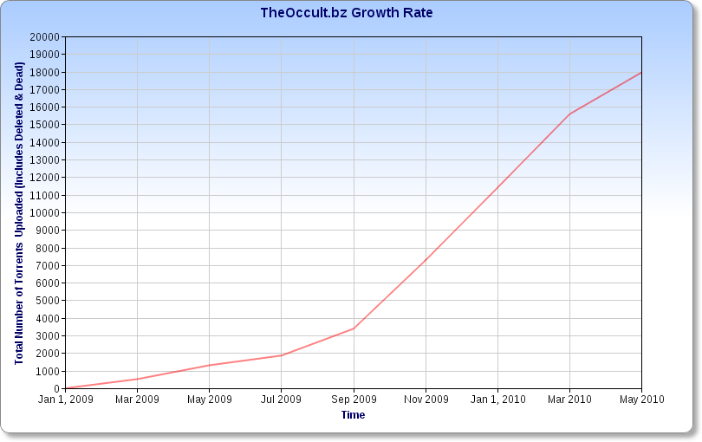
Total numbers of torrents uploaded in 2010
In figure 1, the total number of torrents uploaded is presented. Already in 2010, 18000 torrents were being shared.

Source: Torrent Invites

4.4 The pirate bay
Another famous example of a torrent website would be The Pirate Bay. In the last few years, the popularity of ‘The pirate Bay’ has grown tremendously among torrent users. The Pirate Bay is a Swedish file-sharing network established in 2003 that hosts magnet links and that bills itself as ’the most resilient Bit Torrent site of the world’. The Pirate Bay is currently positioned as the 74th most attended website in the world and 17th in Sweden. The server has over five million registered users and as of May 2012, it provides over more than four million torrent files. According to the Los Angeles Times, the Pirate Bay is ‘one of the world's biggest supporter of illegal downloading’ and ‘the most visible member of an international anti-copyright or pro-piracy organisation’(“The Pirate Bay,” 2012, para.1).The site's torrents offers a wide variety of content to be downloaded such as games, software, television shows, music and much more.
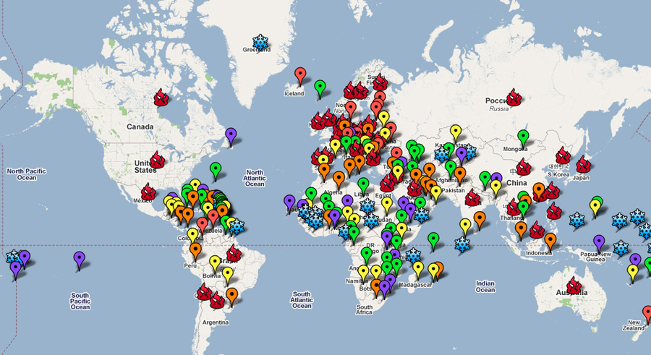
Figure 2 Downloading from The Pirate Bay in 2010
In figure 2, the red snow flame image indicates as very hot and a large number of users. The snowflakes are cold and therefore indicated as low.

Source: Bigofeature

4.5 Legal issues
There were a lot of conflicts over the usage of Bit Torrent files and The Pirate Bay. The biggest issue is still the fact that files are being copied without the permission of copyright holders. Different jurisdictions have pursued legal action against web-servers that provide many kinds of torrent files. Already in the last few years, well known torrent websites such as: Suprnova.org, TorrentSpy, LokiTorrent, BTJunkie, Mininova, Demonoid and Oink's Pink Palace were sued and closed down. The Pirate Bay torrent website, created by a Swedish group, is noted for the legal section of its website and replies on the topic of alleged copyright infringements, are publicly announced (“BitTorrent,” 2012, para. 80). On 31 May 2006, the providers of The Pirate Bay in Sweden were arrested by the Swedish police on assertions by the MPAA of copyright infringement. The Motion Picture Association of America (MPAA) is an American trade association that represents the six big Hollywood studios (“MPAA,” 2012, para.1). During extensive research, conducted by the NBC Universal, the NBC found out that most of the torrent files that were downloaded by people on the Bit Torrent network, violated copyright. From 2010 till 2012, about 200,000 people have therefore been prosecuted by copyright institutions for uploading and downloading copyrighted content by using Torrent. In 2011, nearly 19% of the internet traffic in North America was mainly used by P2P networks, which evens 132 billion music file transmission and 11 billion transmissions of movie files on the Bit Torrent server. Therefore, on April 30, 2012, the High Court in the United Kingdom ordered five prominent Internet Service Providers to block the website of The Pirate Bay and not support the ‘torrent file downloading’(“BitTorrent,” 2012, para. 85). An example would be internet provider ‘Ziggo’ in the Netherlands that blocked its users to access The Pirate Bay. Another well-known institution that is currently fighting against piracy, is the organisation ‘Brein’ in The Netherlands. Protecting movies, music, games and software in The Netherlands are their main concern.

4.6 Conclusion
Fighting against piracy still remains a big issue for producers and other companies. Throughout the years, many kinds of ‘sharing client systems’ have been introduced in the market to provide materials such as movies, software music etc. The most famous ones are the peer to peer networks, Internet Relay Chat system and the torrent file sharing. The files are characterised by so called seeders and leechers, to put a certain file collectively available. The popularity of torrent network sharing systems such as Bit Torrent and The Pirate Bay have grown tremendously in the last few years and is expected to develop further in the future. Many of these torrent search engines are in conflict with copyright law. Therefore, a lot of torrent websites were closed down in the past. The Pirate Bay still remains a special case, however, the search engine of this website has already been banned by the high court of the United Kingdom in some countries, in order to protect copyrights of movies and music. Other examples are Ziggo and Brein in The Netherlands. Strict legal measurements will have to be introduced against piracy.

5 development in The Netherlands

5.1 Introduction
The first part of the dissertation discussed the different types of piracy. The focus was given to computer, software, and digital audio piracy. The second part presented the various networking servers, promoting file sharing where users can download from. Furthermore, the current issues of file sharing were also discussed. This chapter will go deeper in the content of the dissertation by focussing on cinematography in The Netherlands. Developments in the past concerning cinematography will be briefly discussed. Obviously, movie piracy affected cinemas in different ways. In previous chapters, it was already mentioned that movie industries made huge losses because of piracy. However, what impact will it have towards Dutch cinematography in the future?

5.2 In the early years
In the year 2006 about 150 million movies were downloaded from different torrent servers. The total number of movies, accounted for at least eight million euro’s per month. These were mostly movies that just appeared on Dutch cinema or on DVD. Besides that, four million DVD’s that were burned were again sold with a total street value of approximately 24 million euro’s. With this happening, film piracy became a huge problem for Dutch Cinemas in this year. This was also confirmed by Mr Wilco Wolfers, who is the chairman of the Dutch Federation for Cinematography, during an official press release. He indicated the occurrence of ‘film piracy’ as the main reason for a decrease in visitors with 11,2 per cent. Another secondary reason was the lack of big success of the movies. From research that was conducted by the ‘Brein’ organisation in this year, it appeared that a certain group of hard-core movie-downloader’s was responsible for 100 million movie downloads in one year. This group consisted of mostly students from high school and university, with an age of 12 – 29 years old. In this year, The Netherlands was one of the countries in the world with the topmost broadband connections without data limitation. ("NRC Archief," 2010, p. D1)
This made movie downloading more or less easy for people. Another issue was the fact that people simply shared their files with friends and family, after downloading them. A lot of jobs were on stake, such as screenwriters, program-makers, employees in movie stores and DVD rental stores (“ProfNews,” 2006, p.1). In 2007 and 2008, film piracy caused a lot of damage to the cinemas. According to the Dutch Federation for Cinematography, the total loss for the movie and DVD branch was 153 million euro’s. These were loss revenues within this sector. The main issue was the occurrence of ‘cam recording’. Visitors that were present in film-rooms were making recording of movies with their own camera. The total amount of visitors got stabilised. There were 22 million visitors in 2007. Apart from that, there was also a small increase in the market share for Dutch movie Titles.

5.3 developments in 2009 – 2011
The issue with cam recording in cinemas continued in 2009. Measures were taken in order to protect the cinema from film piracy. A nigh-watch device was introduced for cinemas that were dealing with the problem of cam recording. The night-watch device was mainly used for inspection purposes. Some employees in cinemas obtained the device and checked whether everything went according to plan during a movie. However, a lot of visitors did not felt comfortable during a movie. Therefore, a decrease in the total number of visitors in cinemas was recognised. Furthermore, around 2009 till 2010, a huge number of DVD rental stores closed down, for they could not cope with film piracy. Dutch video companies like Ster and Videoland had to close down their affiliates. Both companies were not able to produce more customers (“Future of copyright,” 2009, p.1). The image of the cinema became more stabilised since more visitors were recognised in 2010 and in 2011. Cinema became a an important aspect of entertainment for individuals. People with low and high incomes, male and females, young and old and higher or lower educated, visited the cinema. This was 54 per cent of the Dutch people that visited the cinema in this year.
A new target group became important. These were people in the age of 55 years old. However, the movie industries worried about the huge decrease of young people that visited the cinema. Especially visitors in the age of 16 - 17 years. In 2010, 88 % were people in the age of 16 or 17 years old. In 2011, this was about 64 % (“Filmonderzoek,” 2012, p.4). A very important reason for the decrease in this age group would apparently be the increasing file sharing activity and DVD piracy among students in schools and universities. Since students are so much connected with each other, they share a lot of information on social media such as YouTube, Twitter and Facebook. All in all, the image of Dutch cinemas continued to stabilise. However, movie piracy is still growing. What will happen to film concerns and cinemas in the next five to ten years? It is already a fact that film piracy will certainly continue in the future and people will not stop sharing information with each other.

5.4 Conclusion
In the past, there were a lot of issues concerning cinematography in The Netherlands. Movie piracy was the biggest problem for the Dutch movie industry. The impact of broadband connection without data limitation caused a huge loss for movie producers as well as for cinemas. Another problem was the usage of cam recording in Dutch cinemas. The film industry in The Netherlands got more or less stabilised in the last few years. However, a huge decrease was recognised for an important target group. These were visitors, probably students, in the age of 16 and 17 years old. Since this target group is so much connected with downloading and sharing, it is expected that this phenomenon of ‘sharing information’ will certainly continue in the future. The important question here would be: ‘Will history repeat itself?’. A great number of DVD rental stores, in different provinces in The Netherlands, already closed down, for they are not able to compete with the increasing amount of film piracy. The second victim-group were the DVD stores. If customers will not pay for their DVDs and rather download the movie from a torrent site, DVD stores will make a huge loss in revenues. Jobs in stores will eventually disappear. Will Dutch cinemas also become a victim of movie piracy? The risks are there. Therefore, in the future, cinemas like ‘Pathe’ will have to make cinematography in The Netherlands more appealing and attractive towards customers, and at the same time, compete against piracy.

6 The internal analyses

6.1 Introduction

After using the filter model, and filtering the concept of the dissertation from a broad perspective into a specific concept with special regards to Pathé The Netherlands, the actual marketing strategy plan will be created. The company ‘Pathe’ will be presented and outlined in this chapter and in the following chapters. In this chapter, the focus will be given on the internal analyses of the company. Here, the internal factors, influencing the company will be discussed. First, a description of Pathé will be given, followed by the companies vision and mission. Afterwards, the current market mix of the company will be discussed. Finally, the company’s internal strengths and weaknesses will be outlined.

6.2 Company’s description and history

Pathé or Pathé Frères is the name of a French company, founded and originally run by the Pathé Brothers of France from 1896. In the beginning of the 1900s, the company became the biggest movie equipment and production company in the world, as well as a major producer of phonograph records. In 1908, Pathé introduced the newsreel that was presented in theatres, prior to a feature film. The company was initially founded by the following four brothers: Charles, Émile, Théophile and Jacques Pathé (“Pathe,” 2012, para.2). The most prominent person behind the film operation was brother Charles Pathé, who helped to open a gramophone shop in the year 1894. Afterwards, he established a phonograph business at Chatou on the western part of Paris. As the business became very successful, Pathé saw the advantages offered by new means of entertainment. After deciding to expand the record business by including the film equipment, Charles Pathé oversaw the quick expansion of the company. (“Pathe,” 2012, para.3). In order to finance the business, Charles Pathé gave the company the following name: ‘Compagnie Générale des Établissements’ (“Pathe,” 2012, para.2). The share of the business was listed in the stock market in Paris. In 1902, Pathé asked the Lumière brothers to implement the new design, and to improve the studio camera in the business. Besides that, the company introduced their own stock in film. Their technological advanced equipment, allowed them to gain a major part in the international market. In 1909, Pathé introduced more than 200 movie theatres in France and Belgium. The year after that, they had new locations in Madrid, Moscow, Rome and New York City plus Australia and Japan (“Pathe,” 2012, para.3). Before the outbreak of World War I, Pathé dominated Europe's market in motion picture cameras and projectors. It has been estimated that once, 60 per cent of all movies, were taken with Pathé equipment. In the next following years, Pathé invented different kinds of tools and innovations for their industry such as: the newsreel, the company’s logo and the 28 mm non-flammable film and equipment under the brand name Pathescope (“Pathe,” 2012, para.4) Around 1918, Pathé had expanded to a point where it was forced to separate its operations into two divisions. Pathé Records dealt only with phonographs and recordings while brother Charles was responsible for film production, distribution, and exhibition. In 1921, Pathé sold off its United States motion picture production branch. In 1927, Pathé sold its British film studios to Eastman Kodak while maintaining the theatre and distribution part. In 1929, the company was facing a lot of financial troubles. In order to stabilise the situation, Mr Natan, who was a movie actor and director, took control of the company. He, eventually sold the name and logo of Pathé, just to get a two percent return in revenues. Pathé performed well under Mr Natan’s guidance. During this period, the company had to face the great world crises. (“Pathe,” 2012, para.5) Despite the crises, the company was still able to make a profit of approximately 100 million francs. Mr Natan, also invested a lot in research and development in order to expand the business. It was for this reason that he was able to introduce the first sound feature film (“Pathe,” 2012, para.8). He also expanded Pathé's business interests into communications industries other than film. In 1929, Pathé became the first television company. After this year, the company came again under financial pressure and made huge losses. Eventually, in 1935, Pathé went bankrupt (“Pathe,” 2012, para.10) One of the investor banks collapsed due to financial problems, and Pathé was forced to follow through, with the purchase of several movie theatres. Eventually, they could no longer afford to buy. The company lost more money, than it could bring in. In the later years, the company was taken over by Adrien Ramauge. In 1990 Chargeurs, a French conglomerate, took control over the company. Finally in June 1999, Pathé merged together with Vivendi, a French multinational mass media and telecommunication company headquartered in Paris. (“Pathe,” 2012, para.13). Currently, Pathé is active in France, USA, The Netherlands, Switzerland and Italy.

6.3 Pathé in The Netherlands

Pathé is one of biggest movie concerns in The Netherlands and is therefore recognised as a market leader. The affiliates of Pathé cinemas can be found in: Amersfoort, Amsterdam, Arnhem, Breda Delft, The Hague, Eindhoven, Groningen, Haarlem, Helmond, Maastricht, Rotterdam, Tilburg, Utrecht, Zaandam and Zwolle.(“Pathe,” 2012, para. 1). Pathé has over more than 24.000 seats. About 1100 people are currently working for the company. Pathé is very active within the movie industry and is also recognised as an initiator of premières and parties. Furthermore, Pathé supports a great number of film events in The Netherlands. The company is also known as the official sponsor of the Dutch Film and Television Academy.

6.4 Company’s vision

The vision of Pathé can be described as follows: ‘Top entertainment for everyone’. Apart from that, the following vision is also essential: ‘Pathé, more than movie’. By providing optimal movie experience and service, Pathé wants to be a frontrunner in film entertainment. (“Pathe.nl,” 2012, p.1)

6.5 Company’s mission

Pathé is characterised by providing top movie entertainment to customers, and commitment to high standards in service and technology. The following mission statements are very relevant:
- For all varieties of film fans, in the cinema or at home.
- A top employer for all our employees.
- To add value towards out partners, stakeholders, and determine a growth in cooperation. (“Pathe.nl,” 2012, p.2)

6.6 Pathé’s culture

Pathé functions according to rules and regulations. Everyone has their own tasks. Employees should know how to act responsible. Mistakes can be made. However, there should be also improvement. Employees of Pathé are characterised as hard workers. Besides that, every customer is very relevant. The employees are proud of the fact that the company is a well-known market leader. Pathé is a brand, known for innovation. By being a market leader in The Netherlands, the company claims to have to best cinemas in The Netherlands. (“Pathe.nl,” 2012, p.1)

6.7 Products and services offering
product / service | description
Pathé Tickets | tickets at the spot or via internet for the available movies
Pathé Coupon | This is a coupon bought by a person, to give it as a present. The motto of the Pathé coupon is known as ’the best present for in the dark’
Pathé snacks | Food during the movie such as: popcorn, chips, cold and warm drinks
Pathé Unlimited | A card that gives you unlimited access to all movies in all days of the week. There are two different cards that can be chosen as an unlimited card: the regular Pathé unlimited and Pathé unlimited Gold
Pathé Gold | Same as an unlimited card, but with more advantages, such as free popcorn and drinks
Pathé preview | The magazine for the latest and popular movies
Pathé Books | Books on specific movies, topics or genres
Pathé Vouchers | Pathé gifts, presents for employees, customers or relations
Pathé Cinema | Provide top quality movies for customes
Pathé Home | Watching a high quality movie at home
Pathé preview | A preview of a unknown movie
Pathé DOCS | provide documentaries to the public
Pathé Opera | high definition of metropolitan opera
Pathé Theatre | provide stand up comedy and live acts
Pathé Music | Provide music such as concerts
Pathé Events | Particular movies for a specific public

Source: www.pathe.nl

6.8 Current marketing mix

6.8.1 Product
As explained previously, Pathé offers a wide variety in products and services for customers as well as for companies. However, the central product of the company is presenting movies on a high quality screen. The main product can be divided in two aspects. The first one would be ‘Pathé Cinema’. This the classical system where a ticket is bought by the customer at the cinema or online. The second aspect of the product is the so called ‘Pathé Home’. In this system, the customer is able to enjoy the movie at home. A fair price is being paid by the customer through internet banking. However, Pathé endeavours to attract the customers in buying a ticket at the cinema. This is the way in which the company is able to make more profit. Since the movies are provided on a high quality screen with special sound effects, customers are lined up, mostly during new popular releases and previews. Customers keep themselves updated by reading the magazine previews. In this way, customers certainly appreciate the products, provided by Pathé in The Netherlands. (“Pathe.nl ,” 2012.).

6.8.2 Price
Pathé has fixed prices of their products and services. The focus of the company are people with an average income, who are willing to spend their money on movie entertainment. However, other target groups are also very relevant. The price of movie tickets did not change over the years. However, the prices can be expensive for certain target groups such as students in the age of 16 – 17. Apart from that, the company provided a discount for students in the past. However, with the financial situation in The Netherlands while facing the crises, Pathé eliminated certain discounts such as to the previous fix student discount. Pathé wants to make a strong effort to serve the customer in the best way possible. Therefore, with the long history brand quality of Pathé, present customers are still willing to pay the full price.

6.8.3 Place
The headquarters of Pathé in The Netherlands is based in Amsterdam. The distribution office is also located in this city. The company is also affiliated in other Dutch regions to increase the number of visitors. Currently, Pathé has affiliates in the following cities: Amersfoort, Amsterdam, Arnhem, Breda Delft, The Hague, Eindhoven, Groningen, Haarlem, Helmond, Maastricht, Rotterdam, Tilburg, Utrecht, Zaandam and Zwolle. Since Pathé is located in mainly big cities, the company has a very central position. .(“Pathe,” 2012, para. 1)

6.8.4 Promotion
In this regard, the website of Pathé is a very essential place. Customers are able to find all kinds of information concerning the latest movies, new releases and previews. Apart from that, the website provides the convenience to reserve a seat in the cinema, and buy the tickets online. Obviously, this is very convenient for the customers since they do not have to stand in long lines. Secondly, Pathé’s magazines are also a relevant part of the promotion. These magazines are available for free, and provide a lot of information on certain popular rated movies. Furthermore, customers can read the different comments on the movies. Therefore, the free magazine is a relevant promotion tool. Thirdly, Pathé creates a lot of advertising in many locations to promote certain movies. Finally, customers are able to download the mobile application of Pathé on their mobile phone. With this application, people are able to order the tickets online and get all the information they need.

6.8.5 Current strategy of Pathé
Currently, Pathé uses a very solid strategy in presenting the variety of their products and services. The company is focussing on different target groups. Movies are presented for different types of persons, of different ages. The fact that the company presents itself as a market leader, is recognised as the most important strategy. Pathé carries long history brand name. On top of that, the company works hard, in presenting movies at a high quality rate with the best sound effects. Consequently, Pathé wants to provide the ultimate movie experience for people of different ages. Besides that, the strategy of convenience is implemented for customers. People are able to order tickets and reserve seats in many possible ways. Pathé finds it also important to deliver high quality movies at the homes of people. By implementing the ‘Home Cinema’ application, people are able to watch movies at home, in a high quality. By reaching customers in a personal way and at home, Pathé wants to fascinate customers with their high quality movies. (“Pathe.nl,” 2012, p.4)

6.8.6 Product availability
Before a certain movie is released in the cinema, Pathé already draws the attention of the customer by promoting popular rated movies in advance. People are able to reserve seats before the official release. Most of time, tickets are sold out before the release. In this way, Pathé creates the excitement and popularity of certain movies. If tickets are sold out, the movie would not be available to the public for a short period of time. If the number of visitors goes down for a certain movie, people who did not have the chance of watching the movie, would now have the chance. The company wants to create a balance in the number of visitors after the release period. It is relevant to understand that movies are not always available or accessible to the public. In this way, an excitement is created by the company for the customers. Apart from this, the company introduced ‘Pathé Unlimited’ in the past. This is an unlimited card, that gives access to all movies, at all affiliates of Pathé in The Netherlands. Another example would be ‘Pathé Gold’ that provides unlimited access to movies. By paying a certain amount per month, Pathé wants to increase the product availability in The Netherlands.

6.8.7 Finances
In the year 2011, 30.434.937 people visited a Dutch cinema, theatre or a art house. Movie and art houses attracted in total 1.976.000 visitors in that year. This was an average increase of 11,9% (“Nederlands Film Festival,” 2012, p.6). Dutch cinemas contributed a lot to the increasing number of visitors. With a total market share of 21,88%, 2011 was exceptionally a very good year for the film industry. The average price of a cinema ticket was approximately 7,88 euro’s (“Nederlands Film Festival,” 2012, p.9) Out of the top four cinemas with a large market share, Utopia cinemas, is positioned on at fourth place. Utopia cinema, had a total market share of 4,2%. The total amount of money they received from customers was estimated at 10,3 million euro’s. The total number of visitors for Utopia was estimated at 1.285.000 visitors. The third place goes to ‘Wolff Cinemas’. This cinema had a market share of 6%. The total amount of money they received from visitors was 14,3 million euro’s. In total 1.828.000 people came to visit ‘Wolff Cinemas’ in this that year.
The second place goes to ‘JT Cinemas’. The total amount of money they received from their visitors was estimated at 24,3 million euro’s. The market share that was held by this cinema was fixed at 9,3%. The total number of visitors ‘JT Cinemas’ received in this year was 2.816.000 visitors. Finally, according to the statistics of the ‘Dutch Organisation for Cinema operators’ ‘Pathé Cinemas’ is positioned at the first place’. They had a total market share of 43,4 %. The total amount of money they received from customers was 105.820.000 euro’s. The total number of visitors that came to visit Pathé was about 13,3 million.

6.8.8 website and application
As mentioned previously, customers are able to order tickets online at www.pathe.nl. The website is a very relevant promotion tool. Specific information on cinemas at other locations, prices of tickets, customer service and advertising are presented in this website. Apart from this, customers are also able to use the ‘Pathe Home’ function on the website. A fair price is paid by the customers. The online movie application functions more or less as a rental store. Furthermore, the website provides specific information for other companies. If a business wants to order a cinema hall, they can get all the information from the website. The Pathé application for mobile phones, became very popular recently. The application provides all the necessary information on movies. Furthermore, customers are able to pay or reserve seats by using the method of internet banking. Buying a ticket becomes very easy and convenient. The application is available for Apple products such as the Iphone and Ipad, but also for Blackberry and Nokia phones. (Pathe Mobiel,” 2012, p.1)

6.9 Company’s strengths

6.9.1 Market leader in cinematography
Pathé is currently a market leader in The Netherlands. Compared with other available cinemas, Pathé has the highest rate in visitors. Furthermore it has a large market share within the film industry. Pathé is striving to provide high quality products and services towards customers.

6.9.2 Wide variety of service
The company provides a very wide variety of products and services. The products and services are both focussed on private customers and business companies. Apart from that, a variety of movie genres are available to the public. This makes the position of the company strong, in attracting different kinds of target groups, such as students and older people above the age of 65.

6.9.3 Strong brand name
Pathé has a long history line. The symbol of the company signifies a rooster. From a historical angle, the symbol comes from the founding brothers of Pathé. The rooster signifies the bringer of news and the country ‘France’. The exclamation mark of the symbol stands for excitement. This is very essential while watching a movie. Together with a long history line, Pathé is known for providing high quality products and service.

6.9.4 Innovation
By giving an optimal movie experience to customers, Pathé is presenting all movies on a high definition screen with high quality megapixels. By introducing 3D and IMAX in the last few years, Pathé became very innovate in proving top quality sound to customers.

6.9.5 Uniqueness
The products and services are very unique. By providing the top movie experience that Pathé is offering, the organisation has a very strong unique position in the Dutch film industry. Furthermore, Pathé’s cinema design, is also recognised as very attractive to customers, with special regards to the combination of movie, bar and restaurant at certain Pathé affiliates.

6.10 Company’s weakness

6.10.1 Expensive costs
Since the financial crises, a lot of companies, industries including the entertainment industry had to face financial difficulties. Despite the financial crises, the average ticket price slightly increased. In other words, going to the cinema became more or less expensive. With the increased tax rate in products, people are more careful in their spending. Previously, students in The Netherlands use to receive a fix discount in the ticket price. However, they do not receive the discount anymore. The full ticket price has to be paid, even by students. Furthermore, the price for snacks and drinks in cinema are also very high, compared with the prices of the same products in supermarkets. Therefore, the expensive price for tickets as well as for snacks and drinks are recognised as a weakness. (“Inside Gamer,” n.d., para. 1)

6.10.2 Focus on core business
The core business of Pathé is the ‘movie watching’. This is of course very exciting towards the public. However, after some time the excitement could eventually become less. There is almost no interaction during the movie. Therefore, Pathé could introduce more activities for customers, and make the cinema also a place where customers can interact. Introducing more activities, could therefore be more interesting.

6.10.3 Less people during the week
The average number of visitor during the week from Monday till Thursday is lower than from Friday till Sunday. Obviously, most of the customers are performing other activities such working or studying. Pathé should make a strong endeavour to balance the number of people in weekdays and during the weekend.

6.10.4 Competitiveness of networking
With the introduction of peer to peer networking such as Bit Torrent and The Pirate Bay, Pathé became very vulnerable towards these types of networks. This will give the company and other film industries a very weak position in the market. ‘Movie downloading’ is nowadays available for free. Most of the time, the quality of Torrent files are very good. Pathé should make a strong endeavour in becoming more competitive and encourage people to watch movies at the cinema. (“BitTorrent,” 2012, para.3)

6.11 Conclusion
Pathé offers a wide variety of products and services towards customers. In this way, they are trying to provide the best movie experience to different target groups. Looking at the internal analyses, the company has a lot of strengths. By being a market leader with a strong historical brand name, the company is recognised as innovative and unique. The company is currently also dealing with weaknesses. The expensive costs, the exclusive focus on the core business and the low number of visitors during the week are therefore recognised as a weakness. Apart from that, the competiveness of networking has a negative effect to the company. Therefore, Pathé should make a strong endeavour in becoming more competitive in the future.

7 The external analyses

7.1 Introduction

In this chapter, the focus will be given to the external analyses of the company. In other words, external factors which might create opportunities for or threats to a company, will be introduced. The external analyses of the company will be divided into two parts. The first part will outline the meso-environment of the company. In this section, the analyses in customers, competition and distribution will be presented. The second part of the external analyses will discuss the macro environment of the company. In this last section, special attention will be given towards the market research that was conducted. Finally, the results of the market research will be presented.

7.2 Meso environment

The meso environment of the company will present the customer analyses, competition and distribution analyses. The customer analyses will discuss the different kinds of target groups that are relevant to the company Pathé. The competition analyses will present the threats arising from outside the company. The famous model of Michael Porter will be used, in order to establish the five forces of completion. Afterwards the distribution channels will be discussed.

7.3 Customer analyses

The company offers a wide variety of products and services for different target groups. In most cases, special movies are presented for specific target groups. Below, an overview of the different target groups, relevant to company, will be presented.

7.3.1 Target groups
- Children in the age of 6 – 9 years old.
- Teenagers, in the age of 10 – 14 years old.
- Young adults, in the age of 15 – 24 years old.
- Adults, in the age of 25 – 49 years old.
- Elder people, above the age of 50 years old.
- Other potential target groups are: schools, universities, companies and neighbour centres. Another potential target group for the company are small businesses.

7.3.2 The Dutch cinematography market
The years 2011-2012 were recognised as very good years in Dutch cinematography, with special regards to cinemas and theatres. Nearly 300 million people bought a ticket for watching a movie at the cinema. This quantity was not reached since 1978. Despite the great success, Dutch cinematography worries on the retrenchment of the current film culture. Obviously, the Dutch economic recession since 2008 would be recognised as a major cause in this regard. Therefore, the total number of Dutch movie that will be produced in 2013, will drastically decrease. The market share for Dutch cinemas will eventually come under a lot of pressure. Still, the Dutch film sector continued to contribute in the film market. The market share of cinematography in 2011 was 21,88. With this result, 2011 was exceptionally a good year for the film industry in The Netherlands. The positive growth in the total number of cinema screens was also an important reason. In the past five years, 13.000 chairs and 96 cinema-halls were introduced. Especially in cities where new cinemas were opened, the total number of visitors surprisingly increased. In total, 30.434.937 persons visited a Dutch cinema, theatre or art house.(“Nederlands Film Festival,” 2012, p.6)
According to the new chairman of the Dutch Cinema Operators (NVM) Ms Sorgdrager, the increasing movie piracy is still a major problem towards Dutch cinematography. In her opinion, the Dutch government has to implement strict measures to prevent the illegal supply of downloading with special regards to film piracy. She wants to provide optimal protection towards the digital products of film producers and operators on the internet. Since there is a big chance that cinematography will become a victim of film piracy in The Netherlands, juridical measures have to be implemented in the system in order to safeguard the products of producers and operators. The cinema-sector will digitalise all cinema-halls in 2012. With this transformation, The Netherlands will achieve a prominent position in the European market from a technological point of view. Digitalising will be seen as a fundamental change for cinemas, with special regards to film production and distribution. The new sound system for movies will also be a major change. Increasing the brand value of cinemas will be a future challenge for Dutch cinemas .(“Nederlands Film Festival,” 2012, p.5)
Figure 1) Reach of Dutch cinematography divided in age-category
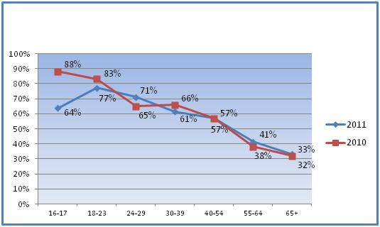
In figure 1, the visits are divided in age categories. Remarkably, less people in the age of 16-17, visited the cinema in 2011 than the previous year. A decrease of 24% can be noticed in this age category. Source: (Film onderzoek)

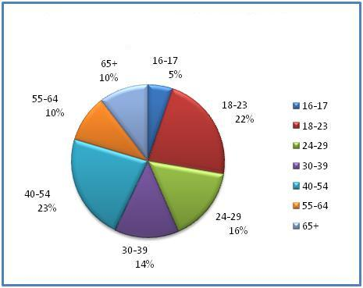
Figure 2) Market share divided in age category

In figure 2, the total amount of the market share is presented. Remarkably, the market share for people in the age of 16 – 17 is only 5 %. The biggest market share is for people in the age of 40 – 54. This is 23 %.

source: Film onderzoek

7.3.3 Future prospects
Looking at the two figures above, it can be concluded that the current situation of Dutch cinematography is stable. However, a decrease is noticed for people, probably students, in the age of 16 – 17 years old. This age category also hold the smallest market share. Students are a very important target group for Dutch cinemas. History has shown us, how vulnerable the cinemas can be, especially when it comes to the topic of film piracy. Even though the current situation is stable, producers of movies still fear film piracy. Film piracy could eventually have a negative impact on the Dutch film industry. DVD rental stores and other movies stores had to face huge losses. Many of them had to cope with financial problems as well as a huge decrease in customers.

7.3.4 Customer expectations
As described above, people from different categories and social class are recognised as a current or potential target group. The customer expectations are described below:
- Customers are seeking for the ultimate movie experience. With the high quality screen provided by the company, customers are able to see movies in the topmost quality. However, customers are looking for more. They want watch their movies without other people bothering them.
- Customers are looking for affordable ticket prices. If the ticket price becomes more expensive, it is likely to expect that the average number of customers will decrease. Apart from that, customers would like to consume cheap snacks and drinks. Since the prices of different snacks and drinks are high, supermarket will have more advantage. The possibility exist that customers will not consume at Pathé but rather, buy the snacks in supermarkets.
- As described previously, target groups are looking for the ultimate movie experience. The company claims to provide this experience in this best way possible. However, film can nowadays be downloaded for free in high quality. Instead of going to the cinema and spending money, students have the opportunity to stay at home and watch movies for free. This can be also recognised as a ‘family experience’. The question arises of how competitive the company is able to be. An incentive has to be created by the company to convince customers to visit the cinema.

7.3.5 Customer care
According to Pathé, customer care is very relevant. The company implemented a solid system where people with specific questions, are able to approach the customer service department. In every cinema of Pathé, there is always a customer service department. Apart from this, the central helpdesk is also reachable by phone. If a customer would have any questions concerning prices or tickets, they can contact the customer service department of the company, which is located in Amsterdam. Furthermore, customers can also send an email with their questions to the customer service department. (“Pathe klantenservice,” n.d., para. 1) This department deals most of the time with the following activities:
- Questions and problems with online purchasing
- If you happen to lose something, you may call this department
- Any questions concerning prices and other services
- Information on movies, prices and tickets
- Contact with Pathé Unlimited/Gold service
- Complaints and issues during movies
- All other questions and issues

7.4 Distribution analyses

The company is cooperating with other major businesses that are involved in their distribution channel. Below, an overview of the distributors is presented. Big American movie companies such as 20th Century Fox and Warner Bros are important players concerning international distribution. Apart from that, Pathé has its own distribution channel which is headquartered in France. Pathé Distribution B.V. in Amsterdam is mainly dealing with the domestic and international distribution of the products in The Netherlands. Other main players are for instance retailers, transporters and other small film producers. The main headquarter of Pathé which is located in France is also known as a producer of movies. Therefore, Pathé distributes not only its own movies, but also produces their own movies. (“Pathe,” 2012, para.16)

Distributor | Description
1. 20th century Fox | one of the six major American film studios as of 2011. Located in the Century City area of Los Angeles
2. Pathé distribution B.V. | headquartered in Amsterdam
3. warner Bros | an American producer of film, television, and music entertainment
4. Film producers | These are mainly small film producers in The Netherlands. E.g. The Hague filmhouse
5. Film transport | These are transport companies, transporting the products of the company domestically or internationally
6. Retailers | These are film stores, cooperating together with film concerns

This table gives a brief overview of the main actors of the company distribution. There is a long line of film producers, film transporters and retailers. Therefore all the names are not mentioned. It is important to understand that these distributors are cooperating with the company. Major companies like 20th Century Fox and Warner Bros are important players since they are both acting as a producer and a distributor.

7.4.1 distribution chain

7.5 Industry analyses

7.5.1 Forces of Porter
After presenting the customer and distribution analyses as well as the opportunities for Pathé in cinematography, the factors concerning threats towards the company will be discussed. The next figure indicates the five forces of the model, introduced by Michael Porter.
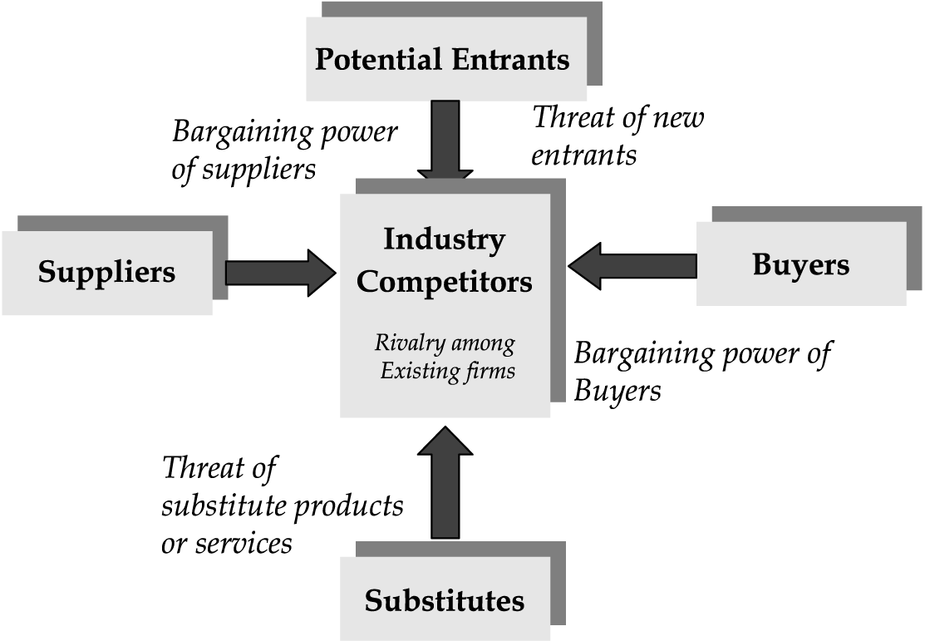
Figure 3
Figure 3, presents the five forces of Michael Porter. The model focuses on threats arising from entrants, suppliers, buyers and substitutes.

7.5.2 Threats of new entrants
As explained previously, Pathé is a market leader in the Dutch cinematography market. They even have their own distribution channel and produce their own movies. However, the threat of film piracy caused a lot of problems and financial losses for movie concerns and stores. In the past, Pathé made a huge loss because of the increasing problem of film piracy. Peer to peer networks have increased drastically throughout the years. These networks provide movies for free. Most of the time, the materials concern new released movies. Therefore, the increasing number of Torrent sites are considered as Threats of new entrants. Other new entrants are regional film theatres, proving movies for a cheaper price, and independent film concerns in The Netherlands. (“AD.nl,” 2008, p.1)

7.5.3 The power of the buyer
The buyer plays obviously a major role in form of a customer. Customers are looking for the best movie experience on high quality screens. However, in times of inflation and financial crises, customers tend to be more careful with their spending on entertainment. If movies become too expensive, and discounts are not provided, there is a bigger chance for downloading the movie. Furthermore, the power of the buyer translates itself into ‘searching for the cheapest price’. Other cinemas besides Pathé, may offer the movie for a cheaper price, or even offer a discount. In conclusion, customer are looking for movies for a reasonable price.

7.5.4 The power of the suppliers
Most movies are coming from American companies. These film producing companies are therefore very important players in the Dutch Market for cinematography. Examples of main players are: Warner Bros, Walt Disney, New Line Cinema and 20th century Fox and Motion pictures. If one of these producers refuse to cooperate with Pathé, it this will cause an obstruction for the company. Therefore, apart from their own movies produced by Pathé, they are more or less depended on the American producing companies.

7.5.5 Threat of substitute products
In the past, the introduction of DVD technology provided a lot of profit, since the demand VHS drastically decreased and mostly got eliminated from the market. In the same way, DVDs can nowadays be ripped or burned and sold for a very low price. The files are provided for free in torrent websites. This already caused a financial crises among film industries in the past. In this case, the file offered online can easily replace other material products or service such as a DVD or even a movie ticket. In a longer term, this eventually could cause a threat to cinemas.

7.5.6 Competitive rivalry
Even though Pathé is considered to be a market leader, other film concerns could be more competitive with proving cheaper movie prices or being more competitive. Other Dutch cinemas such Wolf and JT cinemas should be also taken into account. Still the most important one is the increasing uploading of movies on networks. Since 2011, Pathé introduced ‘Home Cinema’ for customers. Customers can stay at home and watch the movie online in high quality. However, blue ray rips are nowadays available for free on torrent networks. In the section of competitor analyses, the situation will be further discussed. However, according to statistics, Pathé has still the highest share in the film market. Furthermore, culture movies in small cinemas are currently also popular.

7.6 Competitor analyses

7.6.1 movie uploaders
As previously mentioned in the dissertation, film piracy can eventually cause great danger and financial losses to producers and operators of movies. Therefore, film piracy that takes place in The Netherlands, would be recognised as the number one competitor for Pathé Cinemas. It is a fact that 2011 was a good year for Pathé. However, this does not mean that people will stop downloading movies. Obviously, people would visit the cinema if the movie is recognised as a top rated movie. But in most cases, this would go together with the increasing amount of downloads. Therefore, people who are uploading a movie for free, are considered to be a huge threat and competitor for cinemas in The Netherlands. In others words, movie uploaders are more competitive than Pathé Cinemas. The uploaded files are available for free of costs for a downloader, downloader’s can share the movie with friends and family and the usage is more compatible in the sense that it is not necessary to spend money in the cinema. This will save visitors a lot of costs. Apart from that, movies that are not highly rated are more likely to be downloaded from a torrent site. People do not wish to see a movie which is bad rated, what to speak of actually spending money in bad rated movies. Again, in this regard, uploaders of movies are more competitive. A big potential competitor is for instance ‘The Pirate Bay’. This torrent site is the most popular one amongst European countries, and therefore considered as a big competitor for Pathé cinemas. The high court of the United Kingdom agreed with some internet providers like Ziggo to block the website. However, the blockage can very easily be trespassed. History has already shown us that film concerns such as Pathé, made huge losses because of film piracy. If people continue to download movies, Pathé has to make a stronger effort in being more competitive. In figure 5, the total number of torrent downloads in Europe is presented. On December 3rd, 2012, the highest number of high quality downloads can be noticed. Obviously, a great number of downloader’s comes from The Netherlands. In total, about 10,3 billion people downloaded a movie.
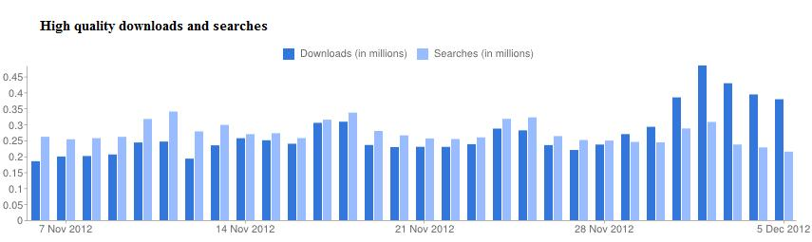
Figure 4

Figure 5 Total downloads in Europe
Sub total downloads

Torrents | 19.867
Downloads | 10.301.177.874
Searches | Unknown
Source: Mininova

7.6.2 Wolff, JT, Cineworld and Utopolis
In the figure below, an overview is presented of other cinemas in The Netherlands. Some of these cinemas hold a smaller market share but belong to the top four list of market share holders. They are more competitive in their prices than Pathé. Therefore, they can also be recognised as a potential competitor.
 | Comments | Pathé | Wolff | JT | Cineworld | Utopolis
regular price €
normal |  | 9,5 | 9 | 8,75 | 9,25 | 9
advantage prices €
CJP price |  | 7,5 | 7 | 7,25 | 8,25 | 7,5
Familiy ticket | for persons, two childeren of max 11 year | 26 | 25 | 20 |  | 25
child | till 11 year | 7,5 | 7 | 7,25 |  | 7
seniors | 65+ | 7,5 | 7 | 7,25 | 8,25 | 7
advantage card |  | 6,75 | 7,5
students | discount for students | no discount | 7 | 7,25 | 8,25
special prices
ladies night |  | 13 |  | 10
preview |  | 7,5

The first factor to be noticed is the normal price. Out of all the other cinemas, Pathé is the most expensive one with an average price of 9,50 euro’s The second factor to be noticed, is the fact that Pathé does not offer a student discount. Wolff, JT and Cineworld are all providing some kind of student discount. Also the CJP discount is lower at Pathé than at Wolff, JT and Utopolis Cinemas. The family ticket price on average is more expensive at Pathé Cinemas than the three other cinemas. Looking at the price on average for children, the ticket price of children is also the highest at Pathé. Finally, the price for people above the age of 65 is also more expensive at Pathé Cinemas. Therefore, the following cinemas: Wolff, JT and Utopolis cinemas, seem to be more price competitive than Pathé. For customers, the price is a very relevant factor. Students might go to the other cinemas, since they offer a student discount. Also customers that are living in cities, with any of the above mentioned cinemas, will have more choice. They are able to compare the prices and choose the cheapest one.

7.6.3 Independent film concerns
One of the biggest competitors for Pathé are independent film concerns. Apart from the main movie concerns that are present in The Netherlands, the sum total of all the independent commercial film concerns hold a very big market share in this industry. According to the year rapport of the ‘Dutch Organisation for Cinema Operators’, these independent concern hold a market share 30%. The total amount of money they received from customers was estimated at 72,1 million euro’s. In 2011, a total number of 9,3 million people visited independent film concerns. An independent concern that was visited the most in 2011 was ‘Euroscoop’ located in Tilburg. The price competitiveness can again be noticed of this company. Euroscoop and other independent film concerns such as Cinemec B.V, are therefore also recognised as a potential competitors for Pathé cinemas in The Netherlands.

7.6.4 Home cinema
In the last few years, a lot of websites introduced ‘home cinemas’ for watching movies at home. With the introduction of Pathé Home, Pathé offers a wide variety of online movies. A fair prices is being paid by the customer. However, many other websites offer movies for cheap reasonable prices. Websites such as: Movie Max online, Mejane, Direct Movie and Ximon are well known home cinema websites. They all offer a wide variety of movies of many genres in high quality. Therefore, other home cinema websites are also potential competitors for Pathé’s home cinema segment.

7.6.5 Product positioning
In order to understand the significance of the position in the current market, the companies with an average large market share besides Pathé, have been placed in the ‘product positioning table’ in figure 5. The first factor to be noticed is the position of Pathé in the market. By becoming a market leader over the years, they provide the highest quality movies, however, for a higher price. Other cinemas such as JT, Wolff and Utopilos, are more positioned to the left since they provide a bit cheaper prices on average. Independent movie concerns such as ‘Euroscoop’ are more position to the left since they are more cheaper. It was mentioned previously, that besides Pathé cinemas, independent film concerns have a large market share. Finally, the occurrence of film piracy in The Netherlands is also noticed on the positioning table. The sub total of film uploaders in The Netherlands, are completely position to the left. Pirated movies are mostly available for free. However, the quality is considered to be a bit less.
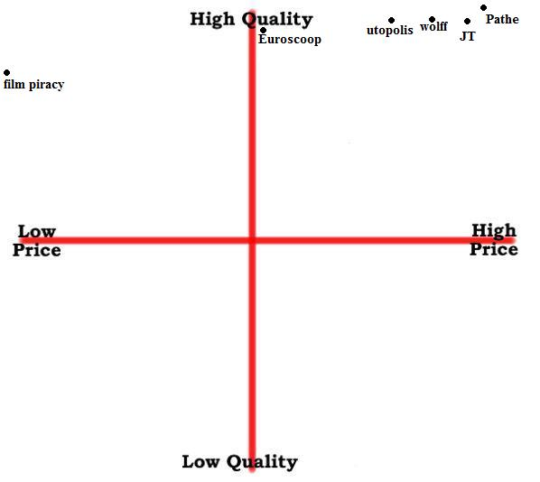
Figure 5 Product positioning
The price indicates the average price, paid by customers. Quality indicates the quality of movies that are shown in a certain movie concern. Film piracy indicates the sub total of uploading and downloading in The Netherlands.

7.7 Macro environment

7.7.1 Introduction
In order to get a deeper insight of what people think of ‘film piracy’, a questionnaire was performed towards people. First, the questionnaire was created online, on a website. After creating all the questions, the questionnaire was first send by email to students of The Hague University. Students were able to click on the link that would direct them to the actual questionnaire. In the email, it was requested to forward the questionnaire to friends, family, parents and other students. In total, 75 people responded to the questionnaire. The purpose of the questionnaire was mainly to get an indication of what people prefer the most: visit the cinema or downloading the movie. Besides that, other specific questions have also been asked concerning cinemas and film piracy. Below, some important results of the questionnaire are highlighted.

7.7.2 results of questionnaire

Figure1) How often do you visit the cinema?
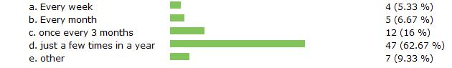

It can be noticed that at least 62% of the respondents visit the cinema a few times in a year. 16% of the respondents visit the cinema once every three months.

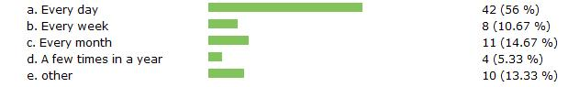
Figure 2) How often do you download movies?

Remarkably, 56% of the respondents of the respondents, download movies on a daily basis. 14,6% of the respondents download on a monthly basis. About 3,6% of the respondents download on a yearly basis.
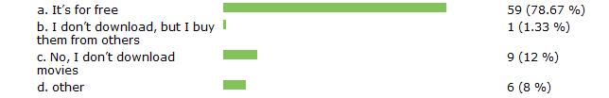
Figure 3) What is the reason for downloading a movie?

In the third question of the figure, more than 70% of the respondents download, because it is for free of costs.

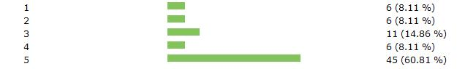
Figure 4) On a scale of 1 strongly disagree – 5 strongly agree: I prefer downloading a movie more than visiting the cinema

In figure 4, 60,8% of the respondents strongly agrees with the above mentioned statement

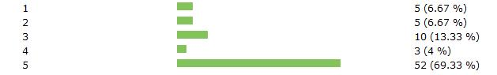
Figure 5) On a scale of 1 strongly disagree – 5 strongly agree: In the next few years, I will download more movies than watch them in the cinema

remarkably, 69,3% of the respondents agrees with the above mentioned statement.

7.8 Conclusion
The external analyses consisted of the opportunities and threats that are influencing the company. The growth in the total number of visitor as well as the huge market share are great opportunities. Furthermore, Pathé wants to reach out to different target groups. With their broad line of products and services they are very successful in achieving their target groups. However, the Pathé also has to deal with some important threats. The biggest threat for the company is the increasing amount of download activity in The Netherlands, with special regards to film downloading. From the questionnaire that was performed, it can be concluded that a great part of the respondent are engaged with film downloading. According to the respondents, cinema is recognised as expensive. Therefore, downloading is more convenient and cheaper for the respondents.

8 The SWOT and confrontation Matrix

Strengths  - Long history line  - Strong brand-name  - Market leader with largest market share  - Variety of different products and services  - High quality movies  - Innovative with special regards to sound  - Uniqueness  - Centralised position, located in big cities | Weaknesses  - Expensive ticket price  - Too much focus on core business  - Less customers during weekdays  - Weak against competitive networks
Opportunities  - Lot of potential towards customers  - Growth in total number of visitors  - Growth in cash inflow  - Reach of different target groups  - Growth in market share | Threats  - Growing film piracy  - Price competitiveness of other cinemas  - Growing market of independent concerns  - Growing number of Home Cinemas

8.1 Strengths vs. opportunities
From the SWOT analyses, the strong market position of Pathé can be noticed. A very strong part and characteristic of the company is the fact that it carries a long history line. This enabled the company to have a very strong brand over the years. Therefore, a lot of recognition was given by customers. With the broad line of products and services, the high quality movies with special regards to innovation, the company’s uniqueness made Pathé a well-respected market leader within the movie industry. All the strengths, made place for solid opportunities within the company. With their high quality products and the position of a market leader, Pathé reached different target groups with huge potentials. Therefore, the company created a huge growth potential with special regards to customers and the growing market share.

8.2 Strengths vs. Threats
Being a market leader in The Netherlands and proving movies of high qualities attracted a lot of competitors to the market. The biggest threat as well as competitor for Pathé is ‘film piracy’. An increasing amount of downloading activity took place in The Netherlands over the years. Peer to Peer network such as torrent websites are becoming a big threat for the film industry. Already in the past, film concerns such as Pathé made huge financial losses because of film piracy. Apart from that, the growth of independent film concerns in The Netherlands are attracting more customers. Just like other cinemas, they are more competitive in their prices. Apart from that, they also hold a very large market share. Being more competitive than the other will eventually make a huge difference for customers, especially in periods when customers are being more careful with their spending.

8.3 Weakness vs. Opportunities
As already mentioned before, the company created huge potentials for growth. Throughout the years the company expanded a lot and establish new cinemas in different regions in The Netherlands. This eventually created a growth in the total number of customers and a growth in the market share. Therefore, a huge number of opportunities were created for Pathé. The variety in products and services had a profound effect on different target groups. However, the company carries also some weaknesses. By being a market leader and have a strong brand name, the average price for a ticket paid by a customer raised. Visiting a Pathé cinema became expensive. Furthermore, less customers are noticed during the weekdays then in the weekend. Perhaps, Pathé should strive for a balance during the weekend and weekdays. Also, the emphasised focus on the core business could eventually lead to less excitement among customers. Pathé could introduce other activities and create more interaction for customers. Finally, since peer to peer networks provide movies for free, Pathé has to make a stronger effort in being more competitive.

8.4 Weakness vs. threats
The less price competitiveness of Pathé and the increasing fear of film piracy in The Netherlands, will push the company to be and act more competitive in the market. The achievements of the last few years were very promising. However, the total amount of movie downloading have been growing drastically in the last few years. In order to be more competitive against the growing number of film piracy, Pathé will first have to become price competitive. Reintroducing a fixed discount for students would be again very attractive. Apart from this, the Home Cinema application on the website of Pathé has to compete with other online demand websites. Furthermore, the position of independent concerns became more attractive to customers. All in all, Pathé should strive for a balance between customer needs and customer prices.

9 New marketing mix strategy

9.1 Introduction

The internal and external analyses of Pathé were discussed. Afterwards, the strengths, weaknesses, opportunities and threats were eventually presented and confronted in a matrix. In this last section of the dissertation, an improved marketing mix will be presented. All the information in the previous sections and chapters on the company will be collected and summarised in this chapter. However, new ideas for further implementation will be also presented in this chapter. Since, Pathé is recognised as a strong market leader in the film industry, the company already has a solid business system. Due to a strong brand name, high quality of products and services, the company stabilised itself in the last few years. However, the increasing activity of film piracy in The Netherlands, is still recognised as the number one threat for the film industry. The following sections, will therefore discuss new ideas and strategies to keep attracting customers to cinematography, and at the same time, compete against the rising fear of film piracy in The Netherlands. The purpose is eventually to create a better link between company and customer.

9.2 Product and service strategy
Pathé has already a wide variety in products and services. Along with their strong brand name, high quality of products, growth in customers and an increasing market share, the company is stabilised in the product and service strategy. However, there are some important factors that could be implemented in the product strategy of the company. Customers have almost no interaction during the movie, therefore, Pathé should consider in implementing new activities, resulting in more interaction with friends and families. Furthermore, there are some other points in which the company should pay attention. Measures for further implementation are presented in the table below.
Strategy | Description of Strategy | Result of strategy
Extra hosts | In theory, all the employees are hosts towards customers. In reality, everyone is busy. Therefore appoint a few people to act as the main host for the company | reach people more personal, create interaction
Implement breaks | Breaks during a movie should be re-introduced. During breaks, customers can purchase drinks and snacks. This will contribute to the company's profit. People can also go to the toilet if they want. If the duration of movie is 2,5 hours, at least after 1,5 a break for consumers. | contribution to company's profit, give opportunity to go to toilet
Pathe Games | Introduce new games for friends and family and children. Games should be connected with the movies. | increase interaction
Inspection | A lot of movies are age related. The host should have an active role in this matter and inform parents on particular movies. Some movies contain abusive language. | prevent/protect children from being exposed to abusive language.
Gadgets shop | Not necessary, but could be interesting. Products such as movie posters, books, small furniture and other gadgets for customers. | increase revenue, expand product line
Bar-restaurant-café | Combination of these three anables the company to become a meeting place for customers and expand the product line | increase revenue, become a meeting place and expland product line
Practical products | Products such as Pathe Unlimited and Gold could increase the product availability, however, people do not visit the cinema on daily basis. Therefore, Pathe should really consider about some products. Being more practical towards customers would be more effective | Practical use of products

9.3 Price strategy
The price strategy would be the most prominent adjustment in the dissertation. For many years, Pathé focussed on making a lot of profit. With the profit, the company introduced new affiliates in different regions in The Netherlands. This resulted in an increasing number of visitors and a larger market share in the film industry. However, it also gave the raise to film piracy. Producers of movies fear that in the future, the film industry will make huge losses. In order to keep attracting people, Pathé has to be more price competitive. Offering cheaper ticket prices and discounts would be very attractive for future customers. Therefore, instead of focussing too much on profit, the company should invest in the customers. Below, a rough sketch of the income statement of Pathé is presented. All the given information are on a yearly basis.
The total number of visitors in the last year was estimated at 13.228.000. There are in total 22 Pathé cinemas. Therefore, the total number of visitor on average per Pathé cinema would be
- 13.228.000 / 22 cinema, would be 601.273 visitors on average for 1 Pathé cinema.
indicators | amount in € | calculation
Revenues | 5.411.475 | 9 x 601.273
Costs direct / indirect | 1.623.437 | (5411475/100) x 30%
Gross Margin | 3.788.020 | 5411475 - 1623437
Margin in % | 70% | (3788020/5411475) x 100%
V.A.T (25%) | 947.005 | (3788020/100) x 25%
Expenses
Rent | 104.000 | (8000/4)x 52
Payroll employees (total 19 employees) | 260.000 | (14.000 + 6000) / (4 x 52)
Payroll tax | 65.000 | (5000 / 4) x 52
Utilities | 299.000 | (23000 / 4) x 52
Insurance | 312.000 | (24000 / 4) x 52
Total Operational Costs | 1.768.000 | 104.000+260.000+ 65000+299.000+312.000
EBITDA | 1.073.015 | gross margin-operational costs-VAT
Operating expenses | 65000 | (5000 / 4) x 52
Profit on year basis | 1.008.015 | 1.073.015 - 65000

revenues on consumption | amount in € | calculation
Total customer consumption | 3.307.002 | 601.273 x 5,5
Purchase costs + tax | 901.909 | 601.273 x 1,5
Profit on consumption | 2.405.093 | 3307002 - 901909
Total Nett Profit (exclusive earnings for trailers) | 3.413.108 | 1.008.015 + 2.405.093

indicator | outcome in € | results | strategy remarks
Total Nett Profit | 3413108
Average customers per Pathe on yearly basis | 601.273
New investment per customer for next year | 3 |  | the total number of customers per Pathe is estimated at 601.300 in the next year. € 2 is invested in the ticket price, and € 1 euro is invested for the students
Total investments | 1.803.900 |  | € 3 x 601.300
Nett Profitt | 1.609.208 |  | 3413108 - 1.803.900
New average ticket price | 7 |  | 9 - 2 = 7
New average price for students | 8 |  | 9 - 1 = 8
new average price for consumption | 4.5 |  | investment of 1 euro per average consumption
total investments consumption | 601.300 |  | 601.300 x 1
New Net profitt | 1.007.908 |  | 1.609.208 - 601.300
New income
income for next year by introducing breaks during movies |  | 180390 consumers | expected visitors for next year: 601300, 30% of this number will consume during break. Therefore 30% of 601.300
New profit and earnings only for breaks | 811.755 |  | 601.300 x 4,5

Important to understand is the fact that Pathé is able to invest in cost reductions to make the average ticket price as well as the price for consuming, a little cheaper. However, one can conclude that the company rather has a different strategy. In the past year, the company introduced new affiliates in different regions in The Netherlands. Consequently, the market share increased. However, it also means that all the profit gained from customers, will eventually go in the company’s own investments, such as introducing more affiliates in other regions. Therefore, the following statement is very essential to understand: the more affiliates in the country, the greater the market share, and therefore, the more expensive the average price of a ticket. With the total amount of profits, the company should invest in cost reductions. In this way, the average price for tickets and consuming becomes cheaper. Apart from that, reintroducing breaks during movies, will certainly contribute to the company’s profit. In conclusion, investing in cost reductions from the profits gained in the previous year, will certainly make the company more price competitive. This can be established from the above calculations.

9.4 Place strategy
Currently, Pathé has 22 affiliates, located in different regions in The Netherlands. As explained previously, if the total number of affiliates in will increase, the market marker share will increase as well. Eventually, it will have a profound effect in the average price for tickets and consuming. Therefore, the place strategy of the company is already recognised as solid and stable. The locations of the affiliates are very central, customers are able to reach cinemas without any problems. There is also a very clear public transport network around the big cities. The headquarter of the company is located in Amsterdam together with its main distribution office. Pathé clearly focuses on big cities, in the Northern and Southern part of The Netherlands. These parts have a large population density. Thus, the company enables itself to reach different target groups in big cities. Furthermore, Pathé should focus only the current 22 locations. In the next six years, the company should therefore not introduce new affiliates.

9.5 Promotion strategy
The promotion strategy will also be an essential part of the dissertation. Several adjustments have to be made by the company to keep attracting new customers in the future. First of all, the above mentioned strategies should be implemented in the promotion strategy of the company. Customers have to be aware of the new changes. Therefore, promoting all the new adjustments, with special regards to the new price and product strategy, will form an important part of the promotion strategy. Essential promotion tools are for instance, promoting through advertising, the website, mobile application, newspapers and magazines. Approaching customers in a personal way and thus, promoting the new changes in the company will be very essential. The host of a specific affiliate will play a major role in this. So far, it has already been discussed how Pathé is able to be more price competitive and keep attracting customers in the future. However, the company should also pay attention to film piracy in The Netherlands. In the next sections, the promotion against film piracy will be discussed as well as the improved promotion strategy for Pathé.

9.5.1 advertising from a different angle
In the past, Pathé introduced advertisements against film piracy on television and also during movies. Currently, Pathé does not make any advertisings against film piracy on television or during movies. Therefore, the company should reintroduce the advertisings against film piracy, especially during movies. One can imagine why the company stopped promoting against film piracy. Film producers and concerns could come to the conclusion that advertisements against piracy will not work. Therefore, the company should change its scope and approach downloader’s from a different angle. The focus should therefore be more personal. Pathé can introduce advertisements with the negative effects of downloading. For instance, too much downloading will eventually cause a lot of damage towards a computer. Most the downloaded files are infected with a virus and therefore not trustworthy for a computer. Apart from that, the company should be aware of all the statistics on the ‘downloading activity’. Furthermore, Pathé should create posters and other kinds of advertising against film piracy. In this way, the company is able to at least reach a certain number of people.

9.5.2 cooperation with ‘Brein’
Brein is the association for the protection of the rights of the entertainment industry of the Netherlands. Obviously, the organisation already cooperates with the film industry by conducting research on piracy in The Netherlands. One of the main tasks of Brein is to take legal steps against certain websites. Furthermore, the organisation wants to block several websites such as The Pirate Bay through internet providers. In the past, the organisation was successful in blocking several Dutch torrent websites. Brein has a list of important shareholders. Therefore, Pathé could support the activities of the organisation by acting as a sponsor or shareholder. In this way, Pathé enables itself to compete against film piracy in an indirect way. Supporting organisations such as Brein, will eventually also contribute to the protection of copyrights. Brein could make a stronger effort in finding out the issues on proxy servers. Recently, the court of the United kingdom ordered some of the biggest internet service providers to block some torrent sites such as the Pirate Bay. However, new proxy servers were created to trespass the blockage and allow users to download files. If the organisation finds out how to block proxy serves without violating the privacy of users, it will eventually be more difficult to download from a torrent site. All in all, cooperating with Brein could eventually benefit Pathé in many ways.

9.5.3 securing distribution channel
Sometimes it occurs that new released movie, already leaked out on the internet before coming on the cinema. Therefore, an important tool against film piracy is to secure the distribution channel. It appears that other small companies who are in charge of instance, subtitling, advertising and promoting the movie, are leaking the movie to third parties. Therefore, Pathé should perform specific research in its own distribution channel, with special regards to distributors from abroad. Connections with third parties should be broken immediately, in case the company discovers the leakage. Therefore, securing and inspecting the distribution channel of the company will give Pathé a lot of advantages and is an effective promotion tool against film piracy.

9.5.4 promotion of price competitiveness
From the questionnaire that was performed, a great number of respondents indicated the expensiveness of Pathé with special regards to consuming and movie tickets. Therefore, the most effective way to keep attracting customers in the future and at the same time compete against film piracy, is the promotion of cheaper prices. By offering cheaper ticket prices consumers are more appealed to visit the cinema regularly. Apart from that, the promotion of certain products should be more practical. Pathé Unlimited and Gold will increase the product availability. However, not a lot of people visit the cinema on a daily or regular basis. Apart from that, reaching out to customer in a personal way, promoting through TV commercials, posters and a yearly upgrade the website should also be taken in account.
10 Conclusions

The objective of this dissertation was to finally answer the main question. To provide an answer to the main question, several sub questions were introduced. In each sub questions, desk and field research was conducted to provide all the answers on the sub questions. The main question in this dissertation was:
“How would Pathé be able to make cinematography more attractive for customers, and at the same time, compete against film piracy”?
By first providing background information on the topic as well as creating a marketing plan for the company, the first sub question was answered: ‘What is the core problem of film piracy and how does it affect movie concerns’? By simply making some backup copies of movies without the permission of the rightful owner, is already considered as movie or film piracy. Stealing a certain print of a movie, burning a disc and resell it, or recording a movie while being present in the cinema are other more severe forms of movie piracy. Currently, internet movie piracy is considered as a great danger, especially for movie concerns. Simply downloading movies will cause huge losses for movie concerns. This again will affect retailers and other companies that are dealing with movie selling, importing and exporting. Eventually, if all kinds of movies will be available for free on the internet, film concerns with special regards to cinemas, will recognise a huge decrease in customers in the future.
The second sub questions was: ‘What is the situation of film piracy in The Netherlands’? In the year 2006 about 150 million movies were downloaded from different torrent servers. The total number of movies, accounted for at least eight million euro’s per month. These were mostly movies that just appeared on Dutch cinema or on DVD. Besides that, four million DVD’s that were burned were again sold with a total street value of approximately 24 million euro’s. With this happening, film piracy became a huge problem for Dutch Cinemas in this year. This was also confirmed by Mr Wilco Wolfers, who is the chairman of the Dutch Federation for Cinematography, during an official press release. He indicated the occurrence of ‘film piracy’ as the main reason for a decrease in visitors with 11,2 per cent. In 2007 and 2008, film piracy caused a lot of damage to the cinemas. According to the Dutch Federation for Cinematography, the total loss for the movie and DVD branch was 153 million euro’s. These were loss revenues within this sector. The main issue was the occurrence of ‘cam recording’. Visitors that were present in film-rooms were recording the movie with their own camera. The total amount of visitors got stabilised. There were 22 million visitors in 2007. The issue with cam recording in cinemas continued in 2009. Measures were taken in order to protect the cinema from film piracy. A nigh-watch device was introduced for cinemas that were dealing with the problem of cam recording. The night-watch device was mainly used for inspection purposes. Cinemas became more stabilised since more visitors were recognised in 2010 and in 2011. A new target group became important. These were people in the age of 55 years old. However, the movie industries worried about the huge decrease of young people that visited the cinema. A very important reason for the decrease in this age group would probably be the increasing file sharing and DVD piracy among students in schools and universities. Since students are so much connected with each other, they share a lot of information on social media such as YouTube, Twitter and Facebook.
The third sub question was: ‘Which strategy is Pathé currently using in attracting customers’? Customers keep themselves updated by reading the magazine previews. In this way, customers certainly appreciate the products, provided by Pathé in The Netherlands. Pathé uses a very solid strategy in presenting the variety of their products and services. The company is focussing on different target groups. Movies are presented for different types of persons, of different ages. The fact that the company presents itself as a market leader, is recognised as the most important strategy. The strategy of convenience is implemented for customers. People are able to order tickets and reserve seats in many possible ways. Pathé finds it also important to deliver high quality movies at the homes of people. By implementing the ‘Home Cinema’ application, people are able to watch the movies at home, in high quality. By reaching the customers in a personal way and at home, Pathé wants to fascinate customers with their high quality movies. The website of the company is a very essential promotion tool in reaching out the new customers. Furthermore, the application for mobile phones, became very popular recently. The application provides all the necessary information on movies. Furthermore, customers are able to pay or reserve seats by using the convenience of internet banking. The application is available for Apple products such as the iphone and ipad, but also for Blackberry and Nokia phones.
‘The fourth sub question was: ‘Who are the competitors of Pathé’? The most dangerous competitor for Pathé is the increasing amount of film piracy in The Netherlands. The uploaded files are available for free of costs for a downloader, downloader’s can share the movie with friends and family and the usage is more compatible in the sense that it is not necessary to spend money in the cinema. Apart from that, movies that are not highly rated are more likely to be downloaded from a Torrent site. People do not wish to see a movie that is bad rated. Other Dutch cinemas such as: JT, Wolff and Utopolis Cinemas, are more cheaper than Pathé. They appear to be more price competitive. Furthermore, the sum total of all the independent commercial film concerns hold a very big market share in the movie industry and are therefore also recognised as a potential competitor.
The fifth and last sub question discussed the following question: ‘Which new strategies should Pathé introduce, in order to be more competitive’? Customers have almost no interaction during the movie, therefore, Pathé should consider in implementing new activities, resulting in more interaction with friends and families before or after the movie. Therefore, extra hosts in each affiliate, implementing breaks during movies and a combination of bar, restaurant and cafe will attract more customers and create more interaction among customers. Important to understand is the fact that Pathé is able to invest in cost reductions to make the average ticket price as well as the price for consuming, a little cheaper. However, throughout the years Pathé focussed more in making huge amounts of profits rather than investing back in the customer. In conclusion, investing in cost reductions from the profits gained in previous years, will certainly make the company more price competitive. A new promotion strategy should also be considered. Advertising from a different angle could be more effective in promoting against film piracy. In this regard, the organisation ‘Brein’ is a major player in the promotion against film piracy. Cooperating with ‘Brein’ could eventually benefit Pathé’s promotion in many ways. Furthermore, Pathé should make a stronger effort in securing its distribution channel. It appears to be that a lot of movies are leaked out on the internet, before they reach the cinema. From the questionnaire that was performed, a great number of respondents indicated the expensiveness of Pathé with special regards to consuming and movie tickets. Therefore, the most effective way to keep attracting customers in the future and at the same time compete against film piracy, is the promotion of cheaper prices. Furthermore the promotion of several products should be more practical. Products such as Pathé Gold will increase the product availability, but at the same time, not many customers visit the cinema on a daily basis. In conclusion, carefully selecting which products should be promoted, investments in cost reductions and cooperate with certain anti-piracy organisations will make Pathé more competitive.

11 Recommendation

In the past, Pathé had to face a lot of problems regarding piracy in The Netherlands. However, with a long history and strong brand name, the company was able to stabilise itself. Film producers and other movie concerns still fear the impact of film piracy. Pathé should therefore make a strong endeavour in being more competitive. It is therefore first recommended to invest in cost reduction. Making prices of tickets cheaper and reintroducing student discounts will certainly enable the company to be more price competitive. Throughout the years, the focus of the company was mainly on making profits. Consequently, Pathé achieved the largest market share within the Dutch film industry. Since the company already holds a large market share, it is recommended not to introduce any more affiliates in The Netherlands. The profits gained from previous years, should be invested in cost reductions such as cheaper tickets and consuming. Furthermore, a huge decrease of an important target group took place in the last year. These are mostly young people, probably students. It is therefore recommended to also invest in students, by reintroducing student discounts.
Pathé should also make a strong effort in creating more interaction for customers. Interaction will create more enthusiasm towards customers. Therefore, it is recommended to introduce new product and services in order to provide optimal interaction for customers. Placing extra hosts, will make the interaction between company and consumer more personal. Furthermore, a lot of promotion went out to products such as: Pathé Unlimited and Gold. From the questionnaire performed in this dissertation, not any of the respondents were holding one of these cards. Introducing an unlimited card could increase the product availability, however not many customers are interested in paying a fixed amount of money per month to watch unlimited movies. Furthermore, not many people would indeed have the time to visit the cinema on a regular basis. It is therefore recommend to be practical while selecting a product for promotion.
Obviously, the occurrence of film piracy in the Netherlands cannot be stopped. Eventually, the company has to act more competitive. However, anti-piracy organisation such as ‘Brein’ are very essential in fighting against film piracy. It is therefore also recommendable to support an organisation such as ‘Brein’. Sponsoring their activities or becoming a shareholder would eventually benefit the company in many ways. Pathé already has a solid promotion system. Mobile applications and the website were very essential in this regard. However, there could be still a distance between the company and consumers. It is therefore recommended to reach the customers in a more personal way. All in all, the introduction of cheaper prices would be the most relevant strategy for Pathé in becoming more attractive as well as more competitive.

Referencing

A digital media blog. (2009, June 13) Internet movie piracy. Retrieved October 27, 2012, from the A digital media blog website: http://mishy79.wordpress.com/2009/06/13/internet-movie-piracy-a-tale-of-illegal-file-sharing-in-the-united-states/
AD.nl. (2008, January 10) Film piraterij drukt bioscoopbezoek naar beneden. Retrieved December 2, 2012, from the AD.nl website: http://www.ad.nl/ad/nl/1023/Film/article/detail/2130289/2008/01/10/Filmpiraterij-drukt-bioscoopbezoek-naar-beneden.dhtml
Bigofeature. (n.d.) The Pirate Bay. Retrieved December 5, 2012, from the Bigofeature website: http://bigozine2.com/feature/?p=141
Binary code. (2012). In Wikipedia, the free encyclopedia. Retrieved October 26, 2012, from http://en.wikipedia.org/wiki/Binary_code
BitTorrent. (2012). In Wikipedia, the free encyclopedia. Retrieved November 5, 2012, from http://en.wikipedia.org/wiki/Bit_Torrent
Copyright. (2012). In Wikipedia, the free encyclopedia. Retrieved October 25, 2012, from http://en.wikipedia.org/wiki/Copyright
Crack. (2012). In Wikipedia, the free encyclopedia. Retrieved October 27, 2012, from http://en.wikipedia.org/wiki/Crack_%28password_software%29
Ed Cox. (n.d.) Digital audio piracy. Retrieved October 26, 2012, from the Ed Cox website: http://www.edcox.net/about-me/research/music-on-the-internet/protecting-music-on-the-internet/the-problem-audio-piracy/
Filmonderzoek. (2012, November 2). Verschuivingen in het bioscoopbezoek. Retrieved November 18, 2012, from the Filmonderzoek website: http://www.filmonderzoek.nl/verschuivingen-in-het-bioscoopbezoek
Future of copyright. (2009, December 3). DVD piraterij:Net geld drukken. Retrieved November 15, 2012, from Future of copyright website: http://www.futureofcopyright.com/nl/home/blog-post/2009/12/03/dvd-piraterij-net-geld-drukken.html
IMI. (n.d.) What is Piracy? Retrieved October 25, 2012, from the IMI website: http://www.indianmi.org/whatispiracy.htm
Inside Gamer. (n.d.) zijn de prijzen voor bioscoopkaartjes te hoog? Retrieved November 30, 20102, from the Inside Gamer website: http://www.insidegamer.nl/forum/viewtopic.php?f=16&t=76288&sid=60f6b706490ce0e3a8652141fd538087
Internet Relay Chat. (2012). In Wikipedia, the free encyclopedia. Retrieved November 4, 2012, from http://en.wikipedia.org/wiki/IRC
Jaarverslag Nederlandse Verenninging voor Bioscoop exploitanten. (2011). Statistieken, 2011, 38-58
Leech. (2012). In Wikipedia, the free encyclopedia. Retrieved November 4, 2012, from http://en.wikipedia.org/wiki/Leecher
Mininova. (n.d.) Downloads and searches per day. Retrieved December 5, 2012, from the Mininova website: http://www.mininova.org/statistics
Motion Picture Association of America. (2012). In Wikipedia, the free encyclopedia. Retrieved November 8, 2012, from http://en.wikipedia.org/wiki/MPAA
Nederlands Film Festival. (2012) . Goed jaar voor de bioscoopbranche. Retrieved November 28, 2012, from the Nederlands Film Festival website: http://www.filmfestival.nl/publiek/nieuws/2011-zeer-goed-jaar-voor-de-bioscoopbranche/
NRC Archief. (2010, January 11). Piraterij dupeert bioscopen, pp. D1, D4
Pathe klantenservice. (n.d.) Veelgestelde vragen. Retrieved November 30, 2012, from the Pathe klantenservice website: https://www.pathe.nl/klantenservice/
Pathe Mobiel. (2012). Pathe mobiel vernieuwd. Retrieved November 30, 20102, from the Pathe.nl website: https://www.pathe.nl/mobiel/
Pathe. (2012). In Wikipedia, the free encyclopedia. Retrieved November 21, 2012, from http://en.wikipedia.org/wiki/Path%C3%A9
Pathe.nl. (2012). Bioscopen. Retrieved November 25, 2012, from the Pathe.nl website: www.pathe.nl
Pathe.nl. (2012). De cultuur. Retrieved November 28, 2012, from the Pathe.nl website: https://www.pathe.nl/werken/home/hrm_de_cultuur
Pathe.nl. (2012). De missie van Pathe. Retrieved November 26, 202, from the Pathe.nl website: http://www.pathe.nl/klantenservice/over-pathe/
Pathe.nl. (2012). Onze visie. Retrieved November 28, 2012, from the Pathe.nl website: https://www.pathe.nl/werken/home/hrm_visie_en_missie
Pathe-thuis.nl. (2012). Pathe Thuis. Retrieved November 28, 2012, from the Pathe-thuis.nl website: https://www. http://pathe-thuis.nl/
Peer to peer file sharing. (2012). In Wikipedia, the free encyclopedia. Retrieved November 5, 2012, from http://en.wikipedia.org/wiki/P2P_file_sharing
Prof News. (2006, January 12). Bioscopen hebben last van piraterij. Retrieved November 10, 2012, from the Prof News website: http://www.profnews.nl/699392/bioscopen-hebben-last-van-piraterij
The Gemini Geek. (n.d.) What is piracy? Retrieved from October 26, 2012, from the Gemini Geek website: http://www.thegeminigeek.com/what-is-piracy/
The Pirate Bay. (2012). In Wikipedia, the free encyclopedia. Retrieved November 7, 2012, from http://en.wikipedia.org/wiki/The_Pirate_Bay
Torrent Invites. (n.d.) The Occultz BZ growth rate. Retrieved December 5, 2012, from the Torrent Invites website: http://www.torrent-invites.com/
Yahoo Answers. (n.d.) What are seeders and leechers? Retrieved from November 5, 2012, from the Yahoo website: http://answers.yahoo.com/question/index?qid=20070613224743AA5GEky

Appendix

Interview summary
Date: 2 December 2012
Who: Mr. P. Flens (General Manager)
Where: The Hague, Pathe Buitenhof

What can Pathe actually offer for their costumers?
Pathe has a broad line of products and services. Providing people with top quality movies is our main concern. Furthermore, with the service from our employees towards the customers, we are trying to satisfy the customer in the best way possible. Some of the Pathe affiliates have the combination of restaurant bar and café. This is also quite attractive for customers and comes under the category of ‘Pathe Culinary’. We focus on a broad target group, in this way we want to make Pathe accessible for different people of different ages. An example of this is ‘Ladies Night Deluxe and Pathe DOCS. All in all, by providing the highest quality of products and services, we want to fascinate the customer.
How has Pathe been developing in the last few years?
The last few years, especially 2011, were very exciting. The most exciting one would be that all of our cinemas are digitalised. This means, that movies are presented in a higher quality with better sound effects. Replacing cables with a digital network created a lot of convenience. In the past (between 2000-2005) we had to deal with some problems. There was a decrease in customers. This obviously, had many reasons. But over the years, we have grown.
What would be the most important reason for the decrease in customers in those years?
Probably the development of ICT and internet in The Netherlands has caused some problems for cinemas. With the introduction of a broadband connection, people were able to share all kinds of information such as, DVDs, downloading etc. The film industry in The Netherlands made huge losses. Another reason was the less availability of really good movies. We are somewhat dependent from American distributors and producers. But the situation is very stabilised now.
From the questionnaire that I performed, it can be concluded that a majority of the respondents prefers downloading more than visiting a cinema such as Pathe
With the new introduction of digital cinema, and therefore providing movies in the highest quality available we are basically a frontrunner in digital technology. We are fully convinced and this will create a completely different experience for customers. Of course the ‘downloading’ issue will always be a problem for the film industry.
What would Pathe do in the upcoming years, to make cinematography more attractive to customers, and at the same time compete against piracy?
By making investments in projects such as digital technology already attracted a lot of customers. This is also the reason why cinema has become a bit more expensive. A higher quality means a higher price. The price is not affordable for all our target groups such as students. This year, we had a decrease of young people. It could be possible that Pathe would therefore re-introduce the student discount. Furthermore, the combination of restaurant bar and café would attract more customers. In this way, Pathe would be a meeting place for different people. Interaction is also essential. We do this by face to face contact from out employers. But sometimes, during previews it can be too busy. In a few weeks from now, we are presenting ‘The Hobbit’ in out cinema. We expect lot of customers.
Competing against film piracy will always be a problem. Re-introducing advertisements against piracy could be a possibility, to at least secure some of our target groups. Other promoting against film piracy could be a possible cooperation with an anti-piracy organisation. If more cinemas would invest in these organisations, internet providers would eventually also cooperate. Securing our distribution channel is also important. Other cinemas had to deal with a possible leakage, so we have to be careful. Becoming a little bit cheaper would also attract more customers. Pathe has some very interesting plans for the future.

questionnaire
Questionnaire on cinematography in The Netherlands
For my dissertation i am conducting research on the connection between cinematography and movie piracy in The Netherlands. Would you please be so kind to answer all the quest ions. It will only take you five minutes.
Thank you very much in advance.
1.What is your age?
2.What is your gender?
a. male
b. female
3.What is your occupation?
4.How often do you visit the cinema?
a. Every week
b. Every month
c. once every 3 months
d. just a few times in a year
e. other

5. Pathe is the cinema that I would visit if I want to watch a movie.
a. Yes
b. No
6. Do you have Pathe unlimited?
a. Yes
b. No
7. (if you answered yes in the previous question, continue with quest ion 8) If you don’t have Pathe Unlimited, do you want to purchase an unlimited card in the future?
a. Yes
b. No
8. How often do you download movies?
a. Every day
b. Every week
c. Every month
d. A few times in a year
e. other
9.The reason why i download movies is because
a. It’s for free
b. I don’t download, but I buy them from others
c. No, I don’t download movies
d. other
10. I download my movies most of the time from a torrent site.
a. Yes
b. No

11. How often do you buy DVD movies?
a. At least one DVD every month
b. More than one DVD in a Month
c. I don’t buy DVDs anymore
d. other

12. I prefer downloading a movie more than buying it in the store.

1 Strongly disagree - Strongly agree 5

13. I prefer downloading a movie more than visit the cinema

1 Strongly disagree - Strongly agree 5

14. What do you think about movie piracy? such as downloading high quality movies for free from a torrent site

15. There is a movie in the cinema, however, the movie is also available in high quality on a website for free, what would you do?

16.What is the most important adjustment , a cinema like Pathe should make for the future?
a. Make cinema more cheaper
b. Give more discounts
c. Organise more events
d. Nothing
e. other

17. In the upcoming year, I will visit the cinema (Pathe) less, than I did in the previous years.
1 Strongly disagree - Strongly agree 5
18. In the future, i probably will download more movies, than watch them in the cinema.

1 Strongly disagree - Strongly agree 5
19. In the future I will stop buying DVDs, and download more
1 Strongly disagree - Strongly agree 5
20. What do you think that Pathe should do, to make cinematography more attractive for customers? (explain in short)

Results questionnaire
From the 75 respondents, 25 persons were females. The majority of the respondents were students in the age of 17-27 years old. Furthermore, 17 respondents were older than 27 years.
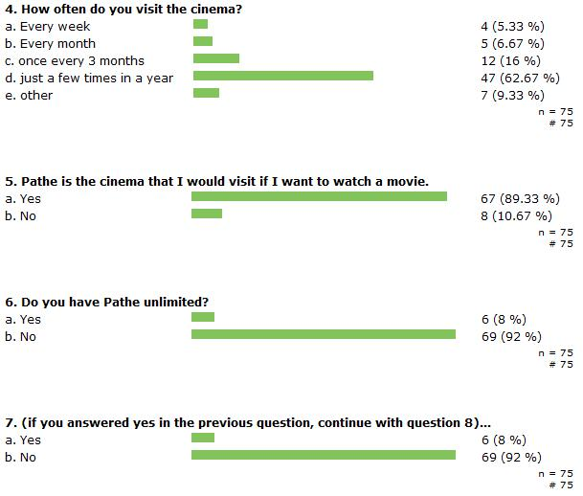
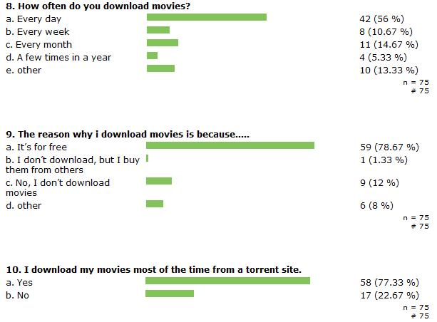
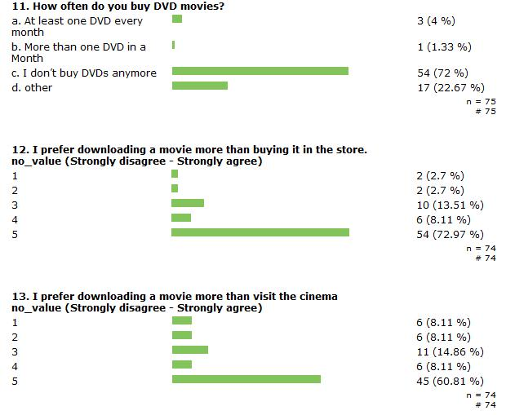
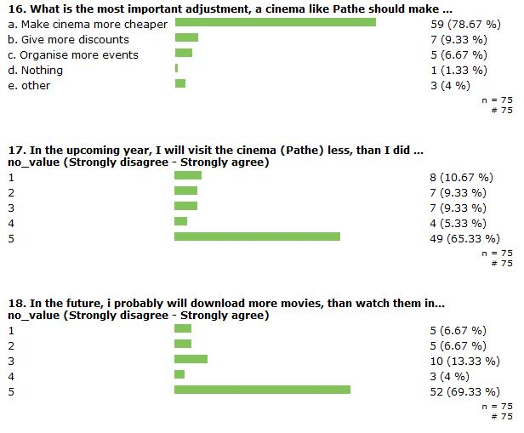
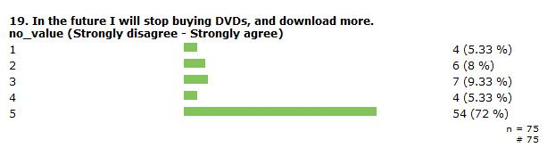
On question 14, the majority of the respondents were very positive on the concept of piracy. Therefore, the majority of the respondents would download the movie if it would be available on the internet (question 15). Also on question 20, the majority of the respondents agreed on the fact that cinemas are nowadays too expensive. Making prices a bit cheaper would therefore be more appealing and attractive towards consumers.

Geographical chart Pathe

