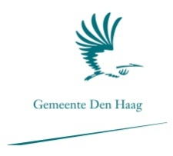
Academy of European Studies & Communication Management
The Hague university of Applied Sciences
Author
C.L. Spobeck
Prins Hendrikstraat 185
2518 HP The Hague

Student number: 09019057
Class: ES4

The Hague University of Applied Sciences
School of European Studies
Johannawesterdijkplein 75
2501 EH Den Haag

Graduation mentor
W.M.J. van Leeuwen
Gemeente Den Haag
Spui 70
2511 BT Den Haag
Postbus 12 600
2500 DJ Den Haag
Tel: 14070

International Community Platform
Noordwal 10, 3rd floor
2513 EA The Hague
Tel: +31 (0)70 363 7975

Assignment providers
Gemeente Den Haag: 15-4-2013 till 19-7-2013 F.J. de Graaf
19-7-2013 till 22-10-2013 M. Awater
International Community Platform: N. van Haelst
The records shown are only for the purpose of this report. No rights may be derived from the outcomes of this report.

Executive Summary

The research ‘’Talent recruitment and internships according to students’’ has been conducted in assignment of the municipality of The Hague and in co-assignment of the International Community Platform (ICP) between June and November 2013. The research is part of the action program ‘’Geslaagd in het Vak’’ (‘’Succes in the field’’) 2012. The goal of the action program is to align the labour market and educational institutions.
The overall aim of this research is to identify the experience of students in higher education during their first formal encounters with the labour market, namely during an internship. A gap analysis is made on how the students have experienced their internship, which obstacles they encountered and what the ideal situation should look like. The main question of this research is: ‘’What are the required improvements regarding internship programs from a student’s perspective?’’
Desk research has been used to identify the outline and purpose of this research. The desk research consisted of policy documents, previous performed studies, reports, research papers, books and academic websites. Field research existed of an online questionnaire amongst (former) interns from higher education and (in-depth) interviews with educational institutions and international employers.
This research shows the experience of interns from the start (orientation) of their internship until the final phase (retention). The findings of the questionnaire show that a better network would have helped the interns in their orientation to the labour market and their search for an internship. Furthermore, the interns stated that intensified contact between their educational institution and their internship company would have improved the quality of their internship. Lastly, the interns would have liked to have stayed more in touch with their internship company or organisation, in order to expand their network and for the possibility of a future job.
Based on the results of the research, the following recommendations are made. Companies and organisations that are located in The Hague region should present themselves to the students during the early phases of study. This can help the students with their orientation to the labour market and enhances their awareness of the available companies and organisations. Another recommendation is to organise personal meetings at the beginning and at the end of the internship between the mentor from school, organisational supervisor and intern. These meetings will help to improve the quality of the internship and enhance the bond between the educational institutions and the organisation or company. The final recommendation is to organise annual alumni events at the educational institutions. At these events, the alumni can share their labour market experiences with students.

Table of Contents

1. Executive Summary 3
2. Table of Contents 4
3. Preface 6
4. Introduction 7
5. Stakeholders 9
5.1 Labour market 9
5.1.1 Organisations and companies 9
5.1.2 International Community Platform 10
5.2 Educational institutions 11
5.3 Local government – municipality of The Hague 11
5.3.1 Department of Education, Culture and Science 12
5.3.2 Geslaagd in het Vak 12
5.4 Students 13
6. Theoretical framework 14
6.1 Access to talent 14
6.2 Students and competitiveness 15
6.3 2012: Talent recruitment according to international employers 15
6.4 2013: Talent recruitment according to students 16
6.6 Students & Internships: drivers and distractions 17
7. Methods of research 18
7.1 Desk research 18
7.2 Field research 18
7.2.1 Online questionnaire 18
7.3 Interviews with employers and education 19
8. Research results 20
8.1 Profile survey participants 20
8.1.1 Demographic features 20
8.1.2 Educational background 20
9. Sub question 1: Orientation phase 22
Gap analysis 23
10. Sub question 2: Search and selection phase 25
Gap analysis 27
11. Sub question 3: The actual internship 29
Gap analysis 29
12. Sub question 4: Retention phase 31
Gap analysis 32
13. Conclusion 33
13.1 Conclusion orientation phase 33
13.2 Conclusion search and selection phase 33
13.3 Conclusion actual internship 34
13.4 Conclusion retention phase 34
14. Recommendations 35
14.1 Recommendations for orientation phase 35
14.2 Recommendations for the search and selection phase 36
14.3 Recommendation for internship itself 36
14.4 Recommendation for retention phase 37
15. References 38
Books 38
Internet 38
Reports 39
16. Appendixes 41
Appendix 1: Different Generations and their characteristics 41
Appendix 2: Press release International City Podium 42
International City Podium: kansen in Den Haag 42
Appendix 3: Overview participants of ‘’Geslaagd in het Vak’’: 43
Appendix 4: Answers of the questionnaire 44
Appendix 5 76
The questionnaire ‘’The quality of my internship program’’ 76

Preface
This final paper is the last step in finalising my bachelor program of European Studies at The Hague University of Applied Sciences. The report contains information about the overall experience of students during their internship. The report was commissioned by the municipality of The Hague and the International Community Platform.
During my final paper period a number of people helped me through the process of writing this report. I am very grateful to my company supervisor Nicole van Haelst, from the International Community Platform, she always provided useful tips –based on the thesis and professional career wise- and feedback during my graduation internship. I would also like to thank Daniëlle Emans for her help, understanding and support. Nicole and Daniëlle have been a great source of inspiration and have supported me throughout the whole process. I would furthermore like to thank Ms. F.J. de Graaf from the municipality of The Hague, for being a great support at the beginning of this final dissertation. Finally, I would like to express my sincere gratitude to Ms. M. Awater from the municipality of The Hague, who replaced Ms. F.J. De Graaf, in the middle of my thesis, her help has been appreciated very much.
Furthermore, I would like to thank my supervisor from The Hague University, Mr. W.M.J. van Leeuwen, for his advice and guidance during the last couple of months.

Caroline Leonie Spobeck

The Hague, 8 November 2013

Introduction

Improving the economic competitiveness of the Netherlands is one of the top priorities of Dutch politics. Key focus in the government policies are the top sectors, these are economic sectors that are ‘knowledge-intensive and export-oriented’ (Planbureau voor de Leefomgeving, 2012). The research of PBL also states that when looking at these top sectors, they are mainly situated in three regions of the Netherlands, Noord-Brabant, Noord-Holland and Zuid-Holland. Over 55 per cent of Dutch export comes from within these regions and over 70 per cent of foreign companies situated in the Netherlands are settled in these regions (2012).
When in this report ‘’the region’’ is mentioned, the region referred to is West-Holland. This region is situated between Amsterdam Schiphol Airport and Rotterdam sea port, including the regions Haaglanden and Rijnland. The region of West-Holland has their top sector focus’ on It & Telecom, Oil & Gas, Government, Pension & Security and Peace and Justice (WFIA, 2013). The greater The Hague region has chosen to position itself as The Hague International City of Peace & Justice with a focus on the (top) sectors of Peace, Justice and Security. These top sectors are supported by both local and international companies and organisations. In order to attract and retain these companies and organisations within The Hague an optimal investment climate is essential. Factors that influence this investment climate are the fiscal climate, political and social stability and the access to talent (2011, Topteam Hoofdkantoren).
Regarding the access to talent in the current market, the general conclusion is that the local and national labour market have been suboptimal and will not improve considerably in the years ahead. The population is aging, the generation Y workers – with their specific DNA - are entering the labour market (definition Generation Y can be found in Appendix 1) and employers prefer multilingual teams. However, the existing structural gap between the Dutch education supply and the labour market’s needs is part of the problem (ICP, 2013). These developments put pressure on the labour market. The economic crisis makes things even more challenging and requires maximum attention from the government and their education to align with the needs of employers.
In order to react to the above mentioned shifts in the labour market and the problem of trying to fill the gap between the need for skilled workers in areas where shortages arise, the city of The Hague (also referred to as: City of The Hague, the city or municipality in this report) is increasing its efforts in recruiting and retaining skilled workers from outside of the Netherlands. However, this is a short-term solution. The developments in the labour market call for long-term solutions. The Hague region has responded with an action program: ‘’Geslaagd in het Vak, leren en werken effectief verbinden (2012)’’ (Success in the field, effectively connecting learning and working). Within this action program The Hague aims at aligning the educational institutions with the (international) companies and organisations.
Currently there is insufficient access to talent within the region, there is not enough contact between the educational institutions and (international) organisations and companies Geslaagd in het vak, 2012). A research of ICP focused on discovering the needs of the demand side – the employers. The outcomes have been shared with the supply side - the educational institutions during several seminars and sessions. However, to ensure enduring access to talent in this region, there also needs to be a clear understanding of the subjects of education: the students. What is their perspective on the alignment between their education and the labour market?
The focus is hereby on the internship programs of the students: how did they experience (one of) their first formal encounters with the labour market, in their role as student? It is interesting to explore how (former) students have perceived all the aspects involved in an internship program, which obstacles they encountered and what their ideal internship would look like, from start (planning) to finish (retention). The main question for this research is:
‘What are the required improvements regarding internship programs from a student’s perspective?’’
The sub questions have their focus on the orientation on the labour market, the search and selection phase, the actual internship and the retention after the internship has ended. Based on gathered data, a gap analysis is applied between the actual situation and the ideal situation. At the end of this report, a conclusion is drawn and recommendations are given intended for the international organisations and companies, the educational institutions and for the municipality of The Hague. With the proposed solutions given in the recommendations, the action program ‘’Geslaagd in het Vak’’ is one step closer in aligning education and labour market.

Stakeholders
The original assignment was provided by the municipality of The Hague in cooperation with the International Community Platform (ICP). This assignment is under the umbrella of the action program ‘Geslaagd in het vak’ (2012). The overall objective of the action program is to align the labour market with education.
The stakeholders that take part in this research are:
- The labour market;
- The educational institutions;
- The municipality of The Hague;
- The students

Figure 1 Division of the alignment process between government, education and employers
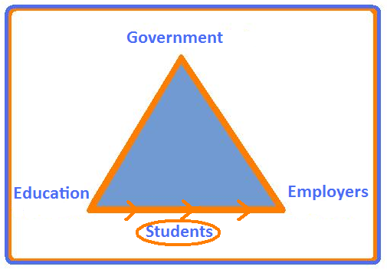

5.1 Labour market

5.1.1 Organisations and companies
The organisations and companies involved in this research are intergovernmental organisations (IGO’s), non-governmental organisations (NGO’s) and (international) companies. Within The Hague, the city has over 310 international organisations and institutions which employ over 18.000 people. These organisations include IGO’s such as the NATO, UN, International Court of Justice, Permanent Court of Arbitration, Yugoslavia tribunal. These international organisations also include NGO’s such as Global Human Rights Defence, Cordaid, International Institute for Communication and Development (IICD), Oxam Novib, and Amnesty international (Guide to international organisations in The Hague, 2013). Furthermore, the city has over 36,000 businesses, including headquarters of multinational corporations such as Aegon, KPN and Shell, employing over 260,000 people (Quality is Key. Dec, 2011).

5.1.2 International Community Platform
The recruitment and retention of high skilled migrants and talents is becoming more challenging for employers in the current labour market. The ‘hard’ factors such as salary and status have become increasingly subordinate. Today, talents also decide their career path based on so called ‘soft’ factors such as the quality of housing, (international) education, healthcare systems, career possibilities for the partner, childcare and a wide offer of culture and leisure opportunities. Specifically on these aspects, which influence the quality of life, the international competition is increasing. The question is: which steps can be taken to effectively increase the ‘quality of life’ for internationals in the Netherlands? (ICP, 2013).
In 2009 the “International Community Platform” (ICP) was founded to react to the issue named above. ICP stimulates alignment between international employers with the shared mission of: “improving the working & living environment for the (international) employees and families in the Netherlands and thereby, the working environment for employers themselves.”
ICP conducts research, analyses the largest discrepancies between the demand of the ‘internationals’ and the local offer of products and services, defines pragmatic solutions and tests the feasibility with the (local) government and entrepreneurs. Then it is up to the local government and entrepreneurs to, in collaboration with the employers, further realize the ideas.
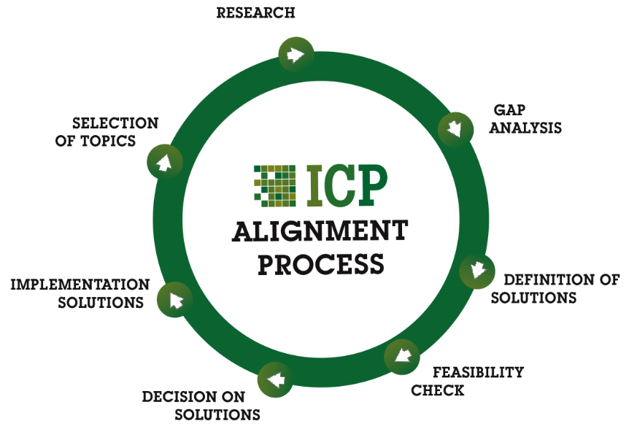
Figure 2. The ICP alignment process (ICP, 2013)
This approach has resulted in a constructive collaboration between employers and service providers in The Hague area. An example of such an initiative of ICP is Check-NL, a toolkit website for internationals within the region. This website serves as a search engine for internationals who want information about availability of healthcare, childcare, housing and more. (Check-NL, 2013). Another initiative of ICP has been the ‘’International City Podium’’, organised in November 2013. This podium provided a stage for internationals, students, volunteers, employees and employers to explore what is ‘’on offer’’ in The Hague region, how to access these opportunities and the ability to share networks to help make The Hague international city work for everyone (International City podium, press release, 2013, Appendix 16.2).

5.2 Educational institutions
Another stakeholder in this research are the higher educational institutions, with a subdivision between Universities and Universities of Applied Sciences (universiteiten and hogescholen). The role of the educational institutions has become more important in the alignment process with the (international) organisations and companies since the report from the committee Veerman (committee future expenses higher education) which came out in 2010. In this report the statement is made that the current educational system is not flexible enough to react to the changing needs of the labour market. Furthermore, the educational institutions were all given the assignment to define plans on how to better fulfil their task of delivering talent to the labour market.

5.3 Local government – municipality of The Hague
The municipality of The Hague is one of the stakeholders which is involved in this research. The municipality is facilitating the closer alignment between the educational institutions and the labour market. Hereby it is creating employment and welfare for The Hague region.
The municipality of The Hague is the third largest municipality in the Netherlands. It has a population of more than 500,000 inhabitants of which almost 49% is immigrant, 35.000 is an expat and 28.000 is a student of higher education (CBS, Sep. 2011). These students are registered at The Hague University of Applied Sciences, InHolland The Hague, Hotelschool The Hague, Leiden University Campus The Hague, Royal Academy of Arts, Royal conservatory and Fontys Hogeschool (Hoger onderwijs in Den Haag, 2012) .
The city establishes itself as international city of Peace and Justice. The ambition of the city is, stated by The Hague City Marketing Vision 2011-2015:
‘In 2020 The Hague will be internationally known as the world’s international headquarters for peace and justice and a dynamic city with five-star quality facilities for living, working, studying and enjoying leisure time. The city will be inviting, welcoming to the world as well as international, multifaceted and inspiring.’ (Feb. 2013)
The policy of The Hague city marketing focuses on The Hague and its juridical organisations, but the city also owes its international climate due to the presence of companies in top sectors such as IT and telecom, pension and insurance, security and Oil and Gas. Furthermore, to respond to (future) human resource needs of these sectors, the city also increased the marketing efforts as ’’Sudentcity’’ (Binnenstadsplan Den Haag, 2010).
As a reaction to the report of committee Veerman, the local governments within the Netherlands have adapted several programs of change. The municipality of The Hague has responded to the report of committee Veerman by introducing the action program ‘’Geslaagd in het Vak’’, more information about this action program can be found in chapter 5.3.2.

5.3.1 Department of Education, Culture and Science
The department of Education, Culture and Science (Onderwijs Cultuur & Welzijn) is a department of the municipality of The Hague. Its mission is, as stated on the municipalities’ website, to ensure that everyone gets good education and is prepared for responsibility and independence. It also wants people to enjoy the arts and aims to create the right conditions for teachers, artists and researchers to do their work (2013). The department has, in cooperation with the educational institutions, local government and employers, created the action program ‘Geslaagd in het vak’ (2011).

5.3.2 Geslaagd in het Vak
The action program ‘Geslaagd in vak’ has been mentioned before in this report, to clarify its purpose and outline its objectives, this section has been put in the research. The start of this action program came as a reaction to the report from committee Veerman (2010). Hereby the adaption of programs of change in aligning the labour market and educational institutions is of paramount importance. The goal of aligning the labour market with the educational institutions helps to improve the functioning of the labour market –the driving force of a well-functioning economy. However, the affiliation of demand and supply in the labour market is insufficient. This has to do with several factors such as a high population of unemployed low educated workers and the high amount of unfilled job vacancies in the technology sector, healthcare sector and (secondary) education, which will only rise in the near future (SER, 2013). In order to react to these factors, the action program has come up with seven focus points. These focus points, as stated in the report ‘Geslaagd in het vak’ (2012) are:
- Making studying and working more attractive in the technological sector
- Addressing the staff shortages in healthcare
- Addressing the staff shortages in the educational field
- Strengthen the promising clusters of Peace, Justice and Security via education
- Encourage entrepreneurship via education
- Help young people with a good career start
- Encouraging labour market dynamics
It is of great importance that the region is able to offer an adequate supply of educated staff in the sectors of Peace, Justice and Security. Hereby, the city needs to cooperate with the educational institutions to develop relevant degree programmes which fill the needs of these sectors. Thus the organisations and companies can share their knowledge and the educational institutions are able to supply qualified employees that meet the specific needs in the sector (Geslaagd in het Vak, 2012).
In 2012, an inventory has been made, investigating the needs of the (international) employers of the regional labour market. The results of this research can be found in Ch. 6.3. To complete the analysis and ensure a multi-stakeholders approach, the focus will now be put on the students’ perspective.

5.4 Students
Students are the future labour force – the talent that will challenge the pressures in the global economy. Students and alumni mentioned in this research are the students and alumni from higher education, who have completed an internship within the past 10 years in the Netherlands at a national or international company or organisation. When there is a reference to ‘students’ or ‘interns’ in this research, we mean the students and alumni that have completed the questionnaire. This questionnaire provides the basis of this research. These students are a sample of the total student population, more information about the questionnaire can be found in chapter 7 and more information about the participants of the questionnaire can be found in chapter 9.
The focus of this report is on students who completed an internship within the Greater The Hague region. However, a part of the completed questionnaires came from students that studied outside of the region. These questionnaires have also been used in the analysis, hereby maximising the number of responses. Students from all study programs were able to fill out the questionnaire.

Theoretical framework

6.1 Access to talent
During the past decade talent management has become a top business and risk area for many companies and institutions (DTTL, 2013). Increasing globalisation in business development, markets and trade impacts on the international competitiveness of countries. More and more experts reason that human resources are the organisation’s most important asset and primary source of competitive advantage (Morton, 2004, 2005). The increased focus on recruitment and retention of talent can be seen as a result of this predominant mind-set. Christensen and Rog emphasize the ability to attract and retain new talent as being the two most important critical people management issues facing organisations nowadays (2005).
A high quality and diverse labour force determines the level and range of innovation and flexibility of a company. Agility has become the new source for welfare (BCG, 2012). The classical model of talent no longer exists, instead talent is employed directly by a company. HR departments now also have to start thinking in terms of talent in joint ventures, contracting relationships, freelance workers and open source talent. With these developments, access to talent in many ways will become as important as acquiring and maintaining it. (DTTL, 2013).
Structural access to talent is a challenge that businesses have to face. And it is a must because ‘talented people are creative, self-confident, self-starters, edgy, resilient, entrepreneurial, intellectually flexible, opportunistic, unique and different’’ (K. Thorne and A. Pellant, 2007). They will make the difference whether a company survives in an ever competitive environment with shortening life cycles of product lines due to technological and social innovations that enter the market on a daily basis (BCG, 2012).
A paradox exists in the western world as the labour market population is ageing rapidly whilst more flexibility and innovation is required. Moreover, the alignment between education and the labour market is suboptimal. Gaps exist in supply and demand for talent, e.g. in the fields of technology, care, education and more (SER, 2013).
The Netherlands did well in acquiring foreign investors. They represent a substantial contribution to our economy. To keep both the foreign investors and Dutch companies satisfied we must perform well in fiscality, political stability and a highly educated labour market. These three factors are decisive in the location policies of the corporates. Our country does well in the first two factors. We can do better in regard to the labour market.
The Netherlands should invest more in developing and/or securing successful recruitment and retention efforts as regards to an (internationally mobile) labour force. Providing high quality programs to students – of Dutch or any other nationality – will contribute to increasing our access to talent, successful recruitment and retaining them for the Dutch labour market (SER, 2013). The (future) position of The Hague, International City of Justice & Peace also builds on this ability to present itself as attractive place for
people to study and work.
Figure 3. The Netherlands is doing well in recruiting and retaining companies. However, the recruitment and retention of talented workers needs improvement

6.2 Students and competitiveness
According to several researches of Groot en Maassen van den Brink on the topic of what a highly educated population can mean for a city, it turned out that having a highly educated population leads to less unemployment, a more healthy population and less criminal activities (2002, 2003). Another positive factor is stated by a research of S. van Ede, I. Blankers & R. Goudriaan in 2010, namely that students have a positive influence on the level of education within a region. S. van Ede et al. also state in their research that students have a positive influence on the regional economy, due to the fact that they have (part time) jobs and thereby spend their money in the region where they study (p. 14-18). Furthermore, in areas where the number of higher educational students is high, the level of innovation is higher as well in comparison to areas with (almost) no students (Hanushek, E. A. & Woessmann, L., 2007). Confirmed by A. Funk and J.H.C. Walenkamp in the research: ‘Binding international Talent to the Netherlands’, the binding of (international) students to the Netherlands increases the competitive position on the global market for highly skilled professionals (2013).

6.3 2012: Talent recruitment according to international employers
In 2012 and in the context of the “Geslaagd in het Vak” program, ICP was approached by the Municipality of The Hague with the request to make an inventory of the specific needs of the internationals employers – as assembled in ICP – as regards recruitment of talent, including interns, trainees, starters and more experienced staff.
The ICP research titled “Talent recruitment according to international employers” addresses the questions of how the international employers recruit their talent, which obstacles they encountered during this process and how (local) educational institutions could help in dealing with these obstacles.
Within the recruitment process of talent five steps have been used to identify the process. These five steps were:
- the strategic staff planning
- definition of profiles
- search for talent
- selecting procedures
- retention of talent
The results of this research showed that there is a diversity between companies and organisations in the way they recruit talent. As an example, intergovernmental organisations have a long procedural and highly bureaucratic way of recruiting their talent. Their talent mainly comes from corporate websites. However, non-governmental organisations tend to recruit their talent only through their networks. Furthermore, (international) companies recruit their talent in a more 'traditional' procedure, through websites, job sites, ads, social media and recruitment agencies.
Another finding in the research showed there is need for better and more structural interaction between the employers and the local higher educational institutions. There seems to be a lack of knowledge about the presence of educational institutions by the employers and vice versa: students and teachers are not always aware of the presence of the international companies and organisations within the region. The contact between these two parties is mostly based on personal network. Another result in this research of ICP showed that – although employers have a preference for candidates with practical skills – the employers tend to focus on academic schooled talent only, thus excluding HBO and MBO students. And finally, a third record in this research showed that the employers have issues with the (in)flexibility regarding timing and starting period of internships set by the educational institutions.
This research focused on the demand side- the employers. However, to gain a balanced view, the municipality and the ICP –under the umbrella of ‘’Geslaagd in het vak’’ found it interesting to see the students’ perspective on the development of careers in the labour market within the Netherlands.

6.4 2013: Talent recruitment according to students
This research examines the view of students focussing on talent recruitment. To create a mirror image with the outcomes of the previous assignment ‘’Talent recruitment according to international employers’’, it was decided that the ICP approach of aligning supply and demand should also be applied to the study on the perspective of students.
This research into the students’ perspective on talent recruitment – in the form of internships – will follow the proven ICP methodology and answer the following questions:
1) What motivates students in regard to their internship: what are their criteria for success?
2) How do they assess their internship – addressing the different phases in the process (orientation, search & selection, internship itself and the period following the internship (retention);
3) Based on the assessment, what suggestions for improvement would students like to make with regard to internship programs?
The ‘rules of the game’ of the ICP approach apply here as well:
- Data gathering using multiple ‘trusted’ sources: via ICP member organisations, ICP relations and social media;
- Focusing on pragmatic solutions only: proposals for improvement have to implementable within one year;
- Checking of the feasibility of proposed solutions with the market: in this case with the educational institutions, (local) government and the employers that will assign the internship.

6.6 Students & Internships: drivers and distractions
Internship: ‘’A job that lasts for a short time, that someone, especially a student, does in order to gain experience’’ (Longman, n.d.).
An internship is important for a students’ total experience of the work field of their study. According to a study of C. Wan et al.(2012) a cooperative curriculum (an internship) enables students to connect theory with the reality of work. Moreover, they note in their research that workplace learning is beneficial to the development of social skills and students also get connections within their chosen industry that may be beneficial for their future careers. Other important components are, as stated by Nobiles (2013): theoretical knowledge can be put into practice, students get experience on how to apply for a job (interview), how to build a network, getting used to working rhythms, getting work experience for their cv and last but not least, finding out where the students’ interests lay.
In the study of C. Wan et al. they note that companies should see interns as human capital rather than cheap labour or a way to cut the labour costs. Companies should provide a workplace that is conducive to learning, provide good mentoring and give the students the time and place to be innovative and creative. Only if these factors are well implemented, one can speak of a successful and fruitful internship program (2012). The positive effects on companies when hiring interns are on the base that interns are almost always enthusiastic about working at the company, -otherwise they would not have applied for the internship- this enthusiasm can influence co-workers in a positive way and even bring new ideas to the company. Another factor is that -due to the current economic climate-, a lot of graduates do not have enough work experience to start a job somewhere, they can use an internship as a kick-start to their career and an asset to their cv (C. Wan, 2012). To conclude, interns, -if they are treated with the respect they deserve-, will be an indispensable asset to a business.
Taking the subject to the Greater The Hague region, in order to align the labour market and educational institutions, providing internship programs in fields where there is a shortage of workers is a good beginning of aligning the supply and demand.

Methods of research
Multiple research methods have been used in order to answer the research questions. These methods will be illustrated in the following sub paragraphs.

7.1 Desk research
Desk research has been done to define the outline and purpose of this research. Study has been made of policy documents, previous performed studies, reports, research papers, books and academic websites. Documents came from the ICP and the municipality. Furthermore, documents were extracted from the schools’ academic search engine, Lexis Nexis, other documents were obtained by using academic search engines. At last, books and reports came from the Royal Library of The Hague and the library at The Hague University.

7.2 Field research
The use of field research has been a big source of information for this research. The most important source of information has been an online questionnaire (Ch. 7.2.3). More field research was done during the quarterly updates of the ICP on September 12th, the working conference ‘Geslaagd in het vak’ on the 3rd of October and during the Captains Conference of ICP on the 4th of October. The participation of these events served as a tool for obtaining information from the different stakeholders involved in this research.

7.2.1 Online questionnaire
Since the perspective of students has been the main focus of this study, the most important method of field research to assess the quality of internship programs amongst students has been an online questionnaire. This questionnaire has been filled out by students and alumni from various educational institutions. These (former) students had to be from HBO or WO studies (comparable to bachelors or master degree students) and had to do or have done an internship within the Netherlands in the past 10 years. To get a broad scope of the students and their internship experience this questionnaire had been completed by students from all kinds of studies.
The questionnaire has been designed in surveymonkey.com, a website supporting the creation and distribution of surveys. The approximate time to fill the questionnaire was 10 to 15 minutes. The questionnaire consisted of 55 questions. The structure of the questionnaire began with personal facts on their geographical, demographical and educational background. After that the four steps of an internship process were researched. The first step focused on the orientation phase, second step on the search and selecting phase, third step on the internship itself and the last step on the retention phase of the internship.
To make the questionnaire more appealing to complete, the ICP arranged a giveaway of five tickets to their End of the Year party at the Hilton Hotel in December 2013. In order to win these tickets, the participants needed to complete the survey and leave their email address at the end. The survey was anonymous, so the students were not obliged to fill in their email address. The outcomes of the survey were treated confidentially and were only used for the purpose of this research.

7.3 Interviews with employers and education
The outcomes of the questionnaire provided insight into the students’ first encounters with the labour market –during their internship program. The international employers’ view has already been researched through ‘’Talent recruitment according to international employers’’ (Ch. 6.4). To complete the triangle between students, employers and education, the feasibility of the proposed recommendations and solutions have been shared with the educational institutions. Their reactions have been implemented in the sub questions (Ch. 9-12), conclusion (Ch. 13) and recommendations (Ch.14).
The following people were interviewed:
- Y. Shitrit – Program director economy, innovation and entrepreneurship, The Hague University
- K.D. Krepa - Coordinator International Marketing & Communications, The Hague University
- T. Nighat – Placement coordinator, teacher finance & control, The Hague University
- J.G. Hoekstra – Teacher academy International Business and Management Studies, The Hague University
- J. van den Oever- Placement coordinator Media and Entertainment Management, InHolland The Hague

Research results
The information provided in the following chapter is based on results of the online questionnaire and input of 5 representatives of the educational field.
The questionnaire was completed by 218 participants that met the requirements – (former) students from HBO or WO studies (comparable to bachelors or master degree students) who did an internship within the Netherlands in the past 10 years. The participants will be referred to as ‘’interns’’ or ‘’students’’ in the report.
They represent the target group, based on a margin of error of 5%, a 95% level of truthfully answered surveys, on a population of 183,000 students that have done or are doing an internship whilst they are currently studying in higher education (2011, stagemonitor). This means that at least 125 students needed to fill in the survey to get a thrust wordy sample of the target group (2013, checkmarket.nl).

8.1 Profile survey participants
The participants of the survey are checked on being representative for the total population of (former) interns. Their profile is checked on demographic features, educational background and the type of internship they did.

8.1.1 Demographic features
- 68% of the respondents are female, 32% are male, their age is between 18 and 34 years with an average of 23 years
- 56% of the participants is Dutch, 44% is of non-Dutch nationality
- 80% is an European citizen and 20% of the participants is a non-European citizen
- 53% of all participants is student, 31% is employee, 7% is unemployed looking and for a job, 3% is entrepreneur, 3% is volunteer and 0,5% is unemployed and not looking for a job.

8.1.2 Educational background
- 56% of the participants studied or studies in higher education (HBO) and 29% is in academic level education (WO)
- The most mentioned fields of study are economics & business (29%), law (21%), language & communication (13%), social sciences (11%) and engineering & design (6%), pedagogy & education (5%)
- 20% of the respondents studied at The Hague University during their internship, 17% at InHolland. 5% at Hogeschool Leiden, 4% at Hogeschool van Amsterdam, 3% at Leiden university and other respondents came from Leiden University Campus The Hague, University College Utrecht, University of Bradfort (UK), Wageningen University, University of Twente, Université de Montreal (CN), University of Barcelona (SP), Radboud University and Universiteit Maastricht.
- 92% did a full time study. 48% has not yet graduated
There are no abnormalities with the population of (former) interns, the division between HBO and WO interns and the nationalities are spread properly, based on the CBS information about the current student population (CBS, 2013).
The five fields of study from law, economics & business, language & communication, social sciences and engineering & design will be used as comparison in the next part of the report. They are best represented among the participants of the survey. These fields of study are also representative when compared to the five most popular studies of academic and higher education (HBO and WO) in the Netherlands, which are social studies, law studies, economic studies, communication studies and psychology (CBS, 2012).

Sub question 1: Orientation phase
How did the interns experience the orientation process, which obstacles did they encounter and what would their ideal situation look like?
For many students the orientation phase is the first and most formal step in positioning their future on the labour market. The participants of the questionnaire (thus the interns) were asked how they underwent this phase. The participants were asked if they felt sufficiently prepared for their next step – from study to labour market. And what kind of support they received in the process of orienting on the labour market.
Internship as first orientation on labour market
Interns were asked to pick the three best ways they got prepared in orienting on the labour market. Hereby, 49% of the interns stated that an internship was the only way they got introduced to life after study. Other reactions were that the participants got prepared through case studies/projects (36%), company visits (27%), guest lectures (24%) and through the help of lecturers that where part-time employed in the field (22%) 16% of the respondents see their extracurricular activities as a good orientation on the labour market. Finally, 26% used job/ career fairs to orientate on the labour market (Appendix 4.1).
Help with orientation
As shown in Figure 3, most of the respondents (44%) got help from their personal network when orienting their future on the labour market. Followed by the claim of 33% of the respondents who did not receive help from anybody during this phase. Furthermore, the answers show that school did not play a big role in this phase; only 2% got help from a mentor at school, nobody got help from their professional network or by a professional coach.
Figure 3. Reactions on the question: “who helped you the most on what to do when orienting on life after study”?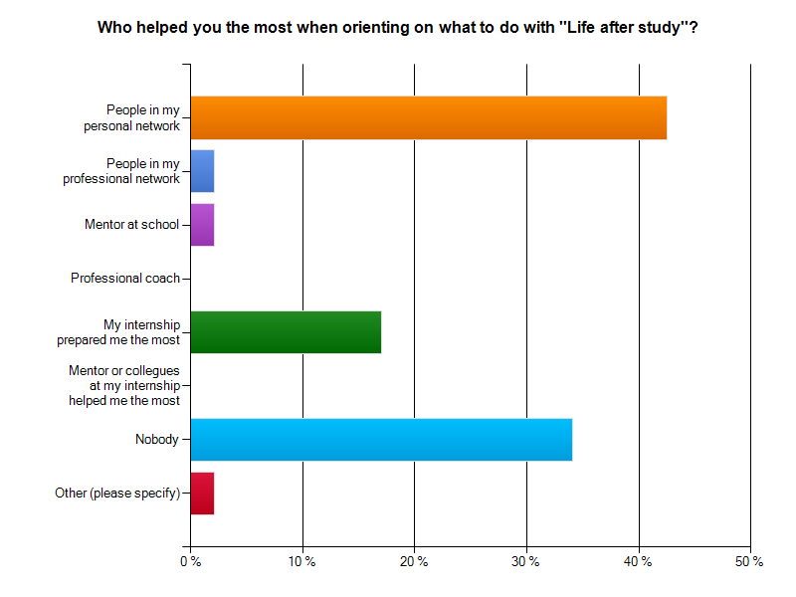
There is a distinction between the help participants got per field of study. Participants who studied in the field of engineering & design (67%), economics & business (53%) and language & communication (37%) received the most help from their personal network. The majority of interns who studied in the fields of law (57%) stated they did not receive help from anybody when orienting on the labour market (Appendix 4.2). Furthermore, a difference is seen between students from higher education (HBO) and academic education (WO). The majority of students from higher education got help through their personal network, whilst the majority of students from academic education stated that nobody helped them in their orientation process, more often they used extracurricular activities in their orientation phase (Appendix 4.3).

Gap analysis
The overall grade the interns gave for the orientation phase was a 6,6. Engineering & design students seemed to be most satisfied with their orientation on life after study, with a 7,0 on average, law students graded it the lowest, with a 5,7 on average (Appendix 4.4).
The general obstacles, stated by a majority of interns, were that they had too little knowledge about future job opportunities, another obstacle encountered was that they would have liked more company visits and thirdly, they had too little knowledge about which companies interested them. The current situation shows that internships are mostly the first moment when students start preparing for the labour market.
Sub conclusion
The ideal situation for students would be a better and earlier preparation on the labour market during their study. The time span for this orientation phase proves to be too short – starting to build up an applicable network and a decent overview of the labour market takes time.
Educational institutions could help students becoming more aware of the benefit of an earlier focus on the labour market and networking. They could offer the support the students request via (more) orientation focused courses, guest lectures and company visits within their study programs. They can also help students to be more aware of the effect of the right network in life after study. By offering networking workshops or emphasize the benefits of extracurricular activities to orientate on the labour market. An important adjustment to the current situation would be to offer this support in the first or second year of the study program.
According to the educational institutions the orientation on the labour market is mostly the student’s own responsibility. The students could do this by visiting career fairs, applying for (online) networks in their fields of study and search for companies that interest them and finding ways to get in touch with them.
Closer contact between employers and education is key when offering guest lectures and company visits. Educational institutions encounter the obstacle that employers tend to find it hard to have one point of contact within the educational institutions to present their internship opportunities.
The international employers say they notice that their presence within The Hague region is often not only unknown by the interns but also within the educational institutions. There is a lack of knowledge on what is on offer and what kind of future opportunities lay within the region (ICP, 2013). Finally, the employers also state that when they do seek contact with educational institutions, this is mostly with universities, rather than with HBO and MBO institutions.
The (international) employers stated in the ICP research that when the educational institutions do seek contact, this is mostly with companies that have a Dutch background and this contact is mainly based on personal contacts. There is no structural contact between the educational institutions.
The recommendations regarding the educational institutions and the companies can be found in chapter 14.

Sub question 2: Search and selection phase
What did the search process of the interns look like, which obstacles did they encounter during this process and what would their ideal situation look like?
The search phase focuses on the application process, the way the interns applied, the tools the interns used, who helped them and which channels proved to be the best. The selection phase looks at their personal requirements regarding their internship and the perceived requirements of the educational institution and organisation. The way the interns rated the applying process, which obstacles they encountered and what their ideal situation would look like is also being implemented in this chapter.
Searching for an internship: search time, application process and used sources
It took the majority of interns an average of 2 to 8 weeks to successfully complete the process of beginning the search and finding an internship. 36% sent one application to get accepted, 35% got accepted after sending 2 to 5 applications and for the rest it took 6 to 15 applications until they got an internship (figure 4).
Figure 4. Number of applications versus the number of weeks of searching and applying before the intern successfully found an internship.
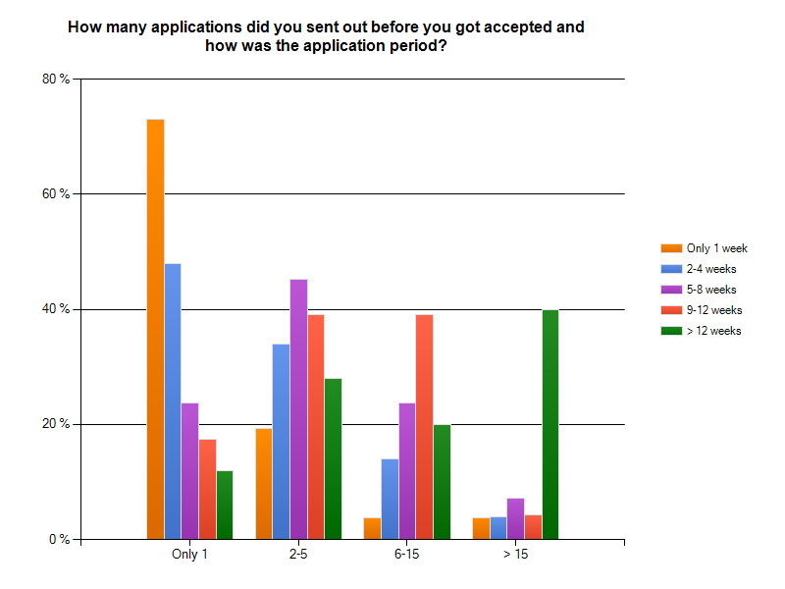

When we divide the interns per sector it is interesting to see in which sectors the participants found their internships faster than others. A majority of interns from language & communication, economics & business and law found their internship between 2 to 4 weeks. It took the majority of engineering & design interns longer to find an internship, the majority spent over 12 weeks to finish a successful application process. This could mean that there are fewer internships available for the engineering & design students or they perhaps had a less sufficient network (Appendix 4.5).
Within the different sectors of business, a remarkable outcome was that interns who applied in the IGO sector on average took longer to finish their application period, than interns who applied at companies or NGO’s (Appendix 4.6). This long period of application can be derived from the fact that IGO’s have a longer procedural application process, with stricter rules and regulations (ICP, 2013).
Most respondents made use of multiple sources on the Internet when searching for an internship: 38% used the company website, 33% used social media, other websites that were popular in searching for an internship were stagemoter.nl (10%), monsterboard.com (10%), stageplaza.nl (9%) and stagebureau.nl (9%). 36% stated they did not make use of any website during their searching phase for an internship (Appendix 4.7).
When the interns were asked which resources they used in their (professional) network, 53% of them stated that friends and relatives proved to be the most helpful, 22% stated that fellow students helped them the most and 35% claimed they did not get any help in their (professional) network (Appendix 4.8). Interns from higher education relied more on their friends when searching for an internship than interns from academic education (Appendix 4.9).
49% claimed they did not use help from school in finding an internship. The students who did make use of school related help in finding an internship, 26% got an internship through the university data base, 22% through the help of professors,11% through their study database, 9% through information sessions by companies and 6% through help of former interns (Appendix 4.10). One intern expressed another source in finding an internship:
‘’I found my internship through speed dating sessions with other students.’’
Selection requirements
When searching for a suitable internship the requirements of three parties have been taken into account, the requirements of the interns and the requirements of the educational institution and the employer as perceived by the student. Which requirements were most important for each party and were there any conflicting requirements?
The three most important requirements from the interns were that there had to be a variety in activities (knowledge and skills) during their internship. The future opportunities within the company were second most important and they had a preference for a well-known organisation (Appendix 4.11).
The most important requirements from the educational institutions –noted by the respondents- were that the internship had to be a fixed time period, this means that the internship had to be a certain amount of months. Furthermore, the internship had to be approved by a mentor/coordinator from the institution and the third most important requirement was that the internship had to be in a specific sector that had to be approved by their institution (Appendix 4.12). A difference between interns from higher education and academic education was, that interns from higher education preferred to do an internship at a profit organisation or business, whilst students from academic education preferred to do an internship at a non-profit organisation (Appendix 4.13).
In the ICP research ´´Talent recruitment according to international employers´´, the international employers were asked the same question. The outcomes from IGO’s were: internships and job applications are via formal procedures. Furthermore, the IGO’s stated that a basic knowledge of French is seen as an advantage when applying for a job/internship in that field.
57% of the interns could apply for an assignment made by the organisation, whilst 31% of the interns made a proposal of their own (Appendix 4.14).
The vast majority had to send a motivation letter plus their CV in order to apply for the internship and 63% had to combine their application with a job interview (Appendix 4.15). Some interns tried to distinguish themselves through their previous work experience in order to get the internship. In addition, their previous work experience seemed to be a plus in their application process because it took them less applications to receive an internship (Appendix 4.16).
When it came to a financial allowance, the interns mostly said (59%) that they would prefer it, but it would not be a show stopper. However 33% stated they would not do the internship if they did not receive any allowance (Appendix 4.17). The amount they expected to receive per month was an average of 383 euro’s. The amount differed for students from higher education and students from academic education, the higher education interns expected to get an average of 279 euros per month, whilst the academic education interns expected to receive 528 euros per month. One intern expressed the following statement regarding an allowance:
‘’Every job should be paid, even it is an internship for an international organization. At least minimum allowance and transport expenses should be covered’’

Gap analysis
The overall grade of the search phase is a 6,9. Within the fields of study the interns from language and communication and engineering & design rated it the highest with a 7,3. The interns from law the lowest with a 6,6 (Appendix 4.18).
The main obstacles the interns encountered in this phase were that they would have preferred a better network which would have enabled them to get in touch with the right organisations. Hereby, having the right contacts could also shorten their search process and having to send a less amount of applications. This corresponds with the orientation phase.
Another obstacle they encountered was that they did not receive the necessary information of the employers on time, which was needed for the schools’ approval. Furthermore, the interns would have appreciated more help in writing a good resume. Some remarks the interns had on their search phase were as followed:
‘’Employers should be less afraid of hiring people from other regions. There is some level of scepticism with non EU nationalities’’
‘’The school could have made some effort to help students find an internship that matched their (latent) requirements. Personally I was fine but some of my fellow students had more difficulty finding the internship that could help them grow in their future careers’’
Sub conclusion
The main difference between the current situation on searching for an internship and the preferred situation lays in the fact that the interns would have liked to have a better network that could have helped them in getting the internship they desired.
The educational institutions point out that it sometimes is not clear to them how the recruitment processes work and which requirements certain companies and organisations require. There is lack of practical knowledge in this field which makes it more difficult to support and advise students in the application process.
The ICP research tells us that IGO’s recruit their talent via their corporate website or recruitment agencies. Vacancies are published internally on the intranet and, if open to external competition, are published on their website. NGO’s tend to recruit their talent via network (often no vacancy). Companies recruit their talent in a more 'traditional' procedure, through websites, job sites, ad’s, social media and recruitment agencies (ICP, 2013).
We also see a conflict of requirements regarding the internship between student, school and employer. The requirements of the students lay in the fact they are looking for an internship where they can practice skills and knowledge. The requirements of the schools make them mostly focus on the right time period, while that frustrates the employers. Employers are mostly looking for the right skills (language & international attitude). Now students have to bridge the gaps in requirements of school, employers and their own.
The recommendations regarding the search process for the educational institutions and organisations can be found in chapter 14.

Sub question 3: The actual internship
How did interns evaluate their internship, which obstacles did they encounter and what would their ideal situation look like?
- The internship took 6 to 12 months for 38% of the interns, for 36% 5 months and for the rest it was a shorter time period
- 66% qualified their internship as a practical internship, whilst 30% qualified it as a research internship
- 29% of the participants based their answers on their third year internship, 26% on their final internship, 17% on extracurricular internship and the rest differed between first year, second year internship or an internship during a master’s study
- 55% of the interns worked in a company, 23% at an IGO, 9% at a NGO and 8% at an educational institution
- 60% of the interns was part of a team during their internship, 20% worked on their own specific assignments, 9% had contact with only a few colleagues and 7% was part of a (temporary) project
- 45% of the interns worked at a company with mainly Dutch employees, 43 % worked at a company with mainly non-Dutch employees
- The interns who did their internship as an extracurricular activity, 40% of them did an internship at an IGO and 40% of them did an internship at a NGO
- The top five most popular organisations were active in justice and peace, economics & business, art & culture, social work and the government
Guidance
63% of the interns stated that the guidance provided by school was mostly done by one mentor. 42% spoke their mentor only a couple of times during the internship (Appendix 4.19- 4.20). An exception are the interns who did an internship at an IGO or NGO, most of them were not assigned a mentor from school. This is due to the fact that interns in this field mostly did their internship as an extracurricular assignment (Appendix 4.21). 64% stated that they had contact with the mentor from the organisations several times per week (Appendix 4.22- 4.23).

Gap analysis
The overall evaluation from the interns was a 7,6. The internship was rated lowest by students from law, with a 7,2. The internship was rated highest by students from engineering & design by a 8,3 (Appendix 4.24). Interns that worked in teams gave a higher grade (7,9) to their overall internship experience than students who only had contact with a few colleagues (6,6) (Appendix 4.25). This grading difference might be due to the fact that working in teams is more appreciated by the interns than working on your own. There was no considerable difference between interns that worked at a company and interns that worked at an IGO or NGO.
An overall obstacle encountered by the interns was that there was too little contact between education and organisations. This is expressed in two concrete dissatisfactions: the guidance during the internship and the wish to do more meaningful work. Other statements the interns made regarding obstacles they encountered in the search phase were:
‘’Resources and support were not enough’’
‘’Internship could have been more organized, I could have received more/better training’’
The obstacle encountered about doing more meaningful work was most frequently mentioned by interns of language & communication and law. They sometimes felt they were not appreciated. Quotes from former interns:
‘’There was no growth or learning process. It was more an assistant to the boss (photocopy and printing and shredding)’’
‘’Organizations should be able to not use internships as an excuse for slave labour and free labour’’
Sub conclusion
The main difference between the current situation and the preferred situation of the interns lay in the fact that the intern would have liked intensified contact between school and the employer. This improved contact could have helped to tune the guidance from school and from the mentor at the internship. Closer contact prior to the start of the internship can also make the internship more meaningful. With more insight in the (expected) skills, knowledge and expertise of a student of a particular level, the employer can adjust his assignment to this level. The educational institutions mention that an internship is the place for the intern to learn to speak up for themselves and learn how to cope with job related issues.
The recommendations regarding the educational institutions and the employers on this matter can be found in chapter 14.

Sub question 4: Retention phase
How did the interns experience the follow up phase, which obstacles did they encounter and what would their ideal situation look like?
Career help
For 26 % of the interns the internship helped in building a network and making contacts. 24% stated that they were able to work at the company or might be able to work there. For others (18%) it was the name of the organisation on their CV that helped them the most (Figure 5).
Figure 5: how did the internship helped the students in their future career?
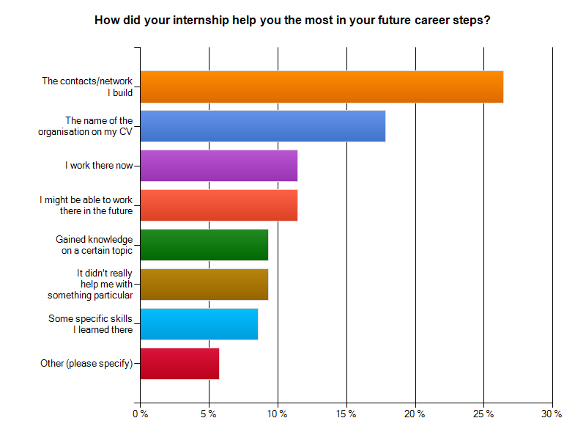
Contact
Over 39% still has contact with their internship company and 26% said they have contact because they work there. 35 % has little to no contact with the company (Appendix 4.26).
The interns who do not have (any) contact with their internship company anymore were asked for their reason. The answer to this question was they did not see a point in keeping contact, they went away from the internship with bad feelings or the internship did not fit the future goals (Appendix 4.27).
Interns from engineering & design (33%) and law (38%) were able to work at the company of their internship. The majority of interns from the other studies stated they still have contact now and then (Appendix 4.28).
Function of the internship
A majority of the interns from businesses stated that the internship helped them in building a network. A majority of the interns from IGO’s stated that the internship organisations’ name was an asset to their cv (Appendix 4.29).
The network function of an internship was mentioned as being most important by interns that came from studies such as economics & business (36%), social sciences (21%) and language & communication (26%). For a majority (33%) of the students from engineering & design the internship helped them with the knowledge/experience they retrieved on a certain topic (33%). For a majority from the interns of law (21%), the company/organisations name served as an asset to their CV (Appendix 4.30).

Gap analysis
The evaluation of the ‘’follow up’’ phase was rated with an average of 6,9. The lowest grade came from law interns with a 5,6 and the highest grade came from interns of social studies with a 7,4 (Appendix 4.31). Within the different sectors, the interns from IGO’s rated the retention phase the lowest with a 6,2, the interns from NGO’s rated it with a 6,4, whilst the interns from business companies rated it the highest with an average of a 7,2 (Appendix 4.32).
When the interns were asked about the biggest obstacles they encountered in this phase, the majority stated that the employer could have invested more in the closure, for example in personal feedback. The employers could have had a personal feedback session with the intern and mentor from school, to evaluate the internship and to make the students become aware of his/her personal qualities.
Sub conclusion
The main difference between the current situation and preferred situation lays in the fact that the interns would have liked more personal feedback after the internship period ended. The employers stated in the ICP research that they would prefer one point of contact within the educational institutions.
The educational institutions say they already implement the desired closure and feedback A competence list is filled in at the beginning of the internship and is evaluated multiple times throughout the internship.

Conclusion

‘’What are the required improvements regarding internship programs from a student’s perspective’’
In this chapter the overall experience of the interns during their internship is evaluated, the obstacles they encountered are looked at the improvement on the current situations are evaluated. The perspective of the students is considered to be the most important. The opinion of the educational institutions and organisations will also be taken into account.

13.1 Conclusion orientation phase
The orientation on the labour market is not taken into account during the studies. The first step in this orientation usually starts during the search for an internship, which often is in the third or final year of study. A moment too late to choose an internship that prepares well for a first step on the labour market. This preparation takes time, the students need an overview of the labour market, insight on their career possibilities based on their personal qualities and a network that can help them achieve their career goals.
The international employers underline the fact that their presence is mostly unknown. If a relationship exists this is usually between them and universities, rather than HBO and MBO institutions.
To create properly prepared students for their future career, a good orientation on the labour market is essential in the early phases of the students’ study.

13.2 Conclusion search and selection phase
Within the search phase, the importance of having a valuable network is again emphasised by the interns.
The expectations of the interns about the search phase did not always meet the outcome. They stated that training in writing a good resume would have been useful.
To prevent any disappointments, the students should be better informed about the recruitment processes of the different types of employers. For example; the application process at IGO’s takes longer for internships at businesses or NGO’s. This can be derived from the fact that IGO’s have a longer procedural application process, with stricter rules and regulations in which the interns must apply to.
One of the most important requirements –stated by the interns- from school was a fixed time period. This means that a majority of the interns could not be flexible about the time they have to do an internship. When a student wishes to do an intern at an IGO an earlier start with the application process is needed. However, the students seem to be unaware of this fact.
The most important requirement from the interns was that they would like to gain knowledge and improve skills during their internship. This matches with the most important requirement from organisations since they are looking for an ‘’all-rounder’’; an intern that possesses a variety of skills and knowledge. Some interns wished that the employer could have been more clear about their requirements.

13.3 Conclusion actual internship
The overall grade the interns gave to this phase was relatively high (a 7,6). However, the expectations of the interns did not always meet the outcome of the internship, they were sometimes disappointed about the fact that they did not get as much responsibility as they desired or the work they did was not supportive for the improvement of their knowledge and skills.
These unfulfilled expectations can be derived from the fact that the interns might not know what to expect at their internship and vice versa, the expectations of the employers concerning knowledge and skills of the interns are sometimes too high. Furthermore, according to the interns, the mentor from school did not have an insight view on the actual work the intern is doing.
The guidance from school could also be intensified, since most interns only had contact with their mentor a couple of times during the internship.

13.4 Conclusion retention phase
A majority of the interns stated they have had contact with the company only a couple of times since their internship finished. This was considered unfortunate because better contact could result in an asset in their network and might be useful for their future careers.
What is remarkable of the internships is that in the survey, the students stated that when looking for an internship, the most important asset was that they gained knowledge and skills. However, looking back at the internship, they see that the contacts and network they built seemed to be a more important asset. This is in alignment with the outcomes throughout the whole report, since the importance of having a valuable network would have helped the interns in their orientation and search phase. At the end of the internship they see the importance of actually having a valuable network.
Furthermore, interns who had an internship at an IGO or NGO rated the follow up phase lower than interns that did their internship at a business company. This outcome can be derived from the fact that internships at certain IGO’s forbid the intern to immediately work after their internship period. The interns have to wait between 1 to 6 months before they can apply for a job at the IGO. However, an internship at an IGO can be of such quality that it would not matter for certain interns.
A last point made by the interns was that they appreciated a personal feedback session at the end of their internship. This session could consist of the three parties involved in the internship, namely the intern, the mentor from the organisation and the mentor from the educational institution.

Recommendations
This final chapter of the report supports the recommendations for international employers and educational institutions. The recommendations are drawn from the outcomes of the questionnaire, interviews with interns, alumni and people from educational institutions and the previous performed research of the ICP ‘’Talent recruitment according to international employees’’ (Ch. 7, methods of research).

14.1 Recommendations for orientation phase
The implementation of labour market orientation in an early stage of the study course could be very helpful. The students could get an impression on ‘’what is out there’’. One recommendation would be on the base of providing business professionals who can give lectures or organise company visits. Another method is providing case studies for students based on actual labour market trends. With these proposals, the companies and organisations get the chance to present themselves and make the students aware of their presence in the region.
Another recommendation is to present the opportunities within the region at the very beginning of the students orientation, namely during the Open Days. The educational institutions could present the presence of companies and organisations as a ‘’plus factor’’. This enables the students to become aware of the opportunities and possibilities in both national and international companies and organisations which lie within the region of The Hague.
The last recommendation aims at giving the students trainings on how to write a good resume, how to do a job interview and improve their networking skills. These trainings should be given at the start of the study courses, so the students become aware of the importance of having a valuable network and how to achieve this. In this way, students get the opportunity to start orienting on what companies match with their career goals and furthermore focus on forming their network.
Quotes by visitors from the International City Podium on building a network:
‘’Employers could help students build up a network by organising a (school related) project with the help from experts’’ – stated by an employee of ESA – ESTEC
‘’Educational institutions could help the students by showing them they already possess a network, namely their friends, family and relatives. There could be job opportunities closer than they would think’’ – stated by an employer

14.2 Recommendations for the search and selection phase
The following recommendation covers the encountered obstacle of the educational institutions’ most important requirement, namely the fixed time period for an internship. One proposal that could solve this problem is providing better information from both sides concerning time, expectations and duration of the internship.
Students who wished to do their internship at an IGO came across procedural boundaries that complicated and delayed their application process. The educational institutions could help the students who wish to do an internship in this field by providing information sessions about these strict rules and regulations regarding the application process. Furthermore, someone in the field of the international organisations could provide an annual training at the educational institutions for these interns on the exact requirements regarding the resume, job interviews and other legal documents.
Thirdly, a recommendation given to the educational institutions is a proposal in which former interns can provide an active role in the search process for the future interns. This could be through speed dating sessions. Within these session the former interns can share their experience about their own internship. These interns could also help the future interns in their search process, prepare them for what they can expect during the internship and give tips about how they could close their internship in the best possible way.
The following recommendation could help the interns by providing them with an overview on all the companies and organisations that are present within the region. A general overview could be posted on blackboard (students manual) where the organisations and companies can post their internship placements on their own page. Hereby, non-obvious –but high quality- internships can be introduced to the students. This overview can broaden the internship possibilities, so the students do not only look for internships at the ‘’big names’’ (such as Shell, KPN, Aegon etc.) but also get the chance to see interesting internships at smaller companies, NGO’s and IGO’s within the region.
The fifth recommendation concerns communicating the difference between HBO and WO to international companies and organisations. The educational institutions could provide a clear form where these differences are explained. Thus enabling companies and organisations to look for the right interns and students in finding the right internships.
Finally, the (international) organisations and companies must not only look for interns at academic education. In the ICP research the employers stated they have internship possibilities in different sectors of the company. Herewith interns from HBO (and even MBO) studies can be a perfect match for organisations and companies.

14.3 Recommendation for internship itself
One recommendations given is to assess the expectations of interns and employers before the internship starts. Hereby you avoid false expectations from both sides.
In order to improve the communication between the educational institutions and the organisations it would be wise to organise a meeting within the first period of the internship. This meeting should be attended by student, employer and mentor from school. Hereby the mentor from school can get more insight of the actual assignments. At the same time, the intern also has someone to fall back on if an issue with their company should occur.

14.4 Recommendation for retention phase
A recommendation in this phase is that the organisations and companies should invest more in the retention of the interns after their internship ended. The organisations could inform the interns about vacancies in their company or keep them updated through their newsletter. An event such as an annual meeting with all the former interns at the company could prove to be a perfect asset to the network of the intern, as well as for the companies and organisations. A good retention is regarding the intern as an asset for their ‘’pool of talent’’ and as a possible future employee.
Another recommendation regards the educational institutions. They should also take some kind of responsibility in the retention phase, namely providing (at least) one personal feedback session after the internship has ended. This feedback session should be with the three parties involved in the internship.
The final recommendation is that the educational institutions could invest more in the retention with their students. Former students working in international companies and organisations within the region, can share their experiences about the labour market with the students. Organising an annual ‘’meet and greet’’ with alumni, enhances the bond between alumni and educational institutes as well as allowing students to expand their network and receive helpful information and tips. This could also provide opportunities for forthcoming internships. This allows the intern to be well equipped when entering the labour market!

References

Books
A. Bontekoning. (2012). Generaties! Werk in uitvoering. ISBN: 9789490463212. Netherlands, Amersfoort: De Vrije Uitgevers
K. Thorne & A. Pellant (2007). Managing talent. How top companies recruit, train and retain the best employees. ISBN: 978-0749444631. Great Britain, London: Kogan Page

Internet
Centraal Bureau voor de Statistiek. Beroepsbevolking; geslacht en leeftijd,
(September 2013). Retrieved on 7th of October, 2013 from CBS web site:
http://statline.cbs.nl/StatWeb/publication/?DM=SLNL&PA=71738ned&D1=0-6,22-23&D2=a&D3=a&D4=0&D5=l&VW=T
Centraal bureau voor de Statistiek. Jaarboek onderwijs in cijfers. 2012. Retrieved on 21st of October, 2013 from web site: http://www.cbs.nl/NR/rdonlyres/3036B4E1-A671-4C9E-
95BF-90C0493B4CD9/0/2012f162pub.pdf
Checkmarket. (2013). Enquête oplossingen. Retrieved on the 14th of October from web site:
http://nl.checkmarket.com/marktonderzoek-hulpbronnen/steekproefgrootte-
berekenen/
City Marketing The Hague, The Hague’s city marketing policy.(February, 2013). Retrieved on
7th of October, 2013 from web site: http://en.denhaag.nl/en/business/to/The-Hagues-
City-Marketing-policy.htm
Hanushek, E. A. & Woessmann, L. (2007). The role of education quality for economic growth. World Bank Policy Research Working Paper No. 4122. Retrieved on the 10th of October at SSRN web site: http://ssrn.com/abstract=960379.
L. Kusak. SER. (2013). SER-advies over binden van internationale studenten. Retrieved on October 20th from SER web site: http://www.ser.nl/nl/sitecore/ content/Internet/nl/Publicaties/Overzicht%20SER%20Bulletin/2013/februari2013/talen
t-vasthouden.aspx
Longman Dictionary.(n.d.) Dictionary of contemporary English. Retrieved on October 15th from web site: http://www.ldoceonline.com/dictionary/internship
Ministry of Education, Culture and Science. (2013). Retrieved on October 15th from Government web site: http://www.government.nl/ministries/ocw
Nobiles. (2012). Waarom stage lopen? Retrieved on 15th of October from Nobiles web site:
http://www.nobiles.nl/index.php?id=12&article=479
Rijksoverheid (2013). Techniekpact: gezamenlijke actie voor meer vakmensen. Retrieved on
10th of October, 2013 from Rijksoverheid news on web site: http://www.rijksoverheid.nl/nieuws/2013/05/13/techniekpact-gezamenlijke-actie-voor- meer-vakmensen.html
Studentenbureau. (2011). Stagemonitor. Rapportage mei 2011. Retrieved on 14th of October from web site: http://universonline.nl/wp-
content/uploads/2011/05/StudentenBureau_Stagemonitor_2011.pdf
The Hague Marketing. (2013). Image homepage. Retrieved on October 20th 2013 from web site: http://www.thehagueomc.com/imagebank/flex/clean/list/denhaag
Volkskrant (2010). Commissie hoger onderwijs: Meer geld en betere keuzes. Retrieved on 30th of October, 2013 from Web site: http://www.volkskrant.nl/vk/nl/2686/Binnenland/article/detail/998655/2010/04/13/Com
missie-hoger-onderwijs-Meer-geld-en-betere-keuzes.dhtml

Reports
A. Funk & J.H.C. Walenkamp. (2013) Binding international talent to the Netherlands. The Hague University of Applied Sciences. Research Group International Cooperation. ISBN: 978-90-73077-508
B. Adachi, M. Gretczko & B. Pelster. (2013). Deloitte: Human Capital Trends 2013
Leading indicators. Retrieved on 31st of October from web site: http://bit.ly/XhgCTw
Chin-Sheng Wan , Jen-te Yang ,Shu-yun Cheng & Chiakai Su (2012). A longitudinal study on internship effectiveness in vocational higher education, Educational Review, 65:1, 36- 55. Retrieved on October 10th 2013, from web site: http://www.tandfonline.com.proxy.library.uu.nl/doi/pdf/10.1080/00131911.2011.63496
9
Committee Veerman. (2010). Differentiëren in drievoud, omwille van kwaliteit en verscheidenheid in het hoger onderwijs. Advies van de Commissie Toekomstbestendig Hoger Onderwijs Stelsel (Advice from the committee future expenses higher education). Retrieved on November 3rd 2013, from web site: http://www.nvao.net/page/downloads/Rapport_Differenti__ren_in_drievoud_commissi
e-Veerman.pdf
Department for Urban Development - Economic Affairs, Municipality The Hague. (2011).
Quality is Key. The Hague. PDF file: 15930-1.
Gemeente Den Haag, dienst OCW. (2012). Hoger onderwijs in Den Haag. Positie bepaling en Agenda.
Gemeente Den Haag. (2010). Binnenstadsplan Den Haag, ‘’Naar een complete Haagse Binnenstad, 2010-2020’’. Retrieved on November 3rd, 2013 from web site:
http://www.kvk.nl/download/Binnenstadsplan_2010-2020%5B1%5D_tcm14-
258107.pdf
Guide to International Organisations in The Hague. 2013. City of The Hague. Retrieved on 30th of October from web site: http://www.denhaag.nl/en/business/international-The-
Hague/to/NonGovernmental-Organisations-NGOs.htm
Groot, W., & Maassen van den Brink, H. (2003). Investeren en terugverdienen: Inverdien- en welvaartseffecten van onderwijsinvesteringen. Rapport voor het Sectorbestuur Onderwijsmarkt.
Groot, W., & van den Brink, H. M. (2002). Investeren en terugverdienen: Kosten en baten van onderwijsinvesteringen. Rapport voor het Sectorbestuur Onderwijsarbeidsmarkt.
H. Kurstjens, J.W. Maas & T. Steffens. (2012). The Boston consultancy Group. Contouren van een nieuw Nederlands verdienmodel. Retrieved on 4th of November, 2013, from web site: http://www.bcg.nl/documents/file120331.pdf
J. Christensen Hugens & E. Rog. (2008). Talent management: A strategy for improving employee recruitment, retention and engagement within hospitality organizations. PDF file from journal retrieved on Emerald web site on 8th of October, 2013: http://www.emeraldinsight.com/journals.htm?issn=0959-6119
J. Einstein. (2013). P. 33: The new greatest generation, Why millennials will save us all. TIME magazine. ISBN: 9770928843102
M. de Valk. Hoger onderwijs en arbeidsmarkt. (2013) ING Nederland. Internal document \
Planbureau voor de Leefomgeving. (2011). De internationale concurrentiepositie van de topsectoren. Den Haag: Planbureau voor de Leefomgeving. Retrieved on the 15th of October from web site: http://www.pbl.nl/sites/default/files/cms/publicaties/PBL_2012_Internationale-
concurrentiepositie-topsectoren_500210003-deel-1.pdf
S. van Ede, I. Blankers & R. Goudriaan. 2010. Studenten maken de stad? De impact van Nederlandse en buitenlandse studenten op hun gaststad – lessen voor Den Haag. A research in assignment of the municipality of The Hague. Aarts De Jong Wilms Goudriaan Public Economics BV (APE).
Survey. 2013. The quality of my internship program.
https://www.surveymonkey.com/s/3TNHCS5
Topteam Hoofdkantoren. (2011). Actie-Agenda ter versterking van het vestigingsklimaat, de
acquisitie en het behoud van internationale bedrijven en talenten. Report of Topteam
Hoofdkantoren.

The Hague University of Applied Sciences (2012). Academic year 2012- 2013. ES4 Guide for
Final Project and Dissertation

The Hague University of Applied Sciences (2013). Academic year 2013- 2014. ES4 Guide for
Final Project and Dissertation

Appendixes

Appendix 1: Different Generations and their characteristics
Generations | Date of birth | Characteristics | Quotation
Silent generation | 1925- 1940 | Law-abiding, behaved like was ‘’expected’’ of them | ‘’Youth today has little cynicism, because it never hoped for much’’  TIME, Nov. 1951
Protest generation, Baby Boomers | 1940- 1955 | As leaders: Idealistic and passionate democrats.  As seniors: vital idealists who want to stay useful and active | ‘’They want to be recognized as individuals, but individuals play a smaller and smaller role in society’’  Senator R. Kennedy, on hippies, in TIME, July 7, 1967
Generation X/ Lost generation | 1955- 1980 | Fast connectors, constructive exploitation of diversity; focused on working ‘’together’’ to achieve results | ‘’Our generation has had no great war, no great depression. Our war is spiritual. Our depression is our lives’’  From Fight club by C. Palahniuk, published in 1996
The millennials, Generation Y, Generation Einstein, Boundless Generation | 1980- 2000 | Creative and authentic multi-taskers, want to work flexible and equivalent in an ‘’open’’ atmosphere | ‘’God didn’t give me these talents to just sit around being a model or being famous. I want to lead a huge organization. I want to lead a country for all I know’’  A. Neiers, member of ‘’the Bling Ring’’
The Bright Generation, Y² Generation, Generation Z; the Digi-generation (based on preliminary observations) | 2000- 2015 | Free, bright spirited minded, are very conscious about their environment
Sources: A. Bontekoning (2012).Generatie! Werk in uitvoering. J. Einstein (2013) The new greatest generation TIME magazine.

Appendix 2: Press release International City Podium

International City Podium: kansen in Den Haag
Op dinsdag 5 november vindt het eerste International City Podium plaats, een carrière boost voor professionals en studenten met ambities in de internationale sector van Den Haag. Doel is het vergemakkelijken van ‘de volgende stap’; in werk, studie, ondernemerschap of vrijwilligerswerk. Inzet is een zo aantrekkelijk mogelijk investeringsklimaat voor (internationale) investeerders en organisaties. Een hoog opgeleide en goed functionerende arbeidsmarkt is daarbij randvoorwaarde.
Op het International City Podium zijn vertegenwoordigers van veertig internationale bedrijven en organisaties zoals Shell, Schlumberger, EPO, ESA Estec, Europol, het Internationale Strafhof, onderwijs instellingen (TU-Delft, Campus Den Haag, Haagse Hogeschool, INHolland), Kamer van Koophandel én vrijwilligersorganisaties (ACCESS, PEP).
De bijeenkomst vindt plaats in Career Plaza in New Babylon. Al 500 geïnteresseerden hebben zich aangemeld.
Het International City Podium is een initiatief van het International Community Platform (ICP), de gemeente Den Haag en het Ministerie van Buitenlandse zaken. Alexander van Noort, voorzitter van het ICP en Country manager NL/DK Schlumberger spreekt Marleen Zuijderhoudt, directeur WFIA over Den Haag als zakenstad, Aart-Jan Smits van Thales zal laten zien welke kansen de ontwikkeling van The Hague Security Delta biedt en Sam Muller, directeur van het HiiL laat zien dat de Vrede & Recht sector op zoek is naar meer dan alleen juristen.
Wethouder Van Engelshoven (Onderwijs en Dienstverlening) en Klein ( Jeugd, Welzijn & Sport) zullen aanwezig zijn. Het evenement draagt bij aan de realisatie van de doelstellingen van “Geslaagd in het Vak”, het programma waarbij overheid, onderwijs, ondernemers en werkgevers in Den Haag gezamenlijk werken aan een optimale aansluiting tussen onderwijs- en arbeidsmarkt.
Het Internationaal City Podium zet hierbij in op behoud van talent – uit binnen- of buitenland – door te laten zien wat er allemaal mogelijk is, welke behoeften bestaan in de kansrijke sectoren, het instappen te vergemakkelijken, door de verwachtingen van talent te beantwoorden.

Over het programma, sprekers en partners: zie www.internationalcitypodium.nl
Over ICP: zie: www.ICPlatform.nl
Contact: Nicole van Haelst: Mobiel: +31 (0)6 54980909 E-mail: vanhaelst@ICPlatform.nl

Appendix 3: Overview participants of ‘’Geslaagd in het Vak’’:

AOC Wellant
Bouwend Nederland, Afdeling Haaglanden
Calibris
Campus Den Haag, Universiteit Leiden
De Haagse Hogeschool
Ecabo
FME-CMW, Regio West-Nederland
Gemeente Delft
Gemeente Den Haag
Gemeente Leidschendam-Voorburg
Gemeente Midden-Delfland
Gemeente Pijnacker-Nootdorp
Gemeente Rijswijk
Gemeente Wassenaar
Gemeente Zoetermeer
Haagse Academische Coalitie
Hoofdbedrijfschap Ambachten
Hogeschool Inholland
International Community Platform
Kamer van Koophandel Den Haag
Kenniscentrum Handel
Kenteq
Kone, Liften en Roltrappen
Koninklijke Metaalunie, district Zuid-Holland
Lentiz MBO Greenport
Middin (voorheen Steinmetz de Compaan)
MKB Den Haag
Museon
Netwerk Ondernemend in Zorg
Platform Zelfstandige Ondernemers
Regionaal Platform Arbeidsmarktbeleid Haaglanden
Rode Loper
ROC ID College
ROC Mondriaan
Scholengroep Den Haag Zuidwest
Scholengroep Spinoza
Stichting Samenwerking Beroepsonderwijs Bedrijfsleven
Stichting Champs on stage
Stichting Lucas Onderwijs
Stichting VO Haaglanden
The Hague Security Delta
Trigion
TU Delft
UWV Werkbedrijf Den Haag/Leiden
VNO-NCW Den Haag
ZW Haaglanden

Appendix 4: Answers of the questionnaire
Appendix 4.1.
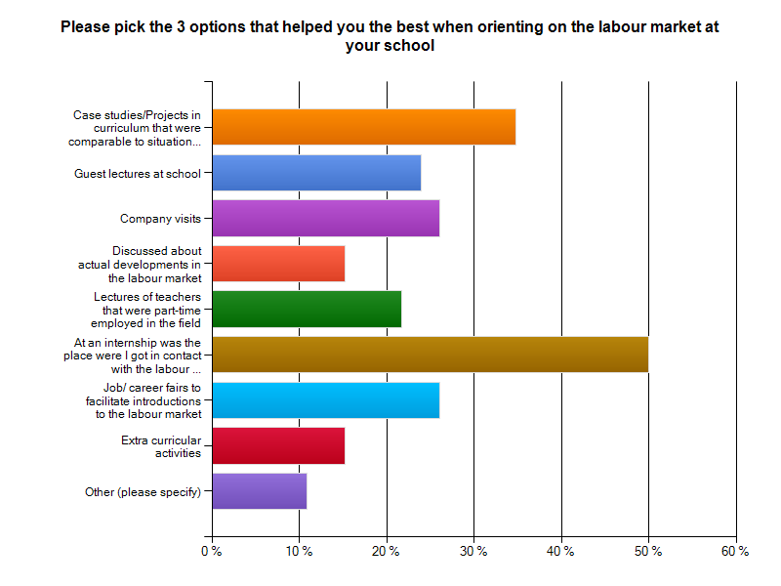

Appendix 4.2
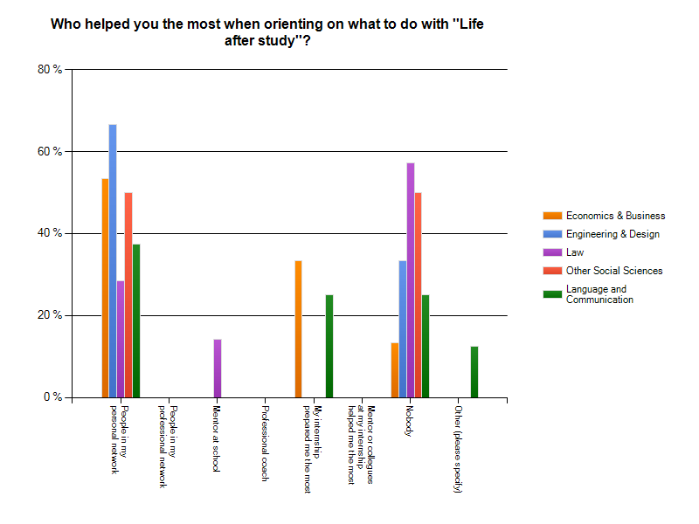

Appendix 4.3
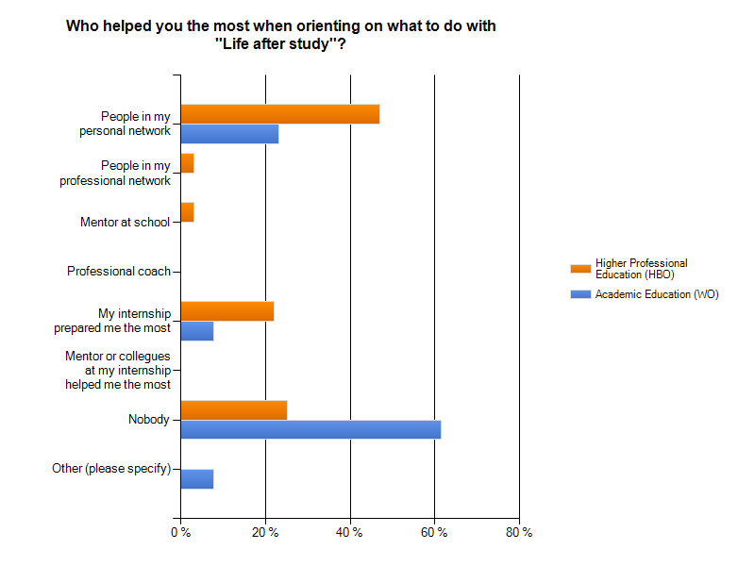

Appendix 4.4
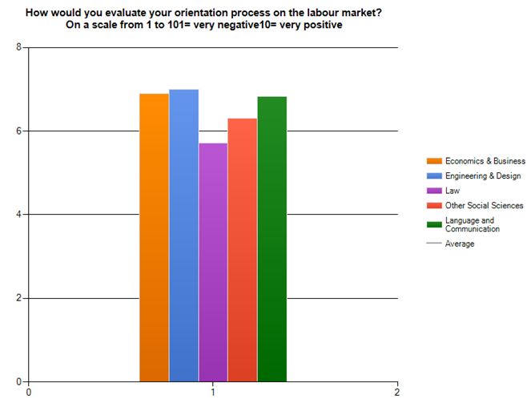

Appendix 4.5

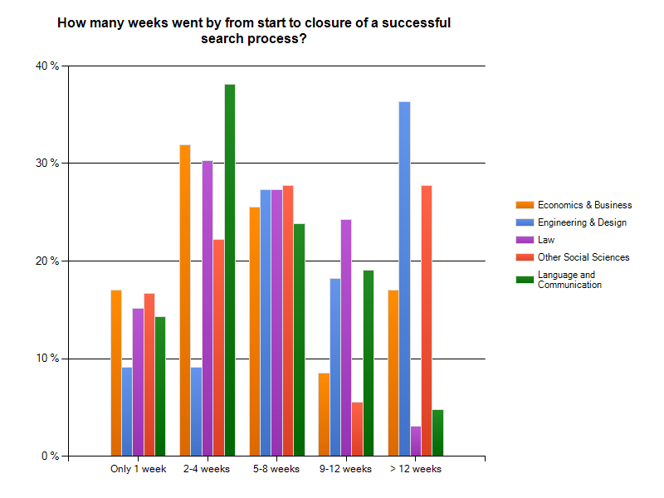

Appendix 4.6
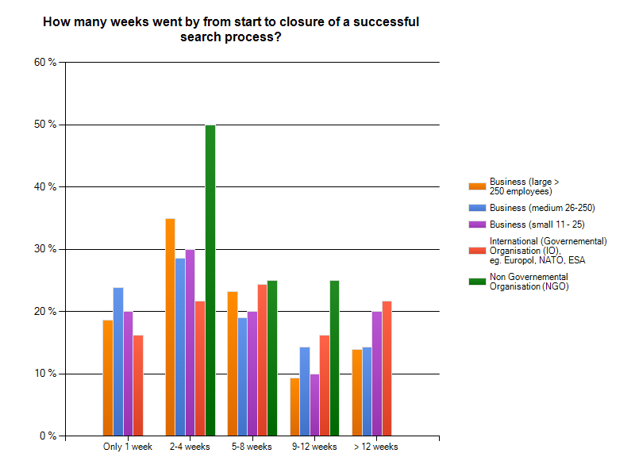

Appendix 4.7
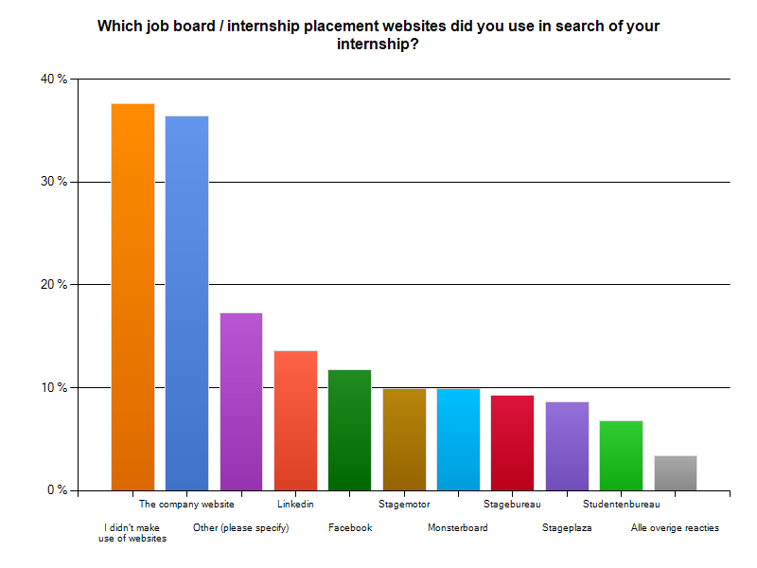

Appendix 4.8
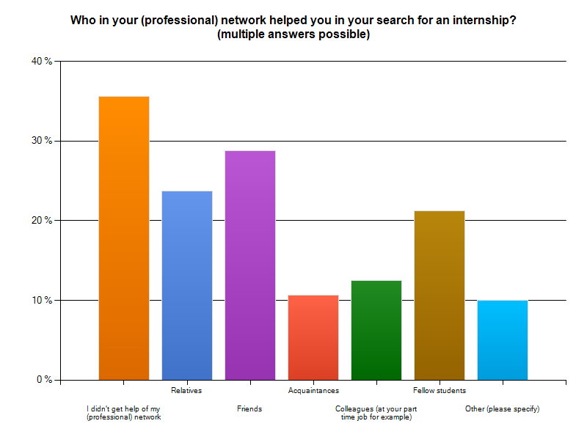
Appendix 4.9
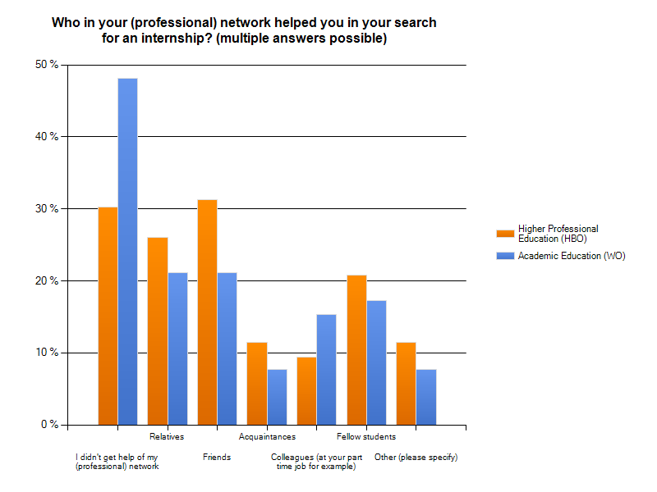

Appendix 4.10
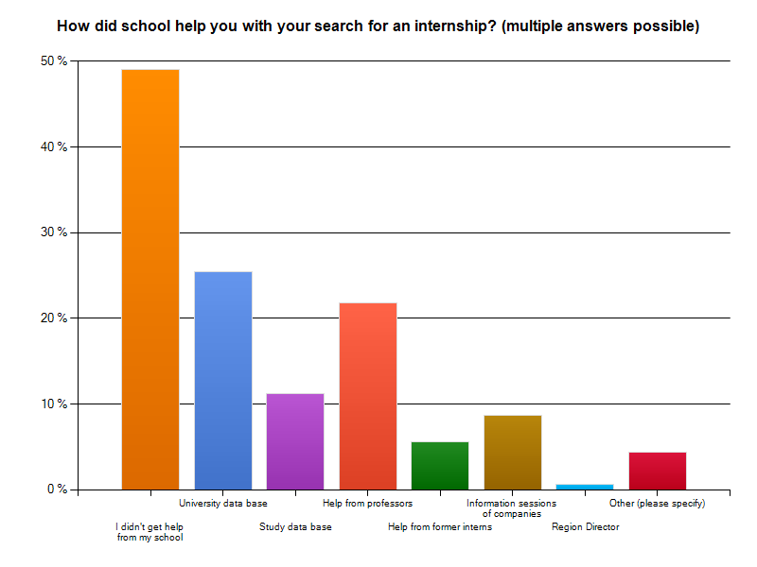

Appendix 4.11
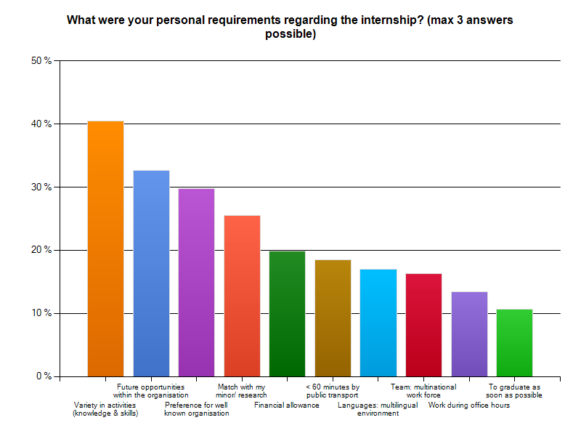

Appendix 4.12
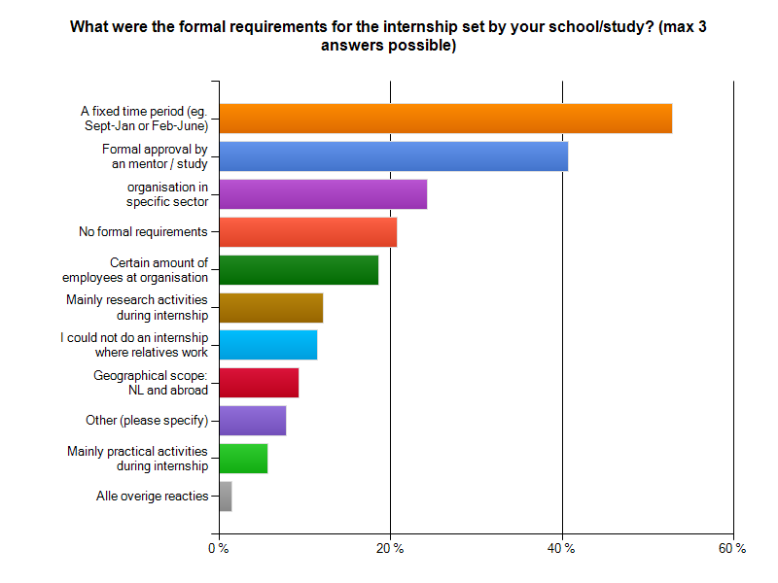

Appendix 4.13
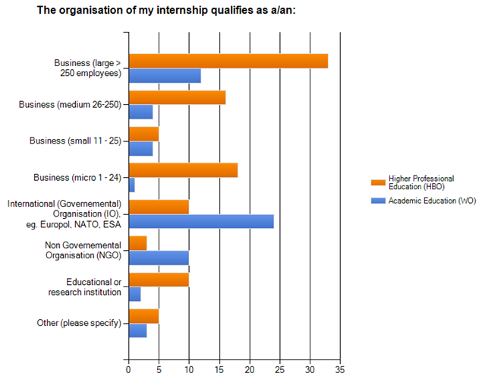

Appendix 4.14
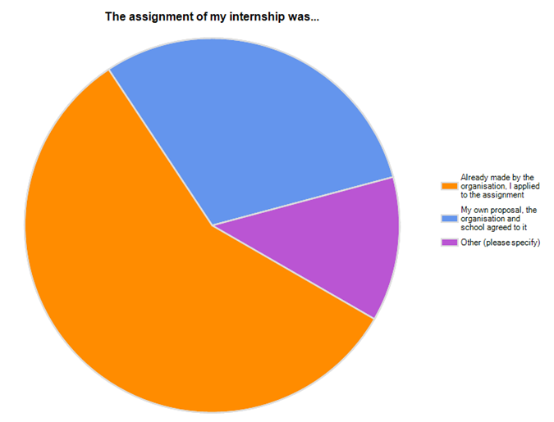

Appendix 4.15
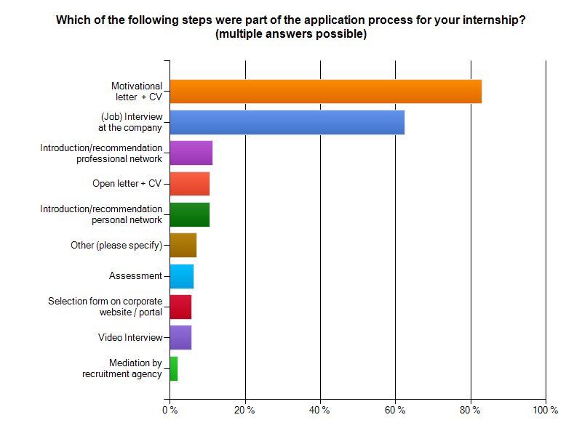

Appendix 4.16
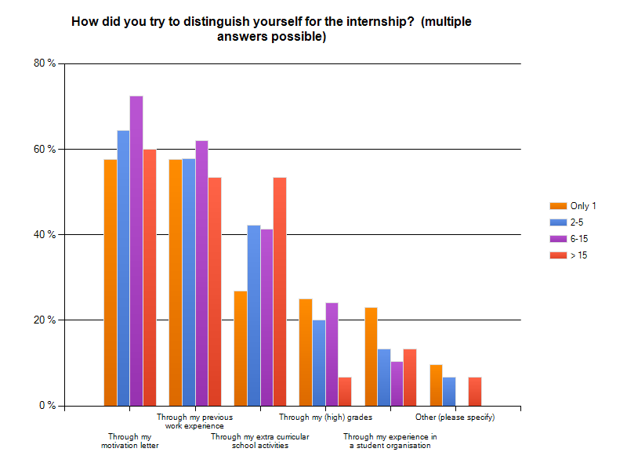

Appendix 4.17
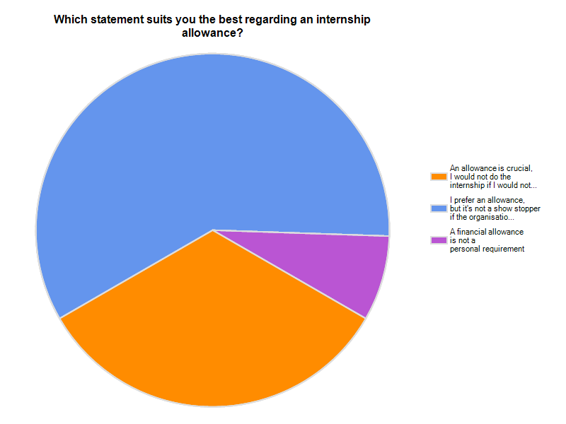

Appendix 4.18
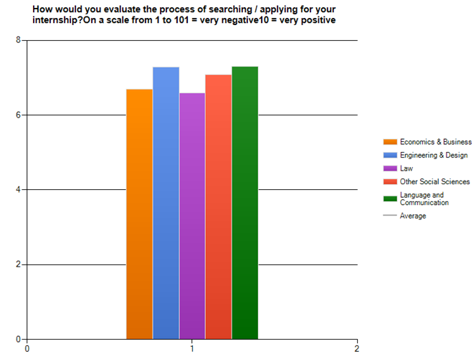

Appendix 4.19
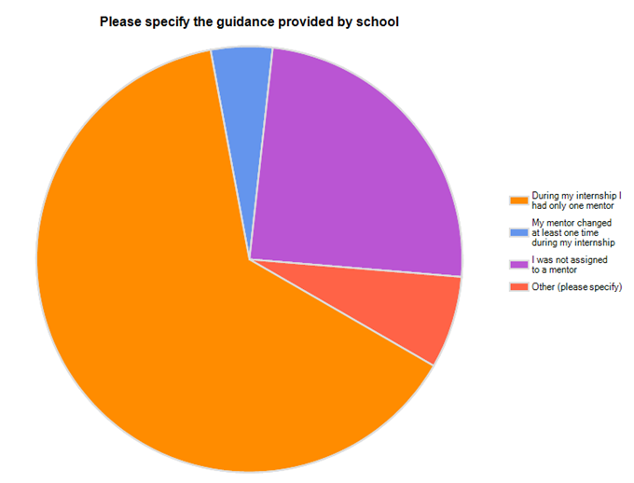

Appendix 4.20
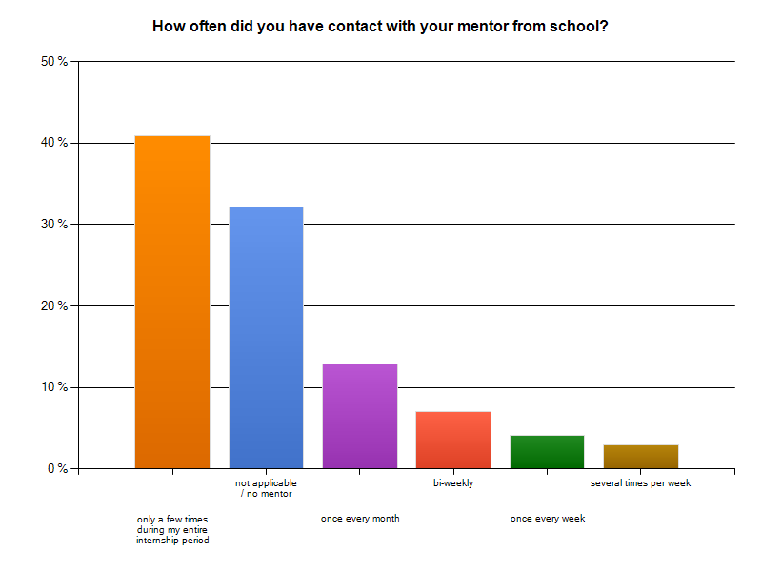

Appendix 4.21
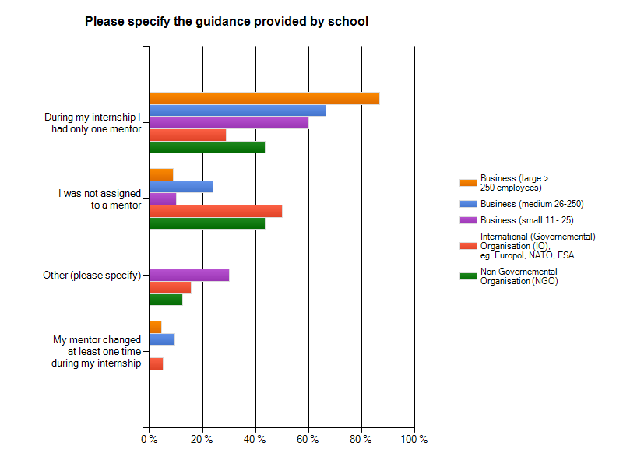

Appendix 4.22
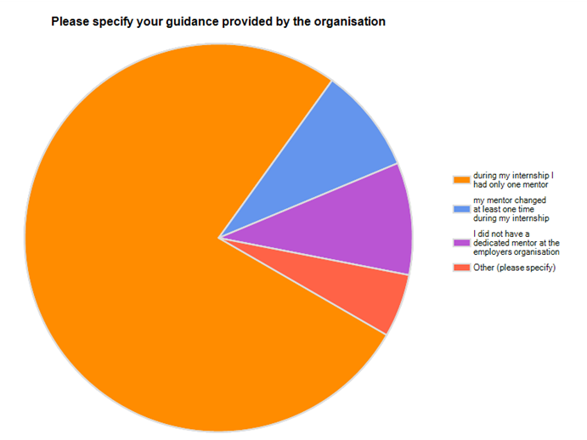

Appendix 4.23
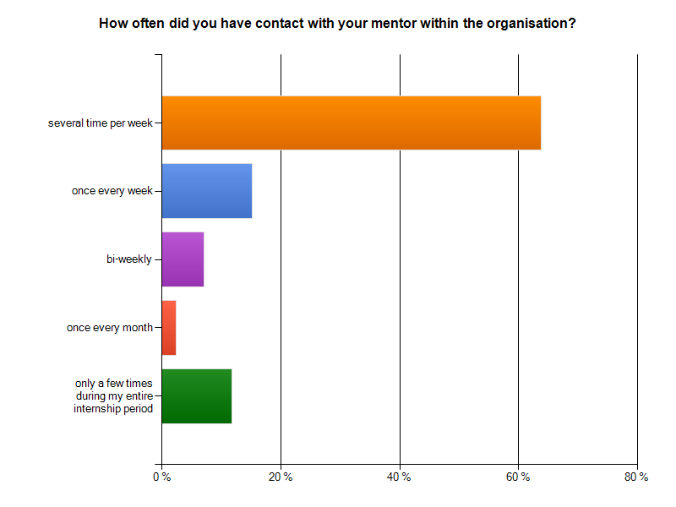

Appendix 4.24
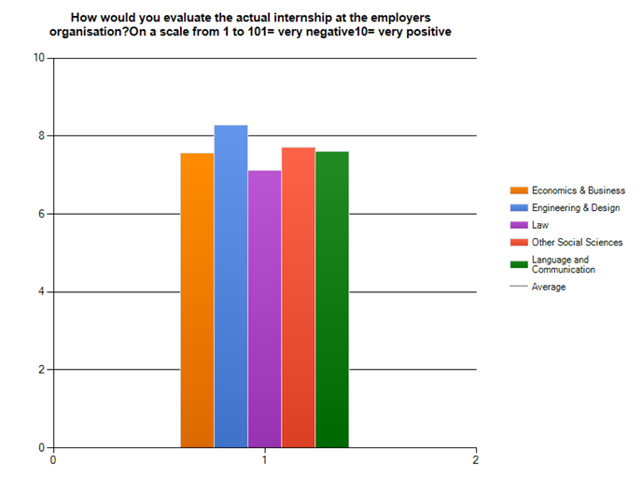

Appendix 4.25
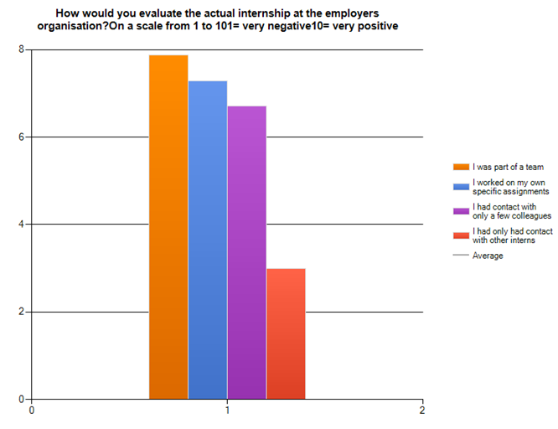

Appendix 4.26
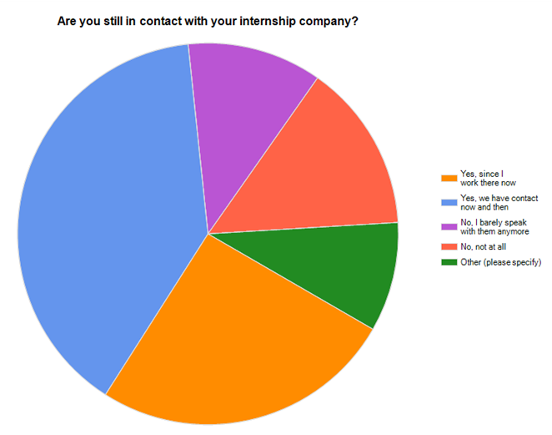

Appendix 4.27
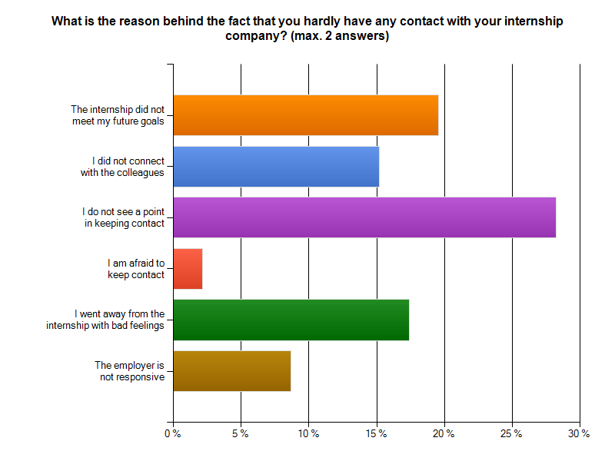

Appendix 4.28
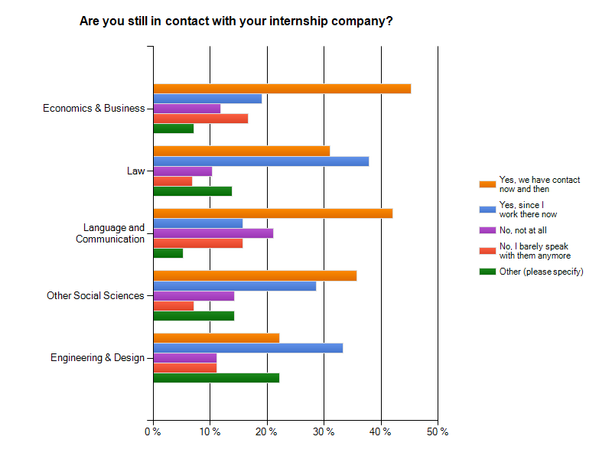
Appendix 4.29
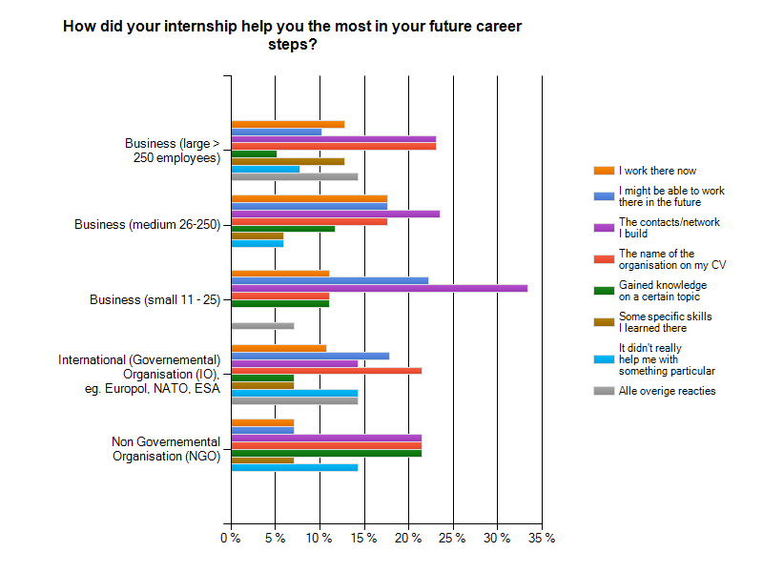

Appendix 4.30
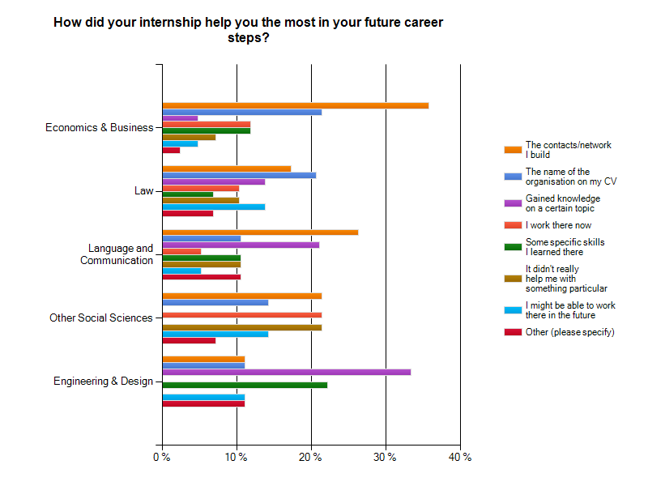
Appendix 4.31
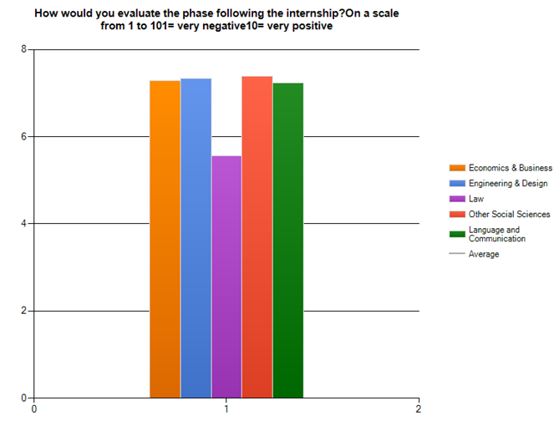

Appendix 4.32
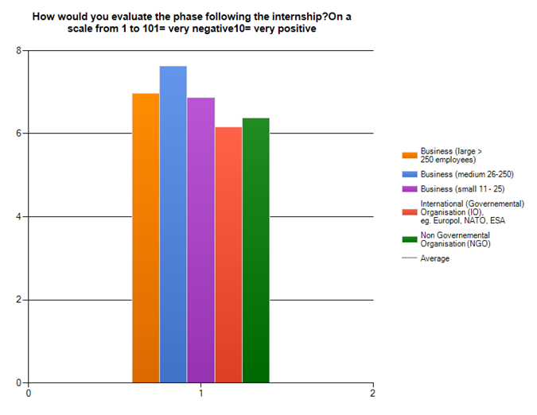

Appendix 5

The questionnaire ‘’The quality of my internship program’’

