ENCEE Paper:
Are incubators the new wonder tool for entrepreneurship education?

Background
In the nineties of the last century, a lot of (ICT) incubators started in the Netherlands, many private (GorillaPark, Ant Factory, Lost Boys and Newconomy), some public, such as Twinning. Most of them stopped early this century or gone bankrupt. From 2005 university incubators like YesDelft!, Erasmus MC Incubator, UtrechtInc, Biopartner and ACE opened their doors to students which operate alongside the curriculum. Afterwards also incubators of colleges aroused, often integrated with education. Enterprize of the The Hague University of Applied Science was one of the first ones. In recent years, all kinds of private initiatives arises, called Accelerators (Rock Start and Start-Up Boot Camp).
The primary purpose of an incubator is to create successful entrepreneurs, for different reasons. Much research has been done to the success rate of companies through incubators. It is assumed that the entrepreneur of a successful business should have learned a lot in this initial period. In the emerged entrepreneurial education it is therefore assumed that incubators also should be a good tool for students to quickly and efficiently learn. But is that so?

As a successful serial entrepreneur, I started more than ten incubators. Most of them were a tool for regional development, cluster development or for further investments (private equity). Now he wanders if an incubator can also be a tool for teaching. He has been given the opportunity to researche this at the The Hague university for applied sciences; “What is the (added) value for entrepreneurship education of an incubator?”
This paper is a preamble to that research and a call for participation.

Toon Buddingh’ Msc
The Hague University of Applied Science
December 2014

Contents
Background 2
Chapter 1. Rapidly emerging numbers of incubators for economic wealth. 3
Chapter 2. Successful entrepreneurship is not successful learning 4
Chapter 3. The minimum 3 x 5 competences in an high learning environment 5
Chapter 4. Student environment becomes active in entrepreneurship education 7
Chapter 5. Incubator is a typical flipped classroom 9
Chapter 6. The minimum what education should facilitate means the efficiency of the incubator 11
Call for co-research a case studies in different entrepreneurship education 12

Chapter 1. Rapidly emerging numbers of incubators for economic wealth.

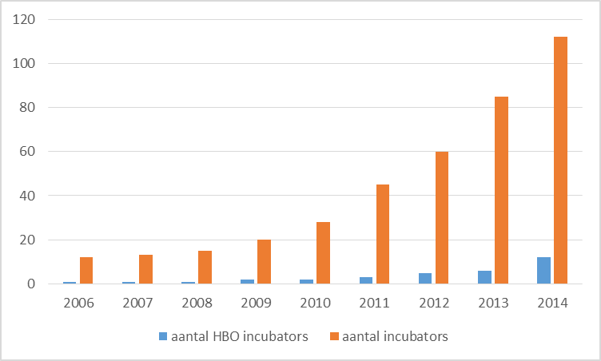
Nowadays business incubators are more popular than ever. In the Netherlands the population of incubators grew 500% in dyh last six years to 115 in the Netherlands (fig 1). Worldwide there are now more than 9000 incubators. The growth of the number of incubators is public driven by regional development.
Fig 1
The overall aim of an incubator often is to contribute to regional or local development. This means job creation a term that prevails, since most Incubators are supported publically, whether from local or national government . Other goals of the incubator are often described profitability of tenants, which is an argument again for regional development, but also for private investments.
In 2014 a growing number of incubators at universities for applied science in the Netherlands can be detected as well (fig 1). Following the success of university incubators such as the Dutch Venturelab (elected as Best Science Based incubator 2013), Australians ATP Innovations or UNITEC Incubadora from Brazil (elected as Best Science Based incubator 2014). They have been developed for the reason of technology transfer, but a side effect was a high popularity of these institutes amongst students. Silicon Valley’s flagship incubator YCombinator has the most commercial basis. Universities for applied science, however, have the primary purpose of creating well educated people.
Note that result on public investment is not public result of education. The responsibilities for teaching are others then for creating knowledge. Using incubators as a tool to teach students in entrepreneurship is different to using an incubator as a tool for regional development or for knowledge transfer. Still more and more universities of applied science adopt an incubator.
Yet less is known about what, precisely, a student has learned during his or her incubation period. In order to teach entrepreneurship we need to ask ourselves how student entrepreneurs learn during their stay at an incubator and what is the best way to set up an incubator in order create a measurable high learning environment.

Chapter 2. Successful entrepreneurship is not successful learning

It is easy to assume that a successful entrepreneur must know a lot about entrepreneurship, yet that is not always true. Yes, an experienced entrepreneur uses a lot of skills, knowledge and attitude. But a successful entrepreneur can be very good in just one thing and knowing how to delegate all other. Doing only that one thing, won’t develop him further as a person. Another entrepreneur can have several failing startups before he is successful. He has learned a lot of his mistakes, though.
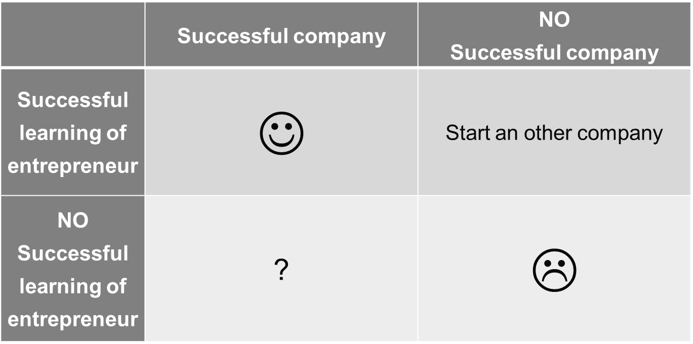
Successful learning and having a successful company during a study period is ideal, but is seldom seen. In that case a student that has not had entrepreneurial experience before, starts his first company, and it becomes a success for the first time. On top of that the student develops himself equally as his peer students and gets a degree. When this occurs universities can only be satisfied.
Fig 2
Far more often it is seen that the first company is not successful, or even failed in the first two years. If the student has developed himself equally as the other students, universities for applied science can be satisfied with the learning result. But often the students learns extra from the failure process. The student has also developed entrepreneurial behaviour. Since ‘success’ differences only one step from ‘failure’, namely one more time getting up then falling down, starting all over has to be encouraged.
Cheering students to start their own company, while they don’t show any progress in personal development can be disappointing. Especially when the students company also fails or even creates great debts. In this scenario the university failed to deliver something it supposed to do; teaching. Since the chances are not zero, universities should have a fall-back plan.
For all of those who create a successful company, but have a far flatter learning curve as their peers, one can argue about the educational system in its social function. A successful company is created, jobs are created, taxes are being paid and the entrepreneur is probably very happy. But the primarily goal of an applied university, teaching has not been met.

Chapter 3. The minimum 3 x 5 competences in an high learning environment

Universities of applied science that want to use incubators as a tool for teaching do need to know what competences the students need to develop. When starting up a business in any kind, one develops entrepreneurial competences, besides developing professional competences. That last ones would be for instance programing in a IT company, genetic analysis in a bioscience company and mechanics in a company which builds drones. In this paper the professional competences are left out of consideration, although they are of course far from being neglected.
The five most recognizable entrepreneurial knowledge competencies in entrepreneurship education are
- Product development: the complete process of bringing a new product to market meaning the transformation of a market opportunity into a product available for sale and it can be tangible or intangible.
- Marketing: the methodology of communicating the value of a product or service to customers, for the purpose of selling that product or service. Marketing techniques include choosing target markets through market analysis and market segmentation, as well as understanding consumer behavior and advertising a product's value to the customer.
- Project Management: the process and activity of planning, organizing, motivating, and controlling resources, procedures and protocols to achieve specific goals in scientific or daily problems. A project is a temporary endeavor designed to produce a unique product, service or result with a defined beginning and end, undertaken to meet unique goals and objectives, typically to bring about beneficial change or added value.
- Finance: a field that deals with the allocation of assets and liabilities over time under conditions of certainty and uncertainty. Finance can also be defined as the science of money management.
- Commercial law, also known as business law: the body of law that applies to the rights, relations, and conduct of persons and businesses engaged in commerce, merchandising, trade, and sales.

Soft skills is a sociological term relating to a person's Emotional Intelligence Quotient (EQ), that characterize relationships with other people. Soft skills complement knowledge on how they are used. The top five of skills that entrepreneurs should develop in order to be successful are
- Business model construction: describes the rationale of how an organization creates, delivers, and captures value in economic, social, cultural or other contexts
- Networking: a socioeconomic business activity by which groups of like-minded businesspeople recognize, create, or act upon business opportunities.
- Negotiation: is a dialogue between two or more people or parties intended to reach an understanding, resolve points of difference, to gain advantage for an individual or collective, or to craft outcomes to satisfy various interests.
- Sales: the exchange of a commodity for money or service in return for money or the action of selling something.
- Leadership: a process of social influence in which a person can enlist the aid and support of others in the accomplishment of a common task".

The five competences of attitude to be developed are best described by the Big Five. A summary of the factors of the Big Five and their constituent traits, such that they form the acronym OCEAN
- Openness to experience: (inventive/curious vs. consistent/cautious). Appreciation for art, emotion, adventure, unusual ideas, curiosity, and variety of experience. Openness reflects the degree of intellectual curiosity, creativity and a preference for novelty and variety a person has. It is also described as the extent to which a person is imaginative or independent, and depicts a personal preference for a variety of activities over a strict routine. Some disagreement remains about how to interpret the openness factor, which is sometimes called "intellect" rather than openness to experience.
- Conscientiousness: (efficient/organized vs. easy-going/careless). A tendency to be organized and dependable, show self-discipline, act dutifully, aim for achievement, and prefer planned rather than spontaneous behaviour.
- Extraversion: (outgoing/energetic vs. solitary/reserved). Energy, positive emotions, assertiveness, sociability and the tendency to seek stimulation in the company of others, and talkativeness.
- Agreeableness: (friendly/compassionate vs. analytical/detached). A tendency to be compassionate and cooperative rather than suspicious and antagonistic towards others. It is also a measure of one's trusting and helpful nature, and whether a person is generally well tempered or not.
- Neuroticism: (sensitive/nervous vs. secure/confident). The tendency to experience unpleasant emotions easily, such as anger, anxiety, depression, and vulnerability. Neuroticism also refers to the degree of emotional stability and impulse control and is sometimes referred to by its low pole, "emotional stability".
To use incubators as an educational tool , universities must focus on the development of the student rather than focus on the success of the business. The minimum the above 3 x 5 competences should be tested in an high learning environment.

Chapter 4. Student environment becomes active in entrepreneurship education

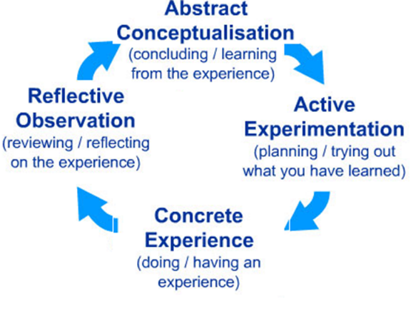
In traditional learning environment students are getting knowledge in classes, groups or sometimes as individuals. Theory is given by teachers, books and more and more via internet. The traditional KOLB cycle [fig 3] is used. In practice this results in homework, workshops and case studies. A student is prepared to become the entrepreneur he is learning for. In the end there is an exam that measures what the student has learned.
Fig 3
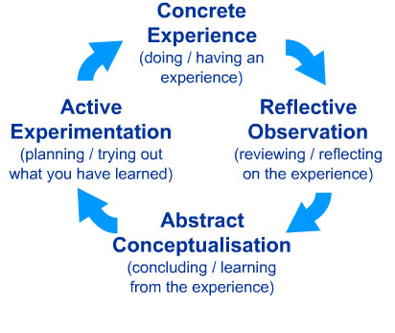
When starting the company, the start-up process itself is leading. Teaching then reacts active on the daily situations and one can speak of active learning. In particular, students must engage in such higher-order thinking tasks as analysis, synthesis, and evaluation. Active learning engages students in two aspects – doing things and thinking about the things they are doing . It focuses on competence rather than creating ideas . In entrepreneurial teaching, three methods can be distinguished.
Fig 4
- Professor Steve Blank launched the Lean LaunchPad class at Stanford University at the start of 2011. The class teaches founders how to reduce their failure rate through the combination of business model design, customer development and agile development in a Customer Development methodology. It incorporates learning aides such as videos, quizzes, and homework assignments to teach Blank's principles of entrepreneurship.
- Effectuation is a way of thinking that serves entrepreneurs in the processes of opportunity identification and new venture creation. Effectuation includes a set of decision-making principles expert entrepreneurs are observed to employ in situations of uncertainty. Situations of uncertainty are situations in which the future is unpredictable, goals are not clearly known and there is no independent environment that serves as the ultimate selection mechanism.
- Seasoned entrepreneurs are Mentor of the student entrepreneur. The university is flexible towards students running their own business when it comes to deadlines. Universities still teach all the necessary things in traditional learning environment, while the mentor guides them through the development of the start-up.

Chapter 5. Incubator is a typical flipped classroom

In a way starting a company in an incubator is a typical way of active learning. The student is working primarily at his own start-up company, he experienced a lot of real life situations and his peer and the incubator manager has the roll of mentor. They challenge the entrepreneur to formulate his experiences into learning experiences. Although that is not always a structured process.
Concrete experience are made when real customers entrances the building. They seek for a solution to their problem.
Reflective observation is giving by the incubator manager who sees everything happening in the incubator.
Abstract conceptualization of the experience (customer demand) occurs at lunch or coffee corner when the peer group they challenge the student-entrepreneur to summarize the meeting with the customer.
Active experimentation means to deploy customer demands.
In the traditional learning environment and in active learning the university supplies students with nothing more than a classroom, access to knowledge and some facilities as a copy machine. For every twenty-five students there is one teacher and two to four mentors.
An incubator is a separate environment, preferable with a commercial front door and an educational back door. Customers have the feeling that they enter a place where companies add value to their owns. Those expectations make the student entrepreneurs more focused of even doing so. The educational back door is needed, for professors and teachers to come in at the end of the day to define the learnings of the day and transform that to new, more specified learning goals in the next period.
In order to manage the incubator, universities should supply more facilities than in a traditional environment. Things that are common in most incubators are housing and facilities, network and access to knowledge, capital access, services and support. An average student incubator is 500 till 1000 m2 and host twenty till fifty companies, consisting of one to five persons per company. There is, average, one incubator manager and an office manager.

Chapter 6. The minimum what education should facilitate means the efficiency of the incubator

Entrepreneurship is accepted as a potential catalyst and incubator for technological progress, product and market innovation. McAdam and McAdam explore in 2008 the longitudinal use of the unique resources offered by university incubators to high-technology firms at different stages of growth. It is now understood that incubation is not a static process or simply a menu of services. The nature of incubation changes according to:
- the varying resource needs of the tenant firm over the duration of the incubation period;
- the tenant firm‘s industrial relationship.
The facilities that an incubator offers difference equally. But in general all incubators facilitate Network and access to knowledge; Service and support; (access to) Capital; Housing and other facilities. The manner and amount of these facilities determine the efficiency of the incubator.
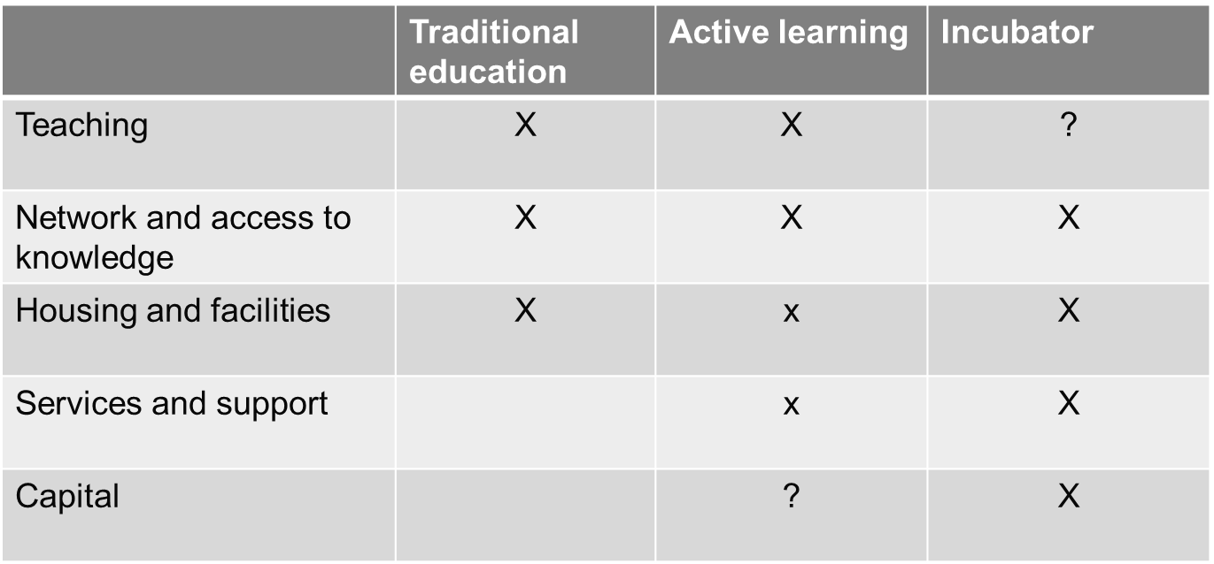
Fig 6

Compared to traditional learning and active learning, incubation requisite more support and services. Not all of that requires teaching capacity. The minimum what education should facilitate is the ground of a research program at The Hague University of Applied Sciences.
If we can compare the learning abilities of students in traditional education, Active learning and in an incubator on one hand and the amount of effort and money of those three on the other, the following question can be answered:
“What is the (added) value for entrepreneurship education of an incubator?

Call for co-research a case studies in different entrepreneurship education

At the beginning of the third quarter, 1 February 2015, 6 groups of students will be followed. They are divided in three types of educational forms; traditional learning, coached education and in a incubator. Their competences will be measured in the beginning of this quarter and at the end of the fourth quarter.
- Knowledge with tests
- Entrepreneurial skills via Linkedin progress in their own profile
- Attitude with BIG5 test

In the Netherlands we focus on six case studies.
 | Traditional education | Active learning
 |  | Coached education | Incubator
HHS – minor O&I, minor 1 | X
HHS – minor O&I, minor 2 |  | Effectuation
HHS - Casus eigen bedrijf |  |  | X
HS Rotterdam |  | Lean Startup
HvA – Startech |  |  | X
Citylab | ?
Starsmart (2006) |  | Mentoring

From each types of educational forms the capacity of the staff and manner and amount of the facilities will be measured.
The case study will end in July 2015 and will be ready to evaluate for further research. Given that incubators are used widely in enterprise education and business management courses all over Europe it might be of interest to other European research institutions to join either with a case study or further research.

http://worldbusinessincubation.wordpress.com (date 04/12/’14)
(Mian, 1997; Aernoudt, 2004; Peña, 2004; Aerts, Matthyssens and Vandenbempt, 2007)
(Hackett and Dilts, 2004b; Aerts et al., 2007).
(Mian, 1997; Hackett and Dilts, 2004b; Aerts et al., 2007; Aaboen, 2009; Ratinho and Henriques, 2010).)
A study on the factors of Business Incubation, by Lars Kolkman, .F. Ratinho Antunes de Oliveira MSc PD Dr. R. Harms, August 5th, 2011 Enschede, The Netherlands
(Aernoudt, 2004; Hackett and Dilts, 2004b; Rice, 2002)
"What is Project Management? | Project Management Institute". Pmi.org. Retrieved 2014-06-04.
The Definitive Guide to Project Management. Nokes, Sebastian. 2nd Ed.n. London (Financial Times / Prentice Hall): 2007.
Business Model Generation, A. Osterwalder, Yves Pigneur, Alan Smith, and 470 practitioners from 45 countries, self published, 2010
Hubert Österle, Elgar Fleisch, Rainer Alt (2001), Business networking: shaping collaboration between enterprises (2, illustrated ed.), Springer,.
http://www.merriam-webster.com/dictionary/sale (date dec. 2014)
Chemers M. (1997). An integrative theory of leadership. Lawrence Erlbaum Associates
Atkinson, Rita, L.; Richard C. Atkinson; Edward E. Smith; Daryl J. Bem; Susan Nolen-Hoeksema (2000). Hilgard's Introduction to Psychology (13 ed.). Orlando, Florida: Harcourt College Publishers. p. 437
Renkl, A., Atkinson, R. K., Maier, U. H., & Staley, R. (2002). From example study to problem solving: Smooth transitions help learning. Journal of Experimental Education, 70 (4), 293–315.
Bonwell and Eison, 1991
08/12/2014: http://businessmodelyou.com/2014/08/18/entrepreneurship-education-dead/
"EGR 495: The Lean Launchpad". Keller Center. 2012. Retrieved 2 November 2012.
Steve Blank (6 September 2012). "The Lean LaunchPad Online". Small Business America. Retrieved 2 November 2012.
Society for Effectual Action (2012). "Principles". Batten Institute, Darden School of Business. Retrieved 2014-01-26.
Saras Sarasvathy et al. (2001). "Effectual Entrepreneurial Expertise: Existence and Bounds". pennState. p. 46.
E.A. Rasmussen, R. Sørheim / Technovation 26 (2006) 185–194
Mueller, S.L., Thomas, A.S. (2000/1), "Culture and entrepreneurial potential: a nine country study of locus of control and innovativeness", Journal of Business Venturing, Vol. 16 pp.51-75
McAdam and McAdam (2008), ―High tech start-ups in University Science Park incubators: The relationship between the start-up's lifecycle progression and use of the incubator's resources‖, Technovation, Volume 28, Issue 5, pp. 277–290

