#### **Strategic Marketing Plan**



The UK:

**“Just a stamp away”**

03-06-2010

Yvette Kessels

4R

# Index

1 Foreword 4

2 Management Summary 5

3 Introduction 7

4 Internal Analysis 9

4.1 Paperclip International Group bv 9

4.1.1 Current strategy 9

4.1.2 Organisation 10

4.1.3 Corporate Social Responsibility 11

4.1.4 Innovation 11

4.1.5 Financial Analysis 11

4.1.6 Marketing 11

4.2 Paperclip Cards UK 12

4.2.1 Financial overview 12

4.2.2 Target group 12

4.2.3 Product 12

4.2.4 Price 13

4.2.5 Communication 14

4.2.6 Distribution 14

5 External Analysis 15

5.1 Industry Analysis 15

5.1.1 DESTEP 15

5.1.2 Market size/growth 16

5.1.3 Porters’ five forces 16

5.1.4 Business Culture 18

5.2 Client Analysis 19

5.2.1 Who are the current and potential clients? 19

5.2.2 What do the clients do with the products? 20

5.2.3 Where do the clients buy the products? 20

5.2.4 When do the clients buy the products? 20

5.2.5 Why do the clients choose for a certain supplier? 21

5.2.6 Why don’t the clients choose for a certain supplier? 21

5.3 Competitor Analysis 21

5.4 Distribution Analysis 23

6 SWOT 25

6.1 Conclusion 25

7 Confrontation matrix 26

8 Objectives 27

9 Strategy 28

9.1 Organisation 28

9.2 Target group 29

10 Marketing mix 29

10.1 Product 29

10.2 Price 30

10.3 Communication 31

10.3.1 Sales team 31

10.3.2 Discount 31

10.3.3 Promotion 32

10.4 Distribution 33

10.4.1 Supply Chain 33

11 Budget 34

12 Implementation 35

12.1 Conclusion 35

13 Appendix 1 Customer Satisfaction Survey UK 36

14 Appendix 2 Results CSS UK 39

15 Appendix 3 Financial overview Paperclip Cards UK 41

16 Appendix 4 Product lines 42

17 Appendix 5 Potential Clients 43

18 Appendix 6 Suitability – Feasibility – Acceptability 44

19 Appendix 7 Coded Consistency 45

20 Appendix 8 Regions sales representatives 46

21 Appendix 9 Customer Satisfaction Research NL (Dutch) 47

# Foreword

Since it is my end-paper for the educational program International Business and Languages at the Fontys University of Applied Sciences, writing this strategic marketing plan for Paperclip Cards has been an important assignment. In my opinion I have been very lucky to being able to do my final internship at this company. Everybody has been very helpful with a few persons in particular. I would like to give thanks to Lisette Scheurwater, Gerbrand Dekker, Marcel Oldeman, Leon Corstens, Puck van Aart, Steph Webster, Rob Steward, and Rebecca Harris to be directly involved by helping me finishing this plan.

Of course it is important for me to write a graduate-stately paper, but according to me it is even more important to write a plan that helps the company to improve doing business in the concerning country. Paperclip Cards really wants to become an important player in UK’s greeting cards industry, which makes it even more exciting and motivating to write this plan.

Yvette Kessels

May 18th 2010, Veenendaal

# Management Summary

*The management summary shows the complete plan in a nutshell.*

From the internal and external analysis it can be concluded that the greeting cards industry in the United Kingdom is a tough market, but also one with many opportunities. To become successful in the UK as a supplier of greeting cards, it is important to have a good and clear strategic plan.

**Objectives**

The long-term objectives for Paperclip Cards UK are:

* To reach a turnover of £1 000 000.- in financial year 2015.
* To reach a profit of 15% of the total turnover in financial year 2015.
* To reach a number of 275 clients (minimum yearly turnover: £1000) in financial year 2015.

The short-term objectives are:

* To develop the independent sector with at least 50 new independents (minimum yearly turnover: £1000) within 1 year, increasing to 100 within 2 years.
* To increase sales within existing independent clients by 35% within 1 year.
* To increase sales within existing national clients by 15% within 1 year.
* To provide 100% stock availability to the items that are selected by the national clients.
* To reach a break-even point on the profit-loss balance in June 2012.

**Strategy**

The vision of Paperclip Cards UK is: ‘To build a sustainable competitive advantage as a publisher of design led, high quality, fresh and unique ranges of cards and stationery, providing first class service and availability, whilst upholding the values and interests of the parent company.’

By starting over with a new sales team, the company will focus on the current and potential independent retailers. In general, the product collection will keep remaining the same, but it will be renewed by selecting which product lines should appear in the new collection and which don’t. Besides that, the collection will be extended with mid-range price pointed cards.

**Target group**

The primary target group of Paperclip Cards UK will exist of the independent retailers that are located in the main regions of England.

The secondary target group will be the current and the potential national clients (branch organisations). Last year’s strategy had been to focus on these nationals. The result of this is that almost all nationals are current clients of Paperclip Cards. Nevertheless, there are still a lot of opportunities in this category to make these clients more profitable.

**Sales team**

The new sales manager will lead the entire sales team and will have to take care that every sales representative or agent performs the way he or she should be. Besides that, the sales manager is responsible for the secondary target group: the current and potential nationals.

At the moment there are 2 sales representatives. This number will have to increase to 4 within 5 years. Research shows that there are 4 key regions in the UK that are interesting for Paperclip Cards. Because of the fact that recruiting sales representatives is expensive, this will be done in steps.

Of course there are also current and potential clients in the other parts of the UK besides the key regions. These regions will be subdivided to the current and possible new sales agents. The agents that didn’t perform well enough will be let go.

**Product**

The greeting cards collection will be renewed by reducing the number of product lines to 11 ranges that will form the standard greeting cards collection of Paperclip Cards UK. This collection will reflect the high quality-image that the company wants to get in the United Kingdom.

**Service**

To create a USP, the company will offer services that are fairly new in UK’s greeting cards industry and difficult for the primary competitors to copy. These services are for example:

* To offer the client what he wants and give him a private label. In return, Paperclip Cards will be sure to sell the designed product and won’t get any returns.
* To outsource the physical distribution to the client. This means that the client gets the products for lower prices, and Paperclip Cards saves distribution costs, time, effort, and probably even more important: risks.

**Price policy**

The price policy is based on the appearance of the greeting cards in combination with the product line that it belongs to. The price margins are divided into 4 levels between £2.26 and £4.45.

**Discounts**

Giving discounts is a big issue for greeting cards suppliers in the UK. Especially with nationals and branch organisations, giving discounts is something you can’t get away from. This makes negotiating with these clients very important. The minimum margins for the multinationals are:

* 65% at the chain stores selling books, stationery, magazines, newspapers, and entertainment products.
* 75% at the supermarket chains.

A ‘discount’ that can be given to independent retailers is to give a first (small) selection of cards

* with a very large discount (condition: the sales rep. decides the place of the cards);
* for free, but on the condition that the retailer has to place a second order.

The reason for Paperclip Cards to do this is so that the company can prove to the independent retailer that the Paperclip Cards collection sells well.

**Sampling**

The sales representatives and agents should always bring several samples with them when they do their daily visits to potential and current clients. This way the clients can touch and experience the cards, which is important in the United Kingdom. Besides that, it makes it easier for the sales representative/agent to influence the choice of the client.

**Profit/Loss**

Since the current situation of the subsidiary is not very well, and it is important to remain realistic, the forecast for the profit-loss overview is that Paperclip Cards UK won’t become a profit-making office until the start of financial year 2011-2012. This is due to the fact that the company first has to convince the (potential) clients that it is a good supplier of greeting cards.

**Consistency**

Of course, when starting to implement a new strategic plan, a head office has to invest. The most important aspect of this plan though, is reorganisation. There are not many expenses for the future that weren’t present in the past. The largest investment will be the recruitment of new employees, but this is in a long term which means that these expenses will only appear when the forecast is looking positive and objectives are being reached.

Especially in the beginning, the backing from Paperclip International Group bv is very important. Not only as a (financially) supporting organ, but also as a controlling organ. The new sales manager might be knowing a lot of the greeting cards industry, but still needs help to understand the standards of Paperclip Cards as an international organisation.

# Introduction

This plan is written for Paperclip International Group bv. Paperclip Cards is an international publisher of greeting cards, gifts and back to school collections. The head office is located in Veenendaal, the Netherlands. The subsidiaries are located in Germany, Belgium, Sweden, and England and besides that the company is exporting its products to many other countries all over the world.

The definition of the problem is: “How is Paperclip Cards able to improve the client satisfaction in the Netherlands and how will the company become an important player in the greeting cards industry in the UK?”

The name of this project is: The UK: “Just a stamp away”. This title is related to the most important part of the project that is to say the strategic marketing plan. Paperclip Cards sees a lot of opportunities in the United Kingdom, but the current situation of the company in the UK is not very good. After trying to become an important supplier of greeting cards for already several years, the company has decided to start over with a new strategy. A new sales manager has been recruited and will start in June 2010.

To be sure that the new sales manager will meet the needs of Paperclip International Group bv when starting to lead the UK office, she will be able to use this strategic marketing plan as a starting point.

**Composition**

The strategic marketing plan is divided into five parts:

|  |  |  |
| --- | --- | --- |
|  |  | Chapters |
| 1 | A good and clear overview of the current situation of Paperclip International Group bv and Paperclip Cards UK. (strengths and weaknesses) | 4 |
| 2 | The opportunities and threats in UK’s greeting cards industry. | 5 |
| 3 | How these strengths, weaknesses, opportunities and threats can lead to a strategy. | 6 + 7 + 8 |
| 4 | How this strategy can be implemented by Paperclip Cards in the UK. | 9 + 10 |
| 5 | Which (financial) consequences belong to the implementation of this plan for Paperclip International Group. | 11 + 12 |

**Customer satisfaction research UK**

To get a good impression of the current situation of Paperclip Cards in the UK, both desk research and field research have been done, of which the field research has been done by means of a customer satisfaction research.

The research in the UK has been very small and the results have only be used to attend the strategic marketing plan. There have been sent 100 questionnaires to current clients of Paperclip Cards in the UK. The survey can be found in appendix 1. The results of the research have been used for the internal analysis as well as for the external analysis and can be found in appendix 2.

**Customer satisfaction research NL**

Not only has the customer satisfaction been researched in the UK, but also in the Netherlands. This research has been a part of the new strategic performance management tool of Paperclip International Group called the balanced scorecard. Since this research has no consequences for the strategic marketing plan for Paperclip Cards in the UK, it is added to this plan as an appendix. The complete research can be found in appendix 9.

**Sources**

The most important sources that have been used in this plan are the Progressive Greetings magazines of 2009 and 2010, the Internet and experts from Paperclip International Group and in the UK that are acquainted with the greeting cards industry in the UK. All sources can be found as foot remarks at the end of the pages.



# Internal Analysis

The strategic plan of Paperclip Cards UK has to have a connection with the general strategy of Paperclip International Group bv. That’s why the first part of the internal analysis is a description of the current situation of Paperclip Cards’ head office. The second part of the internal analysis will reflect the current situation of the subsidiary in the UK.

## Paperclip International Group bv

### Current strategy

**Mission**

The mission of Paperclip Cards it to take care that clients choose for Paperclip Cards as their supplier of greeting cards, by being flexible and easily accessible and by constantly improving the organisation as well as the collections. Being innovative and to work with passion for cards are important aspects of the organisation.

**Vision**

The vision of Paperclip Cards is to become one of the (two) total suppliers of greeting cards in the Netherlands and to become an important player in the greeting card industry of North-Western Europe.

**Strategy**

The company wants to approach the existing market with exiting products (market penetration). By adapting to the wishes of the retail organisations, Paperclip Cards retains their customer relations. A few years ago, the organisation has out-sourced the production to China. The logistics of the company are completely out-sourced to Centraal Boekhuis in the Netherlands. This has made the logistics very flexible, through which the company is able to serve the clients in all phases of the supply-chain.

By continuously investing in product development (a design studio in the UK and one in the Netherlands), Paperclip Cards creates an innovative and differentiated image. For the company, the focus lays on the product (product leadership).

Due to the fact that the retailers in the greeting cards industry are clustering more and more, Paperclip Cards is trying to start partnerships with buying associations, franchisers, retail organisations and department stores.

### Organisation

Paperclip Papeterie BV is founded by Puck van Aart Sr. in 1984. This company has two subsidiaries: Paperclip International AG in Switzerland and Paperclip International Group bv in the Netherlands. These two companies have approximately the same policy and product-portfolio. As regards the size though, Paperclip International AG in Switzerland is very diminutive. This plan is written for Paperclip International Group bv.

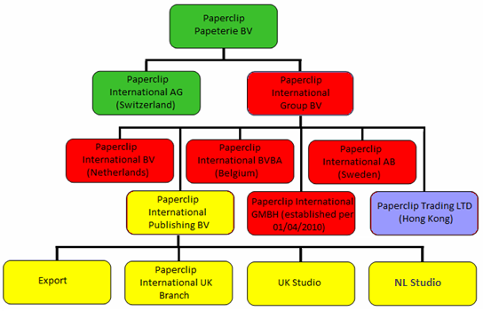

Organisation Chart

**Paperclip International Group bv**

Paperclip International Group bv is the head office of Paperclip Cards and is located in the Netherlands. The company counts 5 sales offices, of which one (in the UK) belongs to Paperclip International Publishing bv. The largest part of the production has been out-sourced to Hong Kong. Since October 2007 there has been a purchasing office of Paperclip Cards. There are 2 design studios: one in the Netherlands and one in the UK. Both studios are under the management of Paperclip International Publishing bv. The board of managers of Paperclip International Group bv counts 7 members. Puck van Aart Jr. is the general director of the Group.

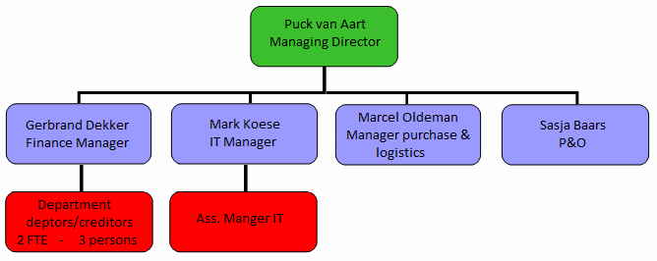

Paperclip International Group

**Decision making**

Paperclip International Group bv is only a controlling organ of the organisation, what means that every subsidiary makes its own (marketing) decisions. The purchases of the products were previously done by Paperclip Cards International bv, but are nowadays done by each subsidiary individually. This means that there is one product collection that is composed by Paperclip International Publishing bv in the Netherlands, but every subsidiary is able to select the products that lead to a collection which fits the concerning industry.

### Corporate Social Responsibility

The largest part of the consuming market of Paperclip Cards thinks social responsibility is very important, but up to now, CSR isn’t influencing the consumer while buying a greeting card. That doesn’t mean that the company doesn’t look to the future. Paperclip Cards is aware of its social responsibility and tries to secure an environmentally aware production process with its suppliers.

Since April 2010, the company has permission to put the FSC-label on the products as soon as these are checked by the organisation. The Forest Stewardship Council is an independent, non-governmental, not for profit organisation established to promote the responsible management of the world’s forests. To get this label though, every greeting card including the envelope has to be made from this durable material.

### Innovation

Paperclip Cards positions itself worldwide as an innovative supplier of high-quality greeting cards. A large part of the investments are related to innovation. Recently the company has been trying very hard to refresh the product collection. The number of collections has been reduced to the ones that have been sold best in the past. These collections have been renewed and recently presented on the Paper & Convenience Show in the Netherlands. The greeting card industry changes very fast and since Paperclip Cards wants to become an important player in the greeting card industry, it is important for the company to keep following and adapting to the trends. That’s why they will keep investing in renewing the collections in the future. Product development is done by Paperclip International Publishing bv in the Netherlands.

### Financial Analysis

The balance sheet of Paperclip International Group bv reaches a break-even-point. This is good for a company to keep existing, but in the end, the goal of each company is to make as much profit as possible. The problem is that momentary, some subsidiaries make profit just to restore the profit-loss-balance.

In comparison with the year before, the turnover of Paperclip International Group bv in financial year 2008/2009 has decreased with 7.7%. The gross margin has decreased with 6.6%. This is probably due to several happenings:

* The development of the purchasing office in Hong Kong in October 2007.
* The losses of the minority shareholding in Germany and the sales office in the UK.
* Investments in among others: innovation, new product collections and professionalization of the organisation.

In view of the developments in the market, the collection and the internal organisation, Paperclip International Group bv thinks the future prospects are positive. The product portfolio is very important, so Paperclip Cards will keep investing in this. Large mutations in the organisation structure and number of employees are not planned or expected. The largest part of the (external) loans has already been paid off and the remains will gradually be paid off in the future.

### Marketing

The last 10 years, Paperclip Cards has developed itself as a total supplier of greeting cards. Marketing decisions are done by every subsidiary individually. The composition of the product collection is different for every subsidiary (some collections are almost equal like for example the Dutch collection and the collection in Belgium). In general, Paperclip Cards focuses on the higher market segment and positions itself as an innovative and creative company. This means that the quality is high which leads to higher price-pointed cards. Target groups mainly exist of branch organisations, department stores and individual retailers. To get these clients interested, Paperclip Cards uses a push-strategy by offering services like ‘delivery within 24 hours’. Standing on fairs is one of the most important means of promotion and is something that the company does globally.

## Paperclip Cards UK

The current situation of Paperclip Cards in the UK is not good. Paperclip Cards has been doing business in the UK for a long time already, but the current office is founded in 2006. The subsidiary has been focussing on the higher segment of the market from the beginning. The client doesn’t have to choose for Paperclip Cards as a total supplier, but as their supplier of high-quality greeting cards.

### Financial overview

The loss of Paperclip Cards UK was -211,660 pounds in financial year 2008. A year later this loss had decreased to -100,308 pounds which obviously looks good given that there was a rising line. The reason for this though, was that the costs of the studio in the UK hadn’t been registered in the Profit and Loss Account of Paperclip Cards UK anymore as of financial year 2008. The turnover had, with 350 000 pounds in financial year 2009, decreased with 2.5% in comparison with the year before. The margin had even decreased with 9.5% in comparison with financial year 2008. A profit/loss overview can be found in appendix 3.

### Target group

There is no clear description of the target group, because Paperclip Cards UK doesn’t focus on one. As soon as a company sells greeting cards, it is seen as a potential client. Many of these retailers are very small and non-profitable for Paperclip Cards.

### Product

**Collection**

The complete product collection of Paperclip Cards UK can be divided into 5. Besides the greeting cards collection (Everyday, Christmas and Spring Season), the subsidiary offers gifts and display- and wrapping material. Until the end of financial year 2008 there was also a Back to School collection, but due to a too small circulation, the office stopped offering this.

Because the gifts-collection and the display-/wrapping material are no primary product collections of the company, this plan is only focused on the greeting cards collection. Besides that, these products are sold to the same clients that buy the greeting cards.

|  |  |
| --- | --- |
| **Complete product collection of Paperclip Cards UK** | |
| **Collection** | **% of total sales** |
| Everyday | 77 in 2009 (85.9 in 2008) |
| Christmas | 4.7 in 2009 (7 in 2008) |
| Spring Season | 1 in 2009 (3 in 2008) |
| Gifts | 0.1 in 2009 (2.6 in 2008) |
| Display- /Wrapping material | 17 in 2009 (0.04 in 2008) |

The greeting cards collection of Paperclip Cards UK is smaller than it is in the Netherlands. When Paperclip Cards opened a studio in the UK, it was decided that this studio would focus on the higher segment of the market. This means that the products emit luxury and quality. This was and is what the designers of this studio do best. The greeting cards mainly have soft colours, an elegant handwriting, and are hand-made. The quality is high and most of the cards are 3D, what makes them special and creative. The top 3 association with the collection is: 1.Creative 2.Innovative 3.Modern[1].

**Product lines**

At the moment, there are many product lines in the collection of Paperclip Cards UK of which some are selling very well, while others only cost money. A list with all the ranges that are sold in the UK in 2009 (including the collection that comes from the Dutch collection) together with a description and the turnover per client per product line in 2009 can be found in appendix 4.

It is easy to say that the product lines with the largest turnover are the best, but in reality this might not be true. The causes for this are:

* Some cards are too high-priced while others are too low-priced.
* The cards are sold with a large discount.
* Some product lines are fairly new, while others have been in the collection for a long time already.

More important is to inquire the opinion of the sales team in the UK office. There are 10 ranges of the UK collection that are the strongest and are the best prospects for the future according to the UK office. These ranges are:

|  |  |  |
| --- | --- | --- |
| **Product line** | **Number of clients that ordered the range in 2009** | **Description** |
| Trail Blazer | (new) | Male transcends age |
| Velvet Sky | 198 | Core ‘bread and butter’ range |
| Cherry Blossum | 196 | Contemporary design and high quality finishing |
| Jellytot | 210 | Fun and trendy with extra special touches |
| Casablanca | (new) | Handmade elegant female |
| Papillon | 248 | Stylish with high quality applications |
| Crème et Noir | 764 | Stylish and sophisticated |
| Hot Diggitty Dog | 193 | Exclusive with fun and quirky animal characters |
| Whisper | 197 | High quality with a subtle verse and a ribbon |
| Kaleidoscope | 660 | Stylish and contemporary |

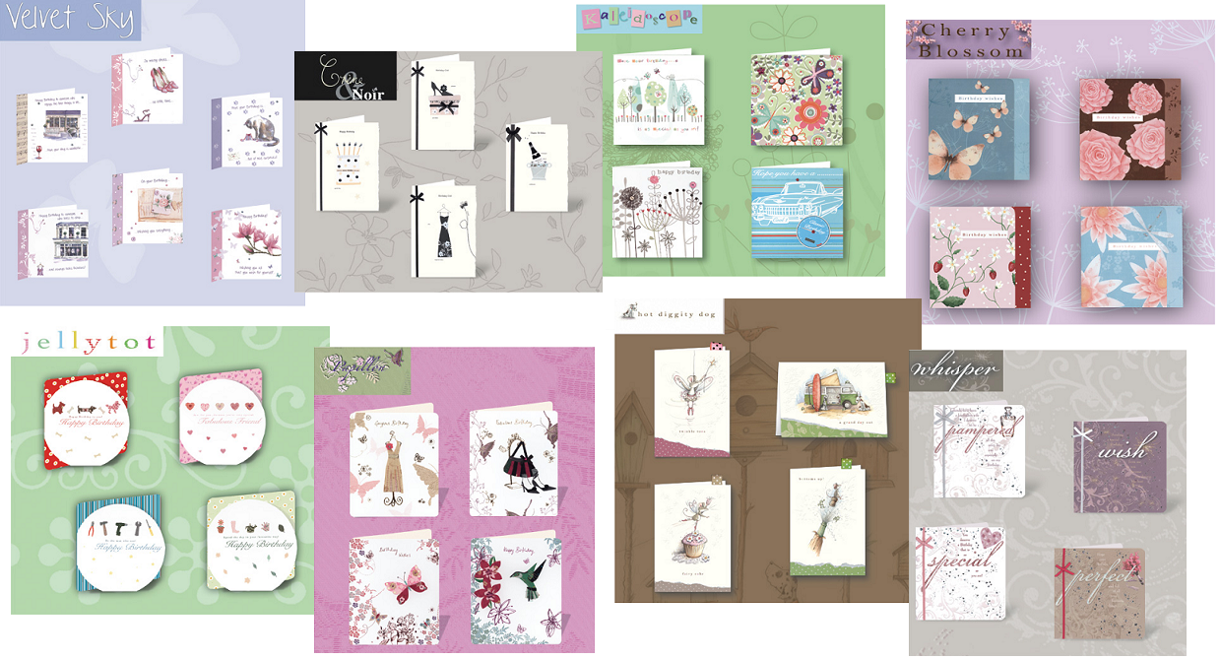

*‘Crème & Noir’ was nominated for a coveted Henry award. The product line ‘Whisper’ was the winner of the coveted 2008 Henries Awards for the best Words and Sentiments category.*

### Price

At this point, Paperclip Cards UK doesn’t have a good price policy. This is due to the fact that there is no clear price setting. In fact, prices arise from the following questions:

* What should the price be when you look at the quality and the appearance of the card?
* What is the cost-price of the card?
* What should the margin be to make the card profitable?

Because there is no clear price setting, some price-points are too high, while others are too low in proportion to the quality and the appearance. This makes it impossible to give an overview with current price margins (which should be present). According to the results of the client satisfaction research, the clients think that the prices are a little too high and that Paperclip Cards should offer some lower price-point cards too.

### Communication

The most important means for a supplier of greeting cards with relation to marketing communication is personal selling. It is very important to have a sales team that is able to communicate the benefits to the client of having the company as a supplier of their products. At the moment there are sales representatives and agents that are on the road daily to visit current and potential clients. The disadvantage of the sales agents with relation to marketing communication though, is that they will try to sell your products, but will most of the time not really make promotion for your company[2].

Another very important means of marketing communication is being present on a fair[3]. This is expensive but also very efficient. The last few years Paperclip Cards has been economising by buying a smaller stand or by standing on a fair less often. Since the company wants to start over in the UK this will change. There are already new plans to be present on several fairs in the future.

In the past, Paperclip Cards had been advertising in magazines focused on their clients to improve the reputation in the UK. Since this didn’t lead to a direct result, the company stopped doing this. At the moment the name ‘Paperclip Cards’ and the address appears in the product directory of the magazine ‘Progressive Greetings’, the greeting cards industry’s leading magazine. The ‘advertisement’ is very unclear and inconspicuous. The current clients of Paperclip Cards UK receive leaflets when (for example) a new product-line is published.

### Distribution

In the UK, Paperclip Cards has a sales office including a depot (with expansion possibilities) and a design studio where greeting cards are designed for the English market as well as for the other markets spread all over the world. At the moment there are 2 sales representatives and 8 independent sales agents. Most of the current sales agents don’t perform as they should according to Paperclip International Group. This is due to the fact that sales agents in the UK are self-employed and therefore difficult to control, discipline or motivate. In June 2010, a new sales manager will start leading the office.

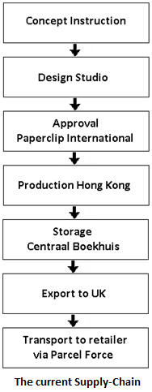

An overview of the current supply-chain can be found along-side. The supply-chain starts at Paperclip International Publishing, where an instruction is sent to the design studio in the Netherlands or in the UK. The studio sends back a concept of a design and as soon as it is approved, it is taken into production in Hong Kong. After being shipped to the Netherlands, the products will be kept in storage at Centraal Boekhuis. From here, the products that are needed in the UK will be exported. The local delivery service is done by Parcel Force.

There is also a webshop available to sell the products. When a client orders products through the online shop he or she will get a discount. The results of the customer satisfaction survey (appendix 2) show that none of the interviewed clients use the webshop and a large part doesn’t even know it exists. Only 5 clients would like to get information about this possible way to order the products.

# External Analysis

The external analysis shows the opportunities and threats in the greeting cards industry in the UK. Almost all information from the desk-research comes from the Progressive Greetings magazines of January, February and March 2010. With regards to field research, all information comes from the customer satisfaction research and from internal experts in the UK as well as in the Netherlands.

## Industry Analysis

The industry analysis gives a short overview of the market attractiveness and the opportunities and threats in the industry. This overview exists of a trend overview, a DESTEP-analysis, the market size/growth, the five forces of Porter and the business culture.

### DESTEP

The DESTEP-analysis is a broad analysis of macro factors that may influence an organisation’s business and operations.

**Demographic**

The UK greeting card industry is the most successful one in the world. The average number of greeting cards sent is 31 per person per year. 85% of all greeting cards are bought by women. There are approximately 800 greeting cards publishers in the UK, most of which are small businesses[4]. This year, the vast majority of retailers has no intention in opening another shop, though a part is harbouring the urge to grow. Post offices have been and are still closing.[5]

**Economic**

Many independent card retailers have feared the start of 2009, but over three quarters of respondents to the PG/Cardgains Independent Retail Barometer either saw their business grow or hold steady in the last year. Only 9% of the respondents are bracing themselves for a decline with over half setting their sights on marginal growth in 2010.[6] The prices of stamps won’t influence the greeting cards industry in the near future. The prices of stamps have increased a little this year, but they remain affordable and represent excellent value for money. Besides that, stamp prices are still lower that the European average.[7]

**Social**

In terms of design, the UK greeting cards industry is ten years ahead of the rest of the world. No other country has such a tradition of card sending or card display in the home; sending and receiving cards is an important part of the culture. Very remarkable in this country is that for almost every occasion, a greeting card is sent.

**Technological**

Sending a traditional greeting card is and will stay an important part of the British culture. In the near future, the E-card won’t become a big threat for Paperclip Cards. Not only because the E-card is not yet a hype in this country, but also because the collection of Paperclip Cards is difficult to copy thanks to the 3D-applications. Another card that is sent through the Internet though, might become a threat in the future. This is the Personalized Printed Greeting Card. This means that consumers are able to create a card by using photos or images (of their own).

**Ecological**



Just like in the rest of Europe, corporate social responsibility is an upcoming matter in the UK. In the greeting cards industry, paying attention to this might help a company to be distinctive from competitors, but for now CSR isn’t strongly influencing the UK’s greeting cards industry. A certification system that is used in this industry is ‘Forest Stewardship Council’. This is an independent, non-governmental, not for profit organisation established to promote the responsible management of the world’s forests.

With Christmas however, corporate social responsibility is important in the greeting cards industry. Charities estimate that in 2009, 50 million pound is raised for good causes through the sales of charity Christmas cards.

**Political**

The laws affecting the licensing industry are mainly categorised as Intellectual Property Law (IP) – rights of ownership in creative works and rules governing how this ownership in creative works and rules governing how this ownership is protected. In the UK this involves Copyright and Trademarks. Briffa is a modern legal practice specialising in intellectual property: the protection of copyright, designs, patents, trademarks, trade secrets and information technology. [8]

### Market size/growth

According to the GCA market research[9] in 2009, the greeting cards industry in the UK is annually worth more than 1.7 billion pound. The report says that this industry is, with 800 publishers that jointly produced 1.5 billion greeting cards in 2009, the most successful greeting cards industry in the world. On average, one person sends 31 greeting cards per year. The average retail price of a card in the UK was 1.17 pound in 2008.

|  |  |  |
| --- | --- | --- |
| **Greeting card collection in the UK** | | |
| Collection | % of the **value** of all cards bought in 2008 | % of the **volume** of all cards bought in 2008 |
| Everyday | 70 | 51 |
| Christmas | 19 | 43 |
| Spring Season | 11 | 6 |

### Porters’ five forces

According to Michael Porter, an industry is being influenced by five forces. To understand the greeting card industry better, this model can be used.[10]

Five forces

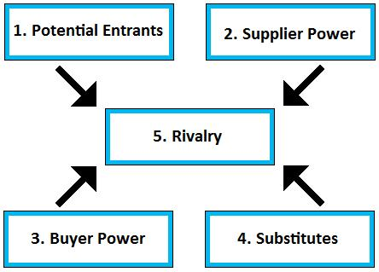

Potential Entrants

It is very easy for a new company to enter the greeting cards industry, as long as the company starts by having a good strategic plan. There are numerous of companies or individuals who are trying to enter the market, but only a part of them will survive and become a successful greeting cards supplier.

Supplier Power

The most important suppliers in the greeting cards industry are logistic service providers and the manufacturers of the products. Almost all companies in the greeting cards industry have outsourced the production to China, where labour and production costs are very low. Quality of the products and the service is very important. This means that having a good logistic service provider as well as having a good manufacturer is crucial when doing business in the UK. The number of suppliers is very high, but on the other hand, finding a good one is very difficult. From this, it can be gathered that the supplier power is medium.

Buyer Power

The buyer power in the greeting cards industry in the UK is very high. The number of suppliers of greeting cards is almost numerous. The number of retailers is also very large, but more and more retailers are joining a branch organisation, which decide the offer of products of these retailers.

Substitutes

The Internet is the biggest threat of substitution for traditional greeting cards suppliers. While the e-card is not a big threat (for now), the personalized printed greeting card is. Especially the (standard and timeless) low-price pointed cards have a high degree of substitution. By offering products that are difficult to copy through the Internet, like greeting cards with 3D applications, it is possible to compete with these companies.

Rivalry

The greeting cards industry shows a lot of competition, with only a few companies having a large part of the market. These companies have nearly the same technology and manufacturing processes, supplier relationships and distribution systems, so the intensity is very strong.

Conclusion

When making a strategic plan for the future, knowing how to handle this industry is very important. The points that have the most influence are (in order of importance):

1. Buyer Power - The growing power of the retailers.
2. Rivalry - The few influencing companies.
3. Supplier Power - The lack of good and reliable suppliers.
4. Substitutes - Internet is a threat.
5. Potential Entrants - Some possible competitors that try to become successful in

the greeting cards industry (like Paperclip Cards).

This analysis not only shows that it is difficult to become an important player in UK’s greeting cards industry, but also that when you do it right, there are a lot of chances for a supplier to do business in this country.

### Business Culture

In the United Kingdom as well as in the Netherlands, people attach value to equality. There are certain words that may not be said in this country. For example: there are no subordinates but employees. Despite this, the power distance in the UK is large. In this country, the top decides what happens. People are fairly autocratic and directive.

The culture of the UK is very individualistic. Having an own opinion is important as well as having self-respect. Paperclip Cards would like to have long-term client relations in the UK. This is fairly hard, because managers in the UK are real ‘job-hoppers’. Alliances between companies are often temporary and usually don’t really stand firm.

The British culture is fairly masculine. It is important that work is a challenge that leads to personal satisfaction. This means that making money is more important than having a good business relation. ‘Small talk’ is important for Britons, but what really matters is whether a certain deal has useful benefits.

The uncertainty avoidance is relatively fairly low. There are rules, and contracts will be read through carefully before they will be signed, but Britons aren’t afraid to take risks and are always accessible for new ideas and interesting business proposals.

Just like in the rest of Western-Europe, people in the UK are short-term focused. Fast results are expected and proceedings such as signing contracts and responding to questions or remarks should be handled as soon as possible. [11]

**Humour**

The UK is very well-known for its exceptional style of humour. Despite this, humoristic greeting cards will rarely be found in this country. Britons rather want greeting cards to express luxury and fashion, than humour.

## Client Analysis

To decide which target group should be focused on in the future, it is important to know who the current and potential clients are and how to reach them. For this, the six W’s of Ferrell are used.

### Who are the current and potential clients?



The current clients of Paperclip Cards UK are especially nationals (store chains) and independent retailers. The number of clients of Paperclip Cards UK that has received an invoice in 2008 and/or in 2009 is approximately 2100. In 2009 there were only 23 clients with whom a minimum of 1000 pound per client was reached. The greeting cards retailers mainly exist of[12]:

**Nationals**

The nationals are chain stores that own more than 1 shop. Paperclip Cards UK’s last strategy has been focussing on these retailers which led to the fact that most of these are already clients of Paperclip Cards.

*30.4% of the client database of Paperclip Cards UK exists of nationals. The nationals (branch organisations) lead to the largest part of the turnover of Paperclip Cards in the UK.*

Main retailers:

* Specialist Card shops: Clintons, Birthdays, Card Factory
* Bookshops/Stationers: WHSmith, Waterstones, British Bookshops
* CTN’s: McColls
* Supermarkets: Tesco, Sainsburys, Waitrose, ASDA
* Department Stores: John Lewis, Selfridges, House of Fraser
* NUS
* Discounters: Matalan, Poundland, Wilkinsons, 99p stores, Primark
* Service Stations: Moto, Welcome Break, Roadchef
* Other: Garden Centres

**Independents**

There are numerous independent retailers that sell greeting cards. A part of them is joining a branch organisation but still, every retailer makes its own decisions concerning which cards are sold in the store.

*69.6% of the client database of Paperclip Cards UK exists of independents. There are still a lot of independents that are not yet clients of Paperclip Cards.*

Main retailers:

Card shops, Gift shops, Book shops, Post Offices, CTN’s, Garden centres, Department Stores

**Other**

Internet: Moonpig.co.uk

This company offers a totally new concept in buying greeting cards. Consumers are able to personalise captions to create a completely unique card. Moonpig.co.uk offers designs from many of the leading card publishers in the UK.

A list with information about (potential) clients can be found in appendix5, as well as a list with the most important streets in the UK where (potential) clients for the higher segment might be located.

### What do the clients do with the products?

The problem in England is that there is almost no retailer that has a total supplier. In England, there are purchase managers that don’t buy the cards per collection (like in the Netherlands) but per set of cards. For Paperclip Cards this leads to sales of (for example) 50 pound per year per retailer.

There are also some trends regarding to what the clients want. These trends are among others:

**Handmade cards**

Having been top of the tree in last year’s ‘growth league’ humorous cards have been just ousted from the top spot by handmade or hand-finished cards as the cards having gained the most sales for retailers in the last year. The aspect of the personality that people want to communicate the most is ‘thoughtfulness and caring’. Over 70% of 18-24 year old consumers would be disappointed if they receive no cards and over 90% of the consumers aged 65+ would feel let down[13].

**Cards for men**

According to the UK office, product lines that are created for men are a niche in the UK’s greeting cards industry. At the moment, there is very good interest from the new male range of Paperclip Cards called ‘Trail Blazer’.

### Where do the clients buy the products?

Sales representatives and independent agents visit the clients to sell the products. Most suppliers have a showroom to present the products and fairs are used to present as well as to sell products. Besides this, webshops are often used.

### When do the clients buy the products?

**Everyday collection**

The Everyday collection is sold throughout the whole year.

**Christmas**

Usually the national clients select Christmas cards in January for the following December. This means that Christmas ranges have to be put together for October with samples for selection ready in December or January. When the ranges have been selected, the cards will be printed in April, and delivered to the clients in September.

For the independents this process is similar however all of the dates are slightly later with clients not selecting until January or February and not requiring stock until October.

**Spring**

Valentines: The nationals select the cards in January for February, the following year. The independents make selections in March. For both, these selections usually go on display two weeks after Christmas.

Mother’s day: The nationals select the cards in February for March, the following year. The independents select the cards one month later. The selections go on display straight after Valentines.

Easter: The nationals select the cards in February for March/April (depending on when if falls), the following year. The independents make selections in March. The cards go on display 6 weeks before Easter.

Father’s day: For both, the nationals and the independents, selections start in March for June, the following year. Selections go on display late April.

### Why do the clients choose for a certain supplier?

Clients want a supplier of greeting cards that is reliable, has price points that are competitive with the other suppliers, and that is innovative. Retailers don’t mainly purchase a range of cards but fill their collection by selecting every set of cards. That’s why it is more important for a supplier to offer a small, but well selected card-collection, instead of a large and very diverse card-collection. One of the key elements for a retailer is the product selection, with differentiation from other shops. Retailers would like to see more of a choice in the following card caption areas: (in order of importance) Step-Mum/Step-Dad, Adoption, Anniversary, Divorce, Boyfriend, Gramp/Grampy, Great Grandparents, Great Granddaughter/Great Grandson, Relation ages, Traditional 18 and 21, Good Luck In Your New Venture, Wife/husband on Diamond anniversary, Partner and Partner Anniversary.

An important reason for a client to choose for a particular supplier is when this supplier offers something that others don’t. An example could be to offer the client a ‘private label’ by listening to the clients’ wishes. This way the supplier doesn’t only know for sure that he will sell what he creates, but also that the relationship with this client will improve.

### Why don’t the clients choose for a certain supplier?

According to the results of the customer satisfaction survey, the main aspects that should be improved are: Products and Price. It is very predictable that the aspect Products is chosen the most, because (just as one of the clients says) ‘it is always about the product’. For several clients, the price points are too high and one of the remarks is to expand the collection with lower price-pointed cards.

## Competitor Analysis

In the United Kingdom, Paperclip Cards is only a small company with little employees. The company will (the following 5 years) not become a total supplier, but will only focus on the higher segment of the market with luxury and hand-made greeting cards. The direct competitors of Paperclip Cards are ‘Five Dollar Shake’, ‘Cavania’, ‘Second Nature’ and ‘Caroline Gardner’. These companies offer similar products.

|  |  |
| --- | --- |
| **Five Dollar Shake** | **Average competition matrix: 4.5** |
| This company positions itself as a publisher of unique and beautiful designs for stationery and greeting cards. Their device is ‘to be different than the rest’. All products are made of ecological products and all envelopes are F.S.C. approved. The company has a very good reputation and wins many awards each year. | |
| **Cavania** | **Average competition matrix: 4** |
| Cavania produces greeting cards, gifts, and jewellery. The company develops all products, so that they match. For example: every present or piece of jewellery has a matching greeting card. Their focus lays on luxury and hand-made products. | |
| **Second Nature** | **Average competition matrix: 3** |
| This company is a worldwide supplier of greeting cards. They specialise in imaginative and innovative products. The handmade cards are sold worldwide and represent a substantial part of their offering. Their collection consists of: Handmade, Printed Cards, Pop Ups, Caption Cards, Humour and General Sentiment. They have recently ventured into electronic products. | |
| **Caroline Gardner** | **Average competition matrix: 3.5** |
| Caroline Gardner uniquely original designs are available as cards, wrapping paper, social stationery and other paper products to design-focused people around the world. Outlets range from High Street names and Department Stores to small chains, independent galleries and the webshop: www.carolinegardner.com. | |

|  |  |  |  |  |  |  |
| --- | --- | --- | --- | --- | --- | --- |
| **Competition matrix Paperclip Cards UK[14]** | | | | | | |
| **Characteristic** | **Value**  (1) | **Paperclip** | **Five Dollar Shake** | **Cavania** | **Second Nature** | **Caroline Gardner** |
| **Reputation** | 0.30 | 2 | 4.5 | 4 | 3 | 3.5 |
| **Collection/design** | 0.25 | 4 | 4.5 | 3.5 | 3 | 3.5 |
| **Price-point** | 0.20 | 2 | 4.5 | 4 | 3.5 | 4 |
| **Technology** | 0.15 | 1.5 | 4 | 4.5 | 4 | 4 |
| **Award winning** | 0.10 | 2.5 | 5 | 3 | 2 | 1.5 |
| **Average** 5 = strong  1 = weak |  | **2.5** | **4.5** | **4** | **3** | **3.5** |



**Explanation**

Reputation: Brand image (When a new retailer starts, which supplier would he choose)

Collection/design: The general appearance of the collection

Price-point: Price-quality combination

Technology: Usage and the offer through the Internet

Award winning: Frequency of winning prices.

**Conclusion**

To become a stronger player in this industry as regards to the competitors, Paperclip Cards UK should change the price setting and improve the reputation. Improving the reputation can be done by offering a USP. This will give the clients a reason to choose for a certain supplier.

Using the Internet as a marketing tool and to sell products is one of the weaker points of Paperclip Cards UK in comparison with the competitors. As the value of this point shows though, this is not very important at the moment.

**Secondary competitors**

Competitors shouldn’t only be seen as rivals. Besides the primary competitors of Paperclip Cards UK, there are also the leading suppliers of greeting cards in the UK that are important to keep an eye on. Hallmark, UK Greetings and Great British Card Company are trendsetters in this industry, so Paperclip Cards should try to keep following what they are doing and how they influence the market.

|  |
| --- |
| **Hallmark** |
| Hallmark UK is responsible for 60% of Hallmark International. The company focuses on the quality by constantly improving the management processes and by optimising the quality of the products. They keep adapting to the wishes and expectations of the consumer. These days, Hallmark UK produces approximately 2 billion greeting cards per year and offers the largest product collection in the UK with almost 20,000 designs per year. |
| **UK Greetings** |
| Together with Hallmark, UK Greetings accounts for 47% of total retail sales. The core business of the company is to design, produce and sell greeting cards to retailers. The company offers many brands through which it can meet the wishes of the client. |
| **Great British Card Company** |
| Since July 2009, ‘The Great British Card Company’ has become the umbrella organisation of Paper House, Medici Cards and Waterwells Distribution. The company is well-known for the humour collections and has more than 1,000 different designs. Their product collection consists of: photography, art and temporary trends. Annually, 500 new titles are published. |

## Distribution Analysis

**Production**

At the moment, China (especially Hong Kong) is by far the largest non-EU suppliers of greeting cards to the UK, together accounting for a massive 94.1% of the value of non-EU imports and more than four-fifths of all imports. India will establish itself as a major supplier of paper products to the UK because they invoice in sterling.[15]

A market research of Key Note Publications Ltd in 2008 says that it has been suggested that the increasing costs of production in China may persuade publishers to move their operations elsewhere, perhaps even back to the UK. [16] This doesn’t have to mean that the production costs will decrease for that company, but they might stay the same. A possible more important reason to move the production elsewhere is that the lead-time will become shorter.

**Transport**

The recession in 2009 has had big consequences for transporting to and from the UK, but nowadays this has been changed. In the fourth quarter of 2009 the number of trucks driving through the Eurotunnel has increased with 12 percent as regards to the last quarter of 2008.

The sea sector is a very important part of UK’s infrastructure. 95% of total business is transport by shipping. An obstacle that companies have to face when importing from China is that shipping companies ask for surcharges. Reasons for this are: piracy and the ‘peak seasons’[17]. These peak seasons are usually from may till august, a period when many companies are importing products for Christmas. Not only will the shipping companies ask for surcharges, they will also make the shipping time longer to decrease the costs. Booking in time and keeping an eye on the developments regarding this matter is very important.

**Distribution channel**

Direct-to-retail

Direct-to-retail publishers supply retailers via sales agents or representatives. The majority of greeting cards sold through specialist card shops and gift shops are from DTR publishers. This sector spans from the multi-national corporations such as Hallmark down to the small, trendy niche publishing companies. Direct-to-retail publishers launch series of ranges based on distinctive design themes or characters.[18]

Sales Agents

Sales agents sell on a commission basis. In the UK, a sales agent works for several suppliers and sells what he/she can with as little effort as possible. The big disadvantage is that an agent is self employed and therefore difficult to control, discipline or motivate. Besides that, a sales agent will try to sell your products, but will most of the time not really make promotion for your company.

A sales agent is the only way to distribute products across the UK without employing a sales representative or a distribution company (dealer).

Sales representative

A sales representative is a person that is employed by the company to represent a business and to sell its merchandise. It is expensive to hire a sales representative, but also the most efficient way to do business in the UK’s greeting cards industry.

Dealer

A dealer, using its own warehousing facility and network of sales agents across the UK, will take responsibility for the sales, marketing and distribution of card ranges leaving the publisher to concentrate on developing and producing its ranges.

An example of a dealer is a competitor that sells other brands as well. In the UK, the company UK Greetings sells their own product to their clients, but also products of competitors. As a result, these competitors (that are most of the time small-businesses) get a payment for the sold goods.

Internet

Having a webshop will become more and more important in the future. Furthermore, this will simplify doing business across the UK. Retailers don’t have to wait for a sales representative or sales agent to place an order.

**Shortening the supply chain**

Something that companies in the UK don’t possess much knowledge of yet is cutting off the supply chain when the materials management stops and the physical distribution starts. Materials management contains the production planning and the production process. This means that retailers have to take care of the physical distribution themselves, but as a result the prices are lower so that their margins will strongly increase.

**Purchasing managers**

In the UK, many small retailers are joining a buying association. This means that eventually, there will be a few purchasing managers that will decide which brands/suppliers will appear in the British greeting cards market. These purchasing managers select each set of cards apart and consider price, quality, availability, reliability, and technical support when choosing suppliers and merchandise.[19]

# SWOT

The SWOT reflects in a short but clear overview what the strengths, weaknesses, opportunities and treats are for Paperclip Cards in the UK. It can be seen as a conclusion of the internal and external analysis.

|  |  |
| --- | --- |
| **Strengths** | **Opportunities** |
| **S1**  Staff with experience in the greeting cards industry  **S2** High quality (award winning) products  **S3**  Creative studio in Bath with designers who are always up-to-date concerning market trends  **S4** A warehouse with expansion possibilities  **S5** Backing from Paperclip International bv  **S6** New sales manager with many connections  **S7**  Very active in social responsibility  **S8** The new male-range is selling very well | **O1**  Supermarkets keep expanding and start selling greeting cards  **O2** Many independent retailers in the UK  **O3** More and more retailers are joining a branch organisation  **O4** Humorous cards are making place for handmade or hand-finished cards  **O5** Leaving the physical distribution to the client might lead to a win-win situation  **O6** Offering a ‘private label’ to clients  **O7** Social responsibility is an upcoming matter in the UK |
| **Weaknesses** | **Threats** |
| **W1** Small team  **W2** Underperforming sales team  **W3** No clear positioning/strategy  **W4** Long production lead times  **W5** No good price policy  **W6** Many non-profit making product lines  **W7** Low brand awareness | **T1** The Personalized Printed Greeting Card through the Internet might become a threat  **T2** Many English companies are producing in China, but will move their production to another country due to an increase in production costs  **T3** In the UK, more and more post-offices are closing  **T4** Many competitors  **T5** Becoming a total supplier of a retailer is almost impossible |

## Conclusion

From this SWOT it can be gathered that UK’s greeting cards industry still has a lot of opportunities. Momentary, Paperclip Cards UK has many weaknesses, but besides the fact that these are all possible to improve, the office also has many strengths which could make the company (as long as they are used well) an important player in this industry. Paperclip Cards is a large company in the Netherlands, but still a small company in the United Kingdom. That’s why it is important to not become overconfident and to keep an eye on the fact that becoming a total supplier is almost impossible in this country. It is better to focus on a small part of the industry and to create a USP by offering its clients something that others can’t.

# Confrontation matrix

The confrontation matrix shows a combination of the 5 most important strengths, weaknesses, opportunities and threats. These combinations are the basis for the possible strategies.

|  |  |  |  |  |  |  |  |  |  |  |  |  |
| --- | --- | --- | --- | --- | --- | --- | --- | --- | --- | --- | --- | --- |
| 1 = A little important  3 = Important  5 = Very important | | Opportunities | | | | | Threats | | | | | Total |
| 1.Expansion supermarkets | 2.Many independent retailers | 3.Handmade cards are upcoming | 4. Retailers join branch organisations | 5. Social responsibility is becoming important | 1.Internet: Personalized Greeting Card | 2.Production costs in China will rise | 3.Post offices are closing | 4.Many competitors | 5.Becoming a total supplier is impossible |
| Strengths | 1.High quality products + FSC logo | 3 |  | 3 |  | 5 |  |  |  |  |  | 16 |
| 2.Backing from Paperclip Int. |  |  |  | 3 | 1 | 3 | 3 |  | 5 |  | 10 |
| 3.New sales manager |  | 5 |  | 5 |  | 3 |  |  | 1 |  | 9 |
| 4.Male range sells well |  |  | 1 |  |  | 1 |  |  | 3 | 3 | 8 |
| 5.Studio in Bath |  | 3 |  |  |  | 3 |  |  |  | 5 | 8 |
| Weaknesses | 1.Underperforming sales team | 1 | 5 | 3 | 3 |  | 3 |  | 3 | 3 |  | 12 |
| 2.Bad positioning/strategy |  | 3 | 1 | 3 | 3 |  |  |  | 3 | 5 | 15 |
| 3.No good price policy | 3 |  |  |  |  | 5 | 1 |  | 5 |  | 14 |
| 4.Non-profit making products |  |  |  |  |  |  | 3 |  |  |  | 6 |
| 5.Low brand awareness |  | 5 |  | 3 | 3 |  |  |  | 3 | 5 | 8 |
| Total | | 7 | 21 | 6 | 17 | 12 | 18 | 7 | 3 | 23 | 15 |  |

The 3 options below are different strategies that Paperclip Cards can take in consideration when approaching the UK’s greeting cards industry.

**Option 1**

|  |  |
| --- | --- |
| **S:** 1 – 2 – 3 – 4 – 5  **W:** 1 – 2 – 3 – 4  **O:** 2 – 3  **T:** 1 **–** 4 – 5 | To start over with a new sales team[20], focussing on the independent retailers as the primary target group and the branch organisations as the secondary target group with the current product collection, but extended with mid-range price pointed cards. |

**Option 2**

|  |  |
| --- | --- |
| **S:** 1 – 2 – 5  **W:** 1 – 2 – 5  **O:** 1 – 4  **T:** 1 – 3 – 4 – 5 | Focussing on the current and potential clients that are branch organisations by using the backing from Paperclip Cards International to offer services that are difficult for primary competitors to copy. The current product collection will be extended with mid-range price pointed cards. |

**Option 3**

|  |  |
| --- | --- |
| **S:** 1 – 2 – 3  **W:** 2 – 3 – 5  **O:** 5  **T:** 4 | Focussing on corporate social responsibility and communicating this to the current and potential clients. The price margins will be adjusted to this by setting them higher than the general prices. The current product collection will be reduced. |

# Objectives

To choose the best strategy for Paperclip Cards UK it is important to look at the objectives for the following years. In the end, this strategy has to take care that the objectives will be reached.

The objectives of Paperclip Cards for the subsidiary in the United Kingdom are[21]:

**Long-term oriented (as of the start of financial year 2013-2014)**

* To reach a turnover of £1 000 000.- in financial year 2015.
* To reach a profit of 15% of the total turnover in financial year 2015.
* To reach a number of 275 clients (with a minimum yearly turnover of £1000) in financial year 2015.



**Break-even**

**Short- and mid-term oriented (up to the end of financial year 2012-2013)**

* To develop the independent sector with at least 50 new independents (minimum yearly turnover of £1 000 per client) within 1 year, increasing to 100 within 2 years.
* To increase sales within existing independent clients by 35% within 1 year.
* To increase sales within existing national clients by 15% within 1 year.
* To provide 100% stock availability to the items that are selected by the national clients.
* To reach a break-even point on the profit-loss balance in June 2012 (the end of financial year 2011-2012).

# Strategy



From the SFA-analysis[22] (table above and appendix 6) it can be concluded that option 1* would be the best strategy for Paperclip Cards UK. Besides that, there hadn’t been a very good and clear strategy in the past, but the vision was good and will still be how Paperclip Cards UK positions itself in the future.

The vision of Paperclip Cards UK was to build a sustainable competitive advantage as a publisher of design led, high quality, fresh and unique ranges of cards and stationery, providing first class service and availability, whilst upholding the values and interests of the parent company. The greeting cards industry in the UK is difficult to do business in, but also very interesting with still a lot of opportunities. Paperclip Cards didn’t start off very well in the beginning, but is ready to make a new beginning, with a new sales manager and most important: the will to survive.

* *To start over with a new sales team, focussing on the independent retailers as the primary target group and the branch organisations as the secondary target group with the current product collection, but extended with mid-range price pointed cards. The representatives and/or agents that didn’t perform well enough will be let go. The use of sales representatives will be more in proportion as the sales will rise.*

## Organisation

The goal for the organisation of Paperclip Cards UK is that it will become the same as the other self-operating and decision-making subsidiaries. Paperclip Cards Group bv should only be a controlling organ that will help Paperclip Cards UK starting up, but will eventually leave all operations concerning marketing to the office’s organisation. The new sales manager will start in June 2010. She will lead the office and will bring it, in a matter of speaking, back to live.

Especially the first year, a monthly evaluation will be necessary to control if everything is going as it should be, and if the short-term oriented objectives will be reached. The results will be presented to Paperclip International Group. Every year (at the end of a financial year) there will be an evaluation to control if the long-term oriented objectives will be reached. The sales representatives and agents (especially in the first year) will get a job evaluation, a progress review and an assessment interview.

## Target group

The primary target group of Paperclip Cards UK will exist of the independent retailers that are located in the main regions of England: South East (London), South (M4 Corridor to South Coast), Midlands (M5/M6 Corridor), and North West (M62 Manchester – Leeds). Some companies will actually belong to a branch organisation, but will be seen as independent retailers as they still make their own decisions. A difference between these retailers and independent retailers is that retailers who are joining a branch organisation, will often get a discount.

The secondary target group will be the current and the potential national clients. These nationals are for example: Tesco (supermarket retail chain), Clinton Cards, Boots, and Morrison’s. Last year’s strategy had been to focus on the nationals. The result of this is that almost all nationals are current clients of Paperclip Cards. Nevertheless, there are still a lot of chances in this category to make these clients more profitable.

# Marketing mix

## Product

The list below contains the new standard greeting card collection of Paperclip Cards UK.

The new standard greeting cards collection is composed by looking at the following elements:

* The opinion of the UK office
* The number of clients that ordered the product line in 2009
* The turnover per product line in 2009
* The margin per product line in 2009

|  |  |  |  |  |  |  |
| --- | --- | --- | --- | --- | --- | --- |
| **New greeting cards collection** | | | | | | |
| **Product line** | **Opinion of the UK office[23]** | **Number of clients** | **Turnover** | | **Margin** | |
| Casablanca | + | (new) |  |  |  |  |
| Cherry Blossum | + | 196 | £ | 10 787 | £ | 7 761 |
| Crème et Noir | + | 764 | £ | 69 009 | £ | 31 521 |
| Hot Diggitty Dog | + | 193 | £ | 20 931 | £ | 15 612 |
| Jellytot | + | 210 | £ | 20 011 | £ | 12 596 |
| Kaleidoscope | - | 660 | £ | 17 012 | £ | 10 755 |
| Papillon | + | 248 | £ | 30 759 | £ | 16 944 |
| Trail Blazer | + | (new) |  |  |  |  |
| Velvet Sky | + | 198 | £ | 25 663 | £ | 13 145 |
| Whisper | + | 197 | £ | 11 815 | £ | 7 768 |

Because the range ‘Trail Blazer’ is selling very well at the moment, the new collection will be expanded with an extra male range. The other product lines will have to be re-priced in accordance with the new price policy. The greeting cards that don’t appear in this new collection but that are already in storage will be sold to a junk dealer or will be destroyed.

**Corporate Social Responsibility**

In April 2010 it has been approved for Paperclip Cards to put the FSC-label on the products. This means that the company can distinguish itself from many of its competitors by showing the clients that social responsibility is an important part of the strategy. Since corporate social responsibility is an upcoming matter in the UK, but not strongly influencing the greeting cards industry, Paperclip Cards shouldn’t name it as a key-factor in its strategy, but just as something extra the company offers to its clients.

**Service**

Offering a good service is very important for a greeting cards supplier in the UK. Besides that, it is a good way for a company to distinguish itself from competitors. Since it is difficult to use the product collection as a USP, Paperclip Cards UK should also lay focus on the service.

Especially when branch organisations are to be reached, offering a (special) service can lead to very interesting results. Examples of these ‘special’ services are:

**Win-win situation 1: Private label**

Some nationals might become difficult to persuade, because they don’t see any difference between Paperclip Cards and the other suppliers. Paperclip Cards is able to offer the client an extra service by creating what he wants. As long as it is profitable for Paperclip Cards (which means a minimum of distributed products), the client will have a private label and Paperclip Cards will be sure to sell the designed products.

**Win-win situation 2: Outsourcing the distribution**

Another possibility to distinguish itself from the competitors is to outsource the physical distribution to the concerning client. This way, the client gets the products for lower prices, which means that the margins will strongly increase.

## Price

Since Paperclip Cards UK will keep selling high quality and handmade greeting cards, the price points remain higher than the average. The difference though, between the previous price policy and the new price policy, is that in the new strategy there is one. The high price-pointed card collection will be expanded with mid-range prices. The appearance is what sells a greeting card. That is why it is important to make a combination between this and the prices. On account of the combination of the appearance and the prices, the price margins will be divided into four[24]:

**Price Code: HI - JJ £1.95 - £2.50**

Identification greeting cards:

Luxury appearance, but no 3D applications. Created just to expand the collection, but not to lay the focus on while selling greeting cards to (potential) clients.

**Price Code: LL £2.65 - £3.10**

Identification greeting cards:

Luxury and handmade appearance with little 3D applications.

**Price Code: NN £3.45 - £3.85**

Identification greeting cards:

High quality, luxury appearance with 3D applications.

**Price Code: PP £4.00 - £4.45**

Identification greeting cards:

Very high quality and handmade with many 3D applications. The top-luxury cards that are nominated by the sales team as possible award-winning.

The exact prices that will be given to the products will be chosen in combination with the product lines that they belong to. A certain product line can have different price margins, but the general appearance of the range should be taken into consideration as well when setting the prices.

## Communication

### Sales team

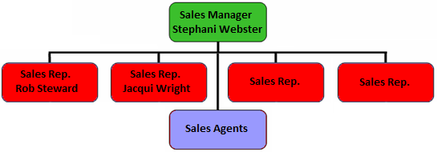

**Sales Manager**

The sales manager will lead the entire

sales team and will have to take care that

every sales representative or agent performs the way he or she should be. Besides that, the sales manager is responsible for the secondary target group: the current and potential nationals. This group is not easy to win over, but important for Paperclip Cards UK to be profitable. Making good deals with these nationals can lead to good results.

**Sales representatives**

At the moment there are 2 sales representatives. This number will have to increase to 4 within 5 years. Research shows that there are 4 key regions in the UK that are very interesting for Paperclip Cards.

These key regions based on retail sales and population are:

* + South East England (London)
  + South England (M4 Corridor to South Coast)
  + Midlands England (M5/M6 Corridor)
  + North West England (M62 Manchester – Leeds)

A map with a general overview of the 4 regions can be found in appendix 8. Recruiting sales representatives is expensive. That’s why this will be done in steps. The first two regions that will be approached are South East England (sales rep.: Jacqui) and Midlands England (sales rep.: Rob). When these 2 sales representatives have earned themselves back, a new representative can be recruited. This sales representative will take over the region Midlands England and Rob will start approaching the region South England. When this new sales representative has earned him- or herself back, a new sales representative will be recruited to approach the last region: North West England.

**Sales agents**

Of course there are also current and potential clients in the other parts of the UK besides the key regions. These regions will be subdivided to the current and possible new sales agents. The agents that didn’t perform well enough will be let go. New sales agents should be selected very carefully.

### Discount

Giving discounts is a big issue for greeting cards suppliers in the UK. Especially with nationals and branch organisations, giving discounts is something you can’t get away from. This makes negotiating with these clients very important.

The minimum margins for the nationals are:

* 65% at the chain stores selling books, stationery, magazines, newspapers, and entertainment products.
* 75% at the supermarket chains.

A ‘discount’ that can be given to independent retailers is to give a first (small) selection of cards

* with a very large discount (condition: the sales rep. decides the place of the cards);
* for free, but on the condition that the retailer has to place a second order.

The reason for Paperclip Cards to do this is so that the company can prove to the independent retailer that the Paperclip Cards collection sells well.

### Promotion

**Advertising**

Momentary, Paperclip Cards UK only advertises in the product directory of the Progressive Greetings magazine. This illustration is very inconspicuous and doesn’t reflect the image of the company at all. Paperclip Cards wants to be associated with innovation, luxury, and high quality. Due to the fact that it is only a small advertisement, it is important to make it as good and prominent as possible.

**Sampling**

The sales representatives and agents should always bring several samples with them when they do their daily visits to potential and current clients. This way the clients can touch and experience the cards, which is important in the United Kingdom. Especially because the cards are of high quality and handmade, the touching-possibility can be an essential persuasion for a client to buy the product. Another reason to do this is because this way, it is easier for the sales representative/agent to influence the choice of the client. These samples have to change at least two times a month to be sure that the products, that have to reflect the rest of the collection, is always up-to-date.

**Brochures & Leaflets**

What sales representatives and agents should also bring with them are brochures and leaflets. The brochure contains the complete collection of Paperclip Cards UK, which clients can use to choose the products they want to order or to get a good impression without visiting the showroom in Bath. When a new product line is published, this should be communicated to the clients by sending them a leaflet.

**Trade shows**



Be present on and visiting trade shows is and will be an important means of communication. That is, for many reasons:

* To introduce new product lines.
* To improve the reputation.
* To increase acquaintance with the brand.
* To keep an eye on the trends in the industry.

The trade shows that Paperclip Cards should attend are: NEC Spring and Autumn Fair, PG Live, and Top Drawer.

**Internet**

The Internet is an important means of communication, but for now, not the most important one in the greeting cards industry of the UK. In the future, having a good website and offering products through a web shop will be important. For Paperclip Cards UK though, it is more important to firstly apply the new strategy. When all the objectives are reached, the company can start looking at other possibilities, where the Internet is an important part of with lots of opportunities.

**Word of Mouth**

The easiest way to promote products is through word of mouth. The big disadvantage though, is that it is very difficult to influence this. Keeping the clients pleased and trying to get in the spotlights is how you can get people to talk about the company. Winning a Henries Award is one way to get in the spotlights in the greeting cards industry in the UK. Henries Awards are ‘the Oscars’ of greeting cards publishing. There are 15 free to enter product categories which are open to all UK greeting card companies. Entry forms are distributed in the May edition of Progressive Greetings.

**Showroom**

The showroom of Paperclip Cards UK, which is located in the studio in Bath, is appointed so that clients can get a good impression of the product collection.

## Distribution

### Supply Chain

The current supply chain is good as it is and will keep remaining the same in the future.

For Paperclip Cards UK this means that:

* the production stays in China;
* a small part of the stocking will be in the UK (to reach the objective: 100% stock availability to the items that are selected by the national customers);
* the rest of the stocking will be at Centraal Boekhuis in the Netherlands;
* and local delivery service in the UK goes through Parcel Force.

In general the physical distribution is done by Paperclip Cards, but as it has already declared in the future strategy of Paperclip Cards UK, this could change for some clients (the secondary target group). These clients will pay lower prices for the products, but on the condition that they will have to take care of the physical distribution themselves.

**Sales office**

The sales office of Paperclip Cards UK is located in Cheltenham. The sales are done by a sales team: 1 sales manager, 2 sales representatives (4 within 5 years) and 4 independent sales agents.

**Web shop**

The web shop is almost not used. Not only because the client doesn’t know that there is one, but also because most of them are not interested in using it. This doesn’t mean that the existence shouldn’t be communicated to the client. Communicating the existence of the web shop to the clients and making them aware of the fact that they will get a discount when they order through the online shop, is easy to do. It does mean though, that for now, the web shop doesn’t need to be expanded. There are many opportunities in the UK for selling through the Internet, but first, Paperclip Cards has to take care that the other marketing-elements are well performed and that the office starts to become a profit-making subsidiary.



# Budget



The Profit-Loss Overview below is composed on account of the standard overview that Paperclip International Group bv uses. The forecast has been made by looking at the previous years and the short-term and long-term objectives.

|  |  |  |  |  |
| --- | --- | --- | --- | --- |
| **Profit-Loss Overview** (in English Pounds x 1 000) | | | | |
|  | **2009-2010** | **2010-2011** | **2011-2012** | **2014-2015** |
| Net sales | 330 | 410 | 510 | 1 000 |
| Cost of sales | 100 | 120 | 153 | 300 |
| **Gross margin** | **230** | **290** | **360** | **700** |
| Salaries and Wages | 150 | 150 | 180 | 280 |
| Distribution Expenses | 170 | 150 | 150 | 180 |
| General Administrative Expenses | 100 | 90 | 80 | 80 |
| Depreciation | 10 | 10 | 10 | 10 |
| **Expenses** | **430** | **420** | **420** | **550** |
| **Profit/Loss** | -200 | -130 | -60 | +150 |

**Net sales**

Referring to chapter 7: Objectives.

**Cost of sales**

In theory, the cost of sales is always 30% of the net sales. The cost of sales contains among others the renewal of the product collection and the liquidation of the remaining products.

**Salaries and Wages**

The recruitment of new sales representatives is the cause for the increase of the salaries and wages. As of the point where Paperclip Cards UK is starting to make profit, agents will be replaced by sales representatives and people will be recruited to support the sales office (e.g. administration). This forecast is presumed on the recruitment of one sales representative in January 2012 and one sales representative in January 2014.

**Distribution Expenses**

The decrease of the distribution expenses is a result of the renewal and improvement of the organisation. Besides that, in financial year 2009-2010 there were many one-time-costs. In financial year 2014-2015 these costs will increase again because of the growth of sales, which leads to an expansion in physical distribution (e.g. stocking). These costs could actually turn out lower when Paperclip Cards decides to outsource the physical distribution to the clients.

**General Administrative Expenses**

Also for these expenses the decrease is a result of the renewal and improvement of the organisation. In financial year 2009-2010 there were many one-time-costs.

**Depreciation**

In theory, the depreciation is always £10 000.

**Profit/Loss**

Referring to chapter 7: Objectives.

*The costs that will be made during the first year with relation to the implementation of the plan can be found in the following chapter: Implementation.*

# Implementation

|  |  |  |
| --- | --- | --- |
| **Action** | **Deadline** | **Costs per year in £[25]** |
| Present new strategy to the team | 1 July 2010 | 1 000 |
| Start new region-division | 14 July 2010 | 3 000 |
| Renew the product collection | 14 July 2010 | 13 000 |
| Adapt prices in accordance with new price policy | 1 August 2010 | 2 500 |
| Renew the brochure | 1 August 2010 | 800 |
| Select the samples | 1 August 2010 | 150 |
| Sell/liquidate remaining products | 1 August 2010 | 6 000 |
| Improve the advertisement in Progressive Greetings | 14 August 2010 | 100 |
| Trade shows |  | 30 000 |
| Monthly evaluation + presentation to head office | 1 month after introduction |  |
| Once every 2 months sales meeting to motivate agents + sales representatives | 2 months after introduction | 3 000 |
| Recruit sales representative 3 | After deciding that sales rep. 1 + 2 have earned themselves back | 50 000 |
| Recruit sales representative 4 | After deciding that sales rep. 3 has earned himself back | 50 000 |
| Job evaluation per agent/sales rep. | 3 months after introduction | 500 |
| Progress review per agent/sales rep. | 6 months after introduction | 500 |
| Assessment interview per agent/sales rep. | 12 months after introduction | 500 |
| Yearly evaluation of subsidiary | 12 months after introduction |  |

## Conclusion

Of course, when starting to implement a new strategic plan, a head office has to invest. The most important aspect of this plan though, is reorganisation. There are not many expenses for the future that weren’t present in the past. The largest investment will be the recruitment of new employees, but this is in a long term which means that these expenses will only appear when the forecast is looking positive and objectives are being reached.

Especially in the beginning, the backing from Paperclip International Group bv is very important. Not only as a (financially) supporting organ, but also as a controlling organ. The new sales manager might be knowing a lot of the greeting cards industry, but still needs help to understand the standards of Paperclip Cards as an international organisation.

# Appendix 1 Customer Satisfaction Survey UK

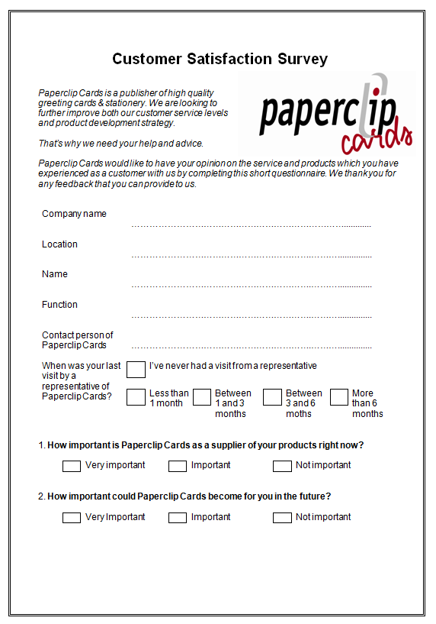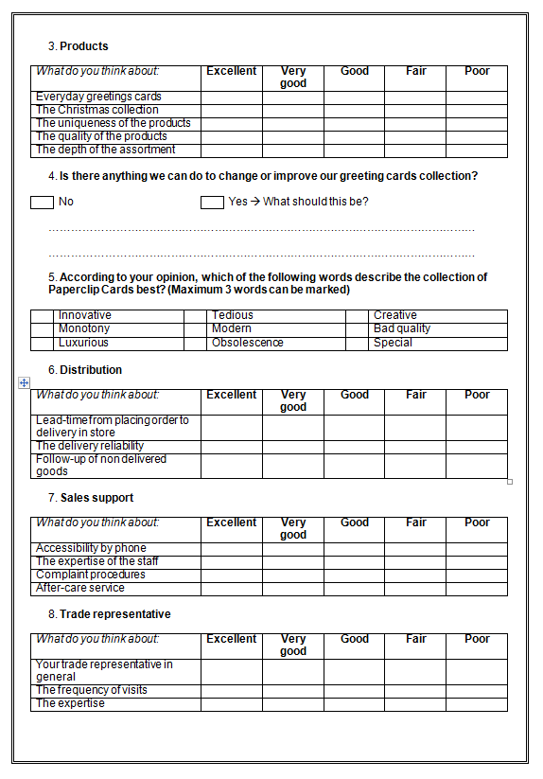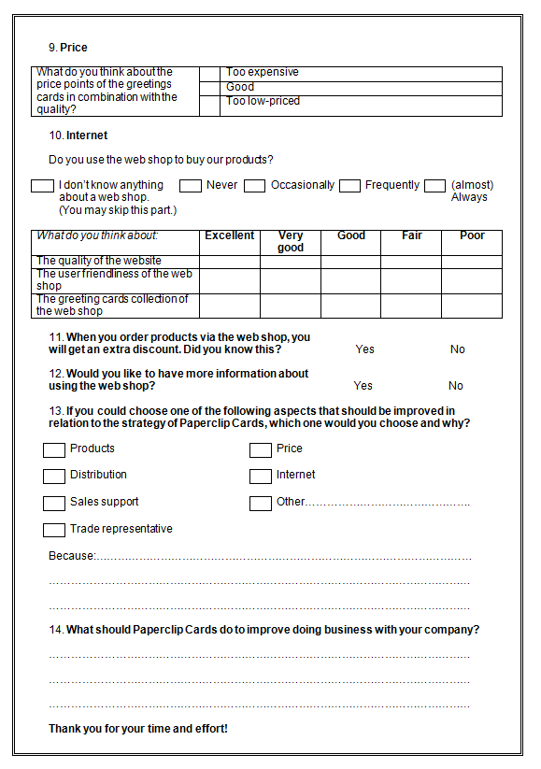

# Appendix 2 Results CSS UK

From the 100 (random selected) clients, 22 clients sent the survey back. Most of these clients are very happy with Paperclip Cards and on average, the clients mention the company as ‘very good’.

|  |  |  |  |  |
| --- | --- | --- | --- | --- |
| **Name** | **Contact person** | **Last visit** | **Paperclip important?** | **Paperclip important in the future?** |
| The Chapel | Jacqui | 1-3 months | Important | Important |
| Rossiters of Bath |  | Never | Important | Important |
| The Hay Loft | Martin? | 3-6 months | Not important | Not important |
| Emzo/J. Lawes | Jacqui | 1-3 months | Very important | Very important |
| Serendipity Interiors Ltd |  | 6> months | Not important | Not important |
| Kind Regards | Barry | 3-6 months | Not important | Important |
| From Me to You | Jacqui | <1 month | Important | Important |
| Acorn |  | 6> months | Not important | Important |
| Jarrolds Norwich | Jacqui | 1-3 months | Important | Important |
| Newport Pagnell Post Office |  | 3-6 months | Important | Important |
| Gemini Trading Ltd | Jacqui | 1-3 months | Not important | Not important |
| D’lights |  | <1 month | Not important | Not important |
| Writtle Road Nursery | Jacqui | 1-3 months | Important | Important |
| LADDS |  | <1 month | Important | Important |
| Colemans of Oundle | Jacqui | <1 month | Important | Important |
| Jarrolds Cromer | Jacqui | 1-3 months | Important | Very important |
| Devon Guild Ltd | Julie Cruikshank | 3-6 months | Important | Important |
| Corsham Post Office | Rob | <1 month | Very important | Very important |
| The Gifted Company |  | 3-6 months | Not important | Not important |
| Fifis | Orders over the phone |  | Very important | Very important |
| The Gift Box Too | Barry Lovatt | 1-3 months | Important | Important |
| Ferrers Gallery Ltd | Neil Cantrill | <1 month | Important | Important |

Only 3 clients say that Paperclip Cards could become more important in the future for them as it is now, and 3 others say that Paperclip Cards is very important at this moment.

All clients, except for 3, have been visited between now and 6 months ago.

|  |  |  |  |  |
| --- | --- | --- | --- | --- |
| **Average Results** | | | | |
| **Products** | **Distribution** | **Sales support** | **Trade rep.** | **Total** |
| 2,3 | 2,1 | 2,1 | 1,9 | **2,1** |
| 1= Excellent | 2 = Very good | 3 = Good | 4 = Fair | 5 = Poor |

These results don’t give Paperclip Cards a good view of where the clients think the problem lays.

It is better to look at the remarks and comments.

When looking at the association with Paperclip Cards, there are 3 words that appear the most. These words are: Innovative, Modern and Creative. The most chosen aspects that should be improved are: Products and Price. It is very predictable that the aspect Products is chosen the most, because (just as one of the clients says) ‘it is always about the product’. Something that Paperclip Cards clearly has to work on is the aspect: Price.

**Internet**

A very remarkable result of this customer satisfaction research is that 100% of the clients mention that they never use the web shop or don’t even know anything about a web shop. 5 clients would like to have more information about this.

These clients are:

* Emzo/J. Lawes
* Kind Regards
* Newport Pagnell Post Office
* Writtle Road Nursery
* Jarrolds Cromer

These clients should be informed by their sales representative.

# Appendix 3 Financial overview Paperclip Cards UK

|  |  |  |  |  |
| --- | --- | --- | --- | --- |
| **Profit / Loss balance sheet** (in English pounds) | | | | |
|  | | **2008-2009** | **2007-2008** | **2006-2007** |
| Net sales | | 359 314 | 401 404 | 242 554 |
| Cost of Sales | | 110 281 | 159 544 | 113 547 |
| **Gross margin** | | **249 033** | **241 860** | **129 007** |
| Salaries and Wages | | 88 354 | 214 561 | 177 095 |
| Distribution Expenses | | 157 130 | 157 725 | 123 917 |
|  | *Car expenses* | *15 022* | *8 731* | *8 631* |
|  | *Travel expenses* | *22 034* | *17 030* | *20 445* |
|  | *Debt collecting* | *977* | *867* | *2 138* |
|  | *Bad Debts* | *8 794* | *1 474* | *5 610* |
|  | *General sales expenses* | *87 452* | *94 310* | *55 482* |
|  | *Commission agents* | *22 851* | *35 313* | *31 611* |
| General administrative expenses | | 92 542 | 79 400 | 58 508 |
|  | *Telephone and postal costs* | *4 102* | *7 182* | *6 931* |
|  | *Office supplies* | *10 355* | *13 159* | *7 606* |
|  | *Office costs* | *0* | *15 703* | *23 853* |
|  | *Computer costs* | *9 599* | *3 252* | *426* |
|  | *Accounting services* | *20 519* | *15 152* | *2 130* |
|  | *Other advisory fees* | *0* | *0* | *0* |
|  | *Management fee* | *3 156* | *11 760* | *0* |
|  | *Other general expenses* | *44 811* | *13 192* | *17 562* |
| Depreciation | | 11 558 | 2 261 | 2 379 |
| Interest | | 243 | 427 | 137.83 |
| Profit / Loss | | **-100 308** | **-211 660** | **-232 754** |

# Appendix 4 Product lines

|  |  |  |  |
| --- | --- | --- | --- |
| **Product line** | **Turnover per client in 2009[26]** | | **Description** |
| Trail Blazer | £ | - | New range of cards aimed at the male market |
| Maxi cards VIS | £ | 655 | From the product collection of Paperclip Cards International |
| High Line | £ | 548 | From the product collection of Paperclip Cards International |
| Gift Cards | £ | 500 | From the product collection of Paperclip Cards International |
| From the Heart | £ | 447 |  |
| Hello Sunshine | £ | 430 |  |
| Handsome | £ | 411 | From the product collection of Paperclip Cards International |
| Postcards VIS | £ | 236 | From the product collection of Paperclip Cards International |
| Spring Season | £ | 202 | The Season collections: Mother’s day, Father’s day, etc. |
| Soundcards | £ | 170 | From the product collection of Paperclip Cards International |
| Fun card 3 | £ | 152 | From the product collection of Paperclip Cards International |
| Gr. cards VIS | £ | 140 | From the product collection of Paperclip Cards International |
| Velvet Sky | £ | 130 | Stunning with watercolour artwork by Rebecca Harris |
| Papillon | £ | 124 | Stylish and upmarket with high quality applications |
| Hot Diggity Dog | £ | 108 | Exclusive and unique with fun and quirky animal characters |
| Jellytot | £ | 95 | Fun and trendy with extra special touches |
| Crème & Noir | £ | 90 | Stylish and sophisticated |
| Life Times | £ | 68 |  |
| Whisper | £ | 60 | High quality with a subtle and sophisticated verse and a ribbon |
| Powder Moon | £ | 57 | Special with a glossy and glittery finish |
| Cherry Blossom | £ | 55 | Contemporary design and high quality finishing |
| Fresca | £ | 52 |  |
| Le Petit Blanc | £ | 43 |  |
| Bright Stuff | £ | 42 | Colourful and trendy with style and panache |
| Fandango | £ | 42 | Bright and colourful which oozes style and sophistication |
| Sand Castles | £ | 42 |  |
| Petticoat Lane | £ | 41 |  |
| Perfect Elegance | £ | 41 |  |
| Scenic Route | £ | 39 |  |
| Camomile | £ | 30 |  |
| Kaleidoscope | £ | 26 | Stylish and contemporary with bright and pastel colouring |
| Christmas | £ | 25 | The Christmas collection |
| Fine Art | £ | 24 |  |
| Small Talk | £ | 14 |  |
| Age Matters | £ | 13 | From the product collection of Paperclip Cards International |
| Hanging Packs | £ | 10 |  |
| Sparkle Dust | £ | 10 |  |
| Photo Factory | £ | 9 | From the product collection of Paperclip Cards International |
| Serenity | £ | 6 |  |
| History | £ | -70 |  |
| Just to Say | £ | -277 | From the product collection of Paperclip Cards International |
| Disco | £ | -396 |  |

# Appendix 5 Potential Clients

|  |  |  |
| --- | --- | --- |
| **Name** | **Number of stores** | **Locations** |
| WH Smith | 565 high street stores and 490 travel outlets at airport, train station, hospital, workplace and motorway service area locations | London, Cardiff/Bristol, Birmingham, Liverpool, Manchester |
| Tesco  *The UK’s second largest greeting card retailer – general Christmas sales smashed forecasts, with group sales up by 7.5%.* | 2,306 (177 Tesco Extra – 448 Tesco Superstores – 174 Tesco Metro – 1001 Tesco Express – 512 One Stop – 10 Tesco Homeplus) | London, Birmingham, Leicester |
| Sainsbury’s  *Results revealed that sales of non-food at Sainsbury’s grew over four times faster that food in the final quarter of the year.[27]* | 525 supermarkets and 303 convenience stores | London, Birmingham, Cardiff/Bristol, Manchester, Liverpool, Sheffield, Leeds |
| Clinton Cards | Over 700 shops | London, Birmingham, Liverpool, Manchester |
| John Lewis | 27 full-line department stores | London |
| Waitrose | 223 branches and 35,573 partners | London + South of England |
| Mayther | Upcoming, very small, no website |  |
| Ryman | 240 | London, Birmingham, Manchester |
| Card Factory | 480 | London, Birmingham, Manchester, Liverpool, Leeds |
| Waterstones  *Bookseller in high streets and shopping centres* | 300 (UK, Republic of Ireland, Europe) | Superstores: Piccadilly London, Gower Street London, Glasgow’s Sauchiehall Street, Bridlesmith Gate Nottingham, Deansgate Manchester, Milsom Street Bath |
| Boots | Around 2,600 stores in the UK from local community pharmacies to large destination health and beauty stores | London, Birmingham, Manchester, Leeds |
| Morrison’s  *4th largest supermarket chain in the UK* | 403 stores in the UK | London, Birmingham, Leeds |

|  |  |  |
| --- | --- | --- |
| **Streets where potential clients from the higher segment are located** | | |
| **City** | **Important shopping streets** | **Exclusive shopping streets** |
| London | Oxford Street, Regent Street, Covent Garden | Bond Street, Knightsbridge |
| Birmingham | High Street, New Street | Corporation Street |
| Leeds | Commercial Street, Briggate | Victoria Quarter |
| Glasgow | Argyle Street, Buchanan Street |  |
| Sheffield | Fargate |  |
| Edinburgh | Princess Street |  |

# Appendix 6 Suitability – Feasibility – Acceptability



# Appendix 7 Coded Consistency

The Great British Card Company, as the ‘unofficial holder’ of the Double Alpha Price Coding Values, has announced that there is no need to adjust any of the price brackets for this year. Any price increases that publishers have imposed can be accommodated within the existing structure.

|  |  |  |
| --- | --- | --- |
| **Double Alpha Price Codes 2010** | | |
| PRICE CODE | 2010 BANDS | |
| AA | Up to 69p |  |
| BB | 70p | * 84p |
| CC | 85p | * 99p |
| DD | £1.00 | * £1.10 |
| EE | £1.11 | * £1.30 |
| FF | £1.31 | * £1.45 |
| GG | £1.46 | * £1.60 |
| GH | £1.61 | * £1.70 |
| HH | £1.71 | * £1.85 |
| HI | £1.86 | * £2.05 |
| II | £2.06 | * £2.25 |
| JJ | £2.26 | * £2.50 |
| KK | £2.51 | * £2.75 |
| LL | £2.76 | * £3.10 |
| MM | £3.11 | * £3.50 |
| NN | £3.51 | * £3.85 |
| OO | £3.86 | * £4.15 |
| PP | £4.16 | * £4.45 |
| QQ | £4.46 | * £4.80 |
| RR | £4.81 | * £5.15 |
| SS | £5.16 | * £5.65 |
| TT | £5.66 | * £6.35 |
| UU | £6.36 | * £7.15 |
| VV | £7.16 | * £8.15 |
| WW | £8.16 | * £9.15 |
| XX | £9.16 | * £10.15 |
| YY | £10.16 | * £11.65 |
| ZZ | £11.66 and over | |

# Appendix 8 Regions sales representatives

1. South East England (London)
2. South England (M4 Corridor to South Coast)
3. Midlands England (M5/M6 Corridor)
4. North West England (M62 Manchester – Leeds)

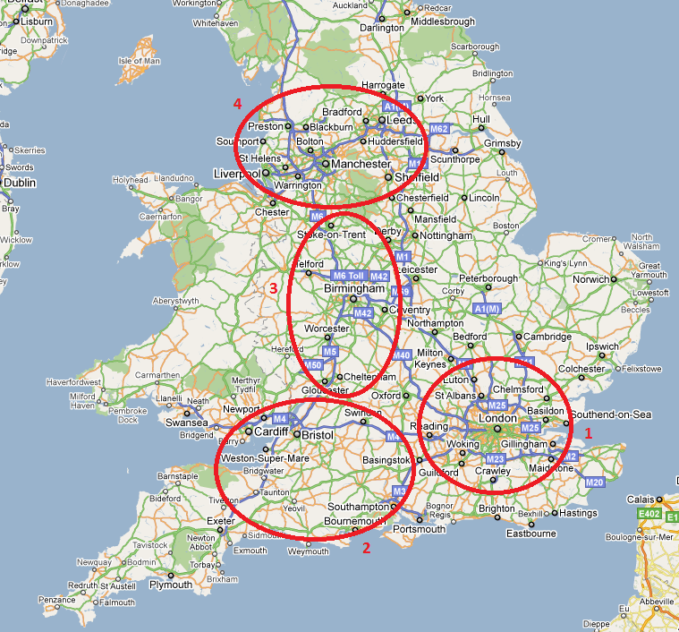

# Appendix 9 Customer Satisfaction Research NL (Dutch)

**Klanttevredenheidsonderzoek**

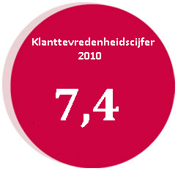

Opdrachtgever: Paperclip Cards bv

Opdrachtnemer: Yvette Kessels

Afstudeerstage Fontys Economische Hogeschool Tilburg

International Business and Languages

16-04-2010

# Inhoudopgave

21.1 Inleiding 49

21.2 Probleemstelling 50

21.3 Kwantitatief onderzoek 51

21.4 Populatie 51

21.5 Enquête 51

21.6 Resultaten 52

21.7 Conclusies & Aanbevelingen 53

21.8 Korte termijn gericht 53

21.9 Lange termijn gericht 54

21.10 Tips om inzicht te houden in de klanttevredenheid 57

21.11 Actieplan 58

Bijlage 1 Enquête 59

Bijlage 2 Inleidende brief 62

Bijlage 3 Merkbekendheidonderzoek 63

Bijlage 4 Ontevreden klanten 64

Bijlage 5 Folder webshop 66

Bijlage 6 Klanten met potentie 67

Bijlage 7 ‘De klant kiest voor Paperclip’ 68

Bijlage 8 Stappenplan Webshop 69

Bijlage 9 Social Media 70

Bijlage 10 Stappenplan klanttevredenheidsonderzoek 71

## Inleiding

Paperclip Cards bv is een bedrijf dat door middel van innovatie, een belangrijke, toonaangevende en bepalende speler wil zijn op de West en Noord Europese wenskaartenmarkt. Het bedrijf ontwerpt en produceert voornamelijk wenskaarten, maar biedt daarnaast ook giftartikelen en Back-to-School collecties aan.

Dit klanttevredenheidsonderzoek is uitgevoerd voor **Paperclip Cards International**.

Paperclip Cards International is de benaming voor de dochteronderneming in Nederland. De missie van dit kantoor is: ‘zorgen dat alle klanten voor Paperclip als wenskaartenleverancier kiezen door zich flexibel en laagdrempelig op te stellen en zowel de organisatie als de collecties continue te verbeteren door innovatie en met passie voor kaarten’. De strategische ambitie is een toonaangevende, innovatieve, professionele en winstgevende totaal aanbieder voor wenskaarten te zijn en één van de twee uiteindelijke totaalleveranciers van wenskaarten te worden.

Om dit doel te kunnen bereiken wordt op dit moment gewerkt met een Balanced Scorecard. Dit is een vertaling van de strategische doelen van een bedrijf in concrete, meetbare parameters: Financieel, klantperspectief, interne bedrijfsvoering en ontwikkeling en groei. Één van de onderdelen van klantperspectief is klanttevredenheid. Op deze BSC is aangegeven dat het bedrijf een 8 wil halen op een schaal van 1 (slecht) tot 10 (goed) voor dit onderdeel.

Dit onderzoek moet leiden tot een goed en betrouwbaar inzicht in de huidige klanttevredenheid en aantonen hoe deze klanttevredenheid te behouden en te verbeteren is.

## Probleemstelling

Om de klanttevredenheid te kunnen verbeteren is het uiteraard van belang dat het bedrijf weet hoe de klant naar het bedrijf kijkt als leverancier van de producten. Het bedrijf kan wel weten wat in het algemeen de interne probleempunten zijn, maar belangrijk is te onderzoeken hoe de klanten dit zien. Tot nu toe is er nog geen klanttevredenheidsonderzoek uitgevoerd.

De probleemstelling is:

Hoe is de huidige klanttevredenheid van Paperclip Cards bv en hoe kan het bedrijf ervoor zorgen dat er binnen 2 jaar een 8 (op een schaal van 1 -slecht- tot 10 -goed-) gescoord wordt voor het onderdeel ‘klanttevredenheid’ op de Balanced Scorecard?

De onderzoeksvragen die bij deze probleemstelling horen zijn:

* Waar associeert de klant het merk Paperclip Cards mee?
* Waarom kiest de klant voor Paperclip Cards? (of waarom niet?)
* Waar is Paperclip Cards volgens de klant sterk in?
* Waar is Paperclip Cards volgens de klant zwak in?

Paperclip Cards wil een goed inzicht krijgen in de tevredenheid van de klanten. Hiervoor moet de informatie zo actueel mogelijk zijn. Het meest essentiële middel is het verrichten van fieldresearch.

## Kwantitatief onderzoek

Het onderzoek is een verkennend onderzoek. Dit wil zeggen dat het doel is informatie te verzamelen over gedrag (gebruiks- en koopgewoonten), denkbeelden (merkbeelden, opvattingen), emoties (beleving, gevoelens) en motieven. De beste manier om dit te doen is door middel van een enquête. Op deze manier wordt naar de mening van de klant gevraagd en wordt duidelijk waar verbetering plaats moet vinden om de klanttevredenheid te verbeteren.

## Populatie

Uit het klantenbestand van Paperclip Cards zijn door het bedrijf 6 branches geselecteerd, welke de populatie van het onderzoek vormen. Deze branches zijn: Kantoorboekhandels, Warenhuizen, Tuincentra, Gemakswinkels, Card & Gift-winkels en Diversen. Deze doelgroep bestaat uit ongeveer 2750 bedrijven. Hieruit zijn aselect 500 klanten geselecteerd welke deelnemen aan het onderzoek.

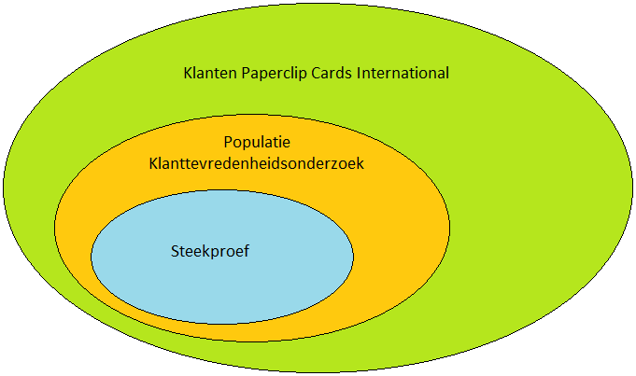

## Enquête

De enquête voor de huidige klant leidt tot de antwoorden op alle onderzoeksvragen. Een voorbeeld van de enquête staat in bijlage 1.

**Proefonderzoek**

Het proefonderzoek van de enquête heeft plaatsgevonden op de Paper & Convenience Show van 7,8 en 9 februari. Tijdens deze beurs is de enquête onder begeleiding afgenomen zodat de klanten feedback hebben kunnen geven en de enquête na de beurs kon worden aangepast. Bovendien is de enquête voor de beurs gecontroleerd door verschillende personen binnen het bedrijf.

**Uitvoering onderzoek**

Donderdag 15 februari 2010 is de aangepaste enquête met de post verstuurd naar 500 huidige klanten van Paperclip Cards in Nederland. Samen met de enquête is een inleidende brief (bijlage 2) en een gefrankeerde enveloppe verstuurd, zodat de klant geen kosten heeft hoeven maken om de enquête terug te sturen. De deadline voor het terugsturen van de ingevulde enquête lag op maandag 1 maart. Dit heeft de klant iets langer dan een week de tijd gegeven.

Naast het klanttevredenheidsonderzoek is er tijdens de Paper & Convenience Show een extra enquête afgelegd. Deze enquête is afgelegd om het imago en de merkbekendheid van Paperclip Cards te onderzoeken. De resultaten zijn opgenomen in bijlage 3.

## Resultaten

Dit hoofdstuk geeft de algemene resultaten weer van het klanttevredenheidsonderzoek. Alle resultaten van het onderzoek per onderdeel, per klant zijn verwerkt in een Excel-bestand. Van de 500 verstuurde enquêtes, zijn er 90 teruggekomen, waarvan er 77 bruikbaar zijn.

Tijdens de Paper & Convenience Show zijn er 50 enquêtes afgelegd. Deze resultaten zijn in dit hoofdstuk niet meegenomen, omdat deze resultaten niet betrouwbaar genoeg zijn. De enquête is namelijk in de stand zelf (waar ongeveer 10 vertegenwoordigers rond hebben gelopen) afgenomen. Bovendien werden de klanten op de beurs ‘verwend’ met een kop koffie en gebak. Wel zijn deze resultaten gebruikt tijdens het trekken van conclusies. Hierbij kan gedacht worden aan de opmerkingen en of klanten wel of niet informatie willen over het gebruik van de webshop.

**Paperclip Cards als leverancier**

Eén van de eerste vragen van de enquête is hoe belangrijk Paperclip Cards op dit moment voor de desbetreffende klant is en hoe belangrijk Paperclip Cards zou kunnen zijn. Voor 38% van de geënquêteerden is Paperclip Cards een heel belangrijke leverancier; voor 53% belangrijk en voor 9% is Paperclip Cards geen belangrijke leverancier. Een belangrijker gegeven is dat 9% aangeeft dat Paperclip Cards een belangrijkere leverancier zou kunnen zijn dan het op dit moment is.

**Resultaten per onderdeel**

De gemiddelde cijfers die de verschillende onderdelen hebben gescoord liggen heel dicht bij elkaar:

|  |  |
| --- | --- |
| **Onderdeel** | **Gemiddeld cijfer** |
| Distributie & facturatie | 7,7 |
| Verkoop binnendienst & administratie | 7,5 |
| Vertegenwoordiger | 7,4 |
| Prijs | 7,3 |
| Internet | 7,2 |
| Producten | 7,1 |

Aan deze resultaten is te zien dat geen van de 6 onderdelen een 8 scoort voor klanttevredenheid, maar dat alle onderdelen wel hoger dan een 7 scoren. Het totale gemiddelde cijfer van het onderzoek is een **7,4**. Dit cijfer is vrij hoog, maar voldoet niet aan de vastgestelde norm.

De onderdelen die verbeterd moeten worden volgens de klant zijn als volgt verdeeld:

|  |  |
| --- | --- |
| **Onderdeel** | **% van ingevulde enquêtes** |
| Producten | 33 |
| Distributie & facturatie | 17 |
| Vertegenwoordiger | 13 |
| Internet | 5 |
| Prijs | 4 |
| Verkoop binnendienst & administratie | 3 |
| Niet ingevuld | 25 |

**De webshop**

Eén van de laatste vragen van de enquête meet de frequentie van het gebruik van de webshop en de behoefte naar informatie hierover. 36% van de geënquêteerden gebruikt de webshop nooit, 4% gebruikt de webshop soms en 12% gebruikt de webshop vrij vaak tot altijd. Opmerkelijk is dat voor bijna de helft (45%) van de geënquêteerden de webshop geheel onbekend is. Daarnaast wil 34% hier graag informatie over.

## Conclusies & Aanbevelingen

Ondanks het feit dat de resultaten duidelijk en overzichtelijk verwerkt zijn in een Excel-bestand, is het moeilijk om goede conclusies te trekken. Als bijvoorbeeld naar de gemiddelde cijfers van de vertegenwoordigers gekeken wordt, kan geconcludeerd worden dat bepaalde vertegenwoordigers veel lager scoren dan andere. Dit hoeft echter in de realiteit niet zo te zijn. Het is mogelijk dat van een vertegenwoordiger slechts twee klanten de enquête terug hebben gestuurd. Als één van deze klanten een laag cijfer geeft, gaat het gemiddelde cijfer van de vertegenwoordiger hard omlaag. Bij een vertegenwoordiger waar bijvoorbeeld tien klanten een enquête hebben teruggestuurd, zal één laag cijfer geen grote gevolgen hebben voor het gemiddelde cijfer. *Het Excel-bestand moet dus altijd voorzichtig gebruikt worden tijdens het trekken van conclusies over de klanttevredenheid.*

## Korte termijn gericht

**Ontevreden klanten**

De eerste stap die nu gezet moet worden is bekijken welke klanten direct aandacht nodig hebben. Dit zijn niet alleen de klanten die het laagste gemiddelde cijfer geven, maar tevens de klanten welke in de opmerkingen aangeven dat er op dit moment iets mis gaat. Deze klanten (inclusief de opmerkingen en hoe deze benaderd moeten worden) zijn opgenomen in bijlage 4.

**Internet - webshop**

Het onderdeel ‘Internet’ is door slechts 15 klanten ingevuld. Dit geeft aan dat er heel weinig klanten zijn die de webshop gebruiken om producten te kopen. 36% van de geënquêteerden geeft aan de webshop nooit te gebruiken en bijna de helft geeft aan niet af te weten van het bestaan van een webshop. Van deze 77 klanten zouden 26 klanten graag informatie willen hebben over de webshop. Op de Paper & Convenience beurs hebben nog eens 16 klanten aangegeven hier graag informatie over te krijgen. *Dit geeft aan dat er nog veel mogelijkheden zijn met betrekking tot de verkoop via internet.*



De volgende stap is daarom het opstellen van een (simpele) folder waar informatie in staat over de webshop. Deze folder moet vervolgens naar deze 42 klanten gestuurd worden. Ook moet er een button op de openingspagina van de website geplaatst worden met de tekst: “Meer informatie over de webshop? Klik hier voor een gratis folder!”. De klant krijgt vervolgens de mogelijkheid om de gegevens in te vullen, waarna de folder wordt opgestuurd. Op deze manier worden alle klanten bereikt, zonder dat het bedrijf afhankelijk is van de vertegenwoordigers. Hoe deze folder eruit moet zien en wat erin moet staan staat in bijlage 5.

## Lange termijn gericht

**Klanten met potentie**

In totaal hebben 13 klanten aangegeven dat Paperclip Cards een belangrijkere leverancier zou kunnen zijn dan het op dit moment is. Dit moet gecommuniceerd worden naar de vertegenwoordigers. De klanten zijn opgenomen in bijlage 6.

**Personeel**

Belangrijk tijdens het verbeteren van de klanttevredenheid is het presenteren van bepaalde onderzoeksresultaten van het klanttevredenheidsonderzoek aan de medewerkers. Deze moeten er namelijk uiteindelijk voor zorgen dat er iets mee gedaan wordt. Ook moet het personeel de mogelijkheid krijgen een mening te geven over bepaalde zaken. Dit is een goedkope en makkelijke manier om op ideeën te komen.

Een voorbeeld is het plaatsen van een whiteboard in de kantine. Elke week wordt hier een vraag op geschreven zoals: “Hoe kunnen we de website aantrekkelijker maken?”. Deze vragen hoeven niet altijd met klanttevredenheid te maken te hebben, maar dit kan er wel een onderdeel van zijn. Dit leidt niet alleen tot goede ideeën, maar zorgt er ook voor dat het personeel wordt betrokken bij alle afdelingen binnen het bedrijf.

**‘De klant kiest voor Paperclip’**

Een resultaat van het verbeteren van de klanttevredenheid moet zijn dat de dekkingsgraad van het aantal verkooppunten in Nederland verhoogt en de marktpenetratie bij bestaande klanten verdiept. Hier heeft de verkooporganisatie uiteraard veel invloed op. Tijdens het invoeren van competentiemanagement is besloten dat aan de norm ‘De klant kiest voor Paperclip’ voldaan wordt wanneer Paperclip Cards 100% of ten minste 3 meter wandcollectie en 80%> of ten minste 6 wenskaartenmolens levert. Momenteel is er een Excel-bestand aanwezig waarin vertegenwoordigers per detaillist aan moeten geven wat er van Paperclip Cards aanwezig is. Bovendien moet niet alleen aangegeven worden hoeveel molens er staan, maar ook welke molens en indien nodig, opmerkingen van de vertegenwoordiger. Op deze manier kan er proactief gehandeld worden. Het stappenplan van het gebruik van het Excel-bestand: ‘De klant kiest voor Paperclip’ is te vinden in bijlage 7.

**Producten**

Aan de resultaten van het klanttevredenheidsonderzoek is te zien dat de klant hier veel waarde aan hecht. Dit is echter ook het onderdeel dat het laagst scoort. Veel klanten geven als opmerking dat er meer vernieuwing plaats moet vinden. Hier is de laatste tijd hard aan gewerkt, maar omdat de time-to-market vrij lang is, heeft de klant hier nog niet veel van gemerkt. Naar aanleiding van de Paper & Convenience beurs in februari 2010 hebben meerdere klanten aangegeven al veel vernieuwing gezien te hebben. Waarschijnlijk zou dit onderdeel dus hoger gescoord hebben als het onderzoek enkele maanden later uitgevoerd zou zijn.

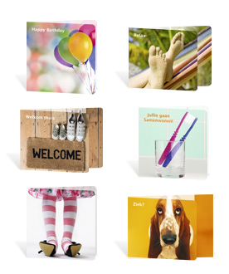

Naast het feit dat Paperclip Cards moet blijven investeren in het vernieuwen van de producten, is het belangrijk dat dit goed gecommuniceerd wordt naar de klant. Paperclip Cards wil gezien worden als een innovatief bedrijf en de klant moet het begrip ‘vernieuwing’ dus opnoemen als wordt gevraagd naar positieve associaties met de collecties van Paperclip Cards. Dit kan onder andere gedaan worden via de website, de mailing of een beurs.

**Distributie & facturatie**

Opvallend aan het onderdeel ‘Distributie & facturatie’ is dat het door 13 klanten benoemd is als onderdeel waar verbetering plaats zou moeten vinden, maar ook het onderdeel is dat het hoogste gemiddelde cijfer scoort. Een verklaring hiervoor zou kunnen zijn dat sommige klanten niet hebben geweten wat ze in moesten vullen en vervolgens alleen maar hoge cijfers hebben gegeven. Het Excel-bestand laat zien dat er enkele uitschieters naar boven tussen zitten.

Wat moet veranderen met betrekking tot het onderdeel ‘Distributie & facturatie’ is de pakbon. Veel klanten klagen over het feit dat de pakbon onduidelijk en onoverzichtelijk is en moeilijk te verwerken en te controleren met de factuur. Er moet dus een pakbon worden opgesteld die goed bruikbaar is voor zowel het bedrijf als de klant.

**Vertegenwoordiger**

Het gemiddelde cijfer van de vertegenwoordigers is een 7,4. Als gekeken wordt naar de vragen die gesteld zijn met betrekking tot de vertegenwoordiger krijgen deze allemaal een gemiddeld cijfer van 7,5 of hoger, behalve het onderdeel ‘Frequentie bezoeken’. Hier wordt gemiddeld een 7,1 voor gegeven.

Bij dit onderdeel wordt het gemiddelde cijfer vooral bepaald door de uitschieters. Er zijn namelijk veel positieve uitschieters (negens en tienen), maar ook veel negatieve uitschieters (drieën en vieren). Hier moet dus per klant gekeken worden naar de vertegenwoordiger die erbij hoort, welke hier vervolgens op korte termijn over aangesproken moet worden. Het kan namelijk zo zijn dat het probleem tijdelijk is (bijvoorbeeld het feit dat één van de vertegenwoordigers onlangs ziek is geweest), maar het kan ook zo zijn dat de klant echt ontevreden is en hier al langer mee zit. Deze klanten zijn opgenomen in bijlage 4.

**Prijs**

De huidige prijsstelling van Paperclip Cards is volgens de klant goed. 45% van de klanten die de enquête hebben ingevuld geeft een 8 of hoger en 44% geeft een 7. Natuurlijk geven de meeste klanten nooit een extreem hoog cijfer voor het onderdeel ‘Prijs’, omdat deze volgens de klant altijd lager mag. Paperclip Cards hoeft hier dus niet veel aandacht aan te besteden en kan zich beter richten op andere onderdelen om de klanttevredenheid te verbeteren.

**Verkoop binnendienst & administratie**

Het onderdeel verkoop binnendienst & administratie scoort gemiddeld een 7,5 en is het onderdeel waar de minste klanten van zeggen dat hier verbetering plaats moet vinden. ‘Nazorg’ is het onderdeel waar het laagste cijfer voor wordt gegeven, namelijk een 7,2.

**Internet - website**

Internet is en zal in de toekomst een steeds belangrijker onderdeel worden. De website van Paperclip Cards wordt op dit moment gebruikt voor het aanbieden van producten door middel van een webshop en voor het geven van algemene informatie. Het bedrijf zou hier echter nog veel meer mee kunnen doen. Zelfs merkbekendheid en het imago zouden op deze manier verbeterd kunnen worden. De website moet aantrekkelijk gemaakt worden voor: huidige klanten, potentiële klanten en de eindconsument. De huidige website ziet er prima uit, maar is niet erg uitnodigend om verder te klikken. De eerste pagina waar (potentiële) klanten en consumenten op terecht komen, moet eruit springen.

Blog

Een (maandelijkse) blog, is een goed voorbeeld om mensen terug te laten komen naar de website. Dit is een verhaal van iemand binnen het bedrijf waarin bijvoorbeeld staat dat er binnenkort een nieuwe productlijn uitkomt, wat de ervaring was op een bepaalde beurs, etc. Oftewel, leuke verhalen en foto’s waardoor de (potentiële) klant en de consument het gevoel krijgt meer over het bedrijf te leren kennen. Een voorbeeld van een bedrijf dat dit doet is Jed Root[28], een modeagentschap voor fotograven, stylisten, etc. Aangezien dit bedrijf heel erg op de mode-industrie gericht is, zijn deze blogs te overdreven voor de wenskaartenindustrie, maar ze kunnen wel gebruikt worden als voorbeeld. Beter zou echter zijn om deze blog direct op de openingspagina van de website te laten zien.

Domein voor de klant

Ook is het mogelijk om klanten een ‘persoonlijk stukje’ van de site te geven. Bijvoorbeeld: klanten kunnen zich inloggen op de site en krijgen bepaalde informatie (zoals aanbiedingen of kortingen), waardoor ze zich speciaal voelen. Op deze manier kan Paperclip Cards marktgerichter te werk gaan en bepaalde groepen op een andere manier benaderen dan andere groepen en worden potentiële klanten sneller klant.

Thema

Een ander voorbeeld om de website aantrekkelijk te maken is door het thema aan te passen op bijvoorbeeld een nieuwe productlijn. Dit creëert een bepaalde sfeer en zorgt ervoor dat de klant meer over deze collectie te weten wil komen.

Webshop

Ook de verkoop via internet kan veel beter in de toekomst. Op dit moment is de webshop onaantrekkelijk en kan de klant alleen producten bijbestellen die al in de winkel aanwezig zijn. Het gebruik van de webshop moet dus aantrekkelijker gemaakt worden en daarnaast moet de klant meer mogelijkheden hebben wat betreft het inkopen van producten. Vanwege een beperkt budget hiervoor moet dit echter in stappen gebeuren. Er moet rekening gehouden worden met: tijd, te besteden budget en de uitvoerbaarheid. Een stappenplan hiervoor staat in bijlage 8.

Social Media

Een andere mogelijkheid om de klanttevredenheid te verbeteren via het Internet is door middel van social media. Naast het verbeteren van de klanttevredenheid kan met dit marketingtool ook een pullstrategie gecreëerd worden met als doel dat de consument bij retailers naar het product gaat vragen.

Wat social media precies inhoudt, is te vinden in bijlage 9.

## Tips om inzicht te houden in de klanttevredenheid

Voor Paperclip Cards is het interessant om te weten hoe de klant het bedrijf ziet als leverancier van hun producten. Dit betekent echter niet, dat de resultaten van dit klanttevredenheidsonderzoek de komende jaren hetzelfde zullen blijven. Sterker nog, het is de bedoeling dat deze resultaten in de toekomst zullen verbeteren. Het is dus belangrijk dat Paperclip Cards geïnteresseerd blijft in de mening van de klant en hier goed op in zal spelen.

**Herhaling klanttevredenheidsonderzoek**

Het doen van een kwalitatief onderzoek zoals het versturen van enquêtes is een onderzoek dat vrij veel tijd en moeite in beslag neemt. Toch zal na bijvoorbeeld 1 of 2 jaar de klanttevredenheid nog een keer gemeten moeten worden, om te kunnen zien of deze verbeterd is of niet. Aangezien de steekproef is afgenomen bij klanten die aselect zijn geselecteerd, moeten bij een volgende steekproef weer aselect 500 klanten geselecteerd worden uit de populatie. Paperclip Cards wil namelijk niet de mening hebben van deze eerste 500 klanten, maar van de gehele populatie. Een stappenplan voor het herhalen van het klanttevredenheidsonderzoek is te vinden in bijlage 10.

Een snelle mogelijkheid om het onderzoek te doen is via het Internet. Indien de website verbeterd wordt en er dus veel klanten zijn die deze regelmatig bezoeken, zou er een enquête afgenomen kunnen worden onder deze bezoekers. Bij het openen van de website zal gevraagd kunnen worden een enquête in te vullen over de klanttevredenheid van Paperclip Cards. Dit kan intern gedaan worden, maar ook goedkoop via een externe service.

**Klantcommissie**

Een hele goede en effectieve manier om de klanttevredenheid te meten is een face-to-face gesprek. Enkele klanten moeten gevraagd worden om (bijvoorbeeld) eens in de twee maanden naar Paperclip Cards in Veenendaal te komen voor een klantencommissie. Deze klanten krijgen dan de kans om opmerkingen te geven over de gang van zaken, maar kunnen ook met ideeën komen.

**Proactief handelen**

Eén van de taken van de vertegenwoordigers is het onderhouden van klantenrelaties. Het probleem is echter, dat als een klant niet meer tevreden is, het bedrijf vaak niet het hele verhaal te horen krijgt. Belangrijk is dus dat ook hier proactief gehandeld wordt. Het bedrijf moet dus niet pas gaan handelen als de situatie uit de hand begint te lopen, maar zodra er iets opmerkelijks gebeurt (bijvoorbeeld: de omzet daalt) proberen te achterhalen wat de oorzaak hiervan is. Iemand van de verkoop binnendienst kan bijvoorbeeld opbellen met de vraag of de klant tevreden is, of dat er iets is waar de klant een mening over wil geven.

## Actieplan

|  |  |  |  |
| --- | --- | --- | --- |
| Stap | Actie | Deadline | Verantwoordelijk |
| 1 | Start stappenplan “De klant kiest Paperclip” | Al in werking | Lisette Scheurwater |
| 2 | Presentatie resultaten aan vertegenwoordigers | 17 mei 2010 | Yvette Kessels |
| 3 | Klanten uitnodigen voor klantcommissie | 17 mei 2010 | Lisette Scheurwater |
| 4 | Terugkoppeling ondernomen acties | 1 Juni 2010 | Vertegenwoordigers |
| 5 | Eerste opzet ‘company brochure’[29] | 1 Juni 2010 | Annemieke den Boer |
| 6 | Digitaal Whiteboard activeren  + versturen e-mail met uitleg | 1 Juni 2010 | Leon Corstens |
| 7 | Start stappenplan webshop | 1 Juni 2010 | Lisette Scheurwater |
| 8 | Eerste samenkomst klantcommissie | Juni 2010 | Lisette Scheurwater |
| 9 | Versturen ‘company brochure’ | 1 Juli 2010 | Annemieke den Boer |
| 10 | Aanpassen pakbon | 1 Juli 2010 | Mark Koese |
| 11 | Herhaling Klanttevredenheidsonderzoek (zie bijlage 8) | Feb. 2011  (Controle doelstelling) | Lisette Scheurwater |

# Bijlage 1 Enquête

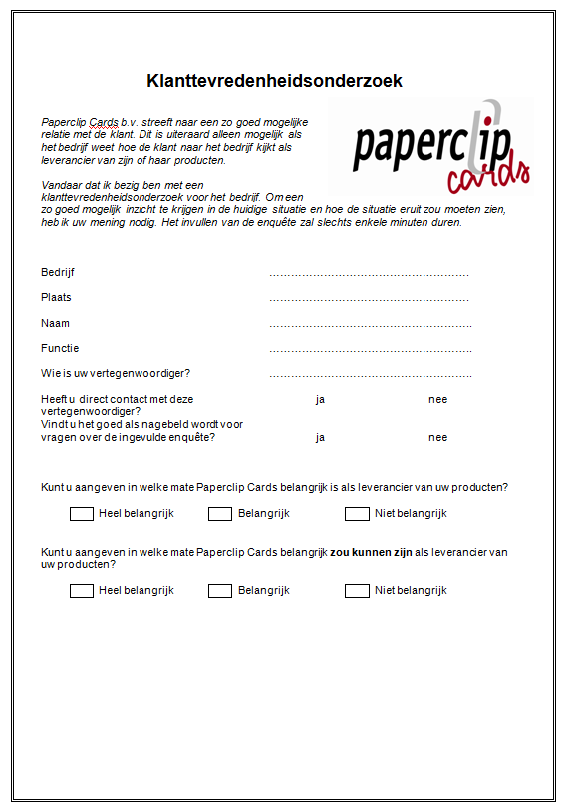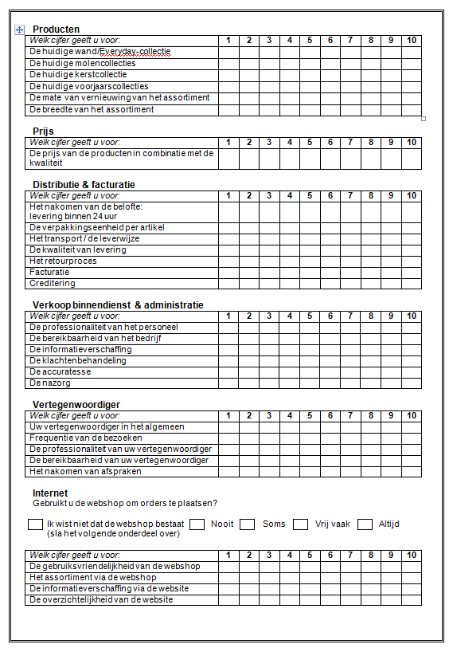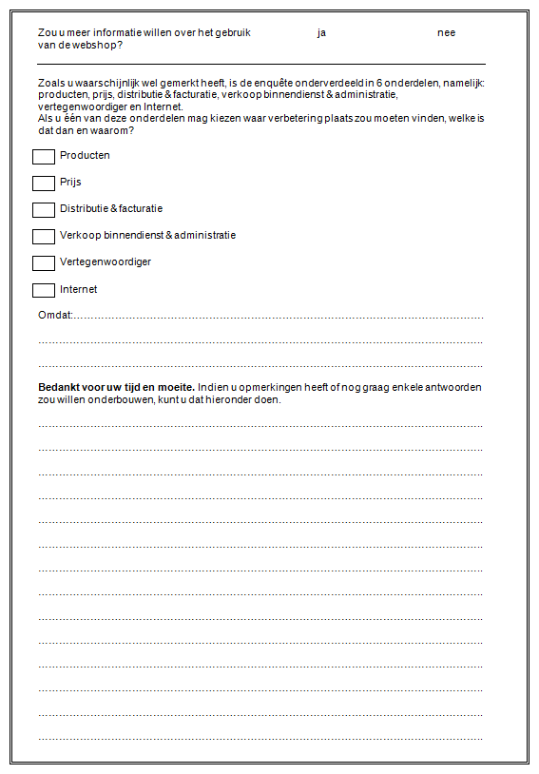

# Bijlage 2 Inleidende brief

Geachte heer of mevrouw,

Mijn naam is Yvette Kessels. Ik studeer International Business and Languages in Tilburg en ben op dit moment bezig met afstuderen door middel van een stage bij het bedrijf **Paperclip Cards** in Veenendaal.

De reden waarom ik u benader is omdat ik bezig ben met een klanttevredenheidsonderzoek voor het bedrijf. Om een zo goed mogelijk inzicht te krijgen in de huidige situatie en hoe de situatie eruit zou moeten zien, heb ik **uw mening** nodig.

Het invullen van de enquête zal slechts enkele minuten duren. Na het invullen van de enquête, kunt u deze in de bijgevoegde (gefrankeerde) enveloppe terugsturen naar Paperclip Cards. Ook mag u de ingevulde enquête scannen en via een e-mail naar mij opsturen. Mijn e-mail adres is: yvette.kessels@paperclipcards.com. Ik wil u vragen de enquête vóór vrijdag **5 maart** a.s. terug te sturen. Na deze datum zullen de gegevens niet meer verwerkt kunnen worden.

Het invullen van de enquête zal uiteraard goed zijn voor het bedrijf, maar natuurlijk ook voor u als klant, aangezien u nu de kans krijgt uw mening te geven over bepaalde zaken, waar vervolgens iets mee gedaan kan worden. Vandaar dat ik u wil vragen de enquête kritisch in te vullen. Indien bepaalde onderdelen niet van toepassing zijn, kunt u deze simpelweg open laten.

Alle gegevens zullen op gepaste en weloverwogen wijze worden gebruikt en zullen niet openbaar worden gemaakt.

Alvast bedankt voor uw tijd en moeite.

Met vriendelijke groet,

Yvette Kessels

[yvette.kessels@paperclipcards.com](mailto:yvette.kessels@paperclipcards.com)

06-83247978

# 

# Bijlage 3 Merkbekendheidonderzoek

Dit onderzoek is bij slechts 13 personen uitgevoerd. De personen die de enquête niet wilden invullen gaven als reden:

* Dat ze bewust geen klant zijn van Paperclip Cards, aangezien de concurrent Paperclip Cards als hoofdleverancier heeft.
* Dat ze de naam ‘Paperclip Cards’ kennen, maar verder niets over de producten weten.
* Dat ze het bedrijf ‘Paperclip Cards’ niet kennen.

Het uitvoeren van dit onderzoek was slechts een bijzaak, wat betekent dat de resultaten niet representatief zijn voor de gehele populatie (alle niet-klanten van Paperclip Cards die het bedrijf wel kennen).

**Resultaten:**

|  |  |
| --- | --- |
| **Top 3** | |
| **Belangrijkste punten leverancier** | **Associatie Paperclip Cards** |
| 1. Betrouwbaarheid | 1. Creatief |
| 1. Breed assortiment | 2. Modern |
| 3. Vriendelijke vertegenwoordiger | 1. Luxe |

**Prijs**

Alle geënquêteerden vinden de prijs-kwaliteitverhouding goed.

**Product**

47% van de geënquêteerden denkt dat Paperclip Cards 9 tot 13 Everyday-collecties heeft en 31% denkt dat Paperclip Cards 8 of minder Everyday-collecties heeft.

**Internet**

Op 1 na, vinden alle geënquêteerden het hebben van een goede website (heel) belangrijk, terwijl een groot deel van de geënquêteerden het hebben van een webshop niet belangrijk vindt.

# Bijlage 4 Ontevreden klanten

**Tien meest ontevreden klanten**

De tien klanten die gemiddeld het laagste cijfer geven, geven de klanttevredenheid van Paperclip Cards een cijfer tussen de 4,4 en de 6,1. Deze tien klanten geven gemiddeld het laagste cijfer voor het onderdeel ‘Vertegenwoordiger’.

|  |  |  |  |  |
| --- | --- | --- | --- | --- |
| **Klant** | **Naam** | **Gem.**  **cijfer** | **Vertegenwoordiger** | **Opmerking** |
| 498 | Ster Videotheek Franeker V.O.F. | 4,4 | Roland Bersee | Geeft aan dat Paperclip Cards niet belangrijk is of zou kunnen zijn. |
| 191 | Ako Bruna Rotterdam | 5,9 | Allan Lemmens | “Ze” is heel goed, maar vaak ziek.  **Wil niet nagebeld worden.** |
| 432 | Totaal Gemak Epe | 5,9 | Paul Diekema | Valentijnmolens werden niet op tijd geleverd. Nalevering verliep ook niet goed. Geeft aan dat Paperclip Cards niet belangrijk is, maar wel belangrijk zou kunnen zijn. |
| 50 | Gebr. Winter Amsterdam | 5,9 | Michel Minneboo | Geen |
| 286 | Boekhandel Ruward – Megastores | 5,9 | Edwin Goedhart | Winkel staat vol met Paperclip Cards, maar de vertegenwoordiger komt nooit. |
| 442 | Totaal Gemak – Hoek van Holland | 6 | Allan Lemmens | Vertegenwoordiger heeft te weinig kennis. Kerstcreditering duurt te lang. Logistiek gezien is het een complete fiasco. Paperclip Cards is wel heel belangrijk. |
| 111 | The Read Shop Slinge | 6 | Allan Lemmens | Doet bijna geen zaken met Paperclip Cards. Spreekt vertegenwoordiger alleen op beurs. **Wil niet nagebeld worden.** |
| 196 | Bruna Middelharnis | 6 | Astrid van den Heuvel | Vertegenwoordiger is vaak ziek, wat niet gemeld wordt. Vindt dat Paperclip Cards meer moeite moet doen om ze als klant te behouden. Overweegt om ‘Paperclip-wand’ te verkleinen ten gunste van een andere leverancier. |
| 311 | Primera Doetinchem | 6 | Mark Lamer | Assortiment voor een Primera binnen de 80-20 regeling is te beperkt. **Wil niet nagebeld worden.** |
| 497 | Passarelle Den Bosch | 6,1 | Richard Visser | Vertegenwoordiger heeft een te groot gebied om te bezoeken. Wacht nog steeds op crediteringen. |

De eerste klant van deze lijst (Ster Videotheek Franeker) is het meest ontevreden en geeft daarnaast aan dat Paperclip Cards geen belangrijke leverancier zou kunnen zijn. Er moet met Ronald Bersee overlegd worden wat hier mee gedaan moet worden.

Opvallend aan de tweede klant (Ako Bruna Rotterdam) is dat het bedrijf spreekt over een vrouwelijke vertegenwoordiger, maar Allan Lemmens de huidige vertegenwoordiger is. Hier zal de heer Lemmens over aangesproken moeten worden. Ook moet deze vertegenwoordiger op korte termijn aandacht geven aan ‘The Read Shop Slinge’.

Paul Diekema moet aandacht schenken aan ‘Totaal Gemak Epe’. Dit bedrijf geeft aan een negatieve ervaring gehad te hebben met Paperclip Cards, maar niet met de vertegenwoordiger. Daarnaast wordt aangegeven dat er potentie is voor Paperclip Cards.

‘Boekhandel Ruward’ heeft aandacht nodig. Het bedrijf geeft aan dat de winkel vol staat met Paperclip Cards, maar dat de vertegenwoordiger nooit langs komt. De huidige vertegenwoordiger is Edwin Goedhart.

Passarelle Den Bosch geeft aan dat de vertegenwoordiger een te groot gebied heeft om te bezoeken. Hieruit kan opgemaakt worden dat de vertegenwoordiger, Richard Visser, te weinig aandacht geeft aan het bedrijf.

Van deze klanten moeten de volgende klanten nagebeld worden: Gebr. Winter Amsterdam, Totaal Gemak – Hoek van Holland en Bruna Middelharnis. Deze klanten worden naar aanleiding van de enquête gebeld en gevraagd wat Paperclip Cards moet doen om de relatie te verbeteren (of herstellen).

**Klanten met een probleem**

De volgende klanten hebben aangegeven dat er op dit moment iets niet goed gaat. Deze opmerkingen moeten op korte termijn naar de vertegenwoordiger gecommuniceerd worden, zodat deze ervoor kan zorgen dat het probleem opgelost wordt.

|  |  |  |  |  |
| --- | --- | --- | --- | --- |
| **Klant** | **Naam** | **Gem.**  **cijfer** | **Vertegenwoordiger** | **Opmerking** |
| 6 | Repelsteeltje Speelgoed | 7,4 | Allan Lemmens | Klikt niet tussen de vertegenwoordiger en het personeel. |
| 262 | Bruna Nederweert | 7,8 | Ronald van Veijfeijken | Oude molens worden maar niet opgehaald. |
| 283 | ’t Kleine Geluk | 7,2 | Allan Lemmens | Nog steeds geen creditfactuur ontvangen van de kerstkaarten. Facturen komen altijd in open enveloppen aan, strip van de plakrand zit er altijd nog op. |
| 398 | De Gemakswinkel Leimuiden | 6,8 | Edwin Goedhart | Nieuwe vertegenwoordiger is nog steeds niet langs geweest. Weet niets van het bestaan van de webshop af. (Vindt dit heel vreemd.) |
| 418 | Multishop Breda | 6,5 | Richard Visser | Uit de wand “Mixed Emotions” wordt te veel niet geleverd en continu andere kaarten. De laatste tijd gaat de service van Paperclip Cards achteruit. |
| 488 | Tabaksspeciaalzaak Kaldenbach | 6,6 | Edwin Goedhart + Marnix Bakkenist | Te vaak te veel lege vakken en dezelfde molens. Special items worden vervangen, wat juist zo uniek was. |
| 497 | Passarelle Den Bosch | 6,1 | Richard Visser | Wacht nog steeds op crediteringen. |
| 28 beurs | De Egel | - | Allan Lemmens | Niet tevreden. Vindt personeel arrogant. Kwaliteit gaat sterk achteruit. Weet niet wie de vertegenwoordiger is. |
| 44 beurs | Bruna Schouwburg-promenade | 7,6 | Richard Visser | Te weinig contact met vertegenwoordiger. (Bestelt via de webshop.) |

# Bijlage 5 Folder webshop

**Uiterlijk**

De folder moet ervoor zorgen dat de klant enthousiast wordt om de webshop te gaan gebruiken, maar mag daarentegen niet te hoge verwachtingen opwekken. De webshop is op dit moment nog geen marketingtool, maar slechts een manier om producten bij te bestellen. Zodra de webshop is aangepast (zie bijlage 8), dan zal dit gepromoot worden naar de klant.

* Thema: dezelfde als de huidige webshop
* Lettertype/-kleur: (niet te) groot en duidelijk
* Logo van Paperclip Cards op de voorkant
* Illustratie: openingspagina van de webshop

**Inhoud**

De inhoud moet vooral duidelijk maken waarom de klant de webshop zou moeten gaan gebruiken. Daarnaast moet de klant informatie krijgen over de stappen die nu gezet moeten worden om het gebruik in werking te stellen.

* Voordelen voor de klant
  + Minder verantwoordelijk van vertegenwoordiger
  + 24/7 beschikbaar
  + Korting
  + Inzicht status order
  + Terugblik orders verleden
  + Factuuroverzicht
* Uitleg hoe de klant toegang kan krijgen tot de webshop
* Uitleg hoe de klant een gratis handleiding toegestuurd kan krijgen

# Bijlage 6 Klanten met potentie

De volgende klanten geven aan dat Paperclip Cards een belangrijkere leverancier zou kunnen zijn dan het op dit moment is. Hier moeten de vertegenwoordigers op aangesproken worden.

|  |  |  |  |  |
| --- | --- | --- | --- | --- |
| **Klant** | **Naam** | **Vertegenwoordiger** | **Huidig** | **Mogelijk** |
| 99 | Thuiskantoor & Aktieboek | Ronald van Veijfeijken | Belangrijk | Heel belangrijk |
| 155 | Mondria Kantoorboekhandel | Edwin Goedhart | Niet belangrijk | Belangrijk |
| 160 | Kbh. Hendriks | Mark Lamers | Belangrijk | Heel belangrijk |
| 271 | Sylt Lifestyle | Michel Minneboo | Niet belangrijk | Belangrijk |
| 396 | Tabak & Lectuur Kalloe | Allan Lemmens | Niet belangrijk | Belangrijk |
| 402 | Techador De Wit Opheusden | Mark Lamers | Belangrijk | Heel belangrijk |
| 431 | Totaal Gemak Can Tabak | Michel Minneboo | Niet belangrijk | Belangrijk |
| 432 | Totaal Gemak Epe 706 | Paul Diekema | Niet belangrijk | Belangrijk |
| 18 beurs | Primera Vathorst | Eelco Engelschman | Belangrijk | Heel belangrijk |
| 25 beurs | Bruna Heemskerk 625 | Michel Minneboo | Niet belangrijk | Belangrijk |
| 27 beurs | Cartoon | Mark Lamers | Belangrijk | Heel belangrijk |
| 28 beurs | De Egel | Allan Lemmens | Niet belangrijk | Belangrijk |
| 36 beurs | Heutink Dier / Tabak | Paul Diekema | Niet belangrijk | Belangrijk |

# Bijlage 7 ‘De klant kiest voor Paperclip’

|  |  |
| --- | --- |
| **Stappenplan** | |
| **Stap** | **Actie** |
| 1 | Alle vertegenwoordigers + service merchandisers moeten duidelijk uitleg krijgen over het plan (incl. deadlines). |
| 2 | Alle vertegenwoordigers + service merchandisers moeten het Excel-bestand gaan invullen en bijhouden. |
| 3 | Elke maand worden 5 klanten geselecteerd. Deze klanten worden kort behandeld tijdens de vergadering met de vertegenwoordigers. |
| 4 | Controle geselecteerde klanten |

# Bijlage 8 Stappenplan Webshop

|  |  |  |  |
| --- | --- | --- | --- |
| **Stap** | **Actie** | **Deadline** | **Verantwoordelijk** |
| **1** | Aangewezen personen duidelijk maken welke taken deze hebben* | 1 Juni 2010 | Lisette Scheurwater |
| **2** | Concept ‘company brochure’ | 1 Juni 2010 | Marketing medewerker |
| **3** | Versturen ‘company brochure’ | 1 Juli 2010 | Marketing medewerker |
| **4** | Uitbreiden: thema (sfeer) aanpassen 🡪 webshop aantrekklijk maken | In overleg | Marketing medewerker + IT medewerker |
| **5** | Uitbreiden: gehele collectie beschikbaar maken voor de klant | In overleg | IT medewerker |
| **6** | Dit communiceren naar de klant d.m.v. mailing | In overleg | Medewerker op de Verkoop Binnendienst |

* Meerdere personen zullen verantwoordelijk gesteld worden voor het aanpassen en onderhouden van de webshop. Dit zal bekend gemaakt worden aan het personeel, met de gedachte dat ideeën en opmerkingen over dit onderdeel daar terecht kunnen.

|  |  |
| --- | --- |
| **Wie** | **Verantwoordelijk voor…** |
| IT medewerker | Alle technische aanpassingen |
| Marketing medewerker | Alle marketing aspecten |
| Medewerker op de Verkoop Binnendienst | De koppeling van de webshop met de klanten |

# Bijlage 9 Social Media

Social media is de Engelse benaming voor een online netwerk waar iedereen over de hele wereld gebruik van kan maken.

Tegenwoordig is social media geen hype meer, maar een standaard onderdeel van de complete marketingmix van B2C bedrijven. Deze manier van marketing wordt vaak geassocieerd met organisaties die zich richten op business to consumer, maar er zijn echter ook veel kansen op dit gebied voor organisaties die zich op business to business richten.

Paperclip Cards is een bedrijf dat veel zou kunnen doen met betrekking to online netwerken, niet alleen naar de klant gericht, maar ook naar de consument. Het bedrijf kan op deze

manier bepaalde hypes opwekken zoals de VIS-collectie een hype is geweest.

**Wel of niet toepassen?**

Dat het gebruik van social media een kans is, is niet te ontkennen, maar of het ook daadwerkelijk toegepast moet worden is de vraag. Aangezien deze manier van communiceren heel snel gaat, kan het ook nadelige gevolgen hebben voor het bedrijf. Indien Paperclip Cards besluit een groter deel uit te gaan maken van het Internet, dan moet het bedrijf hier ook voor de volle 100% voor gaan. Bovendien vergt dit marketingtool ook onderhoud.

**Wat zijn de voordelen?**

Social media wordt op verschillende manieren gebruikt:

* Er kan informatie gegeven worden door bijvoorbeeld nieuwe productlijnen te introduceren of persberichten te plaatsen.
* Ook kan er informatie verkregen worden door forums te plaatsen waar (potentiele) klanten of consumenten een mening kunnen plaatsen. Hierbij kan het bedrijf antwoord krijgen op vragen als: “ Wat zeggen de klanten en de prospects?” “ Wat zijn de wensen en de eisen?” “ Waar zitten verbeterpunten?”.
* Het houden van acties kan ervoor zorgen dat er hypes ontstaan. (Bijvoorbeeld prijsvragen.)
* De mogelijkheid is aanwezig om bepaalde statistieken te bekijken zoals hoe vaak een bepaalde link wordt bekeken.

# Bijlage 10 Stappenplan klanttevredenheidsonderzoek

|  |  |  |  |
| --- | --- | --- | --- |
| Stap | Actie | Deadline | Verantwoordelijk |
| 1 | 500 adressen (aselect) selecteren uit ‘Adressenlijst KTO’ | Week 1 | Lisette Scheurwater |
| 2 | Inleidende brief schrijven (voorbeeld: bijlage 2) | Week 1 | Lisette Scheurwater |
| 3 | 500 grote enveloppen versturen gevuld met:  - Gefrankeerde enveloppe met retouradres: Paperclip  - Inleidende brief  - Enquête (bijlage 1) | Week 3 | Lisette Scheurwater |
| 4 | Verwerken gegevens in Excel-bestand | Week 1 na retourdatum | Lisette Scheurwater |
| 5 | Conclusies & aanbevelingen | Week 3 na retourdatum | Lisette Scheurwater |
| 6 | Actieplan | Week 4 na retourdatum | Lisette Scheurwater |

Stap 1 tot en met 3 kunnen overgeslagen worden indien een enquête afgelegd wordt via de website. Dit scheelt tijd en geld, maar is ook minder betrouwbaar (aangezien alleen bezoekers van de website benaderd worden).

1. Customer Satisfaction Research, United Kingdom, April 2010
2. [www.greetingcardassociation.org.uk/info-resource/starting-up/business-basics](http://www.greetingcardassociation.org.uk/info-resource/starting-up/business-basics)
3. [www.greetingcardassociation.org.uk/info-resource/trade-fairs/trade-shows](http://www.greetingcardassociation.org.uk/info-resource/trade-fairs/trade-shows)
4. [www.greetingcardassociation.org.uk](http://www.greetingcardassociation.org.uk)
5. [www.dailymail.co.uk/news/article-1190982/2-500-Post-Office-closures-bulldozed--saved-nothing.html](http://www.dailymail.co.uk/news/article-1190982/2-500-Post-Office-closures-bulldozed--saved-nothing.html)
6. Progressive Greetings January 2010
7. <http://news.bbc.co.uk/2/hi/8426538.stm>
8. <http://www.greetingcardassociation.org.uk/info-resource/licensing/uk-laws-governing-licensing>
9. [www.greetingcardassociation.org.uk](http://www.greetingcardassociation.org.uk)
10. <http://www.quickmba.com/strategy/porter.shtml>
11. [www.kwintessential.co.uk/intercultural/dimensions.html](http://www.kwintessential.co.uk/intercultural/dimensions.html)
12. Research for Paperclip Cards by Andrew Kemmett
13. Progressive Greetings, October 2009
14. The average of 2 experts from the greeting cards industry.
15. Progressive Greetings December 2009
16. [www.marketresearch.com/product/display.asp?productid=1904218](http://www.marketresearch.com/product/display.asp?productid=1904218)
17. News Letter from RITRA CARGO HOLLAND B.V.
18. [www.greetingcardassociation.org.uk/info-resource/artists/direct-to-retail-vs-wholesale-publishers](http://www.greetingcardassociation.org.uk/info-resource/artists/direct-to-retail-vs-wholesale-publishers)
19. “Organisatie en Management” by Puck van Aart
20. The representatives and/or agents that didn’t perform well enough will be let go. The use of sales representatives will be more in proportion as the sales will rise.
21. In consultation with Paperclip International Group.
22. [www.ruscon.nl/modellen/Digitaal%20opties%20Evaluatiemodel%20NL.xls](http://www.ruscon.nl/modellen/Digitaal%20opties%20Evaluatiemodel%20NL.xls)
23. ‘+’ means that the UK office wants to keep the product line, ‘-‘ means that the UK office doesn’t see potential in the product line.
24. The values of the price margins are chosen by combining the ‘Double Alpha Price Codes 2010’ (appendix 6) and the current prices of the products of Paperclip Cards UK.
25. 2 experts of Paperclip International Group bv
26. Total turnover of the product line divided by the number of clients that ordered products from that range.
27. Progressive Greetings February 2010
28. http://blog.jedroot.com/
29. Folder met informatie over Paperclip Cards, zoals uitleg over de webshop.